Khut'bah Opening
إِنَّ الْحَمْدَ للهِ , نَحْمَدَهُ وَ نَسْتَعينُهُ وَ نَسْتَغْفِرُهُ , وَ نَعوذُ بِالله مِنْ شُرورِ أَنْفُسِنا , مَن يَهْدِهِ اللهُ فَلا مُضِلَّ لَه , وَ مَنْ يُضِلِلْ فَلا هادِيَ لَهْ , وَ أَشْهَدُ أَنْ لا إلهَ إِللهُ وَحْدَهُ لا شَريكَ لَه , و أَشْهَدُ أنَّ مُحَمَّدًا عَبْدُهُ و رَسولُه.
"All thanks and praises are due to Allah, whom we thank, seek for help and invoke for forgiveness. We seek refuge with Allah from the evils within ourselves. He whom Allah guides will never be misled and he whom He misguides will never find one to guide him. I bear witness that there is no deity worthy of worship except Allah and that Muhammad (SAW) is His slave and Messenger.
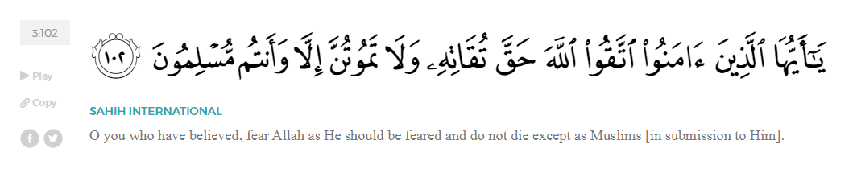
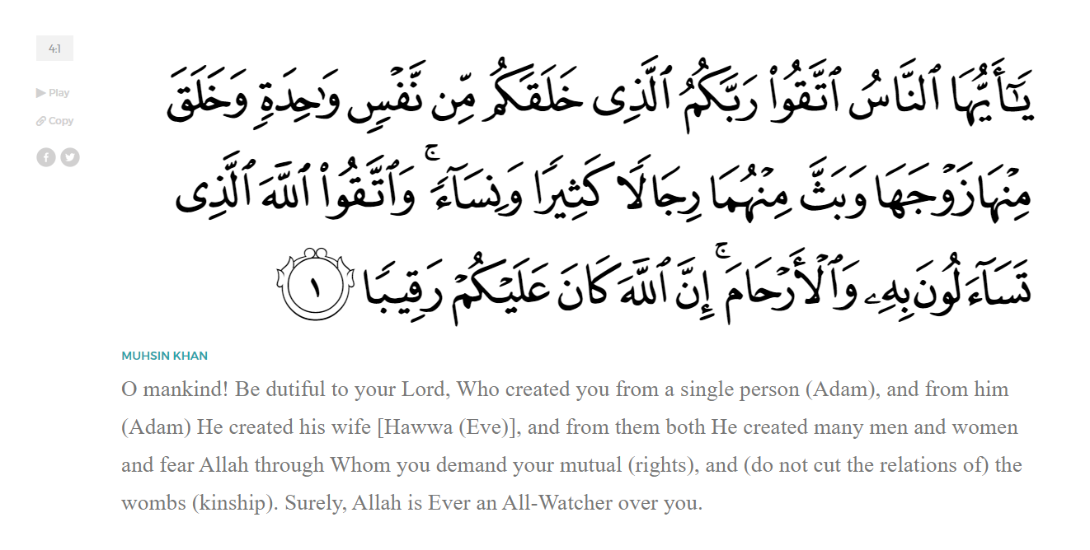
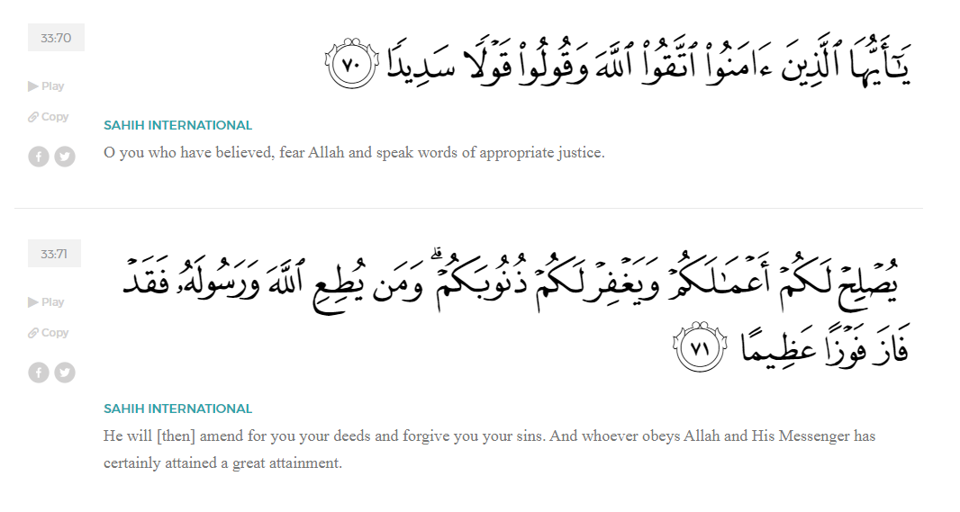
<Sirah of the Prophet (SAW) – Part 12 -Dr. Yassir Qadhi, Book and Series>
Dear brothers and sisters,
InshaaAllah we will continue our khutbah series on the seerah of the Prophet ﷺ, drawing from Dr. Yasir Qadhi’s book, The Sirah of the Prophet, so that we can deepen our understanding of his life and strengthen our love for him. Each step we take through the Prophet ﷺ’s life brings us closer to knowing him more deeply, appreciating his struggles, and embodying his character. Our goal in this series, inshaaAllah, is not just to learn history, but to let the seerah transform our hearts and strengthen our love for the Messenger of Allah ﷺ.
Today we will, inshaaAllah, continue with the chapter of Early Islam, starting with the section titled “Between Bribery and Torture”.
As Islam started to spread more and more in Arabia and the efforts of Quraysh proved ineffective at slowing its adoption, they began negotiating with the Prophet ﷺ directly, offering to compromise. One such attempt was the offer to share religions; they proposed that Allah alone be worshipped one day, and the idols be worshipped the next day, alternating between the two.
There is, of course, no compromise in the Oneness of Allah (SWT), and Allah revealed Surat Al-Kaafiroon in response:
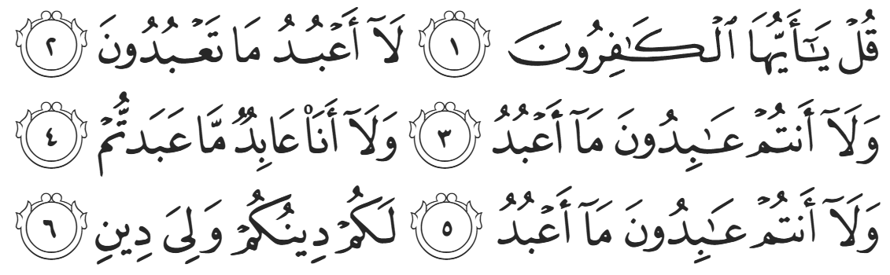
“Say, ‘O you disbelievers! I do not worship what you worship, nor do you worship what I worship, I will never worship what you worship, nor will you ever worship what I worship. You have your way, and I have my Way.’ (109:1-6)”
As previously mentioned, the Quraysh did worship Allah, and yet Allah (SWT) instructs the Prophet ﷺ to say “I do not worship what you worship” because worshipping Allah (SWT) through intermediaries is shirk, nullifying the worship in its entirety.
The Quraysh then asked what the Prophet ﷺ wanted in order to cease his da’wah. The Prophet ﷺ replied that he wanted one statement from them, to which Abu Jahl replied ecstatically, “We will give you ten!” The Prophet ﷺ revealed the statement to be the Islamic declaration of faith: Laa-Ilaaha-Ill-Allah There is no god but Allah.
They responded as described by Allah in the Qur’an in Surat Saad:

“Has he reduced [all] the gods to One God? Indeed, this is something totally astonishing.” (38:5)
When offers of compromise failed, the Quraysh resorted to outright bribery. ‘Utbah ibn Rabi’ah, a distant uncle of the Prophet ﷺ, approached him on behalf of the Quraysh. He said, “O my nephew, you know your lineage and status; you are the grandson of ‘Abd al-Muttalib and the son of ‘Abdullah. You have come forward with a matter that has wreaked havoc on our people. O Muhammad, are you better than ‘Abd al-Muttalib? Are you better than ‘Abdullah?”
The Prophet ﷺ did not respond as there is no wisdom in replying to a loaded, rhetorical question. ‘Utbah continued, “We have never seen a young man as promising as you flip around so suddenly and bring so much harm to our people. The Arabs are mocking us, you are creating disunity, and we are on the precipice of civil war. We have a number of suggestions that may interest you. If you are interested in money, I have the power of the Quraysh vested in me to offer you more money than any of us have, and you shall be the richest Arab. If you want power, we will make you our king. And if you want women, choose any woman that you want, and we will ensure that she marries you. If you think you are ill, we will hire doctors to cure you.”
Embodying true wisdom and respect, the Prophet ﷺ waited until he finished and then replied, “Are you done, O Abu Al-Walid?” ‘Utbah replied in the affirmative, and the Prophet ﷺ said, “Now listen to me.” He ﷺ then began reciting from Surat Fussilat:
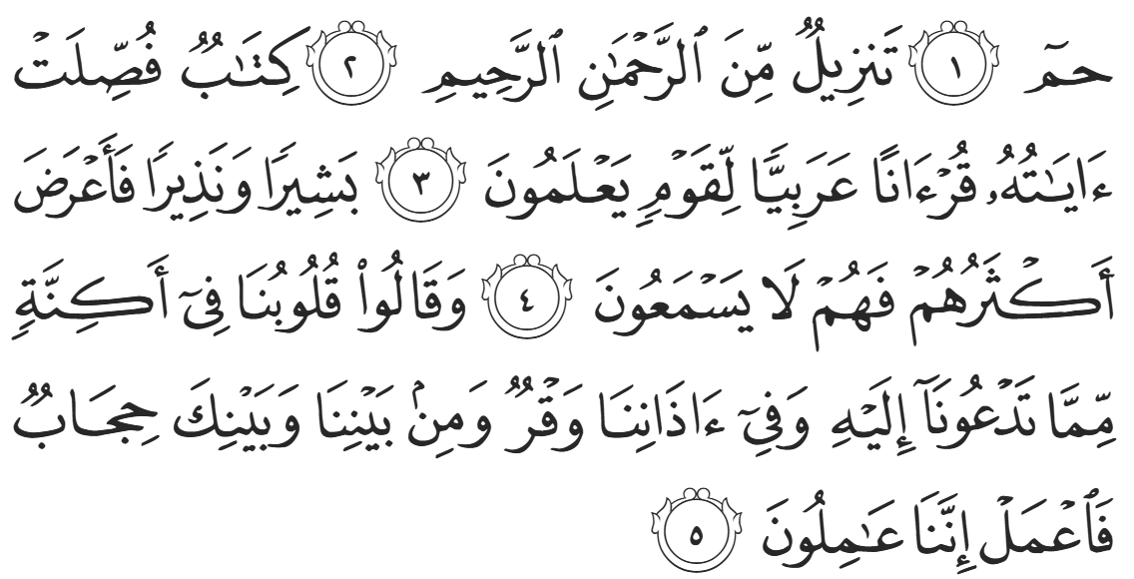
“Ha-Mim. This is a Revelation from the Most Compassionate, Most Merciful. It is a Book whose verses are perfectly explained—a Qur’aan in Arabic for people who know, delivering good news and warning. Yet most of them turn away, so they do not hear. They say, ‘Our hearts are veiled against what you are calling us to; there is deafness in our ears, and there is a barrier between us and you. So do [whatever you want] and so shall we!’
The Prophet ﷺ continued reciting more ayaat from surat Fussilat mainly talking about the absolute Oneness, power, and authority of Allah as the sole Creator of everything until he got to the 13th ayah:
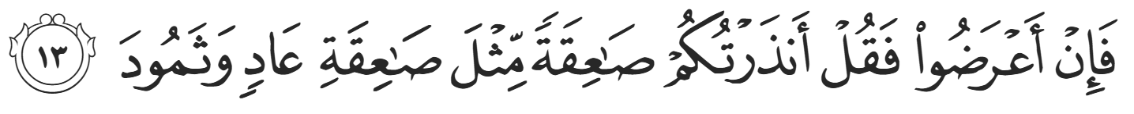
“If they turn away, then say, ‘I warn you of a [mighty] blast like the one that befell ‘Aad and Thamood.’” (41:1-12)
Prior to this conversation, and like most of the Quraysh, ‘Utbah had not actually listened to the Qur’an with intent. As the Prophet ﷺ continued reciting, ‘Utbah’s expression began to change, and as the power of the recitation and tempo began to intensify, he started palpitating. It continued to increase in power and intensity until it rose to a crescendo with the verse, “If they turn away, then say, ‘I warn you of a [mighty] blast like the one that befell ‘Aad and Thamud.’” At this point, ‘Utbah could not take it any longer and jumped up, forcibly putting his hand over the mouth of the Prophet ﷺ, pleading “I beg you by Allah—and by the rights I have over you as a blood relative—stop, and not to send this punishment.”
He then turned and ran back to the Quraysh from whom he came, and said, “Listen to me: leave this man alone because I have heard a speech from him which I have never heard before. I could not comprehend all of it, but he will hold importance [in the world]. If the Arabs get rid of him for us, our hands are clean; but if he is victorious over the Arabs, then by Allah, his victory is our victory, and his power is our power.” The Quraysh dismissed his advice, remarking, “He has bewitched you like he bewitched everybody else.”
<Conclude 1st Khutbah with:
Aqoolu haathaa wa astaghfir-Allaah (I say this and I ask Allah for forgiveness)
أَقُولُ قَوْلِي هَذَا وَأَسْتَغْفِرُ اللَّهَ لِي وَلَكُمْ وَلِسَائِرِ المُسْلِمينَ وَالمُسْلِمَاتْ فَاسْتَغْفِرُوهْ إِنَّهُ هُوَ الْغَفُورُ الرَّحِيمُ
الحمد لله رب العالمين والصلاة والسلام على سيد المرسلين وعلى آله وأصحابه أجمعين
<2nd Khutbah>
Dear brothers and sisters,
After their failures in negotiating with the Prophet ﷺ directly, the Quraysh then turned to a nation more experienced in dealing with monotheistic faiths, the Jews and Christians, who had a long history of Prophethood. Their teachings had been distorted and corrupted, but the “People of the Book”, were still familiar with the idea of Prophethood and the role of a Prophet or Messenger.
Two of the worst of the Quraysh—‘Uqbah ibn Abi Mu’ayt and al-Nadr ibn Haarith—approached the Jews in Medina and asked for ways to quiz and trick the Prophet ﷺ into making a mistake. One instruction was to ask the Prophet ﷺ about the Prophets Ishaaq, Ya’qub, and Yusuf (ASSM), particularly about what happened to the family of Ya’qub. So the Quraysh took their advice and asked the Prophet ﷺ, and Allah (SWT) revealed the entirety of Surah Yusuf as a response.
On another occasion, they instructed the Quraysh to ask the Prophet ﷺ three questions, adding, “No-one would know the answers to these three questions except a true Prophet.” The three questions were:
- Ask him about the young men who slept in the cave and slept a long time.
- Ask him about the man who travelled the world from the east to the west whose experiences are now legends.
- Ask him about the Ruh (the soul)—where does it come from?
The Prophet ﷺ responded confidently, “I will inform you of what you have asked about tomorrow.” However, because the Prophet ﷺ was confident that Allah (SWT) would respond, he ﷺ forgot to say inshaaAllah (if Allah wills). As a result, Revelation did not descend the next day, but rather after two long weeks.
The Quraysh began to mock the Prophet ﷺ after Revelation did not descend the following day as promised. They would provoke him saying, “Muhammad promised us that he would inform us the next day. Two weeks have passed and he has not informed us of anything!” Allah (SWT) reminded the Prophet—and the believers at large—as to the relationship between the Lord and His Slave. Allah is the One Who plans in His infinite wisdom.
It should be noted that being referred to as a slave of Allah is the highest praise, not a derogatory remark. Allah (SWT) refers to the Prophet ﷺ specifically as His slave five times in the Qur’aan; for example, talking about the israa wal mi’raj – the night ascension:
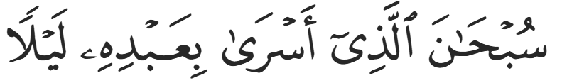
“Glory be to the One Who took His slave by night” (17:1)
Indeed, there is no honor higher than being a worshipper and slave of Allah (SWT).
Allah (SWT) revealed multiple verses of the Qur’an as a response to the three questions. Details were provided about the people of the cave that even the Jews did not know. Similarly, Allah (SWT) identified the man with famous expeditions as Dhul-Qarnayn. As for the ruh (the soul), Allah (SWT) maintained that it is of the mysteries of knowledge that human beings on Earth will never know:
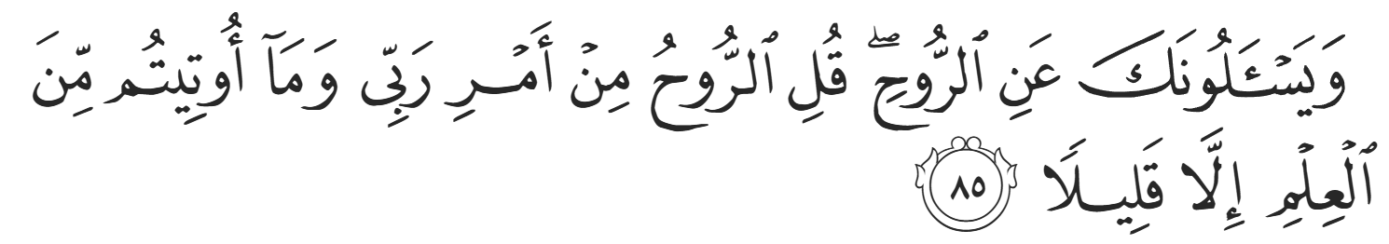
“They ask you about the Ruh. Say, ‘Its nature is known only to my Lord, and you [O humanity] have been given but little knowledge.’” (17:85)
The Jews indeed knew that no-one has knowledge of the Ruh, and so it was a trick question placed alongside two genuine questions in a bid to expose the Prophet ﷺ.
In witnessing how the Prophet ﷺ stood unwavering despite pressure, mockery, and temptation, we are reminded that our faith is not sustained by convenience, but by trust in Allah. Let us strive to embody that same conviction—holding fast to the truth even when tested—so that Allah (SWT) elevates us in this life and the next.
<Duaa!>
- Oh Allah, please grant us a deep love for your Prophet Muhammad, SAW.
- Oh Allah, please make us energetic in doing good for your cause.
- Oh Allah, please enable us in will and means to walk Al-Sirrat-Al-Mustaqeem, even if it estranges us from others.
- Oh Allah, please support the suffering and oppressed Muslims around the world and grant them victory over that which oppresses them.
- Oh Allah, please protect us from ever being overburdened by debt and protect us from all evils and undesirable consequences associated to having debt.
- Oh Allah, please fill our hands with the work and deeds of righteousness and let them be of benefit to ourselves and the Ummah.
- Oh Allah please forgive us our shortcomings and deviances in following your Qur'an and the Sunnah of Rasul'Allah, SallAllahuAlayhiWaSallam.
- Oh Allah please grant us understanding and guidance of your Qur'aan
- Oh Allah, please grant us patience with the trials of this world.
- Oh Allah, please prevent our hearts from getting overly attached to the Dunya and grant us the best in this life and the best in the hereafter.
- Oh Allah, please forgive us our past sins and make us your devoted servants.
- Oh Allah please make us amongst those whose Duaa is accepted.
- Oh Allah, please grant us Jannat'ul Firdaus and protect us from ever coming close to the Fires of Jahannum.

