Khut'bah Opening
إِنَّ الْحَمْدَ للهِ , نَحْمَدَهُ وَ نَسْتَعينُهُ وَ نَسْتَغْفِرُهُ , وَ نَعوذُ بِالله مِنْ شُرورِ أَنْفُسِنا , مَن يَهْدِهِ اللهُ فَلا مُضِلَّ لَه , وَ مَنْ يُضِلِلْ فَلا هادِيَ لَهْ , وَ أَشْهَدُ أَنْ لا إلهَ إِللهُ وَحْدَهُ لا شَريكَ لَه , و أَشْهَدُ أنَّ مُحَمَّدًا عَبْدُهُ و رَسولُه.
"All thanks and praises are due to Allah, whom we thank, seek for help and invoke for forgiveness. We seek refuge with Allah from the evils within ourselves. He whom Allah guides will never be misled and he whom He misguides will never find one to guide him. I bear witness that there is no deity worthy of worship except Allah and that Muhammad (SAW) is His slave and Messenger.
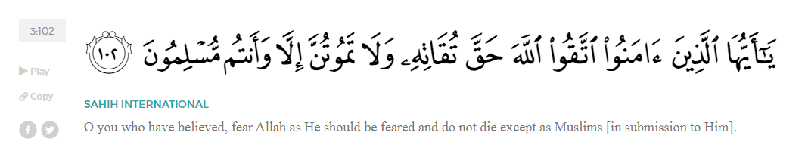
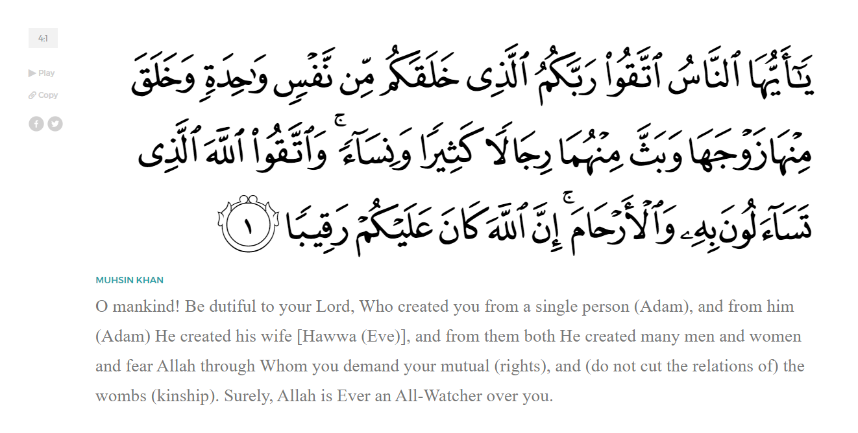
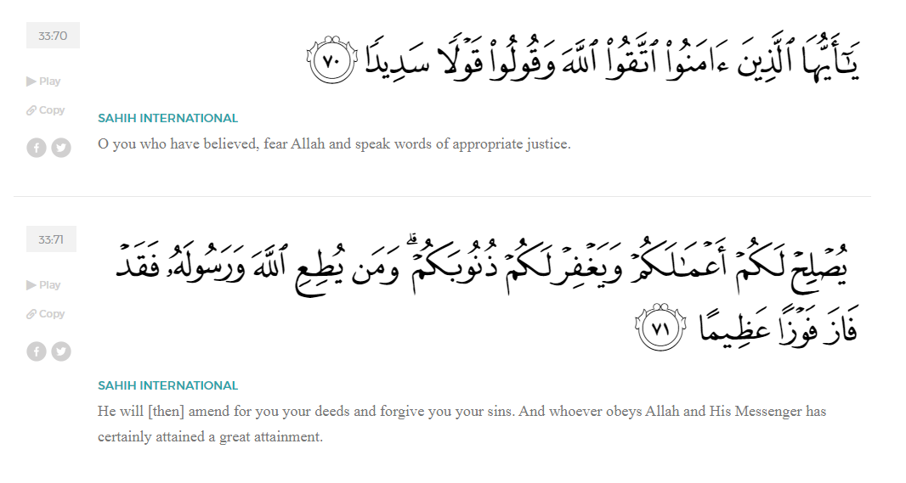
<Sirah of the Prophet (SAW) – Part 13 -Dr. Yassir Qadhi, Book and Series>
Dear brothers and sisters,
InshaaAllah we will continue our khutbah series on the seerah of the Prophet ﷺ, drawing from Dr. Yasir Qadhi’s book, The Sirah of the Prophet, so that we can deepen our understanding of his life and strengthen our love for him. Each step we take through the Prophet ﷺ’s life brings us closer to knowing him more deeply, appreciating his struggles, and embodying his character. Our goal in this series, inshaaAllah, is not just to learn history, but to let the seerah transform our hearts and strengthen our love for the Messenger of Allah ﷺ.
Today we will, inshaaAllah, complete the chapter titled “Early Islam”, beginning with the section, “The Struggles of the First Muslims”.
As Islam spread, and Quraysh’s efforts to compromise with the Prophet ﷺ failed, they escalated their persecution and began to physically torture the Companions. Sa’eed ibn Jubayr (RA) asked Ibn Abbas (RA) about the extent of the torture, to which Ibn Abbas said, “The believers were tortured in the early days of Islam so severely that they were deprived of food and water to the extent that they could not even sit upright. They were tortured until they were asked ‘Is al-Laat your god? Is al-‘Uzza your god?’ and answered in the affirmative.”
‘Abdullah ibn Mas’ud mentioned that the first group of seven that embraced Islam was himself, Abu Bakr, ‘Ammar, Sumayyah, Suhayb, Bilal, and al-Miqdaad (RMAA). He continued:
“As for the Prophet ﷺ, Allah (SWT) protected him [from torture] through his uncle; as for Abu Bakr (RA), Allah protected him through his own tribe, the Banu Quhaafah; and as for the remainder, then the Quraysh rounded them up and began torturing them. They would take burning iron and place it on their bodies until they complied. Every one of them gave up and said out of duress whatever the Quraysh wanted them to say—except for Bilaal ibn Rabaah. He did not consider his soul worth anything in front of Allah (SWT) (i.e., he was willing to give up his soul), and he refused to budge in the slightest. As a result, they concentrated all their efforts in torturing him. I saw Bilal handed over to the thugs of Mecca who proceeded to tie a rope around his neck and drag him across the streets of Mecca, all the while he shouted ‘Ahad! Ahad! One! One!’ (I.e proclaiming the Oneness of Allah (SWT)).”
Bilal’s master was one of the worst culprits of the Quraysh, Umayyah ibn Khalaf, who participated in his torture. It is worth noting that slaves were expensive to acquire and own. It was therefore counter-intuitive to harm one’s own slave, further demonstrating the extent of their animosity to Islam and Muslims. Umayyah would personally take Bilal (RA) into the desert and place a massive rock on his chest and leave him in the Sun for the entirety of the day.
Hassan ibn Thaabit (RA) once recalled that when he performed Hajj from Medina, he noticed how badly Bilal (RA) was being punished, wondering how he remained alive. ‘Amr ibn al-Aas similarly recalled that the rocks placed on Bilal (RA) were so hot that meat could be cooked on them. ‘Amr (RA) continued, “I heard Bilaal repeatedly say, ‘I reject al-Laat and al-‘Uzza and I believe in Allah!’”
Many years later, ‘Urwah ibn Zubayr, the nephew of the Mother of the believers ‘Aaishah (RHAA) narrated, “Bilal was tortured by the people of Mecca, and by Umayyah ibn Khalaf in particular, but he never gave them a single word to please them.”
Bilal’s honor and reward matched his struggles, as the Prophet ﷺ eventually appointed him as the mu’adhan of the ummah – the one who calls the adhan for prayers. The same voice that roared “Ahad; Ahad! One; One!” would echo throughout the city of Mecca five times a day calling the Muslims to prayer. Bilaal’s reputation and prestige withstood 1,400 years of Islamic history, as he is still most known for his bravery, forbearance, and unwavering belief in Allah (SWT). The Qur’aan states in Surat Ar-Rahmaan:

“Is there any reward for goodness except goodness?”(55:60)
The Prophet ﷺ said, “Give the adhan even if you are alone because no jinn or human will hear your voice, except that they will testify to what you said on the Day of Judgement.” Bilaal (RA), having the honor of being the Prophet’s muaddhan, will therefore have the Prophet’s testimony in front of Allah (SWT) on the Day of Judgement.
Khabbab ibn al-Aratt (RA) was of the first ten people to embrace Islaam. He was an Arab slave of Yemeni origin and had a female master, Umm Anmaar. When she found out that he embraced Islaam, she hired a mob to beat him so badly that he lost consciousness, waking up in a pool of his own blood. She would even partake in his torture, holding a piece of burning iron against his back. The Prophet ﷺ was pained by Khabbab’s state so he made a heartfelt du’aa to Allah (SWT), saying, “O Allah, please help Khabbab against his enemy.” A few days later, Umm Anmaar woke up in a rabid state of psychosis. The doctors of Mecca prescribed her with a treatment of cauterization, which led to her death. Allah (SWT) decreed poetic justice that her demise was the result of a brutal, burn-inducing treatment. The Prophet ﷺ once commanded, “No-one may punish with fire except the Lord of fire.”
Many years later, when ‘Umar ibn al-Khattab (RA) was Khalifa, he asked Khabbab about Umm Anmaar. Without saying a word, Khabbab simply lifted his shirt and exposed his back. ‘Umar exclaimed, “By Allah, I have not seen anything like this before!” He then placed Khabbab on the seat beside him as a show of honor.
When Abu Bakr (RA) was Khalifa, he ruled that all government representatives receive the same salary, however when ‘Umar took charge, he ruled that the earliest converts would receive the highest salaries. Khabbab therefore received a very generous salary as one of the earliest to embrace Islaam. He built a modest house in Kufa, and used the remainder of the money to create a charitable trust in the form of a treasure box in his house. The box was unlocked and open for anybody to take whatever they wanted without needing to request permission.
On his deathbed, he began to cry. The people around him said, “Why are you crying? You have suffered so much to reach the highest level and meet the Prophet ﷺ.” Khabbab replied, “I am not crying out of pain or fear of meeting Allah; I am crying because of what you see around you. How will I answer Allah about this luxury? Indeed, I was with a group of people who were all tortured on equal footing, but every one of them has departed without tasting the sweetness of this world, and Allah has left me to enjoy the fruits of this world. I am scared that because I have enjoyed the fruits of this world, my share of the Hereafter will be less than that of my companions.”
As they prepared his kafan–the cloth for shrouding after someone dies—he began to cry once more and said, “By Allah, I remember Hamza, the uncle of the Prophet ﷺ. He did not even have enough cloth for his own kafan, yet here I have this luxurious kafan in front of me. With what will I meet Allah?”
<Conclude 1st Khutbah with:
Aqoolu haathaa wa astaghfir-Allaah (I say this and I ask Allah for forgiveness)
أَقُولُ قَوْلِي هَذَا وَأَسْتَغْفِرُ اللَّهَ لِي وَلَكُمْ وَلِسَائِرِ المُسْلِمينَ وَالمُسْلِمَاتْ فَاسْتَغْفِرُوهْ إِنَّهُ هُوَ الْغَفُورُ الرَّحِيمُ
الحمد لله رب العالمين والصلاة والسلام على سيد المرسلين وعلى آله وأصحابه أجمعين
<2nd Khutbah>
Dear brothers and sisters,
The stories of Yaasir, Sumayyah, and their son ‘Ammar (RMAA) have captured the hearts of Muslims for over a millennium due to their unified struggle in the face of unrelenting, merciless torture. They were a family tortured in front of each other, a fate far worse than the physical pain itself. Their torture was so severe that the Prophet ﷺ made a special du’aa, “Be patient oh family of Yaasir, indeed your place is in Paradise.” Sumayyah bravely rebuked Abu Jahl despite her slave status, to which Abu Jahl murdered her in the most brutal and inhumane manner. She thus became the first martyr in Islaam. Yaasir (RA) was then brutally killed, joining his beloved wife in the Hereafter. Abu Jahl then killed Muhammad, ‘Ammar’s older brother, and turned to 15-year-old ‘Ammar, the youngest of them all. At this point, ‘Ammar could not bear the pain any longer and succumbed to Abu Jahl’s demands, outwardly renouncing his faith.
‘Ammar was so distraught about what he uttered that his worry about potentially committing disbelief was at the forefront of his mind despite the horrific events that just occurred. He ran to the Prophet ﷺ in despair and said, “Oh Messenger of Allah, I have uttered words of kufr –disbelief.” The Prophet ﷺ asked, “How do you find your heart?” ‘Ammar replied, “As it always was” – i.e., his faith is a strong as it always was, and his words did not depict what was in his heart. The Prophet ﷺ reassured him that he had no blame, and he was permitted to repeat those words if they tortured him again. Allah (SWT) then revealed Surat An-Nahl:
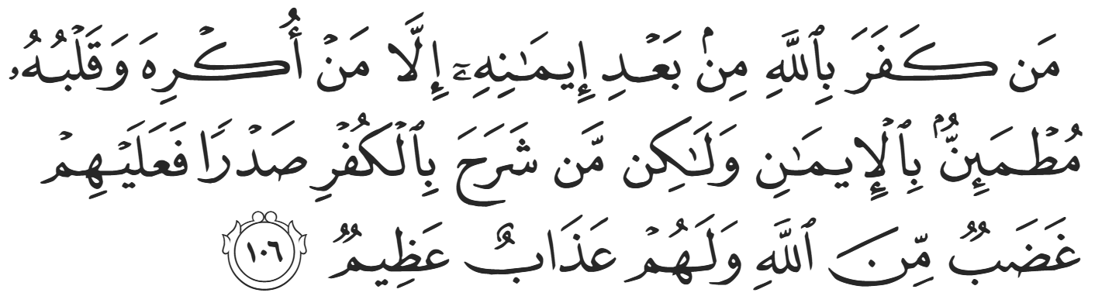
“Whoever disbelieves in Allah after their belief—not those who are forced while their hearts are firm in faith, but those who embrace disbelief wholeheartedly—they will be condemned by Allah and suffer a tremendous punishment.” (16:106)
The Prophet ﷺ said about ‘Ammar, “His imaan has been filled in his heart all the way to his neck”. He ﷺ also said, “Whenever the son of Sumayyah is faced with two options, he always chooses the most correct of the two.”
Suhayb al-Ruumi (the Roman) (RA) was not actually Roman; he was of Iraqi descent but was captured by a Byzantine force as a child and was enslaved in Rome. He escaped, recalling his Arab heritage, and fled to Arabia. Eventually, he was bought by ‘Abdullah ibn Jud’aan in Mecca. While Ibn Jud’aan did not torture him, he did not prevent the likes of Abu Jahl from doing so. However, compared to the likes of Abu Jahl and his ilk, Ibn Jud’aan was more lenient as a master. He granted Suhayb responsibilities in trade and granted him freedom in his will. Upon Ibn Jud’aan’s death, Suhayb emigrated to Medina but was stopped by the Quraysh on the outskirts. Suhayb took out his bow and arrow saying, “You know I am the most accurate shooter, and I promise that none of you will be able to touch me until every arrow in my quiver first touches human flesh. And I promise that none of you will be able to touch me until my sword is bent and broken upon your bones and blood.”
They did not approach any further but demanded that he leave his money behind if he wanted to continue his journey. Not only did they demand his wealth, but they insisted that he leave his horse behind and continue on foot. Suhayb was faced with a choice: turn back with his wealth or continue to the Prophet ﷺ penniless and on foot, leaving with nothing but the clothes on his back. He reached the Prophet ﷺ in Masjid Quba’ disheveled, dehydrated, malnourished, and crawling on his hands and knees. The Prophet ﷺ personally received him and wiped the dust off him. He ﷺ smiled and repeated three times, “Your trade was profitable, O Suhayb.” Astonished, Suhayb replied, “No-one could have told you about that, O Messenger of Allah, except Jibril (AS).” Allah (SWT) then revealed a beautiful verse regarding Suhayb Al-Ruumi,
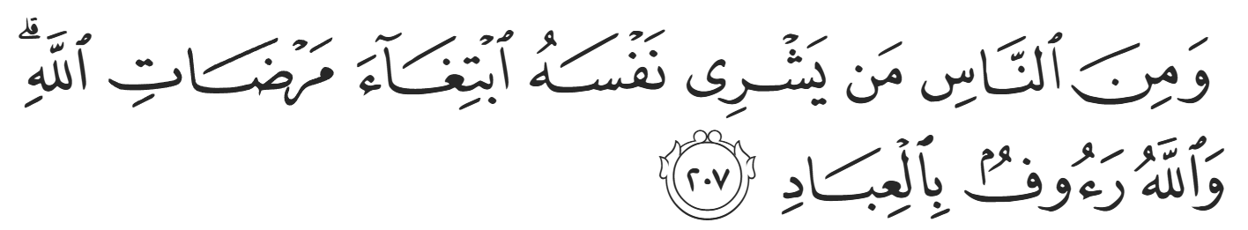
“And there are those among the people who would sell themselves for Allah’s pleasure. An Allah is Ever Gracious to [His] servants.”(2:207)
Once, the leaders of the Quraysh were conversing with the Prophet ﷺ in a promising manner. Abu Jahl intervened, pointing to Suhayb, Bilaal, and ‘Ammar (RMAA), saying, “We cannot accept being ranked beneath such people, so expel them.” Allah (SWT) then revealed in Surat Al-An’aam:
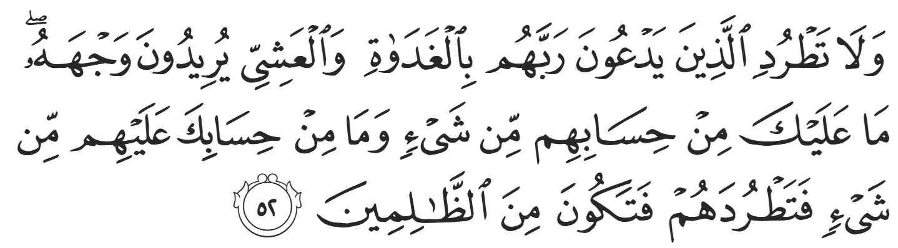
“Do not dismiss those [poor believers] who invoke their Lord morning and evening, seeking his pleasure. You are not accountable for them whatsoever, nor are they accountable for you. So do not dismiss them, or you will be one of the wrongdoers.” (6:52)
Allah (SWT) honored them so much that He instructed the Prophet ﷺ himself that leaving them would be ruinous.
The early Muslims showed us what true faith looks like when tested: steadfastness like Bilal, humility like Khabbab, sacrifice like Suhayb, and a heart unwavering like ‘Ammar. Their stories call us to examine our own lives: Are we firm in obedience? Are we patient in trials? Are we detached from dunya? Do we honor believers as Allah honored them? Let us carry with us these lessons of courage, devotion, sincerity, sacrifice, and hope — and ask Allah to make our hearts as firm as theirs in times of ease and difficulty.

<Duaa!>
- Oh Allah, please grant us a deep love for your Prophet Muhammad, SAW.
- Oh Allah, please make us energetic in doing good for your cause.
- Oh Allah, please enable us in will and means to walk Al-Sirrat-Al-Mustaqeem, even if it estranges us from others.
- Oh Allah, please support the suffering and oppressed Muslims around the world and grant them victory over that which oppresses them.
- Oh Allah, please protect us from ever being overburdened by debt and protect us from all evils and undesirable consequences associated to having debt.
- Oh Allah, please fill our hands with the work and deeds of righteousness and let them be of benefit to ourselves and the Ummah.
- Oh Allah please forgive us our shortcomings and deviances in following your Qur'an and the Sunnah of Rasul'Allah, SallAllahuAlayhiWaSallam.
- Oh Allah please grant us understanding and guidance of your Qur'aan
- Oh Allah, please grant us patience with the trials of this world.
- Oh Allah, please prevent our hearts from getting overly attached to the Dunya and grant us the best in this life and the best in the hereafter.
- Oh Allah, please forgive us our past sins and make us your devoted servants.
- Oh Allah please make us amongst those whose Duaa is accepted.
- Oh Allah, please grant us Jannat'ul Firdaus and protect us from ever coming close to the Fires of Jahannum.

