Khut'bah Opening
إِنَّ الْحَمْدَ للهِ , نَحْمَدَهُ وَ نَسْتَعينُهُ وَ نَسْتَغْفِرُهُ , وَ نَعوذُ بِالله مِنْ شُرورِ أَنْفُسِنا , مَن يَهْدِهِ اللهُ فَلا مُضِلَّ لَه , وَ مَنْ يُضِلِلْ فَلا هادِيَ لَهْ , وَ أَشْهَدُ أَنْ لا إلهَ إِللهُ وَحْدَهُ لا شَريكَ لَه , و أَشْهَدُ أنَّ مُحَمَّدًا عَبْدُهُ و رَسولُه.
"All thanks and praises are due to Allah, whom we thank, seek for help and invoke for forgiveness. We seek refuge with Allah from the evils within ourselves. He whom Allah guides will never be misled and he whom He misguides will never find one to guide him. I bear witness that there is no deity worthy of worship except Allah and that Muhammad (SAW) is His slave and Messenger.
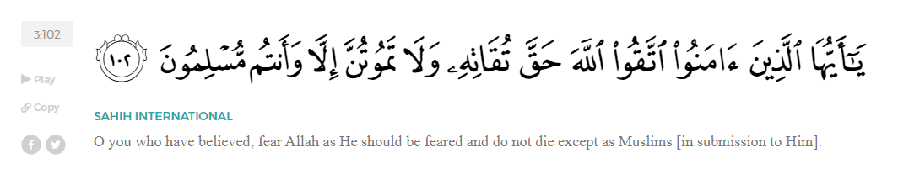
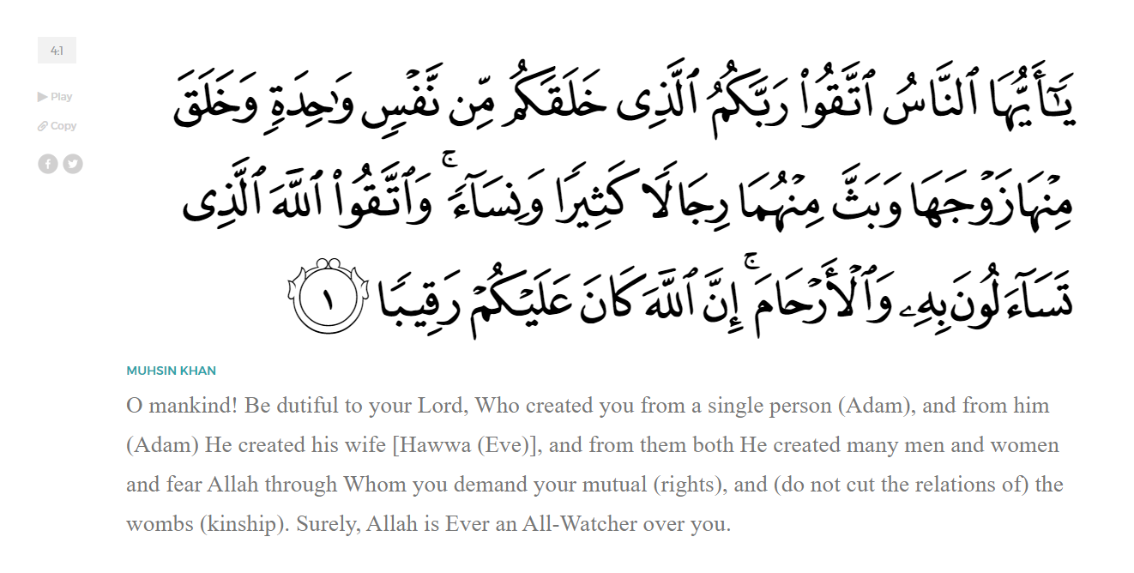
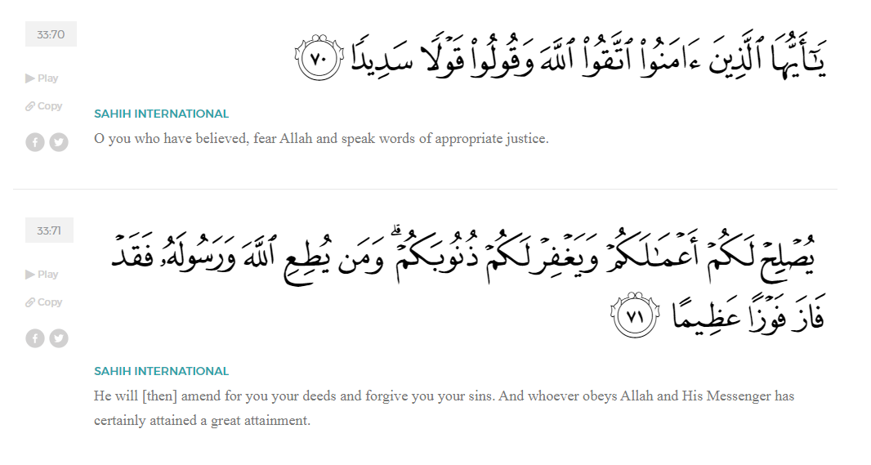
<Sirah of the Prophet (SAW) – Part 14 -Dr. Yassir Qadhi, Book and Series>
Dear brothers and sisters,
InshaaAllah we will continue our khutbah series on the seerah of the Prophet ﷺ, drawing from Dr. Yasir Qadhi’s book, The Sirah of the Prophet, so that we can deepen our understanding of his life and strengthen our love for him. Each step we take through the Prophet ﷺ’s life brings us closer to knowing him more deeply, appreciating his struggles, and embodying his character. Our goal in this series, inshaaAllah, is not just to learn history, but to let the seerah transform our hearts and strengthen our love for the Messenger of Allah ﷺ.
Today we will, inshaaAllah, start with the chapter titled “Emigration to Abyssinia”, beginning with the section about “Attacks on the Prophet ﷺ”.
The Prophet ﷺ himself was harassed and even physically attacked. The abuse escalated into assassination attempts which culminated in the eventual Hijrah. The Prophet ﷺ was one of the few who prayed publicly in front of the Ka’bah, which particularly infuriated Abu Jahl and his ilk. Abu Jahl said, “I swear by al-Laat and al-Uzza, if I see that man again I will put my foot on his neck and throw sand on him.” Later that day, the Prophet ﷺ began praying in front of the Ka’bah and Abu Jahl marched towards him. However, as he approached, he suddenly stopped and began walking backwards, pushing the air in front of him frantically. When asked about this, he said, “I was about to step on him until I saw a pit of fire, above which there were massive wings.” The Prophet ﷺ later explained that those wings belonged to Angels, and had he taken on more step, they would have ripped him to shreds.
Allah (SWT) then revealed the remainder of Surah al-Alaq -- the first part was the first revelation which happened in the cave– we will just read the translation:
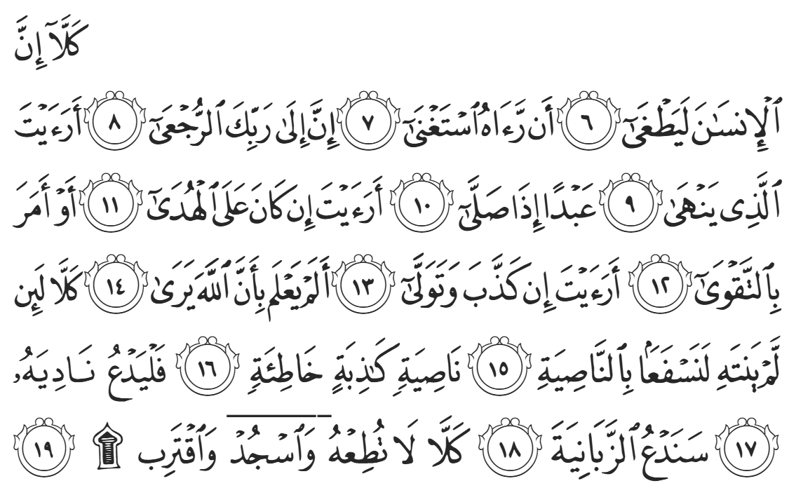
“Most certainly, one exceeds all bounds once they think they are self-sufficient. But surely to your Lord is the return [of all]. Have you seen the man who prevents a servant [of Ours] from praying? What if this [servant] is [rightly] guided or encourages righteousness? What if that [man] persists in denial and turns away? Does he not know that Allah sees [all]? But no! If he does not desist, We will certainly drag him by the forelock-a lying, sinful forelock. So let him call his associates. We will call the wardens of Hell. Again, no! Never obey him! Rather, prostrate and draw near [to Allah].” [96:6-19]
As previously mentioned, the Prophet’s enemies were of two types: the first type were the likes of ‘Umar ibn al-Khattab and ‘Amr ibn al-Aas (RMAA) who initially opposed the Prophet ﷺ but did so with dignity, not resorting to lowly and distasteful tactics. The second type were the likes of Abu Jahl, Abu Lahab, and ‘Uqbah who not only opposed the Prophet ﷺ but did so shamelessly, knowing no bounds of disgrace and dishonor.
‘Urwah ibn Zubayr asked ‘Abdullah ibn ‘Amr, “What was the worst thing you saw happen to the Prophet?” ‘Abdullah said, “One day, the Prophet ﷺ was praying in front of the Ka’bah and ‘Uqbah ibn Abi Mu’ayt approached him from behind, took off his outer garment, threw it over the Prophet’s neck and began to choke him. The Prophet ﷺ was struggling to breathe, and no-one was intervening until Abu Bakr (RA) was informed. Abu Bakr ran over and pushed ‘Uqbah and shouted, ‘Are you going to kill a man just because he says “My Lord is Allah.’?”
Allah (SWT) honored Abu Bakr (RA) by revealing verses of Qur’aan about Musa (AS) with the exact same phrasing, from Surat Ghaafir:
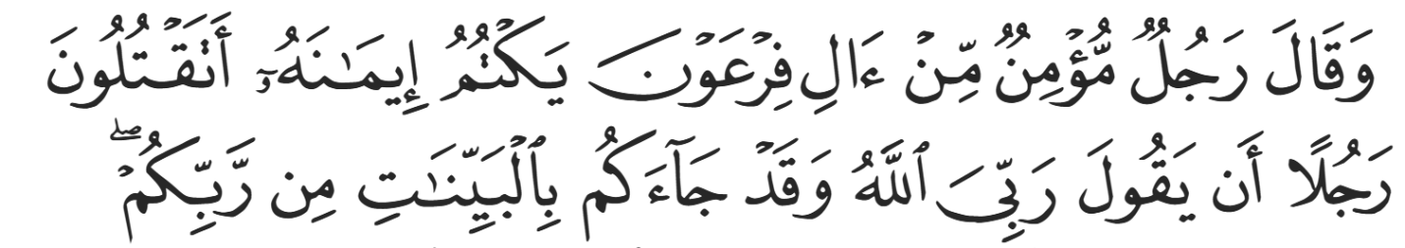
“A believing man from Pharaoh’s people, who was hiding his faith, argued, “Will you kill a man ˹only˺ for saying: ‘My Lord is Allah,’ while he has in fact come to you with clear proofs from your Lord?” (40:28)
<Conclude 1st Khutbah with:
Aqoolu haathaa wa astaghfir-Allaah (I say this and I ask Allah for forgiveness)
أَقُولُ قَوْلِي هَذَا وَأَسْتَغْفِرُ اللَّهَ لِي وَلَكُمْ وَلِسَائِرِ المُسْلِمينَ وَالمُسْلِمَاتْ فَاسْتَغْفِرُوهْ إِنَّهُ هُوَ الْغَفُورُ الرَّحِيمُ
الحمد لله رب العالمين والصلاة والسلام على سيد المرسلين وعلى آله وأصحابه أجمعين
<2nd Khutbah>
Dear brothers and sisters,
As time passed, the intensity grew and acts of violence and aggression escalated. News eventually spread that the Quraysh planned to assassinate the Prophet ﷺ. A neighbor warned Fatimah (RHAA) and she informed the Prophet ﷺ, to which he responded, “My dear daughter, fetch me some water.” The Prophet ﷺ then performed ablution, made du’aa to Allah, and walked to the mosque. His enemies were in the mosque, armed and ready to kill him, but were all suddenly paralyzed. The Prophet ﷺ threw dust in their faces and said, “May their faces be cursed.” Every one of these people were killed in the Battle of Badr.
Pondering upon these extreme hardships, one may wonder why Allah’s foremost Messenger ﷺ was tested in such a manner. Why was the greatest generation on Earth subjugated to such dire tribulations? Allah (SWT) is reminding the believers that we were not created to live in comfort on Earth; the purpose of our creation is to be tested in preparation for the Hereafter. Allah (SWT) states in Surat Hud,
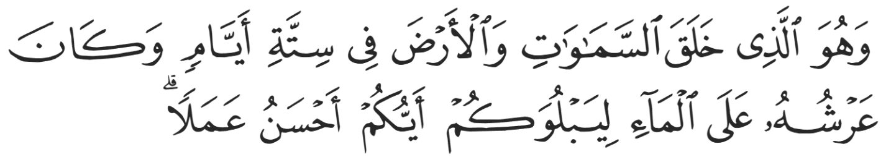
“He is the One Who created the heavens and the earth in six Days—and His Throne was upon the waters—in order to test which of you is best in deeds.” (11:7)
Allah reminds the Prophet ﷺ and Companions (RMAA), and through them He (SWT) reminds us, that we were not created to merely live; we were created for something greater.
While we do not—and cannot—truly earn Paradise, we can earn Allah’s Mercy, which in turn enters us into Paradise. Allah (SWT) tells us in Surat Ankaboot:
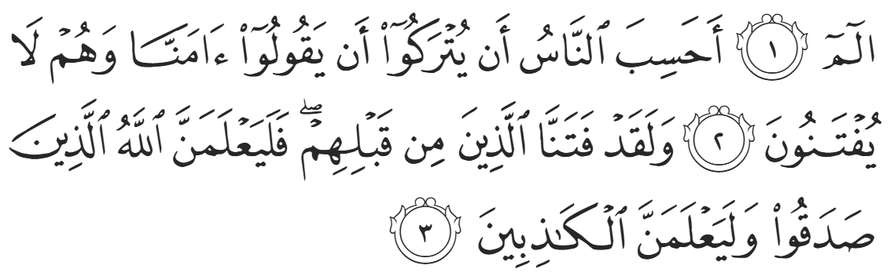
“Alif, Lām, Meem. Do people think once they say, “We believe,” that they will be left without being put to the test? We certainly tested those before them. And ˹in this way˺ Allah will clearly distinguish between those who are truthful and those who are liars.” (29:1-3)
Allah (SWT) further states in Surat Imraan:
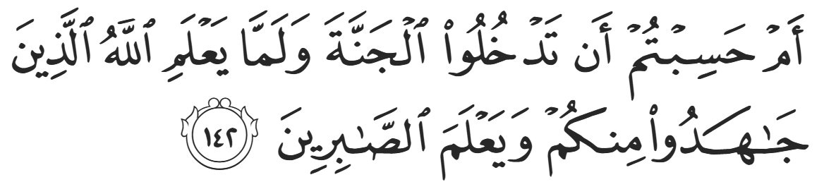
“Do you think you will enter Paradise without Allah proving which of you ˹truly˺ struggled ˹for His cause˺ and patiently endured?” (3:142)
And Allah SWT tells us in Surat al-Baqarah:
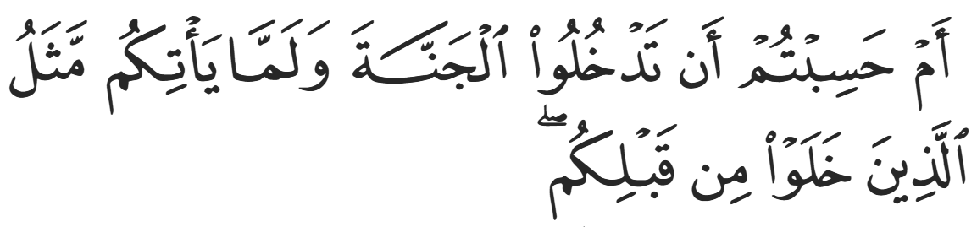
“Do you think you will be admitted into Paradise without being tested like those before you?” (2:214)
Even Khabbab (RA), who remained steadfast and undeterred in the face of severe torture, momentarily felt deflated and asked the Prophet ﷺ, “For how long, O Messenger of Allah? For how long will we be tortured like this? You are the Messenger of Allah; why don’t you ask Allah (SWT) to help us?” The Prophet ﷺ was leaning against the Ka’bah, but then leaned forward and sat straight, and responded, “Indeed the people before you were tortured worse than this; one of them would have their flesh stripped from their bones by a comb of iron, and another would be cut in half by a sword, but that would still not turn them away from the worship of Allah. Indeed, I swear to you by the One Who sent me, that Allah will perfect this matter until you will see a day when a shepherdess will take her flock from Hadramout to Sanaa fearing no-one except Allah and the wolf against her sheep. However, you are a hasty people.”
The Prophet ﷺ did not relent in his belief and faith in Allah (SWT); indeed, the earliest followers of Isa (AS) suffered a similar fate, also enduring severe torture and persecution. The Prophets and righteous believers of the past were tested by Allah (SWT) according to their caliber and piety. Even the Messengers of Allah were required to prove their devotion to the Almighty.
A Muslim’s level and status in the sight of Allah can be measured according to their struggles and subsequent patience in those struggles. Allah (SWT) states in surah Al-Hujuraat:
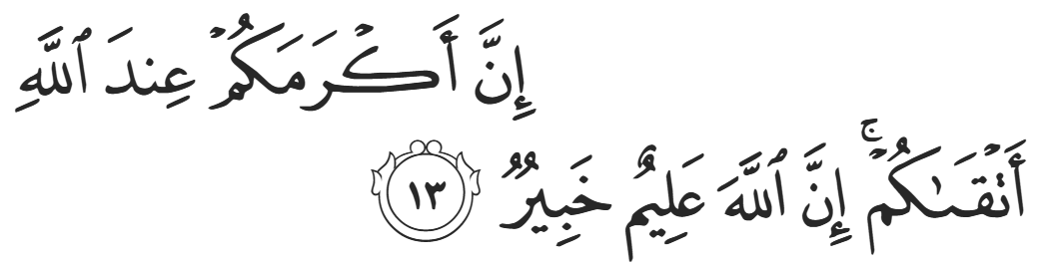
“Surely the most noble of you in the sight of Allah is the most righteous among you. Allah is truly All-Knowing, All-Aware.” (49:214)
The Companions hold the highest status in Islaam due to their unparalleled struggle in the cause of Allah, and even among the Companions there are levels; those who accepted Islaam in Mecca and endured those struggles have their own station above those who accepted later. Allah (SWT) states:
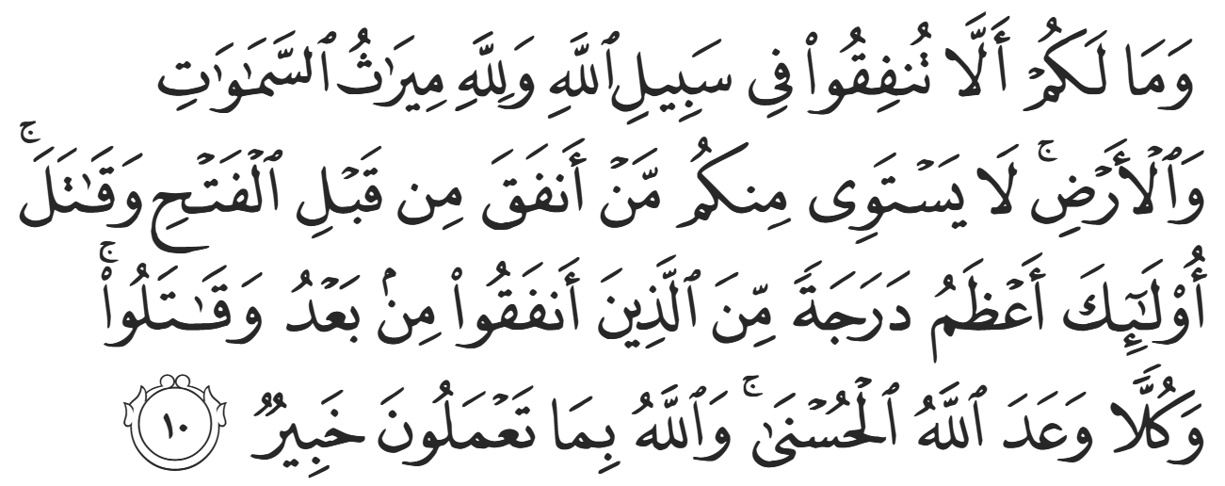
“And why should you not spend in the cause of Allah, while Allah is the ˹sole˺ inheritor of the heavens and the earth? Those of you who donated and fought before the victory ˹over Mecca˺ are unparalleled. They are far greater in rank than those who donated and fought afterwards. Yet Allah has promised each a fine reward. And Allah is All-Aware of what you do.” (57:10)
While Allah has spared us, at least for now, from the raw physical tortures endured by the earliest Muslims, He has not exempted us from trials. Our tests come in different forms: striving to uphold faith within our families in a non-Muslim society, remaining patient with difficult relatives and community members, sacrificing our time pursuing Islamic knowledge, sacrificing our time to come to Jumuah, sacrificing our wealth through charity, and extending ourselves to serve the needy even when it costs us comfort and ease. These struggles, though quieter and less visible, are our share of sacrifice—through which Allah tests our sincerity, patience, and devotion, just as He (SWT) tested those before us.

<Duaa!>
- Oh Allah, please grant us a deep love for your Prophet Muhammad, SAW.
- Oh Allah, please make us energetic in doing good for your cause.
- Oh Allah, please enable us in will and means to walk Al-Sirrat-Al-Mustaqeem, even if it estranges us from others.
- Oh Allah, please support the suffering and oppressed Muslims around the world and grant them victory over that which oppresses them.
- Oh Allah, please protect us from ever being overburdened by debt and protect us from all evils and undesirable consequences associated to having debt.
- Oh Allah, please fill our hands with the work and deeds of righteousness and let them be of benefit to ourselves and the Ummah.
- Oh Allah please forgive us our shortcomings and deviances in following your Qur'an and the Sunnah of Rasul'Allah, SallAllahuAlayhiWaSallam.
- Oh Allah please grant us understanding and guidance of your Qur'aan
- Oh Allah, please grant us patience with the trials of this world.
- Oh Allah, please prevent our hearts from getting overly attached to the Dunya and grant us the best in this life and the best in the hereafter.
- Oh Allah, please forgive us our past sins and make us your devoted servants.
- Oh Allah please make us amongst those whose Duaa is accepted.
- Oh Allah, please grant us Jannat'ul Firdaus and protect us from ever coming close to the Fires of Jahannum.

