Khut'bah Opening
إِنَّ الْحَمْدَ للهِ , نَحْمَدَهُ وَ نَسْتَعينُهُ وَ نَسْتَغْفِرُهُ , وَ نَعوذُ بِالله مِنْ شُرورِ أَنْفُسِنا , مَن يَهْدِهِ اللهُ فَلا مُضِلَّ لَه , وَ مَنْ يُضِلِلْ فَلا هادِيَ لَهْ , وَ أَشْهَدُ أَنْ لا إلهَ إِللهُ وَحْدَهُ لا شَريكَ لَه , و أَشْهَدُ أنَّ مُحَمَّدًا عَبْدُهُ و رَسولُه.
"All thanks and praises are due to Allah, whom we thank, seek for help and invoke for forgiveness. We seek refuge with Allah from the evils within ourselves. He whom Allah guides will never be misled and he whom He misguides will never find one to guide him. I bear witness that there is no deity worthy of worship except Allah and that Muhammad (SAW) is His slave and Messenger.
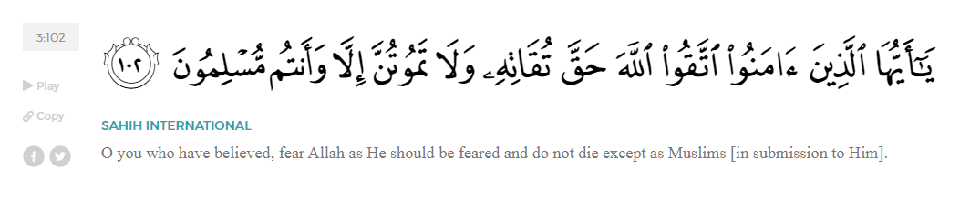
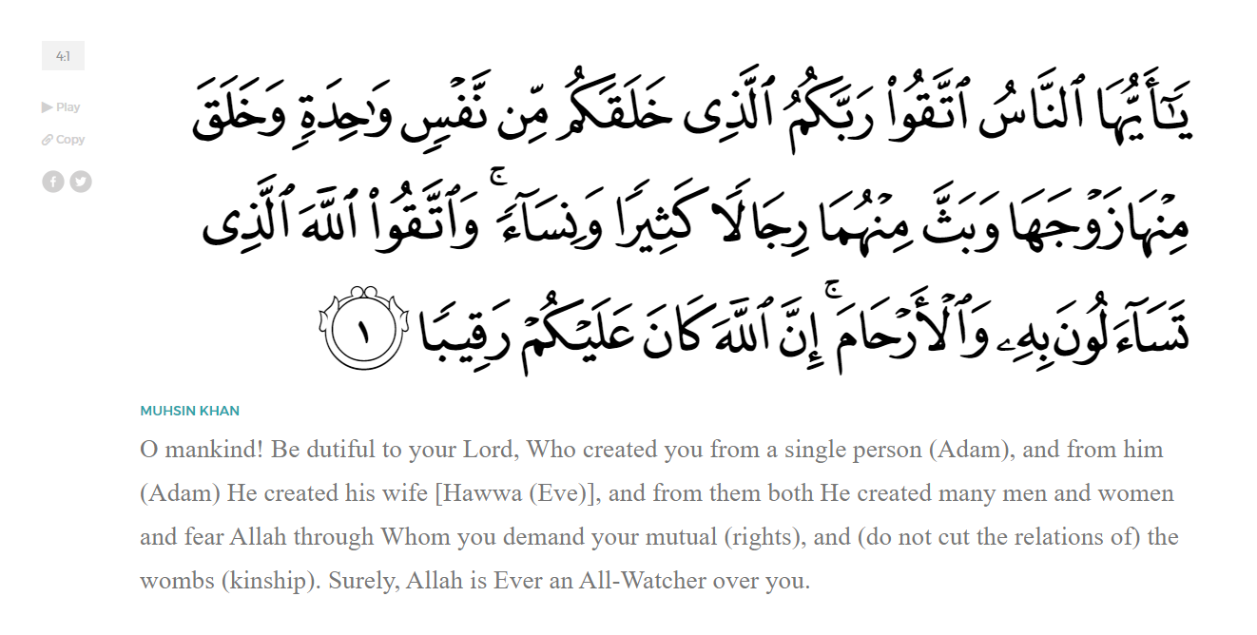
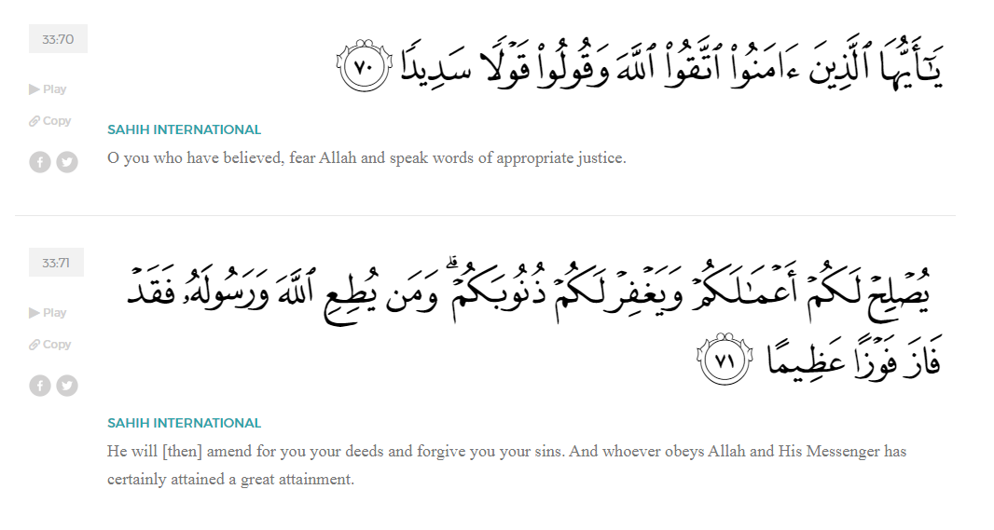
<Sirah of the Prophet (SAW) – Part 15 -Dr. Yassir Qadhi, Book and Series>
Dear brothers and sisters,
InshaaAllah we will continue our khutbah series on the seerah of the Prophet ﷺ, drawing from Dr. Yasir Qadhi’s book, The Sirah of the Prophet, so that we can deepen our understanding of his life and strengthen our love for him. Each step we take through the Prophet ﷺ’s life brings us closer to knowing him more deeply, appreciating his struggles, and embodying his character. Our goal in this series, inshaaAllah, is not just to learn history, but to let the seerah transform our hearts and strengthen our love for the Messenger of Allah ﷺ.
Today we will, inshaaAllah, continue with the chapter titled “Emigration to Abyssinia” starting with the section “The First Emigration”…
Eventually, in the fifth year of the da’wah, the Prophet ﷺ suggested that the companions head to the Negus in Abyssinia – Negus is a title essentially meaning King, similar to how the title “Caesar” was used for the leader of Rome. The Negus’s real name was Ashamah.
The Prophet ﷺ said, “This land has become too constricted for you. For those who want to, why don’t you emigrate to the neighboring land of Abyssinia? There is a Christian king there who is a just king, and he will allow you to worship Allah without interfering.” The da’wah became public in the third year of Prophethood, signifying that the torture and struggle discussed in previous khutbahs occurred over an 18-month period of time, which ultimately became unbearable.
In our current age of globalization and transcendent technology, it may be difficult to fathom the true significance of what Hijrah entails in seventh century Arabia. In an age where tribal backing, familial prestige, and community ties dictate one’s stature and esteem, uprooting oneself to another land instantaneously and dramatically lowers one’s quality of life. Hijrah is therefore a truly drastic measure. With no passports or bank transfers, an impromptu Hijrah compromises one’s safety and wealth; rich Companions became poor overnight, as the secretive nature of their departure meant that they could not sell their property or even carry their money with them. This all indicates the extent of the difficulty the companions endured in Mecca to even consider such a move.
The first to emigrate were 12 men and four women. The great ‘Uthmaan ibn ‘Affaan (RA) was among them, along with his wife, Ruqayyah, daughter of the Prophet ﷺ. The rest were ‘Uthmaan ibn Maz’uun, ‘Abdurrahman ibn ‘Awf, Zubayur ibn al-‘Awwam, Mus’ab ibn ‘Umayr, Ja’far ibn Abi Taalib, Abu Salamah and Umm Salamah, Jahsh ibn Ri’aab, ‘Abdullah ibn Jahsh, Abu Hudhayfah ibn ‘Utbah, Sahlah bint Suhayl, ‘Aamir ibn Rabi’aah, and Layla bint Abi Hathmah (RMAA). It may be observed that they were all noblemen and women of the Quraysh, with the notable absence of the servant class Muslims; as slaves, they did not have the freedom to emigrate despite needing it the most.
Abu Bakr (RA) made the intention to join them, but as he embarked, the Chieftain of a neighboring tribe, Ibn al-Daghinah, saw them leaving and asked why. Ibn al-Daghinah had a good working relationship with Abu Bakr, and after hearing the story, he said, “Someone like you does not deserve to leave the land of Mecca. If your people have persecuted you, let me go and speak on your behalf and grant you my protection.” Abu Bakr’s tribe had relinquished their tribal protection so Ibn al-Daghinah offered his own. As he was not from the Quraysh, he was required to seek permission from the Quraysh. As a trade partner and neighboring tribe leader, the Quraysh accepted, but on one condition: Abu Bakr must not pray publicly. Other than the Prophet ﷺ, Abu Bakr (RA) was one of the only people fearless enough to pray in front of the Ka’bah, and the Quraysh complained that it was impacting the people. Abu Bakr agreed and instead made an extension to his house as a makeshift mosque.
Abu Bakr (RA) then continued to pray but from within his house. However, Abu Bakr’s recitation was very moving and emotional; Ibn Ishaaq narrates that the women and children of the Quraysh would gather outside his house in amazement and marvel at this recitation. Aaishah (RHAA) mentioned about her father, “He was a man who would be easily brought to tears [out of emotion].” Abu Bakr abided by the condition and prayed in his house, but due to his impact even from within his own home, the Quraysh sent a message to Ibn al-Daghinah notifying him that they had updated their condition to ban his recitation even from within his own home. Ibn al-Daghinah then requested that Abu Bakr (RA) stop praying out loud or else he would be forced to rescind his protection. Abu Bakr resolutely replied, “I return your protection and accept the protection of Allah.” Abu Bakr (RA) remained in Mecca relying solely on his unwavering trust in Allah (SWT).
The Prophet’s suggestion of Hijrah demonstrates that not all non-Muslim lands are the same. Abyssinia and Mecca were both non-Muslim, but the former allowed freedom of religion while the latter was hostile. Further, it validates the notion of living in such a land. The companions who emigrated did not immediately return once Medina was established as a Muslim land; in fact, they remained in Abyssinia for 14 years and the Prophet ﷺ only recalled them after the battle of Khaybar. The Prophet ﷺ chose Abyssinia for a number of reasons. As mentioned, their Negus was a man of justice and integrity. Abyssinia was also familiar to them as they had previously established some trade, and it was relatively practical to reach albeit via the Red Sea. In addition to this, they were Christians, who were much more cordial due to the shared notion of Prophethood. Within Christian theology, they were closer to the teaching of Isa (AS) – Jesus Christ—compared to the now main-stream teachings of Christianity. Upon hearing about the Prophet’s teachings, the Negus said, “This comes from the same well as that of [Prophet] Musa.”
The first batch of emigrants initially returned to Mecca after a mere three months due to a misunderstanding. An infamous event occurred which led to widescale rumors that the Quraysh had finally accepted Islaam, prompting the Muslims to hastily return. Despite their safety and freedom to practice their faith, the early emigrants had an extremely difficult time adjusting to life in a foreign country with a new language, culture, norms, and even climate. They were still beginning to adjust when they heard the rumors that the Quraysh had accepted Islaam, and so they pounced on the idea of returning home.
The famous incident is the Prophet ﷺ reciting Surah Al-Najm in public. He ﷺ recited the surah in its entirety, and as the verses compounded, an audience gathered. The Surah is particularly powerful, full of rhetorical devices captivating the listeners. It then builds up to its climax and ends with a commanding ayah of Sajdah, which translates to “Prostrate to Allah and worship Him!”
Not only did all the Muslims immediately prostrate when they heard the ayah, but the Pagans of Quraysh were so overwhelmed and captivated that they could not help but to fall into prostration as well. Other than al-Waleed ibn Al-Mugheerah – who was too arrogant and instead just wiped dust onto his forehead—the entirety of Mecca was in prostration. This unprecedented event inevitably led to rumors that the Quraysh had accepted Islaam, prompting the Muslims in Abyssinia to return.
The emigrants journeyed to Mecca, and as they were on the outskirts of the city, they asked a passerby about the Quraysh accepting Islaam, to which they were informed that the rumor was false. Deflated and disappointed, they considered returning to Abyssinia, but their beloved hometown of Mecca was in their sights, and they yearned to reunite with the Prophet ﷺ. When they left Mecca, they effectively canceled their tribal protection, and so upon their return, they needed to seek new protection agreements. ‘Uthmaan ibn Maz’uun (RA) reached out to his long-time friend al-Waleed ibn Al-Mugheera for protection. As one of the most powerful men in Mecca, al-Walid’s protection ensured that ‘Uthmaan was completely safe. Meanwhile, he saw the rest of the Muslims being persecuted while he was safe, and he was consumed by guilt. His feelings of guilt grew to be unbearable and he eventually asked for his protection to be revoked. He did not do anything wrong and had every right to seek out his own protection, but his conscience would not allow him to continue in peace while his companions were suffering.
Shortly after having his protection revoked, ‘Uthmaan passed by a gathering which included one of Arabia’s most talented poets, Labeed, who had been invited to Mecca. Labeed recited a line of poetry that the Prophet ﷺ would later describe as “the most truthful statement that any poet has ever said” which was, “For truly everything except Allah is naught.” ‘Uthmaan was truly impressed, and exclaimed, “You have spoken the truth!”. Labeed continued, “And every pleasure will undoubtedly cease.” ‘Uthmaan retorted, “You have lied!” because Jannah/Paradise will never disappear. Labeed was incensed—not being aware of the Meccan context of the Islamic struggles… Labeed said, “Since when have you people treated your guests in this manner?” Somebody stood up in anger and punched ‘Uthmaan in the face, giving him a black eye. When al-Waleed heard, he said, “My nephew, why did you rescind my protection? Please allow me to reinstate it.” ‘Uthmaan replied, “No! Indeed, my other eye is in need of the blessings incurred by this eye.” [Pointing to his black eye]
<Conclude 1st Khutbah with:
Aqoolu haathaa wa astaghfir-Allaah (I say this and I ask Allah for forgiveness)
أَقُولُ قَوْلِي هَذَا وَأَسْتَغْفِرُ اللَّهَ لِي وَلَكُمْ وَلِسَائِرِ المُسْلِمينَ وَالمُسْلِمَاتْ فَاسْتَغْفِرُوهْ إِنَّهُ هُوَ الْغَفُورُ الرَّحِيمُ
الحمد لله رب العالمين والصلاة والسلام على سيد المرسلين وعلى آله وأصحابه أجمعين
<2nd Khutbah>
Dear brothers and sisters,
After a short while in Mecca, the initial emigrants conferred and decided it was better to return to Abyssinia. Despite Mecca being their homeland, Abyssinia provided safety and security. Sustenance and security are indeed the cornerstone of human need. Allah (SWT) affirms these priorities in Surat Quraysh:
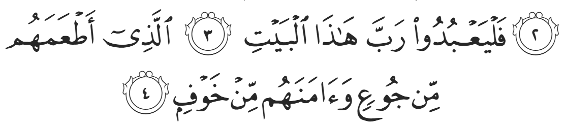
“Let them worship the Lord of this [Sacred] House, Who has fed them against hunger and made them secure against fear.”
After reuniting with the Muslims in Mecca, word spread about the peaceful existence in Abyssinia. More than 80 Muslims decided to emigrate, which was around half of the Muslims in Mecca, and more than 10% of Mecca’s total population.
Losing such a significant portion of the population was humiliating for the Quraysh, especially considering the way in which they voluntarily left their own families and tribes. They could not tolerate such shame, and so Quraysh sent Amr ibn al-Aas, who had not yet converted to Islaam, to lobby the Negus to order their return. ‘Amr ibn al-Aas was an extremely intelligent and shrewd politician who was the ideal tactician to disrupt the Muslims. He eventually used these talents for the betterment of Islaam, but for now he was an asset to the Quraysh. He, alongside another delegate, presented to the Negus’s council gifts from Mecca – essentially bribes. They gave each of his ministers expensive gifts, saying, “You have in your midst a group of renegades and rebels. We will speak to the Negus tomorrow about their case, and we want you to hand them back to us and support us in this cause. When we give the Negus his gifts, remember our gifts to you.”
The next day, they approached the Negus, saying, “Some foolish youth in our nation have emigrated to your country. They have left our faith but not embraced yours. The leaders of our community have sent us to you in order that you send these young foolish people back to us so that we can deal with them.” ‘Amr was appealing to their shared values and customs, such as religion, politics, and respect. The ministers, as promised, stood up and agreed with the Quraysh, recommending that the Muslims be returned. Confirming the Prophet’s description as a just king, the Negus then spoke, “No, by Allah, I cannot turn them back after they chose my land. The least I can do is listen to them.”
The Negus summoned the Companions, led by Ja’far ibn Abi Taalib (RA). It was customary for everyone to prostrate to the king, but Ja’far entered with a firm chest. Outraged, the ministers yelled, “How dare you walk in without prostrating?” It was a defining moment where their lives hung in the balance, yet Ja’far and the Muslims stuck by their principles, saying, “Our Prophet has told us that we can only prostrate to our Lord.” The Negus asked, “What is this new religion that you have invented, and what is the matter that you have forsaken your people yet you have not embraced my religion nor any of the other religions on Earth?”
Ja’far (RA) responded, embodying the pinnacle of eloquence, “We used to be a nation steeped in ignorance; we would worship idols, eat dead meat, and perform promiscuous acts. We would break ties of kinship and treat our neighbors with contempt. The strong amongst us would devour the weak, and we remained in this state until Allah (SWT) sent a Messenger to us. He was known in the community; he never told a lie in his life, and he invited us to worship One God, alone, and to leave idol worship. He told us to abandon the way of our forefathers in the worship of stones and statues. He commanded us to be true when we speak, to fulfil our promises, and to fulfil the ties of kinship. He told us to be good to our neighbors and avoid all evil. He told us not to spill blood and to give true testimony. He forbade us from stealing the property of orphans and accusing others of adultery, and commanded us to worship Allah (SWT) alone without associating anything with him. He told us to pray, fast, and give charity, so we believed in him, followed him, and had faith in him. He worshipped Allah alone and did not worship idols. We forbade upon ourselves everything he prohibited, and we made permissible all that he allowed for us. But our people opposed us, showed hatred towards us, and tortured us. They punished us and tried to force us back to idol worship. They were unjust to us, made life miserable, and prevented us from being who we were. So we emigrated to your land, and we chose you above all other rulers, and we wish to come under your generosity and hospitality; we put our trust in you that we would not be shown injustice in your land, O exalted highness.”
Ja’far ibn Abi Taalib (RA) vindicated the Prophet’s decision in choosing him as the leader of the group, as he showed wisdom, eloquence, and integrity. He appealed to the Negus’s honor, and values, all without compromising his own dignity or beliefs as a Muslim. The Negus was duly moved by the beautiful speech. He asked, “Do you have any revelation sent to your Prophet?” Ja’far replied in the affirmative, and the Negus asked to hear some of it. Ja’far recited the first few pages of Surah Maryam, as it pertained to Jesus Christ and the Virgin Birth. The Negus alongside all his ministers began to weep, and he said, “By God, this recitation and the Message of Moses have sprung from the same fountain.” He then resolutely denied the Quraysh and told them to leave. As they were leaving, ‘Amr said to his companion, “Do not give up just yet; I have one more trick up my sleeve.”
The next morning, they returned to the Negus, saying, “O Holy Emperor, we forgot to mention one more thing: these people say something blasphemous about your Lord, Jesus Christ.” The Negus immediately recalled the companions, demanding their prompt attendance. The companions were anxious about how they would explain their stance, but Ja’far reassured them, “We will say exactly what the Prophet ﷺ told us to say: Jesus Christ is a Prophet of Allah, servant of Allah, and the spirit born of the Virgin Mary.” They approached the Negus once more, who irritably asked, “What is this that I have heard about your blasphemous views on Jesus Christ?” Ja’far responded, “Your Royal Highness, we say exactly what our Prophet teaches, namely that Jesus Christ is the Prophet of Allah, Servant of Allah, and spirit born of Mary, the chaste virgin.” The Negus picked up a twig and said, “By God, what you have just said does not exceed what Jesus Christ said by this branch.” He then turned to ‘Amr ibn al-Aas and said, “Be gone from here, and take your gifts with you, for I have no need for them.”
This story highlights the pragmatism and practicality of the companions in using the system available to them to exact change and fight for justice. They did not dismiss themselves out of the Negus’s court because he was not Muslim; rather, they maintained their beliefs and used his system to fight for their cause. Without violating Islamic creed, they praised him for his good and appealed to his good nature while remaining steadfast upon the tenets of their faith. Without lying or hiding the truth, Ja’far (RA) remained wise, emphasizing the similarities between the two religions without insulting the Negus as to the differences.
The Negus’s profound response indicates that his belief represented the oneness of Allah, similar to the early followers of Christ. This could explain why he was so tolerant of the Muslims and why he was so moved by the Qur’aan. It also explains his response when the Prophet ﷺ eventually emigrated to Medina and wrote the Negus a letter, inviting him to Islam. The Negus wrote back, affirming that he was a Muslim, and that he believes in Islam, saying, “If you command me, O Messenger of Allah, I will come to Medina and serve you.”
However, the Negus’s firm acceptance of the Muslim emigrants earned the suspicion of a group of his ministers who began to plot a coup. The Negus set out to address this matter; he wrote on a parchment, “I bear witness that there is no God except Allah, and that Jesus is the spirit of Allah, the Word of Allah, and the slave of Allah.” He hid this parchment inside his robe next to his chest. He then called the problematic ministers and asked, “What is the matter? Have I not been a good king to you?” They responded, “Yes, but you have abandoned our religion, and you have heretical beliefs.” The Negus asked, “What do you believe?” To which they replied, “We believe that Jesus Christ is the son of God, our Lord and Savior, and the third of the trinity.” The Negus responded, “I swear by God that this is exactly what I believe.” However, the Negus was pointing to his chest—or, more accurately, the parchment within his chest—when he said “this” is what he believed. The Negus utilized tawriyah—double meaning—to preserve his beliefs while safeguarding his position. Prior to this meeting, the Negus sent a message to the Muslims, explaining that he was experiencing tension within his ranks, and that his assassination was possible. He instructed that if they were to hear news about his death, he had organized for one of his ships to be in a certain location for the Muslims to use and escape.
The Negus overcame the ministers, but at a later date faced another threat to his throne. Tensions rose from another faction within the government, and civil war was on the horizon. Umm Salamah (RHAA) narrated, “We were scared that the Negus would be defeated and that somebody else would be installed in his place. We began making du’aa to Allah (SWT) to help the Negus win and remain in power.” Civil war did indeed take place, and the Muslims in Abyssinia grew increasingly anxious. Zubayr ibn-al’Awwam (RA) decided to observe the battle in order to warn the Muslims if the Negus was defeated so that they could flee. In the meantime, Umm Salamah recalls, “We were praying to Allah the most serious prayer, ‘O Allah, allow the Negus to remain in power and grant him authority in the land.’” Zubayr returned to the city a few days later, yelling, “Rejoice, for the Negus has won!” The Negus and his contemporaries were fighting a purely political battle which did not directly pertain to Islam, yet the Muslims were making du’aa fervently for his success.
A number of years later, the Negus died. The Prophet ﷺ explained that Jibril (AS) informed him, “Your brother Ashamah the Negus has died, so pray for him.” News from Abyssinia would usually take a number of days to reach Medina, but the Prophet ﷺ was provided the information instantaneously. He ﷺ gathered the companions and prayed Salah al-Ghayb – The Absentee Funeral Prayer—for the Negus—the only time the Prophet ﷺ ever prayed such a prayer. The Muslims in Abyssinia remained for over ten more years despite the Prophet ﷺ emigrating to Medina and establishing an Islamic state. They did not participate in the famous battles of Badr, Uhud, and Khandaq. It was only after the Battle of Khaybar that the Prophet ﷺ recalled the companions to Medina. This perhaps indicates that the Prophet ﷺ was preparing for all contingencies until his authority in Medina was solidified. The Prophet ﷺ undoubtedly had tawakkul in Allah that he would be victorious, but nevertheless showed the importance of planning ahead.

<Duaa!>
- Oh Allah, please grant us a deep love for your Prophet Muhammad, SAW.
- Oh Allah, please make us energetic in doing good for your cause.
- Oh Allah, please enable us in will and means to walk Al-Sirrat-Al-Mustaqeem, even if it estranges us from others.
- Oh Allah, please support the suffering and oppressed Muslims around the world and grant them victory over that which oppresses them.
- Oh Allah, please protect us from ever being overburdened by debt and protect us from all evils and undesirable consequences associated with having debt.
- Oh Allah, please fill our hands with the work and deeds of righteousness and let them be of benefit to ourselves and the Ummah.
- Oh Allah please forgive us our shortcomings and deviances in following your Qur'an and the Sunnah of Rasul'Allah, SallAllahuAlayhiWaSallam.
- Oh Allah please grant us understanding and guidance of your Qur'aan
- Oh Allah, please grant us patience with the trials of this world.
- Oh Allah, please prevent our hearts from getting overly attached to the Dunya and grant us the best in this life and the best in the hereafter.
- Oh Allah, please forgive us our past sins and make us your devoted servants.
- Oh Allah please make us amongst those whose Duaa is accepted.
- Oh Allah, please grant us Jannat'ul Firdaus and protect us from ever coming close to the Fires of Jahannum.

