Khut'bah Opening
إِنَّ الْحَمْدَ للهِ , نَحْمَدَهُ وَ نَسْتَعينُهُ وَ نَسْتَغْفِرُهُ , وَ نَعوذُ بِالله مِنْ شُرورِ أَنْفُسِنا , مَن يَهْدِهِ اللهُ فَلا مُضِلَّ لَه , وَ مَنْ يُضِلِلْ فَلا هادِيَ لَهْ , وَ أَشْهَدُ أَنْ لا إلهَ إِللهُ وَحْدَهُ لا شَريكَ لَه , و أَشْهَدُ أنَّ مُحَمَّدًا عَبْدُهُ و رَسولُه.
"All thanks and praises are due to Allah, whom we thank, seek for help and invoke for forgiveness. We seek refuge with Allah from the evils within ourselves. He whom Allah guides will never be misled and he whom He misguides will never find one to guide him. I bear witness that there is no deity worthy of worship except Allah and that Muhammad (SAW) is His slave and Messenger.
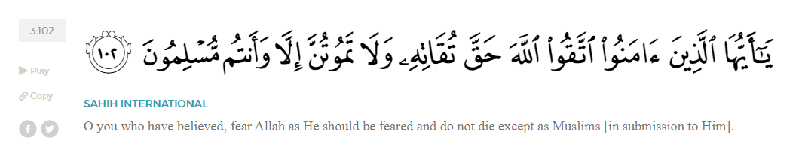
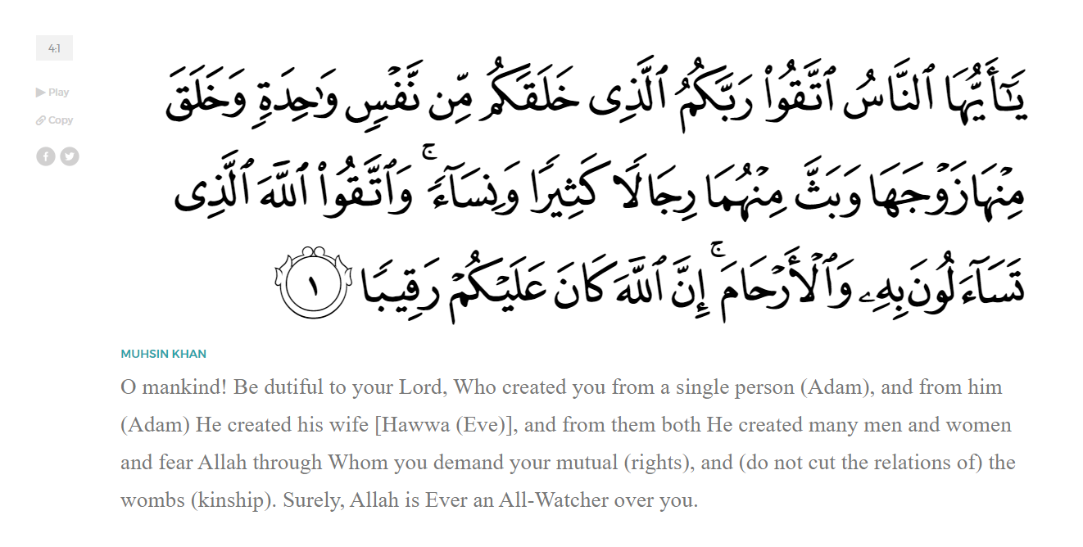
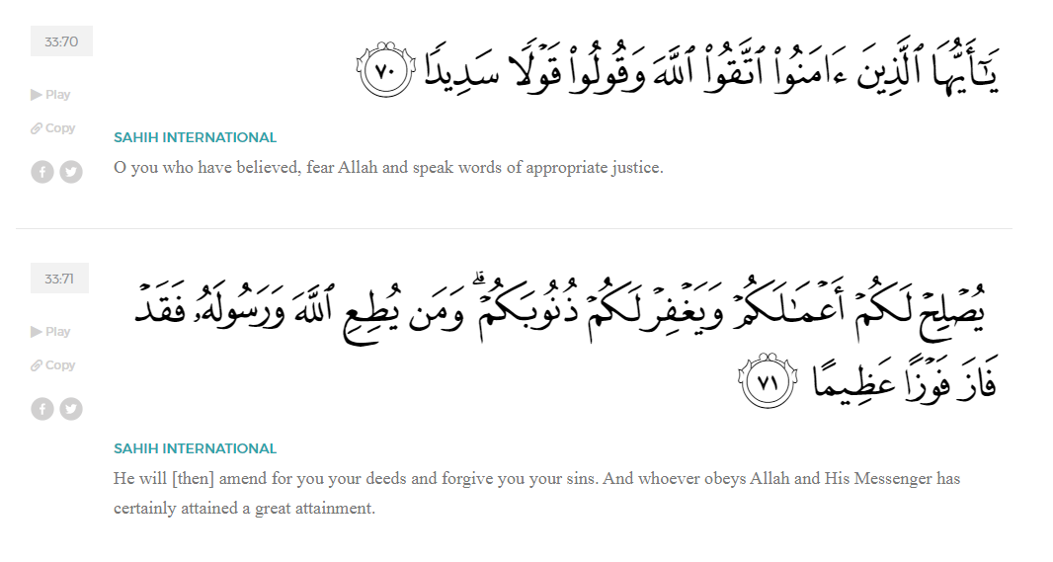
<Sirah of the Prophet (SAW) – Part 16 -Dr. Yassir Qadhi, Book and Series>
Dear brothers and sisters,
InshaaAllah we will continue our khutbah series on the seerah of the Prophet ﷺ, drawing from Dr. Yasir Qadhi’s book, The Sirah of the Prophet, so that we can deepen our understanding of his life and strengthen our love for him. Each step we take through the Prophet ﷺ’s life brings us closer to knowing him more deeply, appreciating his struggles, and embodying his character. Our goal in this series, inshaaAllah, is not just to learn history, but to let the seerah transform our hearts and strengthen our love for the Messenger of Allah ﷺ.
Today we will, inshaaAllah, start with the chapter titled Mecca Reaches the Boiling Point, starting with the section, the “Conversion of Hamzah and ‘Umar”.
After the mass emigration to Abyssinia, the number of Muslims in Mecca dwindled, leaving only around 37 or 38 Muslim men. However, Allah (SWT) blessed two figures to accept Islam which in turn strengthened the Ummah exponentially. The two figures were ‘Umar ibn al-Khattab and Hamzah ibn ‘Abd al-Muttalib.
The first of them to convert was Hamzah, and his conversion story was truly unique. He was the only major figure in Islam to convert out of anger but then have it develop into sincere faith. One day, Abu Jahl was in a particularly foul mood and began hurling insults at the Prophet ﷺ. He continued to verbally abuse the Prophet ﷺ, increasing in vulgarity and profanity, cursing him like he had never done before. The Prophet remained silent despite the relentless tirade. Eventually, Abu Jahl grew tired of his own insults and stormed off home. The women of the Banu Haashim were enraged; While they were not necessarily Muslim, their own kin was being insulted, and they were infuriated as a matter of tribal pride.
Incensed, the women began to goad Hamzah. They narrated everything that happened and Hamzah’s blood began to boil. When they relayed that this was a public incident in front of the whole of Mecca, he flew into a rage and marched towards the Ka’bah. As soon as he approached Abu Jahl, he struck him violently with his hunting bow, causing a gush of blood to spurt out, yelling, “How dare you abuse my own nephew!” and without realizing what he was saying, Hamzah blurted out, “…and I too am a follower of his religion!” The surrounding Banu Makzhuum members were ready to pounce, but Abu Jahl stopped them, saying, “Leave him be, for by Allah today I cursed his nephew like I never cursed him before.”
Hamzah returned home, confused by his own actions. He was truly in a conundrum: he had to save face but had now committed to this religion merely out of familial pride. He made a du’aa to Allah, “O Allah, you know that I am one of the leaders of the Quraysh, and I have now said something too embarrassing to retract. So if this matter is true, then cause my heart to be guided to it, and if it is not true, then cause me to die right now.” He spent the rest of the night sleepless, tossing and turning, until he went to the Prophet ﷺ the following morning. Hamzah explained what happened, and the Prophet ﷺ spent the entire morning preaching to him the tenets of Islam until Hamzah (RA) said, “I testify that you are truthful, and now I do not ever want to return to the Paganism of my forefathers.” As the son of ‘Abd al-Muttalib and brother of Abu Taalib, Hamzah thus became the most senior convert to Islam.
Within a few short days, the Ummah was blessed with another huge boost through the conversion of ‘Umar ibn al-Khattab. ‘Umar’s conversion was a pleasant surprise for the Ummah, and a shocking blow for the Quraysh. When the companions were previously preparing for the second emigration to Abyssinia, Layla bint Abi Hathman was begrudgingly packing her things when ‘Umar saw her and asked why she was packing. She replied in frustration, “You dare ask? It is because of you and your animosity that we are leaving our land and belongings!” ‘Umar was taken aback, replying, “Has it really reached this level?” He then made du’aa for her, “May Allah grant you protection.” Layla excitedly relayed the story to her husband, who scoffed and said, “Do you really think he is going to accept Islam? By Allah, his father’s donkey will accept Islam before he does!” This was the impression that the companions had about ‘Umar due to his tough exterior. However, unbeknownst to him, the Prophet ﷺ had made a special du’aa, “O Allah, bring glory to Islam through the more beloved to you of these two men (referring to Abu Jahl and ‘Umar).” Allah answered the Prophet’s du’aa and guided ‘Umar. His conversion was a shock, but in retrospect, it was a culmination of a number of events. The above narration of Layla bint Abi Hathman was one example of his heart softening towards the Muslims. After all, ‘Umar’s famous tough exterior was matched by his equally famous soft and sensitive interior.
One day, ‘Umar decided to go for a late-night drink with some friends but did not find any. After searching for a while with no success, he changed his mind and decided to go to the Haram instead. He found the Prophet ﷺ alone, praying in front of the Ka’bah, as would often be the case. ‘Umar thought to himself: this is the perfect time to attack, as he ﷺ was completely alone without any witnesses. He crept up behind him slowly but as he got closer, he was suddenly taken aback by the beauty of the recitation and instead began to listen. ‘Umar was hiding, and the Prophet ﷺ was oblivious to his presence. ‘Umar narrates, “I stood behind him and he began reciting Surat al-Haaqah, and I was amazed at its rhythm and composition. I thought to myself: ‘By Allah, this is the speech of a poet.’ As soon as I thought this, the Prophet ﷺ read the verse:
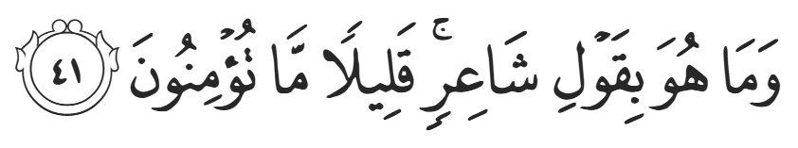
‘It is not the word of a poet; little do you believe!’ (69:41)
So I thought: ‘It must be a fortune-teller.’ And the next verse was:
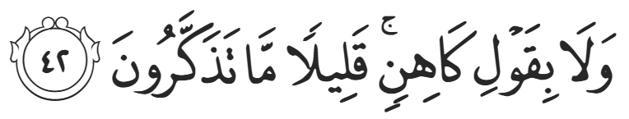
‘Nor is it the word of a fortune-teller, little do you reflect!’ (69:42)
I then thought: ‘Where is this from then?!’ And the next verse was:
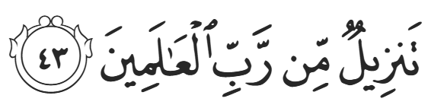
‘It is a Revelation from the Lord of all the worlds’ (69:43)
I then thought: ‘What if he is inventing it?’ and the next verses were:
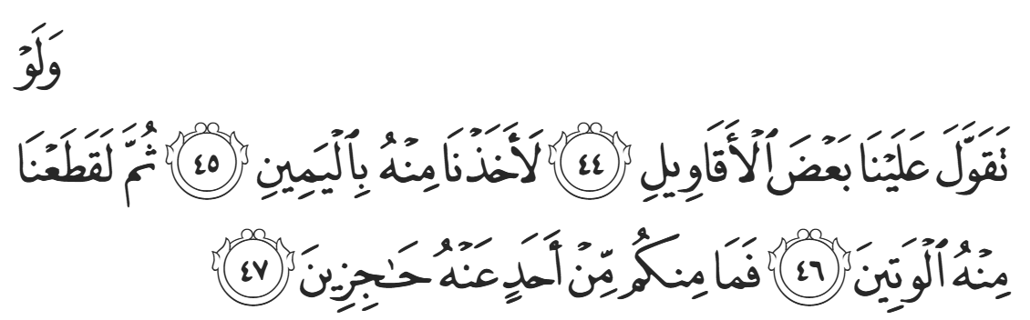
‘Had the Messenger made something up in Our Name, We would have certainly seized him by his right hand, then severed his aorta, and none of you could have shielded him ˹from Us˺!’ (69:44-47)
And that was the first time Islam entered my heart.” ‘Umar then quietly left without disturbing the Prophet ﷺ.
Nothing immediately transpired from the above event. A short while later, the Quraysh were gathered, and Abu Jahl was once again spouting hatred. He said, “This man (i.e., the Prophet ﷺ) has done more to insult our fathers and gods than anyone else. He has cursed our religion and said that anyone who worships idols will go to Hell, which means he is damning our forefathers to Hell. Who will finally rid us of this man? By Allah, I promise 100 of the best camels to anyone who succeeds in doing this, and I will add 1,000 pouches of silver.” This was an extraordinary amount of wealth to offer… ‘Umar became greedy and decided to take Abu Jahl up on his offer. He left and began walking with an unsheathed sword—an unspoken declaration of war. He heard voices from afar telling him to stop but he ignored them and continued forth.
He was finally stopped by Nu’aym ibn ‘Abdillah al-Nahhaam (RA) who had recently accepted Islam but had not yet publicized it. He asked him where he was going, and ‘Umar replied, “Enough is enough. We have been cursed for too long and our ancestors have been ridiculed. I am now going to kill this man.” Nu’aym panicked, “Have you lost your mind, O ‘Umar? Do you really think the Banu ‘Abd Manaaf will let you live after this?” He then had to think on his feet, “If you really want to do something, go and fix your own family!” ‘Umar was perplexed and demanded an explanation. Nu’aym responded, “Haven’t you heard? Your own sister and brother-in-law have accepted Islam!” In a bid to protect the Prophet ﷺ, Nu’aym sent ‘Umar to his sister in hopes that he would not harm his own family.
Enraged, ‘Umar changed course and marched to his sister’s house. As he approached the door, he heard the Qur’aan being recited aloud. Khabbab ibn al-Aratt (RA) was teaching Faatimah bint al-Khattab (RHAA) and her husband, Sa’eed ibn Zayd (RA). Even in times of persecution and tension, education was paramount; the companions did not stop learning and teaching, demonstrating the central importance of seeking knowledge. ‘Umar’s rage grew once more and he banged on the door, demanding to be let in. Khabbab scurried into a hiding place, and Faatimah covered the Qur’aan parchment with her garment. ‘Umar entered and demanded to know what he heard. Faatimah denied that anything was said, but ‘Umar dismissed her, insisting, “I know what I heard. And it has reached me that you have both accepted Islam.” They continued denying it until ‘Umar stepped forward to punch Sa’eed. Faatimah stepped in to stop it and ‘Umar accidentally punched her instead, causing blood to gush from her lip. Both Faatimah and Saeed grew angry and yelled defiantly, “Do as you please! We have indeed accepted Islam, and we believe in the Prophet ﷺ.”
When ‘Umar saw his sister bleeding coupled with the courage it took for them to stand firm, his heart once again softened, and he calmed down. He then asked to see what she was reading. Faatimah hesitated but ‘Umar assured her that he would not disrespect the Qur’aan. She said that only the pure could touch the Qur’aan. While she was referring to spiritual purity, he still offered to do ghusl—the ritual purification consisting of washing the entire body—and did so. He then took the parchment and read from Surah Ta-Ha.
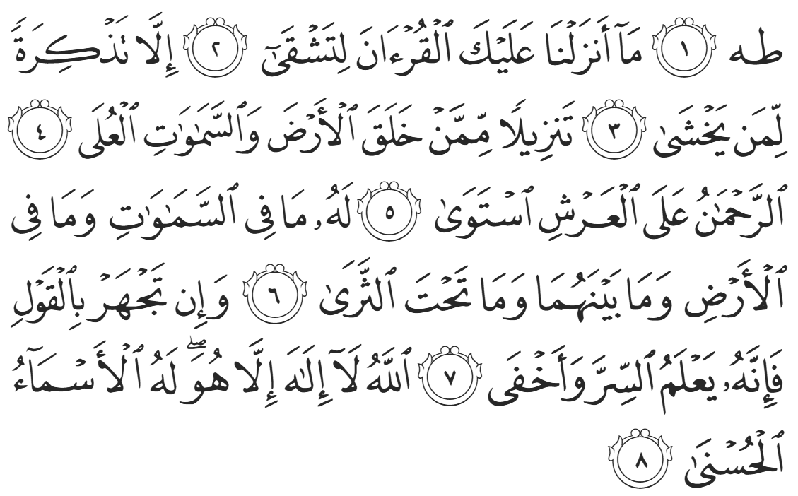
“Ṭā, Hā. We have not revealed the Quran to you to cause you distress, but as a reminder to those in awe [of Allah]. [It is] a revelation from the One Who created the earth and the high heavens— the Most Compassionate, [Who is] established on the Throne. To Him belongs whatever is in the heavens and whatever is on the earth and whatever is in between and whatever is underground. Whether you speak openly ˹or not˺, He certainly knows what is secret and what is even more hidden. Allah—there is no god ˹worthy of worship˺ except Him. He has the Most Beautiful Names.”
Finally, Islam wholly entered ‘Umar’s heart.
He then asked Sa’eed where the Prophet ﷺ was, and Sa’eed, seeing that ‘Umar’s demeanor and intentions had changed, directed him to al-Arqam’s house. ‘Umar set off to Daar al-Arqam, and perhaps unknowingly, he was still holding on to his unsheathed sword. He knocked on the door, and a companion peeked through and saw ‘Umar holding a sword. He returned to the Prophet ﷺ, trembling, “O Messenger of Allah, ‘Umar is at the door with a sword in his hand!” Hamzah (RA), who had been Muslim for a mere few days, said, “Let him in! If Allah wants good, he will accept Islam, and if Allah wants other than this, the very sword he is holding will be the end of him!” The companions then opened the door and pounced on ‘Umar, grabbing his arms and pulling him in. They escorted him to the Prophet ﷺ and he sat down. The Prophet ﷺ grabbed ‘Umar by the collar and said, “O Ibn Al-Khattab! What are you doing here? By Allah, if you continue on this path, Allah will destroy you with a punishment!” ‘Umar shocked the room and replied, “I came to accept Islam and believe in Allah.” The Prophet ﷺ shouted “Allahu Akbar – Allah is the Greatest!” so loudly that everyone in the house immediately knew that ‘Umar accepted Islam.
<Conclude 1st Khutbah with:
Aqoolu haathaa wa astaghfir-Allaah (I say this and I ask Allah for forgiveness)
أَقُولُ قَوْلِي هَذَا وَأَسْتَغْفِرُ اللَّهَ لِي وَلَكُمْ وَلِسَائِرِ المُسْلِمينَ وَالمُسْلِمَاتْ فَاسْتَغْفِرُوهْ إِنَّهُ هُوَ الْغَفُورُ الرَّحِيمُ
الحمد لله رب العالمين والصلاة والسلام على سيد المرسلين وعلى آله وأصحابه أجمعين
<2nd Khutbah>
Dear brothers and sisters,
‘Umar’s conversion was a defining moment in early Islam. On ‘Umar’s deathbed, Ibn Mas’ud said, “We have ever remained in glory since the day ‘Umar accepted Islam.” Ibn ‘Abbas (RA) once asked ‘Umar how he acquired the title “al-Faruq” – The Distinguisher. ‘Umar (RA) replied, “The Prophet ﷺ gave me this title when I converted, and we marched to the Ka’bah and prayed in public for the first time. The Prophet ﷺ then said, “You are ‘Umar al-Faaruq.” Immediately after his conversion, the Muslims indeed marched to the Ka’bah in unison under this newfound strength. They marched in two rows: One led by Hamzah, and the other led by ‘Umar.
Excited by this momentous occasion, ‘Umar insisted on personally informing Abu Jahl of his conversion. He knocked on his door, and Abu Jahl opened the door with a smile, “Welcome! What has brought you here?” ‘Umar replied, “I have come to personally inform you that I believe in Allah and His Messenger, and I am now a follower of the religion of Muhammad ﷺ.” Abu Jahl slammed the door in his face, shouting, “May Allah curse you for what you have come with!” ‘Umar then continued walking, asking the people, “Who is the biggest gossip among you?” Somebody directed him to Jameel ibn Ma’mar, so ‘Umar brought him close and said, “I have a secret to tell you. I have just accepted Islam and I am now a follower of Muhammad ﷺ.” Jameel jumped up, barely grabbing a garment to clothe himself, and rushed outside to spread the news. He began shouting down the streets, “O people of the Quraysh! ‘Umar ibn al-Khattab became a Sabian!” ‘Umar then gently corrected him in that he did not become a Sabian, but rather became a Muslim. As soon as he converted, ‘Umar would be attacked, though ‘Umar was unparalleled in his strength and power, and so he would fight them off each time. Eventually, the influential Chieftain al-Aas ibn al-Waa’il intervened saying, “What is the matter with you people? Let this man be. If he chose a different path to you, it is none of your business.” Al-Aaas ibn al-Waa’il then officially gave ‘Umar protection.
Dear brothers and sisters, the stories of Hamzah and ʿUmar (RA) remind us that guidance is in the hands of Allah alone. Hearts that seem hardened, can be softened in an instant, and moments of anger, pain, or confusion can become the very doorway to iman—the doorway to faith. These conversions teach us never to despair of Allah’s mercy, never to judge who is closest or furthest from guidance, and never to underestimate the power of sincerity, courage, and the Qur’an. May Allah allow us to take these lessons to heart—standing firm upon the truth, embodying the strength of faith, and trusting that Allah (SWT) can bring light even from the darkest seeming of places and moments.
Allah (SWT) tells us in Surah Al-Qasas:
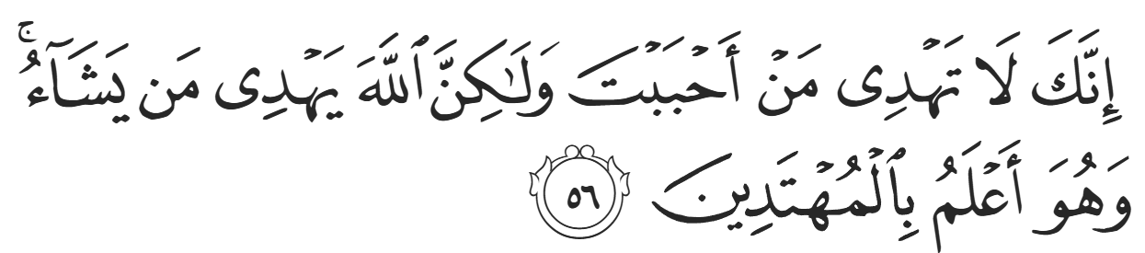
“You surely cannot guide whoever you like, but it is Allah Who guides whoever He wills, and He knows best who are ˹fit to be˺ guided.” (28:56)
<Duaa!>
- Oh Allah, please grant us a deep love for your Prophet Muhammad, SAW.
- Oh Allah, please make us energetic in doing good for your cause.
- Oh Allah, please enable us with the will and means to walk Al-Sirrat-Al-Mustaqeem, even if it estranges us from others.
- Oh Allah, please support the suffering and oppressed Muslims around the world and grant them victory over that which oppresses them.
- Oh Allah, please protect us from ever being overburdened by debt and protect us from all evils and undesirable consequences associated with having debt.
- Oh Allah, please fill our hands with the work and deeds of righteousness and let them be of benefit to ourselves and the Ummah.
- Oh Allah please forgive us our shortcomings and deviances in following your Qur'an and the Sunnah of Rasul'Allah, SallAllahuAlayhiWaSallam.
- Oh Allah please grant us understanding and guidance of your Qur'aan
- Oh Allah, please grant us patience with the trials of this world.
- Oh Allah, please prevent our hearts from getting overly attached to the Dunya and grant us the best in this life and the best in the hereafter.
- Oh Allah, please forgive us our past sins and make us your devoted servants.
- Oh Allah please make us amongst those whose Duaa is accepted.
- Oh Allah, please grant us Jannat'ul Firdaus and protect us from ever coming close to the Fires of Jahannum.
Shahada
“Before we begin, I want to make sure you understand what you’re about to say. You are choosing Islam freely, without pressure from anyone.
Do you believe that there is only one God and that Muhammad ﷺ is the Messenger of Allah?”
…………………………………………
“Excellent, now we will take “The Shahaada” publicly stating this belief – shahada means to bear witness, you are bearing witness to this belief in front of everyone.
We will first say it in English so you know what you are saying, and then in Arabic. Repeat after me:
“I bear witness that there is no god worthy of worship except Allah, and I bear witness that Muhammad is the Messenger of Allah.”
Now in Arabic:
“Ash-hadu an lā ilāha illa-llāh”
“Wa ash-hadu anna Muḥammadan rasūlu-llāh”

Takbir – Allahu Akbar! Takbir! Allahu Akbar! Takbir! Allahu Akbar!

“O Allah, keep her heart firm upon Islam,
increase her in knowledge and peace,
and make this path easy and full of light for her.”

