Khut'bah Opening
إِنَّ الْحَمْدَ للهِ , نَحْمَدَهُ وَ نَسْتَعينُهُ وَ نَسْتَغْفِرُهُ , وَ نَعوذُ بِالله مِنْ شُرورِ أَنْفُسِنا , مَن يَهْدِهِ اللهُ فَلا مُضِلَّ لَه , وَ مَنْ يُضِلِلْ فَلا هادِيَ لَهْ , وَ أَشْهَدُ أَنْ لا إلهَ إِللهُ وَحْدَهُ لا شَريكَ لَه , و أَشْهَدُ أنَّ مُحَمَّدًا عَبْدُهُ و رَسولُه.
"All thanks and praises are due to Allah, whom we thank, seek for help and invoke for forgiveness. We seek refuge with Allah from the evils within ourselves. He whom Allah guides will never be misled and he whom He misguides will never find one to guide him. I bear witness that there is no deity worthy of worship except Allah and that Muhammad (SAW) is His slave and Messenger.
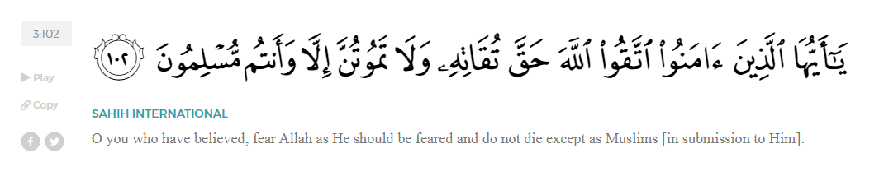
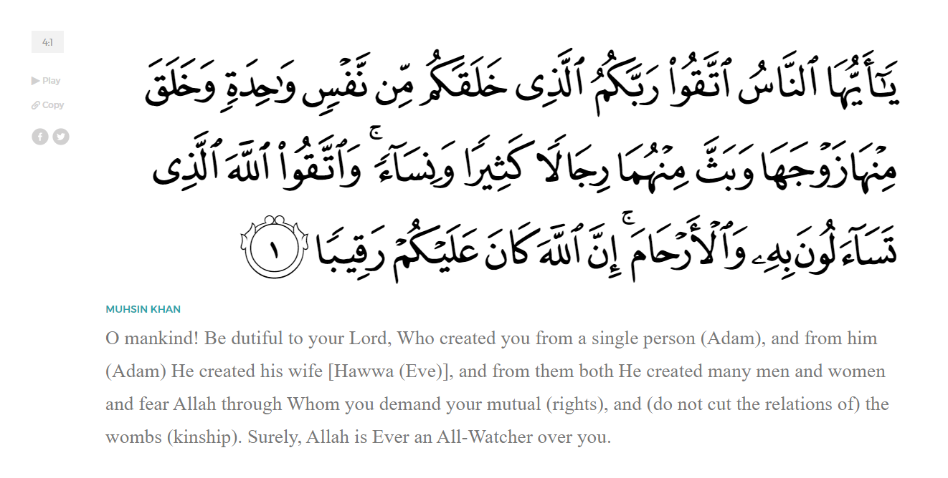
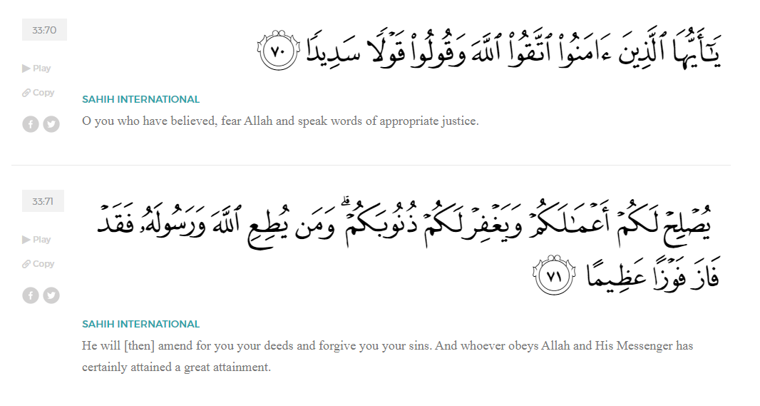
<Sirah of the Prophet (SAW) – Part X -Dr. Yassir Qadhi, Book and Series>
Dear brothers and sisters,
InshaaAllah we will continue our khutbah series on the seerah of the Prophet ﷺ, drawing from Dr. Yasir Qadhi’s book, The Sirah of the Prophet, so that we can deepen our understanding of his life and strengthen our love for him. Each step we take through the Prophet ﷺ’s life brings us closer to knowing him more deeply, appreciating his struggles, and embodying his character. Our goal in this series, inshaaAllah, is not just to learn history, but to let the seerah transform our hearts and strengthen our love for the Messenger of Allah ﷺ.
Today we will, inshaaAllah, continue with the chapter Makkah Reaches Boiling Point starting with the section Boycott and Exile.
Months passed and the Quraysh were still reeling from the multiple blows they suffered. After the shame of losing a huge portion of their population to the self-imposed exile—the Muslims Hijrah to Abyssinia, they lost two of their most prominent figures in Hamzah and ‘Umar. Things were going from bad to worse, and they gathered to finally put a stop to it. They resolved that only way to do that would be to kill the Prophet ﷺ. All the tribes agreed that the Banu Haashim, led by Abu Taalib, must hand the Prophet over, and they would be paid any amount of blood money. They even agreed to allow a third party to kill him ﷺ to avoid revenge attacks. They once again approached Abu Taalib, but this time did not give him a choice in the matter… They gave the ultimatum: either you hand him over, or we will cut you off from the Quraysh. In a truly unprecedented move, they threatened to disown Banu Haashim. Abu Taalib was furious and immediately refused.
The boycott was comprehensive: businesses no longer traded with the Banu Haashim; shops no longer sold to them; bachelors no longer married into them; social gatherings with them were banned; and they were even denied access to food and water. It was an economic, political, and social boycott. They even formalized the boycott with a treaty, which was hung inside the Ka’bah. It was said that Bu’ayd ibn ‘Aamir wrote the treaty, so the Prophet ﷺ made a specific duaa against him, and his hand became paralyzed until his demise.
Abu Taalib then decided to undergo a self-imposed exile and the Banu Haashim relocated to a nearby valley, eeking out an existence. Relying on shrubbery and rainwater for food and water, they managed to barely survive by the grace of Allah (SWT). Due to the scarcity of nutrients in their diet, it is described that their droppings became “like that of sheep”. As they teetered on the brink of death, sympathizers from the Quraysh, such as the likes of Mut’im ibn ‘Adiyy and Haakim ibn Hizaam, secretly sent in food and water. Tribal kinship was so strong that non-Muslims from the Banu Haashim also subjugated themselves to this exile with the exception of Abu Lahab. Instead, he revoked his allegiance to the Banu Haashim in exchange for remaining in Mecca. During this time, the Prophet ﷺ would continue to give da’wah to travelers and pilgrims.
The boycott lasted for two or three years, and the matter was so dire that the Prophet ﷺ began to make severe du’aa against the Quraysh, “O Allah, send upon them a famine like the famine of Yusuf (AS).”
The Prophet’s du’aa was accepted, and the Quraysh experienced a famine so bad that they were forced to eat dead carcasses and animal skin. The Quraysh knew that this must be due to the Prophet ﷺ so they sent some messengers to the valley to ease tensions. Meanwhile, some senior tribesmen of the Quraysh began to sympathize with the Banu Haashim, feeling guilty about the anguish their kith and kin were suffering. Hishaam ibn ‘Amr, a cousin of the Prophet ﷺ, was one such advocate, and he sought a way to bring an end to the boycott. He called Zuhayr ibn Abi Umaymah alongside other sympathizers, such as Mut’im ibn ‘Adiyy and Haakim ibn Hizaam, mentioned above. Zuhayr concocted a plan: they gathered for the regular council meeting and Zuhayr stood up, saying, “For how long shall we starve our own kith and kin to death?” Abu Jahl responded adamantly, “Who do you think you are? We all agreed to the treaty!” Hishaam then stood up and responded, “No, I didn’t agree! It was all your idea!” Abu Jahl began to defend himself when Mut’im also stood up and said, “You forced this upon us!” One by one, each person stood up and added to the argument until Abu Jahl grew privy to what was happening and said, “By Allah this is a plan you have all hatched up!” … The plan was successful in shifting public opinion.
One day, The Prophet ﷺ approached Abu Taalib saying, “O my uncle, Allah has informed me that the treaty they wrote has been consumed by termites except for the phrase ‘In the Name of Allah’.” Abu Taalib decided to stake his entire bid on the word of the Prophet ﷺ and marched into Mecca with a group of non-Muslims from the Banu Haashim. He said, “Let’s revisit this treaty and negotiate.” They Quraysh were obviously happy, as they understood that Abu Taalib was ready to hand over the Prophet ﷺ. As they entered the Ka’bah to retrieve the treaty, which was secured in a pouch and locked inside the Ka’bah inaccessible to the public, Abu Taalib said, “My nephew has informed me that his Lord has told him that the treaty is no longer in existence except for the phrase, ‘In the Name of Allah’. So my challenge to you is: if that is the case, then let us be and we will return to Mecca; and if it is not, then I will hand him over to you, and you can do as you please.” They agreed and opened the pouch only to find the scroll devoured except for the phrase ‘In the Name of Allah’. The Quraysh begrudgingly stuck to the agreement and lifted the boycott.

<Conclude 1st Khutbah with:
Aqoolu haathaa wa astaghfir-Allaah (I say this and I ask Allah for forgiveness)
أَقُولُ قَوْلِي هَذَا وَأَسْتَغْفِرُ اللَّهَ لِي وَلَكُمْ وَلِسَائِرِ المُسْلِمينَ وَالمُسْلِمَاتْ فَاسْتَغْفِرُوهْ إِنَّهُ هُوَ الْغَفُورُ الرَّحِيمُ
الحمد لله رب العالمين والصلاة والسلام على سيد المرسلين وعلى آله وأصحابه أجمعين
<2nd Khutbah>
Dear brothers and sisters,
Not long after the reintegration of the Banu Haashim, Allah (SWT) willed for two great calamities to afflict the Prophet ﷺ: the death of his uncle, Abu Taalib, and the death of his wife, Khadijah (RA). They occurred within a span of 40 days, but the magnitude of the trials led to the entire year being called the year of sorrow.
Less than six weeks after the boycott ended, the pangs of death were upon Abu Taalib. At his deathbed, the Prophet ﷺ begged, “O uncle, say just one statement (‘there is no god but Allah’) that I can use to argue your case in front of Allah to save you.” Abu Taalib was on the brink of conversion, with the words on the tip of his tongue, when Abu Jahl and Abdullah ibn Abi Umayyah quickly interjected, “Are you going to leave the religion of ‘Abd al-Muttalib?!” Whenever Abu Taalib would be on the verge of uttering the shahadah, they would repeat the same question.
Abu Taalib loved the Prophet ﷺ more than anything, but the only person more beloved to him was his father. The prestige and honor of being ‘Abd al-Muttalib’s heir meant everything to him. He was the son of the most respected, revered, and honored person of the previous generation whose reputation was at its height. Though he knew the truth deep down in his heart, the prestige of his lineage gripped his heart to a detrimental consequence, and he passed away that moment without uttering the testimony of faith—the shahaada.
The Prophet ﷺ was so overwhelmed by his death that he ﷺ said, “I will ask Allah to forgive you unless I am prohibited.” No Prophet can take a step forward in their preaching without permission from Allah (SWT). The Prophet ﷺ was so overcome with emotion that he acted and then waited for Allah’s approval rather than waiting for permission first. The Prophet ﷺ continued to ask for his forgiveness until Allah (SWT) sent down a multitude of verses. One of them was from Surah al-Tawbah, where Allah (SWT) gently reprimanded the Prophet ﷺ:
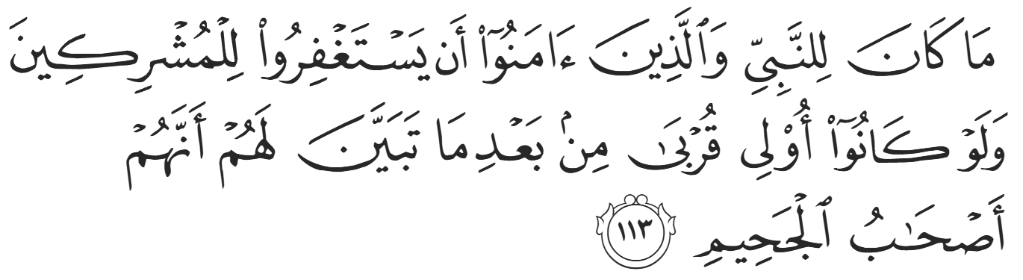
“It is not proper for the Prophet and believers to seek forgiveness for the polytheists, even if they were close relatives, after it has become clear to the believers that they are bound for the Hellfire.”(9:113)
Al-Abbas (RA), the brother of Abu Taalib, asked the Prophet ﷺ, “O Messenger of Allah, have you benefitted your uncle at all? He used to protect you and become angry on your behalf.” The Prophet ﷺ replied, “Yes, I have. He is on the peripheries of the Fire of Hell, and were it not for me, he would be in the depths of Hell.” The Prophet ﷺ also said that the person with the least punishment of all inhabitants of Hell was Abu Taalib. Indeed, all of Abu Taalib’s goodness and support of the Prophet ﷺ could not prevent him from escaping the punishment of Hell. Despite the Prophet’s love for him and the immense benefit he provided the Muslims, his heart contained the pride and arrogance of being ‘Abd al-Muttalib’s heir. This demonstrates the fallibility of mankind and the possibility of good and evil being intertwined within a single soul. The Prophet ﷺ was deeply hurt by Abu Taalib’s fate, yet he submitted to the decree of Allah.
Some find it difficult to accept that a man of Abu Taalib’s standing could be destined for Hell, despite his goodness and the benefit he provided. It also leads some to maintain that he died a Muslim. The historical records are clear that he did not die a Muslim, and our acceptance of this fact is rooted in our belief in Allah (SWT) as our only Lord. Indeed, the case of Abu Taalib reaffirms one’s belief in the Almighty’s supreme decree; despite being the most beloved creation to Allah (SWT), the Prophet ﷺ himself could not guide Abu Taalib. This unequivocally affirms Prophet Muhammad ﷺ as a slave and Messenger, and Allah (SWT) as the Lord of all the worlds. Allah (SWT) states about Himself in Surat Al-Anbiyaa,

“He cannot be questioned about what He does, but they will all be questioned.” (21:23)
Mankind will never truly comprehend the unseen, but our loyalty remains with Allah (SWT).
As for some possible wisdoms behind Abu Taalib’s fate, his standing within the Quraysh provided the Prophet ﷺ the protection that he desperately required to survive and spread the Word of Allah. His conversion would have led to him being disowned by the Quraysh, leaving the Prophet ﷺ exposed and unprotected. However, as a true representative of ‘Abd al-Muttalib, Abu Taalib’s word was final and the Quraysh never dared to undermine his authority. The Prophet’s relationship with Abu Taalib also provides vital lessons in navigating our relationship with non-Muslims. Allah (SWT) recognized the Prophet’s love for Abu Taalib despite his religious affiliation. Allah (SWT) states:
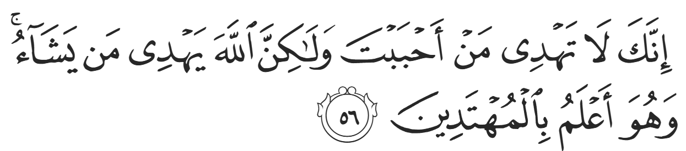“You surely cannot guide whoever you like, but it is Allah Who guides whoever He wills, and He knows best who are ˹fit to be˺ guided.” (28:56)
The Prophet’s love was recognized as a familial love, not that which stems from religious affiliation. Allah (SWT) indeed states,
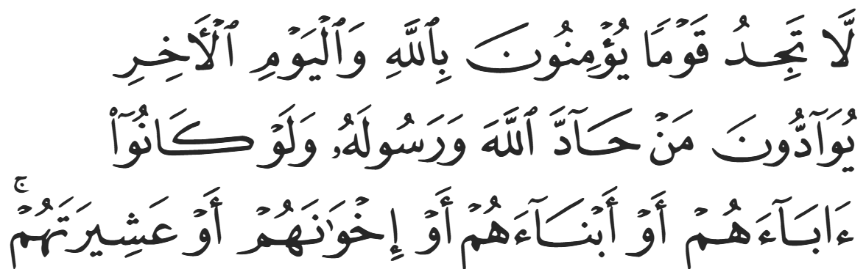
“You will not find a people who believe in Allah and the Last Day truly loving those who defy Allah and His Messenger, even if they were their parents, children, siblings, or extended family.” (58:22)
This is referring to love rooted in shared beliefs and religion, not natural feelings of affection.
The case of Abu Taalib also inspires reflection on what it means to be a Muslim. Imaan—faith—cannot be accurately defined as just believing in Allah and His Messenger, because Abu Taalib admitted his faith in Islaam but refused to accept it. Therefore, Islaam is defined as submitting to the truth, not just knowing the truth. Even Iblis—Shaytan—the devil himself—believed in Allah, yet Allah referred to him as a kaafir—a disbeliever— why? because he “refused and acted arrogantly”.
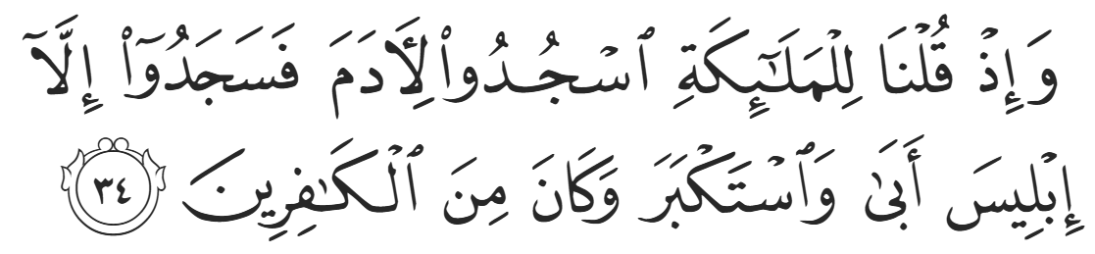
“And [mention] when We said to the angels, "Prostrate before Adam"; so they prostrated, except for Iblis. He refused and was arrogant and became of the disbelievers.” (2:34)
Kufr is therefore understood as rejection, not necessarily disbelief. A pertinent lesson derived from this fact is that theoretical faith does not suffice a Muslim, and an integral part of belief is applying that faith to the best of one’s ability.
Dear brothers and sisters, the boycott of Banu Haashim reminds us that hardship is often the price of standing firm upon the truth, while the story of Abu Ṭaalib reminds us that knowing the truth without submitting to it is not enough. The Prophet ﷺ endured hunger, isolation, and the loss of his greatest supporters, yet never wavered in his trust in Allah. Let us learn from both lessons: to remain steadfast in trials, and to ensure that our imaan is not merely known, but lived through sincere submission and obedience. May Allah (SWT) make us firm upon the truth in ease and in hardship.

<Duaa!>
- Oh Allah, please grant us a deep love for your Prophet Muhammad, SAW.
- Oh Allah, please make us energetic in doing good for your cause.
- Oh Allah, please enable us with the will and means to walk Al-Sirrat-Al-Mustaqeem, even if it estranges us from others.
- Oh Allah, please support the suffering and oppressed Muslims around the world and grant them victory over that which oppresses them.
- Oh Allah, please protect us from ever being overburdened by debt and protect us from all evils and undesirable consequences associated with having debt.
- Oh Allah, please fill our hands with the work and deeds of righteousness and let them be of benefit to ourselves and the Ummah.
- Oh Allah please forgive us our shortcomings and deviances in following your Qur'an and the Sunnah of Rasul'Allah, SallAllahuAlayhiWaSallam.
- Oh Allah please grant us understanding and guidance of your Qur'aan
- Oh Allah, please grant us patience with the trials of this world.
- Oh Allah, please prevent our hearts from getting overly attached to the Dunya and grant us the best in this life and the best in the hereafter.
- Oh Allah, please forgive us our past sins and make us your devoted servants.
- Oh Allah please make us amongst those whose Duaa is accepted.
- Oh Allah, please grant us Jannat'ul Firdaus and protect us from ever coming close to the Fires of Jahannum.

