Khut'bah Opening
إِنَّ الْحَمْدَ للهِ , نَحْمَدَهُ وَ نَسْتَعينُهُ وَ نَسْتَغْفِرُهُ , وَ نَعوذُ بِالله مِنْ شُرورِ أَنْفُسِنا , مَن يَهْدِهِ اللهُ فَلا مُضِلَّ لَه , وَ مَنْ يُضِلِلْ فَلا هادِيَ لَهْ , وَ أَشْهَدُ أَنْ لا إلهَ إِللهُ وَحْدَهُ لا شَريكَ لَه , و أَشْهَدُ أنَّ مُحَمَّدًا عَبْدُهُ و رَسولُه.
"All thanks and praises are due to Allah, whom we thank, seek for help and invoke for forgiveness. We seek refuge with Allah from the evils within ourselves. He whom Allah guides will never be misled and he whom He misguides will never find one to guide him. I bear witness that there is no deity worthy of worship except Allah and that Muhammad (SAW) is His slave and Messenger.
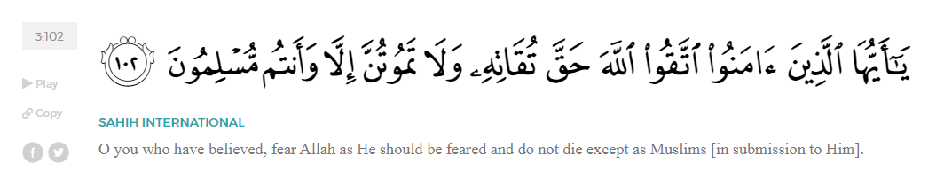
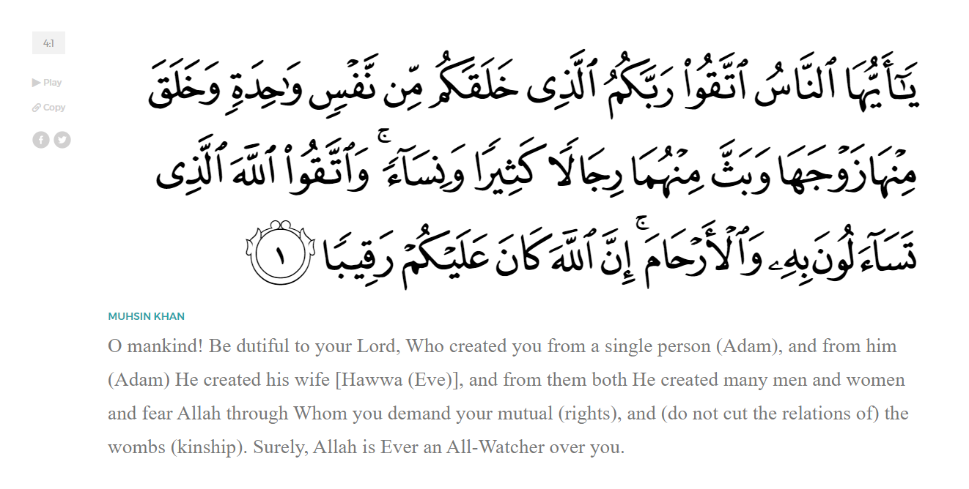
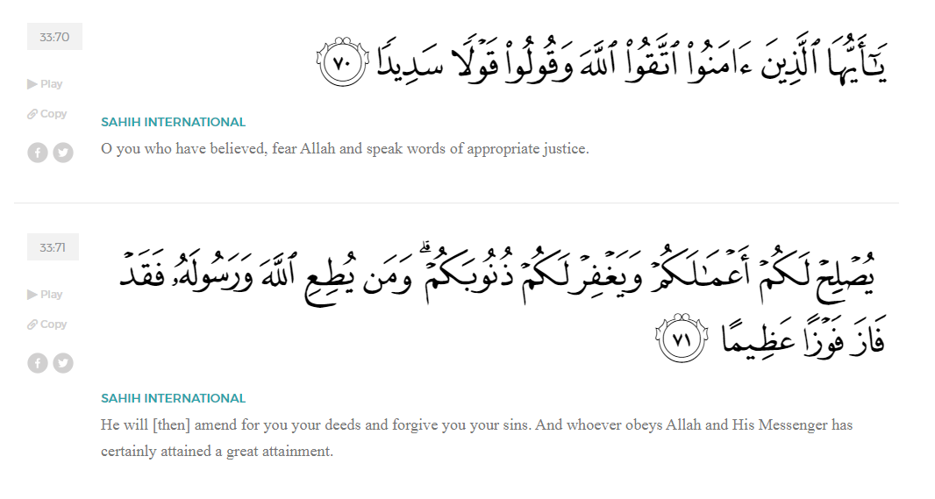
<Sirah of the Prophet (SAW) – Part 18 -Dr. Yassir Qadhi, Book and Series>
Dear brothers and sisters,
InshaaAllah we will continue our khutbah series on the seerah of the Prophet ﷺ, drawing from Dr. Yasir Qadhi’s book, The Sirah of the Prophet, so that we can deepen our understanding of his life and strengthen our love for him. Each step we take through the Prophet ﷺ’s life brings us closer to knowing him more deeply, appreciating his struggles, and embodying his character. Our goal in this series, inshaaAllah, is not just to learn history, but to let the seerah transform our hearts and strengthen our love for the Messenger of Allah ﷺ.
Today we will, inshaaAllah, continue the chapter titled “The Year of Sorrow”.
As we discussed in the last khutbah for this series, the Year of Sorrow is first marked by the passing of the Prophet ﷺ’s closest supporter, his uncle Abu Taalib.
Just over a month after Abu Taalib’s death, the Prophet ﷺ was struck with another major calamity in the passing of his most beloved wife, Khadijah (RHAA). The Prophet ﷺ personally shrouded and buried her, and the experience exacted a heavy toll. The trauma compounded for the Prophet as he lost the love of his life and his father figure within 40 days. Abu Taalib protected the Prophet ﷺ externally, while Khadijah (RHAA) protected him internally. The Prophet’s love for Khadijah was unparalleled; long after her passing, he ﷺ would buy her friends gifts and talk about her with the deepest admiration.
The Prophet ﷺ loved Khadijah (RHAA) so much that his wives that never met her were deeply jealous of her existence. Aaishah (RHAA) had later captured the heart of the Prophet ﷺ and was known to be his most beloved wife, and she admitted that she did not feel jealous of any of his wives except for Khadijah (RHAA). Once, her jealousy intensified so much that she crossed the line. One day, Khadijah’s sister, Haalah, knocked on the door, and the Prophet ﷺ was almost asleep, but when he heard her voice, he jumped up in happiness simply to meet Khadijah’s relative. Aaishah (RHAA) said, “O Messenger of Allah, for how long are you going to keep on remembering an old, toothless hag of the Quraysh when Allah replaced her with someone better?” In a rare occurrence, the Prophet ﷺ responded angrily, “No, by Allah, Allah did not give me someone better! She supported me when no-one else supported me; she spent upon me when everyone boycotted me; she comforted me when the whole world gave me grief; and Allah gave me children through her when Allah deprived all my other wives of this blessing.” When narrating this Hadith, Aaishah recalled, “After that day I never once opened my mouth about Khadijah again.”
As explained in depth, Abu Taalib was the Prophet’s protection, both emotionally and politically. After his demise, the Prophet ﷺ was exposed and the Quraysh could intensify their persecution. ‘Abdullah ibn Mas’ud (RA) narrated a story which grew famous as a defining point in the struggle,
“Once, the Prophet ﷺ was praying in front of the Ka’bah when Abu Jahl was sitting with a group. A day prior, a camel had been sacrificed, so Abu Jahl challenged them, ‘Who amongst you will go to the carcass of that camel and bring the entrails to dump on Muhammad?’ The worst of them, ‘Uqbah ibn Abi Mu’ayt, stood up and went to the carcass and carried the entrails all the way back to the city. He waited until the Prophet ﷺ was in prostration and dumped it all onto the head of the Prophet ﷺ. The weight of the entrails was so heavy that the Prophet ﷺ could not lift himself back up. People began to laugh so hard that some of them were falling onto their sides and others were smacking themselves out of laughter. I was standing from a distance looking, but I had no help or support [due to my servant status] so I could not do anything. The Prophet ﷺ remained in prostration until somebody went to notify Faatimah (RHAA). She was a little girl at the time, and she began crying and running towards the Prophet ﷺ, lifting the entrails off him. The Prophet ﷺ stood up, turned towards the Quraysh, and raised his finger up towards Allah (SWT), which silenced the Quraysh. He then began making du’aa against them by name, one by one. He mentioned each of them by name three times until the blood drained from their faces. They were Abu Jahl ibn Hishaam, ‘Utbah ibn Rabi’ah, Shaybah ibn Rabi’ah, Walid ibn ‘Uqbah, Umayyah ibn Khalaf, ‘Uqbah ibn Abi Mu’ayt, and there was a seventh, but I forgot his name. I swear, by the One Who sent Muhammad with the Truth, that I myself saw every one of those seven dead in the Battle of Badr.”
Consider the vulgarity: a prestigious nobleman of the Quraysh, wearing expensive clothing, volunteered himself into the wasteland to pick up entrails from a carcass and walk from the outskirts of the city all the way into the center of Mecca, all to humiliate a man of piety. Not a single bystander intervened; the only person who desperately wanted to help, Ibn Mas’ud (RA), would have been immediately killed for defying noblemen. It was left to a teary-eyed, eight-year-old girl to traumatically help her father. Nevertheless, the Prophet ﷺ kept his composure and faced vulgarity with dignity and honor, turning to his Lord for support, and the support of his Lord did not fail.
After Abu Taalib died, Abu Lahab became chieftain of the Banu Haashim clan. Under Abu Taalib’s leadership, Abu Lahab was relentless in his tirades, but as the leader of the tribe, his perspective somewhat changed; the Prophet ﷺ was now his subject, and Abu Lahab felt a sense of responsibility and duty. His demeanor softened, and he approached the Prophet, “O Muhammad, be as you were under Abu Taalib.” In other words: you have my protection. After this change in stance, rumors spread that Abu Lahab accepted Islam. The Quraysh asked, “Have you become a Sabian?” Abu Lahab responded, “No, but I am protecting my flock.”
Abu Jahl and ‘Utbah then hatched a plot to change Abu Lahab’s mind. They suggested, “Why don’t you ask your nephew about the fate of your father, ‘Abd al-Muttalib?” Abu Lahab asked the Prophet and he ﷺ responded, “He is with his people.” The Prophet’s wise response was generic enough to suffice Abu Lahab without lying. However, Abu Lahab returned to Abu Jahl who responded, “You fool! Where are his people except in the Fire of Hell?!” Abu Lahab was so enraged that their plot was successful and he revoked his protection within a week. The Prophet ﷺ was once again left exposed, relying only on the protection of Allah (SWT).
<Conclude 1st Khutbah with:
Aqoolu haathaa wa astaghfir-Allaah (I say this and I ask Allah for forgiveness)
أَقُولُ قَوْلِي هَذَا وَأَسْتَغْفِرُ اللَّهَ لِي وَلَكُمْ وَلِسَائِرِ المُسْلِمينَ وَالمُسْلِمَاتْ فَاسْتَغْفِرُوهْ إِنَّهُ هُوَ الْغَفُورُ الرَّحِيمُ
الحمد لله رب العالمين والصلاة والسلام على سيد المرسلين وعلى آله وأصحابه أجمعين
<2nd Khutbah>
Dear brothers and sisters,
After a period of time without protection, the Prophet ﷺ began searching for sustainable options outside Mecca. His reluctance to do so for so many years despite the increasing hardships truly demonstrates the Prophetic method of patience and perseverance. The Prophet ﷺ took inspiration from Prophets before him, such as Prophet Nuh (AS) who gave da’wah to his people for 950 years. However, without protection, the Prophet’s life was in imminent danger, and so Hijrah was imperative.
The closest prominent city to Mecca was Taa’if. Between tensions and peace treaties, the two competing cities enjoyed a love-hate relationship. The people of Taa’if were intimately aware of the people of Mecca, and vice verse. Taa’if was therefore an ideal base for the Prophet ﷺ to explore. He took Zayd ibn Haarithah (RA) and covertly travelled to Taa’if on foot so as not to arouse suspicion. They walked for two days and met with the leaders of Taa’if, three brothers who ruled the tribe of Thaqeef in unison: ‘abd Yaaleel, Mas’ood, and Habeeb.
The Prophet ﷺ presented the Message of Islam, but all three brothers rejected the call with utmost contempt, disrespect, and disdain. One of them replied, “If Allah chose you to be a Prophet, then I might as well tear down the curtains of the Ka’bah.” The other added, “Has Allah not found anyone better than you?” The third mocked, “I cannot speak to you because if you really are a Prophet, you are too holy for me, and if you are a liar, then you are too beneath me to deserve a response.” Despite their insults and mockery, the Prophet ﷺremained dignified and responded, "Very well. If you have rejected my Message, then at least do not inform the Quraysh of my visit.” Note that the Prophet ﷺ continued to cover his tracks. This does not contravene having trust in Allah (SWT), but rather is an implementation of how to trust Allah; namely, place your trust in Him (SWT) and remain diligent in all that you do.
Even though the Prophet ﷺ was rejected in the vilest manner, he remained in Taa’if for another week, spreading his Message to the common folk. This provides invaluable insight into the Prophetic methodology of da’wah. The Prophet ﷺ would always approach the elite class first, as they have the most influence over society. That said, Allah (SWT) made it clear on many occasions that the sincere masses are not to be ignored or neglected.
One such example is in Surah ‘Abasa. The Prophet ﷺ had finally piqued the interest of some of Quraysh’s elite. He ﷺ organized a meeting with them and began preaching with a sense of optimism. A poor, blind, Muslim stumbled into the room and asked the Prophet ﷺ a question, not realizing he ﷺ was in a vital meeting. The Prophet ﷺ did not address his question, so the man repeated it. The Prophet ﷺgrimaced and turned away in frustration.
Allah (SWT) then revealed:
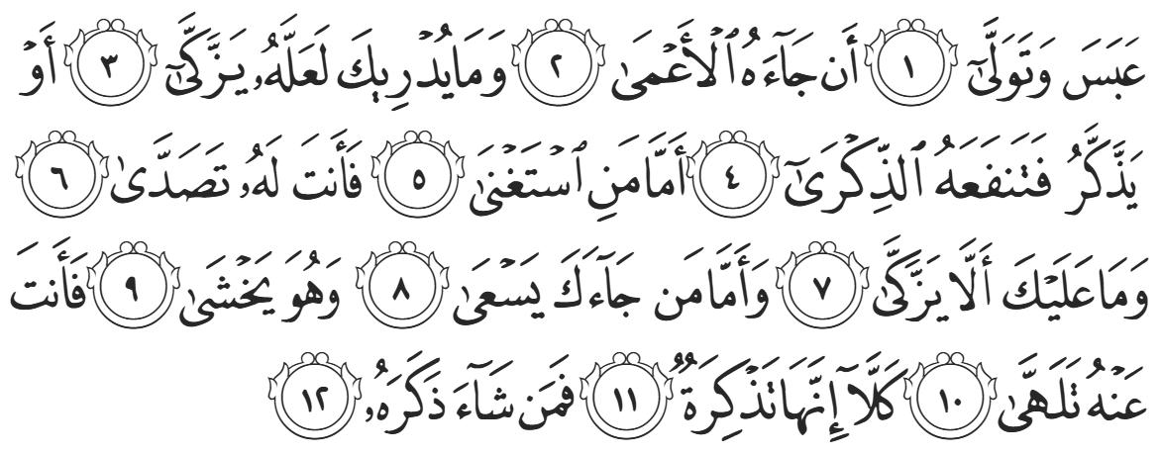
“He frowned and turned away because the blind man came to him [interrupting]. You never know, perhaps he may be purified, or he may be mindful, benefitting from the reminder. As for the one who was indifferent, you gave him your [undivided] attention, even though you are not to blame if he were not purified. But as for the one who came to you, eager ˹to learn˺, being in awe ˹of Allah˺, you were inattentive to him. But no! This ˹revelation˺ is truly a reminder. So let whoever wills be mindful of it.” (Abasa:1-12).
The Prophetic balance is to first approach the elite of the society; if they accept Islam, the masses often follow suit. If they reject, effort is made to preach to the masses.
Despite the Prophet’s efforts, the masses of Taa’if also rejected the call, and no-one converted. Eventually, there were some people who were warming to the idea, which worried the Chieftains. In retaliation, they ordered mobs to physically attack the Prophet ﷺ. They viciously pelted the Prophet ﷺ, and although Zayd (RA) tried his best to protect the Prophet ﷺ, they were both bloodied and bruised from head to toe. They escaped the city and continued until eventually they sat under a tree for shade and respite.
Aa’ishah (RHAA) once asked the Prophet ﷺ, “Was there a day more difficult for you than the day of Uhud?” The Prophet ﷺ immediately replied, “Yes. Indeed, your people hurt me greatly, and the worst of it was on the Day of ‘Aqabah. On that day, I presented to Abd Yaaleel, Mas’ud, and Habeeb and they did not respond to me in the way I wanted. I found myself in a state of grief and sadness, and I did not realize where I was until I reached Qarn al-Tha’aalib.”
Numerous benefits can be derived from the manner in which the Prophet ﷺ answered the question. First, the fact that the Prophet ﷺ described the incident of Taa’if as more traumatic than the Battle of Uhud—where he was physically injured, his life was threatened, and many of his closest companions were killed—indicates the severity of emotional distress. Even the Prophet ﷺ acknowledged emotional pain as a bigger hardship than the ferocity of war. Second, the Prophet ﷺ described what we would now refer to as a disassociation: disconnecting from reality as a result of stress or trauma. This humanizing moment depicts the Prophet ﷺ as a human in need of Allah’s mercy, and great inspiration can be taken from this. Third, the Prophet ﷺ described his situation in a dignified manner, not seeking sympathy. He would not have mentioned it had ‘Aaishah (RHAA) not asked, and he did not complain or victimize himself. We only learn through Zayd’s narration that the reality was much harsher and that the Prophet ﷺindeed faced a truly traumatic ordeal. Instead, the Prophet ﷺ reserved his complaints to the Almighty.
When the Prophet ﷺ escaped the mobs and finally found some shade to rest under, he began making one of the most profound supplications ever recorded:
“O Allah, to You I complain of my weakness and my humiliation before men. You are the Most Merciful of all those who have mercy. You are the Lord of the humble, and You are my Lord. To whom do you entrust me? To a stranger who receives me with hostility? Or to a close relative You have given power over me? As long as You are not angry with me, I do not care, but Your protection is easier for me. I seek refuge in Your Face by which all darkness is illuminated, and from which all the affairs of this world and the Hereafter are rightly guided. May it never be that I incur Your wrath or be subject to Your anger. It is Your right to criticize until You are content, and there is no power nor strength except through You.”
This beautiful, profound, emotional du’aa showcases a masterclass in how to converse with Allah (SWT). The Prophet ﷺ establishes the etiquettes of complaining to Allah (SWT), and how it differs from complaining to other people. There are two types of complaint: the former is the essence of Tawheed—monotheism, whereby one complains to Allah, seeking refuge in Him and hoping for His sympathy. As Prophet Ya’qub complained to Allah (SWT):
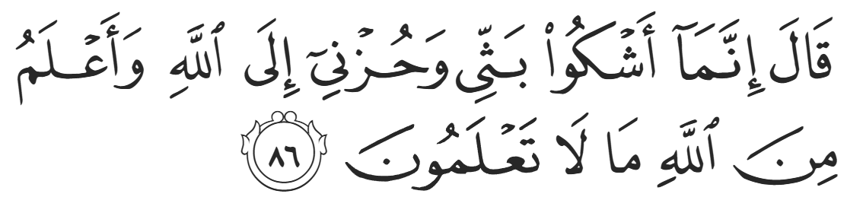
“I complain of my anguish and sorrow only to Allah, and I know from Allah what you do not know.” (12:86)
The latter is to reject the will or wisdom of Allah, questioning His decree; this form of complaint becomes kufr—disbelief. Iblees himself is guilty of this, complaining:
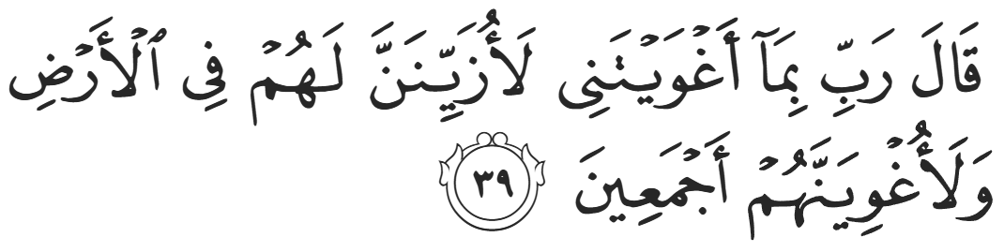
“Satan responded, ‘My Lord, for allowing me to stray I will surely tempt them on Earth and mislead them all together,” (Hijr:39)
The Prophet ﷺ surrendered himself to Allah, expressing that he had no-one to turn to except Him (SWT). He had no foreseeable option to seek help from except his enemies, but then he ﷺ stressed that as long as Allah is happy with him, he has no concerns. However, the Prophet ﷺ then went on to mention that if Allah were to make it easier for him, he ﷺ would prefer that. This clearly shows us that asking Allah (SWT) for ease is permissible, and that one should not seek hardship. The Prophet showed that his priority is whether Allah was pleased with him, and his concern was not that he was bloodied and bruised, but whether or not Allah was angry with him ﷺ.
When the Prophet ﷺ sat down for shade, he did not realize that the land belonged to his Qurayshi uncles, ‘Utbah and Shaybah ibn Rabi’ah. They had witnessed his brutal expulsion from Taa’if and felt pity on their kin as well as a sense of tribal pride. They decided to gift him some fruits from their orchards. They sent their servant, ‘Addas, who was an Iraqi Christian, with some grapes. The Prophet ﷺ accepted the gift and said “Bismillah – in the Name of Allah” before eating. ‘Addas was intrigued, “What is this phrase?” The Prophet ﷺ replied, “This is something my Lord has taught me. Where are you from, O ‘Addas?” ‘Addas replied, “I am from Nineveh.” The Prophet ﷺ smiled and said, “From the city of Yunus ibn Matta!”. ‘Addas was stunned, “And how do you know Yunus ibn Matta?!” ‘Addas was a lone Christian in these lands surrounded by Pagans with no knowledge of Judeo-Christian Prophetic lineage. The Prophet ﷺ replied, “How can I not know Yunus? He is my brother; we are both Prophets of Allah.” As soon as the Prophet ﷺ uttered this statement, ‘Addas immediately began kissing the feet of the Prophet ﷺ in adoration. His two masters, ‘Utbah and Shaybah, looked from afar in bewilderment. When he returned, they shouted, “Woe to you! Why are you kissing his hands and feet?” ‘Addas replied, “O my masters, there is no-one on Earth better than him, for he told me things only a Prophet could know.” His masters responded dismissively, “O ‘Addas, he has bewitched you from your religion! Your religion is better than his.” Later on, when the Battle of Badr commenced, ‘Addas was asked to fight against the Muslims, to which he responded, “You want me to fight that man who was sitting under the tree? By Allah, the mountains could not harm him.” In a truly bold move, he refused his masters’ command, who both met their death in the Battle of Badr.
The Prophet ﷺ described the following events, “Allah (SWT) sent a cloud to protect me and offer me shade. Jibril (AS) was in that cloud, saying, “O Muhammad, your Lord has heard what your people have said to you and their rejection of you. He has sent me with the Angel of the Mountains to be at your disposal and do as you please.’ I then heard another voice, ‘I am the Angel of the Mountains. Peace be upon you. O Muhammad, say as you wish—I am at your disposal. If you want, I can crush this city between these two mountains.’ I replied, ‘No. Rather, I hope Allah (SWT) will extract from their progeny those who will worship Him without associating partners with Him.’”
The symbolism of these events is clear: O Prophet, even if your kith and kin reject you, those furthest away will accept your Message. Just as the du’aa of Musa (AS) was immediately answered as he sat under a tree, exasperated and depleted, the Prophet’s du’aa was similarly accepted. Allah (SWT) provided physical respite through shade and luscious fruits, and spiritual respite through Jibril (AS) and the Angel of the Mountains at his command. While the Prophet’s wounds were still fresh and his shoes were still soaked with blood, he ﷺ had the option of revenge, yet he opted for the higher path, a Prophetic path befitting of true nobility. The true miracle is that the Prophet ﷺ still had the proclivity for mercy after being treated with such cruelty. The Prophet ﷺ once again embodied his famous title of “Mercy for the Whole World”:

“We have not sent you except as a mercy for the whole world.” (21:107)
Less than ten years later, Taa’if was conquered, and most of its inhabitants accepted Islam, including many who were alive at the time the Angel of Mountains offered to destroy it. The very spot that the Prophet ﷺ was brutally stoned on has now been turned into a mosque wherein Allah (SWT) is worshipped throughout the day.

<Duaa!>
- Oh Allah, please grant us a deep love for your Prophet Muhammad, SAW.
- Oh Allah, please make us energetic in doing good for your cause.
- Oh Allah, please enable us with the will and means to walk Al-Sirrat-Al-Mustaqeem, even if it estranges us from others.
- Oh Allah, please support the suffering and oppressed Muslims around the world and grant them victory over that which oppresses them.
- Oh Allah, please protect us from ever being overburdened by debt and protect us from all evils and undesirable consequences associated with having debt.
- Oh Allah, please fill our hands with the work and deeds of righteousness and let them be of benefit to ourselves and the Ummah.
- Oh Allah please forgive us our shortcomings and deviances in following your Qur'an and the Sunnah of Rasul'Allah, SallAllahuAlayhiWaSallam.
- Oh Allah please grant us understanding and guidance of your Qur'aan
- Oh Allah, please grant us patience with the trials of this world.
- Oh Allah, please prevent our hearts from getting overly attached to the Dunya and grant us the best in this life and the best in the hereafter.
- Oh Allah, please forgive us our past sins and make us your devoted servants.
- Oh Allah please make us amongst those whose Duaa is accepted.
- Oh Allah, please grant us Jannat'ul Firdaus and protect us from ever coming close to the Fires of Jahannum.

