Khut'bah Opening
إِنَّ الْحَمْدَ للهِ , نَحْمَدَهُ وَ نَسْتَعينُهُ وَ نَسْتَغْفِرُهُ , وَ نَعوذُ بِالله مِنْ شُرورِ أَنْفُسِنا , مَن يَهْدِهِ اللهُ فَلا مُضِلَّ لَه , وَ مَنْ يُضِلِلْ فَلا هادِيَ لَهْ , وَ أَشْهَدُ أَنْ لا إلهَ إِللهُ وَحْدَهُ لا شَريكَ لَه , و أَشْهَدُ أنَّ مُحَمَّدًا عَبْدُهُ و رَسولُه.
"All thanks and praises are due to Allah, whom we thank, seek for help and invoke for forgiveness. We seek refuge with Allah from the evils within ourselves. He whom Allah guides will never be misled and he whom He misguides will never find one to guide him. I bear witness that there is no deity worthy of worship except Allah and that Muhammad (SAW) is His slave and Messenger.
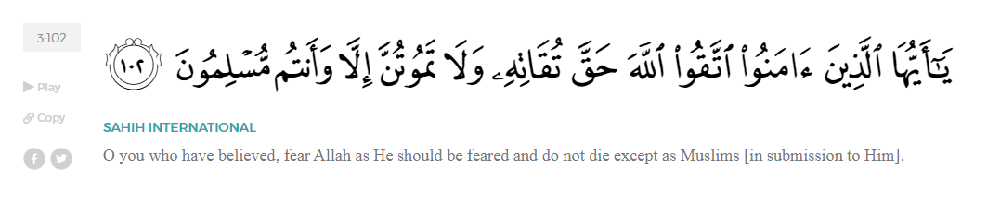
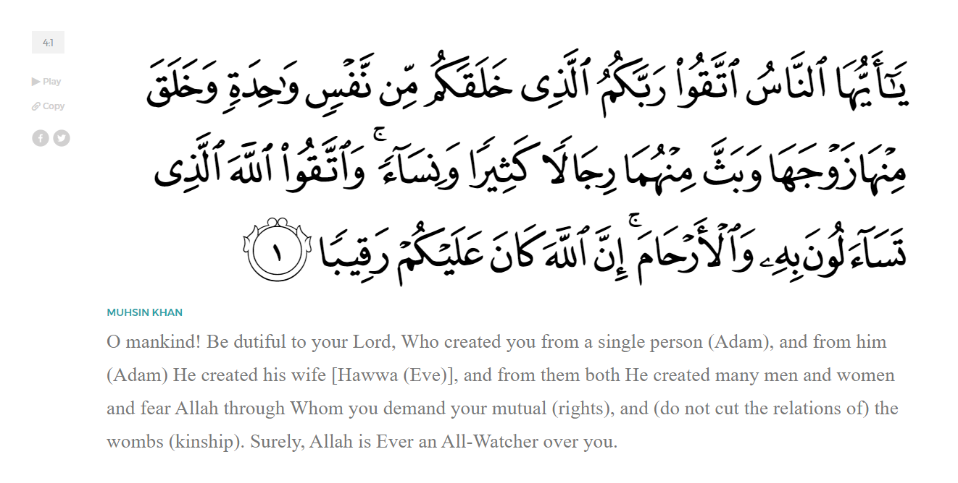
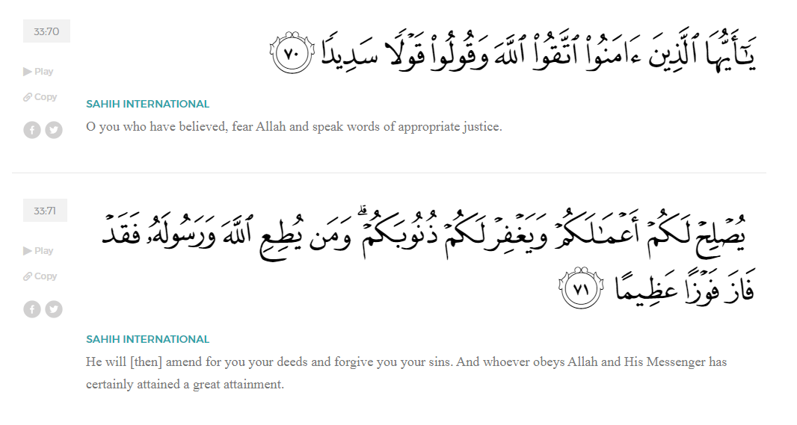
<Sirah of the Prophet (SAW) – Part X -Dr. Yassir Qadhi, Book and Series>
Dear brothers and sisters,
InshaaAllah we will continue our khutbah series on the seerah of the Prophet ﷺ, drawing from Dr. Yasir Qadhi’s book, The Sirah of the Prophet, so that we can deepen our understanding of his life and strengthen our love for him. Each step we take through the Prophet ﷺ’s life brings us closer to knowing him more deeply, appreciating his struggles, and embodying his character. Our goal in this series, inshaaAllah, is not just to learn history, but to let the seerah transform our hearts and strengthen our love for the Messenger of Allah ﷺ.
Today we will, inshaaAllah, start and complete the chapter titled: “The Night Journey & Ascension – al-Isra’ wa al-Mi’raaj”.
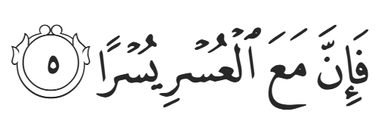
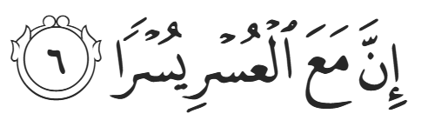
After the Year of Sorrow, Allah (SWT) gifted the Prophet ﷺ the blessing of al-Isra’ wa al-Mi’raj. Allah (SWT) promises:

“So, surely, with hardship, comes ease. Surely, with hardship, comes ease.” (94:4-5)
After one of the most difficult periods of his life, the Prophet ﷺ experiences one of the greatest blessings of Allah. This whole journey was a gift and blessing. Al-Israa’ means “The Night Journey”, referring to the Prophet’s journey from Mecca to Jerusalem, and al-Mi’raaj means “The Ascension”, referring to the Prophet ﷺ ascending to the heavens.
It is worth clarifying the difference between Paradise (Jannah) and the Heavens (Samaawaat). Allah states in Surat Al-Mulk,
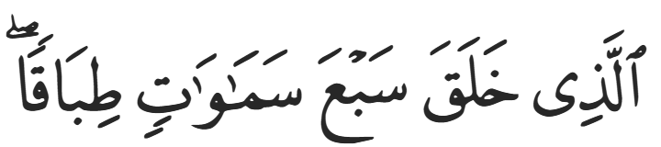
“[He is the One] Who created seven Heavens, one above the other.” (67:3)
Everything in our universe, including all the galaxies and solar systems, are contained within the first Heaven. Allah (SWT) states in Surrat Fussilat,
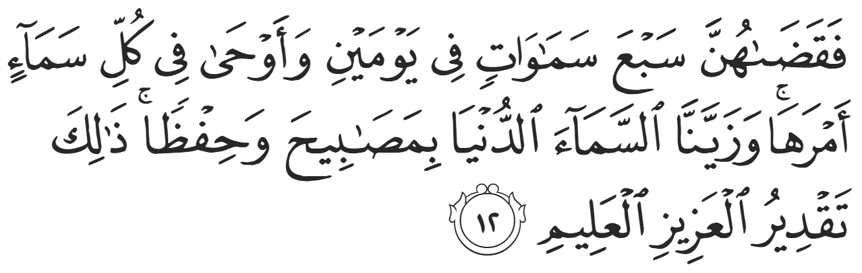
“So He formed the heaven into seven heavens in two Days, assigning to each its mandate. And We adorned the lowest heaven with ˹stars like˺ lamps ˹for beauty˺ and for protection. That is the design of the Almighty, All-Knowing.” (41:12)
Each Heaven above the first Heaven is greater in size and grandeur to an incomprehensible scale. Paradise (Jannah) occupies the seventh Heaven, and it has many of its own levels, increasing in size, beauty, prestige, and exclusivity until Firdaws, the highest level of Paradise, which is reserved for the best of creation.
Al-Israa wa al-Mi’raaj has been thoroughly documented, with over 20 Companions narrating this event. The reports of al-Israa’ wa al-Mi’raaj alone outweigh the reports of the rest of the Meccan era combined. However, the researcher is tasked with differentiating fact from fiction, as grandiose stories attract storytellers, and al-Israa’ wa al-Mi’raaj is the most magnificent story of all. As with any event, reports on the topic are assessed to distinguish the most authentic narrations. The researcher must also compare interpretations; some believe that al-Israa’ wa al-Mi’raaj was a dream, or that the Prophet ﷺ travelled in spirit, but that is not the case. As a bona fide miracle from Allah, the Prophet ﷺ physically journeyed—in a state of wakefulness—from Mecca to Jerusalem, and then to the Heavens and back, within a single night.
There is a difference of opinion as to when al-Israa’ wa al-Mi’raaj took place. However, there are some hints in hadith that give us clues. Aa’ishah (RHAA) narrated, “Khadijah died before the prayer became obligatory.” This is definitive proof that al-Israa’ wa al-Mi’raaj took place within the last 18 months of the Meccan era because the prayer was made obligatory in al-Mi’raaj. The day, or even month, of the event is unknown, and any specified date is not authentically narrated. It is yet another indication that the Companions did not place great emphasis on the dates and anniversaries of major events; they focused on the substance of the events, rather than commemorating its existence.
For the Night Journey portion: al-Israa’,
Allah (SWT) revealed an entire surah titled Surah al-Israa’, opening with the following verse:
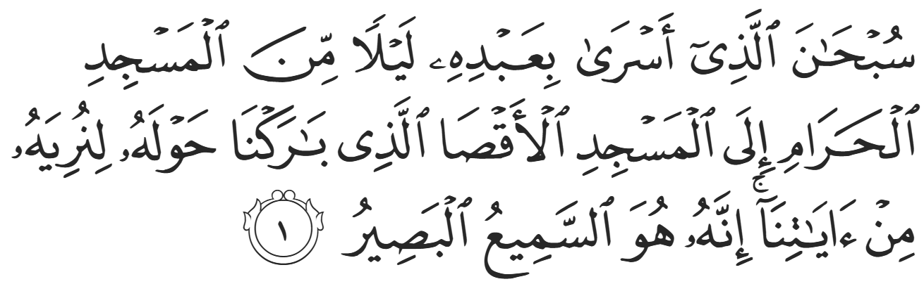
“Glory be to the One Who took His slave by night from the Sacred Masjid to al-Aqsa Masjid whose surroundings We have blessed, so that We may show him some of Our signs. Indeed, He alone is the All-Hearing, All-Seeing.” (17:1)
Allah (SWT) praises the Prophet ﷺ by referring to him as a slave. The Qur’aan states in Surat Al-Dhaariyaat:
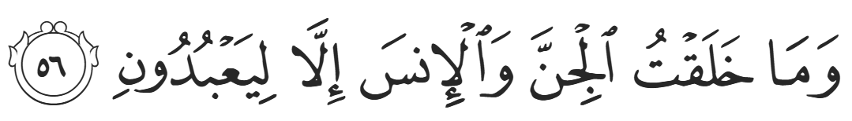
“I did not create jinn and humans except to worship Me.” (51:56)
The word ‘abd means “slave” but also means “worshipper”, as it stems from the same root word as ‘ibaadah (worship). Allah (SWT) is therefore praising the Prophet ﷺ as the perfect worshipper and slave. Allah (SWT) mentions the Prophet’s name in the Qur’aan four times whereas He refers to him by his title, ‘abd, many times. The name ‘Abdullah (slave of Allah) is a prestigious title and descriptor.
The Prophet ﷺ was sleeping at home when Jibril (AS) arrived and took him to the Hateem – the semi-circular area next to the Ka’bah—to pray two rak’aat of prayer. The Prophet ﷺ narrated, “Jibril opened up my chest and brought a bowl made of gold filled with Zamzam. He took out my heart, washed it, and put it back.” This is the second time that Jibril (AS) washed the Prophet’s heart, however on this occasion he did not need to remove a black spot. Nevertheless, his heart needed to be washed with Zamzam to prepare it for the overwhelmingly awe-inspiring sights to come. As Allah (SWT) stated in Surat Al-Najm:

“He certainly saw some of his Lord’s greatest signs.” (53:18)
It was through Allah’s divine intervention and special facilitation that the Prophet ﷺ was able to traverse into the Heavens without being subjected to any of the physical laws of this world.
The Prophet ﷺ continued his narration, “Jibril then brought me a beast, smaller than a mule but bigger than a donkey, pure white, called al-Buraaq. Each of its strides is as far as the eye can see.” The word “buraaq” stems from the root word “barq” which means “lightning”, denoting its lightning speed. However, al-Buraaq is a physical animal, created of flesh and blood, not a spiritual creature. There are no authentically narrated reports about a winged horse. Al-Buraaq had a harness and saddle, and Jibril (AS) held the harness as the Prophet ﷺ mounted. Al-Buraaq neighed, and Jibril (AS) tugged the harness, saying, “Woe to you! Are you not shy? By Allah, no-one has ridden you that is more blessed in the eyes of Allah than your current rider!” The Prophet ﷺ continued narrating, “I rode al-Buraaq and he took me to al-Aqsa Masjid. I tied al-Buraaq to the animal posts used by the Prophets, and I entered and prayed two units of prayer.”
The Prophet ﷺ then saw all the Prophets. He saw Musa (AS) and described him as a strong and muscular man of brown color; he saw Isa (AS) and described him as tanned, shorter than Musa (AS), with flowing, glistening hair. He saw Ibraheem (AS) who looks the most like the Prophet ﷺ himself. The Prophet ﷺ then led all the Prophets and Messengers in prayer, which demonstrated his noble standing amongst the whole of mankind, earning the title, “Master of the Prophets”. Jibril (AS) then approached the Prophet ﷺ with two vessels: one with wine and one with milk. Note that alcohol had not yet been prohibited in Islaam. Jibril (AS) said, “Choose, and choose for your Ummah.” The Prophet ﷺ chose the milk, and Jibril (AS) replied, “You have chosen the fitrah – the innate and pure disposition”. The symbolism is clear: milk is pure and unadulterated, whereas wine is fermented and corrupted (from grapes).
<Conclude 1st Khutbah with:
Aqoolu haathaa wa astaghfir-Allaah (I say this and I ask Allah for forgiveness)
أَقُولُ قَوْلِي هَذَا وَأَسْتَغْفِرُ اللَّهَ لِي وَلَكُمْ وَلِسَائِرِ المُسْلِمينَ وَالمُسْلِمَاتْ فَاسْتَغْفِرُوهْ إِنَّهُ هُوَ الْغَفُورُ الرَّحِيمُ
الحمد لله رب العالمين والصلاة والسلام على سيد المرسلين وعلى آله وأصحابه أجمعين
<2nd Khutbah>
Dear brothers and sisters,
Regarding the Ascension (al-Mi’raaj):
Allah (SWT) references the Mi’raaj in Surah al-Najm:
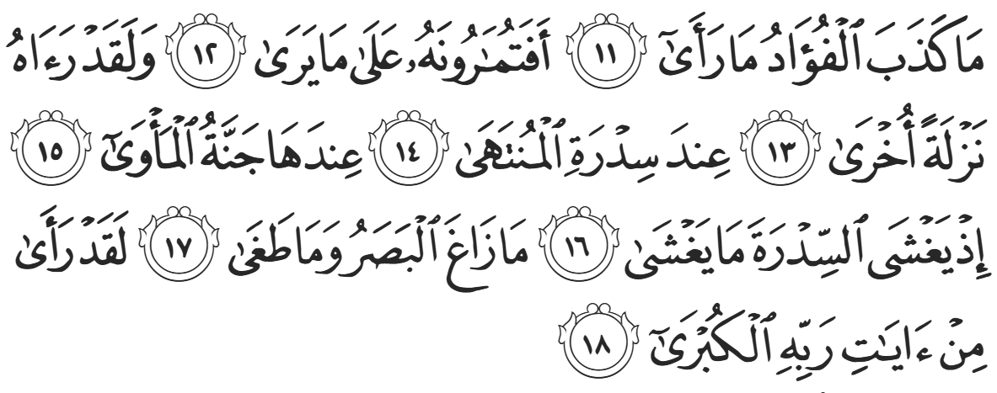
“The Prophet’s heart did not lie about what he saw. So, will you dispute with him over what he saw? Indeed, he saw him (the Angel) descend a second time at the Lote Tree of the Utmost Boundary [in the Seventh Heaven]—near which is the Garden of Abode—while the Lote Tree was overwhelmed with Heavenly splendors. The [Prophet’s] sight never wandered, nor did it overreach. He certainly saw some of his Lord’s greatest signs.” (Najm:11-18)
From al-Aqsa Masjid, Jibril asked permission for the doors of the Heavens to open, and the gatekeeper behind the door asked, “Who is it?” and Jibril replied, “It is Jibril.” The gatekeeper asked, “Do you have anybody with you?” and Jibril replied, “I have Muhammad.” The gatekeeper asked, “Has he been sent for?” and Jibril replied, “Yes.” The door opens and the Prophet ﷺ saw a huge man. Jibril (AS) said, “This is your father, Adam (AS), so give salaam to him.” The Prophet ﷺ did so, and Adam (AS) replied, “Welcome, O righteous son and righteous Prophet.” The Prophet ﷺ then entered the second Heaven and had the same initiation with another gatekeeper, but this time Prophets Yahya and Isa (ASS) were behind the door, who replied, “Welcome, O righteous brother and righteous Prophet.” The third Heaven had Yusuf (AS) who repeated the same greeting, which prompted the Prophet ﷺ to inform the Companions, “Lo and behold, it was as if he were given half of all beauty!” The fourth and fifth Heavens contained Idris (AS) and Haarun (AS) respectively. The sixth Heaven had Musa (AS), and as the Prophet ﷺ began to ascend further, Musa (AS) began to cry, saying, “This young man, who was sent after me, shall have a larger following that will enter Paradise than my Ummah.” The Prophet ﷺ entered the seventh Heaven and saw Ibraheem (AS) who greeted the Prophet as Adam (AS) did, “Welcome, O righteous son and righteous Prophet.”
It is often thought that the Prophet ﷺ met the Prophets in order of rank, but this is not the case, for Adam (AS) is certainly not the lowest. All the Prophets will be in Firdaws, the highest level of Paradise. The Prophet ﷺ met Adam (AS) first, as he is the father of all mankind. Adam (AS) had to temporarily leave Paradise for Earth—a glad tiding for the Prophet ﷺ who would be forced to leave Mecca but eventually return triumphantly. Yahya and Isa (ASS) were next and were closest to the Prophet ﷺ chronologically. They were also persecuted by their people as the Prophet ﷺ was. Next, Yusuf (AS) was betrayed by his own family, but they eventually repented and accepted him back, inspiring the Prophet ﷺ to quote him when he eventually conquered Mecca, from Surat Yusuf:
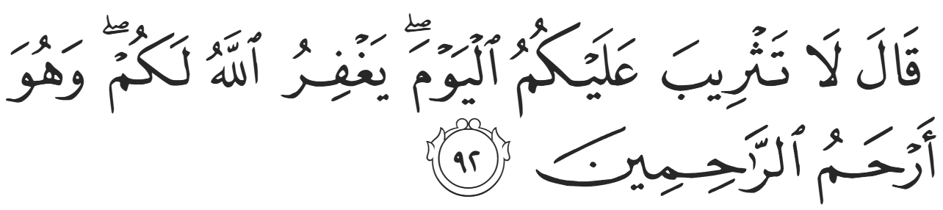
“Yusuf said, “There is no blame on you today. May Allah forgive you! He is the Most Merciful of the merciful!” (12:92)
Idris (AS) was described by Allah as being lifted into a lofty station:

“And We elevated him to an honorable status.” (19:57)
Haarun (AS) was hated by his people but then was eventually accepted, and Musa (AS) faced the most similar trials to the Prophet ﷺ and had the most similar journey. Whenever the Prophet ﷺ was hurt by his people, he would say, “May Allah have mercy upon Musa. He was hurt more than I was yet remained patient.”
A challenge for the researcher when analyzing major events and long stories is piecing the multitude of narrations into an accurate chronological narrative. It is narrated that during al-Mi’raaj, the Prophet ﷺ had a longer conversation with Ibraheem (AS) who said, “O Muhammad, give my salaam to your Ummah. Inform them that the soil of Paradise is luscious, but it is empty. Its trees are planted through uttering ‘Subhanallah (Glory be to Allah); ‘Alhamdulillah (Praise be to Allah); ‘Laa ilaaha ilAllah (There is no god but Allah); and Allahu Akbar (Allah is the Greatest).” It was also narrated that the Prophet ﷺ met the gatekeeper of Hell, Maalik, who was referenced in the Qur’aan in Surat al-Zukhruf:
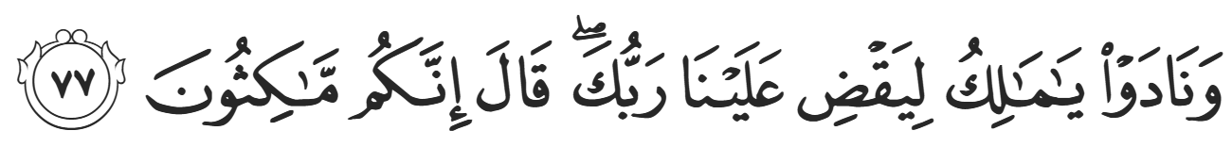
‘They will cry, “O Mâlik! Let your Lord finish us off.” He will answer, “You are definitely here to stay.”’ (43:77)
The Prophet ﷺ described Maalik as completely somber, not smiling at all. This was a stark difference to all the other Angels who greeted the Prophet ﷺ with joy. The Prophet ﷺ asked Jibril (AS) why, and Jibril (AS) responded, “He has never smiled or laughed since he was created.” After seeing the Hellfire, he never smiled. However, Jibril (AS) added, “were he to have smiled for anyone, it would be to you.” The Prophet ﷺ met the Angels at their appointed stations, but Maalik, whose station is in Hell, was brought to the Prophet ﷺ to convey his salaam, emphasizing the Prophet’s distance from the fire of Hell.
The Prophet ﷺ then proceeded above the seventh Heaven, at which point he saw Sidrah al-Muntahaa (The Lote Tree of the Utmost Boundary). It is an overarching tree whose branches extend forth over a vast area, bearing delicious fruits with sweet scents. Jibril (AS) then took him ﷺ even higher, and the Prophet ﷺ said that there were “colors that covered the tree which I cannot describe.” Other versions of the Hadith mention that the Prophet ﷺ witnessed “beautiful butterflies made of gold”. ‘Abdullah ibn Mas’uud (RA) narrated that the Prophet ﷺ said, “The Sidrah al-Muntahaa is in the sixth Heaven, and anything that rises up from the Earth stops there and is absorbed by it. And everything that descends from above is absorbed by it and is distributed below.” In other words, the Sidrah al-Muntahaa is the barrier between this world and the next; anything that rises to the Heavens, such as our good deeds, is absorbed by it, and anything that descends, such as Allah’s Mercy, is taken in. Another narration states that it is in the seventh Heaven, but this can be reconciled by understanding that it begins in the sixth Heaven and transcends into the seventh Heaven.
The Prophet ﷺ described four rivers flowing at the base of Sidrah al-Muntahaa: two hidden and two visible. The Prophet ﷺ asked Jibril (AS) what they were, and Jibril (AS) answered, “The hidden ones are two rivers in Paradise—al-Kawthar and Salsabeel—and the visible ones are the River Nile and the Euphrates River. Throughout human history, the tree has been known as a symbol of spirituality, peace, and nourishment. Our innate disposition towards the tree could very well be linked to the blessings of Sidrah al-Muntahaa. The Prophet ﷺ then saw al-Bayt al-Ma’muur (The Frequented House). Al-Bayt al-Ma’muur is a structure equivalent to the Ka’bah on Earth, situated directly above the Ka’bah but in the seventh Heaven. Every single day, 70,000 Angels visit the Frequented House to pray for the first and last time.
At this point, the Prophet ﷺ saw Jibril (AS) in his original form, as if he were unshackled from the limitations of this world. The Prophet ﷺ described his majestic form, “He had 600 wings, blocking the horizon. Pearls and corals were emanating from his feathers.” Allah states in the Qur’aan in Surat Faatir:
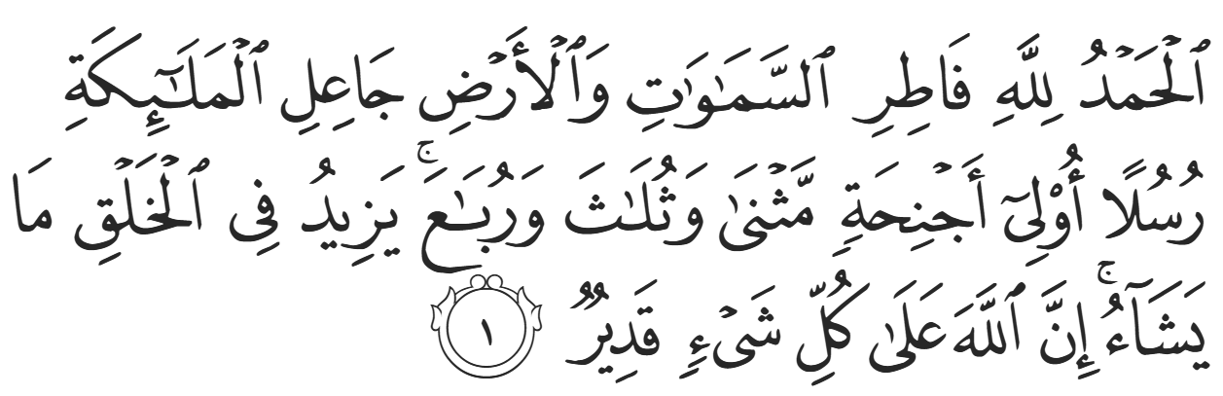
“All praise is for Allah, the Originator of the heavens and the earth, Who made angels ˹as His˺ messengers with wings—two, three, or four. He increases in creation whatever He wills. Surely Allah is Most Capable of everything.”(35:1) However, as the greatest Angel of all, Jibril had 600 wings in his true form. ‘Abdullah ibn Mas’ud (RA) said that the verse, “He certainly saw some of his Lord’s greatest signs” refers to seeing Jibril (AS) in this form.
We will stop our journey here, for now, right before the divine meeting, and complete the al-Israa wa al-Mi’raaj chapter next week inshaaAllah.
<Duaa!>
- Oh Allah, please grant us a deep love for your Prophet Muhammad, SAW.
- Oh Allah, please make us energetic in doing good for your cause.
- Oh Allah, please enable us with the will and means to walk Al-Sirrat-Al-Mustaqeem, even if it estranges us from others.
- Oh Allah, please support the suffering and oppressed Muslims around the world and grant them victory over that which oppresses them.
- Oh Allah, please protect us from ever being overburdened by debt and protect us from all evils and undesirable consequences associated with having debt.
- Oh Allah, please fill our hands with the work and deeds of righteousness and let them be of benefit to ourselves and the Ummah.
- Oh Allah please forgive us our shortcomings and deviances in following your Qur'an and the Sunnah of Rasul'Allah, SallAllahuAlayhiWaSallam.
- Oh Allah please grant us understanding and guidance of your Qur'aan
- Oh Allah, please grant us patience with the trials of this world.
- Oh Allah, please prevent our hearts from getting overly attached to the Dunya and grant us the best in this life and the best in the hereafter.
- Oh Allah, please forgive us our past sins and make us your devoted servants.
- Oh Allah please make us amongst those whose Duaa is accepted.
- Oh Allah, please grant us Jannat'ul Firdaus and protect us from ever coming close to the Fires of Jahannum.

