Khut'bah Opening
إِنَّ الْحَمْدَ للهِ , نَحْمَدَهُ وَ نَسْتَعينُهُ وَ نَسْتَغْفِرُهُ , وَ نَعوذُ بِالله مِنْ شُرورِ أَنْفُسِنا , مَن يَهْدِهِ اللهُ فَلا مُضِلَّ لَه , وَ مَنْ يُضِلِلْ فَلا هادِيَ لَهْ , وَ أَشْهَدُ أَنْ لا إلهَ إِللهُ وَحْدَهُ لا شَريكَ لَه , و أَشْهَدُ أنَّ مُحَمَّدًا عَبْدُهُ و رَسولُه.
"All thanks and praises are due to Allah, whom we thank, seek for help and invoke for forgiveness. We seek refuge with Allah from the evils within ourselves. He whom Allah guides will never be misled and he whom He misguides will never find one to guide him. I bear witness that there is no deity worthy of worship except Allah and that Muhammad (SAW) is His slave and Messenger.
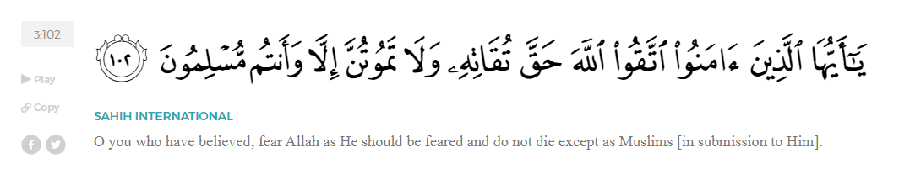
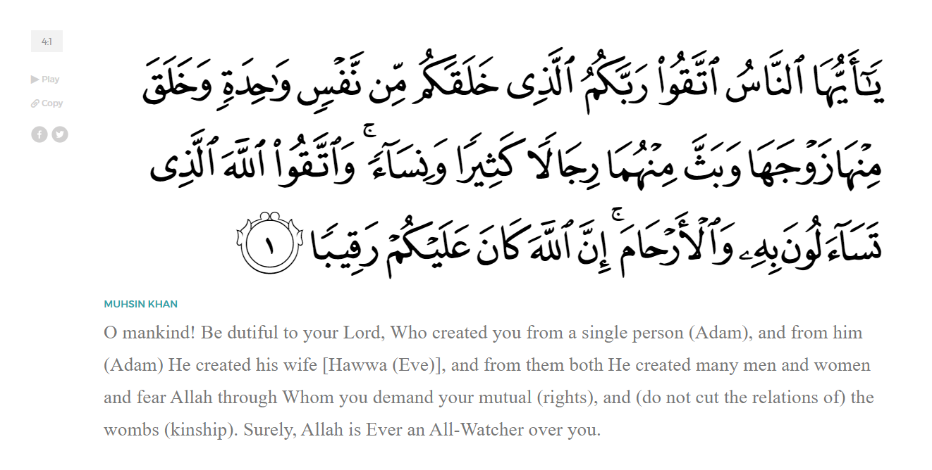
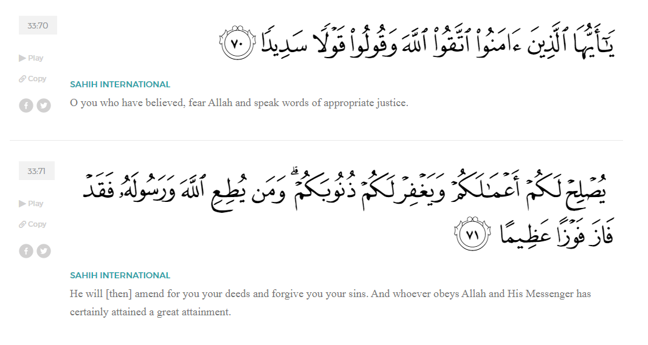
<Sirah of the Prophet (SAW) – Part 2 -Dr. Yassir Qadhi, Book and Series>
Dear brothers and sisters,
InshaaAllah we will continue our khutbah series on the seerah of the Prophet ﷺ, drawing from Dr. Yasir Qadhi’s book, The Sirah of the Prophet, so that we can deepen our understanding of his life and strengthen our love for him. Each step we take through the Prophet ﷺ’s life brings us closer to knowing him more deeply, appreciating his struggles, and embodying his character. Our goal in this series, inshaaAllah, is not just to learn history, but to let the seerah transform our hearts and strengthen our love for the Messenger of Allah ﷺ.
Today we will, inshaaAllah, complete the chapter on the introduction to the Prophet ﷺ, starting with describing the physical appearance of the Prophet ﷺ.
It is from the Sunnah—the custom—of Allah (SWT) to send down Prophets and Messengers with the most perfect characteristics, both inner and outer. The Prophets (AS) not only had beautiful characteristics and mannerisms, but they were all handsome in nature. Yusuf (AS) alone was said to have had “half of all beauty”. The predominant view amongst scholarship is that this refers to half of the beauty of mankind in its entirety. There is, however, another scholarly opinion that states this refers to half of the beauty of our Prophet Muhammad ﷺ.
Al-Rubayyi bint Mu’awwidh (RHA) was asked about the appearance of the Prophet ﷺ, and all she could say was, “My son, if You could have seen him, you would have thought that the Sun has risen up.”. In a perfect juxtaposition, Ka’b ibn Malik (RA) described the Prophet ﷺ as the Moon, saying “Whenever the Prophet was happy, his face would light up as if it were the full Moon”. Likewise, Jaabir ibn Sumarah (RA) said, “I saw the Prophet ﷺ walking one night and beside him was a full moon. By Allah, he was more beautiful in my eyes than the full Moon.”
Amr ibn Al-Aas (RA) – once a staunch opposer of Islam—said, “There was nothing more beloved to me than to stare at the face of the Prophet ﷺ, and I would never suffice myself from looking at him. However, were you to ask me how to describe him, I could not, as I would lower my gaze out of awe.
Anas ibn Malik (RA) was introduced to the Prophet ﷺ at the age of ten after his mother gifted him to the Prophet ﷺ as a helper. Through this blessing of a relationship, we are relayed the most explicit description of our noble Prophet ﷺ, he said, “The Prophet ﷺ was neither very tall such that he stood above a crowd, nor was he short such that he would be overlooked. He ﷺ was not extremely yellow nor dark brown. His hair was not in curls, nor was it completely straight. I have not felt any velvet or silk softer than his hair, nor have I smelled musk of perfume more fragrant than the Prophet ﷺ.”
Ali ibn Abi Taalib (RA) said, “The Prophet ﷺ did not have a very Fleshy face, nor was it completely round. He had a white face with a red tinge. His eyes were large with jet-black pupils, and his lashes were long. His joints were large, as was his upper back. He was not hairy all over his body, but he did have a fine line of hair extending from his chest to his navel. When he walked, he did so briskly, as if he were descending a slope. When he turned to face you, he would turn with his whole body. Between his two shoulders was the Seal of Prophethood. Whoever unexpectedly saw him, would stand in awe of him. Whoever accompanied him and befriended him, loved him. I have never seen anyone before him or after him, like him.
Regarding the character of the Prophet ﷺ…
Umar ibn al-Khattab (RA) once walked in on the Prophet ﷺ in his room adjoined to the Prophet’s Mosque (Masjid An-Nabawi). There was nothing inside except a jug of water and a bed made from date palm branches. The Prophet ﷺ had been lying down when Umar (RA) walked in and so he got up to greet him, revealing the marks on his ﷺ’s back from the harsh material. Umar wept at the sight of these marks and exclaimed, “O Messenger of Allah, look at the Roman and Persian leaders and how they live; don’t you deserve better as the Messenger of Allah?” The Prophet ﷺ rebuked ‘Umar, “Aren’t you happy that they have the dunya-this life- and we have the akhira – the Hereafter?” When his wife Aisha (RHA) once softened his bed, the Prophet ﷺ slept longer than usual and missed tahajjud—the night prayer—as a result. When he woke up, he asked what happened and requested that it be changed back.
Aisha (RHA) would recall that the Prophet ﷺ would, at times, not taste meat for up to six weeks. Upon hearing this, a young Successor (one of the Tabieen), enquired curiously, “How did you live?”. Aisha replied, “We sufficed on the two black things (IE dates and murky water). Many years later, Abdurrahman ibn Awf (RA) was offered a platter of meat and bread, to which he cried and said, “Until his death, the Prophet ﷺ never ate wheat bread to his fill. And I worry that Allah (SWT) allowed us to remain on this Earth to witness these blessings, whereas the Prophet ﷺ has returned to something greater.
One day, ‘Umar (RA) was walking and saw the Prophet ﷺ sitting outside in the middle of the day. ‘Umar asked, “O messenger of Allah, what are you doing outside at this time of day?” The Prophet ﷺ replied, “I am here for the same reason as you: I have nothing to eat at home.” Abu Bakr (RA) then walked by, asked the same question, and received the same answer. Another companion, Abu al-Haytham (RA), was rushing home from work and saw the blessed trio and asked them the same question. ‘Umar replied that they did not have any food at home, so they went for a walk instead. Abu Al-Haytham protested at the noblest three people standing in the heat out of hunger, so he invited them to eat. He returned home and saw that he had an old goat, so he said to his wife, “By Allah, we must sacrifice this goat.” Abu al-Haytham (RA) then served the three of them meat and bread, and the Prophet ﷺ reminded Abu Bakr and Umar (RA) that they left their houses hungry only to be fed by Allah (SWT). He then quoted the verse of the Qur’an from Surat At-Takaathur:

“Then, on that Day, you will definitely be questioned about [your worldly] pleasures.
<Conclude 1st Khutbah with:
Aqoolu haathaa wa astaghfir-Allaah (I say this and I ask Allah for forgiveness)
أَقُولُ قَوْلِي هَذَا وَأَسْتَغْفِرُ اللَّهَ لِي وَلَكُمْ وَلِسَائِرِ المُسْلِمينَ وَالمُسْلِمَاتْ فَاسْتَغْفِرُوهْ إِنَّهُ هُوَ الْغَفُورُ الرَّحِيمُ
الحمد لله رب العالمين والصلاة والسلام على سيد المرسلين وعلى آله وأصحابه أجمعين
<2nd Khutbah>
The humility of the character of the Prophet ﷺ was also narrated by those closest to him. As the timeless maxim states: A person is known by how they treat their family. Anas ibn Malik (RA) said, “I served the Prophet ﷺ for ten years, and not once did he ﷺ say as much as ‘uff’ to me.”
Anas (RA) narrates that on one occasion, the Prophet ﷺ sent him to run an errand. Anas, being a young boy at the time, got distracted on the way and began playing with children on the street. After a while, the Prophet ﷺ noticed the delay and searched for Anas, finding him in play. Anas (RA) recalled, “I felt someone behind me picking me up by my ears. I turned around and saw the Prophet ﷺ smiling at me.”
The Prophet ﷺ’s humility and dignity extended to his enemies. Once, a Jewish leader visited the Prophet ﷺ and said, “Al-sammu ‘alaykum”. It was a play on words with the Islamic greeting of “Al-salaamu Alaykum” except the former means “may death be upon you” as opposed to “may peace be upon you”. The Prophet ﷺ maintained his composure and simply said, “wa ‘alaykum” (and to you too). Aisha (RHA) was so furious that she shouted, “May Allah curse you, and may He cause you to perish! How dare you say that to the Prophet?!” The Prophet ﷺ reprimanded her and said, “Calm down, O Aisha. Don’t you know that whatever is gentle is beautiful, and whenever gentleness is in something, it makes it beautiful, and whenever harshness is in something, it makes it ugly?”
The Prophet ﷺ was a man of the people. A female Companion said, “It was possible for any little girl to grab the hand of the Prophet ﷺ and ask him to do any chore for her.”
He ﷺ would also joke with his Ummah, but only with innocent jokes free from lies. When an elderly lady asked the Prophet ﷺ about Paradise, he ﷺ replied, “Haven’t you been informed that old ladies cannot enter Paradise?” Suddenly she began to cry and wail, the Prophet ﷺ interrupted her and clarified, “Don’t cry. By Allah, old ladies cannot enter Paradise because Allah will first make them into young maidens and then enter them into Paradise.” He ﷺ was sincere, approachable, and compassionate; yet strong, courageous, and always dependable.
We will conclude this Introduction chapter with just a few remarks about the Sirah.
The word sirah stems from the verb sara-yasiru, which means “to traverse”. It is commonly translated as “biography” because the reader travels the path of that person, following in their footsteps. The word sirah, linguistically speaking, may be used for the biography of any person, but since the passing of the Prophet Muhammad ﷺ, the word – when used in Islamic literature—is understood to be exclusively for him ﷺ.
Allah (SWT) commands us throughout the Qur’an to take the Prophet ﷺ as our example and model. Allah tells us in Surat Al-Ahzaab:
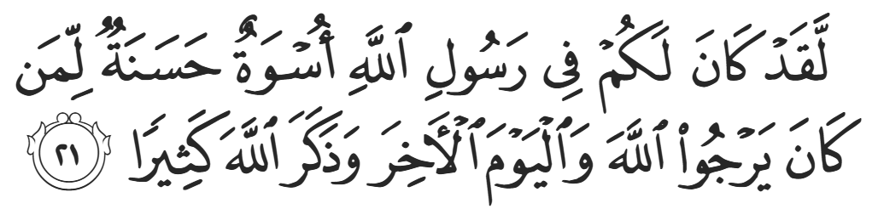
“Indeed, in the Messenger of Allah you have a perfect example for whoever has hope in Allah and the last Day, and remembers Allah often.” (33:21).
The study of the life and times of the Prophet ﷺ is therefore not only an obligation, but a source of benefit and guidance in every facet of our lives. This is not limited to ritualistic aspects of religion but extends to our work, marriage, family life, and social life. Allah tells us in Surat Al-Mu’minoon:
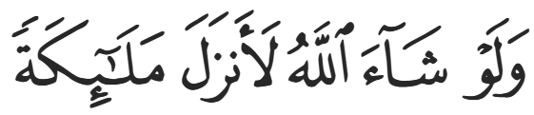
“Had Allah willed, He could have easily sent down Angels instead.” (23:24)
Instead, in Allah’s infinite wisdom, He sent human beings—our own flesh and blood—as carriers of His Message for us to relate to and aspire to emulate.
Studying the Sirah is a marker for one’s relationship with the Prophet ﷺ, as well as the primary way to increase one’s love for him. We cannot claim to love someone or something yet know very little about them. A sign of loving someone is to yearn to know more about them. The more we study the life of the Prophet ﷺ, the more we love him.
The Sirah provides the context upon which the Qur’an was revealed. Familiarity with the Sirah is therefore a prerequisite to understanding the Qur’an. It also outlines the methodology and blueprint for any nation’s revival. Allah SWT even mentions in the Qur’an that He relays the stories of the previous Prophets to Prophet Muhammad ﷺ to strengthen his resolve.
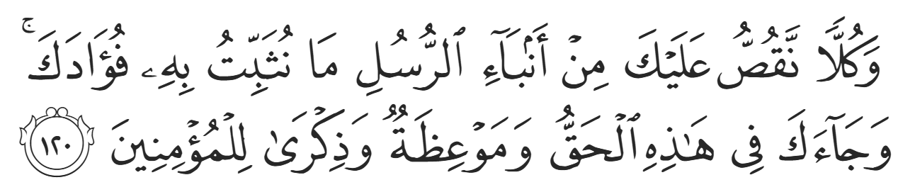
“And We relate to you the stories of the messengers to reassure your heart. And there has come to you, in this, the truth, a warning, and a reminder to the believers.” (11:120)
The Prophet ﷺ’s iman would only increase upon hearing about the previous Messengers and Prophets (AS). It is only befitting for us to increase our iman by learning about the life of the Prophet ﷺ -- and we are surely in greater need.
The entire Sirah, from start to finish, is a miracle. Imam Ibn Hazm aptly states, “By Allah, if the Prophet ﷺ wasn’t given any miracle other than his life and times, it would have been sufficient to prove that he was a Prophet from God”.
The earliest generations in Islam would teach the Sirah just as they would the other Islamic sciences. Ali ibn al-Husayn – the great grandson of the Prophet ﷺ said, “We would teach our children the Maghazi—the expeditions of the Prophet ﷺ-- just like we would teach them the Qur’an.”
The sirah provides an insight into the lives and conduct of the best generation to ever live: The Sahaabah—The Companions—of the Prophet ﷺ. It is set in the most blessed locations in the world, Mecca and Medina. It can therefore be said to be the best of the best of the best: the best man ﷺ, amongst the best nation, in the best location.

<Duaa!>
- Oh Allah, please grant us a deep love for your Prophet Muhammad, SAW.
- Oh Allah, please make us energetic in doing good for your cause.
- Oh Allah, please enable us in will and means to walk Al-Sirrat-Al-Mustaqeem, even if it estranges us from others.
- Oh Allah, please support the suffering and oppressed Muslims around the world and grant them victory over that which oppresses them.
- Oh Allah, please protect us from ever being overburdened by debt and protect us from all evils and undesirable consequences associated to having debt.
- Oh Allah, please fill our hands with the work and deeds of righteousness and let them be of benefit to ourselves and the Ummah.
- Oh Allah please forgive us our shortcomings and deviances in following your Qur'an and the Sunnah of Rasul'Allah, SallAllahuAlayhiWaSallam.
- Oh Allah please grant us understanding and guidance of your Qur'aan
- Oh Allah, please grant us patience with the trials of this world.
- Oh Allah, please prevent our hearts from getting overly attached to the Dunya and grant us the best in this life and the best in the hereafter.
- Oh Allah, please forgive us our past sins and make us your devoted servants.
- Oh Allah please make us amongst those whose Duaa is accepted.
- Oh Allah, please grant us Jannat'ul Firdaus and protect us from ever coming close to the Fires of Jahannum.

