Khut'bah Opening
إِنَّ الْحَمْدَ للهِ , نَحْمَدَهُ وَ نَسْتَعينُهُ وَ نَسْتَغْفِرُهُ , وَ نَعوذُ بِالله مِنْ شُرورِ أَنْفُسِنا , مَن يَهْدِهِ اللهُ فَلا مُضِلَّ لَه , وَ مَنْ يُضِلِلْ فَلا هادِيَ لَهْ , وَ أَشْهَدُ أَنْ لا إلهَ إِللهُ وَحْدَهُ لا شَريكَ لَه , و أَشْهَدُ أنَّ مُحَمَّدًا عَبْدُهُ و رَسولُه.
"All thanks and praises are due to Allah, whom we thank, seek for help and invoke for forgiveness. We seek refuge with Allah from the evils within ourselves. He whom Allah guides will never be misled and he whom He misguides will never find one to guide him. I bear witness that there is no deity worthy of worship except Allah and that Muhammad (SAW) is His slave and Messenger.
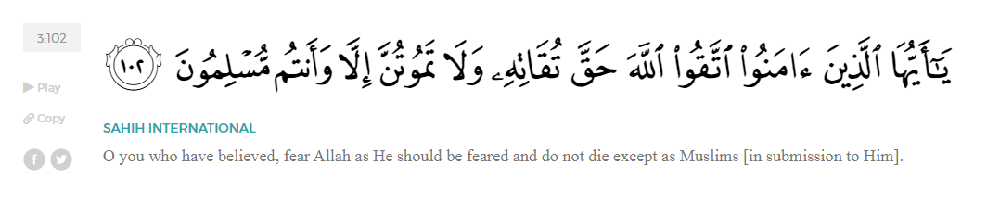
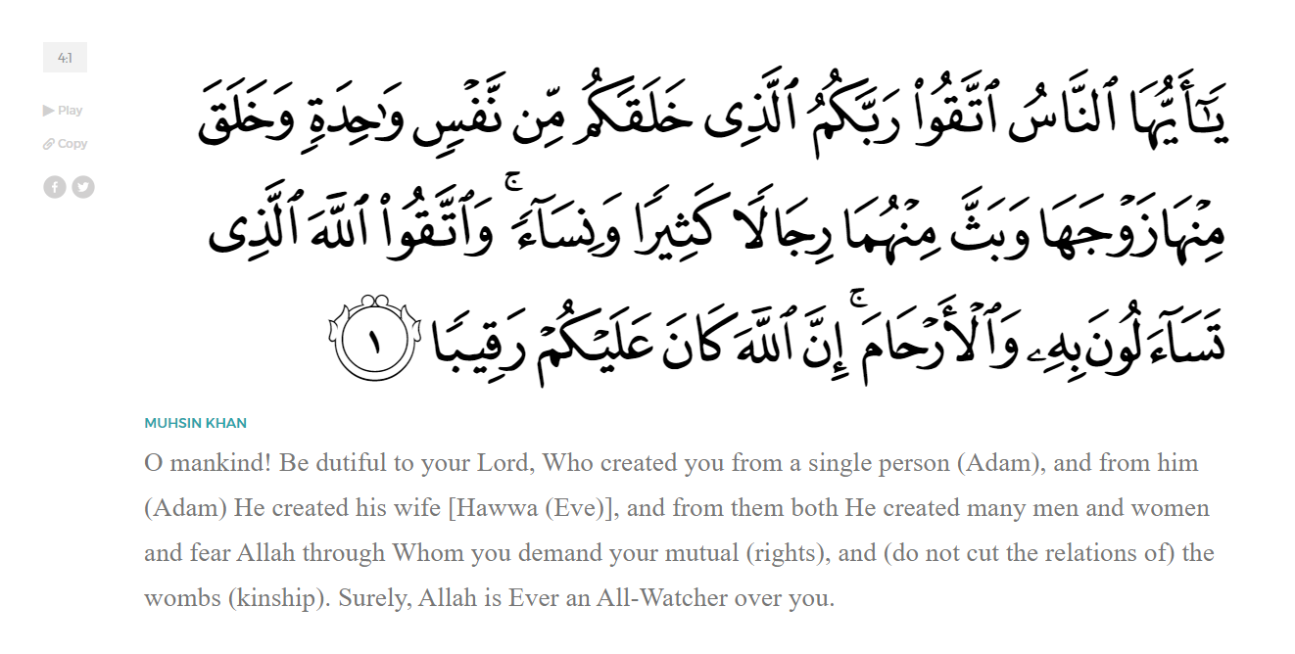
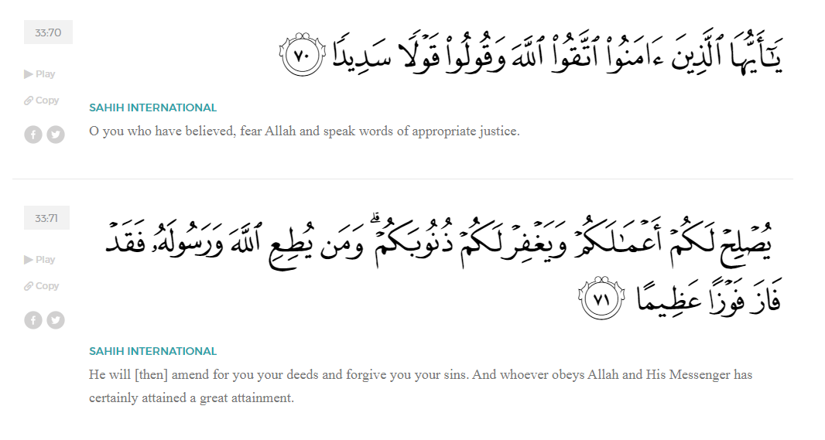
<Sirah of the Prophet (SAW) – Part X -Dr. Yassir Qadhi, Book and Series>
Dear brothers and sisters,
InshaaAllah we will continue our khutbah series on the seerah of the Prophet ﷺ, drawing from Dr. Yasir Qadhi’s book, The Sirah of the Prophet, so that we can deepen our understanding of his life and strengthen our love for him. Each step we take through the Prophet ﷺ’s life brings us closer to knowing him more deeply, appreciating his struggles, and embodying his character. Our goal in this series, inshaaAllah, is not just to learn history, but to let the seerah transform our hearts and strengthen our love for the Messenger of Allah ﷺ.
Today we will, inshaaAllah, complete the chapter of al-Isrāʾ wa al-Miʿrāj that we started last week, the miraculous night which Allah (SWT) honored His Messenger ﷺ with after the Year of Sorrow. In the last khutbah, we reflected on how the journey started with the messenger ﷺ’s purification by Jibrīl (AS) where the Prophet’s heart was removed and washed with zamzam, his miraculous night passage upon al-Burāq from al-Masjid al-Ḥarām to al-Masjid al-Aqṣā, where he ﷺ led of all the Prophets in prayer. We then followed the Prophet ﷺ’s ascension through the heavens, where he ﷺ met Adam, Yahya, Isa, Yusuf, Idris, Haaru, Musa, and Ibraheem (ʿAlayhim-us-salām)… He ﷺ witnessed the angels at their stations, saw Mālik the guardian of Hellfire who never smiled, beheld Sidrat al-Muntahā as the boundary of creation, and saw the two unseen and two seen rivers flowing from it; He ﷺ saw al-Bayt al-Maʿmūr visited daily by seventy thousand angels, and Jibrīl ﷺ in his true form—signs through which Allah showed him the greatest realities of the unseen. We continue our journey from this point…
The Prophet ﷺ was then blessed with a divine meeting with Allah (SWT). He ﷺ said, “Then I was caused to ascend forth to a level whereby I could hear the Pen writing.” It is noteworthy that the Prophet ﷺ used the singular, passive phrase, “I was caused to ascend” which implies that at this stage, he was alone, because until this point, he explicitly mentioned Jibril (AS) taking him. This indicates that the Prophet ﷺ met Allah (SWT) without Jibril (AS), as he did not mention Jibril (AS) again after passing the Sidrah al-Muntahaa. As for the Pen, it was the first thing ever to be created, and the first action ever to be initiated was the writing of all of history. It can therefore be said that the Prophet ﷺ was raised to a level that no living creature ever was.
The Prophet ﷺ did not see Allah (SWT) directly, but he ﷺ saw Allah’s veil, which is the closest any human has ever gotten to seeing Him. Aaisha (RHAA) said, “Whoever says that the Prophet ﷺ has seen his Lord has told a grave lie against Allah.” Masrooq, a student of the Companions, retorted, “O my mother, allow me to ask something, but don’t be angry with me. Didn’t Allah (SWT) say in the Qur’aan:

“And he certainly saw him descend a second time.” (53:13)
And in Surat At-Takwir:

“And he certainly saw him on the clear horizon.” (81:23)
And:

“that he was only two arms-lengths away or even less” (53:9)
Aaisha (RHAA) responded, “Glory be to Allah, my hairs are standing on my head from what you are saying. I was the first person to ever ask the Prophet about these verses. The verses are referring to Jibril. Have you not read in the Qur’aan:
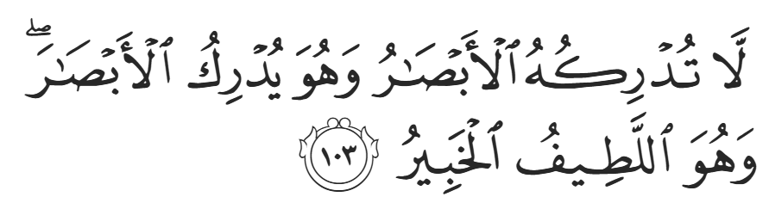
“No vision can encompass Him, but He encompasses all vision. For He is the Most Subtle, All-Aware.” (6:103)
And have you not read in the Qur’aan:
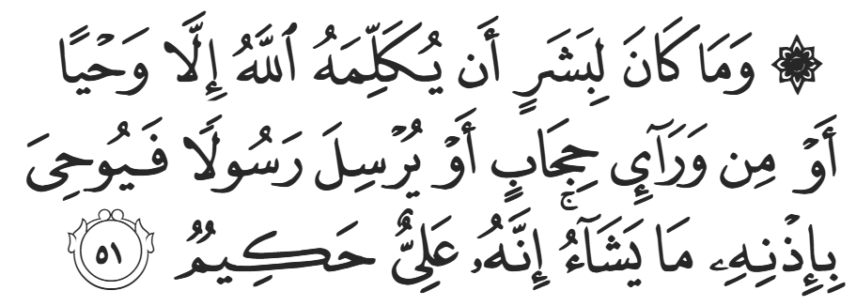
“It is not [possible] for a human being to have Allah communicate with them, except through inspiration, or from behind a veil, or by sending a Messenger-Angel to reveal whatever He wills by His permission.” (42:51)
Abu Dharr asked the Prophet ﷺ directly, “O Messenger of Allah, did you see Allah?” To which the Prophet ﷺ replied, “There was light! How could I see him?” The scholars interpret this light to be the veil of Allah (SWT).
Another Hadith states, “His veil is light. If Allah were to lift this veil, the rays that emanate from His Face would destroy everything.” That is exactly what happened when Musa (AS) spoke to Allah (SWT) on Mount Sinai. As for us seeing Allah (SWT) in the Hereafter, the aakhira is an existence not bound by physical dimensions or limitations in a way that only Allah (SWT) knows.
Despite many legends, there are no authentically narrated reports about the conversation between the Prophet ﷺ and Allah (SWT). The meeting was so precious and noble that it is exclusive; the Prophet ﷺ did not need, or perhaps want, to relay it. We do know, however, that the Prophet ﷺ was granted three things in his meeting: the obligation of prayers, the final two verses of Surah al-Baqarah, and the promise that every Muslim will eventually reside in Jannah.
As for the last two verses of Surah al-Baqarah, they are:
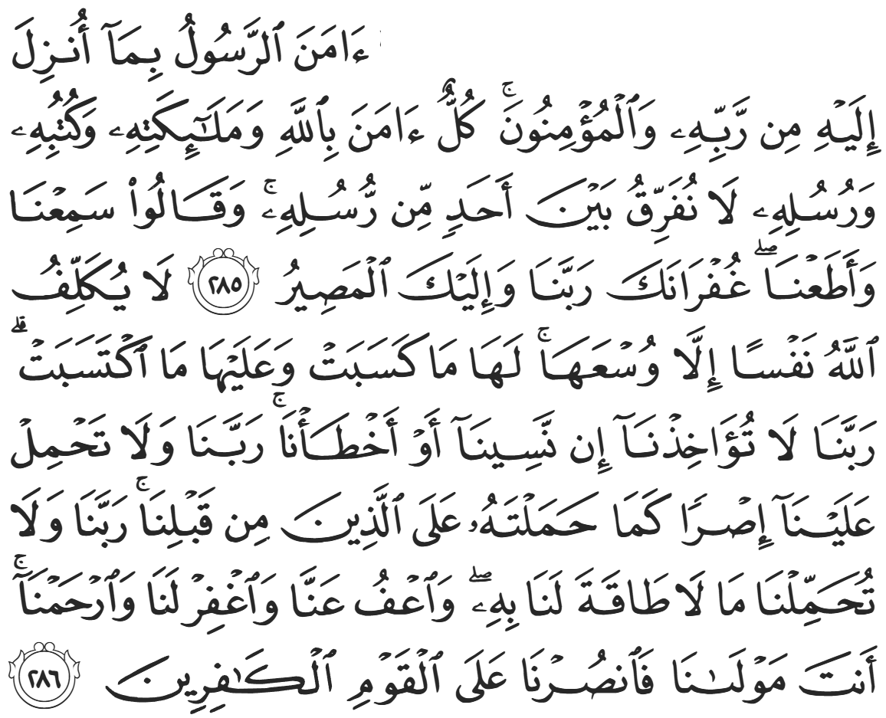
“The Messenger ˹firmly˺ believes in what has been revealed to him from his Lord, and so do the believers. They ˹all˺ believe in Allah, His angels, His Books, and His messengers. ˹They proclaim,˺ “We make no distinction between any of His messengers.” And they say, “We hear and obey. ˹We seek˺ Your forgiveness, our Lord! And to You ˹alone˺ is the final return.” Allah does not require of any soul more than what it can afford. All good will be for its own benefit, and all evil will be to its own loss. ˹The believers pray,˺ “Our Lord! Do not punish us if we forget or make a mistake. Our Lord! Do not place a burden on us like the one you placed on those before us. Our Lord! Do not burden us with what we cannot bear. Pardon us, forgive us, and have mercy on us. You are our ˹only˺ Guardian. So grant us victory over the disbelieving people.”” (2:285-286)
The Prophet ﷺ said, “Whoever recites these two verses every night will be sufficed.” And in another narration, “Whoever recites these two verses every night will be protected.”
<Conclude 1st Khutbah with:
Aqoolu haathaa wa astaghfir-Allaah (I say this and I ask Allah for forgiveness)
أَقُولُ قَوْلِي هَذَا وَأَسْتَغْفِرُ اللَّهَ لِي وَلَكُمْ وَلِسَائِرِ المُسْلِمينَ وَالمُسْلِمَاتْ فَاسْتَغْفِرُوهْ إِنَّهُ هُوَ الْغَفُورُ الرَّحِيمُ
الحمد لله رب العالمين والصلاة والسلام على سيد المرسلين وعلى آله وأصحابه أجمعين
<2nd Khutbah>
Dear brothers and sisters,
As for the prayer, at this point it had already been taught and practiced, but not obligated. At the divine meeting, Allah (SWT) obligated the prayer upon Muslims 50 times a day. The Prophet ﷺ then left and descended through the Heavens. When he reached Musa (AS), Musa (AS) asked, “What did your Lord reveal for your Ummah?” The Prophet explained that he was instructed for his Ummah to pray 50 times a day. Musa (AS) responded, “Return to your Lord and request some relief.” The Prophet ﷺ looked at Jibril (AS), as if to consult his opinion, and Jibril (AS) nodded in approval. The Prophet ﷺ then returned to Allah (SWT) for a reduction and was once again stopped on his way down by Musa (AS) with the same advice. There is a difference of opinion as to how many times the Prophet ﷺ returned to Allah to ask to lighten the burden of prayers, but he did so at least five times until he was instructed for his Ummah to pray five times a day. On the Prophet’s final descent, Musa (AS) once again advised, “Return to your Lord and request some relief.” However, at this point, the Prophet ﷺ replied, “I have gone back and forth, and now I am embarrassed [to ask my Lord for more]. But I am content and happy [with Allah’s command].” Allah (SWT) then called out, “My obligation is decreed, and I have eased the burden on my slaves; it is five [prayers] but it shall be rewarded with 50.”
It is noteworthy that the Prophet ﷺ would have passed Ibraheem (AS) before reaching Musa (AS), yet Ibraheem (AS) did not comment on the 50 prayers. It could be said that Ibraheem (AS) has a higher station and thus accepts Allah’s commands without hesitation, or it could equally be said that Musa (AS) has more experience with large Ummahs and knows the challenges that the Prophet ﷺ will face in this matter. Furthermore, Musa (AS) is the only other Prophet with the experience and honor of speaking to Allah (SWT), so he had the expectation that Revelation would be sent, hence why he asked the Prophet ﷺ about what he received. Indeed, Musa (AS) spoke to Allah (SWT) on Mount Sinai and received the Torah. Nevertheless, the Prophet ﷺ knew exactly when to stop, as Allah (SWT) confirmed that five was the correct number, and the whole exercise was conducted so that the reward of 50 prayers was established for five.
Another reason why Allah (SWT) began with 50 prayers but decreed five was to establish to the Ummah that the primary purpose of life on Earth is prayer, as Allah tells us in Surat Adh-Dhaariyaat:

“I did not create jinn and humans except to worship Me.” (51:56)
The reduction is Allah’s Mercy and Compassion towards His deficient slaves, as Allah (SWT) tells us in Surat Nisaa:
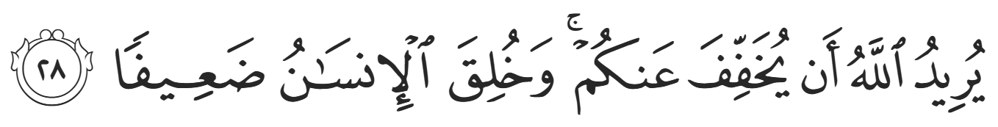
“And it is Allah’s Will to lighten your burdens, for humankind was created weak.” (4:28)
Nevertheless, the origin is continuous worship, just as the Angels do, “They glorify Him day and night, never wavering.”
In his excellence as a Prophet and slave, the Prophet ﷺ regularly prayed 50 units of prayer a day. This is calculated by considering each of the rakaat of prayer as a unit. There are 17 units in the five compulsory daily prayers. The Prophet ﷺ prayed 13 units of the night prayer (that’s 2 brief initiation units, 8 long units, and 3 units for Witr). He ﷺ prayed 12 units for Sunan al-Rawaatib distributed before and after each obligatory prayer, and 8 units for the Duha prayer – this totals 50 regular units a day, not including extra prayers, such as the 2 units for entering the masjid, and so on.
This event truly honors the five daily prayers, emphasizing their importance and gravity. They are so important in the sight of Allah (SWT) that, unlike every other command, the Prophet ﷺ had to be summoned to the Heavens in the presence of the divine to receive the command of prayers being obligated. Allah (SWT) equally commanded Musa (AS) of its significance when He spoke to him:
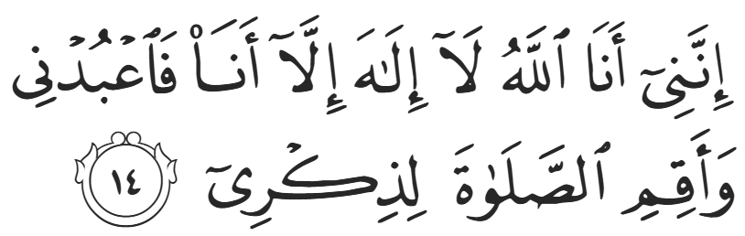
“It is truly I. I am Allah! There is no god except Me. So worship Me, and establish the prayer for My remembrance.” (20:14)
The Qur’aan mirrors this emphasis throughout, such as in Surat Hud:
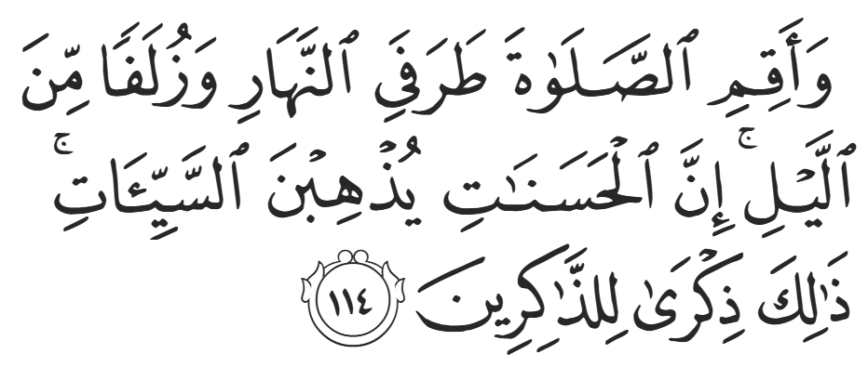
“Establish the prayer at both ends of the day and in the early part of the night. Surely good deeds wipe out evil deeds. That is a reminder for the mindful.” (11:114)
Many other verses corroborate the significance of the prayer.
When the Prophet ﷺ descended back to Jerusalem, he rode al-Buraaq back to Makkah. He ﷺ then narrated firsthand:
“When I woke up the next morning, I felt anxiety about how I would inform the people about what happened and what they would say, and that they would disbelieve me. As I sat by the Ka’bah, nervous and worried, Allah willed that the enemy of Allah, Abu Jahl, passed by and saw me in that state. He asked mockingly, ‘What’s the matter?’ And I said, ‘Last night I was taken to Masjid al-Aqsa.’ He was shocked, and asked, ‘And you are now here amongst us?’ and I replied, ‘Yes.’ He did not know whether to mock me now or call the Quraysh to listen in before I could retract. He said, ‘If I call the Quraysh, will you tell them exactly what you told me?’ I said, ‘Yes.’ And Abu Jahl began shouting, ‘O people of Ka’b ibn Lu’ayy’ until everyone gathered, and he said, ‘Tell your people what you just told me.’ I said, ‘Last night I was taken to Masjid al-Aqsa.’ They asked, ‘And you are now here amongst us?’ And I replied, ‘Yes.’ Some began clapping mockingly, others put their hands on their head, and others began laughing.”
Someone from the crowd who had been to Masjid al-Aqsa then said, “Can you describe it for us?” Everyone knew that the Prophet ﷺ had never been to Jerusalem, so this was a clear test. The Prophet ﷺ began describing Masjid al-Aqsa, but the Quraysh began asking about specifics that he ﷺ was not able to recall. The Prophet ﷺ travelled at night, and was on a surreal mission, so he ﷺ did not notice every detail of his surroundings. Demonstrating his humanity, the Prophet ﷺ admitted, “I was more terrified than I had ever been before.” This was because he could not answer the people’s questions. As the Prophet ﷺ grew in worry, he suddenly saw Masjid al-Aqsa descend from above until he could see everything clearly. He then answered every single question with precision and accuracy, and the Quraysh admitted that his descriptions were correct.
One of the Quraysh then ran to Abu Bakr (RA) and said, “Do you know what your companion has just said? He claims to have gone all the way to Jerusalem and back in one night!” Abu Bakr (RA) replied most diligently, “If he said that, then it is true.” He did not blindly believe it in case the man was lying, yet he did not doubt the Prophet ﷺ for a single second. The man then scoffed, “Do you believe him?!” Abu Bakr (RA) replied, “I believe him in something much more amazing than that. He claims the Revelation descends to him from the seven Heavens!” Thenceforth, Abu Bakr became known as Abu Bakr al-Siddiq (RA) – Abu Bakr the Truthful.
Al-Isrāʾ wal-Miʿrāj teaches us that the greatest honor is not status, power, or recognition, the greatest honor is servitude to Allah. The Prophet ﷺ was elevated because he was first and foremost the perfect slave of Allah. And the gift given on that night was not wealth or ease, but ṣalāh — a reminder that our dignity is found in submission, and our strength in devotion.

<Duaa!>
- Oh Allah, please grant us a deep love for Your Prophet Muhammad, SAW.
- Oh Allah, please make us energetic in doing good for your cause.
- Oh Allah, please enable us with the will and means to walk Al-Sirrat-Al-Mustaqeem, even if it estranges us from others.
- Oh Allah, please support the suffering and oppressed Muslims around the world and grant them victory over that which oppresses them.
- Oh Allah, please protect us from ever being overburdened by debt and protect us from all evils and undesirable consequences associated with having debt.
- Oh Allah, please fill our hands with the work and deeds of righteousness and let them be of benefit to ourselves and the Ummah.
- Oh Allah, please forgive us our shortcomings and deviances in following your Qur'an and the Sunnah of Rasul'Allah, SallAllahuAlayhiWaSallam.
- Oh Allah, please grant us understanding and guidance of your Qur'aan
- Oh Allah, please grant us patience with the trials of this world.
- Oh Allah, please prevent our hearts from getting overly attached to the Dunya and grant us the best in this life and the best in the hereafter.
- Oh Allah, please forgive us our past sins and make us your devoted servants.
- Oh Allah, please make us amongst those whose Duaa is accepted.
- Oh Allah, please grant us Jannat'ul Firdaus and protect us from ever coming close to the Fires of Jahannum.

