Khut'bah Opening
إِنَّ الْحَمْدَ للهِ , نَحْمَدَهُ وَ نَسْتَعينُهُ وَ نَسْتَغْفِرُهُ , وَ نَعوذُ بِالله مِنْ شُرورِ أَنْفُسِنا , مَن يَهْدِهِ اللهُ فَلا مُضِلَّ لَه , وَ مَنْ يُضِلِلْ فَلا هادِيَ لَهْ , وَ أَشْهَدُ أَنْ لا إلهَ إِللهُ وَحْدَهُ لا شَريكَ لَه , و أَشْهَدُ أنَّ مُحَمَّدًا عَبْدُهُ و رَسولُه.
"All thanks and praises are due to Allah, whom we thank, seek for help and invoke for forgiveness. We seek refuge with Allah from the evils within ourselves. He whom Allah guides will never be misled and he whom He misguides will never find one to guide him. I bear witness that there is no deity worthy of worship except Allah and that Muhammad (SAW) is His slave and Messenger.
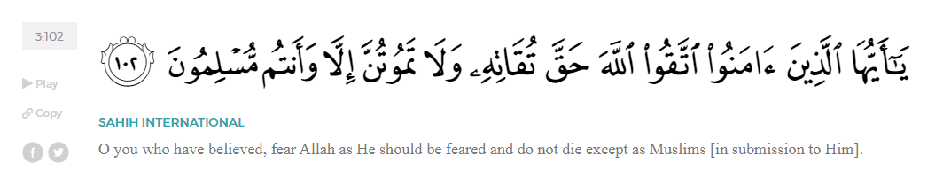
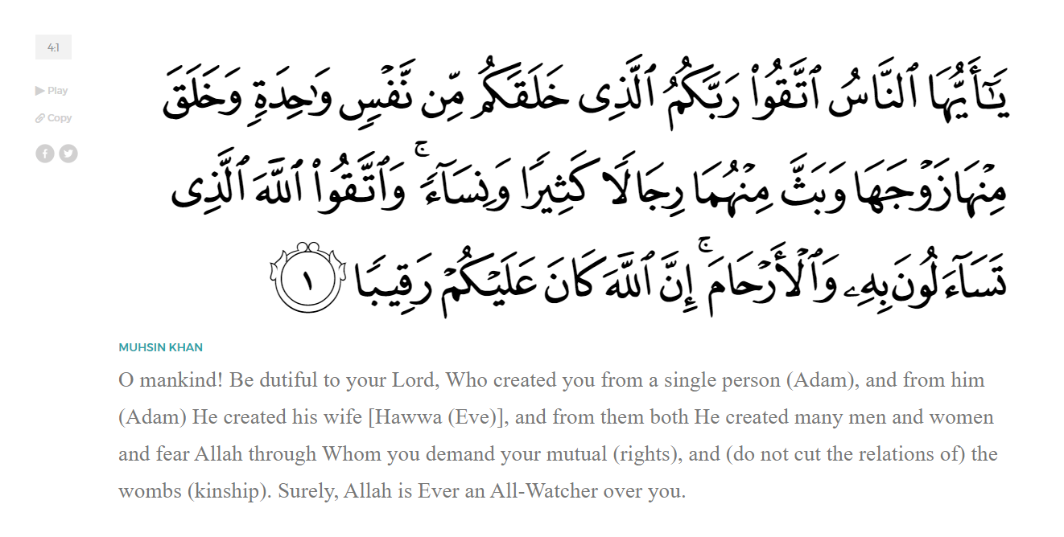
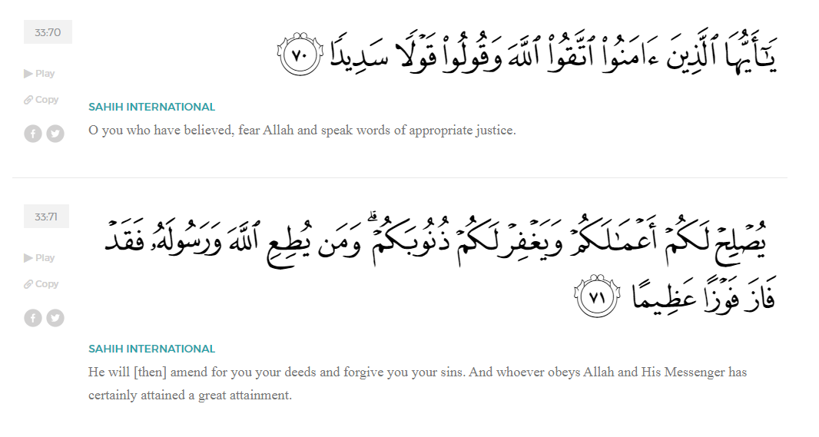
<Sirah of the Prophet (SAW) – Part 21 -Dr. Yassir Qadhi, Book and Series>
Dear brothers and sisters,
InshaaAllah we will continue our khutbah series on the seerah of the Prophet ﷺ, drawing from Dr. Yasir Qadhi’s book, The Sirah of the Prophet, so that we can deepen our understanding of his life and strengthen our love for him. Each step we take through the Prophet ﷺ’s life brings us closer to knowing him more deeply, appreciating his struggles, and embodying his character. Our goal in this series, inshaaAllah, is not just to learn history, but to let the seerah transform our hearts and strengthen our love for the Messenger of Allah ﷺ.
Today we will, inshaaAllah, start with the chapter titled “In Search of a New Base”, but before that, we have to discuss 3 events that happened around the later stages in Makkah – a meeting with the Jinn after Taa’if, and the marriages to Sawdah (RHAA) and Aaishah (RHAA)...
On the way back to Mecca after being rejected in Taa’if, the Prophet ﷺ camped in a small desert grove in the valley of Nakhlah. As per his long-standing habit, he ﷺ stood up to pray tahajjud. He had not yet washed his body or clothes of the dried blood but he ﷺ maintained his priority in worshipping Allah (SWT). A miracle then ensued which was narrated by Allah (SWT) in Surah al-Ahqaaf:
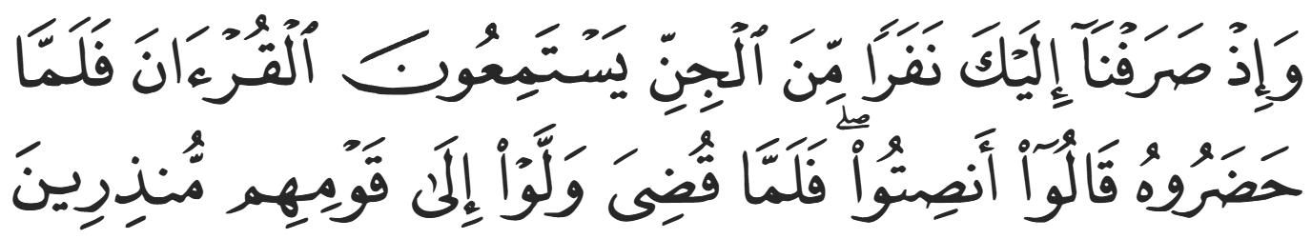
“˹Remember, O Prophet,˺ when We sent a group of jinn your way to listen to the Quran. Then, upon hearing it, they said ˹to one another˺, ‘Listen quietly!’ Then when it was over, they returned to their fellow jinn as warners.” (46:29)
Allah is making it clear to the Prophet ﷺ that this was no coincidence; rather, He (SWT) planned for their paths to cross. The Prophet’s prayer was always long, and his tahajjud was for hours on end, which meant that the jinn were basking in the Qur’an for so long that they returned to their people not only as Muslims, but as warners, preaching the message of Islam to the jinn.
Surah al-Ahqaaf continues:
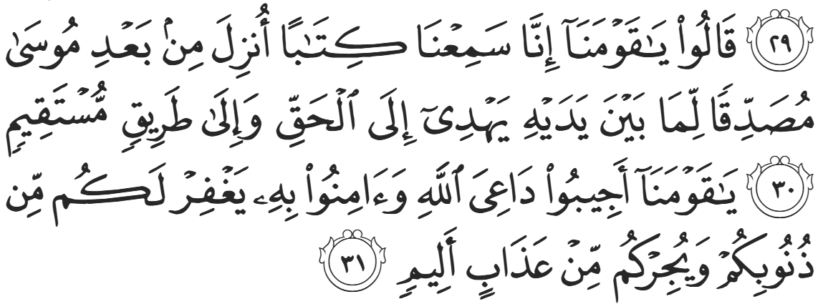
“They declared, ‘O our fellow jinn! We have truly heard a scripture revealed after Moses, confirming what came before it. It guides to the truth and the Straight Way. O our fellow jinn! Respond to the caller of Allah and believe in him, He will forgive your sins and protect you from a painful punishment.” (46:30-31)
Allah’s symbolism to the Prophet ﷺ continues; not only will a distant Iraqi Christian accept your message, but nations from a different species will accept and spread your message. Even if the whole of mankind rejects you, a world beyond mankind has accepted you.
When the Prophet ﷺ left Mecca for Taa’if, he did so covertly because he had no political protection. Physically leaving for ten days was yet another confirmation that he had severed all ties with the Quraysh. Zayd (RA) hence asked, “O Messenger of Allah, how will we enter Mecca after you were expelled?” The Prophet ﷺ replied, “O Zayd, Allah (SWT) will make a way out for us, and Allah (SWT) will help His Prophet and make His Message supreme.” After doing all he could, he simply had tawakkul. The Prophet ﷺ then began sending emissaries to some of his allies in Mecca in hopes for protection. He sent messages to al-Akhnas ibn Shurayq and Suhayl ibn ‘Amr but was met with apologies and excuses. Finally, he ﷺ sent a message to Mut’im ibn ‘Adiyy, chieftain of the Banu Nawfal subtribe, the same man who broke the boycott and sent aid to the exiled Muslims. Mut’im did not only send a message back, but he sent his four sons, instructing them, “Put on your armor and escort Muhammad back to me.” He then stood in front of the Ka’bah and said, “O people of Mecca, I have given my protection to Muhammad.” Abu Sufyaan stood up and asked, “Are you his follower or are you just giving him protection?” Mut’im replied, “I am not a follower; I am just giving protection.” Abu Sufyaan said, “In that case, we accept.” The Prophet ﷺ finally returned to Mecca safely.
The second event to discuss is The Prophet ﷺ’s marriage to Sawdah (RHAA). After the death of Khadijah (RHAA) the Prophet ﷺ was caring for three daughters and was in need of remarrying. One day, Khawlah bint Hakeem (RHAA) visited the Prophet ﷺ and said, “O Messenger of Allah, you appear to be withdrawn.” The Prophet ﷺ replied, “Yes, she was the mother of my children and the caretaker of my house.” After testing the waters, Khawlah asked, “Should I then not make a proposal?” The Prophet ﷺ asked who she had in mind, and she said, “If you want an unmarried lady, then Aaishah is ideal, and if you want a widowed lady, then Sawdah is ideal.” Aaishah was too young at this stage, and so the Prophet ﷺ gave Khawlah permission to approach Sawdah and gauge her interest. She approved, as did her father, and the Prophet ﷺ wed Sawdah bin Zam’ah (RHAA).
The third event is the Prophet ﷺ’s marriage to Aaisha (RHAA). The Prophet’s marriage to Aaishah (RHAA) is one of two marriages commanded by Allah (SWT). Aaisha (RHAA) narrated that he ﷺ said, “I saw you in a dream twice. Someone was carrying you in a silk cloth and said, ‘This will be your wife.’ When I lifted the cloth, I saw you. I said to myself, ‘If this is from Allah, it will come to pass.’” The dreams of prophets are revelation, and the Prophet ﷺ seeing Aaishah (RHAA) as his bride was a command from Allah (SWT). The Prophet ﷺ saw the dream after the death of Khadijah (RHAA) but did not immediately act upon it, knowing that it will be decreed in time.
When Khawlah bint Hakeem (RHAA) visited the Prophet ﷺ and suggested both Sawdah and Aaishah (RHAA), she first approached Sawdah and her family. Later, she also approached Abu Bakr al-Siddiq (RA) and Umm Rumaan (RHAA), Aaishah’s parents. They rejoiced at the news, but Abu Bakr (RA) was initially confused. The prophet ﷺ would always refer to Abu Bakr (RA) as his brother, and Abu Bakr (RA) understood that the rules of kinship would apply to him. The Prophet ﷺ explained that they were brothers in Islaam, and Abu Bakr (RA) was pleased to offer his daughter in marriage. They presented the marriage contract, but did not consummate the marriage for another three years.
In recent times, there have been sensitivities regarding Aaisha’s age of marriage. She was six years of age at the time of the marriage contract – the nikah – and nine at the age of consummation. Detractors have levelled criticisms against the Prophet ﷺ for marrying a “child”, however these criticisms are underpinned by a postmodern notion of childhood and adulthood. In 7th century Arabia—and throughout most of human history—adulthood was understood as the age of puberty. The fact that the Prophet ﷺ waited three years to consummate the marriage clearly shows that Aaishah (RHAA) reached the age of physical maturity. As for emotional maturity and intelligence, then that differs between each society and era. This is evidenced by the fact that the age of consent varies considerably between countries throughout the world. In Islaam, the age of puberty is designated as the age of intelligence and responsibility.
The Prophet’s enemies seized any opportunity to besmirch his reputation, yet they did not recall his marriage to Aaishah (RHAA) in their list of criticisms. It was understood as a norm, so much so that Khawlah bint Hakeem (RHAA) was the one to suggest Aaishah (RHAA) as a potential bride before the prophet ﷺ even married Sawdah (RHAA). Moreover, Aaishah (RHAA) was already engaged to Mut’im ibn ‘Adiyy, which was later called off. In late antiquity, the average lifespan was half that of the 21st century. Naturally, therefore, the ages of marriage, childbirth, and labor were all earlier than the modern era. This was the case across cultures, such as the Queen of England, Isabelle of France, marrying Richard II at the age of seven. This occurred in 1396, over 700 years after the time of the Prophet ﷺ.
<Conclude 1st Khutbah with:
Aqoolu haathaa wa astaghfir-Allaah (I say this and I ask Allah for forgiveness)
أَقُولُ قَوْلِي هَذَا وَأَسْتَغْفِرُ اللَّهَ لِي وَلَكُمْ وَلِسَائِرِ المُسْلِمينَ وَالمُسْلِمَاتْ فَاسْتَغْفِرُوهْ إِنَّهُ هُوَ الْغَفُورُ الرَّحِيمُ
الحمد لله رب العالمين والصلاة والسلام على سيد المرسلين وعلى آله وأصحابه أجمعين
<2nd Khutbah>
Dear brothers and sisters,
The Prophet’s living arrangements in Mecca grew more precarious as time passed; his protector, Mut’im ibn ‘Adiyy, was nearing the end of his life, and his own tribe, Banu Haashim, had disowned him. After the people of Taa’if rejected him and Mecca grew ever more hostile, the Prophet ﷺ accelerated his efforts of finding a base. He began approaching tribes visiting for Hajj. As previously discussed, the Prophet ﷺ did this in the past to preach the Message of Islaam, but now he was seeking to join a new tribe. Such a move was not unprecedented, but was very rare, and it was clear that this was the Prophet’s last resort.
During Hajj season, camps at Mina were allocated according to tribe, and the Prophet ﷺ would utilize this opportunity to approach the tribe leaders separately. Rabi’ah ibn ‘Abbad said, “I remember a young man coming and speaking to my father, telling him to embrace the worship of Allah and leave idolatry, and asking him to accept him into his tribe. I saw an elderly man wearing a Yemeni cloak standing behind him waiting for him to finish. As the first man would go from one tribe to another, the elderly man would approach the same tribes after him, saying, ‘O people, this person is telling you to abandon you gods, al-Laat and al-‘Uzza, and he is calling you to abandon the way of your forefathers!’ I asked my father, ‘Who is this young man, and who is the other man?’ My father said, ‘This is the young man they claim to be a Prophet, and the elderly man is his uncle, ‘Abd al-‘Uzza ibn ‘Abd al-Muttalib (i.e, Abu Lahab).’”
The Prophet ﷺ would usually visit tribes alongside his confidant, Abu Bakr (RA). As well as being his most trusted ally, Abu Bakr was the foremost expert in genealogy, having memorized the history and lineage of a wide variety of tribes throughout Arabia. The Prophet ﷺ relied heavily on Abu Bakr (RA), demonstrating the permissibility and wisdom in accepting help and utilizing expertise. The Prophet’s perfection and infallibility was in religious knowledge and guidance. As for his capacity as a human, he ﷺ would accept advice and assistance. Before meeting each tribe, Abu Bakr would inform the Prophet ﷺ of the names of the people he was addressing, the strengths and weaknesses of the tribe, and so on.
The Prophet ﷺ approached many major tribes and was faced with varying degrees of apprehension; some politely declined while others replied sarcastically or even aggressively. One of the tribes he approached was Kindah, a historically powerful and imposing Kingdom that had fizzled out over time into a modest tribe. One of their chieftains listened to the Prophet ﷺ and his interest was piqued. He said, “This is a very interesting message. Come with me and I will grant you an audience with the other chieftains.” The Prophet ﷺ followed him and preached the message to the chieftains. The first chieftain then said, “O my fellow tribesman, if we were to take this young man from the Quraysh, we will have a message through which we could conquer the other Arabs.” He then turned to the Prophet ﷺ and said, “If we were to follow this matter of yours, and Allah grants us victory over all your enemies, will you give us control over this affair after you?” The Prophet ﷺ replied forthrightly, “The lands belong to Allah, and He gives it to whomever He pleases.” The chieftain then said, “So you are asking us to follow you, stick our necks out behind you to have them cut off, and after we have spilled our blood and you have used it to conquer the Arabs, you will take the Kingdom? Go, for we have no need for this.” Despite the Prophet’s desperate situation, he ﷺ did not compromise; he saw the Kindah were not completely sincere theologically and were instead politically motivated, so he did not push them any further.
The Prophet ﷺ also met with Banu Shayban ibn Tha’labah. Abu Bakr (RA) advised, “O Messenger of Allah, the Banu Shayban are of the most noble, illustrious, and intelligent tribes of the Arabs, and they have amongst them So-and-so and So-and-so.” After exchanging pleasantries, the Prophet ﷺ said, “We have come to invite you to the worship of Allah (SWT) without any intermediaries, and that you reject the false gods. We ask that you accept us into your tribe, as the Quraysh has arrogantly and unjustly prevented us from spreading the Word of Allah.” The Prophet ﷺ then ended by venerating Allah and differentiating his needs from Allah’s self-sufficiency saying, “And Allah is al-Ghaniyy al-Hameed – The Self-Sufficient, The Praiseworthy.” They replied, “Do you have anything else?” And the Prophet ﷺ recited from Surah al-An’aam:
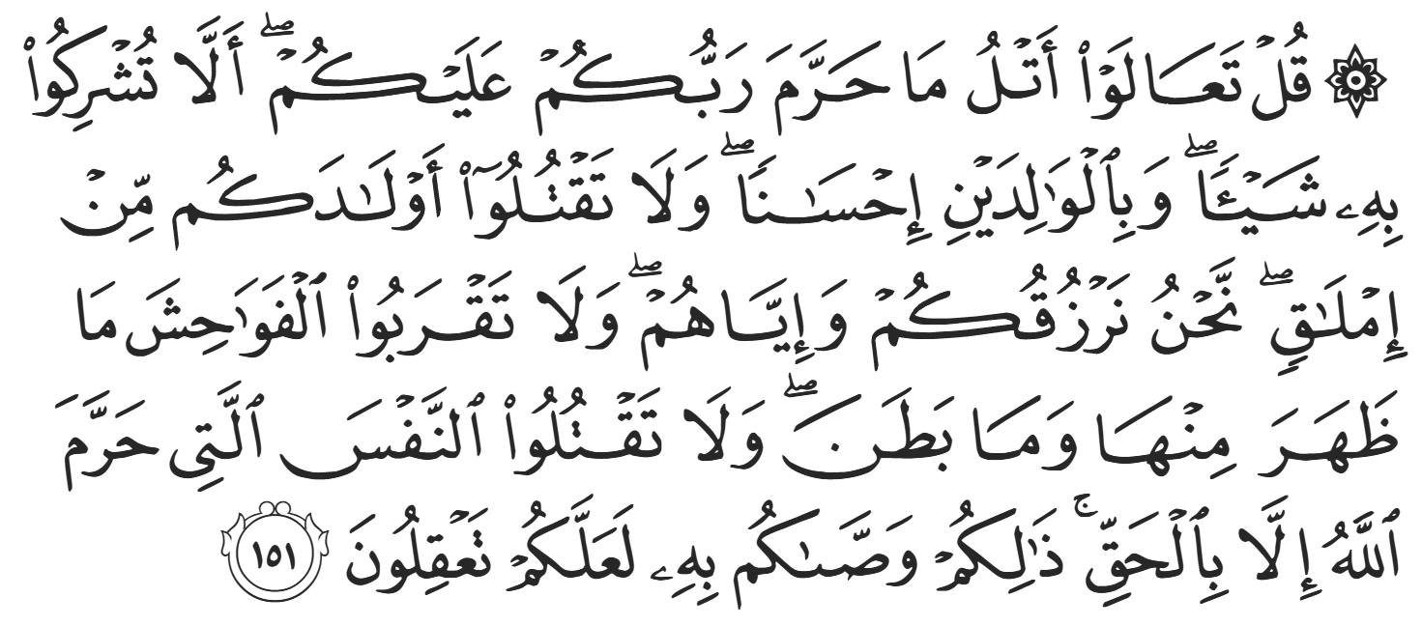
“Say [O Prophet], ‘Come! Let me recite to you what your Lord has forbidden to you: do not associate others with Him. [Do not fail to] honor your parents. Do not kill your children for fear of poverty. We provide for you and for them. Do not come near indecencies, openly or secretly. Do not take a life—made sacred by Allah—except with right.’ This is what He has commanded you, so that perhaps you will understand.” (6:151)
They replied, “Do you have anything else?” and the Prophet ﷺ recited from Surah al-Nahl in what was to become one of the most famous admonitions in Islaam, recited in most Friday Khutbahs:
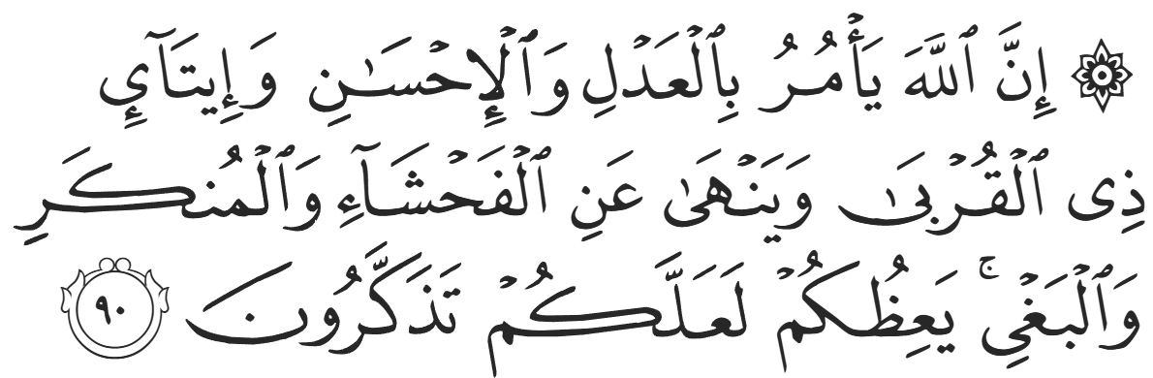
“Indeed, Allah commands justice, grace, and courtesy to close relatives. He forbids indecency, wickedness, and aggression. He instructs you so perhaps you will be mindful.” (16:90)
The chieftain finally replied, “You have indeed come with goodness. You have come with the best of manners and morals.” Proving that the Quraysh went out of their way to approach tribes and slander the Prophet ﷺ, they added, “And the Quraysh has lied against you.” He continued, “I refer you to our elder, Haani ibn Qays.” Haani then stood up and said, “I have heard what you have said, O member of the Quraysh. I feel that if we leave our religion and our way for your religion and way after one meeting, it may be a hasty decision that would cause us harm in the long term. We also have people we left behind (i.e., who did not come for Hajj) whose advice we have not sought and whose support is necessary. I therefore think that we should wait, and you should wait, and we shall return, and you shall return (i.e., next Hajj). I also ask the advice of our military leader: al-Muthanna ibn Haarithah.” Al-Muthanna then stood up and said, “What our elder Haani said is true; we will not make any hasty decisions. There is also another matter. We are a group of Arabs who have loyalties and treaties with two groups of people: our neighboring Arab tribes, and Kisra (i.e. the King of the Sassanid Empire). As for the Arabs, we do not fear or worry about them, but as for Kisra, we have an agreement to be neutral in all affairs of the Arabian Peninsula, and this matter of yours does not seem to be something that Kings approve. If we were to accept your proposal, it would only be on the Arab side.”
The Prophet ﷺ once again remained firm on his principles and responded, “Your response has been good and is sincere, but Allah’s religion will only be helped by those who embrace it wholeheartedly.” Indeed, the Qur’aan states:
“O believers! Enter into Islaam wholeheartedly.” (2:208)
As discussed in previous khutbahs, even the Quraysh had offered to accept Islam on the condition that they alternate between Islam and Paganism, and Allah responded:
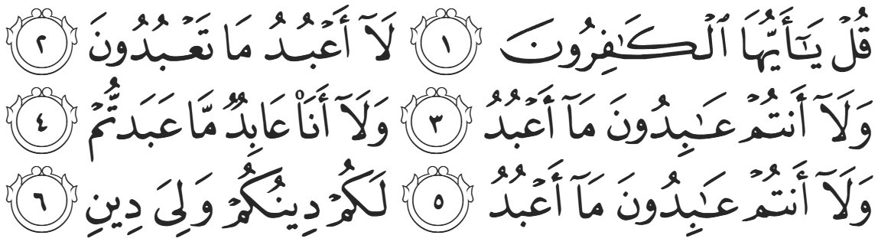
“Say, ‘O you disbelievers! I do not worship what you worship, nor do you worship what I worship. I will never worship what you worship, nor will you ever worship what I worship. You have your way, and I have my way.” (109:1-6)
As the Prophet ﷺ was exiting the tent, he turned back to the chieftains and said, “And what if I were to tell you that Allah (SWT) would grant you victory over Kisra’s kingdom, and you will enjoy their land, money, and captives—would you then accept?” A younger tribesman replied elatedly, “Yes, of course!” But they did not believe that this would ever happen.
The Persion Sassanid Empire was so colossal that the Roman Empire failed to conquer it despite hundreds of attempts and battles. No one could ever predict that the meager tribes of Arabia would slay the goliath. Nevertheless, the Prophet ﷺ had unwavering certitude in his belief (Yaqeen) and the Persian Empire was brought to its knees after a few short years of Islamic conquest. The Banu Shaybaan did eventually accept Islam after Mecca was conquered, but because they did not formally adopt the Prophet ﷺ, they missed out on the reward, status, and honor of being titled al-Ansaar (The Prophet’s Helpers).
Despite the vulnerability of his current situation and the pressures of Quraysh, the Prophet ﷺ demonstrated trust in Allah’s decree, wisdom in his personal affairs, and unwavering integrity in his mission. When offered support with conditions, he refused to compromise the truth. When faced with rejection, he ﷺ remained dignified and steadfast. From his marriages we learn that Allah’s plan unfolds with purpose; from his search for a new base, we learn that victory belongs only to those who uphold faith wholeheartedly. Let us take from this the lesson of yaqeen, principled firmness, and complete submission to Allah—entering into Islam fully, without hesitation, without condition, and without compromise.

<Duaa!>
- Oh Allah, please grant us a deep love for Your Prophet Muhammad, SAW.
- Oh Allah, please make us energetic in doing good for Your cause.
- Oh Allah, please enable us with the will and means to walk Al-Sirrat-Al-Mustaqeem, even if it estranges us from others.
- Oh Allah, please support the suffering and oppressed Muslims around the world and grant them victory over that which oppresses them.
- Oh Allah, please protect us from ever being overburdened by debt and protect us from all evils and undesirable consequences associated with having debt.
- Oh Allah, please fill our hands with the work and deeds of righteousness and let them be of benefit to ourselves and the Ummah.
- Oh Allah, please forgive us our shortcomings and deviances in following your Qur'an and the Sunnah of Rasul'Allah, SallAllahuAlayhiWaSallam.
- Oh Allah, please grant us understanding and guidance of Your Qur'aan
- Oh Allah, please grant us patience with the trials of this world.
- Oh Allah, please prevent our hearts from getting overly attached to the Dunya and grant us the best in this life and the best in the hereafter.
- Oh Allah, please forgive us our past sins and make us your devoted servants.
- Oh Allah, please make us amongst those whose Duaa is accepted.
- Oh Allah, please grant us Jannat'ul Firdaus and protect us from ever coming close to the Fires of Jahannum.

