Khut'bah Opening
إِنَّ الْحَمْدَ للهِ , نَحْمَدَهُ وَ نَسْتَعينُهُ وَ نَسْتَغْفِرُهُ , وَ نَعوذُ بِالله مِنْ شُرورِ أَنْفُسِنا , مَن يَهْدِهِ اللهُ فَلا مُضِلَّ لَه , وَ مَنْ يُضِلِلْ فَلا هادِيَ لَهْ , وَ أَشْهَدُ أَنْ لا إلهَ إِللهُ وَحْدَهُ لا شَريكَ لَه , و أَشْهَدُ أنَّ مُحَمَّدًا عَبْدُهُ و رَسولُه.
"All thanks and praises are due to Allah, whom we thank, seek for help and invoke for forgiveness. We seek refuge with Allah from the evils within ourselves. He whom Allah guides will never be misled and he whom He misguides will never find one to guide him. I bear witness that there is no deity worthy of worship except Allah and that Muhammad (SAW) is His slave and Messenger.
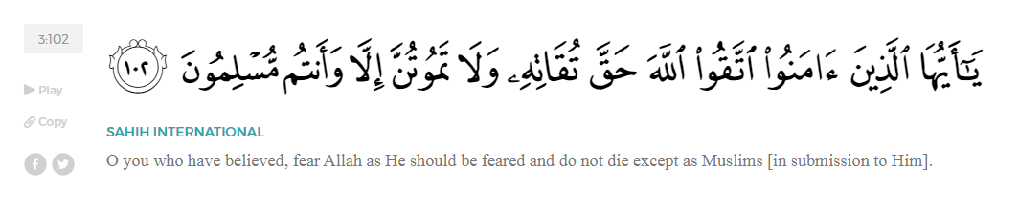
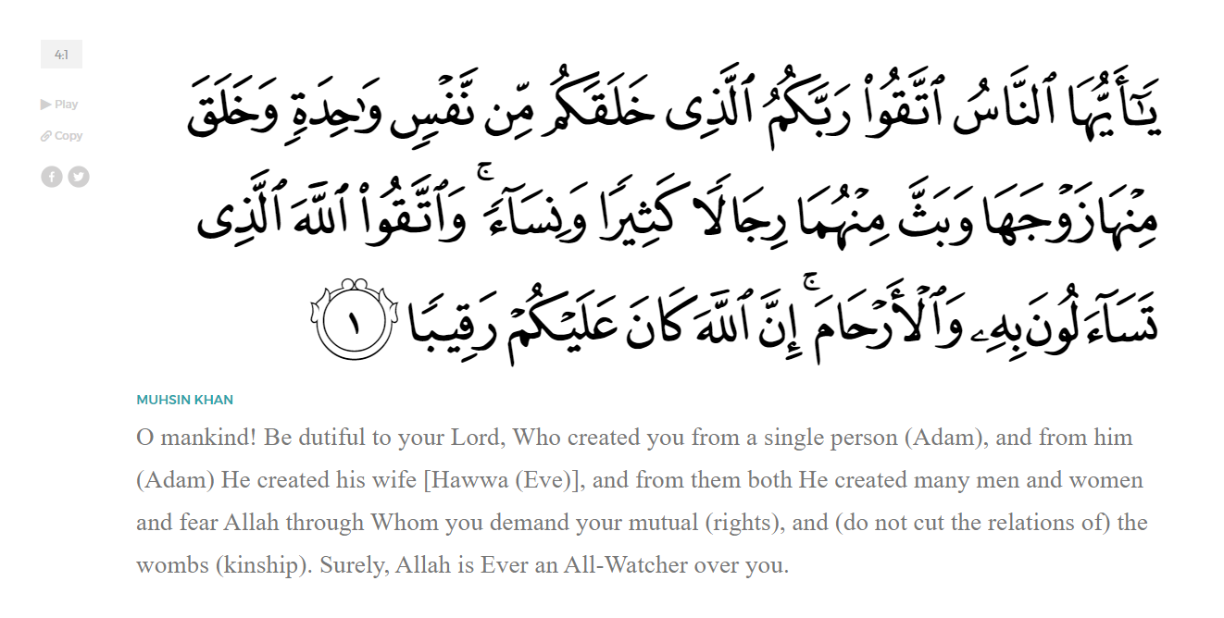
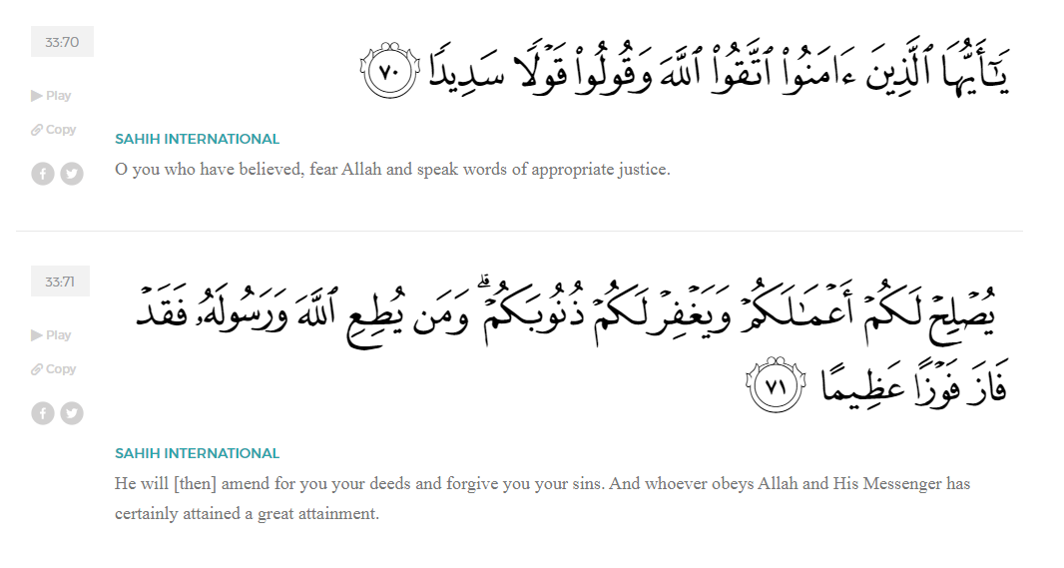
<Sirah of the Prophet (SAW) – Part 22 -Dr. Yassir Qadhi, Book and Series>
Dear brothers and sisters,
InshaaAllah we will continue our khutbah series on the seerah of the Prophet ﷺ, drawing from Dr. Yasir Qadhi’s book, The Sirah of the Prophet, so that we can deepen our understanding of his life and strengthen our love for him. Each step we take through the Prophet ﷺ’s life brings us closer to knowing him more deeply, appreciating his struggles, and embodying his character. Our goal in this series, inshaaAllah, is not just to learn history, but to let the seerah transform our hearts and strengthen our love for the Messenger of Allah ﷺ.
Today we will, inshaaAllah, continue with the chapter titled, “In Search of a New Base”, starting with the section “An Unlikely Savior in Yathrib”.
Before continuing, let us briefly recall where we left off last week. As hostility in Makkah intensified and the Prophet ﷺ lost both tribal and political protection, he began an urgent search for a new base from which the Message of Islaam could survive and grow. During the Hajj seasons, the Prophet ﷺ approached tribe after tribe, inviting them not only to worship Allah alone, but also to offer him protection so that he could continue conveying the truth. Many tribes listened respectfully, yet ultimately refused.
Allah (SWT) willed that the Prophet’s attention be turned to the fledgling city of Yathrib – later to be renamed “Madinah”. On the 10th year of the public da’wah, the year of Abu Taalib’s death, the Prophet ﷺ approached a small group of Arabs from Yathrib. The demographic of Yathrib consisted of three main groups: two Arab tribes, al-Aws and al-Khazraj, and the Jews. The two Arab tribes were the majority and were in power, but they enjoyed a love-hate relationship, alternating between war and peace, as was common in intertribal politics. Tensions gradually rose between the tribes over decades, eventually culminating into a fully-fledged civil war. This was known as the Battle of Bu’aath, and it depleted both tribes to an alarming degree; the elders were largely killed, and the youth grew tired and disillusioned with the constant warring.
Aaisha (RHAA) once said, “The Day of Bu’aath was a gift that Allah granted the Prophet ﷺ. It was due to Bu’aath that their unity (i.e., the Aws and Khazraj) had been fragmented, and their leaders were decimated.” The youth that survived were raised in a fruitless war and were thus naturally more open to change. The lone senior figure who survived the war was ‘Abdullah ibn Ubayy ibn Saluul. As the de facto leader, he was opposed to a foreign entity that would jeopardize his leadership. Nevertheless, he was outnumbered by exuberant youth with an openness to change.
There were indications that the Message of Islaam had reached Yathrib prior to the Prophet ﷺ’s official contact. Suwayd ibn al-Saamit was the leading poet of the Khazraj who heard that there was a mysterious poet or magician from the Quraysh. When he traveled to Mecca for Hajj, he sought the Prophet ﷺ to observe him. He approached the Prophet ﷺ and said, “I have heard that you have eloquent speech. I have something similar.” He then recited extremely eloquent poetry of the highest caliber. The Prophet ﷺ replied, “What you have is good, but what I have is better. I have revelation from the Lord of the worlds.” The Prophet ﷺ then began reciting Qur’aan and Suwayd was astonished by its divine eloquence. He returned to Yathrib, and later that year died in the Battle of Bu’aath. Later, his people said, “We are certain that he died a Muslim.” Another reference states that a young man from the Khazraj was stabbed in the Battle of Bu’aath, and as he took his last breaths, his last words were, “SubhaanAllah, Alhamdulillah, Allahu Akbar! -- Glory be to Allah, Praise be to Allah, Allah is the Greatest!”
Aside from miscellaneous reports, the Message of Islam formally arrived in Yathrib after the Prophet ﷺ spoke to a group of six members of the Khazraj during Hajj. As the Prophet ﷺ was passing between the tents of the major tribes, he saw a small group of young men near the ‘Aqabah area in Hajj. Abu Bakr (RA) was not with him, so he ﷺ asked, “Who are you?” They replied, “We are from the Khazraj.” The Prophet ﷺ replied, “Which Khazraj? The neighbors of the Jews?” They replied in the affirmative, and the Prophet ﷺ sat down and explained the teachings of Islam, warned against polytheism, and recited the Qur’aan. He ﷺ preached to these six youths with the same passion and sincerity as he did with the major tribes of Kindah and its like. They accepted Islam, and the Prophet ﷺ finally made a breakthrough.
Allah (SWT) willed that the Prophet’s helpers – the Ansaar—come from a small, obscure tribe from Yathrib. This clearly teaches us not to belittle any action for the sake of Allah, no matter how small. Had the Prophet ﷺ not approached those six young men and only focused on the larger tribes, they would not have accepted Islam and the Prophet ﷺ would not have established a base. One of Allah’s many wisdoms in choosing Yathrib as a base was that the Arabs of Yathrib were among the very few people in Arabia who were familiar with monotheistic religions. The Pagan Arabs were generally not familiar with the concept of Prophethood, whereas Yathrib was one of only two cities in the whole of the Hijaaz region where Jews resided, creating a relatively multi-cultural society. The Aws and Khazraj were therefore acquainted with the notion of Prophethood, Revelation, and Scripture.
In fact, the Jews would often taunt them with the coming of a Prophet who they claimed would be used to destroy them. Allah (SWT) indirectly references this in the Qur’aan in Surat al-Baqarah:
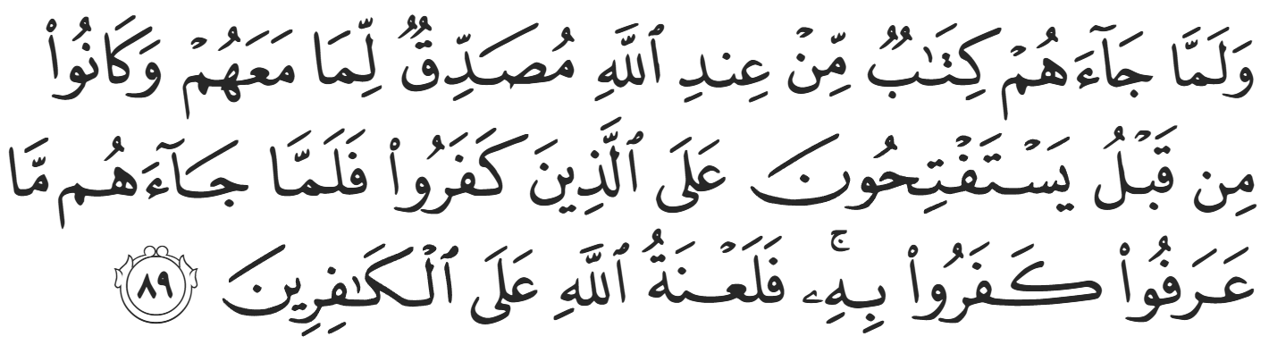
“Although they used to pray for victory ˹by means of the Prophet˺ over the polytheists, when there came to them a Book from Allah which they recognized, confirming the Scripture they had ˹in their hands˺, they rejected it. So may Allah’s condemnation be upon the disbelievers.” (2:89)
Their arrogance backfired, as the Aws and Khazraj were familiar with the idea of a foretold Prophet because of their taunts, which undoubtedly had an impact on their acceptance of the Prophet Muhammad ﷺ.
<Conclude 1st Khutbah with:
Aqoolu haathaa wa astaghfir-Allaah (I say this and I ask Allah for forgiveness)
أَقُولُ قَوْلِي هَذَا وَأَسْتَغْفِرُ اللَّهَ لِي وَلَكُمْ وَلِسَائِرِ المُسْلِمينَ وَالمُسْلِمَاتْ فَاسْتَغْفِرُوهْ إِنَّهُ هُوَ الْغَفُورُ الرَّحِيمُ
الحمد لله رب العالمين والصلاة والسلام على سيد المرسلين وعلى آله وأصحابه أجمعين
<2nd Khutbah>
Dear brothers and sisters,
The six members of the Khazraj did not make a formal public declaration of conversion, but they welcomed the Prophet’s Message and vowed to return the following year. They indeed returned a year later, in the 12th year of the Prophethood, with 12 people who formally converted—the largest number of converts outside of Mecca. The 12 members were comprised of both the Aws and Khazraj, showing that they were already putting tribal differences behind them for the sake of Islam. Together, they pledged their allegiance to the Prophet ﷺ; each of them placed their hand in the hand of the Prophet ﷺ and converted to Islaam. That was called the Covenant of ‘Aqabah because it took place on the plains of ‘Aqabah during Hajj. It is also referred to as “The Covenant of Women” because it was an apolitical covenant. When women would convert to Islam, the Prophet ﷺ did not request from them any political or military commitments; rather, he instructed them to worship Allah (SWT) alone and adopt a moral and righteous life.
This oath was a strictly theological commitment to follow the tenets of Islaam, hence the name. The Qur’aan states in Surat al-Mumtahanah:
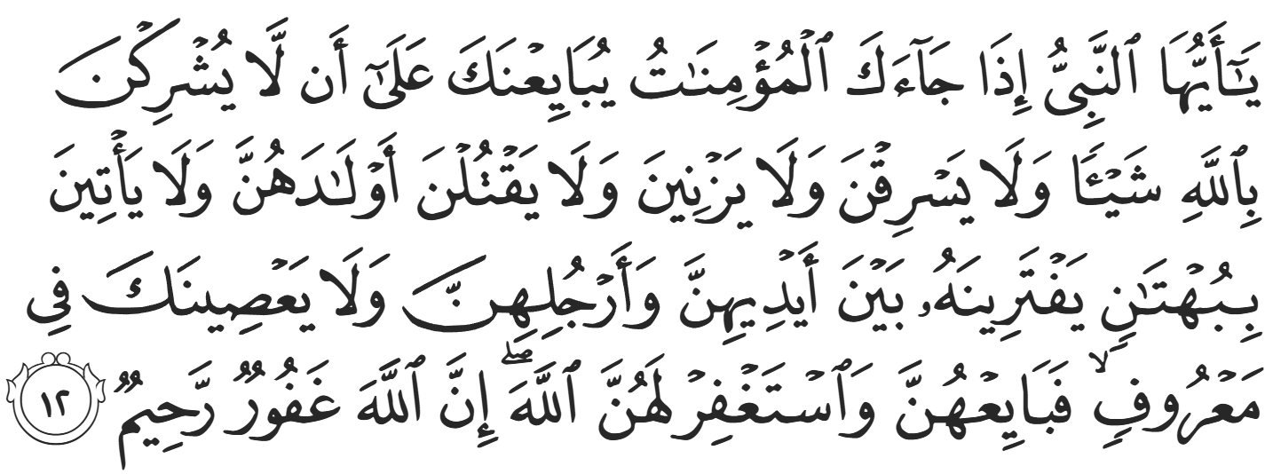
“O Prophet! When the believing women come to you, pledging to you that they will neither associate anything with Allah ˹in worship˺, nor steal, nor fornicate, nor kill their children, nor falsely attribute ˹illegitimate˺ children to their husbands, nor disobey you in what is right, then accept their pledge, and ask Allah to forgive them. Surely Allah is All-Forgiving, Most Merciful.” (60:12)
Ubaadah ibn al-Saamit (RA) said, “The first covenant we made was akin to the oath of women; we swore our allegiance to worship Allah alone, not fornicate, not steal, not kill our children, not live immoral lives, and obey the Messenger in all good matters.”
The Prophet ﷺ said about this covenant, “Whoever fulfills this oath will have their reward with Allah. Whoever commits any of these sins and is punished in this world, then that will constitute their expiation. And whoever commits any of those sins and Allah conceals their sins, then the matter will rest with Him: if He wishes, He may punish them, and if He wishes, He may forgive them.”
The converts requested that the Prophet ﷺ send a knowledgeable Muslim to accompany them and teach them Islam in Yathrib. The Prophet ﷺ agreed and sent Mus’ab ibn Umayr (RA) who taught them Qur’aan and led them in prayer. It is narrated that within a few weeks of Mus’ab reaching Yathrib, 40 people converted to Islaam. At that point, the Prophet ﷺ instructed them to pray Jumuah prayer, meaning that the first ever Jumuah prayer in Islam did not actually include the Prophet ﷺ. Eventually, every single sub-tribe of the Aws and Khazraj had at least one Muslim in their household. The conversion of two people in particular led to an instantaneous mass conversion: Sa’d ibn Mu’aadh and Usayd ibn Hudayr (RHUM). They were the up-and-coming leaders of the Aws and Khazraj following the gap in leadership created by the Battle of Bu’aath, and they would grow to be formidable leaders in Islam.
Mus’ab was preaching in the house of As’ad ibn Zuraarah (RA). Sa’d said to Usayd, “This new religion has come to our land, and my cousin, As’ad, is housing the man spreading this faith. I feel awkward expelling him from my own cousin’s house, so why don’t you go and expel this man from our city?” Usayd immediately went – spear in hand—to As’ad’s house. As’ad saw him from afar and warned Mus’ab nervously, “One of our leaders is approaching!” Usayd stormed in angrily, “Why have you come to our lands? Have you come to brainwash those of us with low intellect? To take our women and children away from our ways? Go back to where you came from if you value your life.”
Mus’ab responded with a calmness and confidence that only imaan could instill. He said, “Why don’t you sit and listen to what I have to say? If you find it agreeable then good, and if not, then I will stop.” Usayd calmed down and found the request to be too reasonable to oppose, so he sat down and listened. Mus’ab (RA) then preached the basic teachings of Islam, and Usayd was immediately convinced. His heart opened up to Islaam and he said, “What you said makes complete sense to me. How does one embrace your faith?” Usayd came to Mus’ab with his spear in hand but left after performing ghusl and declaring the shahaadah. Usayd said, “If you convince the person who sent me (i.e., Sa’d ibn Mu’aadh), then you will have no opposition left.”
When Usayd returned, Sa’d noticed an immediate difference, stating, “This is not the same man who left us.” Usayd said, “I tried speaking to them, but you should try.” To add an element of urgency to the matter, he added, “I have also heard that a certain tribe has vowed to kill As’ad for housing this man.” Sa’d became alarmed and immediately took off, taking his weapons with him. He marched into As’ad’s house and said, “O As’ad, had you not been my cousin, these weapons would not be hanging from my side. It is only because of our blood relationship that I am not taking this matter further. Get rid of your guest and tell him to leave our lands.” Before As’ad even responded, Mus’ab interjected with the same proposal he gave to Usayd. Sa’d was so taken aback by his bravery and stoic confidence that he consented. This time, Mus’ab also recited Surah Zukhruf.
The Qur’an softened Sa’d’s heart, and he immediately accepted Islaam. After these two major conversions, the entire tribe of Banu ‘Abd al-Ashal converted, one of the biggest tribes in Yathrib.
Mus’ab ibn Umayr (RA) was very successful in his da’wah, and the following year, the 13th year of prophethood, 75 people pledged to the Prophet ﷺ-- a huge increase from the original 12. These 75 were the ones who were able to perform Hajj, and it would be reasonable to imagine that there were many more Muslims willing to pledge who could not make the journey. A minimum of 250-300 people in Yathrib were now Muslims, and Islaam continued to spread rapidly.
Jaabir ibn Abdillah (RA), one of the most famous companions from the Ansaar narrates, “The Prophet ﷺ stayed in Mecca for more than ten years, preaching to the people in Hajj, asking, ‘Who will support me so that I can spread the Message of my Lord?’ And he would not find anyone embracing his faith except a man or two from such-and-such tribe. Finally, Allah guided a group of us from Yathrib to Islaam, and we believed in him and recited the Qur’aan until not a single sub-tribe amongst the people of Yathrib existed except that there were Muslims amongst them. Then Allah (SWT) caused us to come together and we said, ‘For how long will we allow the Prophet ﷺ to be repelled from one valley to another outside Mecca and fear for his life?’ and Allah (SWT) gave us the idea to invite the Prophet ﷺ to Yathrib.”
The Prophet ﷺ instructed the 75 Muslims of Yathrib to meet him on the last day of Hajj in the dead of night. Ka’b ibn Maalik (RA) narrates, “When we went for Hajj, we hid our Islaam from our Pagan relatives. We were instructed to meet a few hours before Fajr, so we sneaked out of our tents so as not to arouse suspicion. The Prophet ﷺ appeared with his uncle, al-Abbas, who said to the Prophet ﷺ, ‘O my nephew, I do not recognize any of these men.’” Al-Abbas was not yet Muslim, but he still accompanied the Prophet ﷺ out of familial love. Thinking tribally, he was searching for the elders that he recognized and traded with, but found none. As aforementioned, the Battle of Bu’aath wiped out the leadership of the Aws and Khazraj. With so much at stake, al-Abbas was uneasy trusting these young, unrecognized faces; though, unbeknownst to him, Allah (SWT) recognized and trusted them.
Al-Abbas (RA) then stood up and spoke on behalf of the Prophet ﷺ, “O Khazraj, you know the status of this man amongst us, and we have protected him from his own people even though we agree with our people (i.e. the Banu Haashim are amongst the same religion as the rest of the Quraysh). He has dignity and honor amongst us, and he has protection, but he has decided to leave us to join you. So, if you are sure that you can live up to your conditions, and protect him from those who oppose him, then you shall bear the responsibility. Otherwise, let him go from now, and realize that he is honored amongst his people.”
Al-Abbas was clearly hesitant and cautious. He was also embarrassed at the measures his nephew ﷺ was forced to take, overemphasizing the honorable status the Prophet ﷺ had amongst the Quraysh. The reality, at this stage, was the contrary; the Quraysh had all but expelled him ﷺ and did not show honor nor respect.
The Muslims replied, “O ‘Abbas, you have spoken, so let the Prophet ﷺ speak. O Messenger of Allah, tell us your conditions.” The Prophet ﷺ then stood up and began reciting Qur’aan and preaching to them, advising them to fear Allah (SWT). He then said, “I shall give you [permission of giving] allegiance in return for protection. You shall protect me as one of your own.” Al-Baraa’ ibn Ma’ruur (RA) stood up and said, “We are a people experienced in the art of war; we have inherited it from our forefathers. Stretch forth your hand and we will give you allegiance.” Abu al-Haytham ibn Tayyahaan then stood up and added his wise perspective, “O Messenger of Allah, we have treaties with the Jews of Yathrib. Once we accept you, we will have broken them. Once you come over to our side, and Allah gives us victory, will you then leave us and return to your people?” Ponder upon the resounding imaan of a man asking what will happen after victory will be given despite Islaam being in its infancy. Moreover, his foremost worry was losing the Prophet ﷺ. Contrast this worry to the chieftains of Kindah who were worried about who will rule the kingdom. The Prophet ﷺ replied resolutely, “My blood is your blood, and my destruction is your destruction (i.e. we are now one).”
The Ansaar were thoroughly sufficed and asked the Prophet ﷺ how exactly to pledge allegiance. The Prophet ﷺ instructed, “Pledge that you hear and obey, in ease and in difficulty, and that you spend from your money in the way of Allah (SWT), and that you command the good and forbid the evil, and that you speak the truth no matter what the consequence, and that you help me when I come to Yathrib just like you help your own family.” The Ansaar replied, “And what is in it for us?” And the Prophet ﷺ replied with the one word they were desperate to hear, “Jannah” – Paradise!
They all stood up to pledge their allegiance officially, but As’ad ibn Zuraarah (RA) stood up and pushed the Prophet’s blessed hand down. He said, “Wait! O people of Yathrib, we did not travel all this way except that we know that this is the Messenger of Allah. Once his people expel him, you will be asking for war. If you are ready for your necks to meet swords, then give your oaths. Know that the best of you will be killed, and fathers will lose their sons, and sons will lose their fathers. If you realize this, then go ahead, but if not, then stop now; perhaps Allah will forgive you.” They responded, “O As’ad, you have spoken enough. Get your hand off the hand of the Prophet, we want to pledge our allegiance.” One by one, they pledged to the Prophet ﷺ and officially become the Ansaar.
There were 73 men who pledged by hand and two women, Asmaa’ bint ‘Amr and Nusaybah bint Ka’b, who would pledge by raising their hand towards the Prophet ﷺ, not touching his hand. Despite the first covenant being termed, “The Covenant of Women”, these women participated in this second covenant, “The Covenant of War”, in equal standing to the men. Nusaybah (RHAA) lived the rest of her life on the battlefield, suffering 12 wounds in the Battle of Uhud but continuing to fight for decades to the extent that her hand was amputated in the Battle of Yarmuuk against the Romans.
It is narrated that everybody then heard a loud voice cry out, “O people sleeping in the tents, do you not know that a group of rebels have gathered with the Sabian to wage war against you?” This meeting took place in the dead of the night, so this cry caused a major disturbance and the pilgrims were awoken. The Prophet ﷺ said to the Muslims, “This is ‘Azab ibn ‘Uzayb, the Shaytaan of ‘Aqabah.” He ﷺ then addressed him directly, “I swear by Allah, O enemy of Allah, I will deal with you!” This Shaytaan was so overwhelmed by the positive impact of the meeting that he took the drastic measure of crying out into the physical realm. The Ansaar proposed to the Prophet ﷺ, “O Messenger of Allah, shouldn’t we attack everyone now? We are 70 strong and they are unnamed and asleep.” The Prophet ﷺ responded definitively, “I have not been commanded to do that.”
Contrary to historical slander that the Prophet ﷺ was eager to war, he did not take this easy option. The Prophet ﷺ was simply a slave of Allah and never took a step without His instruction. The Muslims then quickly dispersed and quietly returned to their respective tents. The following morning, rumors had already spread, and the Quraysh sent delegations to every camp, asking if anyone had met with the Prophet ﷺ. When they approached the Khazraj, the unsuspecting Pagans amongst them strongly denied the claims while the Muslims remained silent.
The Ansaar would hold a very special place in the Prophet ﷺ’s heart for the remainder of his life. He ﷺ would frequently praise them, and even went as far as to say, “Were it not for the Hijrah, I would have been a member of the Ansaar. And if the Ansaar went in one direction, and all of mankind went in another direction, I would go with the Ansaar.” He ﷺ also said, “Love for the Ansaar is a sign of imaan, and hating the Ansaar is a part of hypocrisy.” He ﷺ would often make du’aa for them, “O Allah, forgive the Ansaar and the sons of the Ansaar.”

<Duaa!>
- Oh Allah, please grant us a deep love for Your Prophet Muhammad, SAW.
- Oh Allah, please make us energetic in doing good for Your cause.
- Oh Allah, please enable us with the will and means to walk Al-Sirrat-Al-Mustaqeem, even if it estranges us from others.
- Oh Allah, please support the suffering and oppressed Muslims around the world and grant them victory over that which oppresses them.
- Oh Allah, please protect us from ever being overburdened by debt and protect us from all evils and undesirable consequences associated with having debt.
- Oh Allah, please fill our hands with the work and deeds of righteousness and let them be of benefit to ourselves and the Ummah.
- Oh Allah, please forgive us our shortcomings and deviances in following your Qur'an and the Sunnah of Rasul'Allah, SallAllahuAlayhiWaSallam.
- Oh Allah, please grant us understanding and guidance of Your Qur'aan
- Oh Allah, please grant us patience with the trials of this world.
- Oh Allah, please prevent our hearts from getting overly attached to the Dunya and grant us the best in this life and the best in the hereafter.
- Oh Allah, please forgive us our past sins and make us your devoted servants.
- Oh Allah, please make us amongst those whose Duaa is accepted.
- Oh Allah, please grant us Jannat'ul Firdaus and protect us from ever coming close to the Fires of Jahannum.

