Khut'bah Opening
إِنَّ الْحَمْدَ للهِ , نَحْمَدَهُ وَ نَسْتَعينُهُ وَ نَسْتَغْفِرُهُ , وَ نَعوذُ بِالله مِنْ شُرورِ أَنْفُسِنا , مَن يَهْدِهِ اللهُ فَلا مُضِلَّ لَه , وَ مَنْ يُضِلِلْ فَلا هادِيَ لَهْ , وَ أَشْهَدُ أَنْ لا إلهَ إِللهُ وَحْدَهُ لا شَريكَ لَه , و أَشْهَدُ أنَّ مُحَمَّدًا عَبْدُهُ و رَسولُه.
"All thanks and praises are due to Allah, whom we thank, seek for help and invoke for forgiveness. We seek refuge with Allah from the evils within ourselves. He whom Allah guides will never be misled and he whom He misguides will never find one to guide him. I bear witness that there is no deity worthy of worship except Allah and that Muhammad (SAW) is His slave and Messenger.”
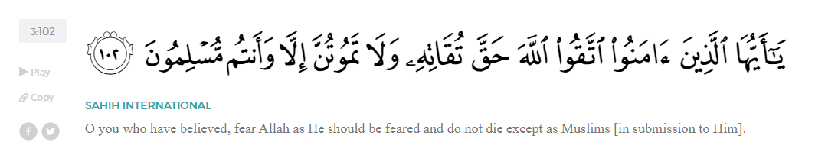
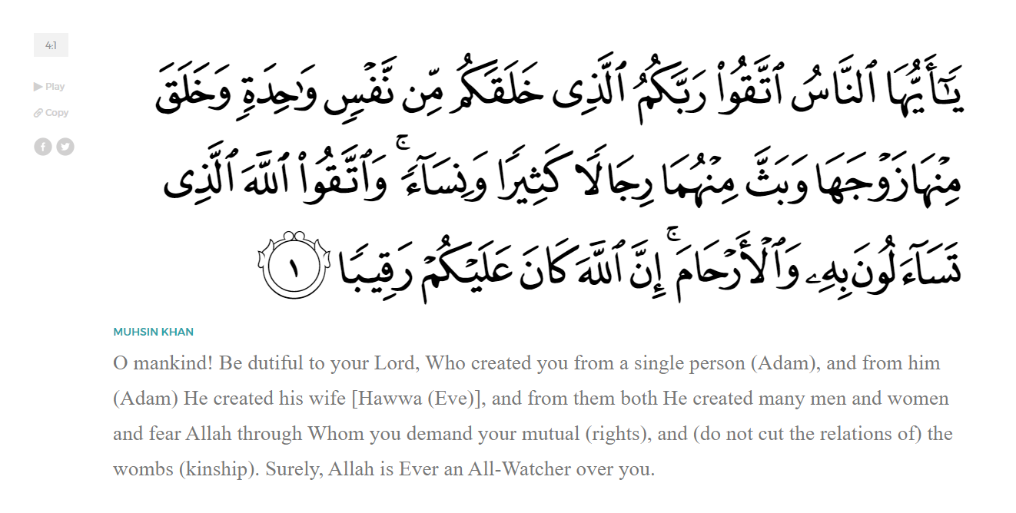
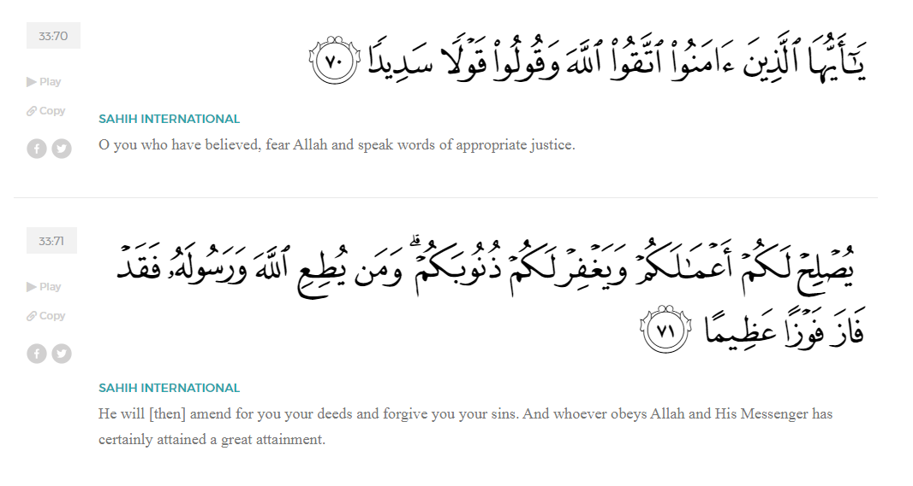
<Sirah of the Prophet (SAW) – Part 23 -Dr. Yassir Qadhi, Book and Series>
Dear brothers and sisters,
InshaaAllah we will continue our khutbah series on the seerah of the Prophet ﷺ, drawing from Dr. Yasir Qadhi’s book, The Sirah of the Prophet, so that we can deepen our understanding of his life and strengthen our love for him. Each step we take through the Prophet ﷺ’s life brings us closer to knowing him more deeply, appreciating his struggles, and embodying his character. Our goal in this series, inshaaAllah, is not just to learn history, but to let the seerah transform our hearts and strengthen our love for the Messenger of Allah ﷺ.
Today we will, inshaaAllah, start and complete the chapter titled “The Hijrah”.
Upon the Prophet ﷺ’s return from the Hajj meeting with the Ansaar, he ﷺ granted the Muslims permission to emigrate to Yathrib and they began doing so individually and in secret. Tensions in Makkah were at an all-time high, and the Quraysh would not allow anyone to openly emigrate without facing aggression and abuse. The first to emigrate was Abu Salamah ibn ‘Abd al-Asad (RA). Abu Salamah was not from the Quraysh, but in a rare occurrence, he joined the tribe in order to marry Umm Salamah, who was from the Quraysh. Abu Salamah and Umm Salamah had previously emigrated to Abyssinia, but when the rumors spread about the Quraysh accepting Islam and the Muslims returned to Makkah, they remained in Makkah whereas most of the emigrants returned to Abyssinia once more. They were among the few Muslims to have made two emigrations for the sake of Allah, and were known as “The People of Two Emigrations.”
As the first to emigrate, Abu Salamah packed his things openly, and as he began to leave, the Quraysh confronted him with unsheathed weapons. They said, “As for you, we have no right to stop you (I.E. as a non-Qurayshi), but as for your wife, she is ours. We will not let you take her or her son, as he is our son now.” Abu Salamah’s original tribe heard of this oppressive event, and their tribal pride made them march over to the Quraysh. They said, “The lady may be yours, but this boy is ours.” They physically took the boy by his arm, and the Quraysh held on to his other arm; they both began pulling until the young boy’s arm dislocated, and Umm Salamah cried out and pleaded that the Quraysh let them take the boy. In a most unfortunate turn of events, Abu Salamah was in Madinah, Umm Salamah was in Makkah, and their four-year-old son was elsewhere with a foreign tribe. Umm Salamah narrates, “For one year, I would go to al-Abtah (the furthest part of Makkah) every day, crying, until finally some of my cousins had sympathy with me and pleaded to the Quraysh to let me go.”
She was finally allowed to leave, so she took her son and marched into the desert on foot, alone, and without any belongings. By the time she got to Tan’im, she saw ‘Uthmaan ibn Talhah—who was not yet a Muslim—returning from an expedition. Shocked to see a woman and child alone in such a dangerous environment, susceptible to attacks from wild animals, foreign entities, or even starvation, ‘Uthman asked what she was doing alone. Umm Salamah declared that she was sufficed with Allah (SWT), but ‘Uthmaan replied, “By Allah, this will not be. I will take you.” Although he was not yet a Muslim, his innate chivalry and honor did not allow him to tolerate such injustice without intervening. Recalling this event, Umm Salamah said, “I do not think there is a more honorable gentleman than ‘Uthmaan. He walked the entire way from Makkah to Madinah while I rode his camel, and he did not talk except that when he stopped, he would gesture to the camel to stop and would turn around (so she could disembark in privacy). He would let me sleep under a tree while he slept next to the camel. He did so all the way home until when I could finally see the houses of Yathrib, he said, ‘Your husband lives there.”
The journey was over two weeks, and he would have returned to Makkah on foot. Allah (SWT) undoubtedly recompenses such noble acts, and ‘Uthmaan was eventually gifted the blessing of Islam. He converted before the Conquest of Makkah, granting him the honor of being amongst the upper levels of companions. Allah (SWT) states in Surat Al-Hadid:
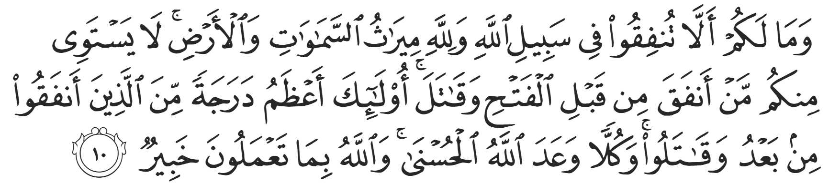
“And why should you not spend in the cause of Allah, while Allah is the ˹sole˺ inheritor of the heavens and the earth? Those of you who donated and fought before the victory [over Makkah] are unparalleled. They are far greater in rank than those who donated and fought afterwards. Yet Allah has promised each a fine reward. And Allah is All-Aware of what you do.” (57:10)
Moreover, Allah (SWT) granted the supreme honor of retaining the keys of the Ka’bah to ‘Uthmaan. Allah (SWT) revealed in the Qur’aan,
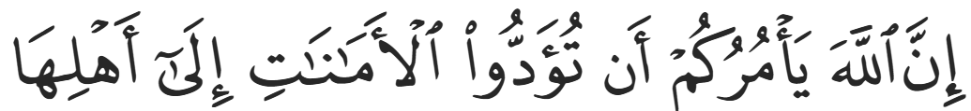
“Indeed, Allah commands you to return trusts to their rightful owners;” (4:58)
This verse was referring to the keys of the Ka’bah being given to ‘Uthmaan ibn Talhah (RA), so ‘Ali (RA) gave ‘Uthmaan the keys and said, “Allah (SWT) revealed something about you.” He then recited the aforementioned verse from Surah An-Nisaa. To this day, almost fifteen centuries later, the keys to the Ka’bah belong to the descendants of ‘Uthmaan ibn Talhah (RA), and indeed Allah’s rewards are never lost.
Ali ibn Abi Taalib (RA) narrates, “I don’t know of anyone who made the Hijrah publicly except ‘Umar ibn al-Khattab.” ‘Umar (RA) packed his bags, wore his armor, and performed tawaf armed with weapons. He then made an announcement, “O people of Makkah, whoever amongst you wishes that his mother lose him tonight, or that his children become orphans, or that his wife becomes a widow, know that I am performing the Hijrah, and you can meet me outside Makkah.”
Most other Muslims made the Hijrah to Madinah secretly.
On the 27th of Safar, the Prophet ﷺ became the last male adult to officially perform the Hijrah. There were a handful of women and children who emigrated after him but the Prophet ﷺ ensured that he was the last man to depart. Aaisha (RHAA) narrated, “We were sitting in our house in the peak of the afternoon heat and we saw a man walking with his face covered. As he approached, we realized that it was the Prophet ﷺ. We said to ourselves that the only reason he would be coming would be for an emergency.” The Prophet ﷺ said, “Remove everyone from the room.” Abu Bakr replied, “O Messenger of Allah, they are but your family.” The Prophet ﷺ then said, “Allah has given me permission to emigrate.” Abu Bakr (RA) replied yearningly, “[And my] companionship? I beg you, by my mother and father!” The Prophet ﷺ replied, “Yes.”
Aaishah (RHAA) then narrated, “I saw Abu Bakr cry, and I had never believed that people could cry out of happiness until I saw him cry out of happiness that day.” Abu Bakr (RA) then said, “O Messenger of Allah, I have prepared two camels, and one of them is yours.” The Prophet ﷺ replied, “Only if I pay you.” Even the Prophet ﷺ was keen on receiving the full reward for his emigration and thus did not want to rely on any gifts.
Abu Bakr (RA) had 40,000 dirhams before he accepted Islam, but only 5,000 dirhams at the time of emigration, as he spent most of it freeing slaves and in the path of Allah. When he emigrated, he took the entire amount with him and left nothing behind for his family. His father, Abu Quhaafah, had not yet accepted Islam and at this time was a stern opposer of Islam. He was a blind, bitter, elderly man armed with a sharp tongue. He approached his granddaughter, Asmaa’ bint Abi Bakr (RHAA), mocking his own son Abu Bakr (RA), for supposedly abandoning his family with no financial support. Asmaa’, in her quick-wittedness, quietly filled a pouch with pebbles, tied it up, and handed it to Abu Quhaafah, saying, “No, my grandfather. He has left us this.” As a blind man, he picked up the bag and felt its weight and was taken aback, so he recanted his criticism. Asmaa’ (RHAA) recalled that indeed her father did not leave them a single penny; he knew they would be safe in Makkah and so he put his trust in Allah, whereas he was accompanying the Prophet ﷺ in the wilderness and would need extra money for safety.
Imam Ahmad (RA) states that Allah (SWT) revealed a verse in the Qur’aan describing the night of the Hijrah in Surat Al-Anfaal:
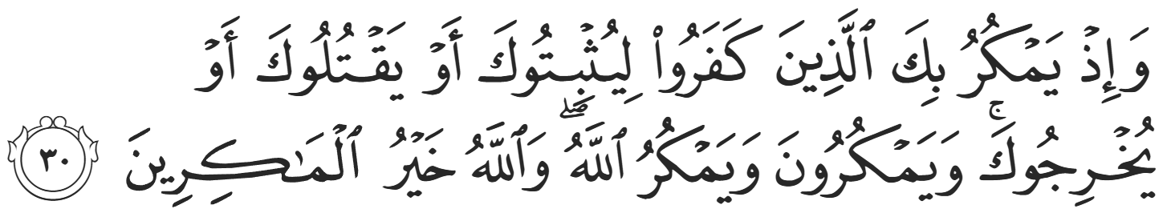
“And ˹remember, O Prophet,˺ when the disbelievers conspired to capture, kill, or exile you. They planned, but Allah also planned. And Allah is the best of planners.” (8:30)
Allah (SWT) described the Quraysh gathering in the Dar al-Nadwah of Makkah—their parliamentary meeting place—to find a final solution to deal with the Prophet ﷺ and the religion of Islam. The Quraysh gathered with the exception of the Banu Haashim; while the likes of Abu Lahab had no issue with plotting against the Prophet ﷺ, it would have been a public disgrace according to tribal politics if he were to allow such an event to occur regarding his own tribesman. He was therefore not invited so that he could claim ignorance of the matter and save face.
The entirety of the Quraysh—except for Abu Lahab and Mut’im ibn Adiyy (because the Prophet ﷺ was living under Mut’im’s protection)—gathered to finally put a stop to the Prophet ﷺ. The first suggestion was to imprison him ﷺ, but imprisonment was an alien concept to the Arabs—it was considered inhumane and impractical. Shaytan physically placed himself amongst the crowd and said, “If you imprison him, his words will still reach his followers.” The second suggestion was to exile him, but Shaytaan responded, “Sending him into exile is to send him back to his followers.” Abu Jahl, the worst of them, then said, “You still haven’t said what everyone is thinking: why don’t we kill him? We will do it in a way where no single tribe can be blamed; each tribe will nominate a young man and they will all attack him in unison so that no single person is to blame. The Banu Haashim won’t be able to declare war and will be forced to accept blood money.” Shaytaan then said, “This is the right decision.” The Quraysh agreed, nominated their tribe members, and sent them immediately to the Prophet’s house. Jibril (AS) descended and informed the Prophet ﷺ that he must leave for the Hijrah immediately.
The Prophet ﷺ instructed Ali (RA) to lie in his bed and cover himself as a decoy as he ﷺ slipped out into the dead of the night with Abu Bakr (RA). As they left Makkah, he ﷺ turned around and addressed his hometown saying, “You are the most blessed land on Earth, and the most beloved to me; were it not for the fact that my own people expelled me, I would not have left you.” The Prophet ﷺ used the exact same wording that Waraqah ibn Nawfal did over 13 years ago which transpired exactly as forewarned. The Prophet ﷺ could not comprehend Waraqah’s words at the time, but 13 years later, he lived them.
The Prophet ﷺ and Abu Bakr (RA) headed straight to Cave Thawr and remained there for three days and three nights in a bid to throw the Quraysh off their scent. It is worth noting that Cave Thawr is a three-hour walk southward of Makkah, the exact opposite direction to Madinah, which is northbound. This demonstrates the extent to which they planned their trip in such meticulous detail. This provides an invaluable lesson in the implementation of tawakkul; it is not blind faith in Allah (SWT) without planning; rather, tawakkul is to plan to the best of our ability and leave the rest to Allah (SWT) with full belief and confidence.
Abu Bakr (RA) had even arranged for his household to carry out tasks after they left. He instructed his son, ‘Abdullah, to bring food and water to the cave. He was also instructed to listen in on the Quraysh’s gatherings, as he was a young boy and they did not take much notice of him. ‘Aamir ibn Fuhayrah was Abu Bakr’s freed slave who felt a strong sense of loyalty and allegiance to him, so he was tasked with erasing the footprints of ‘Abdullah as he went out every morning. ‘Aamir was a shepherd, so he would take out his flock and wipe out ‘Abdullah’s footprints without arousing suspicion.
After eventually realizing that they took a detour, the Quraysh began to look in all directions. They entered upon Cave Thawr, which was an extremely small crevice barely big enough for two men. The Prophet ﷺ and Abu Bakr (RA) were hiding below the cave when they heard footsteps above them. Abu Bakr whispered to the Prophet ﷺ, “If they just look down to their feet, they will see us.” The Prophet ﷺ said, “O Abu Bakr, what do you think about two men whose third is Allah?” There are numerous famous stories surrounding this event which lack authenticity, such as spiders making webs, trees leaning forward, and pigeons setting up nests to block the Quraysh from seeing them. The authentic reports simply state that the Prophet ﷺ reassured Abu Bakr (RA), and Allah (SWT) protected them.
After three days and three nights in Cave Thawr, they met with an expert guide, ‘Abdullah ibn Urayqit, to decipher the best hidden route to Madinah, without leaving themselves exposed in the open. A bounty of 100 camels was offered to find the Prophet ﷺ, dead or alive. A man named Suraaqah ibn Maalik, the leader of the Ju’shum tribe outside Makkah, heard someone talking about three men riding in a particular direction. Suraaqah became greedy and wanted the full bounty for himself, so he said, “No, that is so-and-so who said they are going on an expedition.” Afterwards, Suraaqah slipped away, took his warhorse, and galloped in that direction. Eventually, he saw them from a distance, describing one rider as very agitated, alternating between the front and the back, constantly looking around, and a second rider completely serene, reciting something, not once turning left or right. The first rider was Abu Bakr, worried about the Prophet ﷺ, and the second rider was the Prophet ﷺ, reciting the Qur’aan, steadfast in his mission.
As soon as Suraaqah saw them, his horse sunk into the ground, and flipped him over—something that had never happened before. He then pulled out his azlaam, an ancient, Pagan version of tarot cards used to predict the future. He threw them onto the sand, and the cards instructed him not to proceed. In his greed, he ignored the message and proceeded, and his horse flipped him over once more. It then occurred a third time, and Suraaqah narrated, “I knew that this was a force beyond me.” He then called out to the Prophet ﷺ clarifying that he wanted to approach in peace. Suraaqah narrated that he knew that the Prophet’s Message would spread successfully, and so he asked the Prophet ﷺ for written protection that he could use when Muslims came to power. Almost instantaneously, Suraaqah went from hunting the Prophet ﷺ to requesting his protection. Afterwards, Suraaqah informed the Quraysh of what happened, to which Abu Jahl wrote a scathing poem, criticizing him in the harshest terms. Suraaqah replied, “If you had been there that day, and you saw what I saw, you would not say what you are saying.”
When Suraaqah turned to leave, the Prophet ﷺ said, “O Suraaqah, how will you be on the day that you put on the bracelets of Kisra?” Taken aback, Suraaqah replied, “Kisra, the son of Hurmuz?” There was only one infamous Kisra, but Suraaqah could not fathom the idea. The Prophet ﷺ turned away without responding, leaving Suraaqah to ponder. Many years later, after the Battle of Hunayn, Suraaqah approached the Prophet ﷺ with the piece of cloth promising his protection, asking for safe passage and permission to accept Islam. Years after that, following the Battle of Qadisiyyah, the Islamic caliphate under the rule of ‘Umar ibn al-Khattab (RA) conquered the Persian Empire. ‘Umar called for Suraaqah, placed him on Kisra’s throne, and placed Kisra’s bracelets on his wrists, thus fulfilling the prophecy. The Companions broke into a euphoric chant of “Allahu Akbar!” and Suraaqah was paraded around the city of Medina wearing Kisra’s bracelets.
With all their planning and the help of Allah (SWT), the Prophet ﷺ successfully made the Hijrah to Madinah.
<Conclude 1st Khutbah with:
Aqoolu haathaa wa astaghfir-Allaah (I say this and I ask Allah for forgiveness)
أَقُولُ قَوْلِي هَذَا وَأَسْتَغْفِرُ اللَّهَ لِي وَلَكُمْ وَلِسَائِرِ المُسْلِمينَ وَالمُسْلِمَاتْ فَاسْتَغْفِرُوهْ إِنَّهُ هُوَ الْغَفُورُ الرَّحِيمُ
الحمد لله رب العالمين والصلاة والسلام على سيد المرسلين وعلى آله وأصحابه أجمعين
<2nd Khutbah>
Dear brothers and sisters,
Allah (SWT) commanded the remaining believers to make the Hijrah. This was primarily addressing the new converts to Islam in Makkah as well as any secret Muslims who were yet to disclose their conversion publicly. Over the course of a number of verses, gradually increasing in encouragement and warning, Allah’s counsel became a stern legal order. The first of the verses was in Surah al-Hajj:
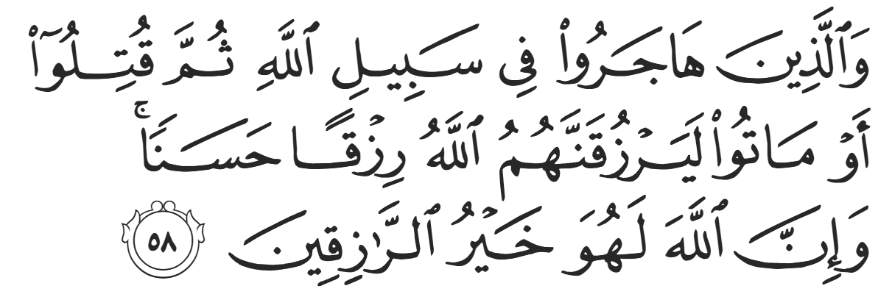
“As for those who emigrate in the cause of Allah and then are martyred or die, Allah will indeed grant them a good provision. Surely Allah is the Best Provider.” (22:58)
This is contrasted to the verses of Surah al-Nisaa revealed two to three years later:
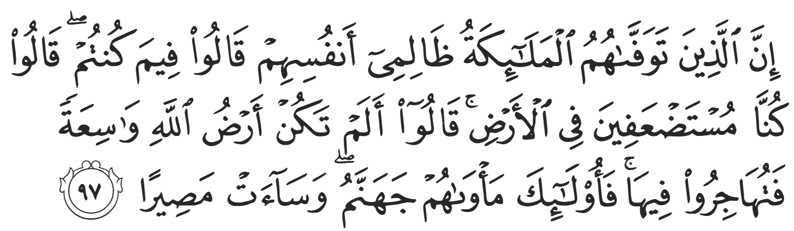
“When the angels seize the souls of those who have wronged themselves—scolding them, “What was wrong with you?” they will reply, “We were oppressed in the land.” The angels will respond, “Was Allah’s earth not spacious enough for you to emigrate?” It is they who will have Hell as their home—what an evil destination!” (4:97)
It is the Sunnah of Allah to implement laws gradually for the believers to digest and reflect. For example, the prohibition of consuming alcohol was implemented over a number of years. First, Allah (SWT) revealed,
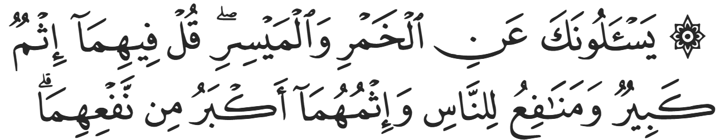
“They ask you ˹O Prophet˺ about intoxicants and gambling. Say, “There is great evil in both, as well as some benefit for people—but the evil outweighs the benefit.”” (2:219)
Then Allah (SWT) revealed:
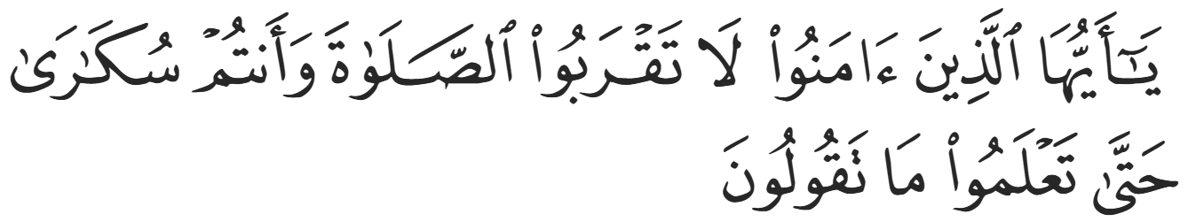
“O believers! Do not approach prayer while intoxicated until you are aware of what you say.” (4:43)
Finally, the prohibition was absolute after the verse in Surat Al-Maaidah:
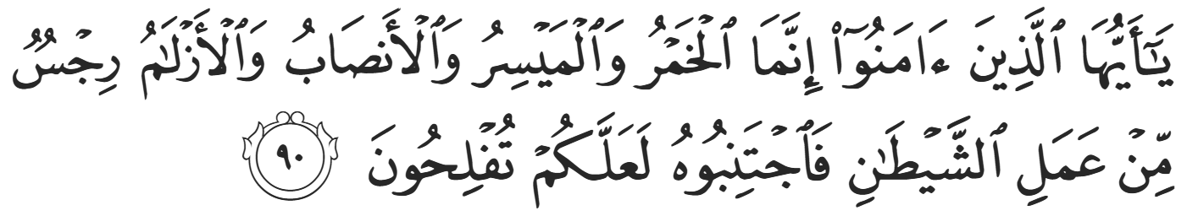
“O believers! Intoxicants, gambling, idols, and drawing lots for decisions are all evil from the work of Shaytan, so shun them so you may be successful.” (5:90)
This example perfectly illustrates Islam’s approach to reform: allowing people time to understand and adapt, while gradually instilling lasting change.
The stern verses of Surah al-Nisaa regarding the Hijrah were revealed after some Muslims died on the battlefield in the Battle of Badr on the side of the Quraysh. There were Muslims who did not yet feel ready to disclose their faith, and they continued to live amongst the Quraysh. When the Battle of Badr ensued, they were forced to participate on behalf of the Quraysh, and while they did not actively fight or kill any Muslims, some of them died from arrows or in the commotion of war. Allah (SWT) then revealed the previously mentioned verses detailing their conversations with the Angels—years after being initially instructed to partake in the Hijrah. Ibn Abbas (RA) explains that they were told by Allah that they have no excuse not to emigrate, and that they were sent this verse. Some Muslims then tried to emigrate, and the Quraysh dissuaded them. Allah (SWT) then revealed verses of Surah al-Ankabuut,
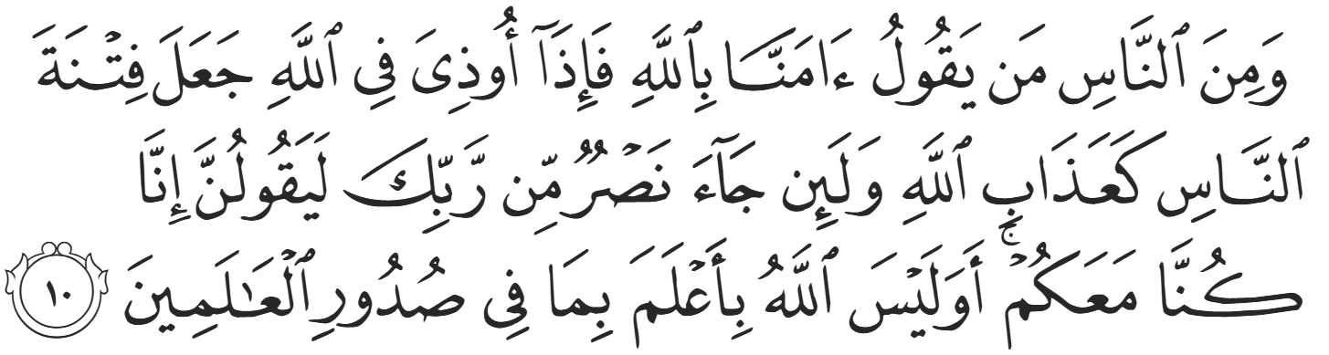
“There are some who say, “We believe in Allah,” but when they suffer in the cause of Allah, they mistake ˹this˺ persecution at the hands of people for the punishment of Allah. But when victory comes from your Lord, they surely say ˹to the believers˺, “We have always been with you.” Does Allah not know best what is in the hearts of all beings?” (29:10)
Allah (SWT) uses the verb “udhiya” which can be translated as “irritated” or “hurt”, denoting the minuscule nature of their test in comparison to the cause.
Junda’ ibn Damrah (RA) was a Muslim in Makkah when this verse was revealed. However, he was blind and decrepit; he was so old that he could not physically walk. Nevertheless, when he heard this verse, he said, “I am not of those who have an excuse. I will not spend another night in Makkah.” He then ordered his servants to lift him up from his bed and carry him outside the city. He had no feasible plan of getting to Madinah, so he put his trust in Allah, and Allah (SWT) bestowed His Mercy and caused him to pass away in Tan’eem, just outside Makkah. As he was dying, he put his right hand onto his left hand and said, “O Allah, this is my pledge of allegiance to the Prophet ﷺ.” When the Muslims in Madinah heard, they bemoaned his case, citing that he “almost” made it. Allah (SWT) then revealed the next two verses of Surat an-Nisaa, which say in translation “…except helpless men, women, and children who cannot afford a way out. It is right to hope that Allah will pardon them. For Allah is Ever-Pardoning, All-Forgiving.”
After the Battle of Khandaq in the year 5 After-Hijrah, the rules surrounding Hijrah became more relaxed. After the Conquest of Makkah in the year 8 After-Hijrah, the ruling was abrogated. The Prophet ﷺ said, “There is no Hijrah after the Conquest [of Makkah].” The Prophet ﷺ was referring to “Hijrah” with the capital “H”, referring to the divinely ordained Emigration from Makkah to Madinah. The Prophet ﷺ did not forbid emigrating for the sake of Allah thereafter, but the special status, as well as the legal obligation of the Emigration ceased. After Makkah was liberated, the official phase of Emigration was over, as Makkah was finally under Islamic rule. Fudayk (RA), a new Muslim in a Pagan land, once approached the Prophet ﷺ and said, “O Messenger of Allah, the people are saying ‘Whoever does not do hijrah will be destroyed.’ And my people are upon shirk.” The Prophet ﷺ replied, “O Fudayk, establish the prayer, avoid evil deeds, and live with your people wherever you like.”

<Duaa!>
- Oh Allah, please grant us a deep love for Your Prophet Muhammad, SAW.
- Oh Allah, please make us energetic in doing good for Your cause.
- Oh Allah, please enable us with the will and means to walk Al-Sirrat-Al-Mustaqeem, even if it estranges us from others.
- Oh Allah, please support the suffering and oppressed Muslims around the world and grant them victory over that which oppresses them.
- Oh Allah, please protect us from ever being overburdened by debt and protect us from all evils and undesirable consequences associated with having debt.
- Oh Allah, please fill our hands with the work and deeds of righteousness and let them be of benefit to ourselves and the Ummah.
- Oh Allah, please forgive us our shortcomings and deviances in following your Qur'an and the Sunnah of Rasul'Allah, SallAllahuAlayhiWaSallam.
- Oh Allah, please grant us understanding and guidance of Your Qur'aan
- Oh Allah, please grant us patience with the trials of this world.
- Oh Allah, please prevent our hearts from getting overly attached to the Dunya and grant us the best in this life and the best in the hereafter.
- Oh Allah, please forgive us our past sins and make us Your devoted servants.
- Oh Allah, please make us amongst those whose Duaa is accepted.
- Oh Allah, please grant us Jannat'ul Firdaus and protect us from ever coming close to the Fires of Jahannum.

