Khut'bah Opening
إِنَّ الْحَمْدَ للهِ , نَحْمَدَهُ وَ نَسْتَعينُهُ وَ نَسْتَغْفِرُهُ , وَ نَعوذُ بِالله مِنْ شُرورِ أَنْفُسِنا , مَن يَهْدِهِ اللهُ فَلا مُضِلَّ لَه , وَ مَنْ يُضِلِلْ فَلا هادِيَ لَهْ , وَ أَشْهَدُ أَنْ لا إلهَ إِللهُ وَحْدَهُ لا شَريكَ لَه , و أَشْهَدُ أنَّ مُحَمَّدًا عَبْدُهُ و رَسولُه.
"All thanks and praises are due to Allah, whom we thank, seek for help and invoke for forgiveness. We seek refuge with Allah from the evils within ourselves. He whom Allah guides will never be misled and he whom He misguides will never find one to guide him. I bear witness that there is no deity worthy of worship except Allah and that Muhammad (SAW) is His slave and Messenger.”
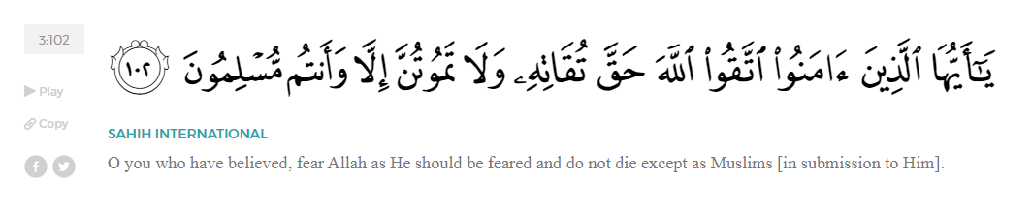
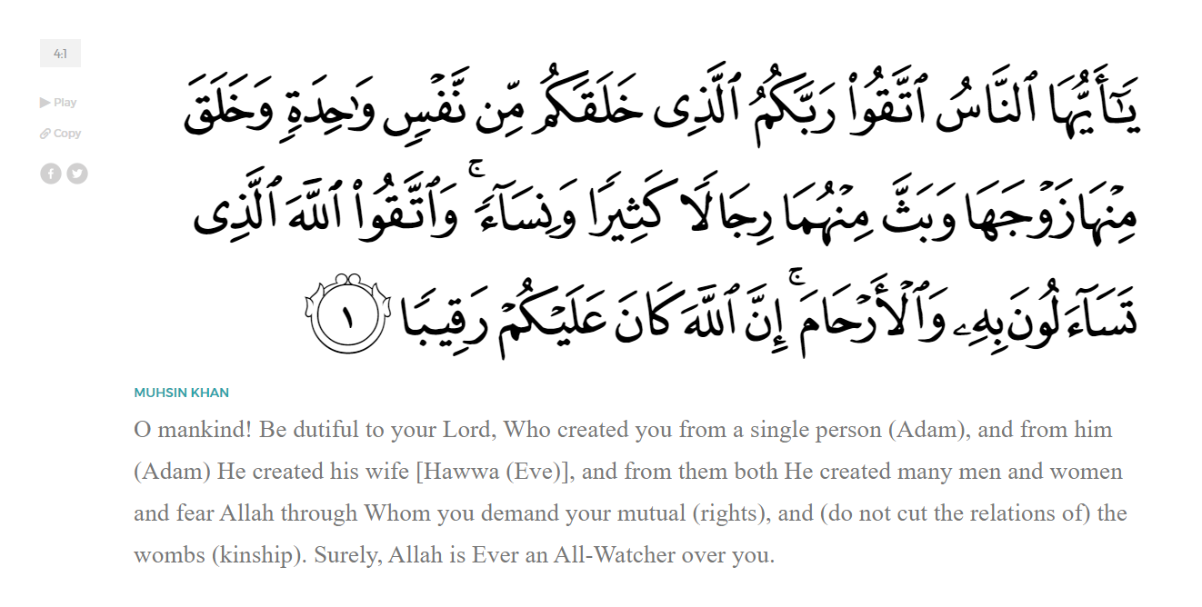
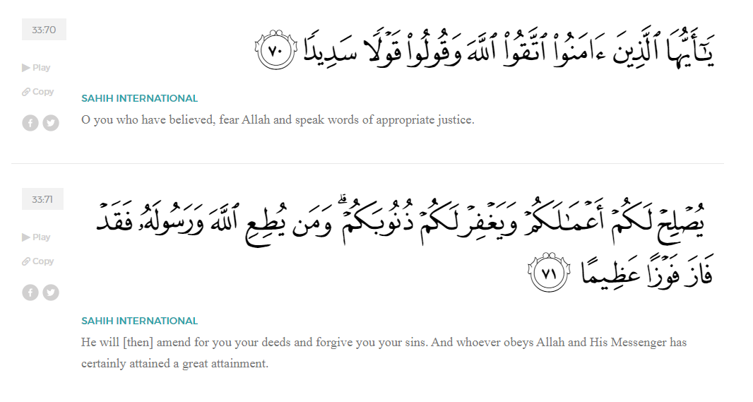
<Sirah of the Prophet (SAW) – Part X -Dr. Yassir Qadhi, Book and Series>
Dear brothers and sisters,
InshaaAllah we will continue our khutbah series on the seerah of the Prophet ﷺ, drawing from Dr. Yasir Qadhi’s book, The Sirah of the Prophet, so that we can deepen our understanding of his life and strengthen our love for him. Each step we take through the Prophet ﷺ’s life brings us closer to knowing him more deeply, appreciating his struggles, and embodying his character. Our goal in this series, inshaaAllah, is not just to learn history, but to let the seerah transform our hearts and strengthen our love for the Messenger of Allah ﷺ.
Today we will, inshaaAllah, begin the Medinan Era, starting with the chapter titled “Establishing a Muslim Nation”.
Madinah’s original name was Yathrib, but the Prophet ﷺ renamed the city Madinah, discouraging the use of the name Yathrib. The official name then became “Madinah Rasul Allah”—City of the Messenger of Allah. It is also referred to as al-Madinah al-Munawwarah –The Enlightened City. The Prophet ﷺ also called it “Taybah” and “Taaba”, both meaning “pure”. The word “Yathrib” means “to criticize”, and the Prophet ﷺ disallowed names with bad meanings; he ﷺ said, “Whoever says ‘Yathrib’ should seek forgiveness from Allah, for it is Taaba, for it is Taaba, for it is Taaba.”
The Prophet ﷺ would always make du’aa for Madinah. He ﷺ said about Mount Uhud in Madinah, “This is a mountain that we love, and it loves us.” And he ﷺ would say, “Uhud is a mountain in Jannah.” The Prophet ﷺ also spoke of the protection of Madinah saying, “The Dajjaal-the Antichrist—will not be able to enter Madinah. On that day it will have seven gates, each one guarded by two Angels.” And he ﷺ would say, “Neither the Dajjaal nor plagues will ever infest it.” The Prophet ﷺ said, “No-one shall plot to harm Madinah except that Allah will dissolve him like salt is dissolved in water.” The Prophet ﷺ made du’aa that Madinah be blessed, “O Allah, give us blessings in this City of ours.” And, “O Allah, your servant and friend Ibraheem, declared Makkah sacred. I too am your servant and Messenger, and I declare Madinah sacred.”
Madinah is a safe haven for the believer, as he ﷺ said, “Imaan returns to Madinah just as a desert animal returns to its hole in the desert.” And he ﷺ said, “No-one leaves Madinah not wanting to live there except that Allah (SWT) will replace them with someone better.” The Prophet ﷺ will even offer intercession on the Day of Judgement for those who die in Madinah, he ﷺ said, “Whoever amongst you is able to die in Madinah, do so, because I will intercede on behalf of anyone who dies there.”
When the Companions first moved to Madinah, they had a very difficult time acclimating to their new surroundings; the climate was different to Makkah, the terrain was new, but most importantly, they were simply feeling homesick. Many of the companions were both emotionally and physically sick in the first few weeks of life in Madinah, so the Prophet ﷺ made a very special du’aa, “O Allah, cause us to love Madinah as much as we love Makkah or even more.” Ever since that du’aa, Madinah has held a special place in the heart of the believers, and this remains true to this day.
The city of Madinah was comprised of a collection of subtribes, each of which occupied their own area, usually separated by expanses of desert or date palm plantations. After the Hijrah, the Prophet ﷺ first arrived in the settlement of Quba’ and then waited for Ali (RA) as well as Abu Bakr’s two daughters, Aaishah and Asmaa (RHUMA) to join them. Ali remained in Makkah for a short while to attend to the Prophet’s remaining affairs, such as returning valuable items to their owners. Without a centralized banking system, the Quraysh had a custom of entrusting valuable items to one another, especially when embarking on travel. Despite their tensions with the Prophet ﷺ, most people left their belongings with the Prophet ﷺ, as he was known to be the most trustworthy, hence his title “al-Ameen (The Trustworthy)”. Once again, this is a testament to his standing amongst his peers, and even his enemies.
There were makeshift masjids in Madinah, as the Muslims had been praying openly in peace, unlike the persecuted Muslims of Makkah who prayed in secret. However, the first purpose-built masjid was built by the Prophet ﷺ in Quba when he first arrived. The Prophet ﷺ laid down the first stone, followed by Abu Bakr (RA), and then the Ansaar (RHUM). The Prophet ﷺ then set off for Madinah to reunite with the Muslims. He ﷺ continued to pray in Masjid Quba every week; Ali ibn Abi Taalib (RA) narrates that he ﷺ would either walk or ride his camel every single week, usually on Mondays, and that he ﷺ said, “Whoever does ablution in his house and prays in Masjid Quba will receive the reward of a full ‘Umrah.” Allah (SWT) even revealed a verse in the Qur’aan in praise of Masjid Quba in Surat Tawbah:
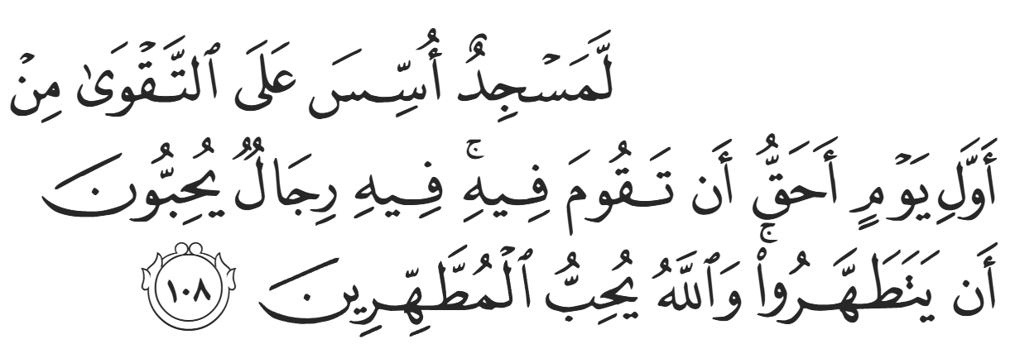
“Certainly, a mosque founded on righteousness from the first day is more worthy of your prayers. In it are men who love to be purified. And Allah loves those who purify themselves.” (9:108)
<Conclude 1st Khutbah with:
Aqoolu haathaa wa astaghfir-Allaah (I say this and I ask Allah for forgiveness)
أَقُولُ قَوْلِي هَذَا وَأَسْتَغْفِرُ اللَّهَ لِي وَلَكُمْ وَلِسَائِرِ المُسْلِمينَ وَالمُسْلِمَاتْ فَاسْتَغْفِرُوهْ إِنَّهُ هُوَ الْغَفُورُ الرَّحِيمُ
الحمد لله رب العالمين والصلاة والسلام على سيد المرسلين وعلى آله وأصحابه أجمعين
<2nd Khutbah>
Dear brothers and sisters…
The Prophet ﷺ continued towards Madinah. As he was mid-journey, it was time for the Friday Prayer, so he stopped at the tribe of the Banu Salamah. The Prophet’s first Friday Sermon, therefore, was neither in Masjid Quba nor the yet-to-be-built Prophet’s Masjid. The Companions were already praying the Friday Prayer in Madinah, as it was commanded by the Prophet ﷺ for Muslims in freedom, and so the Friday Prayer is a rare instance whereby the Companions implemented an act of worship before the Prophet ﷺ.
The Prophet ﷺ stood up and gave a very brief sermon. In fact, every one of the Prophet ﷺ’s recorded sermons were three to five minutes long, and the prayers were much longer. He ﷺ said, “It is a sign of understanding that a person shortens the sermon and lengthens the prayer.” This is contrary to modern customs of giving long sermons and brief prayers. The Prophet ﷺ then gave the following sermon:
“All praise is for Allah. I praise Him, I ask for His Assistance, seek His Forgiveness, and request His Guidance. I believe in Him and I do not deny Him, and I oppose those who disbelieve in Him. I bear witness that there is no deity worthy of worship except Allah, alone and without partners, and that Muhammad is His slave and Messenger sent with guidance, light, and sincere advice, at a point when no Messengers had arrived for some time, knowledge had decreased, people were misguided, time stood still, the Hour had drawn close, and the appointed term was imminent.
Whoever obeys Allah and His Messenger is on the right path, and whoever disobeys them has been negligent, gone astray, and is greatly misguided. I advise you to be conscious of Allah, for the best advice one Muslim can give another is to prepare for their Hereafter and to be conscious of Allah. So, take heed of that which Allah has warned you about Himself. That is the best advice and the best reminder. Whoever embodies taqwa-God consciousness- out of fear and trepidation, and sincerely seeks assistance, will attain whatever they desire in the Hereafter. Whoever rectifies his relationship with Allah in private and public, purely for the sake of His Face, will be remembered and honored in this life, and his good deeds will be stored for after his death, when a person will be in need of what they sent forward and will find nothing else. Then, he “will wish that his misdeeds were far off. And Allah warns you about Himself. And Allah is Ever Gracious to His servants.” (imraan:30)
Allah is the One who spoke the truth and fulfilled His Promise. It is a promise that can never be abandoned, for Allah Exalted says,
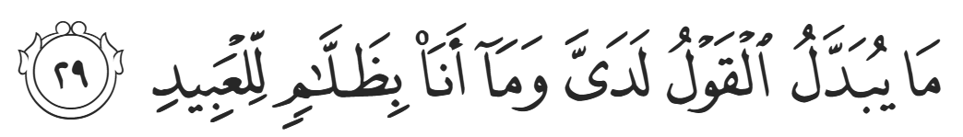
‘My Word cannot be changed, nor am I unjust to My creation’ (50:29)
Be conscious of Allah in your affairs of this world and of the Hereafter, in private and in public,
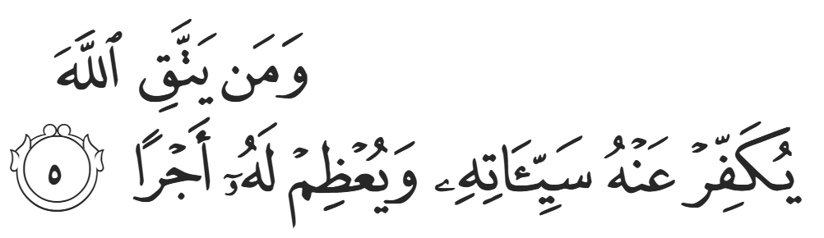
“…Whoever is mindful of Allah, He will absolve them of their sins and reward them immensely.” (65:5)
And whoever is mindful of Allah ‘has truly achieved a great triumph’
Consciousness of Allah repels His anger, punishment, and wrath. Consciousness of Allah brightens one’s face, pleases one’s Lord, and raises one’s rank. So, take your blessings, and do not neglect your relationship with Allah. Allah has taught you His Book and explained His Way, so that He can ‘clearly distinguish between those who are truthful and those who are liars’.
So, be good, just as Allah was good to you, oppose His enemies, and ‘strive for the cause of Allah in the way He deserves, for it is He Who has chosen you… and named you “the ones who submit’”, so that ‘those who were to perish and those who were to survive might do so after the truth had been made clear to both.’
There is no strength except with Allah, so increase in your remembrance of Him, and work for what comes after death. Whoever rectifies his relationship with Allah will be sufficed in his relationship with the people, because Allah judges over the affairs of the people, but the people do not judge Allah; and Allah owns the possessions of the people, but the people do not own the possessions of Allah. Allah is greater, and there is no strength except with Allah, the Most High, the Almighty.
Another source states that he ﷺ also said:
“To proceed: O people, send forward good deeds for yourselves, and know with certainty, by Allah, that one of you will be struck unconscious and will leave his sheep without a shepherd. Then his Lord will say to him, without any intermediary or barrier: ‘Did my Messenger not come and convey My Message to you? Did I not give you wealth and bless you? So, what have you sent forward for yourself?’ The person will look to his right and his left, but he will not see anything. Then he will look forwards, but he will only see the Hellfire. So, whoever is able to protect his face from the Fire, even with half a date, then let him do so. And whoever cannot find even that, then let him say a good word, for the reward of a good action is multiplied by at least ten times, and up to seven hundred times.”
The Prophet ﷺ then stood up for the second time and said the Khutbah al-Haajah:
“All praise is for Allah. I praise Him and ask for His assistance. We seek refuge with Allah from the wrong-doing of our souls and the evil of our actions. Whoever Allah guides, no-one can misguide, and whoever Allah misguides, no-one can guide, and I bear witness that there is no deity worthy of worship except Allah.”
He ﷺ then continued:
“The best of speech is the Book of Allah. If Allah beautifies His Book in a person’s heart, then he has succeeded. He enters Islam after disbelief, and chooses it above all other speech. Certainly, it is the best speech and the most eloquent. Love those whom Allah loves, and love Allah with all your hearts. Do not tire of the Speech of Allah or His Remembrance, and do not allow your hearts to harden. From everything Allah creates, He chooses and prefers something, then names it the best of His works, the best of His servants, and the best of speech. From everything halal and haraam He has given humankind, you should worship Allah, not associate anything with Him, and be conscious of Him in the way He deserved. Be sincere to Allah with the righteous words that leave your tongue, and love one another with the Spirt of Allah between you. Allah hates that you break His Covenant. May peace be upon you, and the Mercy and Blessings of Allah.”
The Prophet’s speech was profoundly concise and impactful. As mentioned earlier, the Khutbah al-Haajah alone led to the likes of Dimaad al-Azdi to convert to Islam. The Prophet ﷺ urged the companions to donate; if there were ever a time where funds were most vital, it was the start of Islamic civilization. He ﷺ reminded them of the reality of life and certainty of death. He gave them hope of Paradise while reminding them of the consequences of their actions and the punishment of Allah (SWT). The Prophet ﷺ’s sermons were perfectly balanced between spirituality and practical application. He ﷺ rallied the Companions to purify their hearts and love Allah (SWT) with the entirety of their heart. He ﷺ instructed them to never tire of two acts of worship: reading the Qur’aan, and doing dhikr (remembrance) of Allah, lest their hearts harden. He then concluded by instructing the Companions to love one another for the sake of Allah (SWT) and then swiftly reminded them that they have a promise to Allah to fulfil.

<Duaa!>
- Oh Allah, please grant us a deep love for Your Prophet Muhammad, SAW.
- Oh Allah, please make us energetic in doing good for Your cause.
- Oh Allah, please enable us with the will and means to walk Al-Sirrat-Al-Mustaqeem, even if it estranges us from others.
- Oh Allah, please support the suffering and oppressed Muslims around the world and grant them victory over that which oppresses them.
- Oh Allah, please protect us from ever being overburdened by debt and protect us from all evils and undesirable consequences associated with having debt.
- Oh Allah, please fill our hands with the work and deeds of righteousness and let them be of benefit to ourselves and the Ummah.
- Oh Allah, please forgive us our shortcomings and deviances in following your Qur'an and the Sunnah of Rasul'Allah, SallAllahuAlayhiWaSallam.
- Oh Allah, please grant us understanding and guidance of Your Qur'aan
- Oh Allah, please grant us patience with the trials of this world.
- Oh Allah, please prevent our hearts from getting overly attached to the Dunya and grant us the best in this life and the best in the hereafter.
- Oh Allah, please forgive us our past sins and make us Your devoted servants.
- Oh Allah, please make us amongst those whose Duaa is accepted.
- Oh Allah, please grant us Jannat'ul Firdaus and protect us from ever coming close to the Fires of Jahannum.

