Khut'bah Opening
إِنَّ الْحَمْدَ للهِ , نَحْمَدَهُ وَ نَسْتَعينُهُ وَ نَسْتَغْفِرُهُ , وَ نَعوذُ بِالله مِنْ شُرورِ أَنْفُسِنا , مَن يَهْدِهِ اللهُ فَلا مُضِلَّ لَه , وَ مَنْ يُضِلِلْ فَلا هادِيَ لَهْ , وَ أَشْهَدُ أَنْ لا إلهَ إِللهُ وَحْدَهُ لا شَريكَ لَه , و أَشْهَدُ أنَّ مُحَمَّدًا عَبْدُهُ و رَسولُه.
"All thanks and praises are due to Allah, whom we thank, seek for help and invoke for forgiveness. We seek refuge with Allah from the evils within ourselves. He whom Allah guides will never be misled and he whom He misguides will never find one to guide him. I bear witness that there is no deity worthy of worship except Allah and that Muhammad (SAW) is His slave and Messenger.”
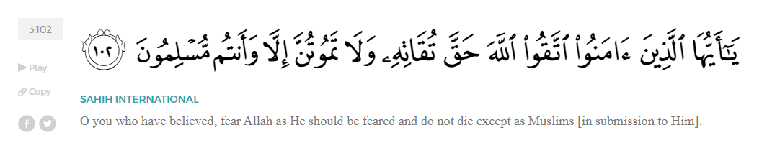
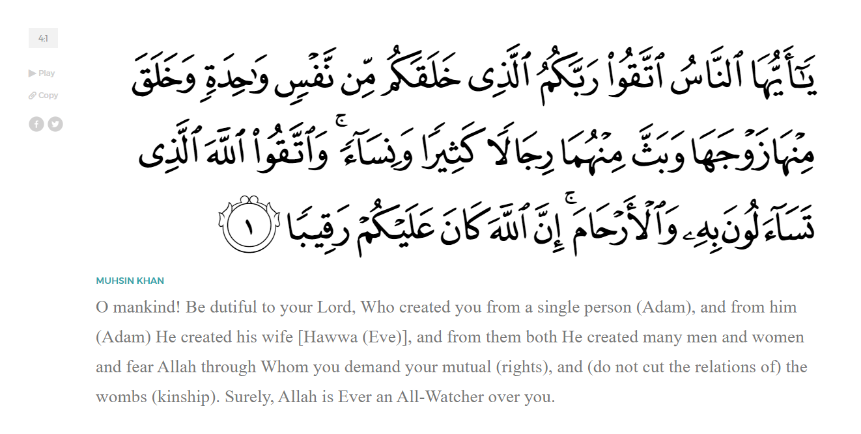
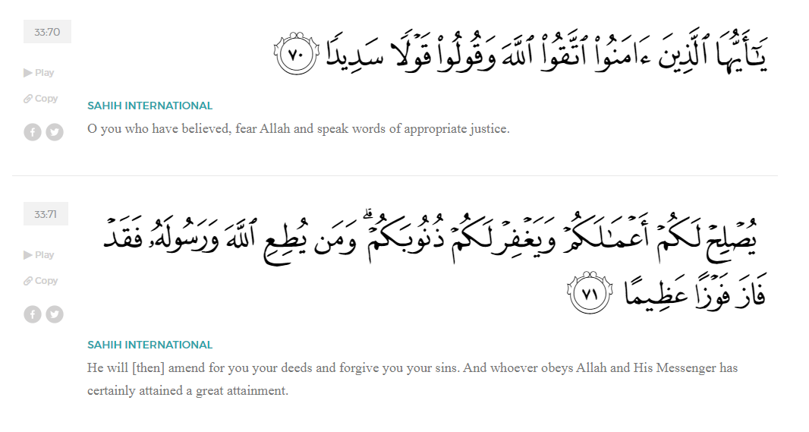
<Sirah of the Prophet (SAW) – Part X -Dr. Yassir Qadhi, Book and Series>
Dear brothers and sisters,
InshaaAllah we will continue our khutbah series on the seerah of the Prophet ﷺ, drawing from Dr. Yasir Qadhi’s book, The Sirah of the Prophet, so that we can deepen our understanding of his life and strengthen our love for him. Each step we take through the Prophet ﷺ’s life brings us closer to knowing him more deeply, appreciating his struggles, and embodying his character. Our goal in this series, inshaaAllah, is not just to learn history, but to let the seerah transform our hearts and strengthen our love for the Messenger of Allah ﷺ.
Today we will, inshaaAllah, continue with the chapter titled “Establishing a Muslim Nation”.
As we discussed previously, the Prophet ﷺ completed the Hijrah and arrived in Quba, where he began establishing the first foundations of the Muslim community before proceeding into Madinah. The Prophet ﷺ continued to Madinah, and the Ansaar heard of his imminent arrival and rushed to greet him. The children of Madinah were running in the streets, yelling, “The Messenger of Allah has arrived!” Even the young women ascended to the tops of their houses asking, “Which one of them is he? Which one of them is he?” The arrival of the Prophet ﷺ in Madinah signified a new era in Islamic history—that of strength, growth, and excitement.
The Prophet ﷺ’s arrival was an event that engulfed the entirety of Madinah. In anticipation, the Ansaar would head to the outskirts of the city every morning and wait until the midday heat was too strong to remain outside. When the Prophet ﷺ did arrive, a Jewish worker plucking dates from the top of a tree was the first to notice, and in his excitement, he yelled, “O Arabs, your King has arrived!” The fact that even the Jews of Madinah were excited was a testament to the atmosphere at the time. However, it is also noteworthy that he said “your King” and nor “our King”, indicating that the Jews were under the impression that the Prophet ﷺ would only be ruling the Aws and Khazraj. This misunderstanding would resurface, which will be addressed as it occurs in the Seerah.
Abdullah ibn Salaam (RA), one of the most senior Rabbis in Madinah who converted to Islam, narrated the first Hadith reported in Madinah, he said, “When the Prophet ﷺ entered Madinah, the people rushed to see him, and I was of the first to arrive. As soon as I saw his face clearly, I knew that this was not the face of a liar. The first thing I heard him say was, ‘Spread peace, feed the people, be good to your relatives, and pray at night when the people are sleeping—you will enter Paradise with peace.’” This hadith was famously known as the “Hadith of Salaam (I.e. Peace)” by ‘Abdullah ibn Salaam.
When the Prophet ﷺ entered the city, the Ansaar would all plead with him to stay in their home, pulling his camel in every direction. The Prophet ﷺ let go of his camel and said, “Let the camel be, as Allah has taken care of it (i.e. Allah will decide).” The camel stopped in a particular place, and the Prophet ﷺ understood that this is where his masjid would be built.
Allah (SWT) tells us in Surat At-Tawbah:
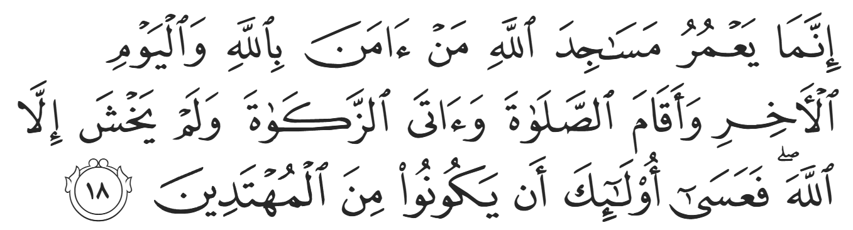
“The masjids of Allāh are only to be maintained by those who believe in Allāh and the Last Day and establish prayer and give zakāh and fear none except Allāh, for it is expected that those will be of the [rightly] guided.” (9:18)
The Prophet ﷺ’s concern and priority was to build a masjid before he had even thought about his own house and living arrangements. The Prophet ﷺ then said, “Whose house from our family members is closest?” He ﷺ had distant cousins in Madinah, another indication that Madinah was planned by Allah (SWT) to be his safe haven, as ties of familiarity were already built. Khaalid ibn Zayd—known famously as Abu Ayyub al-Ansaari (RA) rose up and proclaimed his lineage to the Banu Najjar and ecstatically claimed his right to host the Prophet ﷺ.
The Prophet ﷺ lived with Abu Ayyub (RA) for six months while the masjid was being built. Allah (SWT) blessed Abu Ayyub with a two-story house, which allowed him to accommodate the Prophet ﷺ. Abu Ayyub and his wife occupied the top floor while the Prophet ﷺ and Abu Bakr (RA) occupied the ground floor. One night, Abu Ayyub knocked over some water, and they began to panic that a single drop of water may fall onto the Prophet ﷺ, so they stayed up the whole night soaking their blankets to dry the water. On another occasion, Abu Ayyub (RA) said, “It suddenly occurred to me that we were walking above the head of the Prophet ﷺ.” Abu Ayyub and his wife then spent the remainder of the night cramped in the corner of the room to ensure that they did not walk or stand over the Prophet ﷺ. The next morning, they requested that the Prophet ﷺ move to the top floor. The Prophet ﷺ said that the ground floor was easier, as he would frequently receive guests and conduct meetings. Abu Ayyub did not relent, insisting, “Never, O Messenger of Allah, can we be above a roof that is above you.” It was also the habit of Abu Ayyub and his wife to cook food, send it to the Prophet ﷺ to eat, and finish the leftovers. Whenever the plate was returned, Abu Ayyub asked, “From which place did the Prophet ﷺ eat?” He would then ensure that he ate from the exact same place.
Before the Prophet ﷺ began building the masjid on the plot of land where the camel stopped, he asked, “Who does this land belong to?” It belonged to two orphans, Sahl and Suhayl, who had inherited the land from their late father but did not yet put it to use. They said, “O Messenger of Allah, this is a gift from us.” But the Prophet ﷺ, in a manner befitting a Messenger of Allah, refused to accept it as a gift and instead purchased it. The Companions began building the masjid, and the Prophet ﷺ ordered that the old tree stumps in the ground be repurposed as the front and back walls of the masjid. The remaining two sides of the masjid were built with clay bricks, and the roof was made of date palm leaves. The roof only covered half the masjid, and this remained the case for a few years.
Eventually, the Prophet ﷺ ordered that a full roof be built, however even that roof was only purposed to protect worshippers from the heat of the Sun; it was not sufficient as a cover to protect from the rain or cold. In the eighth year of Hijrah, for example, Abu Said al-Khudri (RA) narrated that the entire masjid flooded due to rainwater, and the ground became extremely muddy. The Companions wondered how they would prostrate in the heavy mud until Abu Said al-Khudri said, “For by Allah I saw the Prophet ﷺ prostrate into the mud, and the mud was on his forehead and nose.” The Prophet’s Masjid remained in this state for the entirety of the Prophet ﷺ’s life as well as the reign of Abu Bakr al-Siddiq (RA). The Khalifah ‘Umar (RA) saw some reinforcements to the masjid, but the first major expansion was under the rule of Uthman (RA) many years later.
The companions formed a line to carry out the work to build, and the Prophet ﷺ was a part of the line. The companions then recited a line of poetry which said, “For us to sit as the Prophet works, how misguided our actions would be!” They continued to recite lines of poetry while they worked, and the Prophet ﷺ joined them saying, “O Allah, there is no good except the good of the Hereafter, so have mercy on the Ansar and the Muhaajirah.” It took two weeks to build the masjid, and it was a very large masjid for its time, spanning 100 by 130 feet. It has three main public entrances: The Door of Mercy on the southside, The Door of Jibril on the westside, and The Door of Women on the eastside. There were also a number of private entrances for those whose houses connected directly to the masjid. On his deathbed, the Prophet ﷺ said, “Every single [private] door to the masjid shall be locked and sealed except the door of Abu Bakr.” Scholars interpret this statement as one of the Prophet’s implicit instructions that Abu Bakr (RA) should succeed him in leadership, for all doors (i.e. paths) are to close except that of Abu Bakr.
<Conclude 1st Khutbah with:
Aqoolu haathaa wa astaghfir-Allaah (I say this and I ask Allah for forgiveness)
أَقُولُ قَوْلِي هَذَا وَأَسْتَغْفِرُ اللَّهَ لِي وَلَكُمْ وَلِسَائِرِ المُسْلِمينَ وَالمُسْلِمَاتْ فَاسْتَغْفِرُوهْ إِنَّهُ هُوَ الْغَفُورُ الرَّحِيمُ
الحمد لله رب العالمين والصلاة والسلام على سيد المرسلين وعلى آله وأصحابه أجمعين
<2nd Khutbah>
Dear brothers and sisters,
The five daily prayers were established as an obligation during al-Israa wa al-Mi’raaj; however, each prayer comprised of only two units – two rakaat. Aiisha (RHAA) narrated, “When we came to Madinah, the prayers were put as you know them, and the two units were kept for the traveler (except Maghrib, which was always 3 units)”
The Prophet ﷺ also gathered the Companions to decide how to call the people to prayer. Madinah was now an open Islamic nation, so the prayer—being the most integral part of Islam—was to be incorporated into everyday life on a public level. The Companions began to discuss, and one said, “Let’s use a bell like the Christians” but this was rejected. The Prophet ﷺ did not like bells, and he said, “The Angels do not accompany any caravan with a bell.” Another Companion said, “Let’s use a shofar” – that is an ancient horn, typically made from a ram’s horn, used for Jewish religious purposes – but this was also rejected. The meeting ended without a decision being made. That night, ‘Abdullah ibn Zayd (RA) had a dream where he encountered a man selling items such as horns and bells. He tried to buy the items for the Prophet ﷺ but the man said, “Should I not tell you something better? When you call for prayer, say, ‘God is the Greatest, , God is the Greatest, . I bear witness that there is no god but Allah, . I bear witness that Muhammad is the Messenger of Allah, , Come to the prayer, , Come to success, , Allah is the Greatest. , -- There is no god except Allah.
‘Abdullah ibn Zayd (RA) woke up and rushed out to the Prophet ﷺ to inform him of the dream. The Prophet ﷺ then said, “Stand up, O Bilaal! You have the loudest voice.” The Prophet ﷺ then instructed ‘Abdullah ibn Zayd (RA) to go with him to the roof and inform him of each phrase for Bilaal to give the adhan. As Bilaal (RA) was giving the adhan, ‘Umar ibn al-Khattab (RA) rushed out from his house and said, “O Messenger of Allah, I heard the same phrases in my dream!” The adhan thus became the only act of Islam legislated via the dream of a Companion. However, it is more accurate to state that the legislation was the Prophet’s approval, not the Companion’s dream itself. There are no narrations regarding the Companion ‘Abdullah ibn Zayd (RA) except this famous narration of the adhan. Suffice to say that he must have had a blessed relationship with Allah and His Messenger to have been bestowed with such a blessing.
The Prophet ﷺ instated a pact called “mu’aakhaah” which bound each Ansaari to a Muhaajir to further instill ties of brotherhood. The Ansaar were already very hospitable and welcoming to their Meccan brothers. The Qur’an states in Surat al-Hashr:
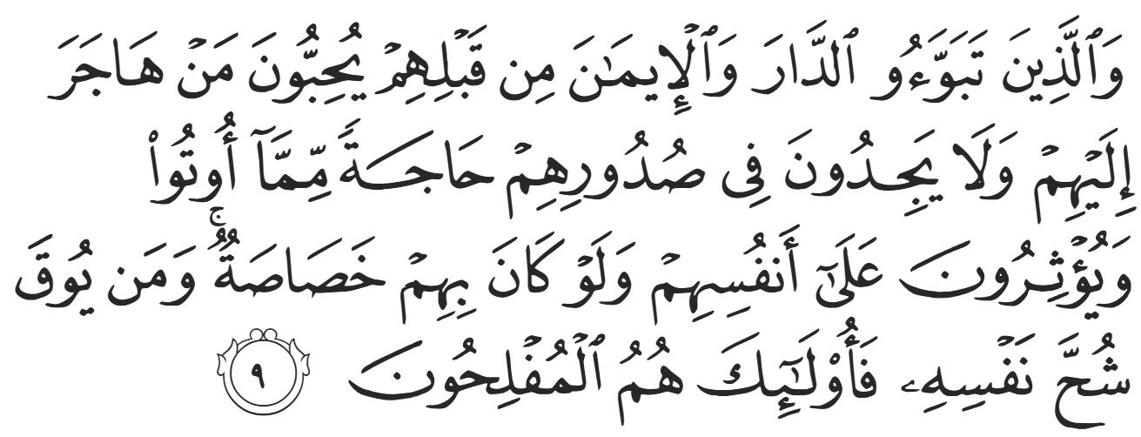
“As for those who had settled in the city and ˹embraced˺ the faith before ˹the arrival of˺ the emigrants, they love whoever immigrates to them, never having a desire in their hearts for whatever ˹of the gains˺ is given to the emigrants. They give ˹the emigrants˺ preference over themselves, even though they may be in need. And whoever is saved from the selfishness of their own souls, it is they who are ˹truly˺ successful.” (59:9)
It is reported that when the Muhaajiruun arrived in Madinah, the Ansaar said to the Prophet ﷺ, “O Messenger of Allah, we shall give half our lands to the Muhaajiroon.” The Prophet ﷺ made du’aa for them, but kindly refused such a generous offer; instead, he ﷺ suggested that the Muhajiroon work for their share of the land.
Despite their generosity, the Prophet ﷺ wanted to impress upon them ties of brotherhood that only the likes of Islam could inspire. A paired Ansaari and Muhaajir were considered brothers by law, even in the rights of inheritance. The most famous story of mu’aakhaah is the bond between the Muhaajir ‘Abdurrahman ibn ‘Awf (RA) and the Ansaari Sa’d ibn al-Rabi (RA). Sa’d, a successful businessman, brought ‘Abdurrahman to his house and said, “I am the richest of the Ansaar, and I will give you half of all of my money; I have a two-story house, and one of them is yours; I have two gardens, and one of them is yours; and I have two wives, and one of them is yours.” ‘Abdurrahman humbly responded, “May Allah bless your wealth and family—just direct me to the market-place.” ‘Abdurrahman ibn ‘Awf then bought and sold items day by day until one day the Prophet ﷺ saw him dressed up and perfumed. The Prophet ﷺ asked what the occasion was, and he replied that he just got married and that he paid the dowry with a small amount of gold. The Ansaari’s generosity was only matched by the Muhaajir’s honor and dignity; one genuinely offered out of imaan and brotherhood, and the other genuinely declined out of imaan and brotherhood.
The Ansaar helped the Muhaajiroon so much that the Muhaajiroon grew worried and actually complained to the Prophet ﷺ saying, “O Messenger of Allah, we have never seen a people like this; they share equally with us in times of difficulty, and are generous with us in times of need. They have taken care of our needs and have allowed us to share in times of good, so much so that we are worried that they will take our reward [in the Hereafter].” The Prophet ﷺ replied, “They will not take your reward as long as you praise them and make du’aa for them.”
After the Battle of Badr and almost two years of the “mu’aakhaah” brotherhood pact, Allah (SWT) revealed verses of Surat al-Anfaal abrogating the inheritance privileges of the bonded brothers:
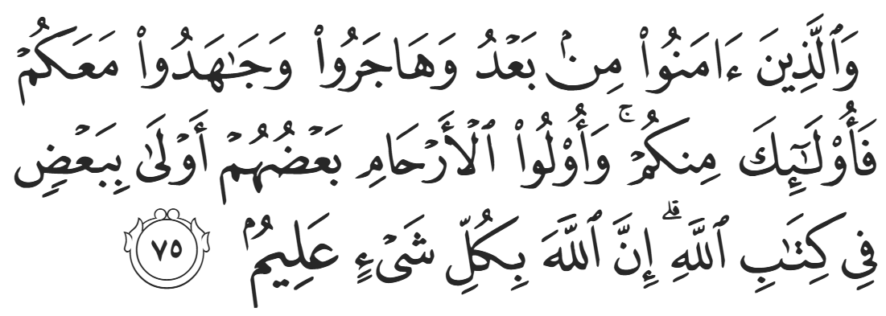
“And those who later believed, migrated, and struggled alongside you, they are also with you. But only blood relatives are now entitled to inherit from one another, as ordained by Allah. Surely Allah has ˹full˺ knowledge of everything.” (8:75)
Even though there was no more inheritance, the mu’aakhaah continued for many more years, even after the Conquest of Makkah. Those who accepted Islaam after the Conquest were also paired with an Ansaari, and the practice did not stop. It can therefore be said that this is a forgotten Sunnah that should be practiced in all times and places, including our own.
As we reflect on the early days of Madinah, we are reminded that this religion was not built upon comfort, but upon sincerity, sacrifice, and brotherhood. A masjid raised with humble hands became the heart of an ummah, bonds formed for the sake of Allah became stronger than blood, and a small community—rooted in faith—grew into a legacy that still lives within us today. Take from their example… Prioritize Allah over ourselves, serve one another with sincerity, and carry this deen not just in knowledge, but in action. If we do this, then we too can hope to be gathered with them, in peace, in the gardens of Jannah.
Allah (SWT) tells us:
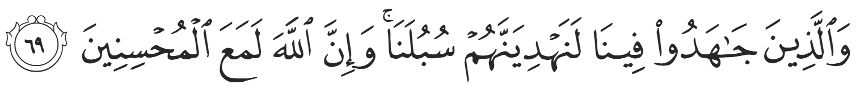
“As for those who struggle in Our cause, We will surely guide them along Our Way. And Allah is certainly with the good-doers.” (29:69)

<Duaa!>
- Oh Allah, please grant us a deep love for Your Prophet Muhammad, SAW.
- Oh Allah, please make us energetic in doing good for Your cause.
- Oh Allah, please enable us with the will and means to walk Al-Sirrat-Al-Mustaqeem, even if it estranges us from others.
- Oh Allah, please support the suffering and oppressed Muslims around the world and grant them victory over that which oppresses them.
- Oh Allah, please protect us from ever being overburdened by debt and protect us from all evils and undesirable consequences associated with having debt.
- Oh Allah, please fill our hands with the work and deeds of righteousness and let them be of benefit to ourselves and the Ummah.
- Oh Allah, please forgive us our shortcomings and deviances in following Your Qur'an and the Sunnah of Rasul'Allah, SallAllahuAlayhiWaSallam.
- Oh Allah, please grant us understanding and guidance of Your Qur'aan
- Oh Allah, please grant us patience with the trials of this world.
- Oh Allah, please prevent our hearts from getting overly attached to the Dunya and grant us the best in this life and the best in the hereafter.
- Oh Allah, please forgive us our past sins and make us Your devoted servants.
- Oh Allah, please make us amongst those whose Duaa is accepted.
- Oh Allah, please grant us Jannat'ul Firdaus and protect us from ever coming close to the Fires of Jahannum.

