Khut'bah Opening
إِنَّ الْحَمْدَ للهِ , نَحْمَدَهُ وَ نَسْتَعينُهُ وَ نَسْتَغْفِرُهُ , وَ نَعوذُ بِالله مِنْ شُرورِ أَنْفُسِنا , مَن يَهْدِهِ اللهُ فَلا مُضِلَّ لَه , وَ مَنْ يُضِلِلْ فَلا هادِيَ لَهْ , وَ أَشْهَدُ أَنْ لا إلهَ إِللهُ وَحْدَهُ لا شَريكَ لَه , و أَشْهَدُ أنَّ مُحَمَّدًا عَبْدُهُ و رَسولُه.
"All thanks and praises are due to Allah, whom we thank, seek for help and invoke for forgiveness. We seek refuge with Allah from the evils within ourselves. He whom Allah guides will never be misled and he whom He misguides will never find one to guide him. I bear witness that there is no deity worthy of worship except Allah and that Muhammad (SAW) is His slave and Messenger.”
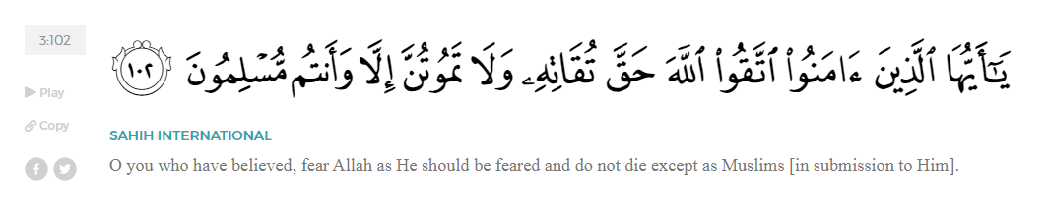
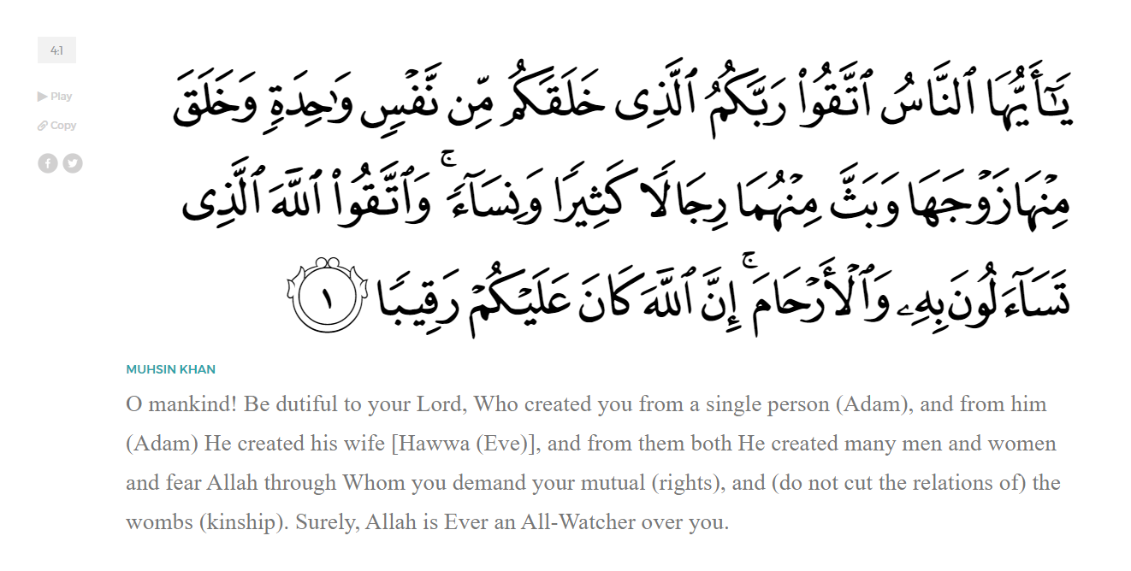
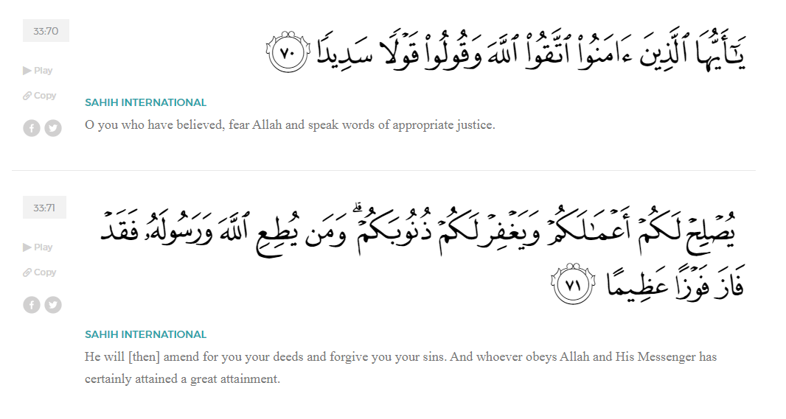
<Sirah of the Prophet (SAW) – Part X -Dr. Yassir Qadhi, Book and Series>
Dear brothers and sisters,
InshaaAllah we will continue our khutbah series on the seerah of the Prophet ﷺ, drawing from Dr. Yasir Qadhi’s book, The Sirah of the Prophet, so that we can deepen our understanding of his life and strengthen our love for him. Each step we take through the Prophet ﷺ’s life brings us closer to knowing him more deeply, appreciating his struggles, and embodying his character. Our goal in this series, inshaaAllah, is not just to learn history, but to let the seerah transform our hearts and strengthen our love for the Messenger of Allah ﷺ.
Today we will, inshaaAllah, continue with the chapter titled “Establishing a Muslim Nation”. After the Hijrah, the Prophet ﷺ was now faced with the immense task of organizing a society composed of different tribes, beliefs, and loyalties.
The Prophet ﷺ wrote a constitution for the inhabitants of Madinah, which comprised all tribal and religious groups, including the Emigrants, the Ansaar, the Jews, and Pagans. It is recorded in full in the earliest books of Seerah, such as Ibn Ishaaq, but without a direct chain of narration. Books of Hadith mention the treaty with a full chain, such as Musnad Imam Ahmad, which states, “The Prophet ﷺ wrote a book between the Muhaajiroon and the Ansaar.” However, they only make reference to the treaty or quote one or two clauses therein. The chain of narration for the full treaty stops at Ibn Ishaaq. This has led some to claim that the treaty did not exist. However, the intricate details of the treaty, such as naming every single subtribe, and the archaic language of the treaty, which did not fit with the language of Ibn Ishaaq’s era, are strong indications of its authenticity.
The treaty was over five pages long and comprised of four main segments:
- Matters pertaining to the Muslims
- Matters pertaining to the Jews
- Matters pertaining to the Pagans
- General rules for every inhabitant of Madinah
In the first segment for Muslim matters, the treaty stated, “The believers from the Quraysh and Yathrib and those who joined them are one Ummah – one nation. This Ummah is unique to itself to the exclusion of the rest of mankind.” The treaty then mentioned 40 subtribes by name and stated that each tribe will carry the responsibilities of its members; they will oversee their own blood-money disputes, prisoners of war, and the poor and needy. Another clause stated, “All Muslims shall unite against those who commit injustice even if it be one of their own.” The treaty also made clear that any Muslim, of any social standing, can bring another person into the fold i.e. they can provide protection – the closest equivalent of a modern-day visa.
As for the second segment, the treaty named each Jewish subtribe and stated, “All the Jewish tribes are one nation along with the believers.” The treaty clarified that the Jewish nation is responsible for all its internal affairs, such as internal disputes, blood-money, and the poor and needy. However, if there are disputes between the two nations (i.e., the Jews and Muslims), it will be deferred to the judgment of the Prophet ﷺ. The Jews therefore enjoyed semi-independent statehood within the Islamic state. The treaty added, “Between the two nations shall be mutual support against those who fight the people of the treaty.” This included financially and physically supporting one another against any external threats. Moreover, if any Jew wishes to convert to Islam, he is to be supported and no-one shall harm them. Finally, the treaty stated that no Jew can revoke their Medinan citizenship without informing the Prophet ﷺ so that everyone is aware of who is bound by the treaty.
As for the third segment pertaining to the Pagans, the treaty stated, “No Pagan shall offer protection to the Quraysh, nor are they to come between the Quraysh and the believers.” The Pagans were not forced, or even asked, to convert; the very fact that there was a sizable Pagan population in Madinah proves that they were not forcibly converted or coerced.
The fourth and final segment consisted of general clauses concerning everyone. First, the treaty outlined the interior of Madinah as a haram for the subjects of the treaty. Like al-Masjid al-Haram and the Ka’bah in Makkah, haram means that many acts which are ordinarily permissible (halal) are prohibited (haraam) in the designated area.
In other words, it is a sacred site. Brandishing unsheathed weapons is forbidden in a haram, as well as hunting and even uprooting trees and plucking plants. The treaty also demarcated the borders of Madinah as: Mount Ayr, Mount Thawr, the eastern volcanic plain, and the western volcanic plain. The treaty reiterated that any interfaith conflict—i.e. between a Jew and a Pagan, a Pagan and a Muslim, or a Muslim and a Jew—will be resolved by Allah and His Messenger. The final clause stated that whoever leaves Madinah is safe except those who commit a crime.
The standing of this treaty has been overstated by some and unduly dismissed by others. Some claim that the treaty was the basis for modern-day constitutions, directly inspiring current conventions around the globe. The treaty was indeed unprecedented for its time; it was the first time in the history of Arabia that relationships were defined based on theology, and that the notion of an Ummah was the backbone upon which society would be governed. That said, it would be an overstatement to claim that the treaty has impacted global governance. In contrast, some claim that the treaty was discriminatory to the Jews, ostracizing them. On the contrary, the treaty dealt with the Jews with respect and fairness, identifying them as an Ummah alongside the Muslims. Most of their rules and regulations were equally applied to the Muslims themselves. It could even be said that the treaty signified a bastion of tolerance compared to the religious intolerance that was rampant throughout the world at the time.
The treaty established the basis and overall philosophy of how an Islamic state is governed. The unification of tribes under the umbrella of Islam was a major step away from tribalism. This was taught from the beginning of Revelation, but it was now codified in a constitution. The Prophet ﷺ did not eradicate tribal identity; the Qur’an states in Surat Al-Hujurat:
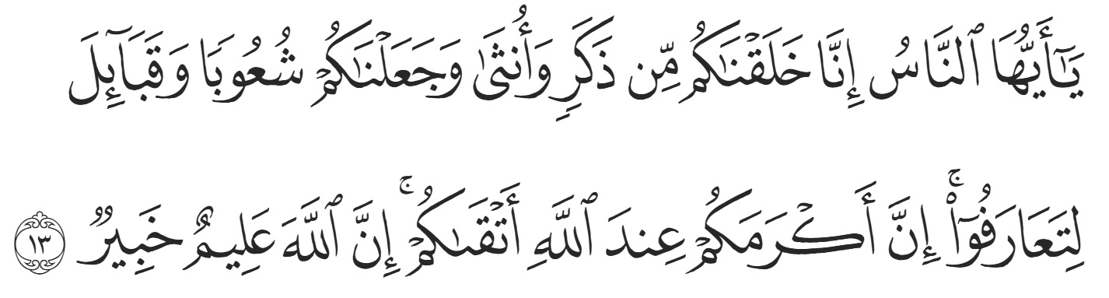
“O mankind! Indeed, We created you from a male and a female, and made you into peoples and tribes so that you may ˹get to˺ know one another. Surely the most noble of you in the sight of Allah is the most righteous among you. Allah is truly All-Knowing, All-Aware.” (49:13)
The Prophet ﷺ therefore accepted the legal norms and customs of every tribe as long as they did not conflict with the laws of Islam. However, rank and status are only derived from piety and closeness to Allah. The word “Ummah” shares the same root as the word “umm” which means “mother”. It is derived from the word “amma” which means “to strive for”. The object of a child’s attention is their “umm” i.e., mother. The Ummah is therefore a nation with one common goal—to please Allah. Indeed, ties based on religion—sharing values, ethics, and theology—are far stronger than those derived from sharing a tribe or nationality.
<Conclude 1st Khutbah with:
Aqoolu haathaa wa astaghfir-Allaah (I say this and I ask Allah for forgiveness)
أَقُولُ قَوْلِي هَذَا وَأَسْتَغْفِرُ اللَّهَ لِي وَلَكُمْ وَلِسَائِرِ المُسْلِمينَ وَالمُسْلِمَاتْ فَاسْتَغْفِرُوهْ إِنَّهُ هُوَ الْغَفُورُ الرَّحِيمُ
الحمد لله رب العالمين والصلاة والسلام على سيد المرسلين وعلى آله وأصحابه أجمعين
<2nd Khutbah>
Dear brothers and sisters,
The direction of prayer – the qiblah – thus far was Jerusalem, as was the case with previous Abrahamic religions. In Makkah, the Prophet ﷺ would always situate himself in a position where he was facing the Ka’bah but with Jerusalem behind it. However, in Madinah, facing Jerusalem would entail turning one’s back towards Makkah, and thus turning one’s back towards the Ka’bah. The Prophet ﷺ grew increasingly uneasy with turning his back towards the Ka’bah, so he started making dua’a to Allah (SWT) to change the qiblah to Makkah. It is narrated that the Prophet ﷺ even expressed his hope to Jibril (AS), to which Jibril replied, “I am merely a slave like you.” The most blessed human asked the most blessed Angel for assistance, yet neither had any power except through Allah (SWT).
The Prophet ﷺ continued to make du’aa earnestly throughout the day. The Sunnah of du’aa is to lower one’s head, but in times of extreme distress or desperation, the Prophet ﷺ would raise his hands high and face towards the Heavens. There were no people to witness this, as the Prophet ﷺ did so in the dead of night, but Allah (SWT) attested to it in the Qur’an, revealing the ayah in Surat al-Baqarah:
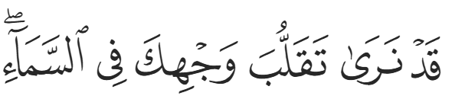
“Indeed, We see you ˹O Prophet˺ turning your face towards heaven.”
Allah (SWT) then gifted the change of qibla to the Prophet ﷺ, continuing the ayah:
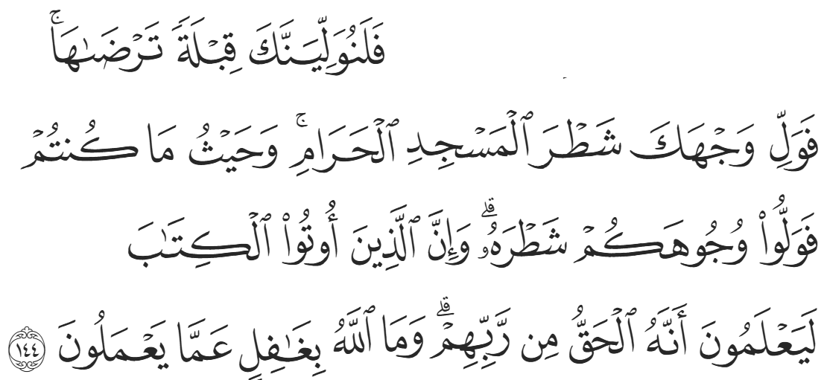
“Now We will make you turn towards a direction ˹of prayer˺ that will please you. So turn your face towards the Sacred Mosque ˹in Mecca˺—wherever you are, turn your faces towards it. Those who were given the Scripture certainly know this to be the truth from their Lord. And Allah is never unaware of what they do.” (2:144)
The commandment became a source of confusion for the people of Madinah. Allah (SWT) states:
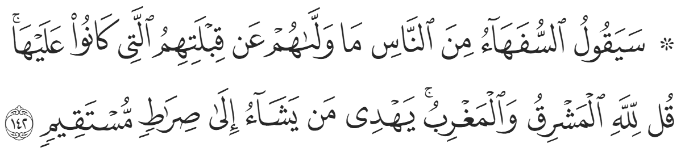
“The foolish among the people will ask, “Why did they turn away from the direction of prayer they used to face?” Say, ˹O Prophet,˺ “The east and west belong ˹only˺ to Allah. He guides whoever He wills to the Straight Path.”” (2:142)
Some of the Jews would scoff, “Had he truly been a Prophet, he would have prayed towards the direction followed by the Prophets before him.” The ruling was a test to the believers to implement a command from Allah (SWT). However, there was a secondary message to the Jews: this Prophet inherited the tradition of your Prophets (and thus faced the same qiblah) but he will now supersede it. The qiblah could have been towards Makkah from the start, but Allah (SWT) wanted to demonstrate to the Jews the commonality and shared root of the two religions. However, as time passed and they persisted in their arrogance and rejection, guidance was sent instructing the believers to distinguish themselves from the Jews, and the change of qiblah highlighted this distinction. The Pagans also ridiculed the change of qiblah, but there was a secondary message to them: the Prophet ﷺ was expelled from Makkah, but he honors the Ka’bah more than you, and he will inherit custodianship of the Ka’bah.
The Jews insisted on their qiblah being the only avenue of righteousness, and Allah (SWT) clarified the true definition of righteousness:
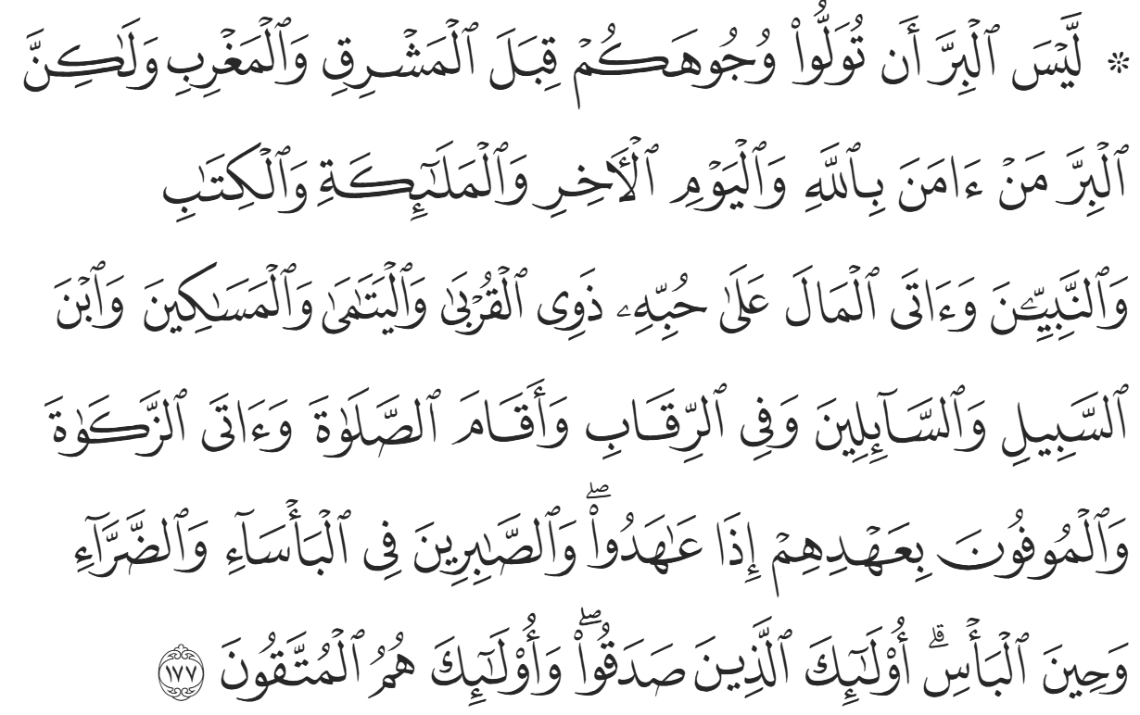
“Righteousness is not in turning your faces towards the east or the west. Rather, the righteous are those who believe in Allah, the Last Day, the angels, the Books, and the prophets; who give charity out of their cherished wealth to relatives, orphans, the poor, ˹needy˺ travelers, beggars, and for freeing captives; who establish prayer, pay alms-tax, and keep the pledges they make; and who are patient in times of suffering, adversity, and in ˹the heat of˺ battle. It is they who are true ˹in faith˺, and it is they who are mindful ˹of Allah˺.” (2:177)
Allah (SWT) then reassured the Prophet ﷺ:
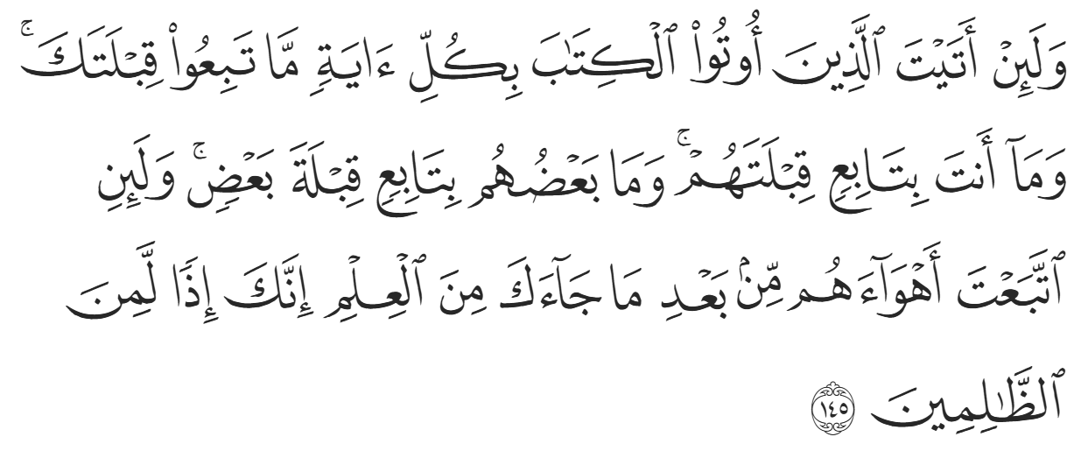
“Even if you were to bring every proof to the People of the Book, they would not accept your direction ˹of prayer˺, nor would you accept theirs; nor would any of them accept the direction ˹of prayer˺ of another. And if you were to follow their desires after ˹all˺ the knowledge that has come to you, then you would certainly be one of the wrongdoers.” (2:145)
There is a common misconception that the Prophet ﷺ was praying in one direction when Allah (SWT) revealed the verses mid-prayer, and the Prophet ﷺ changed his direction while praying. The authentic reports are clear in that the Prophet ﷺ prayed Fajr facing Jerusalem, and Dhuhr facing Makkah, which means the commandment was revealed in the morning. After praying Dhuhr in the new direction, a companion walked towards his local masjid, which was in the area of the tribe of Banu Salamah. When he arrived, the congregation was already praying ‘Asr, so he announced the change of qiblah while they were praying, which caused them to change their direction mid-prayer. After this event, the masjid was then known as Masjid Qiblatayn – The Masjid of Two Directions.
These events remind us that the Muslim Ummah was not just built as a political system, but as a community grounded in justice, unity, and submission to Allah. The Constitution of Madinah showed us that Islam honors diversity while binding people together through faith and shared responsibility, and the change of the qiblah teaches us that true righteousness lies not in directions or appearances, but in sincere obedience to Allah’s commands. These moments from the Seerah teach us that our success as individuals and as an Ummah depends on how firmly we hold on to revelation, how willingly we submit even when tested, and how sincerely we strive to embody the values of faith, unity, and righteousness in our daily lives.
<Duaa!>
- Oh Allah, please grant us a deep love for Your Prophet Muhammad, SAW.
- Oh Allah, please make us energetic in doing good for Your cause.
- Oh Allah, please enable us with the will and means to walk Al-Sirrat-Al-Mustaqeem, even if it estranges us from others.
- Oh Allah, please support the suffering and oppressed Muslims around the world and grant them victory over those who oppress them.
- Oh Allah, please protect us from ever being overburdened by debt and protect us from all evils and undesirable consequences associated with having debt.
- Oh Allah, please fill our hands with the work and deeds of righteousness and let them be of benefit to ourselves and the Ummah.
- Oh Allah, please forgive us our shortcomings and deviances in following Your Qur'an and the Sunnah of Rasul'Allah, SallAllahuAlayhiWaSallam.
- Oh Allah, please grant us understanding and guidance of Your Qur'aan
- Oh Allah, please grant us patience with the trials of this world.
- Oh Allah, please prevent our hearts from getting overly attached to the Dunya and grant us the best in this life and the best in the hereafter.
- Oh Allah, please forgive us our past sins and make us Your devoted servants.
- Oh Allah, please make us amongst those whose Duaa is accepted.
- Oh Allah, please grant us Jannat'ul Firdaus and protect us from ever coming close to the Fires of Jahannum.

