Khut'bah Opening
إِنَّ الْحَمْدَ للهِ , نَحْمَدَهُ وَ نَسْتَعينُهُ وَ نَسْتَغْفِرُهُ , وَ نَعوذُ بِالله مِنْ شُرورِ أَنْفُسِنا , مَن يَهْدِهِ اللهُ فَلا مُضِلَّ لَه , وَ مَنْ يُضِلِلْ فَلا هادِيَ لَهْ , وَ أَشْهَدُ أَنْ لا إلهَ إِللهُ وَحْدَهُ لا شَريكَ لَه , و أَشْهَدُ أنَّ مُحَمَّدًا عَبْدُهُ و رَسولُه.
"All thanks and praises are due to Allah, whom we thank, seek for help and invoke for forgiveness. We seek refuge with Allah from the evils within ourselves. He whom Allah guides will never be misled and he whom He misguides will never find one to guide him. I bear witness that there is no deity worthy of worship except Allah and that Muhammad (SAW) is His slave and Messenger.”
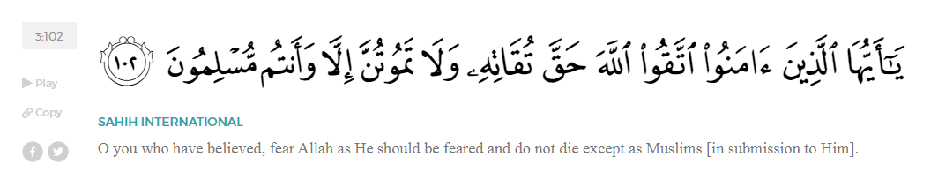
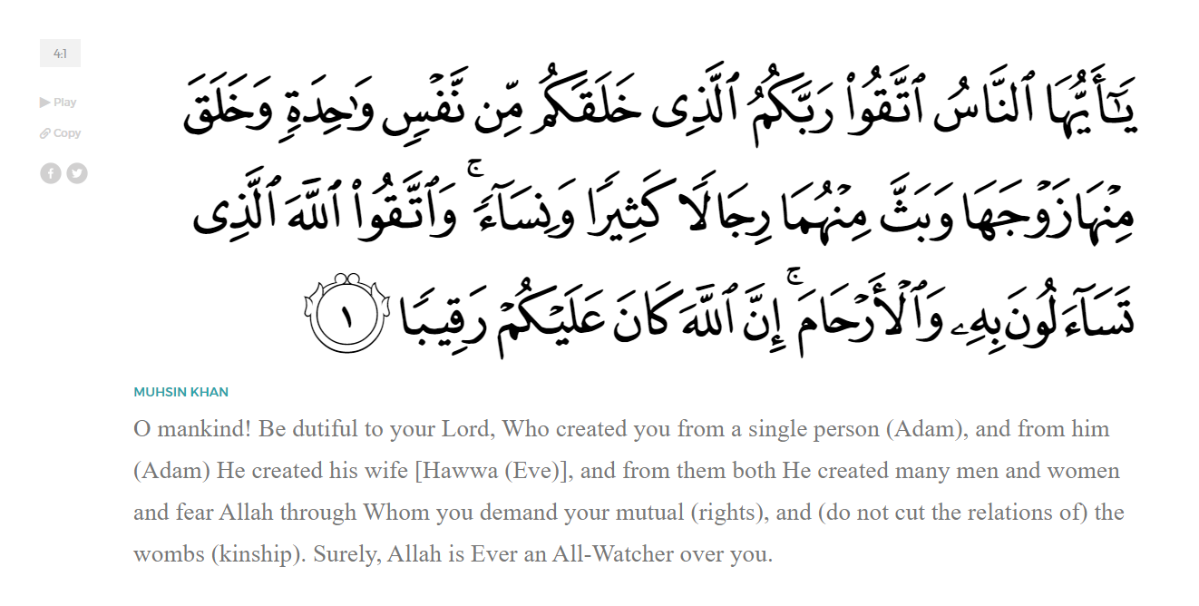
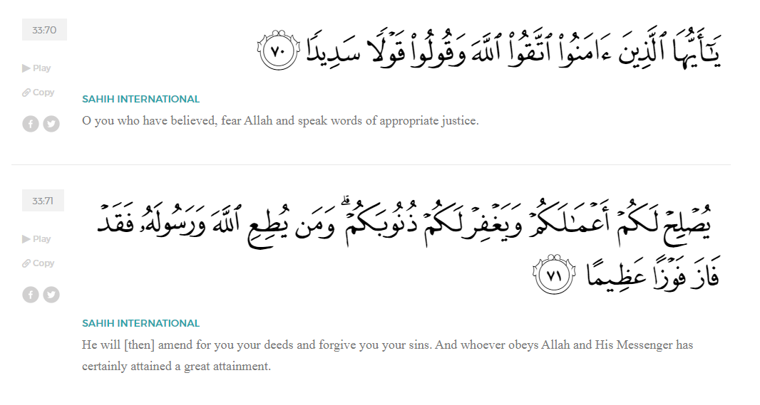
<Sirah of the Prophet (SAW) – Part X -Dr. Yassir Qadhi, Book and Series>
Dear brothers and sisters,
InshaaAllah we will continue our khutbah series on the seerah of the Prophet ﷺ, drawing from Dr. Yasir Qadhi’s book, The Sirah of the Prophet, so that we can deepen our understanding of his life and strengthen our love for him. Each step we take through the Prophet ﷺ’s life brings us closer to knowing him more deeply, appreciating his struggles, and embodying his character. Our goal in this series, inshaaAllah, is not just to learn history, but to let the seerah transform our hearts and strengthen our love for the Messenger of Allah ﷺ.
Today we will, inshaaAllah, complete the chapter titled Establishing a Muslim nation.
As the number of Emigrants continued to increase, there were not enough of the Ansaar to continue the mu’aakhah brotherhood system for everyone. The new arrivals would base themselves in the Prophet’s Masjid, and they became known as the People of the Suffah. Their numbers would fluctuate between 5 and 70, and most of them would stay for a short period of time to learn the fundamentals of Islaam and acclimate to life in Madinah. However, the Suffah soon became a hub of knowledge and faith, and some members would voluntarily remain to learn from, and interact with, the Prophet ﷺ. Most of them were bachelors, but some family men would opt to stay in the Suffah over staying with their own families in order to be closer to the Prophet ﷺ. The Prophet’s Masjid was, in many ways, the first university of Islaam.
Ahl al-Suffah were highly respected, as they sacrificed everything for the sake of Allah. Many of them had nothing but the clothes on their backs. It was even narrated that the female companions would complain to the Prophet ﷺ that the ‘awrah (the private parts) of some of the young men would be exposed when they prostrated in prayer, as their clothes were not even long enough to cover their whole bodies. Once, a beloved daughter of the Prophet ﷺ, Fatimah (RHAA) complained of her household chores and asked for a servant to assist her. The Prophet ﷺ replied emphatically, “How can I give you a servant when the stomachs of Ahl al-Suffah are collapsed from hunger? No, by Allah, I will sell all of them (i.e., the servants) and spend the money on them. [i.e. the Ahl al-Suffah].” Faatimah (RHAA) never asked the Prophet ﷺ for a servant again.
Ahl al-Suffah became the flag-bearers of knowledge and piety. They became memorizers and masters of the Qur’aan to the extent that they were known as “The People of the Qur’aan”. In fact, Ahl al-Suffah were the indirect cause of the compilation of the Qur’aan into a single Book. The Qur’aan was passed down from Allah (SWT) to the Prophet ﷺ through Jibril (AS) orally, and the Prophet ﷺ in turn taught the Companions orally. The entirety of the Qur’aan was written down on pieces of bone, leather, and parchments, but only as a tool of memorization. However, many years later during the Caliphate of Abu Bakr al-Siddiq (RA), the Apostasy Wars against Musaylamah the Liar inflicted many casualties amongst the Muslims. The People of the Qur’aan, practicing what they preached, were warriors that fought for the Religion of Allah. As a result, many graduates of the Suffah were martyred. ‘Umar ibn al-Khattab (RA) then pleaded with Abu Bakr (RA) to compile the Qur’aan before more People of the Qur’aan were lost, and Abu Bakr (RA) eventually obliged.
The most famous member of the Suffah was Abu Hurayrah (RA). His name was ‘Abd al-Rahmaan ibn Sakhr, but was more commonly known as Abu Hurayrah (the Father of Kittens) as he would famously carry a small kitten in his sleeve. He came from a middle-class family yet sacrificed his luxuries to accompany the Prophet ﷺ in the Suffah. He suffered from extended bouts of hunger and fatigue for the sake of this sacrifice. Later, he would recall, “Many times I would ask Companions questions as they walked home, and by Allah I knew the answer better than them, but I would ask in the hope that the conversation would extend until they reached their house, and they would perhaps invite me in to eat.”
Abu Hurayrah was from Yemen and only came to Madinah after the seventh year of Hijrah, yet he narrated the most Hadiths of all the Companions by a large margin.
The Tabiyeen – The Successors– would often ask how Abu Hurayrah knew so much despite accompanying the Prophet ﷺ for a much shorter time than other Companions. He replied, “The people complain that I narrate too many Hadith, but were it not for the fact that Allah (SWT) criticized those who withhold knowledge, I would not have narrated a single Hadith. As for the Muhaajiroon, they were busy buying and selling in the markets of Madinah; and as for the Ansaar, they were busy cultivating and harvesting in their fields. As for me, I would stick to the Prophet ﷺ with an empty stomach, and therefore I would memorize what they would not.”
As the Prophet ﷺ finally established a base in Madinah, a holistic Muslim society began to form. Most major pillars of Islaam – except for Hajj which required access to Makkah—were established within the first year of the new state. The basic rulings of prayer were perfected, and the Prophet ﷺ instructed, “Pray as you have seen me pray.” The rulings of purification, including wuduu—ritual ablution before prayer, ghusl—ritual ablution after a major impurity, and istinjaa’—cleaning of the private parts after using the restroom, were all revealed. Fasting was gradually introduced; the first obligated fast was the 10th of Muharram, nine months after the Hijrah. The Prophet ﷺ decreed, “Whoever had breakfast in the morning, let him fast for the rest of the day.” The following Ramadan was then obligatory to fast. Allah (SWT) revealed,
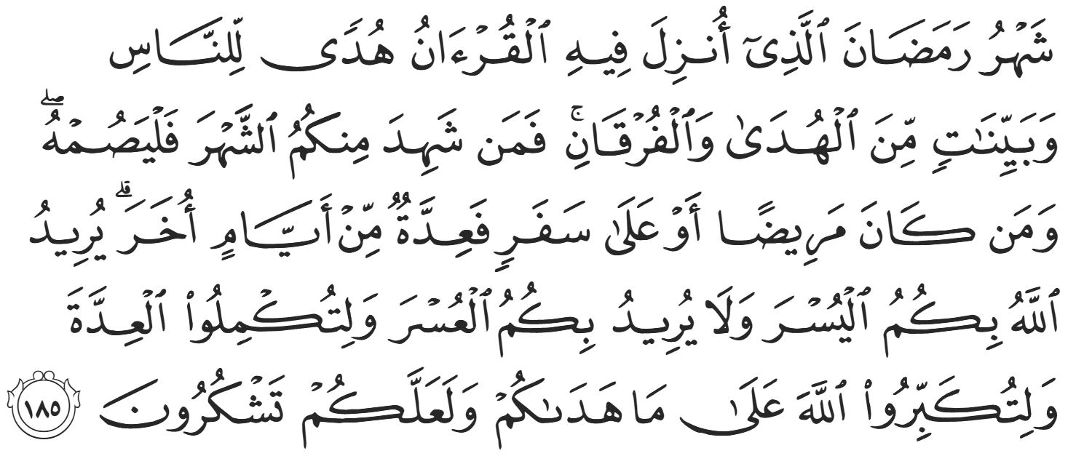
“Ramaḍaan is the month in which the Quran was revealed as a guide for humanity with clear proofs of guidance and the decisive authority. So whoever is present this month, let them fast. But whoever is ill or on a journey, then ˹let them fast˺ an equal number of days ˹after Ramaḍaan˺. Allah intends ease for you, not hardship, so that you may complete the prescribed period and proclaim the greatness of Allah for guiding you, and perhaps you will be grateful.”
Fasting the 10th of Muharram then became Sunnah –no longer obligatory. In Ramadan, Zakah al-Fitr—“Charity of Breaking the Fast” became obligatory. A few months later, Zakah al-Maal—“Charity of Wealth” also became obligatory.
The Prophet ﷺ also began implementing societal reforms, the first of which was to create a new market to establish financial independence. The Ansaar were historically engaged in agriculture and farming, while the market-places were run by the Jewish tribes. The Prophet ﷺ visited these markets and disapproved of many of the practices such as cheating, deception, and high charges. The Prophet ﷺ then said to the Muslims, “This is not a market for you.” He ﷺ then walked back to the masjid and created lines in the sand with his own blessed feet and said, “This shall be your market. Let it not be diminished and let no-one tax the people in it.” The Prophet ﷺ encouraged a free and open market for the Muslims so their businesses may thrive.
The Prophet ﷺ linked trade and commerce to religiosity and spirituality rather than secularizing the religion or limiting it to personal worship. He ﷺ described the righteous businessmen as blessed on the Day of Judgement, while those who cheat and lie will face their consequences. He ﷺ demanded a certain code of conduct: he forbade cheating and lying, swearing false oaths, and hiding defects. He ﷺ even monitored the markets himself; it was narrated that he saw a bag of grain which was partly water-soaked and defective. The trader had attempted to conceal this defect by placing dry grain over the wet parts. He ﷺ then said, “Whoever cheats is not from me (i.e., not from my Ummah)”. He ﷺ banned the exploitative practice of trading with usury – riba—interest, as commanded by Allah (SWT). The Prophet ﷺ even forbade Medinan residents from representing Bedouins in the market, as it was common practice for locals to exploit uninformed Bedouins and travelers.
<Conclude 1st Khutbah with:
Aqoolu haathaa wa astaghfir-Allaah (I say this and I ask Allah for forgiveness)
أَقُولُ قَوْلِي هَذَا وَأَسْتَغْفِرُ اللَّهَ لِي وَلَكُمْ وَلِسَائِرِ المُسْلِمينَ وَالمُسْلِمَاتْ فَاسْتَغْفِرُوهْ إِنَّهُ هُوَ الْغَفُورُ الرَّحِيمُ
الحمد لله رب العالمين والصلاة والسلام على سيد المرسلين وعلى آله وأصحابه أجمعين
<2nd Khutbah>
Dear brothers and sisters,
The Muslims struggled immeasurably in Makkah and were forced to remain patient. They were abused and oppressed with no respite. The Prophet ﷺ could have ordered someone to assassinate the likes of Umayyah ibn Khalaf for torturing Bilal (RA), but he ﷺ knew that the consequences would be severe and did not want to jeopardize the Ummah of Islaam. The Prophet ﷺ always planned many steps ahead, providing vital lessons for Muslims to act with wisdom, long-term planning, and foresight. Some young zealous Companions were eager to fight, and Allah (SWT) revealed to them:
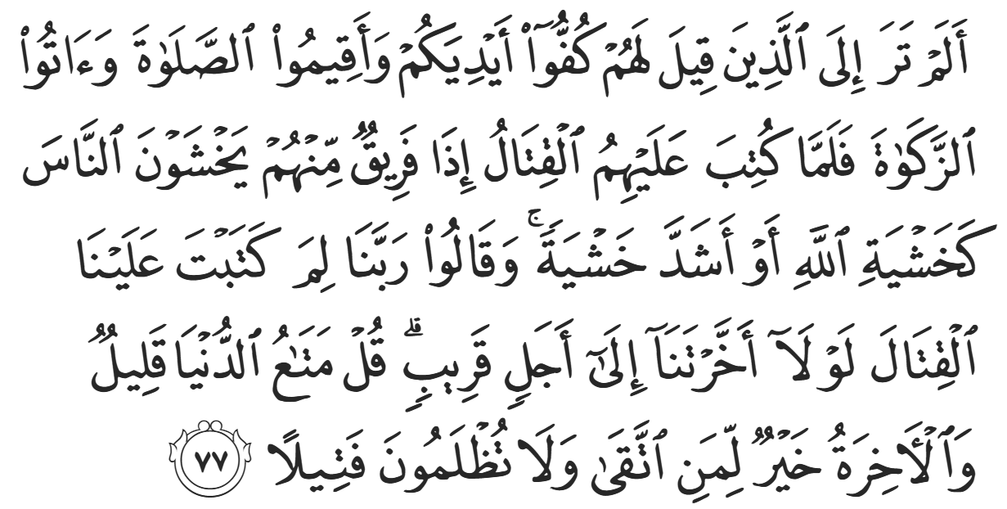
“Have you not seen those who were told, "Restrain your hands [from fighting] and establish prayer and give zakāh"? But then when battle was ordained for them, at once a party of them feared men as they fear Allāh or with [even] greater fear. They said, "Our Lord, why have You decreed upon us fighting? If only You had postponed [it for] us for a short time." Say, "The enjoyment of this world is little, and the Hereafter is better for he who fears Allāh. And injustice will not be done to you, [even] as much as a thread [inside a date seed]."” (4:77)
Allah (SWT) is demonstrating how oftentimes those who talk the loudest, intend the least. In Makkah, the command was to remain patient and steadfast, but in Madinah, Allah (SWT) allowed the believers to fight back.
The first verse of jihad from Surat al-Hajj in the Qur’aan underpins the philosophy of Jihaad and why it was permitted:
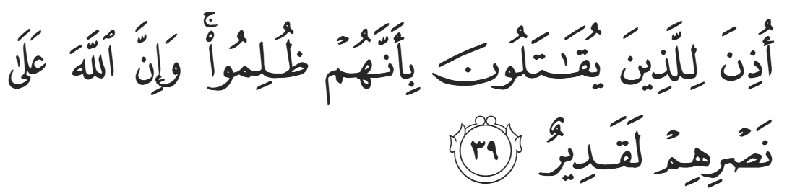“Permission [to fight] has been given to those who are being fought, because they were wronged. And indeed, Allah is competent to give them victory.” (22:39)
In Makkah, jihaad was forbidden, and now it was permitted as a recourse for self-defense. Fighting was permissible for those who have been wronged or oppressed. Abu Bakr (RA) commented, “As soon as I heard Surah al-Hajj, I knew there would be war.”
Following Surah al-Hajj, the Muslims embarked on a series of expeditions. The primary goal of these expeditions was to demonstrate to the Quraysh that the Muslims were not meek and defeated; they were an independent political and military force. The secondary reason was to strangle the Quraysh’s imports and exports. Makkah’s centrality to Arabia’s trade routes made it an economic powerhouse, and compromising those routes was a major blow to their regional dominance. A tertiary goal was to expand the Islamic state by forming alliances with nearby tribes.
There were two types of expeditions: ghazwah – which is any battle that the Prophet ﷺ attended; and sariyyah – which is any battle that the Prophet ﷺ commanded but did not attend. Buraydah (RA) narrates, “The Prophet ﷺ attended 19 ghazawaat, and physically fought in eight of them.” As for the saraaya, there were many. There are differences between accounts as to how many, but there were at least 30 by all accounts.
The first military expedition was called al-Abwaa, which took place on the 12th of Safar, nine months after the Hijrah. The Prophet ﷺ heard that a caravan from the Quraysh was exposed, and the Muslims set off to raid it. They did not catch the caravan, but the Prophet ﷺ made alliances with the tribes surrounding Madinah called the Banu Damrah, and the Islamic state expanded for the first time. In the 2nd expedition, they encountered the enemy but there were no casualties, as a third party quashed the conflict. Sa’d ibn Abi Waqqas (RA) made history by shooting the first arrow for the sake of Allah in Islaam.
The next expedition was Ghazwah al-Ushayarah, which would prove to be a defining moment in Islamic history. The Prophet ﷺ took around 150 companions to raid the Quraysh’s annual caravan heading to Syria. It held over 70% of the wealth in Makkah, including over 70 camels and much more. The Prophet ﷺ had intended to intercept the caravan but they were not able to cross paths. However, a member of the Quraysh had accidentally strayed from the caravan and saw the Muslims approaching, which allowed him to warn Abu Sufyaan, the leader of the caravan. The Prophet ﷺ did not know that the Quraysh knew of their approach, and Abu Sufyaan used this to his advantage. He sent an envoy to Makkah to mobilize an army. In the meantime, one of the allies of the Quraysh ambushed Madinah at night, stole some camels, and killed some camel herders. As soon as the Prophet ﷺ heard, he mobilized 70 Companions, but the men fled. This was referred to as the “First Battle of Badr” – or the “Small Battle of Badr”, as it took place on the plains of Badr, though no actual fighting took place.
After failing to intercept the caravan traveling northbound, the Prophet ﷺ sent eight Muhaajiroon southbound to observe the Quraysh traveling to Yemen, nominating his cousin, ‘Abdullah ibn Jahsh (RA), as the leader. All of the chosen men for the expedition were Muhaajiroon because the Prophet ﷺ was keen to remind them that Makkah was taken from them, and that their fight was not over. He wrote a letter and told them to travel for two days before opening the letter, which instructed them to abruptly change directions and enter Makkah. The Prophet’s secrecy and caution in this regard is a clear indication of the importance of discretion and tactics in warfare. The letter also instructed ‘Abdullah ibn Jahsh not to force any of his seven companions to accompany him into Makkah owing to the extremely high risk of the operation. Assuming certain death, ‘Abdullah ibn Jahsh said, “Whoever of you is eager for martyrdom and wishes to meet Allah (SWT) soon, let him come with me; and whoever does not may return back to Madinah.” They all accompanied him and continued onwards, and the expedition was called Sariyyah al-Nakhlah.
They had four camels between eight of them—yet another indication of the scarcity of resources in early Islaam. One of their camels escaped in the night, so Sa’d ibn Abi Waqqas and ‘Utbah ibn Gazwaan remained in the desert while the remaining six continued to Makkah. As they arrived in the desert grove of Nakhlah, on the outskirts of Makkah, they saw a small business caravan loaded with merchandise. They were faced with a dilemma: this raid would be extremely profitable for the Ummah, but the Prophet ﷺ sent them to gather information, not to fight. Moreover, it was the 30th of Rajab—a sacred month—which means there was one hour left before the day ended and fighting was permissible, just enough time for them to get away to safety. They debated amongst themselves, but the opportunity was so tempting that they decided to pounce. They attacked, killed one guard, captured two more as prisoners of war, and returned to Madinah.
The Prophet ﷺ was displeased with their actions. He reprimanded them and refused to accept any of the war booty, saying, “I did not send you to fight in the Sacred Month.” The Quraysh reveled in this mistake; they proliferated the news of this event and spread their criticisms of the Muslims throughout the whole of Arabia, accusing them of violating the sanctity of the sacred months and transgressing the religion of Ibraheem (AS). The Prophet ﷺ felt great stress over these accusations, as they contained elements of truth. Allah (SWT) then revealed:
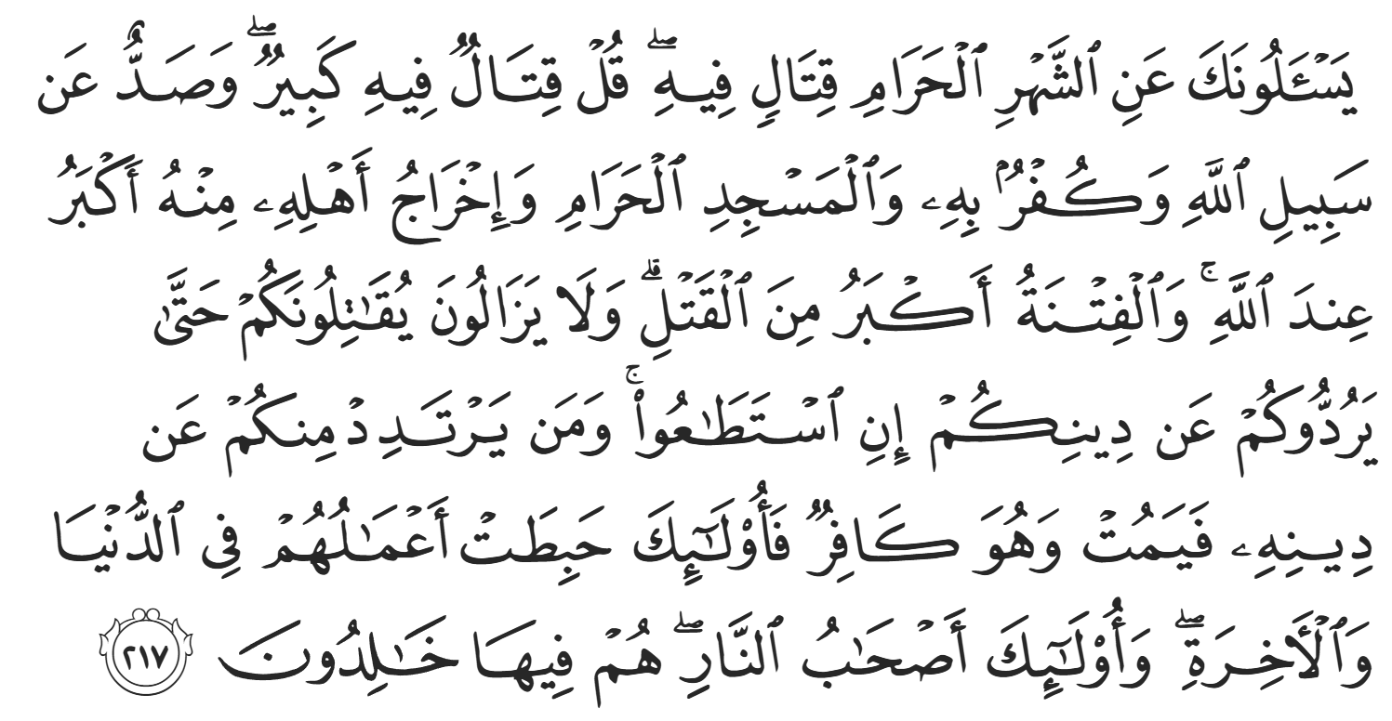
“They ask you about the sacred month - about fighting therein. Say, "Fighting therein is great [sin], but averting [people] from the way of Allah, and disbelief in Him, and [preventing access to] al-Masjid al-Ḥarām, and the expulsion of its people therefrom are greater [evils] in the sight of Allah. And fitnah is greater than killing." And they will continue to fight you until they turn you back from your religion if they are able. And whoever of you reverts from his religion [to disbelief] and dies while he is a disbeliever - for those, their deeds have become worthless in this world and the Hereafter, and those are the companions of the Fire; they will abide therein eternally.” (2:217)
After this verse was revealed, the Prophet ﷺ accepted the war booty and requested ransoms for the prisoners of war. However, he would not release them until Sa’d ibn Abi Waqqas and ‘Utbah ibn Ghazwaan (RHUM) returned safely. The two Companions were not actually captured; they were still in the desert and eventually returned without harm. The Prophet ﷺ then released the hostages, and one of them, al-Hakam ibn Kaysaan, accepted Islam and returned to the Prophet ﷺ on his own accord—but only after the ransom reached the Prophet ﷺ.
These events remind us that the strength of the Ummah is built on sacrifice, knowledge, and sincere devotion, as seen in Ahl al-Suffah, but also on patience, strategy, and obedience to Allah’s commands in times of hardship. From the restraint in Makkah to the measured action in Madinah, we learn that success comes from acting with wisdom, not haste, and trusting Allah’s plan at every stage. May we carry these lessons into our lives by staying steadfast, thinking long-term, and striving for His pleasure in all that we do.
<Duaa!>
- Oh Allah, please grant us a deep love for Your Prophet Muhammad, SAW.
- Oh Allah, please make us energetic in doing good for Your cause.
- Oh Allah, please enable us with the will and means to walk Al-Sirrat-Al-Mustaqeem, even if it estranges us from others.
- Oh Allah, please support the suffering and oppressed Muslims around the world and grant them victory over those who oppress them.
- Oh Allah, please protect us from being overburdened by debt and from all its harms and consequences.
- Oh Allah, please grant healing to those among us who are sick, and grant them comfort, patience, and what is best for their condition.
- Oh Allah, please fill our hands with the work and deeds of righteousness and let them be of benefit to ourselves and the Ummah.
- Oh Allah, please forgive us our shortcomings and deviances in following Your Qur'an and the Sunnah of Rasul'Allah, SallAllahuAlayhiWaSallam.
- Oh Allah, please grant us understanding and guidance of Your Qur'aan.
- Oh Allah, please grant us patience with the trials of this world.
- Oh Allah, please prevent our hearts from getting overly attached to the Dunya and grant us the best in this life and the best in the hereafter.
- Oh Allah, please forgive us our past sins and purify our hearts.
- Oh Allah, please make us amongst those whose Duaa is accepted.
- Oh Allah, please grant us Jannat'ul Firdaus and protect us from ever coming close to the Fires of Jahannum.

