Khut'bah Opening
إِنَّ الْحَمْدَ للهِ , نَحْمَدَهُ وَ نَسْتَعينُهُ وَ نَسْتَغْفِرُهُ , وَ نَعوذُ بِالله مِنْ شُرورِ أَنْفُسِنا , مَن يَهْدِهِ اللهُ فَلا مُضِلَّ لَه , وَ مَنْ يُضِلِلْ فَلا هادِيَ لَهْ , وَ أَشْهَدُ أَنْ لا إلهَ إِللهُ وَحْدَهُ لا شَريكَ لَه , و أَشْهَدُ أنَّ مُحَمَّدًا عَبْدُهُ و رَسولُه.
"All thanks and praises are due to Allah, whom we thank, seek for help and invoke for forgiveness. We seek refuge with Allah from the evils within ourselves. He whom Allah guides will never be misled and he whom He misguides will never find one to guide him. I bear witness that there is no deity worthy of worship except Allah and that Muhammad (SAW) is His slave and Messenger.”
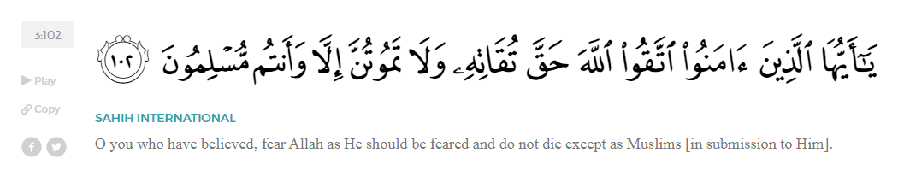
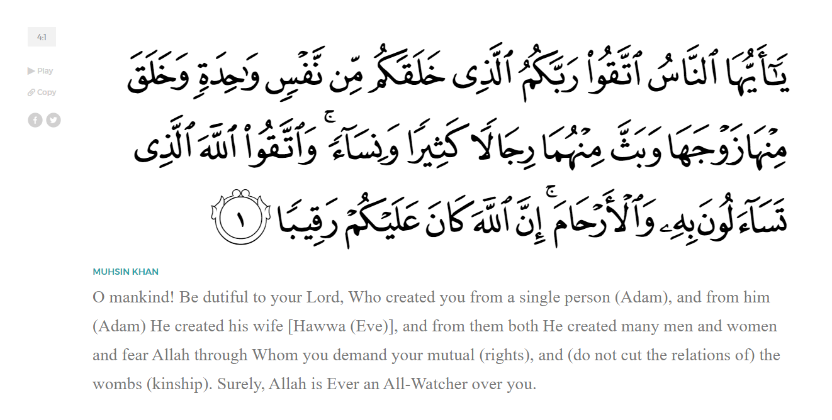
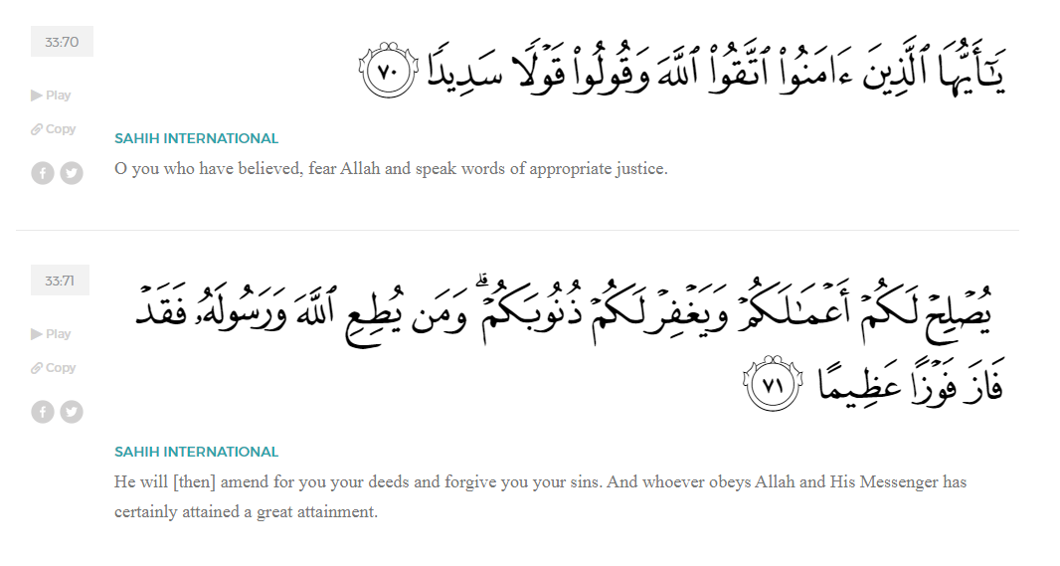
<Sirah of the Prophet (SAW) – Part X -Dr. Yassir Qadhi, Book and Series>
Dear brothers and sisters,
InshaaAllah we will continue our khutbah series on the seerah of the Prophet ﷺ, drawing from Dr. Yasir Qadhi’s book, The Sirah of the Prophet, so that we can deepen our understanding of his life and strengthen our love for him. Each step we take through the Prophet ﷺ’s life brings us closer to knowing him more deeply, appreciating his struggles, and embodying his character. Our goal in this series, inshaaAllah, is not just to learn history, but to let the seerah transform our hearts and strengthen our love for the Messenger of Allah ﷺ.
Today we will, inshaaAllah, begin the chapter titled “The Battle of Badr”. This is a large chapter that will take many weeks to complete.
As you recall from last week, we saw how Allah (SWT) gradually permitted the new Muslim nation to defend themselves, and how the Prophet ﷺ began sending expeditions to assert the presence of the Muslims, gather intelligence, and challenge the Quraysh economically. These early movements set the stage for a major turning point, as tensions between the Muslims and the Quraysh continued to rise, ultimately leading to the events of Badr.
The Prophet ﷺ sent several scouts to observe the Quraysh’s caravan returning southbound. Talhah ibn ‘Ubaydillah and Sa’eed ibn Zayd (RHUM) reported its magnitude, making it one of the biggest caravans in the history of Arabia. The reports do not state why the caravan was so spectacularly large, although the recent looting of all the Muhajiroon’s wealth and possessions, who had to secretly make Hijrah from Makkah to Madinah, is a strong indicator of why their current trade was particularly vibrant. Intercepting this caravan would therefore be hugely significant, as it would bring the Makkan economy to a screeching halt while simultaneously empowering the Muslims, and the Prophet ﷺ was indeed cognizant of this fact.
After the caravan was located, the Prophet ﷺ made an urgent announcement in the masjid. According to a report in Sahih Muslim, he ﷺ did not inform the companions of the details. Instead, he said, “We have a mission to undertake, so whoever has his camel ready shall come with me.” Some of the companions asked to go and retrieve their camels, and the Prophet ﷺ refused, stating that he must leave immediately. The report in Ibn Ishaaq states that he explicitly mentioned that they were heading to the Quraysh’s caravan. These reports can be reconciled by placing the first narration in Madinah, and the second narration en route to the caravan. This explanation is logical because the Prophet ﷺ may have been wary of spies, as there were Pagans still present in Madinah at the time.
As they set up camp, the Prophet ﷺ was finally able to assess his group and plan accordingly. He sent back two people too young to participate: al-Baraa’ ibn ‘Aazib and ‘Abdullah ibn ‘Umar (RHUM), as they were both below the age of 15, the cut-off point for combat. There remained 82 Muhaajiroon, 61 Aws, and 170 Khazraj, totaling 313. There seems to be divine significance in the number 313, as it is the same number of Messengers sent to Earth (that’s total Messengers, not total Prophets), and 313 is the same number of fighters who accompanied Prophet Dawood (AS) to conquer Jerusalem.
The convoy was not prepared for war, as the sole aim was to raid a trade caravan using the element of surprise. The whole group had two riding horses, 100 camels, and minimal armor and weaponry. Each camel was shared by three people, and the Prophet ﷺ shared his camel with ‘Ali ibn Abi Taalib and Abu Lubaabah (RHUM). They both insisted that the Prophet ﷺ take the camel for himself and that they walk, but the Prophet ﷺ provided the most eloquent of responses, saying, “The two of you are not any younger or stronger than me, and nor am I any less in need of reward.” The Prophet ﷺ could have very easily accepted the offer; from a political standpoint, the leader is expected to receive a higher level of prestige, and from a religious standpoint, a Prophet is not equal to his followers. Nevertheless, he ﷺ displayed the unwavering humility for which he was known. He ﷺ was also setting a Prophetic example for his followers – true leadership is not about elevating oneself above others, but about sharing in their struggles, upholding justice, and seeking reward from Allah (SWT) alongside them, not at their expense. The Prophet ﷺ embodied true leadership and mentorship.
After the close call of Ghazwah al-Ushayrah mentioned in the last khutbah, Abu Sufyaan heightened his defense, sending out counterspies to observe the Prophet’s spies. One of his scouts spotted two men, and Abu Sufyan began to investigate. He even analyzed the camel dung left behind and noticed Medinan date seeds, realizing they were Muslim soldiers. Indeed, they were Talhah ibn Ubaydillah and Sa’eed ibn Zayd (RHUM). As soon as he realized, he ordered the caravan to take an unknown route to avoid an ambush. He then sent his fastest rider, Damdam ibn ‘Amr al-Gifaari, to race back to Makkah and call for reinforcements.
<Conclude 1st Khutbah with:
Aqoolu haathaa wa astaghfir-Allaah (I say this and I ask Allah for forgiveness)
أَقُولُ قَوْلِي هَذَا وَأَسْتَغْفِرُ اللَّهَ لِي وَلَكُمْ وَلِسَائِرِ المُسْلِمينَ وَالمُسْلِمَاتْ فَاسْتَغْفِرُوهْ إِنَّهُ هُوَ الْغَفُورُ الرَّحِيمُ
الحمد لله رب العالمين والصلاة والسلام على سيد المرسلين وعلى آله وأصحابه أجمعين
<2nd Khutbah>
Dear brothers and sisters,
While Damdam was racing back, the inhabitants of Makkah were already sensing tension. The Prophet’s aunt, ‘Aatikah bint ‘Abd al-Muttalib, had a vivid dream three days before Damdam’s arrival. She called al-‘Abbas (RA) and informed him that she dreamt that a crier would come to Makkah, racing on his camel, shouting, “O traitors! Meet your death in three days!” The crier repeated the same sentence on top of the Ka’bah, and again on top of Mount Abu Qubays (the highest point in Makkah). The crier then picked up a large boulder and toppled it over the mountain. As the rock reached the base, it splintered into several rocks, hitting every single house in Makkah. The dream worried al-‘Abbas, so he urged her to keep it secret. However, al-‘Abbas contradicted his own advice, telling al-Waleed ibn ‘Utbah, who was sworn to secrecy but still told his father, ‘Utbah. Eventually, the entirety of Makkah was gossiping about this dystopian dream.
As al-‘Abbas was performing tawaf, Abu Jahl ambushed him, asking sarcastically, “O children of ‘Abd al-Muttalib, since when did you get a female prophetess?” Abu Jahl then threatened that if the prediction does not come true, the Banu Haashim would be publicly shamed as the liars of Makkah. Caught off-guard, al-‘Abbas denied everything, but before he even returned to his house, the women of Banu Haashim began chastising him, accusing him of failing to defend his own womenfolk. Embarrassed, the next morning al-‘Abbas headed out to rebuke Abu Jahl to restore his honor, however Abu Jahl turned away in shame and could not even bear to face him. It was the third day after the dream, and the crier had arrived: Damdam was seen racing into Makkah, screaming. He mutilated his horse for dramatic effect, cutting off its nose as a symbolic cry for help. Blood rushed down its face as Damdam yelled, “O Quraysh! Your caravan! Your property and wealth with Abu Sufyaan are being attacked by Muhammad and his Companions! Help!” he was calling them to their wealth, but as ‘Aatikah predicted, he was, in reality, calling them to their death.
Damdam’s dramatic plea rallied the Quraysh and they mobilized 1,300 men in a single day. Every single household in Makkah sent at least one fighter, if not more—again corroborating ‘Aatikah’s dream. There was an eerie feeling amongst the Quraysh, and the worst of them feared death the most, as they knew how badly they had treated the Prophet ﷺ. Abu Lahab found a way out and did not attend, sending al-‘Aas ibn al-Waa’il in his stead. Al-‘Aas owed Abu Lahab a large sum of money and Abu Lahab offered to forgive the entire loan if he fought on his behalf. It is not explicitly stated why Abu Lahab did not attend, though it is perhaps a combination of cowardice and a conflicted feeling of fighting his own tribe. ‘Utbah ibn Rabi’ah also hesitated in attending for the same reasons, but his brother Shaybah reminded him that if they did not attend, they would be humiliated upon their return. Allah (SWT) decreed that they did not return, as they marched to their deaths.
As described throughout the Seerah, ‘Uqbah ibn Abi Mu’ayt was the worst of them all, and he knew he would not be spared. One day in Makkah, ‘Uqbah invited the Prophet ﷺ to eat with him mockingly, to which the Prophet ﷺ said, “I will not eat with you until you testify that there is no god but Allah, and that I am His Messenger.” In his fury, ‘Uqbah spat in the face of the Prophet ﷺ, and the Prophet ﷺ calmly wiped the spit away and said, “O ‘Uqbah, when we meet outside the valleys of Makkah, I will execute you.” Deep down, ‘Uqbah knew this prediction would come true, hence his hesitation. However, a family member reassured him and offered his fastest camel so he could escape if the Quraysh lost the battle. ‘Uqbah then reluctantly agreed to join.
Of those who also desperately tried to avoid attending was Umayyah ibn Khalaf, the abuser and torturer of Bilal (RA). He was obese in stature with no fighting skills whatsoever, so he paid a man to fight in his stead. However, he was one of the most senior figures of the Quraysh, and his absence would cause a blow to their morale. Abu Jahl tried to rally him by massaging his ego, but it was not enough, so he went to ‘Uqbah and hatched a plot to embarrass Umayyah. ‘Uqbah, overcompensating for his own cowardice, approached Umayyah as he was sitting in the Haram and gifted him an incense burner typically used by women, saying, “This is your gift, O Umayyah. Perfume yourself, as you are nothing but a woman.” This public humiliation was enough to rile Umayyah to publicly declare his attendance. Indeed, ‘Uqbah and Abu Jahl led Umayyah to his death, simply to save face.
Before heading to battle, the Quraysh gathered together around the Ka’bah, held onto its cloth, and made du’aa, “O Allah, help whichever of these two tribes is more noble in your eyes, send victory to whichever of these two groups is more honorable, and send your aid upon the better of the two tribes.” Allah (SWT) indeed answered their prayers, and this du’aa is referenced in the Qur’aan:
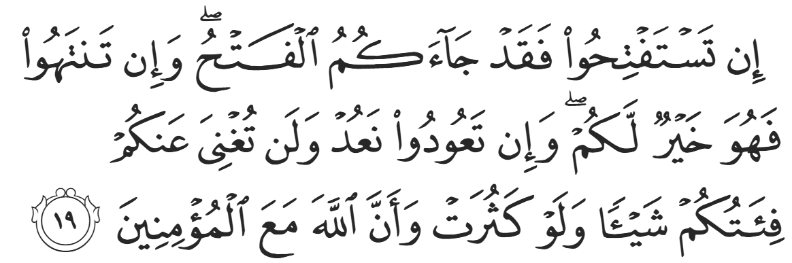
“If you ˹Meccans˺ sought judgment, now it has come to you. And if you cease, it will be for your own good. But if you persist, We will persist. And your forces—no matter how numerous they might be—will not benefit you whatsoever. For Allah is certainly with the believers.” (8:19)
1,300 men then marched out of Makkah—the largest number ever to march in unison—led by Abu Jahl. As Arabia was tribal, previous battles would typically comprise of dozens of fighters, and larger battles between multiple tribes might consist of hundreds, but this was the first time in Arabia that an army was marching in the thousands. They had over 100 horses, 600 suits of armor, and hundreds of camels. The Quraysh wanted to make a show of this power, bringing dozens of singing girls and beating drums. The Qur’aan references their arrogance:
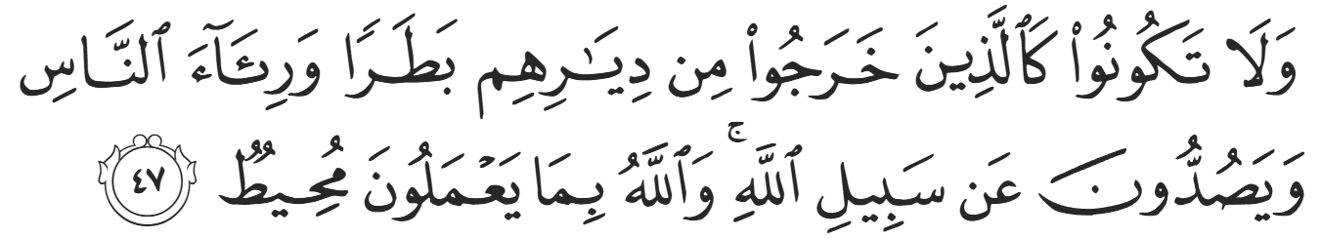
“Do not be like those ˹pagans˺ who left their homes arrogantly, only to be seen by people and to hinder others from Allah’s Path. And Allah is Fully Aware of what they do.” (8:47)
Meanwhile, Abu Sufyaan, still in the desert, sent another messenger to Makkah notifying them that the caravan was safe and that the reinforcements were no longer needed. By this time, the Quraysh were already en route, camped outside Makkah. The message reached them, and the likes of ‘Utbah ibn Rabi’ah argued that there was no longer any need to continue, but Abu Jahl was adamant, saying, “No, we will go to Badr and stay there for three days. We will drink our wine, have women sing for us, and let the Arabs hear that we are a strong and mighty nation.” Despite this, some smaller tribes headed back, leaving 950-1000 of the Quraysh to march on.
InshaaAllah we will continue the part of the Seerah relating to the infamous Battle of Badr in our next Khutbah, talking about the mental state of the Muslims on the other side, everything leading up to the battle, and more.
In these powerful moments, we find timeless lessons that speak directly to our lives today. We see the Prophet ﷺ embodying true leadership—not through privilege, but through humility, sacrifice, and standing shoulder to shoulder with his companions. We see the importance of preparation and trust in Allah (SWT), as the Muslims set out with limited resources but firm conviction. And on the other side, we see how arrogance, pride, and attachment to status will ultimately lead the Quraysh to their downfall, even though they were given explicit warnings from the divine and opportunities to turn back. These events teach us to check our intentions, to avoid arrogance, and to stand firm upon truth even when the odds seem against us.
<Duaa!>
- Oh Allah, please grant us a deep love for Your Prophet Muhammad, SAW.
- Oh Allah, please make us energetic in doing good for Your cause.
- Oh Allah, please enable us with the will and means to walk Al-Sirrat-Al-Mustaqeem, even if it estranges us from others.
- Oh Allah, please support the suffering and oppressed Muslims around the world and grant them victory over those who oppress them.
- Oh Allah, please protect us from being overburdened by debt and from all its harms and consequences.
- Oh Allah, please grant healing to those among us who are sick, and grant them comfort, patience, and what is best for their condition.
- Oh Allah, please fill our hands with the work and deeds of righteousness and let them be of benefit to ourselves and the Ummah.
- Oh Allah, please forgive us our shortcomings and deviances in following Your Qur'an and the Sunnah of Rasul'Allah, SallAllahuAlayhiWaSallam.
- Oh Allah, please grant us understanding and guidance of Your Qur'aan.
- Oh Allah, please grant us patience with the trials of this world.
- Oh Allah, please prevent our hearts from getting overly attached to the Dunya and grant us the best in this life and the best in the hereafter.
- Oh Allah, please forgive us our past sins and purify our hearts.
- Oh Allah, please make us amongst those whose Duaa is accepted.
- Oh Allah, please grant us Jannat'ul Firdaus and protect us from ever coming close to the Fires of Jahannum.

