Khut'bah Opening
إِنَّ الْحَمْدَ للهِ , نَحْمَدَهُ وَ نَسْتَعينُهُ وَ نَسْتَغْفِرُهُ , وَ نَعوذُ بِالله مِنْ شُرورِ أَنْفُسِنا , مَن يَهْدِهِ اللهُ فَلا مُضِلَّ لَه , وَ مَنْ يُضِلِلْ فَلا هادِيَ لَهْ , وَ أَشْهَدُ أَنْ لا إلهَ إِللهُ وَحْدَهُ لا شَريكَ لَه , و أَشْهَدُ أنَّ مُحَمَّدًا عَبْدُهُ و رَسولُه.
"All thanks and praises are due to Allah, whom we thank, seek for help and invoke for forgiveness. We seek refuge with Allah from the evils within ourselves. He whom Allah guides will never be misled and he whom He misguides will never find one to guide him. I bear witness that there is no deity worthy of worship except Allah and that Muhammad (SAW) is His slave and Messenger.”
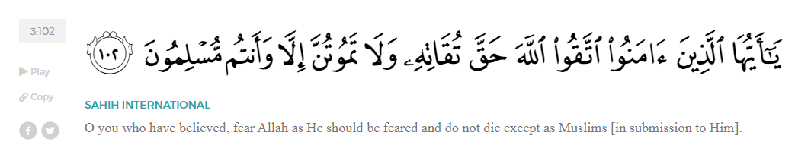
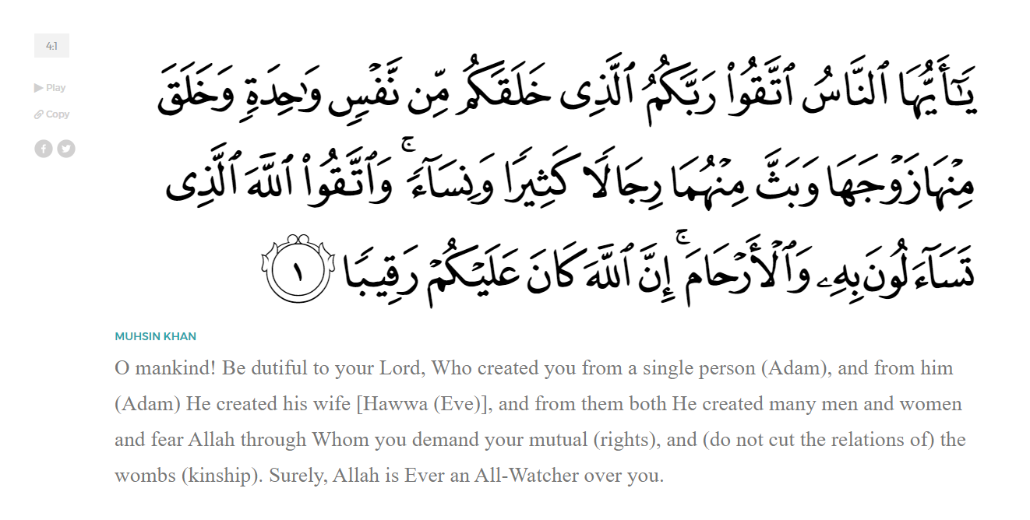
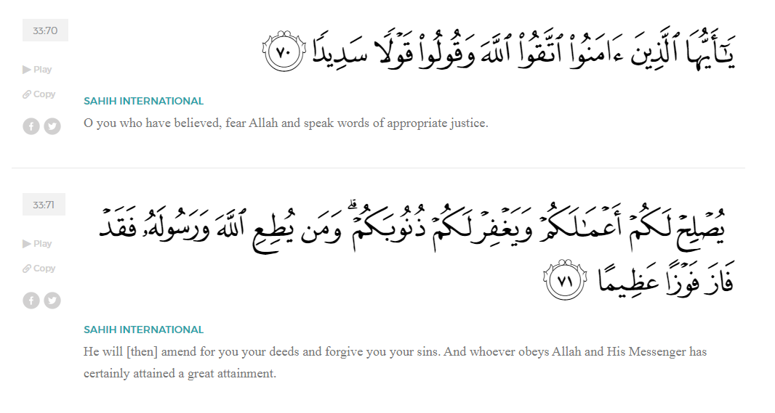
<Sirah of the Prophet (SAW) – Part 29 -Dr. Yassir Qadhi, Book and Series>
Dear brothers and sisters,
InshaaAllah we will continue our khutbah series on the seerah of the Prophet ﷺ, drawing from Dr. Yasir Qadhi’s book, The Sirah of the Prophet, so that we can deepen our understanding of his life and strengthen our love for him. Each step we take through the Prophet ﷺ’s life brings us closer to knowing him more deeply, appreciating his struggles, and embodying his character. Our goal in this series, inshaaAllah, is not just to learn history, but to let the seerah transform our hearts and strengthen our love for the Messenger of Allah ﷺ.
Today we will, inshaaAllah, continue the chapter titled “The Battle of Badr”.
As you recall from the last khutbah, the army of Quraysh had marched out of Makkah in a display of arrogance and pride, bringing nearly a thousand men, along with horses, armor, drums, and singing girls, determined to show all of Arabia their power. Though Abu Sufyaan had already managed to save the caravan and sent word that no battle was necessary, Abu Jahl refused to return, insisting that they proceed to Badr, celebrate there, and make their dominance known. Many of the chiefs of Quraysh joined reluctantly, driven not by courage but by fear of humiliation—men like Umayyah ibn Khalaf and ‘Uqbah ibn Abi Mu‘ayt, who were pressured into marching toward the very fate they sensed awaited them. On one side stood an army intoxicated by wealth, numbers, and ego; on the other side were the believers, who had only set out expecting a caravan and now found themselves facing the greatest military force Arabia had yet seen.
On the Muslim side, the Companions left Madinah expecting an easy raid of a relatively unmanned caravan. They did not prepare for—nor expect—a war. As they progressed, rumors began to spread that there was an army leaving Makkah ready for war. The Prophet ﷺ began to quiz the Companions, asking what they thought if the Quraysh were aware of their plan and ready to fight. Some of the Companions expressed their reservations, citing that they were not properly armed. The next day, the Prophet ﷺ asked again, and some Companions again expressed their concerns. The Qur’aan mentions these doubts:
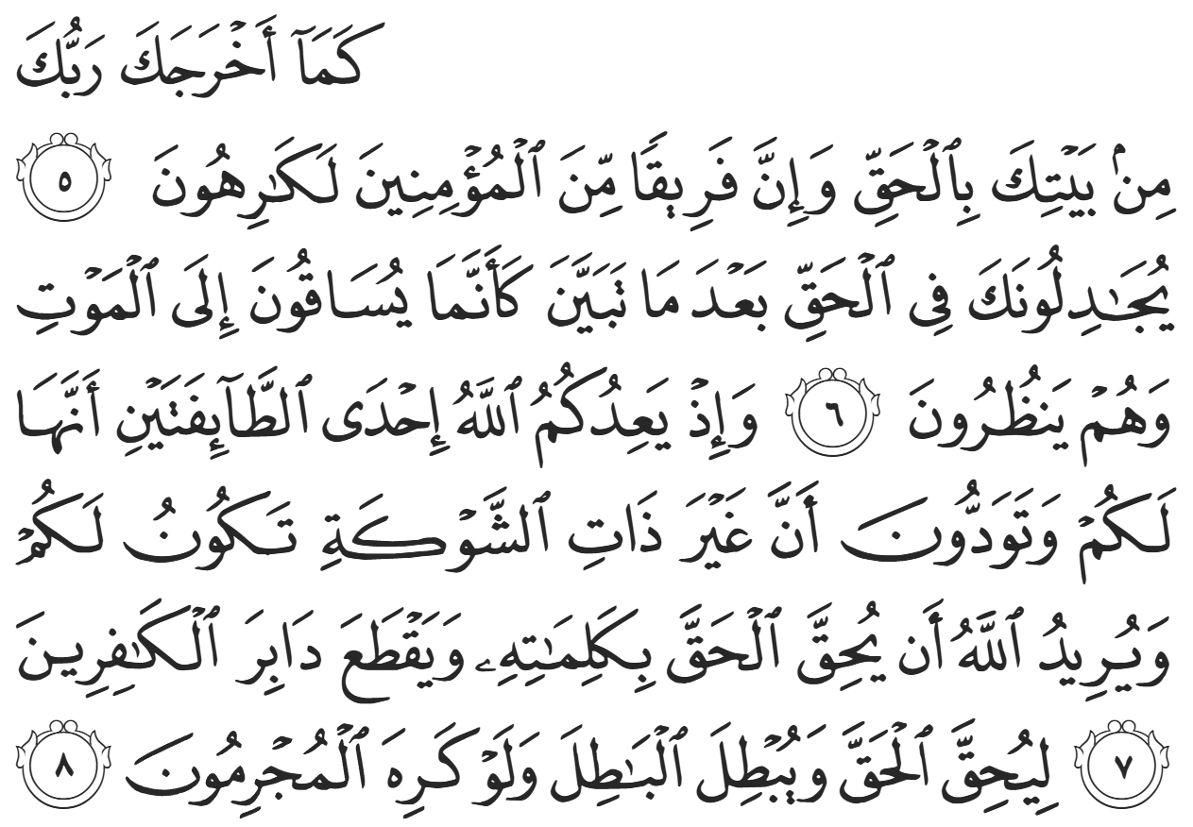
“Similarly, when your Lord brought you ˹O Prophet˺ out of your home for a just cause, a group of believers were totally against it. They disputed with you about the truth after it had been made clear, as if they were being driven to death with their eyes wide open. ˹Remember, O believers,˺ when Allah promised ˹to give˺ you the upper hand over either target, you wished to capture the unarmed party. But it was Allah’s Will to establish the truth by His Words and uproot the disbelievers; to firmly establish the truth and wipe out falsehood—even if the criminals disliked it.” (8:5-8)
Allah (SWT) gently reprimanded the Companions, but still called them believers. They were the best generation to exist, but they were still human.
The Prophet ﷺ began scouting for further information alongside his closest confidant, Abu Bakr (RA). This is the only recorded occasion where the Prophet ﷺ personally scouted, signifying the high stakes of the situation at hand. They eventually came across an elderly Bedouin, and Bedouins were known for carrying information in the desert. The Prophet ﷺ asked, “Do you have any information about the Quraysh, and about Muhammad and his army?” The Prophet ﷺ asked about both parties so as not to arouse suspicion. Replying in kind, the Bedouin said, “First, who are you?” The Prophet ﷺ replied carefully, “I promise to tell you where we are from as long as you give us your information.” The Bedouin then disclosed: Muhammad left on such-and-such date, and if so, he will be camped at such-and-such place. As for the Quraysh, their army has left Makkah on such-and-such date, and if so, they will be camped at such-and-such location.
The Bedouin’s information about the Prophet ﷺ was entirely correct, which indicates that his information about the Quraysh was likely equally as accurate. The rumors were therefore true: the Quraysh had sent their army in full, and war was on the horizon. The Bedouin then asked the Prophet ﷺ about himself, to which the Prophet ﷺ replied, “We are from water.” He ﷺ then immediately left, leaving the Bedouin in a state of bewilderment. The Prophet ﷺ utilized tawriyah-double meaning-to protect himself, as he was referring to the Quranic verse:
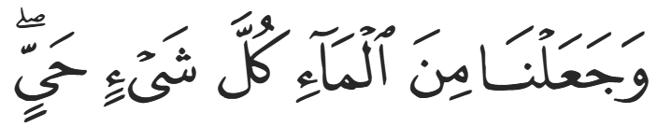
“And We created from water every living thing.” (21:30)
While excessive or unnecessary tawriyah is discouraged in the Shariyah, using equivocations in times of need is permissible to avoid lying, as utilized by Prophet ﷺ and the prior prophets. (AHUM-As)
<Conclude 1st Khutbah with:
Aqoolu haathaa wa astaghfir-Allaah (I say this and I ask Allah for forgiveness)
أَقُولُ قَوْلِي هَذَا وَأَسْتَغْفِرُ اللَّهَ لِي وَلَكُمْ وَلِسَائِرِ المُسْلِمينَ وَالمُسْلِمَاتْ فَاسْتَغْفِرُوهْ إِنَّهُ هُوَ الْغَفُورُ الرَّحِيمُ
الحمد لله رب العالمين والصلاة والسلام على سيد المرسلين وعلى آله وأصحابه أجمعين
<2nd Khutbah>
Dear brothers and sisters,
The Prophet ﷺ returned to the Muslim camp and prayed to Allah (SWT) before addressing the Companions. Throughout the seerah, we note that the Prophet ﷺ would retreat to Allah (SWT) in times of need before resorting to reliance on Allah’s creation. As the Prophet ﷺ prayed, the Companions captured two Qurayshi slaves. The Companions interrogated them, and they disclosed that they were from the army of the Quraysh, to which the Companions would beat them and say, “Do not lie! You are from Abu Sufyaan’s caravan!” The captives would relent and agree but only to stop the beating, and the cycle would repeat. The Prophet ﷺ eventually finished his prayer and said, “When they tell you the truth, you beat them; and when they lie, you let them go.” The Prophet ﷺ discouraged abuse in interrogation and ordered them to stop. He ﷺ then began to ask the captives, “How many of you are there?” The captives pleaded that they were mere slaves and did not hold such information, so the Prophet ﷺ asked how many camels were slaughtered per day. They said, “nine or ten”, to which the Prophet ﷺ declared, “They are 900 to 1,000.” The Prophet ﷺ then asked who was amongst them and they began to list every nobleman of the Quraysh.
The Companions felt tense, as they realized the magnitude of the task before them; the presence of the Chieftains of the Quraysh also meant that huge amounts of wealth, resources, armor, and more are alongside them. The Prophet ﷺ, on the other hand, smiled; he ﷺ knew that Allah’s promise remained true. Allah (SWT) tells us in surat Al-Anfaal:
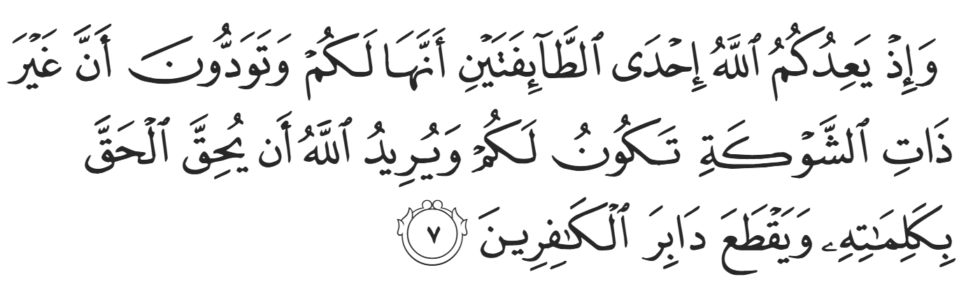
“˹Remember, O believers,˺ when Allah promised ˹to give˺ you the upper hand over either target, you wished to capture the unarmed party. But it was Allah’s Will to establish the truth by His Words and uproot the disbelievers;” (8:7)
Since the Chieftains of the Quraysh were all present, the victory would be even sweeter. He ﷺ then said to the Companions, “Makkah has presented to you the cream of the crop.” When he saw the dejected look on some of their faces, he continued to motivate the troops saying, “By Allah, So-and-so will be killed over here (pointing), So-and-so will be killed over there, So-and-so will be killed over here, and So-and-so will be killed over there…” He named them one by one, pointing to different locations.
He ﷺ then asked the Companions, “What do you think we should do?” The Prophet ﷺ did not need to employ consultation (shuuraa), but the benefit of doing so was twofold: first, his addressees would feel empowered and respected; and second, he was teaching his Ummah the art of leadership. Abu Bakr (RA) immediately stood up, praised Allah (SWT), sent blessings upon the Prophet ﷺ, and spoke words of encouragement and support. The Prophet ﷺ thanked him and repeated the same question, “What do you think we should do?” ‘Umar (RA) then stood up and, like Abu Bakr (RA), uttered words of support.
The Prophet ﷺ thanked him and asked the same question again, and al-Miqdaad ibn Amr (RA), another Muhaajir, stood up. He perhaps thought that Abu Bakr and ‘Umar were not convincing enough, so he replied emphatically, “O Messenger of Allah, do as Allah commanded you, and we are right behind you; O Messenger of Allah, we will not say to you as the Children of Israel said to Musa (AS), ‘So go—both you and your Lord—and fight; we are staying right here!’ … Rather, we say, ‘Go—both you and your Lord—and fight; we are right behind you!’; O Messenger of Allah, take us to all corners of the world, and we will follow you until we meet Allah’s decree!” The Prophet ﷺ thanked him and asked for the fourth time, “What do you think we should do?”
Silence ensued. Then the great leader of the Ansaar, Sa’d ibn Mu’aath (RA), stood up, saying, “Perhaps you are intending us, O Messenger of Allah?” At the Covenant of ‘Aqabah, the Ansaar pledged to protect the Prophet ﷺ from all aggression, but the Battle of Badr did not constitute defensive jihaad, so it was technically outside the fold of the pledge. The Prophet ﷺ did not want to force the Ansaar to continue, as they did not pledge to partake in this type of combat.
The Prophet ﷺ replied in the affirmative—that he was indeed referring to them to answer. Sa’d said, “O Messenger of Allah, we believed in you and trusted you; we testified that you have come with the Truth; we gave you our promises and oaths that we will listen and obey; so go forth and do as you see fit, for we are with you. I swear by the One Who sent you with the Truth, were you to take us to the ocean and charge, galloping into the sea, we would go right behind you. We are not scared to meet the enemy tomorrow, and we will show you our patience in battle. Perhaps Allah will show you, through us, that which will comfort you. So go forth, upon the blessings of Allah—we are right behind you.”
The Prophet ﷺ’s face was described as a shining moon, overjoyed with Sa’d’s response.
Dear brothers and sisters, reflect on the beauty of this scene at Badr. Victory had not yet come, the enemy was larger and stronger, and the road ahead was uncertain—but what filled the heart of the Messenger of Allah ﷺ with joy was not wealth, numbers, or weapons. It was faith. It was loyalty. It was hearts that had submitted fully to Allah (SWT) and companions who stood before him saying, “Wherever you go, we are with you.” These were men whose love for Allah and His Messenger ﷺ was greater than their fear of death, greater than their love of comfort and the pull of this dunya. And when the Prophet ﷺ heard those words of sincerity, courage, and unwavering trust, his blessed face shone like the full moon—satisfied by the brotherhood that Allah had built around him.

<Duaa!>
- Oh Allah, please grant us a deep love for Your Prophet Muhammad, SAW.
- Oh Allah, please make us energetic in doing good for Your cause.
- Oh Allah, please enable us with the will and means to walk Al-Sirrat-Al-Mustaqeem, even if it estranges us from others.
- Oh Allah, please support the suffering and oppressed Muslims around the world and grant them victory over those who oppress them.
- Oh Allah, please protect us from being overburdened by debt and from all its harms and consequences.
- Oh Allah, please grant healing to those among us who are sick, and grant them comfort, patience, and what is best for their condition.
- Oh Allah, please fill our hands with the work and deeds of righteousness that will be of benefit to ourselves and the Ummah.
- Oh Allah, please forgive us our shortcomings and deviances in following Your Qur'an and the Sunnah of Rasul'Allah, SallAllahuAlayhiWaSallam.
- Oh Allah, please grant us understanding and guidance of Your Qur'aan.
- Oh Allah, please grant us patience with the trials of this world.
- Oh Allah, please prevent our hearts from getting overly attached to the Dunya and grant us the best in this life and the best in the hereafter.
- Oh Allah, please forgive us our past sins and purify our hearts.
- Oh Allah, please make us amongst those whose Duaa is accepted.
- Oh Allah, please grant us Jannat'ul Firdaus and protect us from ever coming close to the Fires of Jahannum.

