Khut'bah Opening
إِنَّ الْحَمْدَ للهِ , نَحْمَدَهُ وَ نَسْتَعينُهُ وَ نَسْتَغْفِرُهُ , وَ نَعوذُ بِالله مِنْ شُرورِ أَنْفُسِنا , مَن يَهْدِهِ اللهُ فَلا مُضِلَّ لَه , وَ مَنْ يُضِلِلْ فَلا هادِيَ لَهْ , وَ أَشْهَدُ أَنْ لا إلهَ إِللهُ وَحْدَهُ لا شَريكَ لَه , و أَشْهَدُ أنَّ مُحَمَّدًا عَبْدُهُ و رَسولُه.
"All thanks and praises are due to Allah, whom we thank, seek for help and invoke for forgiveness. We seek refuge with Allah from the evils within ourselves. He whom Allah guides will never be misled and he whom He misguides will never find one to guide him. I bear witness that there is no deity worthy of worship except Allah and that Muhammad (SAW) is His slave and Messenger.
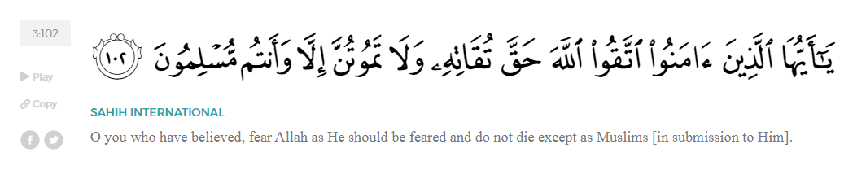
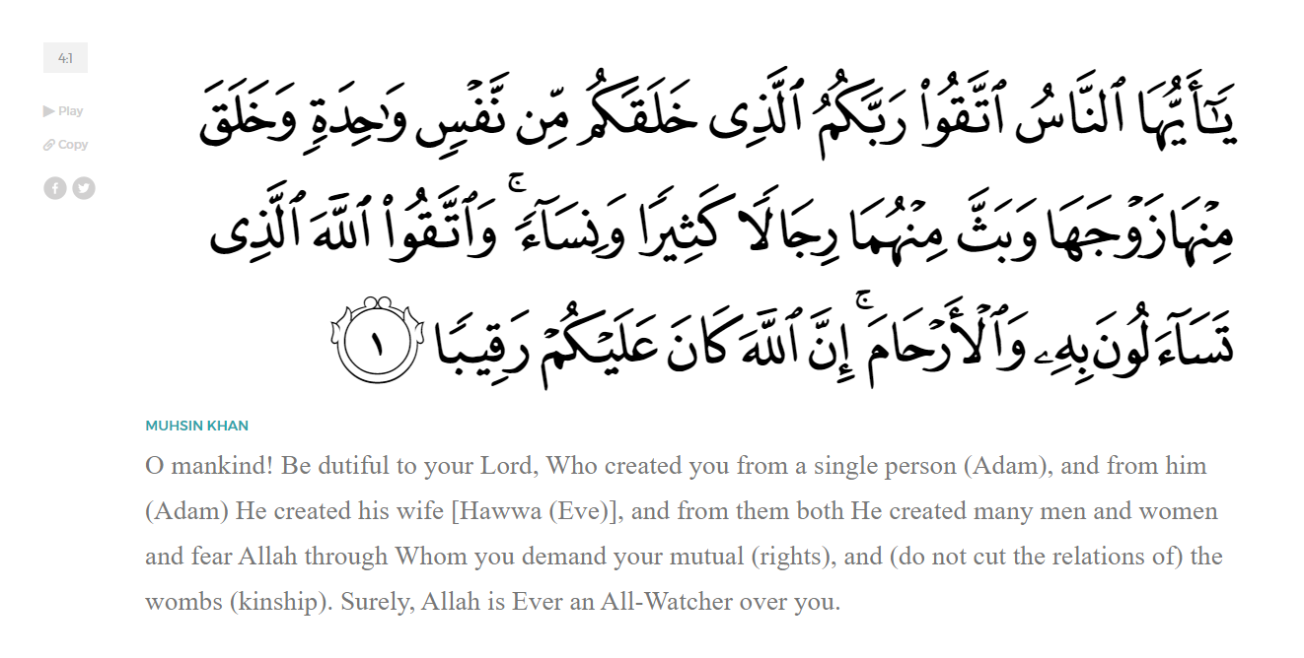
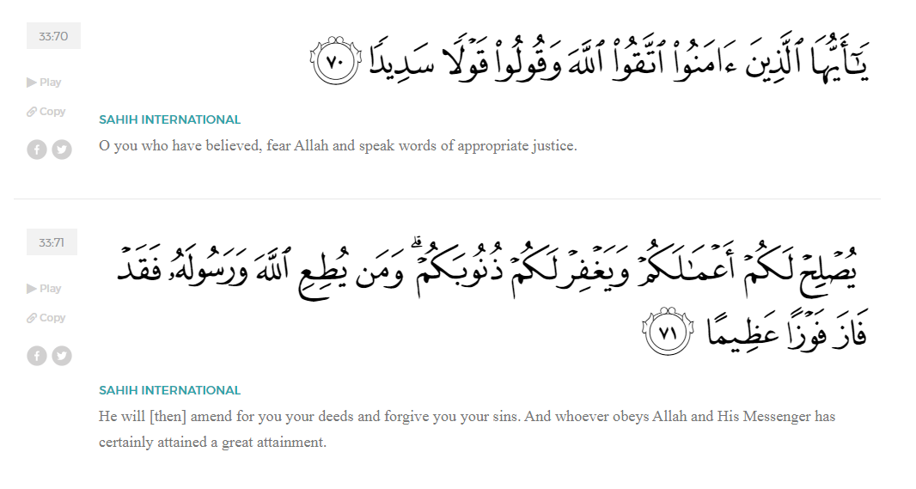
<Sirah of the Prophet (SAW) – Part 3 -Dr. Yassir Qadhi, Book and Series>
Dear brothers and sisters,
InshaaAllah we will continue our khutbah series on the seerah of the Prophet ﷺ, drawing from Dr. Yasir Qadhi’s book, The Sirah of the Prophet, so that we can deepen our understanding of his life and strengthen our love for him ﷺ. Each step we take through the Prophet ﷺ’s life brings us closer to knowing him more deeply, appreciating his struggles, and embodying his character. Our goal in this series, inshaaAllah, is not just to learn history, but to let the seerah transform our hearts and strengthen our love for the Messenger of Allah ﷺ.
Today we will, inshaaAllah, continue with the chapter on Setting the Scene for the coming of the Prophet ﷺ in Pre-Islamic Arabia.
Concepts are often understood and appreciated by analyzing their opposites. Light is appreciated after experiencing darkness, heat is appreciated after experiencing the cold, and so on. Delving into Jahiliyyah (Pre-Islamic Arabic, referred to as The Age of Ignorance), allows us to further appreciate and internalize the blessing of Islam.
The Qur’an affirms that a Prophet has been sent to every nation, in Surat Faatir:
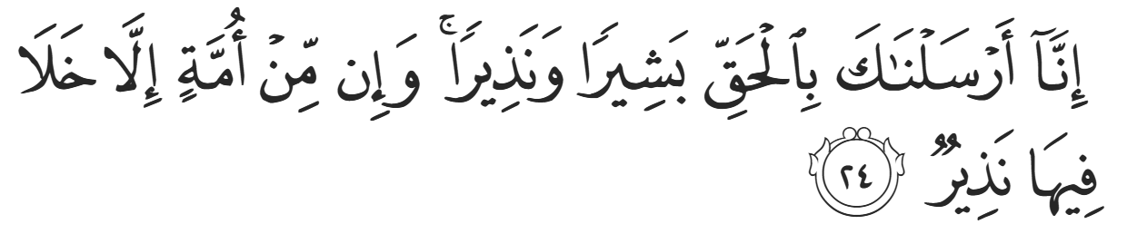
“We have surely sent you with the truth as a deliverer of good news and a warner. There is no community that has not had a warner.” (35:24)
The Prophets sent to the Arabs were Ibraheem (AS) and Ismaeel (AS). Ibraheem (AS) sanctioned many practices that have continued until our time. He ruled Mecca to be Harem (Sacred), which shares the same root as the word haraam (forbidden). It is a sanctuary where some ordinarily halal – permissible- acts are deemed haraam, such as hunting game, cutting down trees, and so on. Ibraheem (AS) built and venerated the Ka’bah. He instituted the four sacred months where all hostilities are ceased, and he instituted the Hajj pilgrimage with all its rituals.
The person who first altered the religion of Ibraheem (AS) and introduced Paganism was ‘Amr ibn Luhayy al-Khuzaaee. The Prophet ﷺ said, “I saw ‘Amr ibn Luhayy Al-Khuzaaee wandering around in the fire of Hell with his entrails cut open behind him. He was the first to alter the religion of Ismaeel.” ‘Amr ibn Luhayy travelled to the Pagan lands in Syria, and returned to Mecca with an idol named Hubal, and thus Paganism was born in Mecca.
Vital lessons can be derived from this deeply consequential event. The pagans of Syria were notoriously powerful, and they attributed their power and dominance to their idols and their Paganism. ‘Amr ibn Luhayy’s inferiority complex led him to yearn to emulate their apparent success, and in turn destroyed his nation’s faith. The lesson here is that technological or infrastructural advancements do not necessarily equate to moral or ethical correctness. Secondly, ‘Amr ibn Luhayy was the Chieftain of the tribe of Khuza’ah, one of the most respected Chieftains of Arabia. It demonstrates how scholars and influential figures can have a profound impact on their community, whether it be positive or negative.
After the introduction of the idol Hubal, idol worship began to proliferate. Pieces of stone from the Ka’bah would be taken as mini-idols and worshipped when travelling. It is pertinent to note that Muslims do not believe in the sanctity of the materials used for the Ka’bah; they are merely bricks and clay. Rather, Muslims believe in the sanctity of the location of the Ka’bah. Neither the marble floor nor the clay structure or the silk cloth of the Ka’bah hold any sacred value in Islam. Abu Raja’ Al-Utaaridi (RA) narrated, “Before the advent of Islam, we used to worship rocks and stones, and if we found a rock more beautiful than the other rock we were worshipping, we would throw the first rock and replace it with the new one. If we were travelling and did not have a rock, we would collect a pile of sand, use milk from a goat to make the sand firm, and perform tawaf around the structure”.
When the Prophet ﷺ conquered Mecca, there were around 360 idols in and around the Ka’bah. Some were in the shape of humans, some were in the shape of animals, and some half-human half-animal. The Quraysh also had the theology that Allah had Angel daughters, so they also worshipped Angels as the daughters of God. This is something Allah rebukes multiple times in the Qur’an, for example, in Surat An-Nahl:
"And they attribute ˹angels as˺ daughters to Allah—glory be to Him! — the opposite of what they desire for themselves.” (16:57)
It is worth noting that that Pagans of Arabia believed in Allah (SWT) and did not have an idol for Him. While some forms of Paganism worship an idol as their ultimate god, Arab Paganism did not depict Allah, as they knew that He (SWT) could not be represented by an idol. The Qur’an notes in Surat Al-Ankaboot:
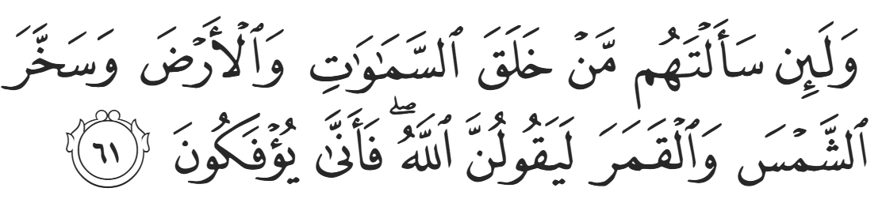
“If you ask them who created the Heavens and the Earth and subjected the Sun and the Moon [for your benefit], they will certainly say, ‘Allah!’. So how can they be deluded [from the truth]?” (29:61)
However, when asked why they worship idols when they believe in Allah, they say, as Allah relates to us in Suart Az-Zumar:
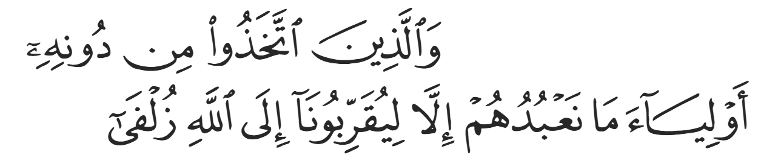
“As for those who take other lords besides Him, ˹saying,˺ We worship them only so that they may bring us closer to Allah” (39:3)
The Qur’an further states in Surat Yunus:
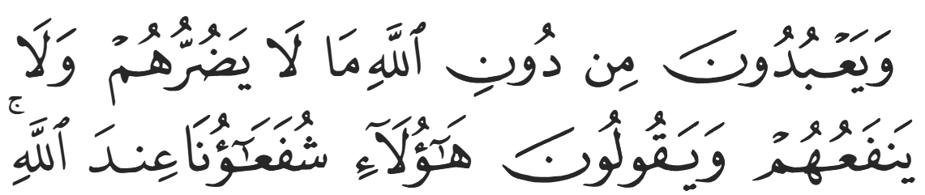
“They worship besides Allah others who can neither harm nor benefit them, and say, ‘These are our intercessors with Allah’” (10:18)
They attributed a level of divinity to these idols, believing them to be lesser gods in comparison to Allah. They believed in the divinity of Allah (SWT) but viewed Him as “too holy” thus requiring intermediaries.
Despite the rise of paganism in Pre-Islamic Mecca, there were a group of people referred to as the Hunafaa’, meaning “those who turn away” (IE turning away from shirk – polytheism—towards Tawheed – the Oneness of Allah. Four prominent Hunafaa’ were: Waraqah ibn Nawfal, Ubaydullah ibn Jahsh, Uthman ibn al-Huwayrith, and Zayd ibn ‘Amr. They made a pact to search for the true religion of Ibraheem (AS) in the form of Hanifiyyah. Hanifiyyah was the closest thing to Islaam during those times.
<Conclude 1st Khutbah with:
Aqoolu haathaa wa astaghfir-Allaah (I say this and I ask Allah for forgiveness)
أَقُولُ قَوْلِي هَذَا وَأَسْتَغْفِرُ اللَّهَ لِي وَلَكُمْ وَلِسَائِرِ المُسْلِمينَ وَالمُسْلِمَاتْ فَاسْتَغْفِرُوهْ إِنَّهُ هُوَ الْغَفُورُ الرَّحِيمُ
الحمد لله رب العالمين والصلاة والسلام على سيد المرسلين وعلى آله وأصحابه أجمعين
<2nd Khutbah>
Dear brothers and sisters, why did Allah (SWT) choose Arabia as the location to send his final message for all of mankind?
Arabia was located right in between two large empires: the Byzantines and the Sassanids. It was connected, but distinct, to these two mighty nations. The Arabs were perfectly placed – with some Prophetic guidance—to conquer these two superpowers within 30 short years. They also had no colonial history, which meant that the infrastructure, or lack thereof, was perfectly placed for Prophethood to flourish. The civilizational vacuum was filled by Prophetic teachings, culture, and ethos.
The Arabs also had certain qualities that made them receptive to a Prophetic Message. They were a simple people, and while simplicity has its own limitations, one of its benefits is its lack of resistance to accepting the truth. They did not have deep-seated ideologies that would oppose the Oneness of God. They also lived in a harsh environment, which made them chiseled instruments for combat, both physically and mentally. This was a vital attribute required in the early battles in Islam. The Arabs also nurtured praiseworthy characteristics, such as bravery, honesty, and honour. They were known to uphold their oaths as a matter of principle, honour, and integrity.
Mecca was the site of the first House built for Allah’s worship. It was the home of Ibraheem (AS) and Ismaeel (AS), and so it was appropriate to house the world’s first universal religion. Above all, Ibraheem (AS) made dua’a to Allah (SWT), as related in Surat Al Baqarah:
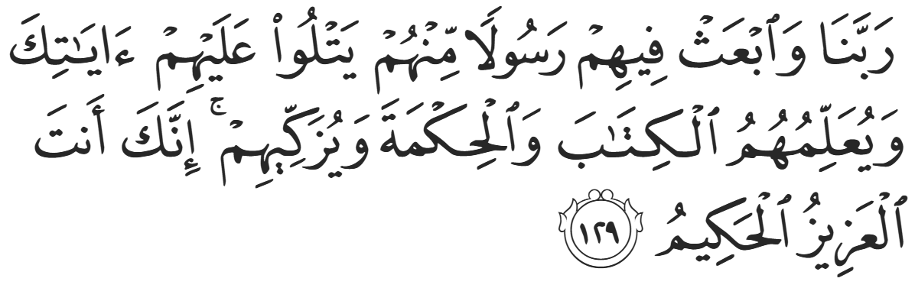
“Our lord, raise from among them a Messenger who will recite to them Your revelations, teach them the Book and wisdom, and purify them. Indeed, You [alone] are Almighty, All-Wise” (2:129)
Ibraheem (AS) asked Allah to grant a Prophet from his progeny. All prophets after Ibraheem (AS) came from the progeny of his son Ishaaq (AS), except for Muhammad ﷺ, who descended from Ismaeel (AS) due to this dua’a. The Prophet ﷺ stated, “I am the response of the dua’a of my father Ibraheem, and I am the glad tiding that Jesus foretold.”

“And truly, you (Muhammad), are of a magnificent standard of character.” (68:4)

<Duaa!>
- Oh Allah, please grant us a deep love for your Prophet Muhammad, SAW.
- Oh Allah, please make us energetic in doing good for your cause.
- Oh Allah, please enable us in will and means to walk Al-Sirrat-Al-Mustaqeem, even if it estranges us from others.
- Oh Allah, please support the suffering and oppressed Muslims around the world and grant them victory over that which oppresses them.
- Oh Allah, please protect us from ever being overburdened by debt and protect us from all evils and undesirable consequences associated to having debt.
- Oh Allah, please fill our hands with the work and deeds of righteousness and let them be of benefit to ourselves and the Ummah.
- Oh Allah please forgive us our shortcomings and deviances in following your Qur'an and the Sunnah of Rasul'Allah, SallAllahuAlayhiWaSallam.
- Oh Allah please grant us understanding and guidance of your Qur'aan
- Oh Allah, please grant us patience with the trials of this world.
- Oh Allah, please prevent our hearts from getting overly attached to the Dunya and grant us the best in this life and the best in the hereafter.
- Oh Allah, please forgive us our past sins and make us your devoted servants.
- Oh Allah please make us amongst those whose Duaa is accepted.
- Oh Allah, please grant us Jannat'ul Firdaus and protect us from ever coming close to the Fires of Jahannum.

