Khut'bah Opening
إِنَّ الْحَمْدَ للهِ , نَحْمَدَهُ وَ نَسْتَعينُهُ وَ نَسْتَغْفِرُهُ , وَ نَعوذُ بِالله مِنْ شُرورِ أَنْفُسِنا , مَن يَهْدِهِ اللهُ فَلا مُضِلَّ لَه , وَ مَنْ يُضِلِلْ فَلا هادِيَ لَهْ , وَ أَشْهَدُ أَنْ لا إلهَ إِللهُ وَحْدَهُ لا شَريكَ لَه , و أَشْهَدُ أنَّ مُحَمَّدًا عَبْدُهُ و رَسولُه.
"All thanks and praises are due to Allah, whom we thank, seek for help and invoke for forgiveness. We seek refuge with Allah from the evils within ourselves. He whom Allah guides will never be misled and he whom He misguides will never find one to guide him. I bear witness that there is no deity worthy of worship except Allah and that Muhammad (SAW) is His slave and Messenger.”
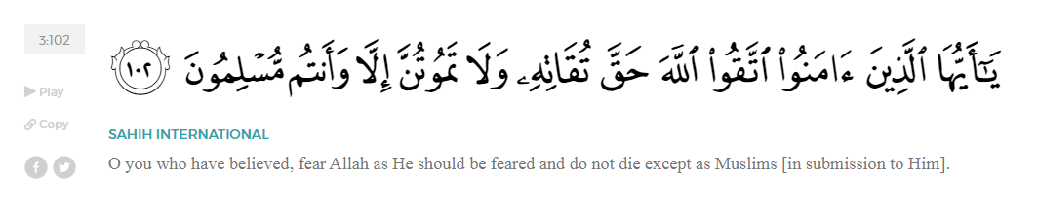
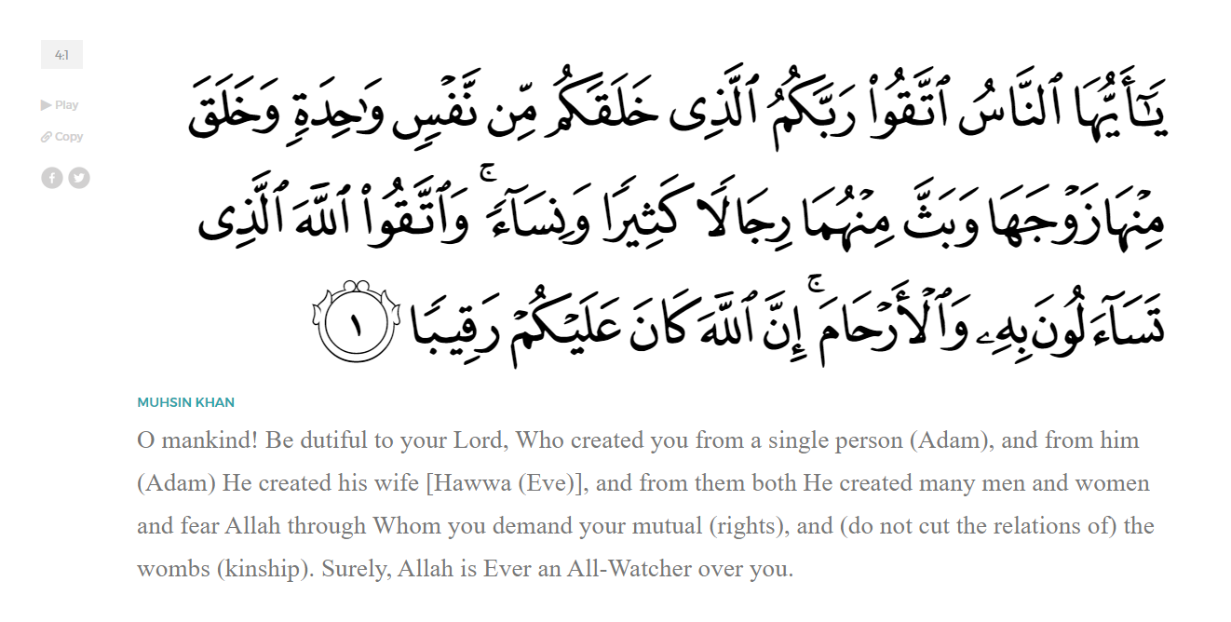
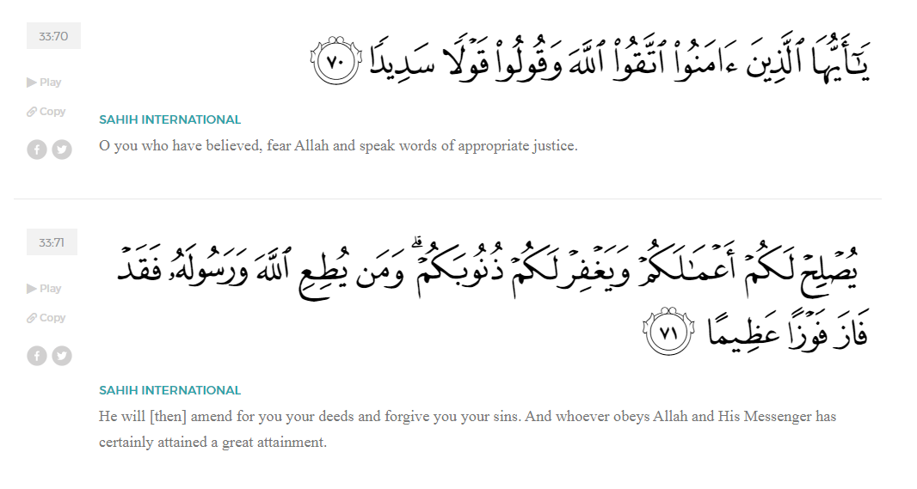
<Sirah of the Prophet (SAW) – Part X -Dr. Yassir Qadhi, Book and Series>
Dear brothers and sisters,
InshaaAllah we will continue our khutbah series on the seerah of the Prophet ﷺ, drawing from Dr. Yasir Qadhi’s book, The Sirah of the Prophet, so that we can deepen our understanding of his life and strengthen our love for him. Each step we take through the Prophet ﷺ’s life brings us closer to knowing him more deeply, appreciating his struggles, and embodying his character. Our goal in this series, inshaaAllah, is not just to learn history, but to let the seerah transform our hearts and strengthen our love for the Messenger of Allah ﷺ.
Today we will, inshaaAllah, continue with the chapter titled “The Battle of Badr”. Previously, we discussed how the Muslims set out towards Badr expecting to intercept the Quraysh caravan, only to discover that a fully armed army from Makkah was marching toward them. Tension and uncertainty spread on both sides, as the Muslims came to terms with the reality of battle while many among the Quraysh sensed the ominous nature of what lay ahead. As fear and uncertainty spread amongst some of the Companions, the Prophet ﷺ consulted them repeatedly, and one after another, the Muhaajiroon and Ansaar rose with words of unwavering faith, loyalty, and courage. Their sincerity and devotion brought immense comfort and happiness to the Messenger of Allah ﷺ. With the believers committed, it was now time to make preparations for the battle…
The Prophet ﷺ divided the troops into three primary flanks, ‘Ali ibn Abi Taalib (RA) was on the left, leading the Muhaajiroon, and Sa’d ibn Mu’aadh was on the right, leading the Ansaar. He ﷺ also designated a back-up group led by Qays ibn Abi Sa’sa’ah (RA). This designation clearly shows that tribal and cultural differences were taken into consideration; the Muhajiroon were together, led by one of their noblest youths, ‘Ali (RA), just as the Ansaar were led by their leader, Sa’d (RA). Allah (SWT) states,
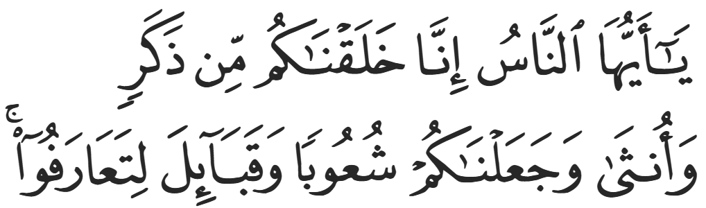
“O mankind, indeed We have created you from a male and a female, and made you into peoples and tribes that you may know one another.” (Hujurat:13)
Mus’ab ibn ‘Umayr (RA) was the flag-bearer, which was a symbolic but revered position. He embodied the unity between the Muhaajiroon and Ansaar; he was a Qurayshi, but converted most of the Ansaar with his own hands and was thus beloved by the Medinans. He was therefore in the perfect position to be a flagbearer, representing both groups.
The Prophet ﷺ and the Companions (RHUM) arrived on the plains of Badr on the 16th of Ramadan, one day before the Quraysh. Before setting up camp, al-Hubaab ibn al-Mundhir (RA), an experienced scout from amongst the Ansaar, asked the Prophet ﷺ, “O Messenger of Allah, is this location for camp ordained by Allah, such that we cannot move it forwards or backwards, or is it from your own opinion based on tactics and strategies of war?” The Prophet ﷺ replied that it was his own opinion based on strategy, and al-Hubaab then suggested that they camp beyond the mid-point of the plains rather than the corner so that the wells of Badr are behind them. This would cut off the Quraysh’s access to water, and they would have to suffice with their own limited supply.
The Prophet ﷺ followed al-Hubaab’s advice and said, “You have directed us to a better opinion.” Incidents like this demonstrate a distinction between the Prophet ﷺ acting in his capacity as a Prophet and his capacity as a man. Al-Hubaab’s advice was vindicated because when the Quraysh ran out of water, they began to suffer. At one point, Al-Aswad ibn ‘Abd al-Asad al-Makhzuumi from the Quraysh volunteered to sneak into Muslim territory to collect some water, and Hamzah (RA) spotted him, and killed him. He therefore became the first person to be killed in the Battle of Badr before formal battle even began.
The Quraysh were seen approaching the plains of Badr, and the stage was set for battle the following morning. The Prophet ﷺ spent the whole night awake making profuse du’aa and prolonging his prostration. He ﷺ said, “O Allah, if you destroy this group [of Muslims], You will not be worshipped on this Earth.” In other words, failure here will mark the end of Islam on Earth. The stakes were never higher, and the Prophet ﷺ relied on his du’aa. Ibn Mas’ud (RA) said, “I have never seen anyone pleading more than when I saw the Prophet ﷺ plead to Allah (SWT) on the night of Badr.” The Prophet ﷺ lifted his arms into the sky as he made du’aa—an action reserved for the most desperate of prayers and requests. ‘Ali ibn Abi Taalib (RA) said, “If you saw us on the night of Badr, you would have seen every single one of us asleep, except for the Prophet ﷺ who was praying behind a tree until the morning.”
The very fact that all the Companions fell asleep was a miracle from Allah, as the night before any battle is notoriously tense and nerve-racking. Allah (SWT) states,
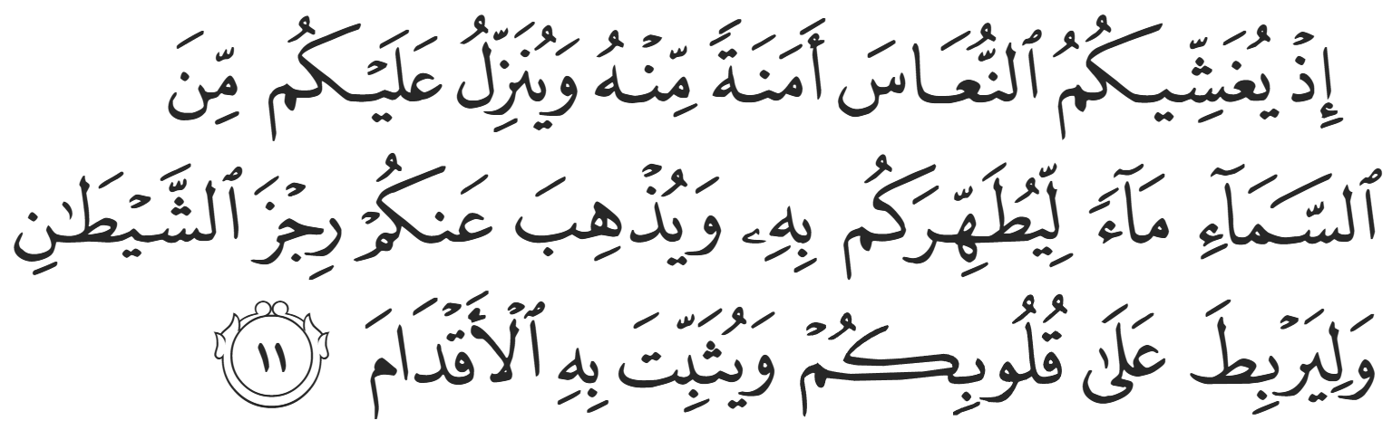
“˹Remember˺ when He caused drowsiness to overcome you, giving you serenity. And He sent down rain from the sky to purify you, free you from Shaytan’s whispers, strengthen your hearts, and make ˹your˺ steps firm.” (8:11)
Ibn Kathir (RA) reports that the Prophet eventually slept for a few moments. In this brief respite, Allah (SWT) showed him a dream of the Quraysh being few in number. The Qur’aan mentions this event,
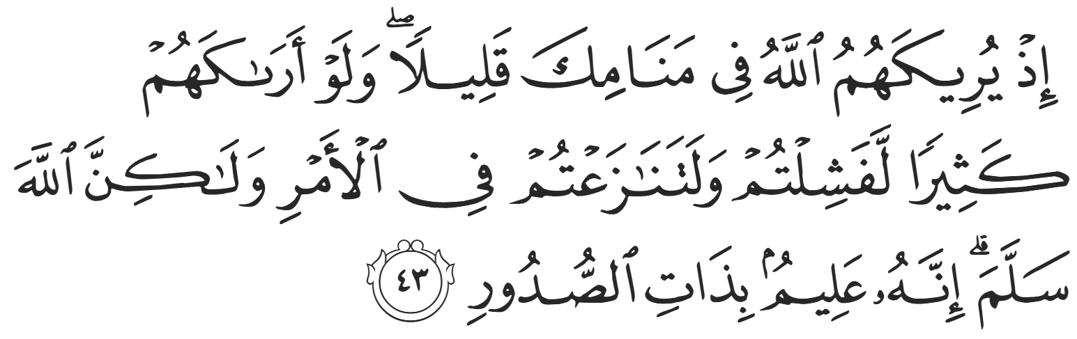
“˹Remember, O Prophet,˺ when Allah showed them in your dream as few in number. Had He shown them to you as many, you ˹believers˺ would have certainly faltered and disputed in the matter. But Allah spared you ˹from that˺. Surely He knows best what is ˹hidden˺ in the heart.” (8:43)
The Prophet ﷺ then lined up the Companions ready for battle. Historically, the Arabs would charge in batches with intermittent bouts of fighting as they would attack and recuperate. The Prophet ﷺ employed an unprecedented tactic—now common in modern warfare—of battalions marching in rows. Allah (SWT) references this tactic,
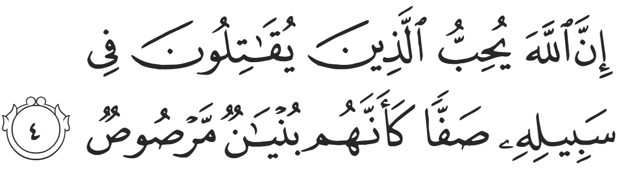
“Indeed, Allāh loves those who fight in His cause in a row as though they are a [single] structure joined firmly.” (61:4)
Those with spears were at the front, bows and arrows were at the rear, and those with swords were the bulk in the middle. The Prophet ﷺ did not attend a military school, but Allah (SWT) blessed him with the Prophetic intuition to arrange the army. He ﷺ walked between the rows, straightening them as he would straighten the rows in prayer.
The Prophet ﷺ poked Sawaad ibn Ghaziyyah (RA) in the stomach, instructing him to step back in line. Sawaad (RA) said, “O Messenger of Allah, you have poked me and caused me pain. Allah sent you with truth and justice, and I demand justice.” The Prophet ﷺ immediately dropped his stick, raised his shirt, and said, “Here is your qisaas – equal retaliation.” Sawaad then hugged and kissed the Prophet’s stomach, to which the Prophet ﷺ said, “What is this, O Sawaad?” Sawaad responded, “O Messenger of Allah, if I die, I wish that my last moment was my skin touching yours.”
The benefits from this beautiful event are innumerable. First, the audacity of a soldier to question the leader in such a manner could only have been borne out of an atmosphere and culture of trust and equality. Second, the Prophet ﷺ did not dismiss his claim, even though they were standing moments before the biggest battle of their lives and the potential extinction of the religion. Third, Sawaad’s love for the Prophet ﷺ was so great that he hatched a plot just to kiss him ﷺ. Indeed, the relationship between the Prophet ﷺ and the Companions was truly unique.
The Prophet ﷺ once again turned to his Lord, raising his hands towards the sky, saying, “O Allah, fulfill Your promise to me; O Allah, give me what You have promised; O Allah, if this group is destroyed, You will not be worshipped on Earth…” The Prophet ﷺ continued to ask Allah and continued to raise his hands towards the sky, until his upper garment fell off. He continued, bare-chested, until Abu Bakr (RA) wrapped the garment around the Prophet ﷺ, hugged him from behind, and said, “Enough, O Messenger of Allah, enough. Your Lord will give you as promised. As soon as the Prophet ﷺ lowered his hands, Allah (SWT) sent down Revelation,
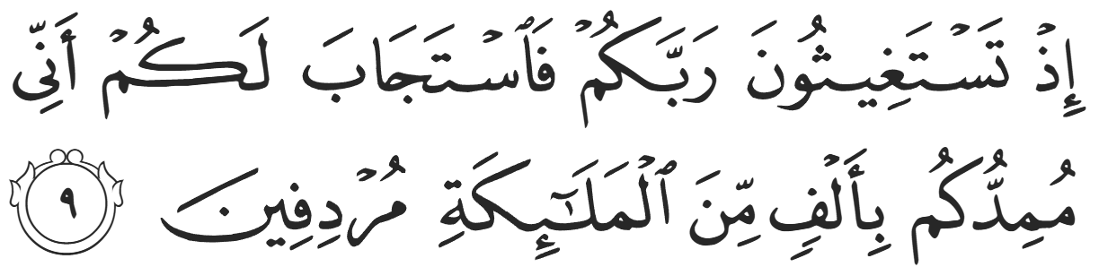
“[Remember] when you were asking help of your Lord, and He answered you, "Indeed, I will reinforce you with a thousand from the angels, following one another."” (8:9)
Ibn Mas’ud (RA) said, “He ﷺ turned around, and his face was like the Moon.” Elated, the Prophet ﷺ then said, “Rejoice, O Abu Bakr, for indeed the help of Allah (SWT) has come. This is Jibril—turbaned and horseback—riding through the valley.”
The Prophet ﷺ then began chanting the verse,
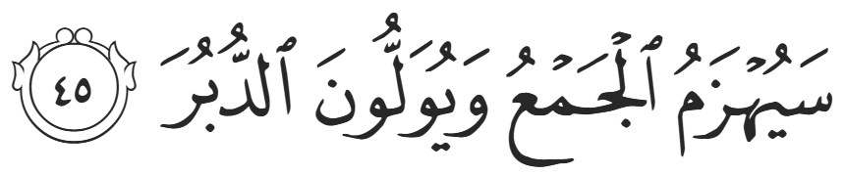
“Soon their united front will be defeated and forced to flee.” (qamar:45)
Umar (RA) later said, “I never truly understood this verse until the Prophet ﷺ recited it on the morning of Badr.”
<Conclude 1st Khutbah with:
Aqoolu haathaa wa astaghfir-Allaah (I say this and I ask Allah for forgiveness)
أَقُولُ قَوْلِي هَذَا وَأَسْتَغْفِرُ اللَّهَ لِي وَلَكُمْ وَلِسَائِرِ المُسْلِمينَ وَالمُسْلِمَاتْ فَاسْتَغْفِرُوهْ إِنَّهُ هُوَ الْغَفُورُ الرَّحِيمُ
الحمد لله رب العالمين والصلاة والسلام على سيد المرسلين وعلى آله وأصحابه أجمعين
<2nd Khutbah>
Dear brothers and sisters,
The Prophet ﷺ also made du’aa against the Quraysh. He ﷺ said, “O Allah, this is the Quraysh; they have come against you with their pride and arrogance, challenging you and rejecting your Messenger. O Allah, [I seek] Your help that has been promised; O Allah, [I seek] Your help that has been promised; O Allah, [I seek] Your help that has been promised. O Allah, cause them to be destroyed today.” He then instructed the Companions that certain people should not be killed, such as the youth of the Banu Haashim, who were forced to attend, the Prophet’s uncle, al-‘Abbas ibn ‘Abd al-Muttalib (RA), and Abu al-Bukhtari, who was integral in lifting the boycott in Makkah.
The Quraysh, still unaware of the size of the Muslim army, sent their most experienced scout, ‘Umayr ibn Wahb al-Jumahi, to gather information. He reported, “They are around 300, but I feel that there is an impending catastrophe. Young men of Yathrib are waiting to inflict death; they are a determined people with no help other than their swords (i.e., they have no armor or extra resources and will thus fight valiantly). By Allah, I do not think that you will be able to kill any of them without them killing an equal amount. And if 300 amongst you die, what pleasure will you gain?” Abu Jahl responded with his usual arrogance, saying, “We did not ask for your advice.”
Hakeem ibn Hizaam approached ‘Utbah ibn Rabi’ah, neither of them wanting a war, to try and mediate a truce. Hakeem suggested that ‘Utbah volunteer the blood money for ‘Amr al-Hadrami, the man killed in Sariyyah al-Nakhlah, which was the catalyst that led to the current turn of events. ‘Utbah agreed and offered to pay this small fortune to de-escalate the situation. He also preached to the people saying, “Do not fight, and if anyone accuses you of cowardice, then put the blame on me. Say ‘Utbah became cowardly’, even though you know that I am not a coward. By Allah, what will you gain by fighting this man? If you are able to defeat him, you will be killing your own father, brother, cousin, and nephew. How would it feel to be amongst the murderers of your own family? Let us return and leave Muhammad and his companions to the rest of the Arabs. If they take care of him, this is what you wanted; and if not, then surely his victory will be ours too (i.e., as a Qurayshi). And if he conquers Makkah, then you will have an excuse to be forgiven.”
As the Sun was rising, and the two armies were in each other’s sight, the Prophet ﷺ saw a man pacing back and forth from afar. He ﷺ said to the Companions, “If there is any good amongst them, it is in the man on the red camel (i.e., ‘Utbah); and if they have any good in them, they will listen to him.” The Prophet ﷺ did not know what ‘Utbah was saying, but Allah (SWT) inspired him to know that what he was saying was goodness.
However, when Abu Jahl heard about this, he rushed to the blood-brother of al-Hadrami and goaded him, “Are you not ashamed of accepting some blood money for your brother while you are able to exact revenge from the killer?” His brother then gave a passionate speech and convinced the troops to remain. Abu Jahl then accused ‘Utbah, “O ‘Utbah, you have become a coward after seeing the ranks of the Muslims!” ‘Utbah—who a moment ago was willing to be labeled a coward to keep the peace—could not tolerate such an accusation directly from Abu Jahl. He lost control, insulted Abu Jahl, and said, “We will see who the coward is!” He then called his brother and son and marched straight towards the Muslim army, volunteering the three of them for the initiation duel.
The initiation duel (mubaarazah) was a custom in Arabia to commence a war. Three individuals of status from each army would meet at the center stage and fight one-on-one. The idea was to rile up the armies to seek vengeance on behalf of those killed, or build on the momentum of the victors. ‘Utbah and Shaybah ibn Rabi’ah alongside al-Waleed ibn ‘Utbah were the three nominees for the Quraysh. They marched forward, yelling, “Who will come forth and battle us?!” Three of the Ansaar immediately rose. ‘Utbah then said, “We have no issue with you.” The Quraysh, thinking through a tribal lens, did not even comprehend the ties of religion. They did not have a desire to fight the Ansaar; they were there solely to fight the Muhaajiroon. He then called out, “O Muhammad! Send out equals worthy of us to fight!”
The Prophet ﷺ said, “Stand up, O ‘Ubaydah ibn al-Haarith; and you, O Hamzah; and you, O ‘Ali.” ‘Utbah asked them to identify themselves (as they were speaking from afar), and when they did, ‘Utbah said, “Noble adversaries. Come, let us fight!” ‘Ubaydah walked towards ‘Utbah, as they were of a similar age; Hamzah walked towards Shaybah for the same reason; and ‘Ali walked towards al-Waleed. Both Hamzah and ‘Ali instantly pounced on their opponents and killed them without suffering a single injury. ‘Ubaydah’s leg was cut off by ‘Utbah, but Hamzah and ‘Ali came to his support and killed ‘Utbah. ‘Ubaydah was carried away to safety but died a few days later from his injuries.
And with the initiation duels, the Battle of Badr had begun…
We will continue in future khutbahs inshaaAllah.

<Duaa!>
- Oh Allah, please grant us a deep love for Your Prophet Muhammad, SAW.
- Oh Allah, please make us energetic in doing good for Your cause.
- Oh Allah, please enable us with the will and means to walk Al-Sirrat-Al-Mustaqeem, even if it estranges us from others.
- Oh Allah, please support the suffering and oppressed Muslims around the world and grant them victory over those who oppress them.
- Oh Allah, please protect us from being overburdened by debt and from all its harms and consequences.
- Oh Allah, please grant healing to those among us who are sick, and grant them comfort, patience, and what is best for their condition.
- Oh Allah, please fill our hands with the work and deeds of righteousness that will be of benefit to ourselves and the Ummah.
- Oh Allah, please forgive us our shortcomings and deviances in following Your Qur'an and the Sunnah of Rasul'Allah, SallAllahuAlayhiWaSallam.
- Oh Allah, please grant us understanding and guidance of Your Qur'aan.
- Oh Allah, please grant us patience with the trials of this world.
- Oh Allah, please prevent our hearts from getting overly attached to the Dunya and grant us the best in this life and the best in the hereafter.
- Oh Allah, please forgive us our past sins and purify our hearts.
- Oh Allah, please make us amongst those whose Duaa is accepted.
- Oh Allah, please grant us Jannat'ul Firdaus and protect us from ever coming close to the Fires of Jahannum.

