Khut'bah Opening
إِنَّ الْحَمْدَ للهِ , نَحْمَدَهُ وَ نَسْتَعينُهُ وَ نَسْتَغْفِرُهُ , وَ نَعوذُ بِالله مِنْ شُرورِ أَنْفُسِنا , مَن يَهْدِهِ اللهُ فَلا مُضِلَّ لَه , وَ مَنْ يُضِلِلْ فَلا هادِيَ لَهْ , وَ أَشْهَدُ أَنْ لا إلهَ إِللهُ وَحْدَهُ لا شَريكَ لَه , و أَشْهَدُ أنَّ مُحَمَّدًا عَبْدُهُ و رَسولُه.
"All thanks and praises are due to Allah, whom we thank, seek for help and invoke for forgiveness. We seek refuge with Allah from the evils within ourselves. He whom Allah guides will never be misled and he whom He misguides will never find one to guide him. I bear witness that there is no deity worthy of worship except Allah and that Muhammad (SAW) is His slave and Messenger.”
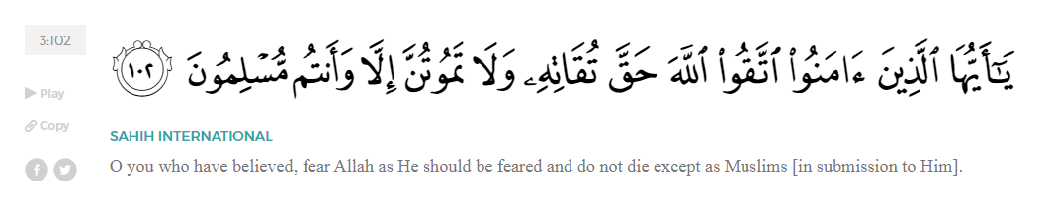
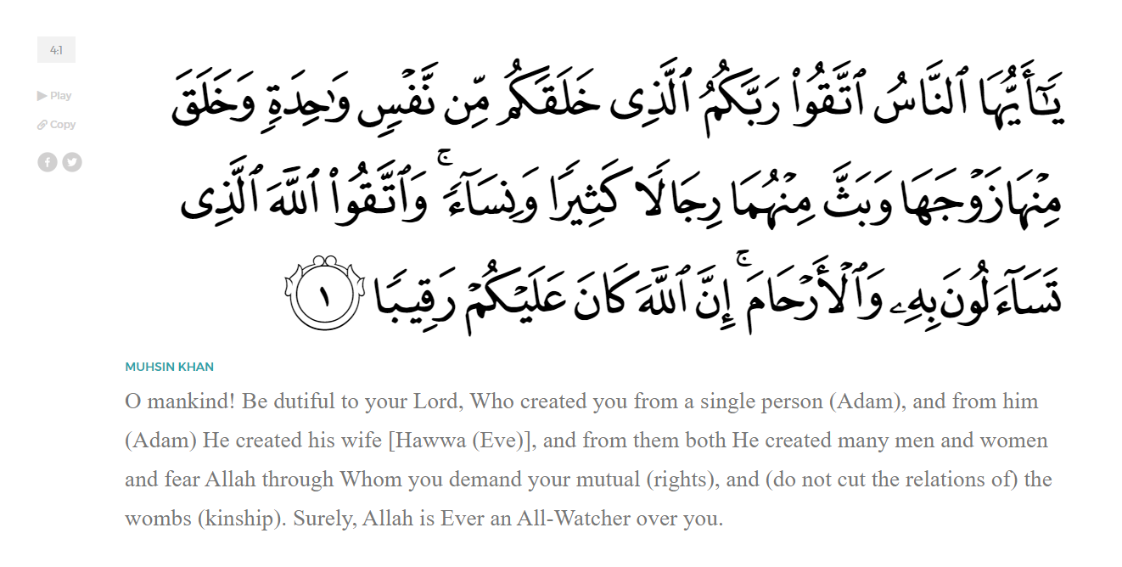
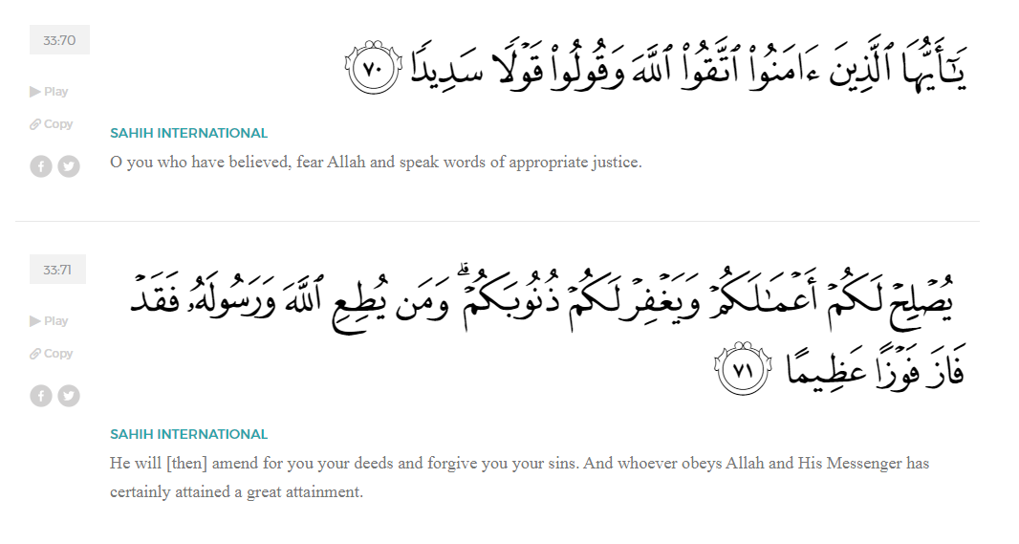
<Sirah of the Prophet (SAW) – Part X -Dr. Yassir Qadhi, Book and Series>
Dear brothers and sisters,
InshaaAllah we will continue our khutbah series on the seerah of the Prophet ﷺ, drawing from Dr. Yasir Qadhi’s book, The Sirah of the Prophet, so that we can deepen our understanding of his life and strengthen our love for him. Each step we take through the Prophet ﷺ’s life brings us closer to knowing him more deeply, appreciating his struggles, and embodying his character. Our goal in this series, inshaaAllah, is not just to learn history, but to let the seerah transform our hearts and strengthen our love for the Messenger of Allah ﷺ.
Today we will, inshaaAllah, continue with the chapter titled “The Battle of Badr”. Previously, we discussed the tense moments leading up to the battle: the Muslims arriving at Badr outnumbered and under-equipped, expecting only to intercept a Quraysh caravan before suddenly finding themselves face-to-face with the full army of Makkah; the Prophet ﷺ consulting the Companions and hearing from them words of unwavering loyalty, courage, and conviction; and the Prophet ﷺ spending the night before battle in prolonged du’aa and prayer while Allah sent tranquility upon the believers and caused them to sleep peacefully. We also covered the opening moments of the battle itself, when the initiation duels took place between the Quraysh and the Muslims, after which the Battle of Badr erupted in full…
Narrating the exact details of the battle with hundreds of people can only be done by compiling individual narrations. The narrations are from surviving Companions as well as those who fought on the side of the Quraysh but later accepted Islam. The difficulty arises when attempting to ascribe a chronological order to each narration. This challenge occurs throughout the seerah, and the researcher is tasked with creating a chronological account from the available resources.
As the Quraysh began charging towards the Muslims, the Prophet ﷺ said to the Companions, “Stand up and charge towards a Paradise whose width is like the Heavens and the Earth” ‘Umayr ibn al-Humaam (RA) scoffed, and when the Prophet ﷺ asked why he scoffed, he said, “If this is true (regarding the width of one level of paradise equating to the entirety of the Heavens and Earth), then what use is it to remain living on this Earth? I want to be of those people!” The Prophet ﷺ replied, “You are of them.” ‘Umayr then threw away the dates in his hand and said, “If I live long enough to finish these dates, I would have lived too long of a life.” He charged towards the enemy and met his martyrdom.
As a military commander, the Prophet ﷺ did not usually fight in battles, as he had the responsibility of directing the army, but he fought in Badr. He ﷺ alternated between commanding the army, making du’aa, and physically fighting. Ali (RA) said, “The Prophet ﷺ was the closest to the enemy, fighting most aggressively, and when fighting grew fierce, we would seek protection through him.” ‘Ali (RA) also narrated that when he came into the Prophet’s tent, he found him ﷺ making profuse du’aa in prostration, saying, يَا حَيُّ يَا قَيُّومُ (Ya Hayyu Ya Qayyum)“O Ever-Living, O All-Sustaining! يَا حَيُّ يَا قَيُّومُ O Ever-Living! O All-Sustaining” ‘Ali (RA) then went out to fight and later returned, finding the Prophet ﷺ in prostration. He again left and later returned and found the Prophet ﷺ still in prostration, and then Allah (SWT) decreed victory for the Muslims. The fact that ‘Ali (RA) narrated both these hadiths is the strongest indication that the Prophet ﷺ alternated between fighting and making du’aa.
Allah (SWT) sent down 1,000 angels to reinforce the Muslims. Allah (SWT) stated in Surat Al-Anfaal:
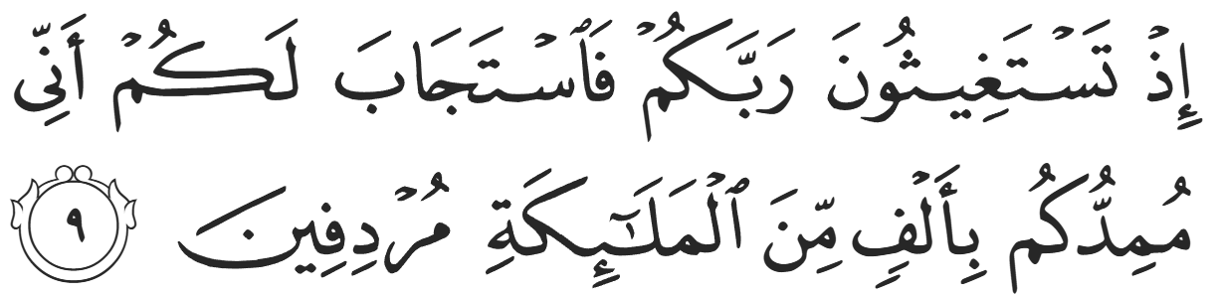
“[Remember] when you cried out to your Lord for help, He answered you, "Indeed, I will reinforce you with a thousand from the angels, following one another."” (8:9)
The phrase “reinforce you” is used to translate مُمِدُّكُم “mumiddukum” because there is a distinction between “help” and “reinforcement”. To reinforce is to help an existing effort; the Muslims would raise their swords, while the Angels would lower the enemy’s swords—a subtle yet important distinction, and a lesson in tawakkul and reliance on Allah. The reinforcement only applies when the initial effort exists.
Allah (SWT) chose specific Angels to attend Badr. Jibril (AS) asked the Prophet ﷺ, “What do you think of those of you who participated in Badr?” The Prophet ﷺ said, “We think they are the best of us.” Jibril (AS) replied, “We too think the same of those of us (i.e., the Angels) who attended Badr.” In reality, Allah (SWT) did not need to send 1,000 Angels when one single Angel would have sufficed considering their supernatural existence. When Allah (SWT) destroyed the people of Prophet Lut (AS), Archangel Jibril (AS) descended in his true form and slammed the ground with the tip of one of his 600 wings, destroying the entire city.
The sending of 1,000 Angels was a show of force to assure the Muslims of the divine support they had as well as a message that said divine support only appears after the initial effort is made. Allah (SWT) said to Maryam (Alayhaa-Assalaam):
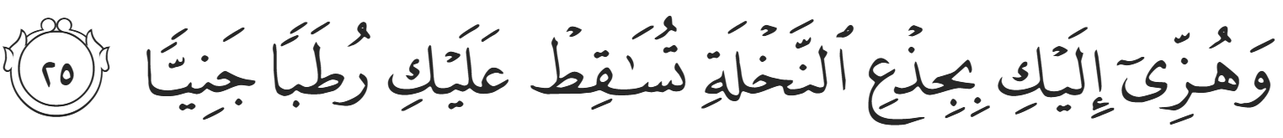
“And shake the trunk of this palm tree towards you, it will drop fresh, ripe dates upon you.”(19:25)
The expectation was not that an exhausted, desperate, heavily pregnant lady could shake the firm trunk of a palm tree; rather, the action was necessary—even if symbolic—for Allah (SWT) to cause the fruit to drop. The Angels arrived at Badr in full force but only after the Companions unsheathed their swords and were ready to strike.
Ibn ‘Abbas (RA) narrates that a Companion was in pursuit of a Pagan when he heard the sound of a whip and a call, “Go forth, Hayzuum!” The Companion then found the Pagan killed before he was able to strike. The Prophet ﷺ said, “That was an Angel that Allah sent down from the third Heaven.” Similarly, when al-Abbas—a physically imposing warrior—was captured by a shorter, skinnier Ansaari, he called out defiantly to the Prophet ﷺ, “This man did not capture me!” The Ansaari insisted, “No, I captured him!” Al-Abbas began looking around for the one who captured him, saying, “The man who captured me was the most handsome man on a beautiful, black and white horse, but I cannot find him.” The Ansaari continued to insist until the Prophet ﷺ said, “Be quiet, for Allah helped you with a noble Angel.”
‘Abdurrahman ibn ‘Awf (RA) narrated that he was hoping to fight alongside strong soldiers for extra support in the battle. He looked to the right and left and was disappointed to see two small-framed adolescents: Mu’aadh ibn ‘Amr ibn al-Jamuuh and Mu’awwidh ibn al-‘Afraa (RHUM). The youth to the right poked ‘Abdurrahman, leaned over, and whispered, “O uncle, do you know Abu Jahl?” ‘Abdurrahman ibn ‘Awf replied that of course he knew him, and the youth replied, “I heard that he disrespected the Prophet ﷺ, and I have made an oath to Allah (SWT) that if I were to see him, we would not part until one of us is dead.” The youth to the left then poked him and asked the same question, for they were teenage friends in competition to kill Abu Jahl to avenge the Prophet ﷺ. ‘Abdurrahman ibn ‘Awf (RA) then felt comforted by their valor and spirit.
When Abu Jahl was in sight, surrounded by his entourage, ‘Abdurrahman ibn ‘Awf (RA) said to the youths, “There is your man.” As soon as he spoke, they both darted into the sea of fighting with one target in mind. They navigated through the throngs of people until they were in proximity, and Mu’aadh leaped into the air, sword first, swinging downwards ferociously. The magnitude of the downward force sliced Abu Jahl’s leg off completely, but Abu Jahl’s son, ‘Ikrimah, also swung, chopping off Mu’aadh’s entire arm. His arm dangled from his body by a thin piece of skin, and Mu’aadh later remarked that it became burdensome and so he placed the arm under his foot and ripped it off to continue fighting. As ‘Ikrimah was turned towards Mu’aadh, Mu’awwidh struck another blow to Abu Jahl.
The two teenage warriors managed to escape the melee and return to the Prophet ﷺ shouting, “O Messenger of Allah, I killed Abu Jahl!” They began arguing with each other, both claiming the fatal blow, until the Prophet ﷺ said, “You both killed Abu Jahl.” After the battle ended, the Prophet ﷺ ordered the Companions to find Abu Jahl’s body. ‘Abdullah ibn Mas’uud (RA), one of Abu Jahl’s main victims of torture and humiliation in Makkah, found him on the ground, breathing heavily, resisting the pangs of death. Ibn Mas’ud (RA) placed his foot on his chest and said, “Do you finally admit that Allah has disgraced you, O enemy of Allah?” Abu Jahl remained obstinate until his last moment alive, scoffing, “How have I been disgraced? I am a person killed by his own people.” Likely suffering delirium from blood-loss, he then asked, “Who has won the battle?” Ibn Mas’ud (RA) replied, “Allah and His Messenger!”
Referring to Ibn Mas’ud’s foot on his chest, Abu Jahl then said, “You have stepped on a high place, O son of a shepherd.” It was to be his last sentence, as Ibn Mas’ud (RA) took Abu Jahl’s own sword and sealed his demise. He then returned to the Prophet ﷺ and said that he found the corpse of Abu Jahl. The Prophet ﷺ responded, “You swear by Allah?” And Ibn Mas’ud did so three times. The Prophet ﷺ then uttered the famous Hadith saying, “He [Abu Jahl] was the Pharoah of this Ummah.”
<Conclude 1st Khutbah with:
Aqoolu haathaa wa astaghfir-Allaah (I say this and I ask Allah for forgiveness)
أَقُولُ قَوْلِي هَذَا وَأَسْتَغْفِرُ اللَّهَ لِي وَلَكُمْ وَلِسَائِرِ المُسْلِمينَ وَالمُسْلِمَاتْ فَاسْتَغْفِرُوهْ إِنَّهُ هُوَ الْغَفُورُ الرَّحِيمُ
الحمد لله رب العالمين والصلاة والسلام على سيد المرسلين وعلى آله وأصحابه أجمعين
<2nd Khutbah>
Dear brothers and sisters…
Umayyah ibn Khalaf was another enemy of Allah who met a humiliating demise at Badr. As mentioned in previous khutbahs, Umayyah desperately tried to avoid fighting at every opportunity. His pleas continued until the very end; when he saw that the Quraysh had fled, he tried to bargain for his life. He saw ‘Abdurrahman ibn ‘Awf (RA), who was a close friend and business colleague pre-Islam, holding some armor as war booty. He desperately held onto him, pleading, “O ‘Abd al-Ilaah! What if I were to give you much more than this? I offer you many milking camels! Take me as a prisoner, and I will give you whatever you want.” ‘Abdurrahman, a shrewd businessman even on the battlefield, took Umayyah up on the offer. He threw the armor and held Umayyah with one hand and Umayyah’s son with the other. However, Allah decreed that justice be served, and none other than Bilaal ibn Rabaah (RA) walked past.
Bilaal saw ‘Abdurrahman holding Umayyah’s hand and exclaimed, “Umayyah ibn Khalaf, the leader of kufr? Over my dead body!” ‘Abdurrahman tried to calm Bilaal down and de-escalate, but Bilaal only grew more infuriated with each attempt, repeating, “Umayyah ibn Khalaf, the leader of kufr? Over my dead body!” He then called over a group of the Ansaar and said, “This is the man who tortured me!” Bilal’s story was famous, and he represented the epitome of perseverance and unwavering patience in the face of unmitigated evil. Stories of the cries of “Ahad; Ahad! One; One!” motivated the Muhajiroon and Ansaar alike to keep fighting on. When Bilaal (RA) identified Umayyah to them, the group of Ansaar surrounded ‘Abdurrahman and began poking their swords past him to stab Umayyah and his son. ‘Abdurrahman continued to hold them back, trying to negotiate, until his foot was wounded in the commotion, and Umayyah and his son were both killed. When they tried to bury him, they could not lift him, as his flesh was stuck to the rocks and pebbles on the ground. One cannot help but compare his fate to the burning rocks he would place on Bilaal (RA) in Makkah. ‘Abdurrahman recalled in his old age, “May Allah have mercy on Bilaal, not only did he stop me from my ransom, I lost the armor too!”
A tragic incident at Badr was the case of Abu ‘Ubaydah ibn al-Jarrah. His father was a staunch Pagan who had a distinct hatred for Islam to the extent that he hated his own son for embracing Islam. His hate was so severe that, in the Battle of Badr, he specifically sought out Abu ‘Ubaydah to fight and kill. Abu ‘Ubaydah, on the other hand, tried his utmost to avoid his father throughout the day. Eventually his father cornered him and pounced. Abu ‘Ubaydah, in self-defense, held out his sword and killed his father. Murmurs spread of Abu ‘Ubaydah killing his own father, and deep sadness and shame overcame him. Allah (SWT) then revealed,
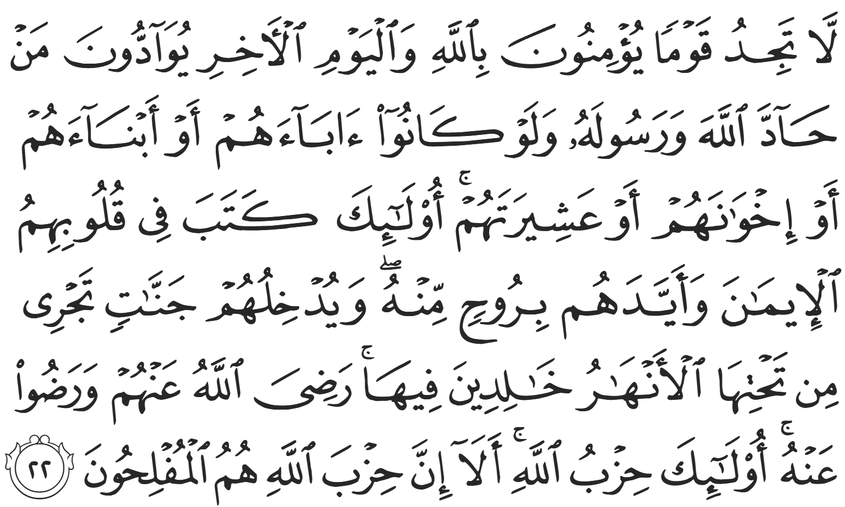
“You will never find a people who ˹truly˺ believe in Allah and the Last Day loyal to those who defy Allah and His Messenger, even if they were their parents, children, siblings, or extended family. For those ˹believers˺, Allah has instilled faith in their hearts and strengthened them with a spirit from Him. He will admit them into Gardens under which rivers flow, to stay there forever. Allah is pleased with them and they are pleased with Him. They are the party of Allah. Indeed, Allah’s party is bound to succeed.” (58:22)
When victory for the Muslims became clear, the Quraysh fled back to Makkah. 70 of them were killed and 70 were captured, meaning 15% of the Quraysh were either killed or taken as prisoners of war. The Muslims suffered 14 deaths (less than 5%) with no captives. The Prophet ﷺ then informed the Muslims that they would camp at the plains of Badr for a further three days to find and gather the Muslim dead and ensure a proper burial. The fiqh of martyrs, as well as the dead in general, was revealed at this time. For example, martyrs are not prayed over, shrouded, or even washed; and the dead are buried as soon as possible and in the location of death, contrary to the common practice of transporting the deceased to their homeland. The Prophet ﷺ has stated, “There is no wound that the martyr incurs on the path of Allah except that on the Day of Judgement its blood will be flowing; it will have the color of blood but the smell of musk”. Maintaining appropriate decorum, the dead of the Quraysh were also placed in an abandoned well and covered from the Sun.
The Prophet ﷺ used this time to allow the Companions to recover and recuperate, but more importantly, to ensure that they were ready for a potential counter-offensive. Above all, the Prophet ﷺ wanted to demonstrate, beyond all reasonable doubt, that the Muslims were emphatically victorious. As they departed on the third day, the Prophet ﷺ diverted the caravan of Muslims towards the well wherein the Quraysh were buried. He ﷺ stopped and began calling every single leader by name, “O Abu Jahl ibn Hishaam! O Umayyah ibn Khalaf! O ‘Utbah ibn Rabi’ah! O Walid ibn ‘Utbah! (and so on)… have you found the promise of your Lord to be true? As for me, I found the promise of my Lord to be true!”
‘Umar ibn al-Khattab (RA) asked, “O Messenger of Allah, how can you speak to corpses with no soul?” The Prophet ﷺ replied, “I swear by the One in Whose Hand is my soul, you cannot hear me more distinctly than them, but they cannot respond.”
When we study Badr, we are not merely studying a battle, but witnessing what faith, sincerity, and complete reliance upon Allah can produce in the hearts of those who dedicate themselves to Allah. The Muslims of Badr were not fearless giants or perfect human beings, but believers whose hearts were filled with conviction, love for Allah and love for His Messenger ﷺ. The Companions of Badr gave everything they had for the sake of Islam, and Allah honored them with a victory that changed history forever. May Allah allow us to carry even a fraction of their courage, sincerity, and love for this religion in our own lives.

<Duaa!>
- Oh Allah, please grant us a deep love for Your Prophet Muhammad, SAW.
- Oh Allah, please make us energetic in doing good for Your cause.
- Oh Allah, please enable us with the will and means to walk Al-Sirrat-Al-Mustaqeem, even if it estranges us from others.
- Oh Allah, please support the suffering and oppressed Muslims around the world and grant them victory over those who oppress them.
- Oh Allah, please protect us from being overburdened by debt and from all its harms and consequences.
- Oh Allah, please grant healing to those among us who are sick, and grant them comfort, patience, and what is best for their condition.
- Oh Allah, please fill our hands with the work and deeds of righteousness that will be of benefit to ourselves and the Ummah.
- Oh Allah, please forgive us our shortcomings and deviances in following Your Qur'an and the Sunnah of Rasul'Allah, SallAllahuAlayhiWaSallam.
- Oh Allah, please grant us understanding and guidance of Your Qur'aan.
- Oh Allah, please grant us patience with the trials of this world.
- Oh Allah, please prevent our hearts from getting overly attached to the Dunya and grant us the best in this life and the best in the hereafter.
- Oh Allah, please forgive us our past sins and purify our hearts.
- Oh Allah, please make us amongst those whose Duaa is accepted.
- Oh Allah, please grant us Jannat'ul Firdaus and protect us from ever coming close to the Fires of Jahannum.

