Khut'bah Opening
إِنَّ الْحَمْدَ للهِ , نَحْمَدَهُ وَ نَسْتَعينُهُ وَ نَسْتَغْفِرُهُ , وَ نَعوذُ بِالله مِنْ شُرورِ أَنْفُسِنا , مَن يَهْدِهِ اللهُ فَلا مُضِلَّ لَه , وَ مَنْ يُضِلِلْ فَلا هادِيَ لَهْ , وَ أَشْهَدُ أَنْ لا إلهَ إِللهُ وَحْدَهُ لا شَريكَ لَه , و أَشْهَدُ أنَّ مُحَمَّدًا عَبْدُهُ و رَسولُه.
"All thanks and praises are due to Allah, whom we thank, seek for help and invoke for forgiveness. We seek refuge with Allah from the evils within ourselves. He whom Allah guides will never be misled and he whom He misguides will never find one to guide him. I bear witness that there is no deity worthy of worship except Allah and that Muhammad (SAW) is His slave and Messenger.”
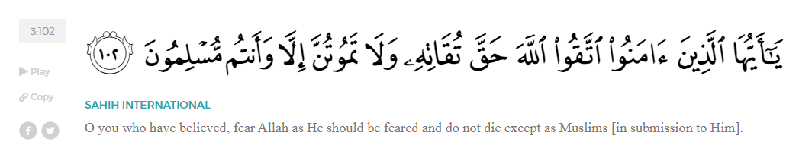
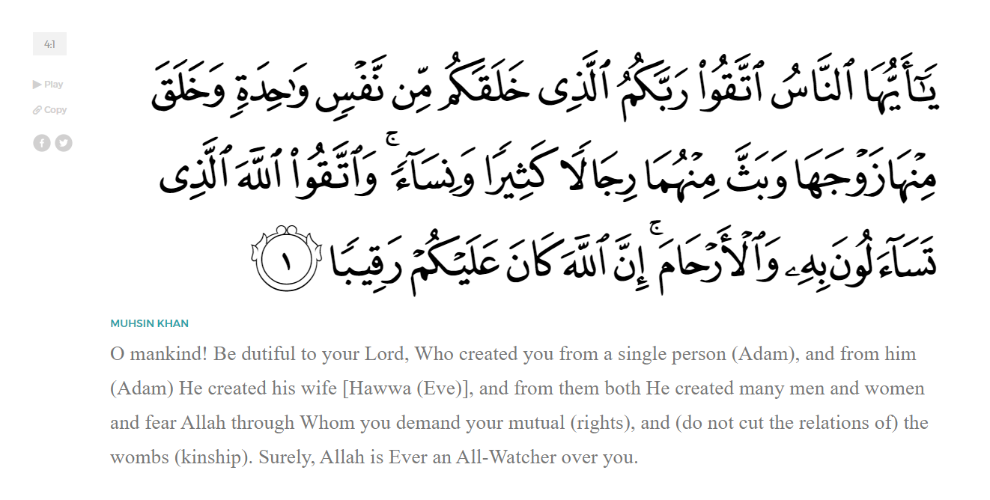
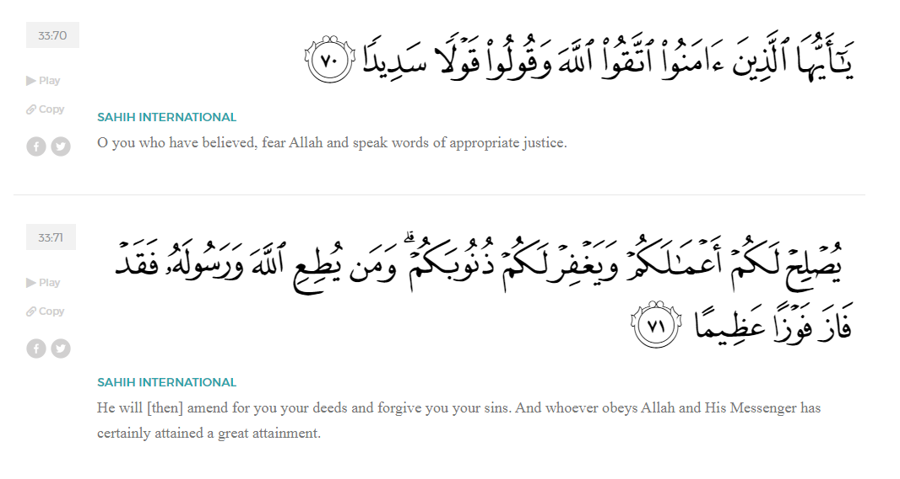
<Sirah of the Prophet (SAW) – Part 32 -Dr. Yassir Qadhi, Book and Series>
Dear brothers and sisters,
InshaaAllah we will continue our khutbah series on the seerah of the Prophet ﷺ, drawing from Dr. Yasir Qadhi’s book, The Sirah of the Prophet, so that we can deepen our understanding of his life and strengthen our love for him. Each step we take through the Prophet ﷺ’s life brings us closer to knowing him more deeply, appreciating his struggles, and embodying his character. Our goal in this series, inshaaAllah, is not just to learn history, but to let the seerah transform our hearts and strengthen our love for the Messenger of Allah ﷺ.
Today we will, inshaaAllah, complete the chapter titled “The Battle of Badr”. In the previous khutbah, we narrated many of the events of the battle itself, which culminated in an overwhelming victory for the Muslims.
The believing nations of the past, such as The Children of Israel, were forbidden war booty, and so the Muslims did not have religious precedent in dealing with their spoils. The Companions began to discuss; in the course of battle, they split up into groups, and each group laid claim to the spoils. One group argued that they collected the war booty and brought it back, another argued that they were the ones to pursue the Quraysh and ensure they did not return, and a third group argued that they were protecting the Prophet ﷺ while the other two groups were busy pursuing or collecting. Allah (SWT) then revealed in Surat al-Anfal:
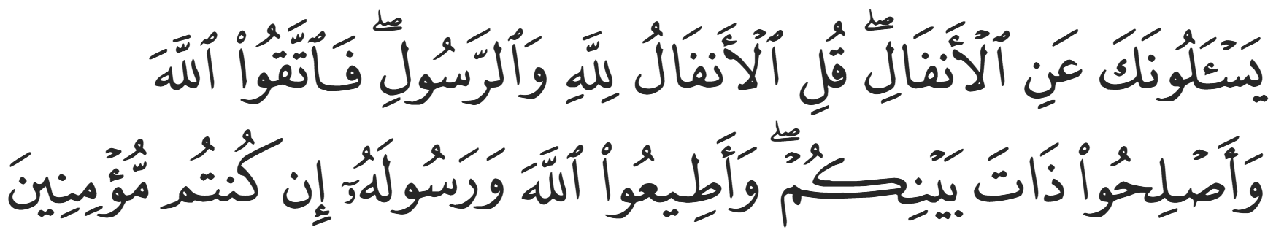
“They ask you ˹O Prophet˺ regarding the spoils of war. Say, “Their distribution is decided by Allah and His Messenger. So be mindful of Allah, settle your affairs, and obey Allah and His Messenger if you are ˹true˺ believers.”” (8:1)
Allah (SWT) then revealed that one-fifth of the spoils are reserved, which is then split into five further categories:
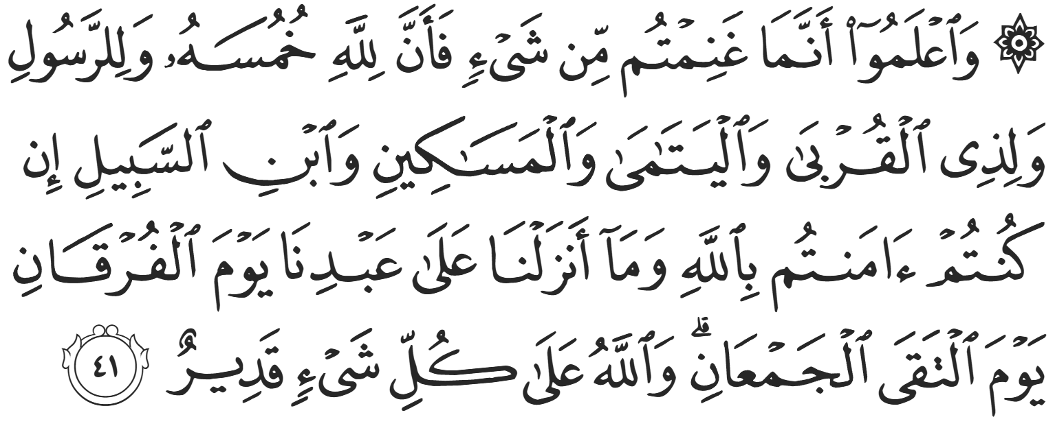
“Know that whatever spoils you take, one-fifth is for Allah and the Messenger, his close relatives, orphans, the poor, and ˹needy˺ travelers, if you ˹truly˺ believe in Allah and what We revealed to Our servant on that decisive day when the two armies met ˹at Badr˺. And Allah is Most Capable of everything.” (8:41)
In other words, 4% of the spoils are allocated to each of the five aforementioned categories. The remaining 80% is distributed between the fighters. In the Battle of Badr, every soldier was given an equal share. Later, at the Battle of Khaybar onwards, the Prophet ﷺ gave the cavalry three times more than the infantry.
Nine people received a full share of spoils despite not attending. ‘Uthmaan ibn ‘Affan (RA) was one of them; he did not attend because Ruqayyah (RHAA), his wife and the daughter of the Prophet ﷺ, was severely ill. The Prophet ﷺ instructed him to stay behind and attend to her needs.
Regarding the Prisoners of War, the Prophet ﷺ said, “If Mut’im ibn ‘Adiyy were alive, and he utters a word requesting the release of these filth, I would have freed them all for him.” Mut’im died a non-Muslim, but the Prophet ﷺ felt indebted to him for his help and compassion in Makkah, particularly for his help in ending the boycott of Banu Haashim and giving the Prophet ﷺ protection when his own tribe disowned him ﷺ.
The Muslims were responsible for prisoners of war for the first time. The Prophet ﷺ consulted the Companions and asked for their opinion. He ﷺ particularly asked his two closest confidants: Abu Bakr and ‘Umar (RHUM), referring to them as “The Prophet’s Two Ministers”.
Abu Bakr (RA) said, “O Messenger of Allah, they are our relatives; they are our blood; they are our kith and kin. Show mercy to them for the sake of brotherhood.” ‘Umar (RA) said, “As for me, O Messenger of Allah, I think you should give ‘Aqeel to ‘Ali to execute; give me someone from the Banu al-Khattab to execute, and so on. We will not leave any of them.” The Prophet’s advisors represented both ends of the spectrum, with mercy on one side and retribution on the other.
The Prophet ﷺ said, “Indeed, Allah (SWT) makes some hearts so soft that they are softer than milk, and he makes others so hard that they are harder than stone. As for you, O Abu Bakr, you have the resemblance of Ibraheem and Isa (AHUM-AS). Ibraheem (AS) said to Allah (SWT),
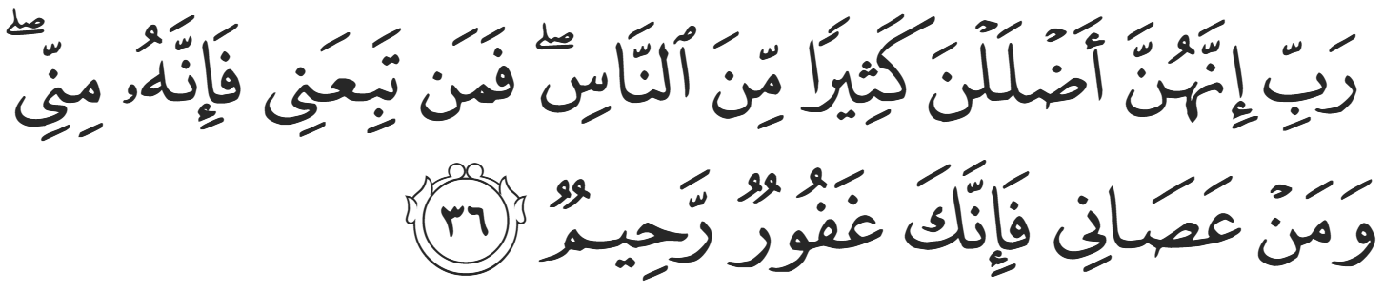
“My Lord! They have caused many people to go astray. So whoever follows me is with me, and whoever disobeys me—then surely You are ˹still˺ All-Forgiving, Most Merciful.” (14:36)
And Isa (AS) said:
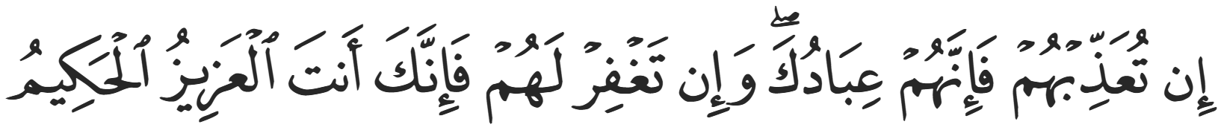
“If You should punish them - indeed they are Your servants; but if You forgive them - indeed it is You who is the Exalted in Might, the Wise.” (5:118)
The Prophet ﷺ continued, “And you, O ‘Umar, are like Nuh and Musa (AHUM-AS). Nuh said,
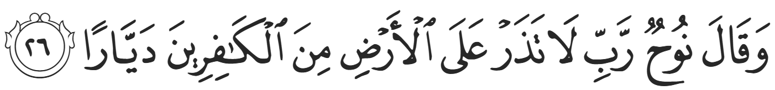
“And Nuh prayed, “My Lord! Do not leave a single disbeliever on earth.” (71:26)
And Musa (AS) said,
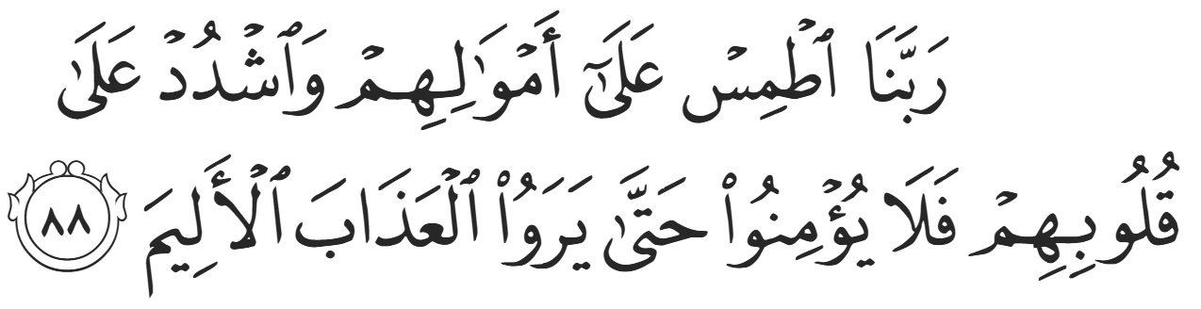
“Our Lord, destroy their riches and harden their hearts so that they will not believe until they see the painful punishment.” (Yunus:88)
The Prophet ﷺ then sided with Abu Bakr (RA).
The following day, ‘Umar (RA) found the Prophet ﷺ and Abu Bakr (RA) crying under a tree. ‘Umar said, “What is causing you to cry, O Messenger of Allah? By Allah, if I understand, I will cry with you; and if I do not understand, I will force myself to cry with you.” The Prophet ﷺ then recited the verses of Surah al-Anfaal that had just been revealed,
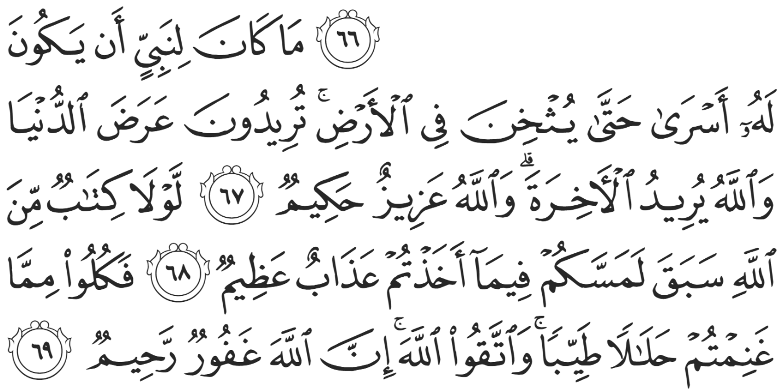
“It is not fit for a prophet that he should take captives until he has thoroughly subdued the land. You ˹believers˺ settled with the fleeting gains of this world, while Allah’s aim ˹for you˺ is the Hereafter. Allah is Almighty, All-Wise. Had it not been for a prior decree from Allah, you would have certainly been disciplined with a tremendous punishment for whatever ˹ransom˺ you have taken. Now enjoy what you have taken, for it is lawful and good. And be mindful of Allah. Surely Allah is All-Forgiving, Most Merciful.” (8:67-69)
Taking prisoners was later established in the seerah, but Allah (SWT) conveyed that the most appropriate course of action in this instance was to solidify the Muslims’ position first. Clemency from a position of weakness is not considered merciful; rather, gaining strength and then forgiving is true mercy, as occurred throughout the Seerah once a position of strength was established. Islam teaches a pragmatic code of conduct, carefully balancing notions of mercy and justice. Indeed, many of the freed captives returned once more to fight, killing Muslims in the Battle of Uhud.
The Muslims then advanced to Madinah, and 70 of the captives were taken as prisoners of war, to be released once their ransoms were paid. However, the Prophet ﷺ insisted that two enemies of Allah be executed: ‘Uqbah ibn Abi Mu’ayt and al-Nadr ibn Haarith. They were the only two captives that the Prophet ﷺ ever executed in his life, but their crimes against Islam were too severe to ignore. As for ‘Uqbah, he was the one who spat in the blessed face of the Prophet ﷺ ; he was the one who strangled the Prophet ﷺ until Abu Bakr (RA) pled, “Are you going to kill a man for saying, “My Lord is Allah’?”; he was the one who threw entrails of a carcass onto the Prophet ﷺ until his young child Faatimah (RHAA) pulled it off; and so on. As for al-Nadr, Ibn ‘Abbas (RA) described him as “A Shaytan from the Shaytaans of Quraysh.” Ibn ‘Abbas (RA) also stated that over eight verses in the Qur’an were revealed about him. He was one of the few literate residents of the Quraysh, and whenever the Qur’an was revealed, he was the first to make sarcastic and disparaging remarks. He was foremost in trying to derail the da’wah of the Prophet ﷺ.
<Conclude 1st Khutbah with:
Aqoolu haathaa wa astaghfir-Allaah (I say this and I ask Allah for forgiveness)
أَقُولُ قَوْلِي هَذَا وَأَسْتَغْفِرُ اللَّهَ لِي وَلَكُمْ وَلِسَائِرِ المُسْلِمينَ وَالمُسْلِمَاتْ فَاسْتَغْفِرُوهْ إِنَّهُ هُوَ الْغَفُورُ الرَّحِيمُ
الحمد لله رب العالمين والصلاة والسلام على سيد المرسلين وعلى آله وأصحابه أجمعين
<2nd Khutbah>
Dear brothers and sisters,
As the Muslims were returning to Madinah, rumors already spread that there was a war and that the Muslims were victorious. However, they could not internalize such a shocking event until Zayd ibn Haarithah (RA) stormed into Madinah riding the Prophet’s camel. Zayd galloped in, chanting, “Allahu Akbar!”, and began listing off the names of the Quraysh’s elite that were killed. Madinah was thrust into elation and the Muslims celebrated joyfully. In a tragic juxtaposition, ‘Uthmaan ibn ‘Affan (RA) heard the celebration as he returned from the cemetery after burying the Prophet’s daughter, Ruqayyah. The Battle of Badr was the single most joyous occasion in the history of Islam to date—it was the first moment of relief and pride after 13 years of hardship and sacrifice. Nevertheless, tragedy struck the Prophet’s household on the very same day; it is as if Allah (SWT) was reminding the Prophet ﷺ that this world will always be a test, and that pure happiness is only for the Hereafter.
The Prophet ﷺ then arrived with the Muslims alongside 70 prisoners of war. Due to the sheer number of captives, the Prophet ﷺ held each Muslim responsible over the person they captured, and he himself hosted the Chieftains of the Quraysh. The Muslims were ordered to treat them as well as they would their own guests. The Prophet ﷺ personally hosted prisoners of war in his own household.
Sawdah (RHAA), the wife of the Prophet ﷺ, had a momentary lapse as she entered the house and saw Suhayl ibn ‘Amr, the most senior figure amongst the captives, sitting in the corner. Not realizing that the Prophet ﷺ was present, and momentarily forgetting her own Islamic identity, she felt a wave of tribal shame, blurting, “O Abu Yazeed, you surrendered?! Why did you not die an honorable death rather than live as a prisoner?” Sawdah narrated herself, “I did not realize what I even said until I heard the Prophet ﷺ next to me say, ‘O Sawdah, are you stoking him to fight against Allah and His Messenger?’ I responded to him, ‘O Messenger of Allah, I swear by Allah; the One with Whom there is no other god, I did not realize what I said. When I saw him sitting like this, I lost sense of myself and could not control myself.’” The Prophet ﷺ accepted her excuse and forgave her.
The Prophet ﷺ ordered the Companions regarding their captives, saying, “Treat them with kindness.” One captive, Abu ‘Aziz, narrated that he was assigned to a group of the Ansaar, and whenever they ate, they would give him the high-quality meat and bread while the Ansaar ate the less desirable dates and water. He felt so embarrassed that he would place the bread back in front of them, but they would insist. This level of kindness towards the enemy was unprecedented, so much so that many of the captives converted to Islam after witnessing such sincere generosity.
The Prophet ﷺ notified the Quraysh that the prisoners would be returned for ransom, and each prisoner’s ransom was according to their financial capabilities to the extent that the poorest of the prisoners were released with no charge. The literate captives were also offered their freedom in exchange for teaching the children of the Ansaar how to read and write. In a largely illiterate society, the Prophet ﷺ truly understood the value of literacy and education.
When Mus’ab ibn Umayr’s brother, Abu ‘Aziz ibn ‘Umayr, was held captive, he saw Mus’ab and rejoiced saying, “O Mus’ab, help!” Mus’ab (RA) then turned to his captor and said, “Make sure he does not escape because his mother is a very wealthy woman who will pay whatever it takes for him.” Shocked, Abu ‘Aziz responded, “O brother, is this how you treat me?” Without missing a beat, Mus’ab pointed towards his captor and replied, “He is my brother, not you.” The Islamic ties of brotherhood were deeply entrenched in his heart—something a tribal Pagan simply could not fathom.
The Ansaari that captured al-‘Abbas—notably with the help of an Angel—approached the Prophet ﷺ and offered to gift al-‘Abbas to him, but the Prophet ﷺ declined and said, “Do not decrease his ransom by one single coin.” The Prophet ﷺ ordered the Companions not to kill al-‘Abbas because he knew that his heart did not have animosity, but he ﷺ was also sternly against nepotism of any kind and insisted that he be treated the same as the other captives. Al-‘Abbas approached the Prophet ﷺ and said, “O Messenger of Allah, why is there a ransom on me when I am a Muslim?” The Prophet ﷺ said, “Allah knows best as to whether your Islam is true.” In other words, it may be true, but we must judge according to the apparent, which is that Al-‘Abbas was physically on the side of the enemy during Badr.
He ﷺ continued, “If what you say is true, Allah will give you something better.” Al-‘Abbas replied, “O Messenger of Allah, you put my ransom as 4,000 dirhams, but I do not have that much money.” The Prophet ﷺ replied, “Where is the money that you and Umm al-Fadl (his wife) hid on such-and-such day? You said to her, ‘If I ever die, this money will go to our children.’ Where is that money?” Al-‘Abbas immediately responded, “I swear by the One Who sent you with the Truth that you are the Messenger of Allah. No one knew about that!” Al-Abbas was a self-proclaimed Muslim, but perhaps certainty did not enter his heart until that moment. Al-‘Abbas later recalled, “Verse 70 of Surah al-Anfaal was revealed about me.” In it, Allah (SWT) states,
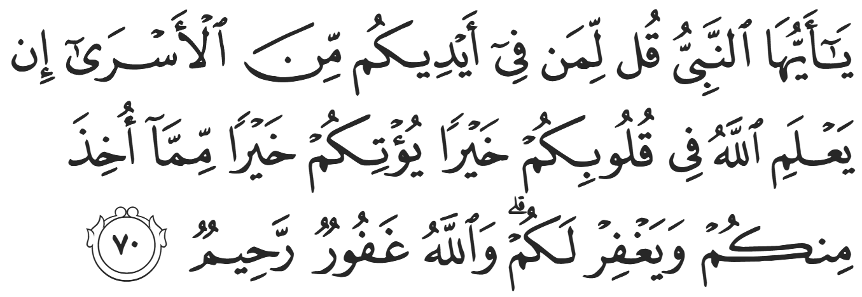
“O Prophet! Tell the captives in your custody, “If Allah finds goodness in your hearts, He will give you better than what has been taken from you, and forgive you. For Allah is All-Forgiving, Most Merciful.”” (8:70)
Al-‘Abbas received so many blessings from Allah (SWT) that he would later say, “O Messenger of Allah, I wish you took much more from me so that Allah may multiply His favors upon me.”
Another notable incident was the case of ‘Amr, the son of Abu Sufyaan. Abu Sufyaan, now the de facto leader of the Quraysh, was being pressured to pay his son’s ransom until he said, “Do they expect me to give up my money along with my blood? They killed Hanzalah (his other son) and now they want to make me penniless to retrieve ‘Amr? Let them keep him!”
Many months later, Abu Sufyaan kidnapped an elderly Muslim who was trading in Makkah. Even though Makkah was considered a Haram even to the Pagans, Abu Sufyaan contravened the sanctity of the Haram to gain leverage. He said that the Muslim, Sa’d, would not be released until his son was returned. Sa’d’s tribe pled with the Prophet ﷺ on his behalf, and the Prophet accepted their pleas and released ‘Amr.
When Zayd (RA) arrived in Madinah, a group of Pagans still living in the city grew increasingly disgruntled. When the Prophet ﷺ arrived and the victory of the Muslims was confirmed, they realized that a page had turned in the history of Arabia and that the Muslims were here to stay. After Badr, they jumped ship and converted to Islam, thus no Pagans remained in Madinah. This group of people who were outwardly Muslim but inwardly resented Islam are known as the Munafiqoon – the Hypocrites.
The leader of the Hypocrites was ‘Abdullah ibn Ubayy ibn Saluul, the lone senior figure that survived the Bu’aath wars between the Aws and the Khazraj. Were it not for the Prophet’s arrival, he would have been the undisputed leader of Yathrib. He would frequently make disrespectful comments about the Muslims. On one occasion, the Prophet ﷺ passed by on a donkey and ‘Abdullah ibn Ubayy sneered, “Do not pollute us with your dust.” He would also complain about the noise when the Companions would recite the Qur’an. When the victory of Badr was finally confirmed, he said, “It appears that the matter is now settled (i.e. Islam is here to stay, and he would never be the Chieftain).” He then outwardly converted to Islam, but his resentment did not wane.
Dear brothers and sisters, after many weeks reflecting on the events and lessons of Badr, we have finally reached the end of this chapter in the seerah. May Allah allow us to carry its lessons with us and make us among those who follow the example of the Prophet ﷺ and his noble Companions.

<Duaa!>
- Oh Allah, please grant us a deep love for Your Prophet Muhammad, SAW.
- Oh Allah, please make us energetic in doing good for Your cause.
- Oh Allah, please enable us with the will and means to walk Al-Sirrat-Al-Mustaqeem, even if it estranges us from others.
- Oh Allah, please support the suffering and oppressed Muslims around the world and grant them victory over those who oppress them.
- Oh Allah, please protect us from being overburdened by debt and from all its harms and consequences.
- Oh Allah, please grant healing to those among us who are sick, and grant them comfort, patience, and what is best for their condition.
- Oh Allah, please fill our hands with the work and deeds of righteousness that will be of benefit to ourselves and the Ummah.
- Oh Allah, please forgive us our shortcomings and deviances in following Your Qur'an and the Sunnah of Rasul'Allah, SallAllahuAlayhiWaSallam.
- Oh Allah, please grant us understanding and guidance of Your Qur'aan.
- Oh Allah, please grant us patience with the trials of this world.
- Oh Allah, please prevent our hearts from getting overly attached to the Dunya and grant us the best in this life and the best in the hereafter.
- Oh Allah, please forgive us our past sins and purify our hearts.
- Oh Allah, please make us amongst those whose Duaa is accepted.
- Oh Allah, please grant us Jannat'ul Firdaus and protect us from ever coming close to the Fires of Jahannum.

