Khut'bah Opening
إِنَّ الْحَمْدَ للهِ , نَحْمَدَهُ وَ نَسْتَعينُهُ وَ نَسْتَغْفِرُهُ , وَ نَعوذُ بِالله مِنْ شُرورِ أَنْفُسِنا , مَن يَهْدِهِ اللهُ فَلا مُضِلَّ لَه , وَ مَنْ يُضِلِلْ فَلا هادِيَ لَهْ , وَ أَشْهَدُ أَنْ لا إلهَ إِللهُ وَحْدَهُ لا شَريكَ لَه , و أَشْهَدُ أنَّ مُحَمَّدًا عَبْدُهُ و رَسولُه.
"All thanks and praises are due to Allah, whom we thank, seek for help and invoke for forgiveness. We seek refuge with Allah from the evils within ourselves. He whom Allah guides will never be misled and he whom He misguides will never find one to guide him. I bear witness that there is no deity worthy of worship except Allah and that Muhammad (SAW) is His slave and Messenger.
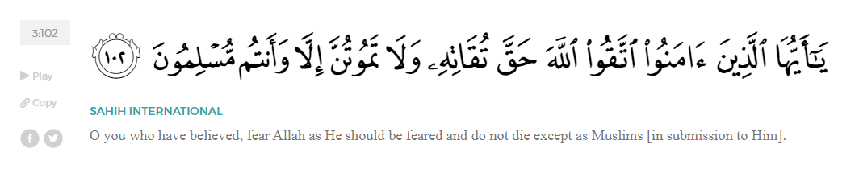
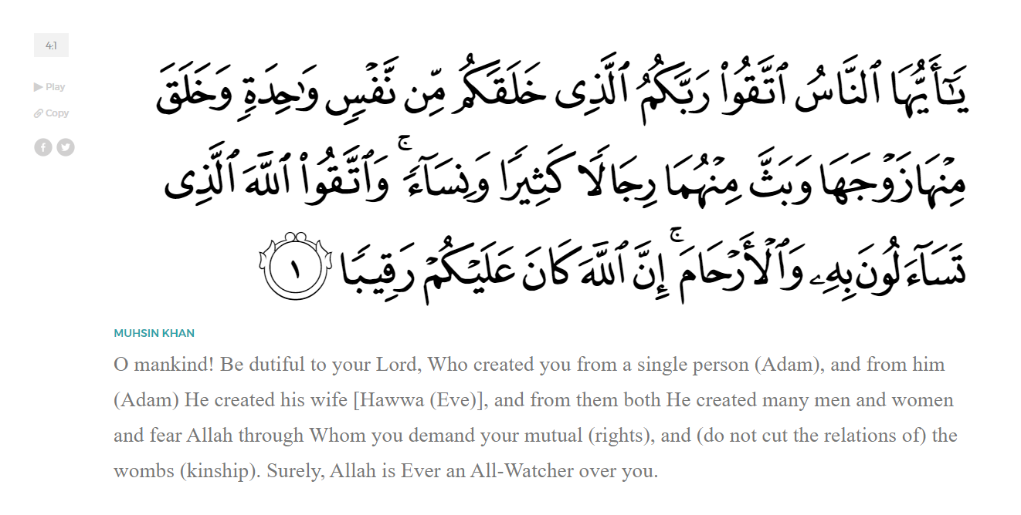
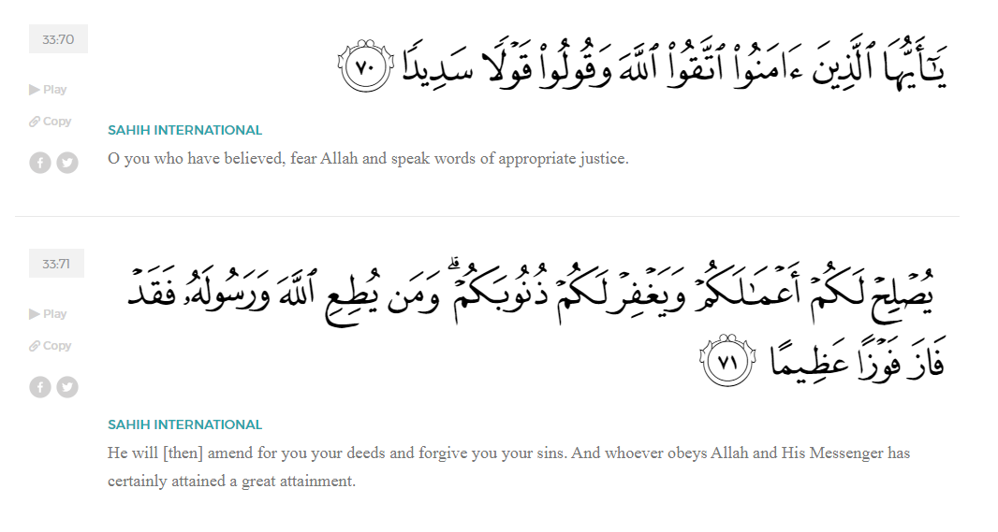
<Sirah of the Prophet (SAW) – Part 4 -Dr. Yassir Qadhi, Book and Series>
Dear brothers and sisters,
InshaaAllah we will continue our khutbah series on the seerah of the Prophet ﷺ, drawing from Dr. Yasir Qadhi’s book, The Sirah of the Prophet, so that we can deepen our understanding of his life and strengthen our love for him. Each step we take through the Prophet ﷺ’s life brings us closer to knowing him more deeply, appreciating his struggles, and embodying his character. Our goal in this series, inshaaAllah, is not just to learn history, but to let the seerah transform our hearts and strengthen our love for the Messenger of Allah ﷺ.
Today we will, inshaaAllah, start with the chapter on the Birth and Early Life of the Prophet ﷺ.
Regarding the date of the birth of the Prophet ﷺ. The commonly cited birth date of the Prophet ﷺ is the 12th of Rabi’ al-Awwal, however, the earliest sources mention a number of potential dates with no unanimous agreement on any date in particular. When asked why he fasted on Mondays, the Prophet ﷺ replied, “This was the day that I was born, and it was the day the Revelation first came to me.” The Prophet ﷺ was born in the Year of the Elephant – In pre-Islamic Arabia – similar to other cultures at the time—exact years and dates were not recorded. Instead, momentous events would be referenced, and any particular event would be quoted in reference to that major event.
Some state that he, ﷺ, was born on the 10th of Rabi al-Awwal, some state the 2nd. Other scholarly opinions include the 9th of Rabi’ Al-Awwal, the 17th of Rabi Al-Awwal, the 22nd of Rabi’ Al-Awwal. Some even state that he ﷺ was born in Ramadan. There are over ten opinions within the earliest sources of Islam regarding the exact day the Prophet ﷺ was born, with no clear cut, indisputable certainty.
When the Prophet ﷺ was named “Muhammad” – which was not the most common name at the time—the people asked ‘Abd al-Muttalib why he chose such a unique name, to which he replied, “I want him to be praised amongst the people as I want him to be praised by Allah in the Heavens.”
It was custom amongst the nobility of the Quraysh to send some of their newborn children to the desert for the first few years of their life. This was done to protect the children by raising them in a purer environment at a time when infant mortality was extremely common. It also conditioned the infants’ bodies to withstand an austere environment and equipped them with a purer, unadulterated form of the Arabic language. The Prophet ﷺ was one of these children, and he was sent as a newborn to the Banu Sa’d ibn Bakr tribe, who were known for their eloquence and proficiency in the Arabic language.
Halimah al-Sa’diyyah recalled the annual custom of travelling to Mecca to choose infants for care. No-one wanted to choose the Prophet ﷺ because he was an orphan, and payment for this service would usually come from the father. By the end of her stay in Mecca, Halimah found herself without a child to take back and so she chose the Prophet ﷺ. As soon as she took the Prophet ﷺ, miracles began to occur.
She said, “When I was unable to take any other child, I took him and brought him back to my camp and I was able to feed him all the milk he wanted with ease. He drank until he was full, as did his milk-brother. My husband then went to our old she-camel, and to our surprise her udder was full of milk. He was able to milk so much that my husband and I both drank until we were full. My husband said, “Halimah, by Allah, I think that you have brought a blessed soul.’”
Her donkey was the oldest and slowest, yet when it would carry her with the Prophet ﷺ it overtook the rest. Halimah continued to experience many miracles of this nature throughout the two-year tenure. It reached the extent that Halimah would desperately persuade the mother of the Prophet ﷺ, Aminah, to extend the period of care so that she could continue enjoying these blessings and benefits.
When the Prophet ﷺ was four years old, the Archangel Jibril (AS) came to the Prophet ﷺ. The other children ran away while the Prophet ﷺ stood his ground. Jibril (AS) overpowered him ﷺ and forced him onto the ground. He opened up the Prophet’s chest ﷺ, took out his heart, and removed a black sliver from it. Jibril (AS) then said, “This is Shaytan’s portion in you.” He then washed his heart in a golden cup of Zamzam, put it back, and sealed his chest.
Many decades later, Anas ibn Malik (RA) remarked, “I used to notice the mark left on his ﷺ’s chest.” This incident worried Halimah and she decided to return the Prophet ﷺ in case anything else happened. It is the Sunnah of Allah (SWT) that the Prophets are infallible with perfect character. This event was Allah’s preparing the Prophet ﷺ for a life of exemplary conduct. Some scholars of tafsir note that the verse in Surat Ash-Sharh refers to this event:

“Have We not uplifted your heart for you ˹O Prophet˺, and relieved you of the burden.” (94:1-2)
The Prophet ﷺ’s father passed away while Aminah was pregnant with the Messenger of Allah ﷺ. Aminah also passed away when the Prophet ﷺ was six years old. Despite their short time together, he ﷺ still had a deep love for her. This was made apparent on a journey some 50 years later when he ﷺ took a detour into a village. His Companions (RHUM) followed him without uttering a word until he ﷺ reached a grave and began to cry. He wept until his beard was wet. The Companions only ever witnessed the Prophet ﷺ cry a handful of times in his life, and this moving event collectively brought everyone to tears. Eventually, the Prophet ﷺ said, “I used to forbid you from visiting graveyards, but you may visit them now”. Another report states that the Prophet ﷺ did not take a single step without being granted permission, including visiting his mother. The mercy of this abrogation has been extended to the Ummah, and the permissibility of visiting graves was sanctioned, serving as a reminder of the shortness of this life.
When both his parents passed away, the Prophet ﷺ was taken into the custody of his grandfather, ‘Abd al-Muttalib, who also had a special relationship with the Prophet ﷺ. However, two years later at the age of eight, his grandfather also passed away. The Prophet ﷺ was then entrusted to his uncle, Abu Talib, who raised the Prophet ﷺ and lived a long life, passing away when the Prophet ﷺ was over 50 years old.
Allah (SWT) said to Musa (AS), who was expelled from his hometown both as a child and adult:

“And I have chosen you for Myself.” (20:41)
Similarly, our Prophet ﷺ was left in Allah’s care and nurture. Growing up in such a harsh environment develops one’s maturity, forbearance, patience, and humility.
Allah (SWT) reminds the Prophet ﷺ of the favors that he has shown him in his upbringing, and then gives a command to us all in Surat Ad-Duhaa:
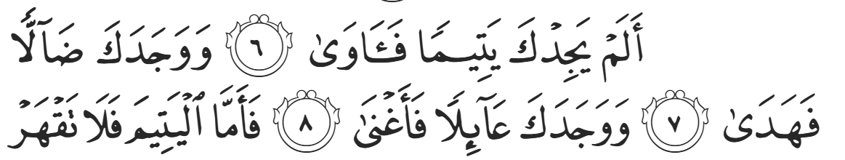
“Did He not find you an orphan and give [you] refuge? And He found you lost and guided [you], And He found you poor and made [you] self-sufficient. So as for the orphan, do not oppress [him].”(93:6-9)
When the Prophet ﷺ said, “I, and the one who takes care of an orphan, will be like this in Paradise (gesturing to his index and middle fingers being pressed together)”, he ﷺ was speaking from a place of true empathy and understanding.
<Conclude 1st Khutbah with:
Aqoolu haathaa wa astaghfir-Allaah (I say this and I ask Allah for forgiveness)
أَقُولُ قَوْلِي هَذَا وَأَسْتَغْفِرُ اللَّهَ لِي وَلَكُمْ وَلِسَائِرِ المُسْلِمينَ وَالمُسْلِمَاتْ فَاسْتَغْفِرُوهْ إِنَّهُ هُوَ الْغَفُورُ الرَّحِيمُ
الحمد لله رب العالمين والصلاة والسلام على سيد المرسلين وعلى آله وأصحابه أجمعين
<2nd Khutbah>
Dear brothers and sisters,
The Prophet ﷺ said, “Allah did not send any Prophet except that he was a shepherd of sheep.” The Companions (RHUM), replied, “What about you, O Messenger of Allah?” And the Prophet ﷺ replied, “Yes, I was a shepherd; I used to tend to the flock of the people of Mecca in return for some pennies.”
The wisdoms of mandating this profession on the Prophets of Allah (SWT) are many. Being a shepherd offers the opportunity of solitude, which encourages reflection and introspection. There is a clear correlation between godlessness and affluence in urban surroundings, especially when compared to the faith of farmers and shepherds largely surrounded by nature and solitude. Constantly observing the miraculous nature of Allah’s creation impacts one’s faith and sense of being.
The Prophet ﷺ also specified shepherds of sheep specifically, because sheep are known for their heedlessness, as humans are. They require constant attention, lest they be led astray. Sheep also vary considerably in personality, and each sheep must be managed in a particular way according to their tendencies. Being a shepherd of sheep requires one to be simultaneously soft and tender as well as brave and courageous; tenderness is needed for one’s own flock, and bravery is essential when defending the flock against wolves and other predatory animals.
Being a shepherd necessitates humility and contentment. It is hard, menial labor with minimal renumeration. It is thus difficult to develop arrogance and pride as a shepherd of sheep. The mandating of Prophets in this role provides an important lesson in our understanding of honor and nobility; it teaches that we should be proud and happy to earn money with our hands to feed our families and communities, just as the Prophets before us did (ASS).
When the Prophet ﷺ was around 15 years old, a series of small battles broke out between two large tribes. A tribe member from the branch of Kinaanah—to whom Quraysh belonged—killed a man from the branch of Hawaazin. The killer escaped and fled into the precinct of the Haram because no-one can be harmed in the sacred grounds. Hawaazin, in their rage, entered the Haram and attacked the man. The Quraysh were so incensed that the sanctity of the Haram was violated that they declared all-out war. The Prophet ﷺ recalled these events at a later date and said, “I remember participating in the Fijaar Wars. I would collect and return arrows for my uncles… I do not regret participating in that war.”
A few years later, when the Prophet ﷺ was 20 years old, another incident occurred. A Yemeni man came to Mecca to perform Hajj. To fund his travels, he sold a few items to Al-Aas ibn Al-Waail, who was a Chieftain and influential politician. Al-Aas evaded payment and continued to stall. The man sought assistance from different tribe leaders of the Quraysh, but was met with a variety of excuses, as no-one wanted to create tensions with a powerful diplomat on behalf of a lone traveler. As a last resort, the man took to a public platform. The closest equivalent to 21st century contemporary media platforms at the time was public speeches through the medium of poetry. The man headed to the Ka’bah, which was a primary gathering place, and began to recite poetry about the injustice he had suffered.
His poem proliferated rapidly until the likes of Al-Zubayr ibn Abd al’Muttalib, the Prophet’s uncle, heard about it. He convened a meeting between the senior tribesmen of the Quraysh in the house of ‘Abdullah ibn Jud’aan, a widely respected and revered Chieftan who passed away before the Prophethood of Muhammad ﷺ. A pact was made, and a treaty was formed whereby the Quraysh vowed to support the oppressed over the oppressor, regardless of the tribal standing of either party.
They gathered in front of the Ka’bah and made a collective vow, signing a treaty by dipping their hands in perfume and imprinting it onto the document. It was thus called Hilf Al-Mutayyibiin (Treaty of the Perfumed), or Hilf al-Fudul (IE, Treaty of none-of-their-business). The pact was made to proclaim that matters of oppression are a societal concern and therefore everyone’s business.
The pact was unprecedented, remembered as a momentous event in the face of injustice. The Prophet ﷺ stated, “I witnessed in the house of ‘Abdullah ibn Jud’aan a treaty that, were I asked to uphold it even in Islaam, I would do so. And I would not give up my place even if offered a large amount of money.”
These two events are noteworthy because they occurred before Prophethood, but the Prophet ﷺ approved and affirmed them after Prophethood. He ﷺ did not regret participating in the Fijaar Wars; rather he was proud. This shows us that it is permissible to fight for causes that do not necessarily pertain to religion but are for a good cause. There is a scholarly debate as to the extent to which we may participate in such disputes and battles, but there is precedent to involve oneself in such disputes. Similarly, the Prophet’s comments ﷺ on Hilf Al-Fuduul demonstrate how he was involved in his society, even though it was a non-Muslim society. He ﷺ was involved in the betterment of his society and stood up against injustices of any kind.
Allah (SWT) tells us in Surat An-Nisaa:
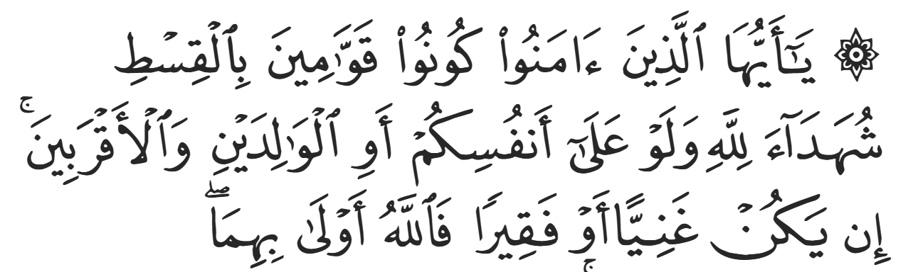
“O you who have believed, be persistently standing firm in justice, witnesses for Allah, even if it be against yourselves or parents and relatives. Whether one is rich or poor, Allah is more worthy of both.” (4:135)
Oftentimes, the best da’wah (calling to Islaam), is through calling to neutral matters of goodness, truth, and justice. Being a spokesperson against racism, or calling on others to give blood, for example, is extremely effective in enhancing the image of Islaam simply due to the fact that it is a visibly Muslim person fighting for these causes. Moreover, when somebody is known to care for their community, they are valued and respected. When the time comes for more direct invitations to Islaam, Muslims will be listened to and taken more seriously, and Islam is then depicted as a sincere faith. This is the Prophetic method, and we should strive to emulate it.
<Duaa!>
- Oh Allah, please grant us a deep love for your Prophet Muhammad, SAW.
- Oh Allah, please make us energetic in doing good for your cause.
- Oh Allah, please enable us in will and means to walk Al-Sirrat-Al-Mustaqeem, even if it estranges us from others.
- Oh Allah, please support the suffering and oppressed Muslims around the world and grant them victory over that which oppresses them.
- Oh Allah, please protect us from ever being overburdened by debt and protect us from all evils and undesirable consequences associated to having debt.
- Oh Allah, please fill our hands with the work and deeds of righteousness and let them be of benefit to ourselves and the Ummah.
- Oh Allah please forgive us our shortcomings and deviances in following your Qur'an and the Sunnah of Rasul'Allah, SallAllahuAlayhiWaSallam.
- Oh Allah please grant us understanding and guidance of your Qur'aan
- Oh Allah, please grant us patience with the trials of this world.
- Oh Allah, please prevent our hearts from getting overly attached to the Dunya and grant us the best in this life and the best in the hereafter.
- Oh Allah, please forgive us our past sins and make us your devoted servants.
- Oh Allah please make us amongst those whose Duaa is accepted.
- Oh Allah, please grant us Jannat'ul Firdaus and protect us from ever coming close to the Fires of Jahannum.

