Khut'bah Opening
إِنَّ الْحَمْدَ للهِ , نَحْمَدَهُ وَ نَسْتَعينُهُ وَ نَسْتَغْفِرُهُ , وَ نَعوذُ بِالله مِنْ شُرورِ أَنْفُسِنا , مَن يَهْدِهِ اللهُ فَلا مُضِلَّ لَه , وَ مَنْ يُضِلِلْ فَلا هادِيَ لَهْ , وَ أَشْهَدُ أَنْ لا إلهَ إِللهُ وَحْدَهُ لا شَريكَ لَه , و أَشْهَدُ أنَّ مُحَمَّدًا عَبْدُهُ و رَسولُه.
"All thanks and praises are due to Allah, whom we thank, seek for help and invoke for forgiveness. We seek refuge with Allah from the evils within ourselves. He whom Allah guides will never be misled and he whom He misguides will never find one to guide him. I bear witness that there is no deity worthy of worship except Allah and that Muhammad (SAW) is His slave and Messenger.
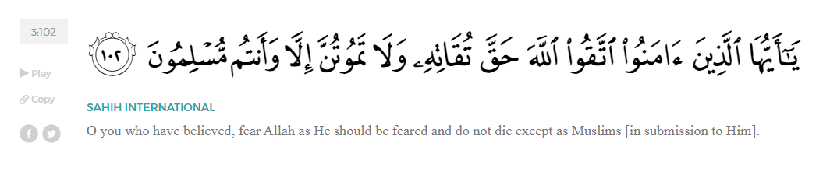
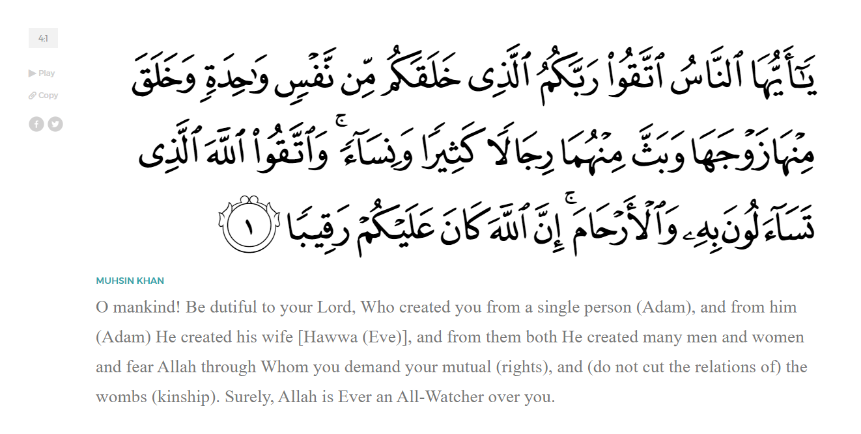
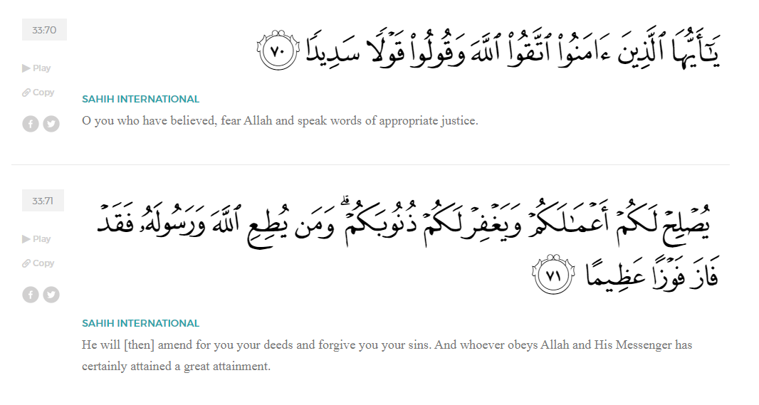
<Sirah of the Prophet (SAW) – Part 5 -Dr. Yassir Qadhi, Book and Series>
Dear brothers and sisters,
InshaaAllah we will continue our khutbah series on the seerah of the Prophet ﷺ, drawing from Dr. Yasir Qadhi’s book, The Sirah of the Prophet, so that we can deepen our understanding of his life and strengthen our love for him. Each step we take through the Prophet ﷺ’s life brings us closer to knowing him more deeply, appreciating his struggles, and embodying his character. Our goal in this series, inshaaAllah, is not just to learn history, but to let the seerah transform our hearts and strengthen our love for the Messenger of Allah ﷺ.
Today we will, inshaaAllah, continue with the chapter of the Prophet ﷺ’s early adulthood, starting with his marriage to Khadijah (RHAA).
Khadijah bint Khuwaylid (RHAA) was a noblewoman of the Quraysh. She shared a common ancestor with the Prophet ﷺ via Qusayy on her father’s side, and Amir ibn Lu’ayy on her mother’s side.
There are a great many differences of opinion regarding Khadijah’s previous marriages and children. Some claim she was never previously married before meeting the Prophet ﷺ, but it is quite evident that she was, not least because her kunyah – her honorific title -- was Umm Haani – the mother of Haani. There are, however, conflicting reports, resulting in a confusing timeline.
The most common understanding is that Khadijah was twice married before marrying the Prophet ﷺ. She married Hind ibn Zuraarah, also known as Abu Haalah, from the Banu Tamiim. She bore two children: Haalah and Hind. Following Abu Haalah’s demise, she married Aatiq ibn Aabid al-Makhzuumi. It is reported that she bore a third child, also named Hind. However, it is quite peculiar for two children to be given the exact same name. Furthermore, the gender of the third child is also uncertain. It may very well be the case, therefore, that the reports are referring to the same child, Hind.
It is also stated that Khadjiah gained a handsome inheritance from her second husband, Aatiq. However, as a Qurayshi, Aatiq’s inheritance would have been allotted to his male kin within the Quraysh. In pre-Islamic Arabia, women did not ordinarily inherit, and Khadijah (RHAA) was reported to have been the wealthiest woman of the Quraysh. It may be more likely that she gained her inheritance from her first husband, Hind, who was Tamiimii. The Banu Tamiim were located in the Najd region, a considerable distance away, which is a more plausible explanation for receiving a lofty inheritance.
As might be expected following the consecutive deaths of two husbands, the Mother of the Believers, Khadijah, led a somewhat secluded life before meeting the Prophet ﷺ. She was proposed to on multiple occasions by the noblemen of Quraysh, but as a widow, she remained reserved and contented herself with solitude.
She continued to reinvest her money and grew her profits through trade as a businesswoman in her own right. She would primarily buy goods during the Hajj season, but as a woman in a Jahilii society, she relied on men to travel and sell the goods for her in Syria and beyond in exchange for profit-share agreements. Due to her reliance on the honesty and transparency of her business partners, she would often be short-changed or scammed.
As we mentioned before, the Prophet ﷺ would tend to people’s flocks for a living. Khadijah’s sister had a herd of camels and hired the Prophet ﷺ alongside another young man to graze them outside Mecca. When it was time to collect their payment, the Prophet ﷺ told the second shepherd to ask for his wages on his behalf, as he ﷺ was too shy to ask directly. Khadijah’s sister said, “I have not seen a man more bashful, noble, and honorable than him ﷺ.” She continued to praise him in such a manner that Khadijah—felt something enter her heart just from hearing the descriptions. After hearing her sister’s extravagant praise of the Prophet ﷺ, Khadijah (RHAA) decided to extend an offer of a business partnership to him, despite his lack of entrepreneurial experience.
This story beautifully shows that honesty is not just a moral virtue — it is a means through which Allah opens doors that no one could have planned. The Prophet ﷺ did not seek worldly gain through deceit or manipulation; rather, his truthfulness and integrity were the very reasons Allah placed barakah in his affairs and brought new opportunities to him, including his partnership with Khadijah (RHAA).
Allah (SWT) tells us in Surat Al-Mutaffifiin:
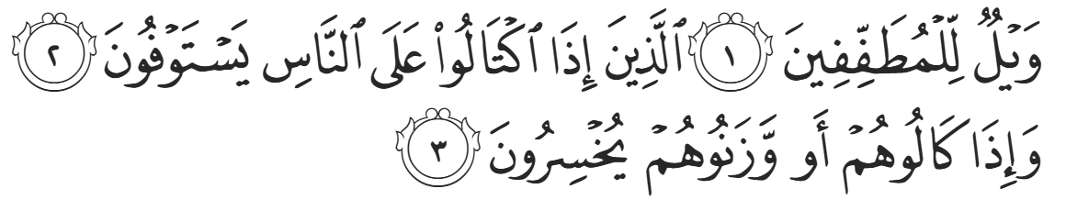
“Woe to those who give less [than due], Who, when they take a measure from people, take in full. But if they give by measure or by weight to them, they cause loss.” (83:1-3)
As Allah warns in Surat al-Mutaffifīn, there is no blessing or lasting success for those who cheat or deceive. Wealth earned through dishonesty may seem abundant, but it is stripped of barakah. True prosperity, as shown by the example of the Prophet ﷺ, comes only from sincerity, fairness, and trustworthiness — qualities that elevate both one’s dunya and akhirah.
As per his respectful nature, the Prophet ﷺ sought counsel from his uncle, Abu Taalib, who strongly encouraged him to accept Khadija’s business offer. He ﷺ agreed, and Khadijah (RHAA) gave a generous offer of an even split, which was above average for such a partnership. The Prophet ﷺ embarked on the first business trip to Syria, and successfully returned with multiplied profits. Not only was the Prophet ﷺ inherently blessed in all his actions, but his honesty and integrity undoubtedly contributed to his successes.
One day, an elderly friend of Khadijah asked, “O Muhammad, why don’t you get married?” The Prophet ﷺ -- who was yet to be a Prophet—smiled and replied, “And who would marry me? I am a poor orphan of the Quraysh.” She responded, “And what if Khadiijah wanted to marry you?” After a short pause, he ﷺ replied, “Why would she want to marry me?” The conversation ended there but developments continued until they did indeed marry.
Abu Taalib gave the sermon, praising Allah and recalling the lineage of the Quraysh. He then said, “My nephew Muhammad ibn ‘Abdullah ibn ‘Abd al-Muttalib—to whom there is no equal amongst the youth in the Quraysh in manners, nobility and lineage—has proposed to your noble daughter. Should he be lacking in wealth, then let it be known that wealth is a temporary provision akin to a fleeting shadow. He desired to marry Khadjiah, and she shares the same sentiment in the matter.”
A dowry of 12 uqiyyah of silver (worth roughly $1200 US Dollars today) was then offered. Her uncle, ‘Amr ibn Asad, said, “This is a young man that cannot be refused” and gave her away.
There is a difference of opinion regarding Khadijah’s age when she married the Prophet ﷺ. The most widespread view is that she was 40 years old when she married the Prophet ﷺ and that she died at the age of 65. However, the likes of Al-Bayhaqi and Ibn Kathir opine that she died in her fifties. There is a consensus that they were married for 25 years, and if she died in her fifties, she would have married the Prophet ﷺ in her late twenties or early thirties. An early authority, Hisham al-Kalbi, states that she married at 28 years old. Likewise, Al-Haakim narrates from Ibn Ishaaq that she was 28 years old. The latter opinion—that she was 28—holds more weight; the narrations are more in quantity, and the narrators, such as the likes of Ibn Ishaaq, are more authoritative. Moreover, the Prophet ﷺ and Khadijah had at least six children. It is much more plausible for a woman in her twenties to have six children than someone in their forties through their fifties.
<Conclude 1st Khutbah with:
Aqoolu haathaa wa astaghfir-Allaah (I say this and I ask Allah for forgiveness)
أَقُولُ قَوْلِي هَذَا وَأَسْتَغْفِرُ اللَّهَ لِي وَلَكُمْ وَلِسَائِرِ المُسْلِمينَ وَالمُسْلِمَاتْ فَاسْتَغْفِرُوهْ إِنَّهُ هُوَ الْغَفُورُ الرَّحِيمُ
الحمد لله رب العالمين والصلاة والسلام على سيد المرسلين وعلى آله وأصحابه أجمعين
<2nd Khutbah>
Dear brothers and sisters,
The Prophet ﷺ’s transition from shepherd to a businessman demonstrates the value of good character and conduct. His honesty, integrity, hard work, and modesty led directly to multiple opportunities. It also paved the way for a perfect marriage. This blessed event also confirms the permissibility of falling in love and even pursuing that feeling in a legitimate way. Khadijah (RHAA) proved to be a vital asset in the Prophet ﷺ’s mission, as is evidenced throughout the seerah.
Allah (SWT) tells us in Surat Ar-Ruum:
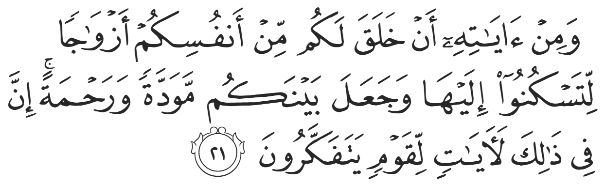
“And one of His signs is that He created for you spouses from among yourselves so that you may find comfort in them. And He has placed between you compassion and mercy. Surely in this are signs for people who reflect. (30:21)”
Khadijah (RHAA) provided our beloved Messenger ﷺ with invaluable emotional support and was a source of tranquility and peace. The Prophet ﷺ once said, “Oh Khadijah, here is Jabril (AS). He is sending Allah’s salaam on you, and he is giving you glad tidings of a home in Paradise with no noise or struggle.” Khadijah, displaying her intelligence and understanding of the religion by not returning peace back to Allah, responded, “Indeed, Allah is Al-Salaam (The Giver of Peace), and may peace be upon Jibril, and you, oh Messenger of Allah”.

<Duaa!>
- Oh Allah, please grant us a deep love for your Prophet Muhammad, SAW.
- Oh Allah, please make us energetic in doing good for your cause.
- Oh Allah, please enable us in will and means to walk Al-Sirrat-Al-Mustaqeem, even if it estranges us from others.
- Oh Allah, please support the suffering and oppressed Muslims around the world and grant them victory over that which oppresses them.
- Oh Allah, please protect us from ever being overburdened by debt and protect us from all evils and undesirable consequences associated to having debt.
- Oh Allah, please fill our hands with the work and deeds of righteousness and let them be of benefit to ourselves and the Ummah.
- Oh Allah please forgive us our shortcomings and deviances in following your Qur'an and the Sunnah of Rasul'Allah, SallAllahuAlayhiWaSallam.
- Oh Allah please grant us understanding and guidance of your Qur'aan
- Oh Allah, please grant us patience with the trials of this world.
- Oh Allah, please prevent our hearts from getting overly attached to the Dunya and grant us the best in this life and the best in the hereafter.
- Oh Allah, please forgive us our past sins and make us your devoted servants.
- Oh Allah please make us amongst those whose Duaa is accepted.
- Oh Allah, please grant us Jannat'ul Firdaus and protect us from ever coming close to the Fires of Jahannum.

