Khut'bah Opening
إِنَّ الْحَمْدَ للهِ , نَحْمَدَهُ وَ نَسْتَعينُهُ وَ نَسْتَغْفِرُهُ , وَ نَعوذُ بِالله مِنْ شُرورِ أَنْفُسِنا , مَن يَهْدِهِ اللهُ فَلا مُضِلَّ لَه , وَ مَنْ يُضِلِلْ فَلا هادِيَ لَهْ , وَ أَشْهَدُ أَنْ لا إلهَ إِللهُ وَحْدَهُ لا شَريكَ لَه , و أَشْهَدُ أنَّ مُحَمَّدًا عَبْدُهُ و رَسولُه.
"All thanks and praises are due to Allah, whom we thank, seek for help and invoke for forgiveness. We seek refuge with Allah from the evils within ourselves. He whom Allah guides will never be misled and he whom He misguides will never find one to guide him. I bear witness that there is no deity worthy of worship except Allah and that Muhammad (SAW) is His slave and Messenger.
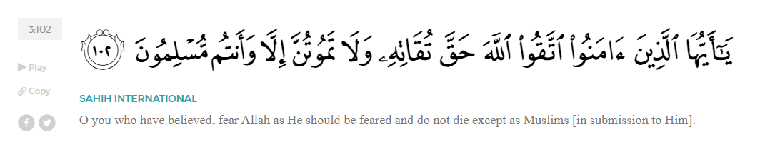
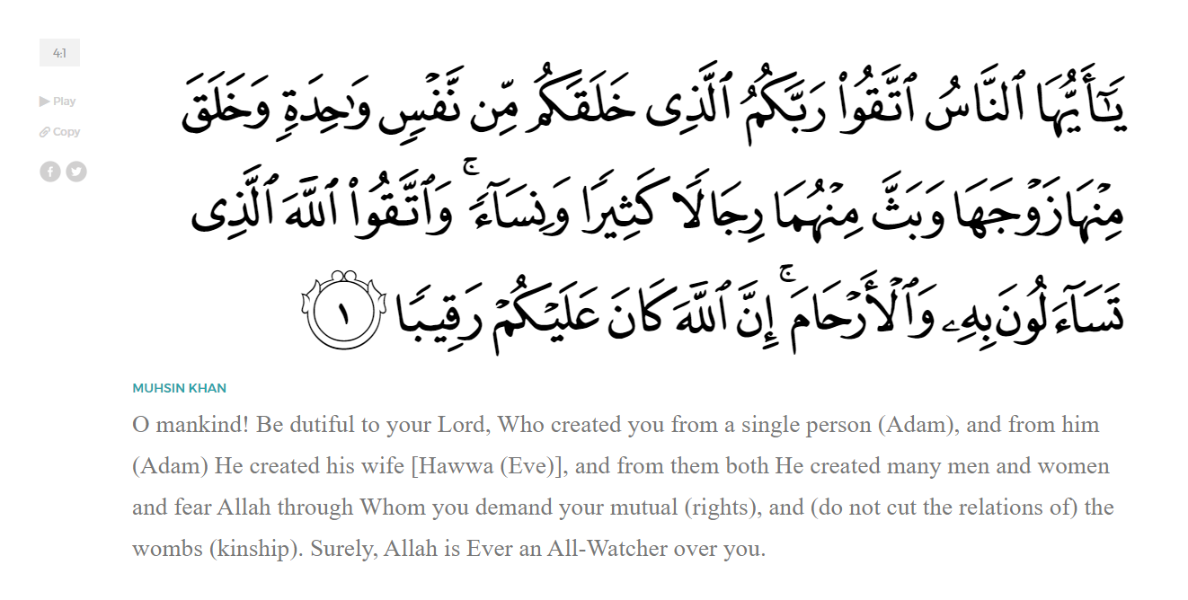
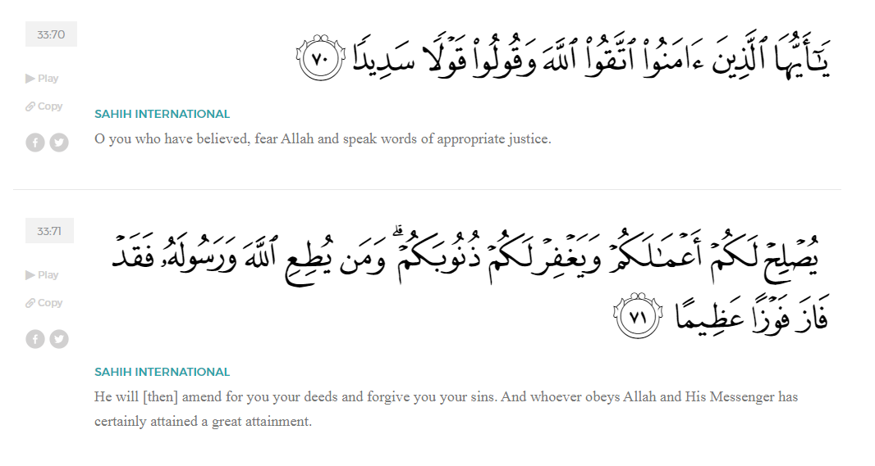
<Sirah of the Prophet (SAW) – Part X -Dr. Yassir Qadhi, Book and Series>
Dear brothers and sisters,
InshaaAllah we will continue our khutbah series on the seerah of the Prophet ﷺ, drawing from Dr. Yasir Qadhi’s book, The Sirah of the Prophet, so that we can deepen our understanding of his life and strengthen our love for him. Each step we take through the Prophet ﷺ’s life brings us closer to knowing him more deeply, appreciating his struggles, and embodying his character. Our goal in this series, inshaaAllah, is not just to learn history, but to let the seerah transform our hearts and strengthen our love for the Messenger of Allah ﷺ.
Today we will, inshaaAllah, conclude the chapter on the early adulthood of the Prophet ﷺ.
The Prophet ﷺ’s first child, Al-Qaasim, was born before his ﷺ ‘s Prophethood. The Prophet’s title was Abu al-Qaasim (The Father of al-Qaasim), as it was—and is still—tradition in Arab culture to be named in relation to one’s first-born child. Al-Qaasim passed away at the age of six or seven. He ﷺ then had Zaynab, Ruqayyah, Umm Kulthoom, Faatimah, Abdullah, and Ibraheem. Some suggest that he ﷺ had two more children: al-Taahir and al-Tayyib, however it is more likely that they were two nicknames for Abdullah, both names meaning “The Pure”. Abdullah and Ibraheem died in their infancy. His four daughters lived until they reached maturity, however three of them died in the Prophet’s lifetime, leaving only Faatimah (RHAA) to outlive him ﷺ.
It is pertinent to highlight the unrelenting calamities and tests our Prophet ﷺ faced. Humanity is unified in the notion that losing a child is the worst calamity that can befall a person, and we find the Prophet ﷺ burying six out of his seven children. This is after growing up as an orphan, with his mother, father, and grandfather all passing away in his own childhood. Allah (SWT) is cementing his ﷺ’s role as a Prophet, because perseverance through trials breeds firmness in belief and tawakkul (reliance on Allah [SWT]). The Prophet ﷺ is therefore tested far more than the rest of humanity. Hardship softens the heart, just as heedlessness hardens it… Hardship forces us to turn to the only One Who can relieve us – Allah (SWT).
Upon the passing of his son ‘Abdullah, the Prophet’s enemy, Abu Jahl, ran through the streets of Mecca shouting, “Muhammad’s progeny is cut off! Muhammad’s progeny is cut off!”. In Jahili culture, male offspring was of the most important aspects of social prestige. Not only did the Prophet ﷺ have to mourn the death of his children, but he also bore his enemy’s gleeful boast, adding salt to an already raw wound. Allah (SWT) replied on the Prophet ﷺ’s behalf in Surat Al-Kawthar:
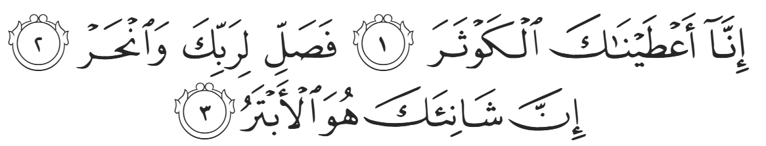
“Indeed, We have granted you abundant goodness. So pray and sacrifice to your Lord alone. Only the one who hates you is truly cut-off [ie, from any goodness]. (108:1-3)”
Indeed, the Prophet ﷺ’s followers, through his Ummah, have now numbered in the billions, each of whom send peace and blessings upon the Prophet multiple times a day. Meanwhile, the likes of Abu Jahl—a name which literally translates as “Father of Ignorance”—is only ever spoken about negatively and will continue to be so until the end of time. Allah’s promise is undoubtedly true, and He (SWT) is sufficient as a defender.
Before the Prophethood of Muhammad ﷺ, the Ka’bah was damaged by both a fire and a flood. At the time, the closest houses to the Ka’bah were a mere few meters away. A woman’s cooking pot caught on fire and spread to the cloth of the Ka’bah. The Ka’bah was damaged but not completely destroyed. Later that year, a big flood occurred. Because Mecca is located in the basin of numerous mountains, massive floods occur approximately every decade. The flood destroyed the roof of the Ka’bah as well as parts of the walls, especially because it was already damaged from the fire. The Quraysh decided that it must be rebuilt.
Meanwhile, the Christian Romans and Zoroastrian Persians continued to war. A church in Yemen was destroyed in the war, and the Caesar financed the rebuilding of the church with the highest quality marble and wood. Allah (SWT) decreed that a powerful storm damaged the ship containing the materials, forcing it to dock at Jeddah. The Romans were forced to sell their materials at Jeddah and return home. The Quraysh caught wind of this rare sale and pooled their funds to buy the materials as well as the services of the expert Roman carpenter onboard the ship.
After initial hesitations to knock down the sacred House of Allah, Al-Waliid ibn Al-Mughirah finally stepped up and swung the first blow. The next day, everybody else joined, and the Ka’bah was torn down and rebuilt. The Banu’ ‘Abd Manaaf were the most prestigious tribe and thus claimed the honor of rebuilding the side of the Ka’bah with the door. Their rivals, the Banu Makhzuum, claimed the side from the Yemeni corner to the Black Stone. As both walls meet at the Black Stone, both tribes demanded the right to place the Black Stone in the Ka’bah. The quarrelling escalated to the point that construction was halted for five days while they were in deadlock.
The Banu Makhzuum made a secret pledge that they would fight to the death before backing down, and even dipped their hands in blood to sign this pledge. On the fifth day, Abu Umayyah ibn Al-Mughiirah, the oldest person alive in Mecca, put a stop to the madness and forbade any further fighting. He suggested that they simply give the honor of placing the Black Stone to the first person who enters through the door, thus leaving the matter to “chance”. The person that walked in next was none other than that of our Prophet Muhammad ﷺ. Both tribes cheered upon seeing the Prophet ﷺwalk in, as he was loved by all. His integrity was recognized so much that it did not matter to them which tribe he belonged to. The Prophet ﷺ placed the Black Stone in a garment and ordered every tribe to send a representative to place the Black Stone in the Ka’bah in unison.
There is clear symbolism in the Ka’bah being destroyed and rebuilt five years before the Prophethood of Muhammad ﷺ; the religion of Ibraheem (AS) had been destroyed, and Muhammad ﷺ is coming to rebuild it again. The Ka’bah represents the religion of Ibraheem (AS), as well as the first House of Allah. The foundation (the ground and location) remains the same --- “I.E There is no God but Allah”, but the dressing -- the bricks-- are renewed (IE the faith of Islam). The Prophet ﷺ being chosen to save the tribes from civil war and bloodshed symbolizes him being chosen by Allah (SWT) to save them from misguidance and Hellfire.
<Conclude 1st Khutbah with:
Aqoolu haathaa wa astaghfir-Allaah (I say this and I ask Allah for forgiveness)
أَقُولُ قَوْلِي هَذَا وَأَسْتَغْفِرُ اللَّهَ لِي وَلَكُمْ وَلِسَائِرِ المُسْلِمينَ وَالمُسْلِمَاتْ فَاسْتَغْفِرُوهْ إِنَّهُ هُوَ الْغَفُورُ الرَّحِيمُ
الحمد لله رب العالمين والصلاة والسلام على سيد المرسلين وعلى آله وأصحابه أجمعين
<2nd Khutbah>
Dear brothers and sisters…
We will conclude the chapter on the Prophet ﷺ’s early adulthood by talking about his adopting of Zayd ibn Haarithah (RA).
Zayd ibn Haarithah was from a Yemeni tribe, descending from the Qahtani branch of Arabs, not the Adnaani branch. Zayd’s parents were from two different tribes in Yemen who would sometimes be in conflict. In one particular skirmish, his relatives from his father’s tribe kidnapped him, and sold him into slavery. He was sold in the Souk of Ukkaaz, the largest marketplace in pre-Islamic Arabia, to Hakiim ibn Hizaam, Khadijah’s nephew, on her behalf. When Khadijah married the Prophet ﷺ, she gifted Zayd to him, and he became the Prophet’s servant.
Over a decade had passed, and Zayd’s father, Haarithah, was still frantically looking for his son. One day, a man recognized Zayd’s Yemeni features and word eventually reached Haarithah, who then made his way to Mecca. He found the Prophet ﷺ (this was before his Prophethood), and said, “Oh Muhammad, grandson of ‘Abd al-Muttalib, you are a noble man of noble lineage, and you are from a people of trustworthiness.” He continued to praise the Prophet before requesting that he return his son. The Prophet ﷺ replied, “I will let Zayd decide. If he chooses you, I will return him without any ransom. But if he chooses me, then I can never turn away someone who has turned to me.” His father was overjoyed and praised the Prophet ﷺ for going above and beyond what was asked. The Prophet ﷺ had a genuine love and affinity for Zayd, and the laws of Jahiliyyah allowed him to refuse, but the Prophet’s morality was above the laws of Jahililyyah, even prior to his Prophethood.
He called Zayd, who by now was in his twenties, to decide. Zayd instantaneously chose the Prophet ﷺ, saying, “I can never choose anyone over you, for you are more than a father and uncle combined.” This response speaks to the Prophet ﷺ’s remarkable character—his warmth, fairness, and care were so profound that they inspired love stronger than blood – at a time when blood relations meant so much to the people. Haarithah grew exasperated and remarked, “Zayd, have you lost your mind? You prefer to remain a slave to a man who is not your kin rather than return to your own father, to your own tribe?!” Zayd responded, “I stick to my choice, for I have seen from this man that which prevents me from choosing anyone over him.”
Upon hearing his response, the Prophet ﷺ took Zayd to the Ka’bah and announced, “Oh people of Mecca, I want you all to testify that Zayd is a free man, and I have adopted him as my son. He will inherit from me, and I will inherit from him.” He became known henceforth as Zayd ibn Muhammad. Over 30 years later, ‘Abdullah ibn ‘Umar, the son of ‘Umar ibn al-Khattab (RMAA), recalled, “I never knew of any other name for Zayd other than Zayd ibn Muhammad until Allah (SWT) revealed verse five of Surah al-Ahzaab.” The verse states:
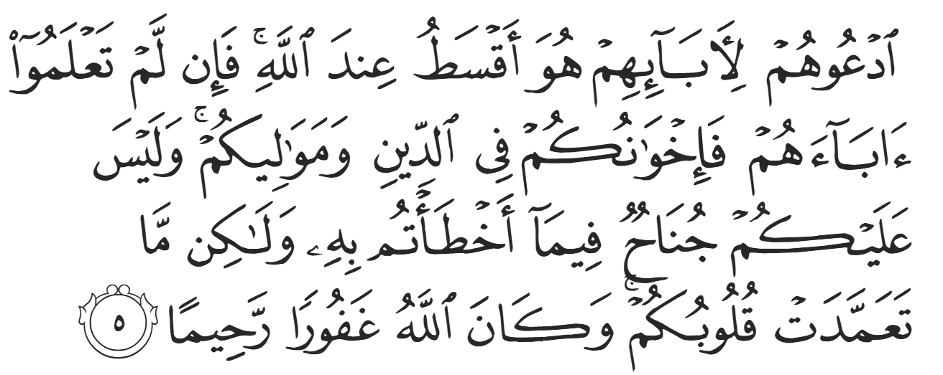
“Let your adopted children keep their family names. That is more just in the sight of Allah. But if you do not know their fathers, then they are ˹simply˺ your fellow believers and close associates. There is no blame on you for what you do by mistake, but ˹only˺ for what you do intentionally. And Allah is All-Forgiving, Most Merciful. (33:5)”
After being given this verse, the Prophet ﷺ then changed Zayd’s name back to Zayd ibn Haarithah.
Zayd was married to Umm Ayman, the servant of the Prophet’s mother, Aaminah. Their child was born in the house of the Prophet ﷺ--the famous Usaamah ibn Zayd (RA). Usaamah was so beloved to the Prophet ﷺ that whenever the Companions (RMAA) wanted something from the Prophet ﷺ, they would ask Usaamah to ask on their behalf. He was nicknamed “The Prophet’s beloved, son of the Prophet’s beloved”. When ‘Abdullah ibn ‘Umar (RA) asked his then-Khalifa father, ‘Umar ibn al-Khattab, why his salary was lower than that of Usaamah ibn Zayd, Umar responded, “Because he was more beloved to the Messenger of Allah ﷺ than you, and his father was more beloved to the Messenger of Allah ﷺ than yours (IE, ‘Umar himself)”.
The biggest blessing attributed to Zayd ibn Haaritah (RA) is that he is the only Companion ever to be mentioned in the Quran by name. This is in Surat Al-Ahzaab:
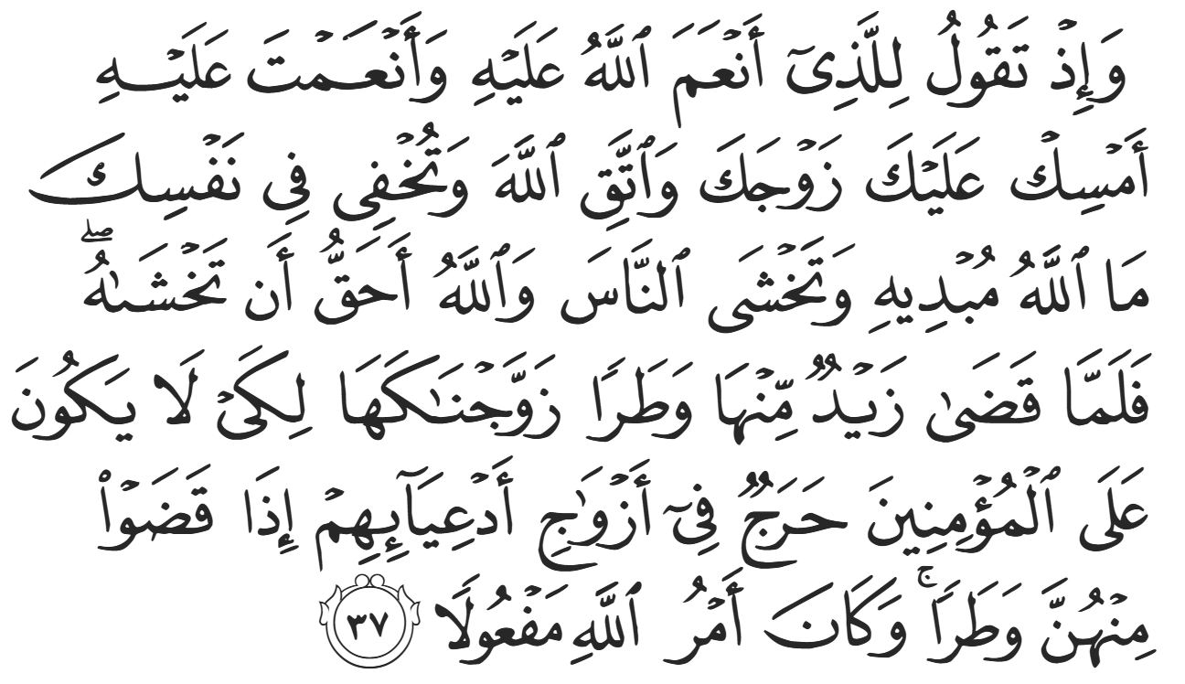
“And ˹remember, O Prophet,˺ when you said to the one for whom Allah has done a favor and you ˹too˺ have done a favor, “Keep your wife and fear Allah,” while concealing within yourself what Allah was going to reveal. And ˹so˺ you were considering the people, whereas Allah was more worthy of your consideration. So when Zayd totally lost interest in ˹keeping˺ his wife, We gave her to you in marriage, so that there would be no blame on the believers for marrying the ex-wives of their adopted sons after their divorce. And Allah’s command is totally binding. (33:37)”
The Prophet ﷺ’s best friend and closest companion, Abu Bakr (RA), was only ever mentioned in inference in the Qur’aan, not directly by name.
The Prophet ﷺ sent Zayd on at least ten expeditions, and he was the commander in each of them. No-one ever commanded Zayd, regardless of age, which demonstrates the high status given to him by the Prophet ﷺ. He was eventually martyred in the Battle of Mu’tah, a fierce battle against the Romans. Aaishah (RHAA) declared, “If Zayd had been alive when the Prophet ﷺ died, he would have been chosen [as Khalifa].”

<Duaa!>
- Oh Allah, please grant us a deep love for your Prophet Muhammad, SAW.
- Oh Allah, please make us energetic in doing good for your cause.
- Oh Allah, please enable us in will and means to walk Al-Sirrat-Al-Mustaqeem, even if it estranges us from others.
- Oh Allah, please support the suffering and oppressed Muslims around the world and grant them victory over that which oppresses them.
- Oh Allah, please protect us from ever being overburdened by debt and protect us from all evils and undesirable consequences associated to having debt.
- Oh Allah, please fill our hands with the work and deeds of righteousness and let them be of benefit to ourselves and the Ummah.
- Oh Allah please forgive us our shortcomings and deviances in following your Qur'an and the Sunnah of Rasul'Allah, SallAllahuAlayhiWaSallam.
- Oh Allah please grant us understanding and guidance of your Qur'aan
- Oh Allah, please grant us patience with the trials of this world.
- Oh Allah, please prevent our hearts from getting overly attached to the Dunya and grant us the best in this life and the best in the hereafter.
- Oh Allah, please forgive us our past sins and make us your devoted servants.
- Oh Allah please make us amongst those whose Duaa is accepted.
- Oh Allah, please grant us Jannat'ul Firdaus and protect us from ever coming close to the Fires of Jahannum.

