Khut'bah Opening
إِنَّ الْحَمْدَ للهِ , نَحْمَدَهُ وَ نَسْتَعينُهُ وَ نَسْتَغْفِرُهُ , وَ نَعوذُ بِالله مِنْ شُرورِ أَنْفُسِنا , مَن يَهْدِهِ اللهُ فَلا مُضِلَّ لَه , وَ مَنْ يُضِلِلْ فَلا هادِيَ لَهْ , وَ أَشْهَدُ أَنْ لا إلهَ إِللهُ وَحْدَهُ لا شَريكَ لَه , و أَشْهَدُ أنَّ مُحَمَّدًا عَبْدُهُ و رَسولُه.
"All thanks and praises are due to Allah, whom we thank, seek for help and invoke for forgiveness. We seek refuge with Allah from the evils within ourselves. He whom Allah guides will never be misled and he whom He misguides will never find one to guide him. I bear witness that there is no deity worthy of worship except Allah and that Muhammad (SAW) is His slave and Messenger.
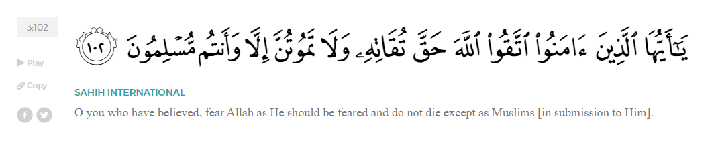
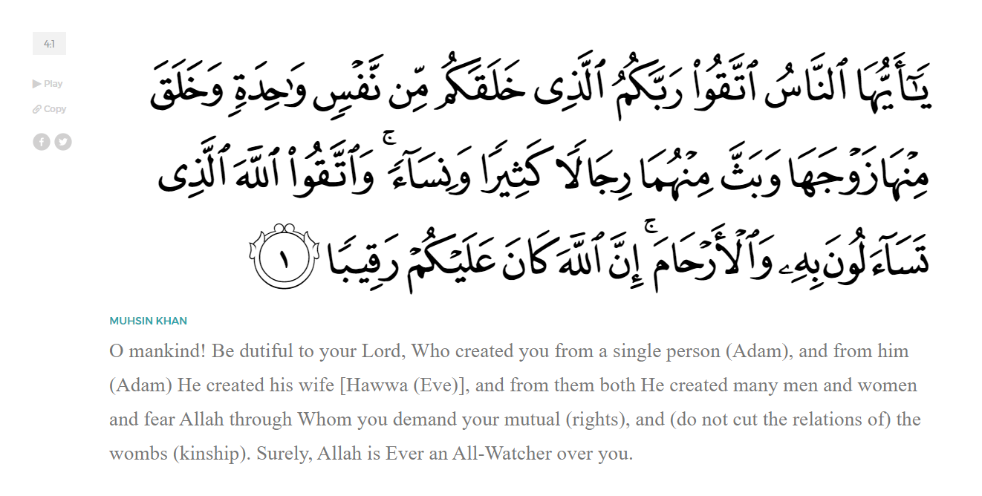
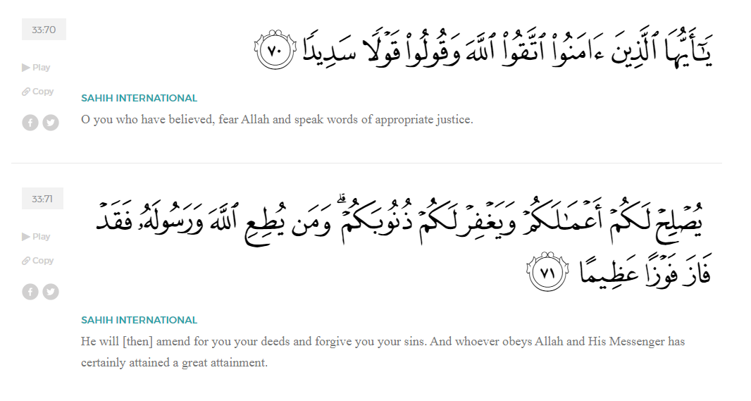
<Sirah of the Prophet (SAW) – Part 7 -Dr. Yassir Qadhi, Book and Series>
Dear brothers and sisters,
InshaaAllah we will continue our khutbah series on the seerah of the Prophet ﷺ, drawing from Dr. Yasir Qadhi’s book, The Sirah of the Prophet, so that we can deepen our understanding of his life and strengthen our love for him. Each step we take through the Prophet ﷺ’s life brings us closer to knowing him more deeply, appreciating his struggles, and embodying his character. Our goal in this series, inshaaAllah, is not just to learn history, but to let the seerah transform our hearts and strengthen our love for the Messenger of Allah ﷺ.
Today we will, inshaaAllah, cover the chapter titled, “The Revelation”.
Prior to the Revelation, the Prophet ﷺ would frequently seclude himself in Cave Hira, a crevice within a mountain on the outskirts of Mecca. He would remain for increasingly long periods, only returning to tend to his duties and collect food and water. The crevice is perfectly carved out in the mountain for one person to reflect and contemplate with a view overlooking the Ka’bah.
During this period, miraculous things would begin to occur. He ﷺ would hear salaam, but not see anyone, only to realize it was coming from the rocks and stones. He ﷺ recalled to the Companions, “I know of a stone in Mecca which would give me salaam”.
The Prophet ﷺ would also receive premonitions in his dreams that would come true the following day. These dreams continued daily for six whole months. We know that the Revelation began in Ramadan. The Qur’aan states in Surat Al-Qadr:

“Indeed, We sent it [I.E. the Qur’an] down during the Night of Decree.”(Al Qadr:1)
This means that the visions began in Rabi’ al-Awwal and continued for six months. During this time, The Prophet ﷺ grew worried and informed Khadjiah (RHAA) about his dreams, but his closest confidant and loving wife duly reassuring him that these visions were glad tidings.
On a Saturday during Ramadan in Cave Hira, The Prophet ﷺ saw a light and heard a sound, but nothing came of it. The same thing occurred the next day; he saw a light and heard a sound. The following day, on a Monday, Jibril (AS) appeared. When the Prophet ﷺ was later asked why he fasts on Mondays, he ﷺ said, “I was born on Monday, and the Revelation began on Monday.”
The Angel Jibril (AS) came to him and said, “Read! (Iqra’!)” The Prophet ﷺ replied, “I cannot read.” Jibril (AS) then grabbed him and squeezed him so tightly that the Prophet ﷺ lost all energy. Jibril (AS) again demanded, “Read! (Iqra’!)” And the Prophet ﷺ again replied, “I cannot read.” Jibril (AS) squeezed him again a second time with the same vigor and force. For the third time, Jibril (AS) said, “Read! (Iqra’!)” This time, he continued with the first verses of the Qur’an ever to be revealed, in Surat Al-Alaq:
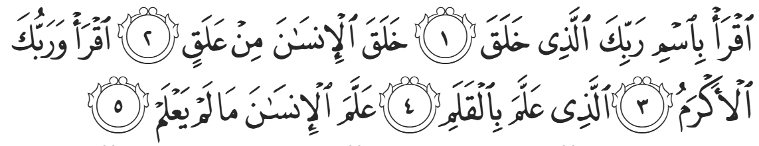
“Read in the name of your Lord Who created; [He] created humans from a clinging clot. Read! And your Lord is the Most Generous, Who taught by the pen; [He] taught humanity what they know not. (96:1-5).”
Scholars have discussed why Jibril (AS) squeezed the Prophet ﷺ, and why he did it so tightly. There is no definitive answer, but some assert that it was done to show the Prophet ﷺ that he was not dreaming, and that this was indeed reality. Others suggest that Jibril (AS) was indicating to the Prophet ﷺ that he was about to receive a weighty inspiration; Surat al-Muzzammil states:
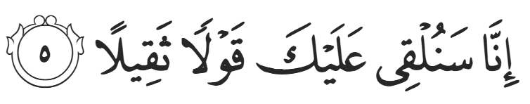
“We will soon send upon you a weighty Revelation” (73:5)
Some scholars opt for a more symbolic explanation, stating that the three squeezes refer to three major trials the Prophet ﷺ would experience but ultimately survive. They are: The Meccan Boycott, the assassination attempt and resulting hijrah (migration), and the battle of Uhud, all events we’ll discuss in future khutbahs inshaa’Allah.
The word iqra’ has two linguistic meanings: to read, and to recite from memory. When Jibril (AS) commanded “Iqra’!”, the Prophet ﷺ understood the former i.e., to read, so he responded, “I cannot read” because he ﷺ was unlettered, illiterate. Jibril (AS) intended the latter, as the recitation will be in the Name of Allah (SWT). Jibril (AS) responded “Iqra’ bi ismi Rabbika Al-Ladhi Khalaq”. The bi is commonly translated as “in” i.e., in the Name of your Lord, however it can also mean “by”, so, “Read, by the name of your Lord”. i.e., by Allah’s help and permission. Allah (SWT) then ends the first sentence with “created” because He created everything.
He (SWT) specifies in these verses that the Creator of everything created mankind. This magnificent Creator is commanding you to recite. Iqra’ is then repeated intentionally, as it means “keep reciting” i.e., keep spreading the Message, no matter what. Some scholars add that the first iqra’ is for knowledge of the Qur’aan, and the second is for knowledge of this world, which is why the verse following the second instance is “Who taught by the pen; taught humanity what they know not.”
After this event, the Prophet ﷺ raced back to Khadjiah (RHAA) with a palpitating heart. As he entered the door he exclaimed, “Cover me up, cover me up!” This clearly shows how unexpected the whole event was for the Prophet ﷺ. Moreover, it demonstrates his sincerity and humanity; he did not know what had just occurred and returned to his wife terrified. This was clearly not a premeditated ploy to claim Prophethood for worldly gain. Khadijah (RHAA) calmed him down and asked him what was wrong.
The Prophet ﷺ told her, “I am worried for myself.” This statement has led to strange interpretations about what the noble Messenger ﷺ intended, such as him doubting his sanity. The more credible and sensible explanations are that either he feared for his safety due to the intensity of the squeezes, or that he ﷺ was scared about seeing things other humans could not.
Solidifying her role as an emotional rock, Khadjiah (RHAA) responded, “No, by Allah, Allah will never cause you harm; you are good to your kin, take on the burdens of others, give charity to the needy, are hospitable to guests, and you carry out all types of good.” Khadijah (RHAA) eloquently encapsulated the character of the Prophet ﷺ and then espoused the unequivocal principle that whoever does good by Allah (SWT), will have Allah (SWT) do good by them.

<Conclude 1st Khutbah with:
Aqoolu haathaa wa astaghfir-Allaah (I say this and I ask Allah for forgiveness)
أَقُولُ قَوْلِي هَذَا وَأَسْتَغْفِرُ اللَّهَ لِي وَلَكُمْ وَلِسَائِرِ المُسْلِمينَ وَالمُسْلِمَاتْ فَاسْتَغْفِرُوهْ إِنَّهُ هُوَ الْغَفُورُ الرَّحِيمُ
الحمد لله رب العالمين والصلاة والسلام على سيد المرسلين وعلى آله وأصحابه أجمعين
<2nd Khutbah>
Dear brothers and sisters,
After the event, Khadijah (RHAA) went to ‘Addas, her uncle’s Christian slave. After hearing what happened, he exclaimed, “What?! An Angel of Allah in this heathen place of idols?”
Khadijah (RHAA) then went to Waraqah ibn Nawfal, her cousin and one of the only Hunafaa’ remaining in Mecca. Waraqah replied, “By Allah, this is the Keeper of Secrets who came down to Musa.”. Musa (AS) was mentioned rather than Isa (AS) because Waraqah correctly predicted that Muhammad’s Prophethood ﷺ would resemble that of Musa (AS) more, as they both had political power and established laws, while the Message of Isa (AS) was spiritual. Waraqah continued and said, “How I wish I were a young man so I could help you when your nation ridicules, persecutes, and expels you.” The Prophet ﷺ asked in disbelief, “My nation will expel me?” Waraqah replied in the affirmative, saying, “Yes. Never has a Prophet been sent except that his people ridicule, persecute, and expel him.” Waraqah then passed away a short while after this conversation.
It may sound peculiar for a Prophet to ask a non-Prophet for guidance, but at this moment the Prophet had not yet digested and internalized the implications of what had occurred. The Arabs of Mecca were not familiar with the concept of Prophethood whereas the Jews and Christians had a long history of Prophethood.
A few months passed without Revelation or Jibril’s presence at all. The Prophet ﷺ would wander around the valleys of Mecca and revisit Cave Hira expecting to see him, but to no avail. This continued until one day, the Prophet ﷺ suddenly saw him again. The Prophet’s name was called, but he could not see anyone. The Prophet ﷺ looked left and right, but could not see anyone until he finally looked up and saw Jibril (AS). The Prophet ﷺ said, “I saw the same Angel I saw in Cave Hira. He was sitting on a throne that was both in the Heavens and the Earth. I began to tremble and palpitate and rushed back to Khadijah again, saying “زَمِّلُونِي زَمِّلُونِي ‏ -- Cover me, cover me.”
That is when Jibril (AS) came with the second Revelation in the form of Surah al-Muddatthir:
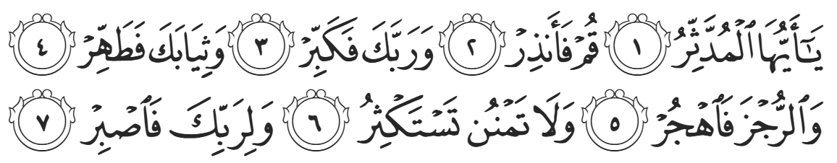
“Oh you covered up, arise and warn. Revere your Lord [alone]. Purify your garments. Shun all idols. Do not do a favor expecting more [in return]. And persevere for the sake of your Lord.” (74:1-7)
The symbolism is clear: Oh you wrapped up in comfort, discard the cloak; stand up and be active. Purify your garments physically, but more important spiritually. Do not put your hopes and expectations in the hands of men, but rather, rely on Allah (SWT).
Some scholars note that with the first revelation—“Read”—he ﷺ became a Prophet, and with the second revelation—“Arise and warn”—he ﷺ became a Messenger. As for the difference between a Prophet and a Messenger, there are numerous scholarly opinions. Some state that they are synonymous, however Allah states in the Qur’aan, “Whenever We sent a Messenger, or Prophet, before you…” (Hajj:52), which clearly indicates a difference.
Moreover, another Hadith states that there have been 313 Messengers as opposed to 124,000 Prophets. Another scholarly opinion is that a Messenger has a new Shariah—a code of Allah—whereas a Prophet follows the Shariah of a previous Messenger. However, Dawood and Sulaymaan are examples of Messengers that followed a previous Messenger’s Shariah (that of Musa). Imam Ibn Taymiyyah submits the opinion that a Prophet is sent to a believing nation to renew and correct their faith, whereas a Messenger is sent to an unbelieving nation. Linguistically, the word Nabiyy (Prophet) is derived from the word naba’a-yanba’u (to inform), and Rasul (messenger) is from arsala-yursilu (to send). This definition is most plausible and correlated with all the Qur’anic verses describing the previous Prophets and Messengers.
We will conclude the chapter by talking about the Forms of Revelation.
Wahy (Revelation) is a direct communication from Allah (SWT) to mankind. Imam Ibn Qayyim mentions that our Prophet ﷺ was inspired through wahy in seven different ways. The lowest from of Revelation is true dreams. Dreams can be categorized in three ways: regular dreams resulting from daily activity or thinking; dreams from the Shaytaan; and dreams from Allah. The third type is characterized through its content as well as being able to vividly remember them.
The second form of Revelation is ilhaam, whisperings from an Angel other than the Archangel Jibril (AS). An example of this form of Revelation is the mother of Musa being inspired by Allah (SWT) to part with her baby. The Qur’aan states in Surat Al-Qasas:
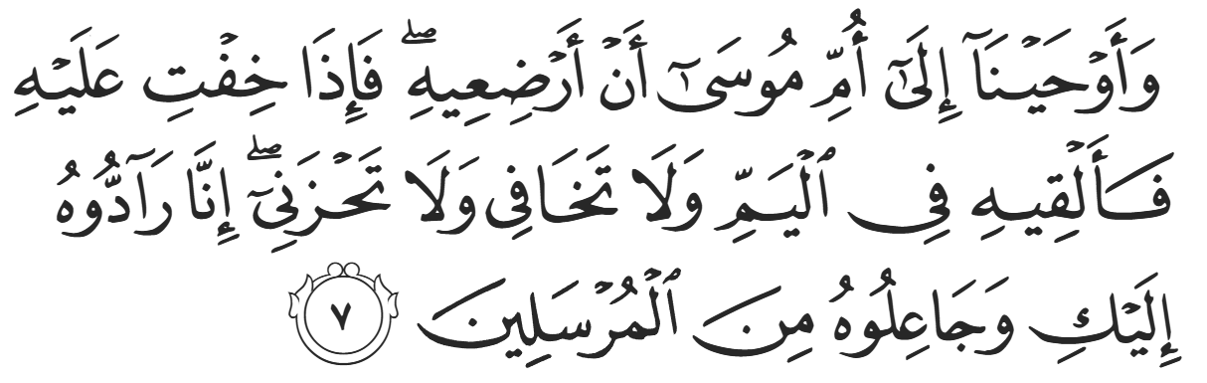
“We inspired the mother of Musa, ‘Nurse him, but when you fear for him, put him into the river, and do not fear or grieve. We will certainly return him to you and make him one of the Messengers.” (28:7)
The third form of Revelation is to speak to an Angel directly but in human form. When Jibril (AS) would usually reveal himself to the Prophet ﷺ, he would do so in the form of a human. In Medina, Jibril (AS) would often take the form of Dihyah al-Kalbi (RA), a Companion known for his beauty. Sometimes he would appear in the form of an unknown man. ‘Umar (RA) once recalled, “We were sitting with the Messenger of Allah when a man walked towards us with extremely white clothes, extremely black hair, and no dust on him from travelling. We all looked at each other [as if to say] we do not know this man and he does not look like a traveler…” The Prophet ﷺ then informed ‘Umar that it was indeed Jibril (AS).
The fourth form is for Jibril (AS) to communicate the Revelation through an intense noise. When this would happen, the Prophet ﷺ would enter some sort of a trance. Jibril (AS) would not be seen by anybody else, but in this trance the Prophet ﷺ would somehow communicate with Jibril (AS) and remember the words upon his waking. A’aishah (RHAA) stated multiple times that when Jibril (AS) would visit the Prophet ﷺ and bring revelation, the Prophet ﷺ would break into a sweat even on the coldest day. When Surah Al-Maaidah was revealed, the Prophet ﷺ was on a camel. The revelation was so heavy that the camel was forced to sit down due to the pressure and weight. Al-Haarith ibn Hishaam (RA) asked the Prophet ﷺ how he received Revelation. The Prophet ﷺ replied, “Sometimes, Jibril communicates with me in a form resembling the ringing of a bell, and this is the most difficult state for me. After it ends, I become aware of what was said. Sometimes he would come in the form of a man, and I would understand what he says.”
The fifth form is to communicate with Jibril ﷺ in his original form. This is what occurred in the two previously mentioned cases of verses from Surah Al-‘Alaq and Surah Al-Muddaththir being revealed. Jibril ﷺ was in his true Angel form on both occasions, which overwhelmed the Prophet ﷺ.
The sixth form is when Allah (SWT) inspires a Prophet without an intermediary Angel.
The seventh form—the highest form of Revelation—is Allah (SWT)’s direct Speech. This has only ever occurred once, namely in Al-Israa wa Al-Mi’raj – I.e. the Night Journey and Ascension. The Prophet ﷺ journeyed to the Heavens and spoke to Allah (SWT) directly, without the presence of Jibril (AS) or anyone else. The Prophet ﷺ is the only person to be granted the highest honor of speaking to Allah (SWT) without any barrier.

<Duaa!>
- Oh Allah, please grant us a deep love for your Prophet Muhammad, SAW.
- Oh Allah, please make us energetic in doing good for your cause.
- Oh Allah, please enable us in will and means to walk Al-Sirrat-Al-Mustaqeem, even if it estranges us from others.
- Oh Allah, please support the suffering and oppressed Muslims around the world and grant them victory over that which oppresses them.
- Oh Allah, please protect us from ever being overburdened by debt and protect us from all evils and undesirable consequences associated to having debt.
- Oh Allah, please fill our hands with the work and deeds of righteousness and let them be of benefit to ourselves and the Ummah.
- Oh Allah please forgive us our shortcomings and deviances in following your Qur'an and the Sunnah of Rasul'Allah, SallAllahuAlayhiWaSallam.
- Oh Allah please grant us understanding and guidance of your Qur'aan
- Oh Allah, please grant us patience with the trials of this world.
- Oh Allah, please prevent our hearts from getting overly attached to the Dunya and grant us the best in this life and the best in the hereafter.
- Oh Allah, please forgive us our past sins and make us your devoted servants.
- Oh Allah please make us amongst those whose Duaa is accepted.
- Oh Allah, please grant us Jannat'ul Firdaus and protect us from ever coming close to the Fires of Jahannum.

