Khut'bah Opening
إِنَّ الْحَمْدَ للهِ , نَحْمَدَهُ وَ نَسْتَعينُهُ وَ نَسْتَغْفِرُهُ , وَ نَعوذُ بِالله مِنْ شُرورِ أَنْفُسِنا , مَن يَهْدِهِ اللهُ فَلا مُضِلَّ لَه , وَ مَنْ يُضِلِلْ فَلا هادِيَ لَهْ , وَ أَشْهَدُ أَنْ لا إلهَ إِللهُ وَحْدَهُ لا شَريكَ لَه , و أَشْهَدُ أنَّ مُحَمَّدًا عَبْدُهُ و رَسولُه.
"All thanks and praises are due to Allah, whom we thank, seek for help and invoke for forgiveness. We seek refuge with Allah from the evils within ourselves. He whom Allah guides will never be misled and he whom He misguides will never find one to guide him. I bear witness that there is no deity worthy of worship except Allah and that Muhammad (SAW) is His slave and Messenger.
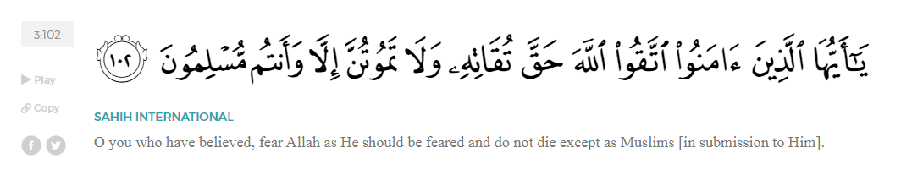
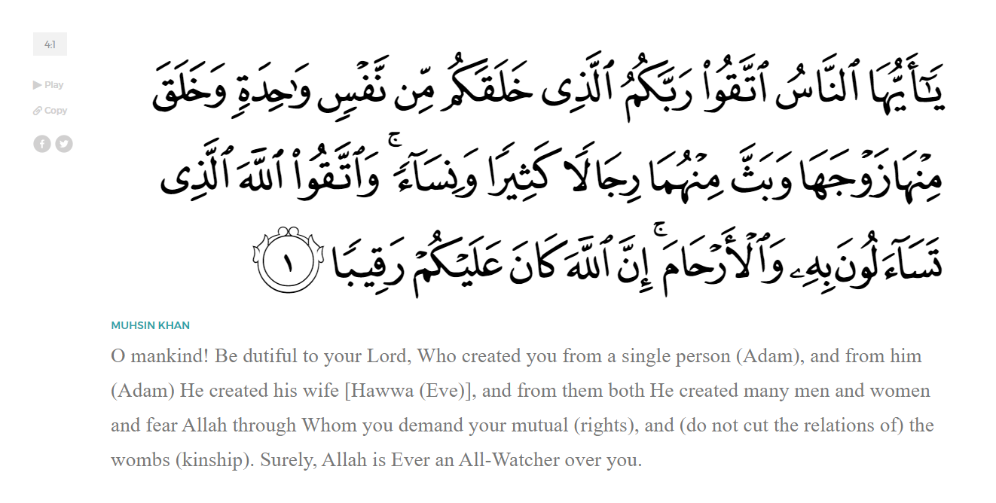
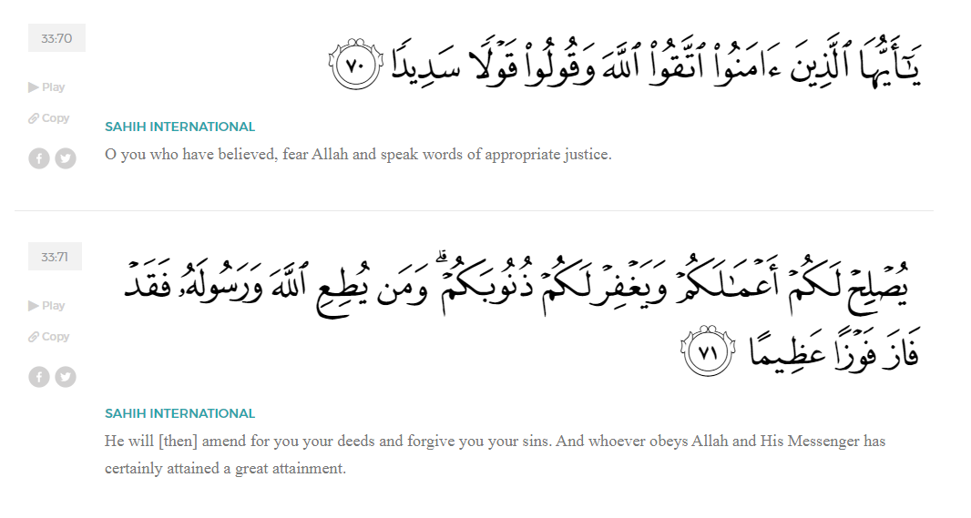
<Sirah of the Prophet (SAW) – Part 8 -Dr. Yassir Qadhi, Book and Series>
Dear brothers and sisters,
InshaaAllah we will continue our khutbah series on the seerah of the Prophet ﷺ, drawing from Dr. Yasir Qadhi’s book, The Sirah of the Prophet, so that we can deepen our understanding of his life and strengthen our love for him. Each step we take through the Prophet ﷺ’s life brings us closer to knowing him more deeply, appreciating his struggles, and embodying his character. Our goal in this series, inshaaAllah, is not just to learn history, but to let the seerah transform our hearts and strengthen our love for the Messenger of Allah ﷺ.
Today we will, inshaaAllah, start with the chapter titled Early Islam, beginning with the First Converts.
In the earliest days of Prophethood, immediately following the Revelation of:

“Arise and Warn”, the Prophet ﷺ would preach to his family and closest friends. An argument can be made for Khadijah (RHAA) being the first convert to Islam, as she believed in the Prophet ﷺ before even knowing what had truly happened, demonstrating her unwavering faith. As such, Waraqah ibn Nawfal (RA) would be the second to convert despite never uttering the shahadah. Scholars differ over the third convert to Islam; some say Abu Bakr Al-Siddiq, some say ‘Ali ibn Abi Taalib, and some say Zayd ibn Haaritha (RMAA). The way the scholars reconcile all these opinion is to say: Khadijah (RHAA) was the first women to accept Islam, Abu Bakr (RA) was the first free man to accept Islam, ‘Ali (RA) was the first child to accept Islam, and Zayd (RA) was the first freed slave to accept Islaam.
There is, however, no dispute regarding the status of Abu Bakr al-Siddiq (RA). The Ummah of Islaam is unanimous in championing Abu Bakr as the best of all Companions. The Prophet ﷺ said, “Allah has chosen me as a Khalil – a close friend – so I am not allowed to choose a Khalil, but if I were allowed, I would choose Abu Bakr.”
Once, when Abu Bakr and ‘Umar (RMAA) had an argument, the Prophet ﷺ said to ‘Umar (RA), “When Allah sent me with the Truth, all of you accused me of being a liar, and it was only Abu Bakr who believed me. So won’t you leave my Companion alone?!” On another occasion, he ﷺ said, “There was not a single man whom I invited to Islam except that he had some doubts before converting, except for Abu Bakr, for as soon as I presented [Islam to him], he did not hesitate before accepting.”
Abu Bakr (RA) was indirectly referenced in the Qur’an in Surat At-Tawbah:
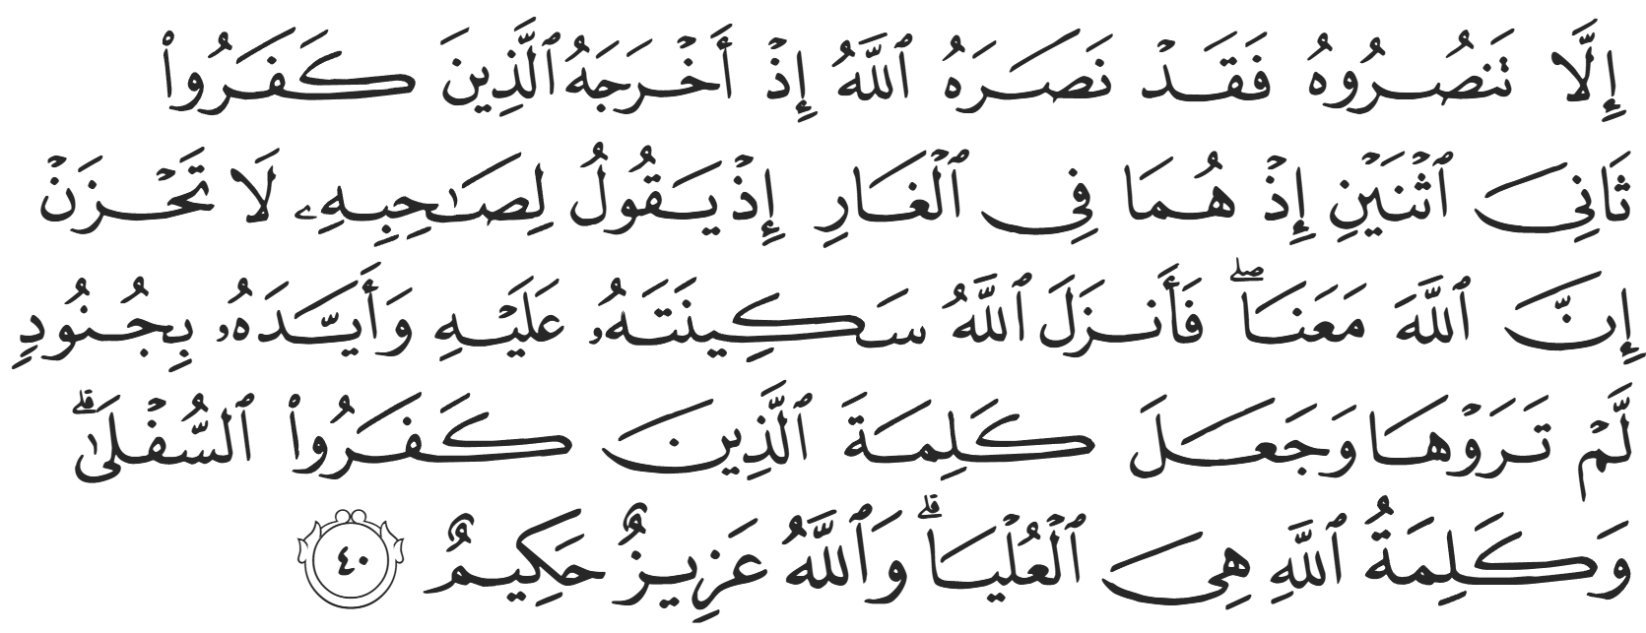
“[It does not matter] if you do not support him, for Allah did in fact support him when the disbelievers drove him out [of Mecca] and he was only one of two.” This is in reference to the Prophet ﷺ and Abu Bakr (RA) hiding in the cave, moments away from capture and death while emigrating to Medina. The verse continues, “While they were both in the cave, he reassured his Compaion, ‘Do not worry, for Allah is certainly with us.’” Allah (SWT) refers to Abu Bakr as the Prophet’s Companion, which is indeed sufficient praise. And the verse finishes. “So Allah sent down His serenity upon him, supported him with forces you ˹believers˺ did not see, and made the word of the disbelievers lowest, while the Word of Allah is supreme. And Allah is Almighty, All-Wise.” (9:40)
The next batch of converts all accepted Islam at the hand of Abu Bakr (RA), further reinforcing his status in Islam and his integral role as the Prophet’s helper. They were Sa’d ibn Abi Waqqas, Uthmaan ibn ‘Affan, Zubayr ibn al-Awwaam, and Abdurrahman ibn Awf (RMAA). Sa’d ibn Abi Waqqas was the youngest at around 16 years of age. His faith was so strong that he remained steadfast despite his mother’s severe emotional blackmail. She went on a hunger strike, vowing to not eat or drink unless Sa’d would renounce his faith and return to idol worship; her health deteriorated until she began withering away. Sa’d finally said, “Oh my mother, I will never renounce Islaam. Even if you had one thousand lives, I would let you lose them one after the other before renouncing my faith.” Only upon witnessing such unwavering faith did she realize her efforts were futile and so began eating and drinking again. Allah (SWT) revealed verses of Qur’an in response to this event in Surat Luqman:
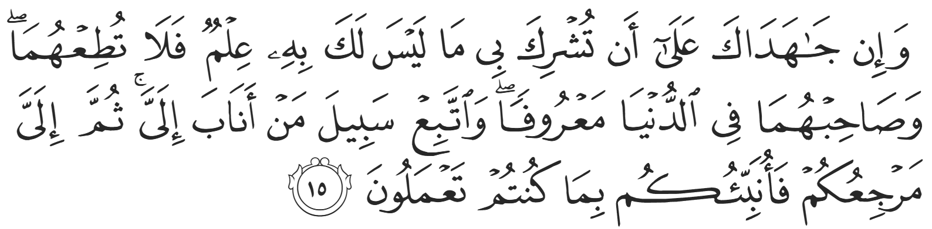
“But if they pressure you to associate with Me what you have no knowledge of, do not obey them. But keep their company in this world courteously, and follow the way of those who turn to Me [in devotion]. Then to Me you will ˹all˺ return, and then I will inform you of what you used to do.” (31:15)
‘Uthmaan ibn ‘Affaan (RA) was one of the Prophet’s closest friends. The Prophet ﷺ said, “Even the Angels are shy in his presence.” He went on to become the third Khalipha in Islaam and will be mentioned in future khutbahs inshaaAllah.
Zubayr ibn al-‘Awwam (RA) is a direct cousin of the Prophet ﷺ , his mother being Safiyyah bint ‘Abd al-Muttalib. The Prophet ﷺ once said, “Every Prophet has his disciples, and my disciple is Zubayr ibn al-Awwam.”.
‘Abdurrahman ibn Awf (RA) was the oldest of these four converts. When he emigrated to Medina, he left behind all his possessions and did so with no money or belongings. One of the Ansaar (the Helpers) in Medina famously said, “I have two wives and two gardens. I will divorce one wife for you and give you one garden.” ‘Abdurrahman ibn ‘Awf replied, “May Allah bless you. Just direct me towards the marketplace.” In no time, his entrepreneurial nature led him to be of the wealthiest businessmen in Medina, serving the Prophet ﷺ in every way he could. Each of these early converts became giants in the Muslim Ummah, leading prominent lives in Islaam and playing pivotal roles in the growth and development of Islamic society.
<Conclude 1st Khutbah with:
Aqoolu haathaa wa astaghfir-Allaah (I say this and I ask Allah for forgiveness)
أَقُولُ قَوْلِي هَذَا وَأَسْتَغْفِرُ اللَّهَ لِي وَلَكُمْ وَلِسَائِرِ المُسْلِمينَ وَالمُسْلِمَاتْ فَاسْتَغْفِرُوهْ إِنَّهُ هُوَ الْغَفُورُ الرَّحِيمُ
الحمد لله رب العالمين والصلاة والسلام على سيد المرسلين وعلى آله وأصحابه أجمعين
<2nd Khutbah>
Dear brothers and sisters, we will conclude this khutbah talking about the next batch of the early converts to Islaam inshaaAllah.
The next to convert after the 4 previously mentioned was ‘Abdullah ibn Mas’ud (RA). He was the first prominent figure not from a noble class to convert. He was not a slave, but he was of the servant class. He was hired as a shepherd for ‘Uqbah ibn Abi Mu’ayt, a severe enemy of Islam. One day, the Prophet ﷺ was travelling with Abu Bakr (RA) and as they passed by a farm, they said to Ibn Mas’ud, “Oh young man, we are thirsty. Can you give us some milk?” Ibn Mas’ud, demonstrating his honesty and integrity early on replied, “I cannot because it is not mine to give.” The Prophet ﷺ said, “Very well. Show us one of the elderly she-goats that has stopped giving milk.” Ibn Mas’ud pointed to one and the Prophet ﷺ went to the goat, made du’aa, and its udder filled until it was full, so the two of them drank. In his astonishment, Ibn Mas’ud asked who he was talking to, and after introducing himself as a Prophet, Ibn Mas’ud converted on the spot, becoming the sixth to convert to Islam. The Prophet ﷺ once said about Ibn Mas’ud, “Whoever would like to know how to recite the Qur’an properly as it was originally revealed, should read according to the recitation of Ibn Umm ‘Abd (IE. Ibn Mas’ud).” Ibn Mas’ud once said, “I learned more than 70 surahs directly from the mouth of the Prophet ﷺ”.
The next batch of converts primarily comprised the slave class of Mecca. The most famous of them were Bilal ibn Rabaah, Khabbab ibn al-Aratt, and Yaasir ibn Aamir, alongside his wife Sumayyah bin Khayyat, and their son ‘Ammar ibn Yaasir. Later, when the Prophet ﷺ wrote to the Byzantine Emperor, Heraclius, the Emperor quizzed Abu Sufyaan, the Prophet’s enemy at the time before he converted to Islam. One of the emperor’s questions were, “Who are his followers? Are they the rich and powerful or the weak and downtrodden?” Abu Sufyaan replied that the latter was true, and Heraclius responded, “This is a sign of a true faith; that the first people who accept are the weak and downtrodden.”
The rich and powerful always have more to lose by the changing of the status quo. They are also more embedded in their own philosophies and traditions. The poor, on the other hand, have less attachment to this dunya – this world.
The first non-Meccan convert to Islaam was ‘Amr ibn ‘Abasa, a Yemeni Arab. He recalled, “I always knew that idolatry was wrong. One day, news came to me that someone in Mecca was preaching the same, so I travelled all the way from Yemen to Mecca to meet him.” ‘Amr found the Prophet ﷺ who had not yet publicly disclosed his Prophethood. After conversing, ‘Amr asked, “What are you?” To which the Prophet ﷺ replied, “I am a Messenger.” ‘Amr asked to join the Prophet ﷺ but the Prophet ﷺ did not allow for it, for the da’wah was too weak and ‘Amr would have no protection. The Prophet ﷺ then said, “Return home, and when news reaches you that I am victorious, come back.” The Prophet ﷺ demonstrated his firm belief at the earliest stage of his Prophethood. Over 15 years later when the Muslims entered Medina, ‘Amr delivered on his promise and reunited with the Prophet ﷺ.
This event shows that the Message was preached in stages. When ‘Amr ibn ‘Abasa asked the Messenger of Allah ﷺ what his Message was, he ﷺ replied, “To fulfill the ties of kinship, to be good to one’s family, and to break all idols so that only Allah (SWT) be worshipped.” At this stage, neither prayer nor fasting, nor the Hajj pilgrimage were prescribed. As the da’wah did not have any political implications at this point, it did not cause major tensions with the Quraysh, even when they heard rumors.
We will talk more about the other stages of da’wah in the next khutbah inshaaAllah.
Allah (SWT) tells us in Surat Ali ‘Imraan:
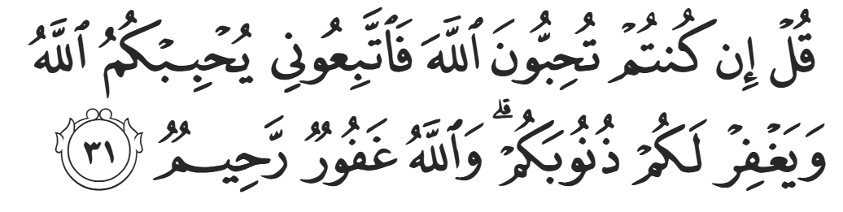
“Say, ˹O Prophet,˺ ‘If you ˹sincerely˺ love Allah, then follow me; Allah will love you and forgive your sins. For Allah is All-Forgiving, Most Merciful.’” (3:31)
Let us make Duaa inshaaAllah:
<Duaa!>
- Oh Allah, please grant us a deep love for your Prophet Muhammad, SAW.
- Oh Allah, please make us energetic in doing good for your cause.
- Oh Allah, please enable us in will and means to walk Al-Sirrat-Al-Mustaqeem, even if it estranges us from others.
- Oh Allah, please support the suffering and oppressed Muslims around the world and grant them victory over that which oppresses them.
- Oh Allah, please protect us from ever being overburdened by debt and protect us from all evils and undesirable consequences associated to having debt.
- Oh Allah, please fill our hands with the work and deeds of righteousness and let them be of benefit to ourselves and the Ummah.
- Oh Allah please forgive us our shortcomings and deviances in following your Qur'an and the Sunnah of Rasul'Allah, SallAllahuAlayhiWaSallam.
- Oh Allah please grant us understanding and guidance of your Qur'aan
- Oh Allah, please grant us patience with the trials of this world.
- Oh Allah, please prevent our hearts from getting overly attached to the Dunya and grant us the best in this life and the best in the hereafter.
- Oh Allah, please forgive us our past sins and make us your devoted servants.
- Oh Allah please make us amongst those whose Duaa is accepted.
- Oh Allah, please grant us Jannat'ul Firdaus and protect us from ever coming close to the Fires of Jahannum.

