Khut'bah Opening
إِنَّ الْحَمْدَ للهِ , نَحْمَدَهُ وَ نَسْتَعينُهُ وَ نَسْتَغْفِرُهُ , وَ نَعوذُ بِالله مِنْ شُرورِ أَنْفُسِنا , مَن يَهْدِهِ اللهُ فَلا مُضِلَّ لَه , وَ مَنْ يُضِلِلْ فَلا هادِيَ لَهْ , وَ أَشْهَدُ أَنْ لا إلهَ إِللهُ وَحْدَهُ لا شَريكَ لَه , و أَشْهَدُ أنَّ مُحَمَّدًا عَبْدُهُ و رَسولُه.
"All thanks and praises are due to Allah, whom we thank, seek for help and invoke for forgiveness. We seek refuge with Allah from the evils within ourselves. He whom Allah guides will never be misled and he whom He misguides will never find one to guide him. I bear witness that there is no deity worthy of worship except Allah and that Muhammad (SAW) is His slave and Messenger.
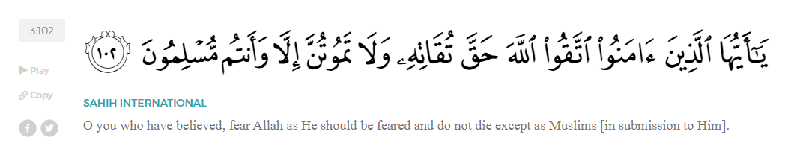
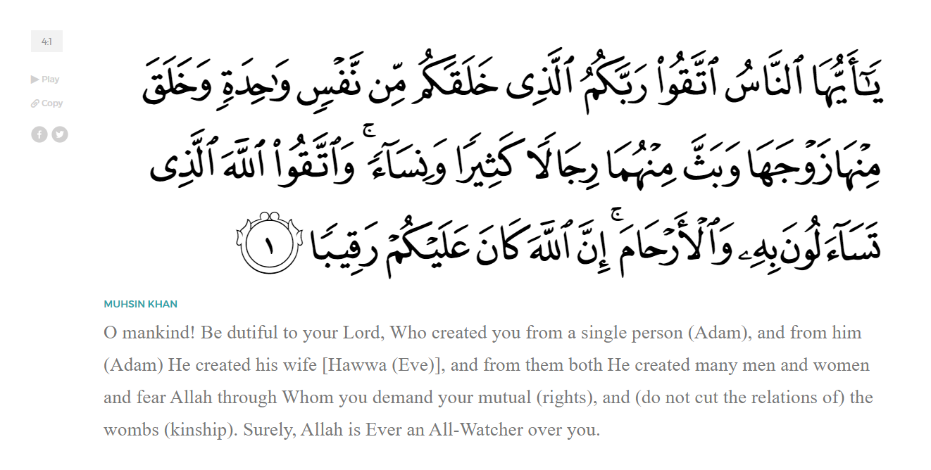
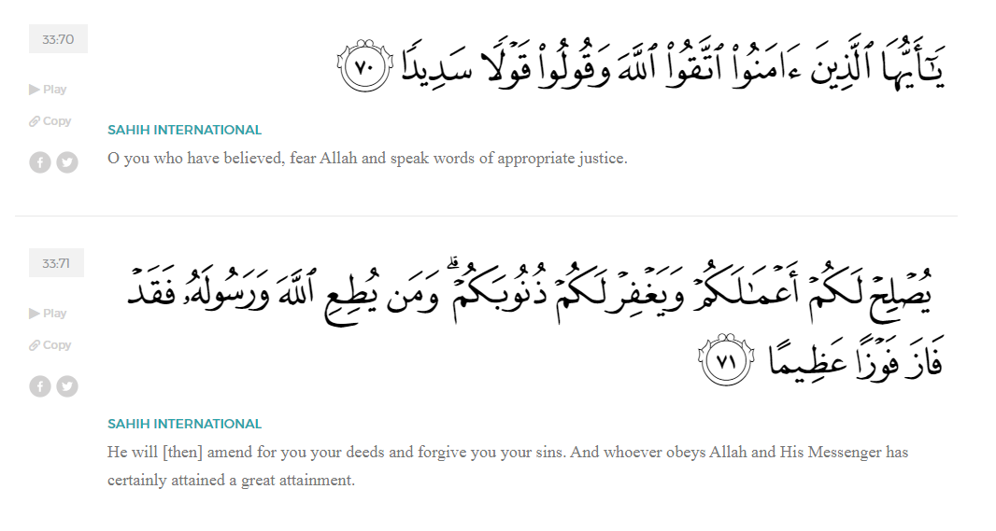
<Sirah of the Prophet (SAW) – Part 9 -Dr. Yassir Qadhi, Book and Series>
Dear brothers and sisters,
InshaaAllah we will continue our khutbah series on the seerah of the Prophet ﷺ, drawing from Dr. Yasir Qadhi’s book, The Sirah of the Prophet, so that we can deepen our understanding of his life and strengthen our love for him. Each step we take through the Prophet ﷺ’s life brings us closer to knowing him more deeply, appreciating his struggles, and embodying his character. Our goal in this series, inshaaAllah, is not just to learn history, but to let the seerah transform our hearts and strengthen our love for the Messenger of Allah ﷺ.
Today we will, inshaaAllah, continue with the chapter about Early Islam, starting with the public Declaration of Prophethood.
Three years after the initial revelation of “Iqra” - “Read”, Allah (SWT) revealed a number of verses commanding the Prophet ﷺ to preach publicly. Two of these revelations were especially pivotal in taking the Message public. The first was Surah Al-Hijr, where Allah (SWT) instructs:

“So proclaim what you have been commanded, and turn away from the polytheists.” (15:94)
The other explicit verse sent at this time is in Surah Al-Shu’araa:

“And warn your closest relatives.” (26:214)
The verse was not limited to the Prophet’s close relatives; the command extended to all of the Quraysh, but with particular emphasis on those closest.
First, the Prophet ﷺ went to his immediate tribe, the Banu Haashim, which included his immediate uncles and aunts. He instructed ‘Ali ibn Abi Taalib (RA), who was a young boy at the time, to prepare some food. He invited around 40 of his relatives and tribesmen. It was a blessed broth, as it was reported that everyone ate from one plate yet ate until their fill. Abu Lahab, who had already heard the rumors, suspected that the Prophet ﷺ may make an announcement and declare publicly what he had been preaching privately. He then strategically excused himself, citing some business he needed to take care of. A number of other tribesmen followed suit and left. The Prophet ﷺ recognized this tactic and organized a similar gathering a few days later. This time, he ﷺ made the announcement before anyone could leave.
The Prophet ﷺ stood up and began by praising Allah (SWT). He gave Khutbah Al-Hajjah, now recited in most Friday sermons around the world, though it was not known to the Quraysh at this time. He ﷺ said:
“All praise is due to Allah. I praise Him and seek His help. I believe in Him and rely upon Him alone. I testify that there is no God but Allah alone, without any partners.”
The Prophet ﷺ then continued, “O Banu ‘Abd al-Muttalib, I do not know of any Arab before me who has come to his people with a message that is better than that which I am coming to you with.” He ﷺ then continued to preach his Prophethood and Islam. This was the first time that the Prophethood was publicly announced in such a manner. Abu Lahab grew irritated and stood up, remarking to those around him, “O Banu ‘Abd Al-Muttalib, by Allah this call is reprehensible, so obstruct him before others do so. If you don’t, you’ll either accept Islam, which will be your disgrace, or you’ll later oppose him and be killed.” The other relatives were not as harsh, though they did not take the message that seriously.
A short time later, the Prophet ﷺ announced his prophethood publicly to the whole city. He climbed Mount Safa (which is now much smaller than it was during that time due to erosion). A man would only climb Mount Safa in such a manner if he had an elaborate announcement. The Prophet ﷺ exclaimed, “O sabaahaah!”, an exclamation specifically used to gather people’s attention in sudden and dramatic fashion. He then called out to each tribe, “O Banu Fihr! O Banu ‘Adiyy!” and so on… People began to gather in throngs, and those who could not attend sent a representative in their place, until the Prophet ﷺ asked, “If I told you that horsemen were advancing to attack you from the valley on the other side of this mountain, would you believe me?” They replied, “Yes of course! We have never known you to lie.” The Prophet ﷺ then said, “Then [know that] I am a warner of an impending severe punishment.” He ﷺ then called them to Islam and to the worship of Allah (SWT) alone.
He continued to call them, starting from the furthest tribe from him and working inwards, “O Banu Ka’b ibn Lu’ayy, save yourselves from the fire of Hell, for I will not be able to help you [on the Day of Judgement]. O Banu Murrah ibn Ka’b, save yourselves from the fire of Hell… O Banu ’Abd Manaaf…” and so on. When he ﷺ arrived at his tribe, Banu Haashim, he began naming his family member ones by one, “O Hamzah ibn ‘Abd al Muttalib… O Safiyyah bint ‘Abd al-Muttalib” and son on… And after each name was said, the same sentence was uttered, “…save yourselves from the fire of Hell, for I will not be able to help you.”
Abu Lahab stood up, picked up some sand, and threw it in the direction of the Prophet ﷺ in a display of disgust, saying “May your hands perish! Is this the reason you have gathered us here today?” Allah (SWT) revealed the verses in response:
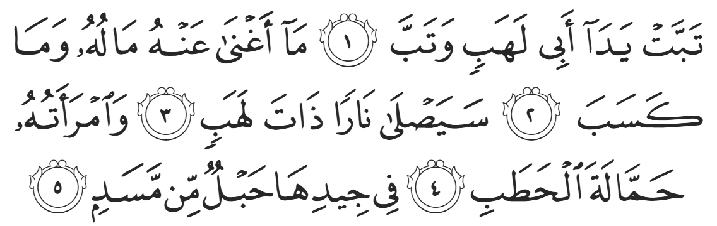
“May the hands of Abu Lahab perish, and may he [himself] perish! Neither his wealth, nor his [worldly] gains, will benefit him. He will burn in a flaming Fire, and [so will] his wife, the carrier of [thorny] kindling. Around her neck will be a rope of palm-fire.”
Proving his own demise, Abu Lahab would indeed go on to display the most animosity and cruelty to the Prophet ﷺ and his companions (RMAA). Regarding Abu Lahab’s wife, it is reported that she wore a valuable necklace and would say, “By al-Laat and al-Uzza, I will sell this necklace and spend the money to satisfy my hatred against Muhammad.” Allah (SWT) therefore promised her a necklace in the Hellfire.
The Prophet’s methodology in calling out the tribes in order of closeness to him is particularly striking. It clearly outlines how each person is responsible first and foremost to their immediate family followed by society at large. Allah (SWT)’s command in Surat As-Shu’araa “And warn your closest relatives.” applies to us, as it did to the Prophet ﷺ.
The Prophet ﷺ first called Banu Hashim, then he made a public call to the people of Mecca, and a few years later he extended his call to the whole of humanity. After this event, the Prophet ﷺ began preaching publicly throughout Mecca. He would preach at the Ka’bah, at public venues, and at the marketplace. He ﷺ would even wait outside Mecca for Pilgrims of Hajj to arrive, and preach to them. The Prophet’s da’wah – the call to Islaam-- became public, and opposition to it inevitably began.
<Conclude 1st Khutbah with:
Aqoolu haathaa wa astaghfir-Allaah (I say this and I ask Allah for forgiveness)
أَقُولُ قَوْلِي هَذَا وَأَسْتَغْفِرُ اللَّهَ لِي وَلَكُمْ وَلِسَائِرِ المُسْلِمينَ وَالمُسْلِمَاتْ فَاسْتَغْفِرُوهْ إِنَّهُ هُوَ الْغَفُورُ الرَّحِيمُ
الحمد لله رب العالمين والصلاة والسلام على سيد المرسلين وعلى آله وأصحابه أجمعين
<2nd Khutbah>
Dear brothers and sisters…
As the number of believers grew over a dozen, they needed a place to congregate. They did not have a mosque and could not meet in public without compromising their safety. A few months after the da’wah became public, the Prophet ﷺ chose the house of al-Asad ibn ‘Abd al-Uzza, more famously known as al-Arqam ibn Abi al-Arqam.
He was one of the first ten people to accept Islam but was from the Banu Makhzuum clan, not the Banu Haashim. This situated him perfectly to be the host of this gathering, as no-one would suspect a Makhzumi to harbor a Haashimi. Moreover, al-Arqam’s house was situated in the center of Mecca, which was always busy. It was therefore an ideal location for regular meetings, as attendees could seamlessly enter and exit without suspicion. Daar al-Arqam (The House of al-Arqam) thus became the hub of the Muslims – a center for teaching, prayer, and strategy.
The people of Mecca did not have one ruler. Instead, they deferred to a council of senior figures. Their rule can be described as a form of aristocracy. Each tribe had a leader, and each leader held a seat on this senior council. The leader of the Banu Haashim was Abu Taalib, so the Quraysh tried to appeal to him. They urged him—as a representative of his tribe members—to stop the Prophet’s activities. Abu Taalib calmed their moods and briefly stalled them.
A few weeks later, as the da’wah continued to spread, they returned to Abut Taalib, this time with intensified efforts. They tried to sweet-talk him, bribe him, and even threatened him. The Prophet ﷺ condemned idolatry. The Quraysh took this as a personal attack, and equated it to a condemnation of their culture, way of life, and honor. They gave Abu Taalib an ultimatum: either stop him from preaching, or hand him over. This ultimatum was significant, as Abu Taalib had never been confronted in such a manner before. Tribal law dictates that they cannot do anything to the Prophet ﷺ without the tribe leader’s consent, lest they be subject to dishonor and ridicule.
Abu Taalib returned to the Prophet ﷺ and said, “Oh my nephew, my people have approached me and told me such-and-such. So, be merciful to yourself and be merciful to me; do not place me in a situation that I cannot bear.” The Prophet ﷺ responded in the most profound manner, “Oh my uncle, by Allah, if they were to give me the Sun in my right hand and the Moon in my left, I cannot give up this Message until I succeed or I am martyred.” In another narration, he ﷺ said, “Do you see the Sun in the sky, oh uncle? By Allah, I have no more power to stop preaching than you have to light your [walking] stick with the Sun.” When Abu Taalib saw the Prophet’s persistence in his actions, the passion in his eyes, and sincerity in his speech, he replied, “Do as you wish, my nephew, for by Allah, I will never approach you again asking you to stop.” Indeed, Abu Taalib fulfilled his word until his death, even when ridiculed, boycotted, and expelled.
The Quraysh then gathered and approached Abu Taalib once more, this time in their entirety, not just Banu Haashim. They proposed an offer, “We have chosen the most noble young man in Mecca, Al-‘Umarah ibn al-Waleed. Our offer is to exchange one son for the other; you adopt al-‘Umarah in exchange for your nephew.” Abu Taalib was enraged with this proposition, “What an evil bargain! You want me to fatten up your son in exchange for you to kill mine?” Mut’im ibn ‘Adiyy then spoke out, “Your people have done all they can and exhausted all their means. You must choose an option.” This was a weighty remark, as this senior figure was the last person to remain neutral, and his decision to side with the Quraysh meant that the entirety of Mecca was against one single man.
Abu Taalib’s bravery in this regard is unparalleled, as the next step would be to overthrow a tribe leader – an unprecedented move. Abu Taalib stood firm in his brave support. He said, “Oh Mut’im, this is a plot you have hatched! Do as you please, for I will not stand down.” Abu Taalib then composed a series of poems of the highest caliber of eloquence chastising the Quraysh, accusing them of treachery. Abu Taalib’s poetry was so powerful and moving that it caused the Quraysh to momentarily back down and de-escalate. Abu Taalib’s strength and dignity, rooted in his sincerity, saved the Prophet ﷺ—by the will of Allah—when there was no other way out.
The Prophet ﷺ did not love anyone more than he did Abu Taalib. He served as his father and mother in one; raising, supporting, and nurturing him his whole life. Abu Taalib was so beloved to the Prophet ﷺ and the Companions, that years later at the conquest of Mecca, when Abu Bakr’s father, Abu Quhaafah, accepted Islaam near the end of his life, Abu Bakr (RA) wept and said to the Prophet ﷺ, “Oh Messenger of Allah, how I wish that this hand was the hand of your uncle, Abu Taalib, rather than the hand of my own father.”
Alas, Abu Taalib never converted to Islaam, despite the Prophet’s most desperate pleas. Indeed, Allah’s wisdom reigns supreme; had Abu Taalib converted, he would have been deposed as Chieftain, and the da’wah would have been crushed. Moreover, it clearly demonstrated both the sincerity and limitation of our Prophet ﷺ. Only a sincere Messenger would accept this fate despite the emotional impact. Moreover, he ﷺ is a slave of Allah… Only Allah (SWT) Himself can guide a soul to Islaam.
Allah (SWT) tells us in Surat Al-Qasas:
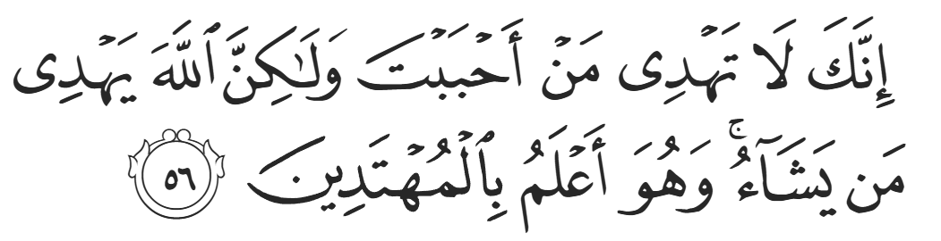
“You surely cannot guide whoever you like ˹O Prophet˺, but it is Allah Who guides whoever He wills, and He knows best who are ˹fit to be˺ guided.” (28:56)

<Duaa!>
- Oh Allah, please grant us a deep love for your Prophet Muhammad, SAW.
- Oh Allah, please make us energetic in doing good for your cause.
- Oh Allah, please enable us in will and means to walk Al-Sirrat-Al-Mustaqeem, even if it estranges us from others.
- Oh Allah, please support the suffering and oppressed Muslims around the world and grant them victory over that which oppresses them.
- Oh Allah, please protect us from ever being overburdened by debt and protect us from all evils and undesirable consequences associated to having debt.
- Oh Allah, please fill our hands with the work and deeds of righteousness and let them be of benefit to ourselves and the Ummah.
- Oh Allah please forgive us our shortcomings and deviances in following your Qur'an and the Sunnah of Rasul'Allah, SallAllahuAlayhiWaSallam.
- Oh Allah please grant us understanding and guidance of your Qur'aan
- Oh Allah, please grant us patience with the trials of this world.
- Oh Allah, please prevent our hearts from getting overly attached to the Dunya and grant us the best in this life and the best in the hereafter.
- Oh Allah, please forgive us our past sins and make us your devoted servants.
- Oh Allah please make us amongst those whose Duaa is accepted.
- Oh Allah, please grant us Jannat'ul Firdaus and protect us from ever coming close to the Fires of Jahannum.

