Configuring Clarotech FHIR Check Validator
For Mental Health eDischarge FHIR message validation

1. Download the Clarotech FHIR Check validator from their website

http://clarotech.co.uk/products/tool-fhir-check/

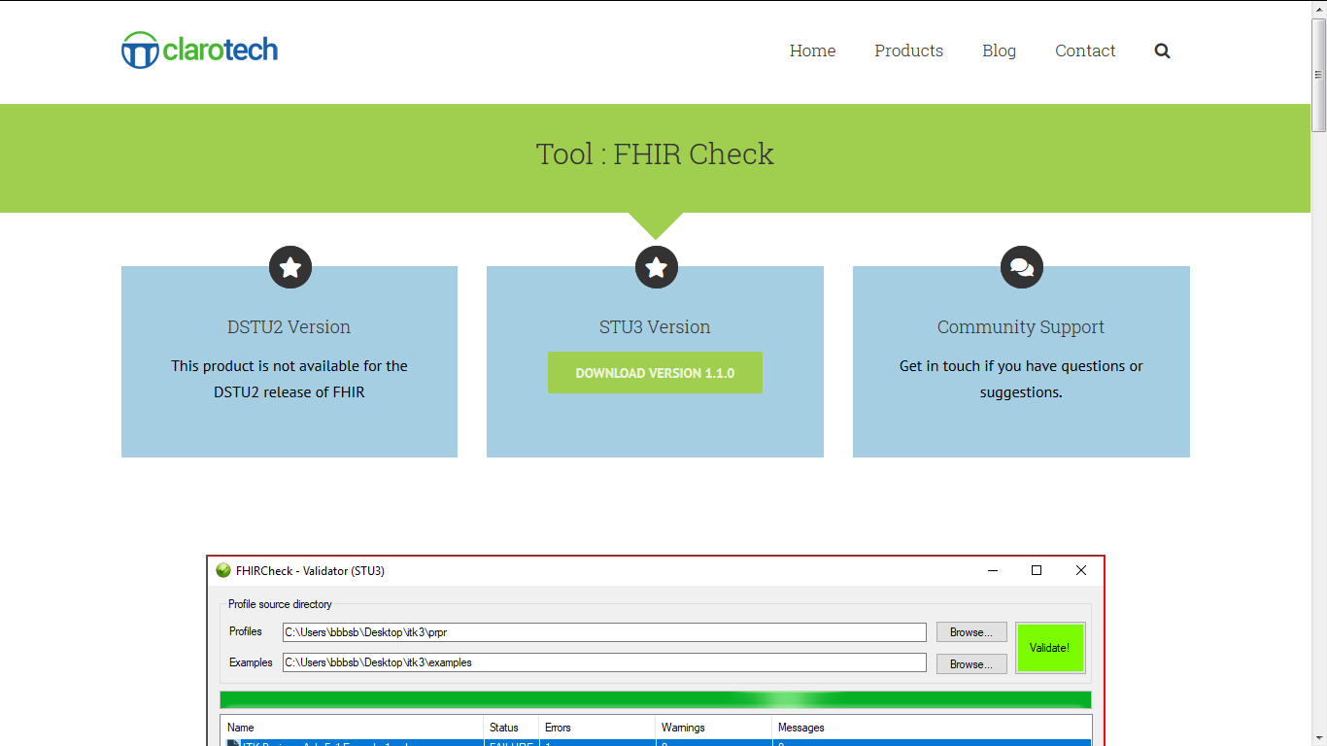
(Please note the version show above may be older – the newest version is recommended, and that the webpage layout may appear differently.)

2. Extract the contents of the download to any directory location

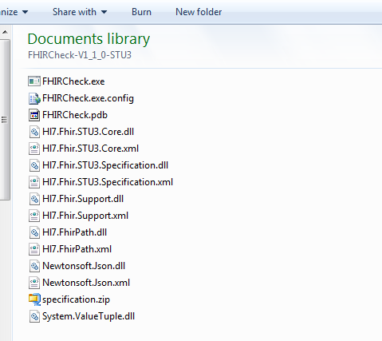

3. Create two folders immediately within the Clarotech FHIR Check directory, one named Profiles and the other FilesToValidate

(Note folders can be placed anywhere, but for ease in finding, placing them inside the FHIR Check folder seems sensible.)
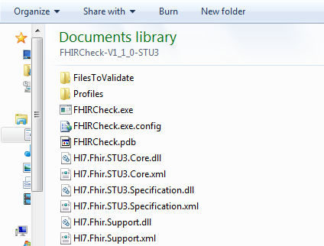

4. Download the exampe Mental Health eDischarge documents

You can do this in one of two ways:

Via the NHS Digital Website

4a. Go to the Jon Burrows Test Example Document webpage

https://nhsconnect.github.io/ITK-FHIR-Mental-Health-eDischarge/engage_jon_burrows.html

4b. Scroll to the bottom (using the ‘End’ button on the keyboard is very handy here as it’s very long) to where it says ‘view raw’
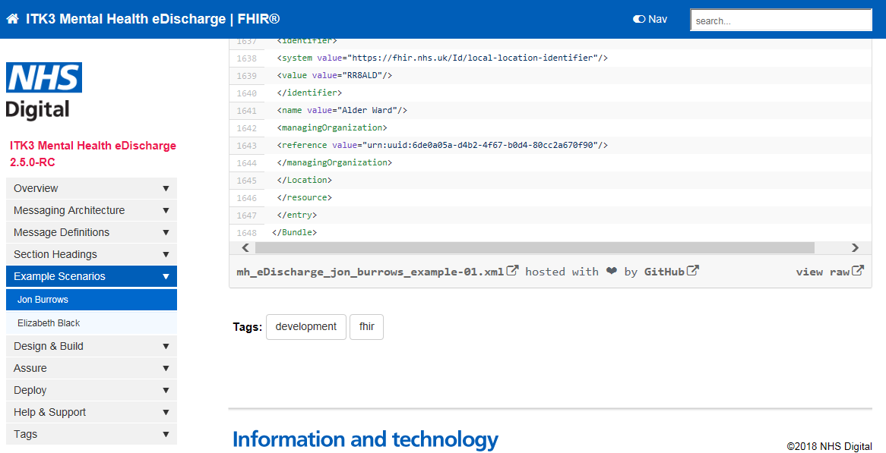

4c. Right-click ‘view raw’, click ‘save as’:

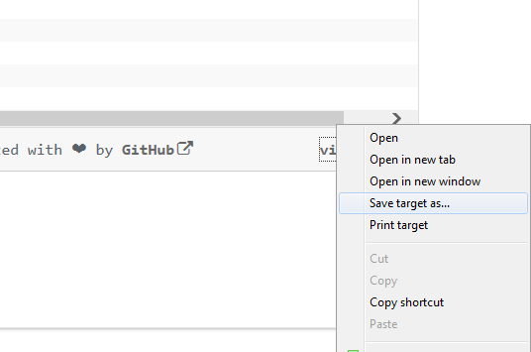

4d. Change .txt to .xml and save to the FilesToValidate folder:

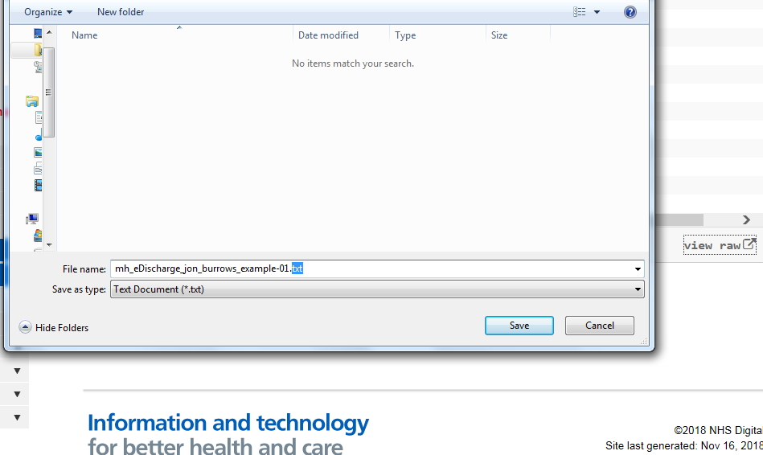

4e. Follow the steps b to d for the Elizabeth Black test document:

https://nhsconnect.github.io/ITK-FHIR-Mental-Health-eDischarge/engage_elizabeth_black.html

(Note: at time of writing the Elizabeth Black document did not validate even with profiles included.)

Via a GitHub page which I’ve set up

If one downloads the entire contents of the MH-FHIR-Profiles GitHub resource, they will find the example files under FilesToValidate, along with a zipped set of profiles under Profiles:

https://github.com/HIE-DEV/MH-FHIR-Profiles/

Direct ZIP download:

https://github.com/HIE-DEV/MH-FHIR-Profiles/archive/master.zip

5. Now add the appropriate FHIR Profiles, ValueSets and CodeSystem files (.xml, usually) to the Profiles folder.

You can do this in one of two ways.

Via manual download of pre-existing FHIR resources:

You can manually visit each individual StructureDefinition, ValueSet and CodeSystem resource (along with others) on the relevant pages:

https://fhir.nhs.uk/StructureDefinition
https://fhir.hl7.org.uk/StructureDefinition

https://fhir.nhs.uk/ValueSet/
https://fhir.hl7.org.uk/ValueSet

https://fhir.nhs.uk/CodeSystem/
https://fhir.hl7.org.uk/CodeSystem

And on each link for each resource, view the raw XML:

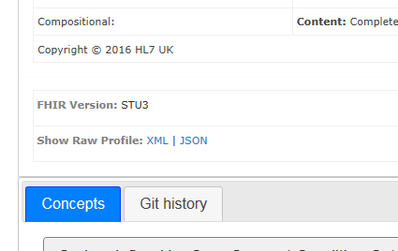
Then save that raw XML as a .xml individually (to our count there’s at least 469 resources).

(For more technically minded people: you may wish to employ Webscraping tools to automate such a process, but be warned, as the FHIR websites give a different packet response to non-webbrowsers, usually a FHIR bundle, which is often incomplete or inaccurate for the purposes of obtaining all profiles – this can cause validators that rely on the bundle response to validate FHIR messages issues. A method for tricking the server into giving a HTML page instead of a FHIR bundle for automated tools has not yet been figured out; user-agent strings do not appear to work.)

Or you can download the Profiles, ValueSets, CodeSystems etc from our GitHub page:

https://github.com/HIE-DEV/MH-FHIR-Profiles/

Direct ZIP download:

https://github.com/HIE-DEV/MH-FHIR-Profiles/archive/master.zip

6. Run FHIRCheck.exe, and configure the validator folder fields to point at the right folders

Per the image, you’ll want to point the Profiles source directory at the Profiles folder, and the Examples source directory at the FilesToValidate folder, using the browse buttons next to them.

It’s worth closing FHIR Check after you’ve done this, and re-opening it, as closing it will save the folder locations (validation can, rarely, crash and lose the configuration settings).

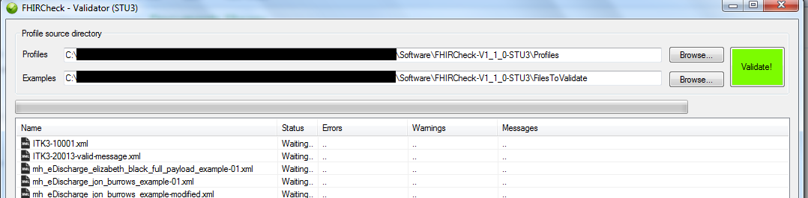
7. Click ‘Validate’ to begin validation of the Mental Health eDischarge forms

After you click ‘Validate’, the button will turn red, it will take some time to validate, indicated by the loading bar directly under the source directory boxes:
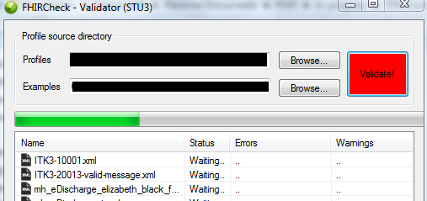

Then, after it has finished validating, the button will turn green and a list of errors will be displayed when you select each file. If you wish to copy the errors, simply click the ‘Raw Results’ tab.

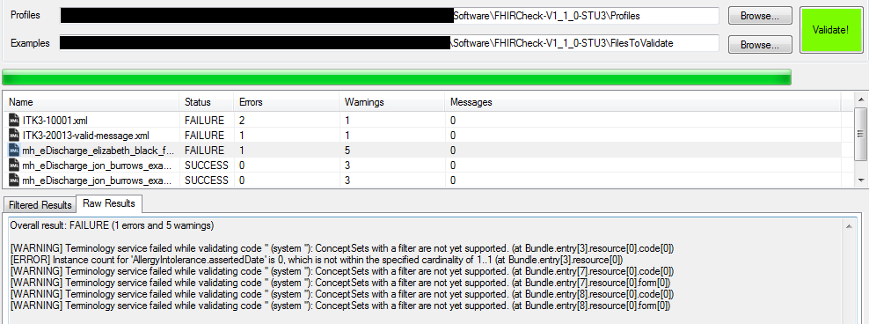

It’s worth noting that the FHIR Check validator will not automatically refresh the list of files (however it will automatically refresh it’s references to the profile files. It’s also worth noting it ignores the filenames of the Profile, ValueSet, CodeSystem etc files) and you will need to close and re-open it every time you add new files to the FilesToValidate folder.

Congratulations! You have just validated a Mental Health eDischarge message!

