陣列

一維陣列：

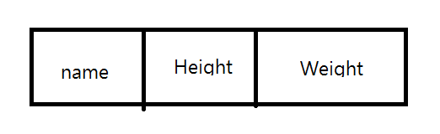

<?php

$myarray =array("name"=>"ppla","Height"=>175,"Weight"=>55);

echo myarray["name"]."<br/>".$myarray["Height"]."<br/>".$myarray["Weight"]."<br/>";

?>

二維陣列：

二維陣列可視為兩個一維陣列(一維陣列裡還有一維陣列)

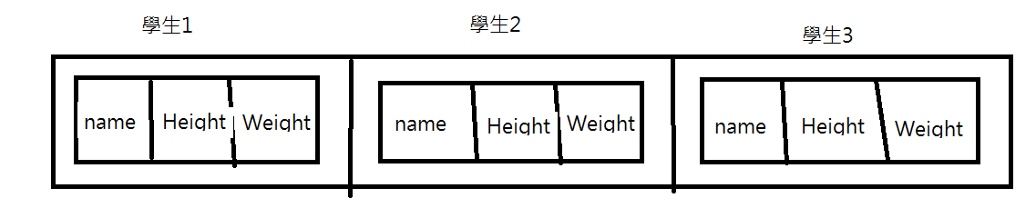

<?php

$s=array(array("ppla",175,55),

array("bbd",175,65),

array("bss",165,90));

for ($j=0;$j<3;$j++){

for ($i=0;$i<3;$i++){

echo $s[$j][$i]."<br/>";

}

echo "<br/>";

}

?>

使用array()函式嵌套

<?php

$student1 = array("ppla",175,55);

$student2 = array("bbd",175,65);

$student3 = array("bss",165,90);

$s = array($student1,$student2,$student3);

for ($j=0;$j<3;$j++){

for ($i=0;$i<3;$i++){

echo $s[$j][$i]."<br/>";

}

echo "<br/>";

}

?>