**Results analysis**

Hillel Ohayon 325300820

(תמלאי פה את השם שלך)

Part A: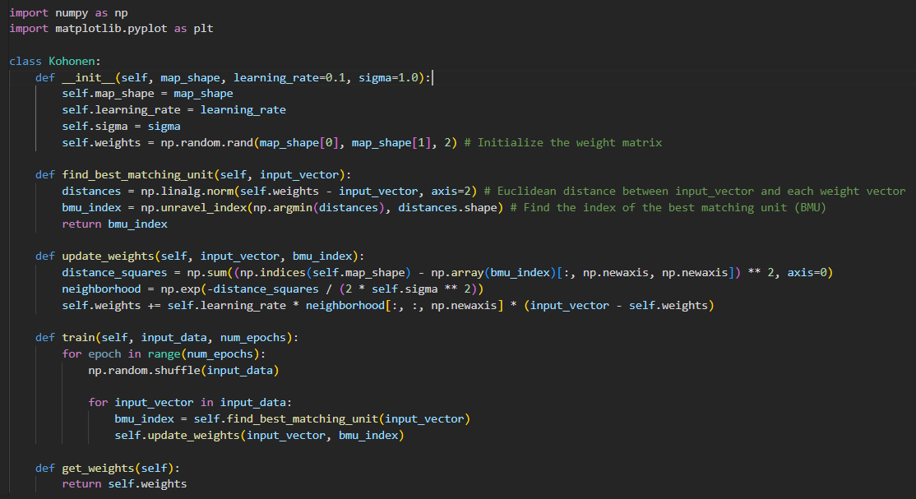

Here is the Kohonen algorithm implementation.

1. {(x, y) | 0 <= x, y<=1}

* 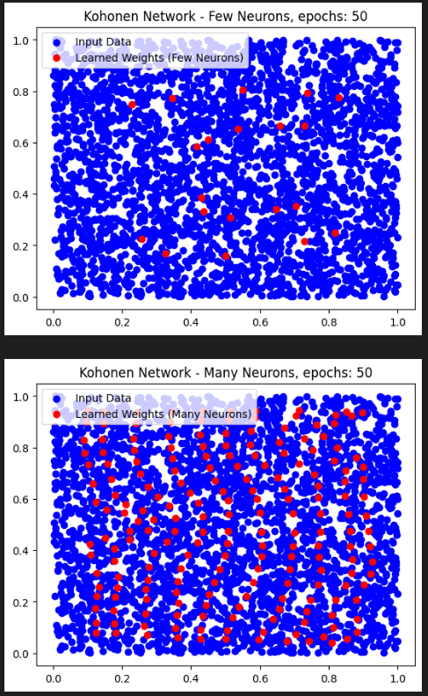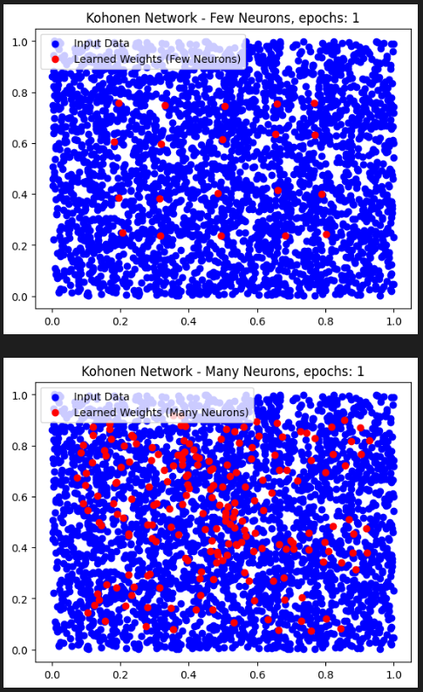Uniform distribution:

We can see here that the top of each figure represents 20 neurons and the bottom of it is 200 but the difference is in the number of epochs, and as the number of it grow up, the accuracy of the clusters is better, the neurons adapt themselves to the input data.

* 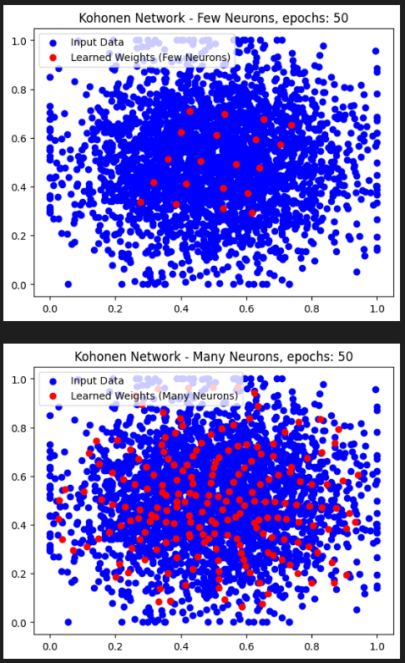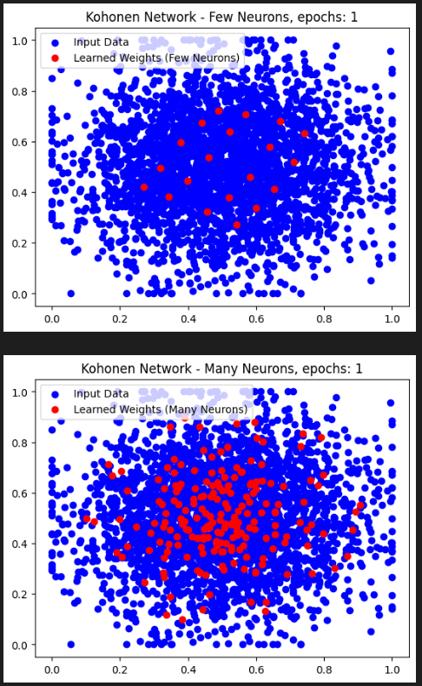 Normal distribution:

Here we have the results of the same but with Normal distribution and from those figures, we see that the same happens, the cluster adapt themselves to the input data.

* 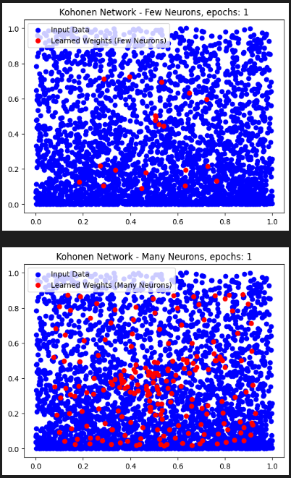Here we chose, Input_data = np.column_stack((x, y**2))

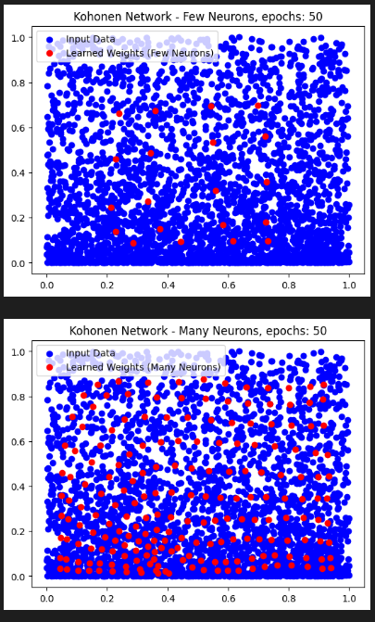

* Here we chose, Input_data = np.column_stack((x**2, y))

In the first example of a non-uniform distribution, the likelihood of picking a point in the dataset is proportional to the size of the x-coordinate, but uniform to the size of the y-coordinate. This means that points with larger x-values are more likely to be chosen, resulting in a distribution that is denser towards higher x-values. By squaring the y-coordinate, we accentuate this non-uniformity. This distribution creates a diagonal elongation in the data, with more points concentrated towards the upper right and lower left regions of the square. In the second example, the likelihood of picking a point is proportional to the size of the y-coordinate, but uniform to the size of the x-coordinate. This leads to a distribution that is denser towards higher y-values, causing more points to cluster towards the top of the square. By squaring the x-coordinate, we emphasize this non-uniformity. The resulting distribution exhibits a horizontal elongation, with a higher density of points towards the right side of the square. These two non-uniform distributions highlight the impact of different probability distributions on the input data. By altering the likelihood of selecting points based on their coordinates, we can manipulate the clustering and density patterns in the data. This, in turn, affects the learning process and the resulting learned weights in the Kohonen self-organizing map, as the network tries to capture and represent the underlying structure of the data.Top of Form

1. {(x, y) | 4<= x^2 + y^2 <=16}

* Uniform distribution

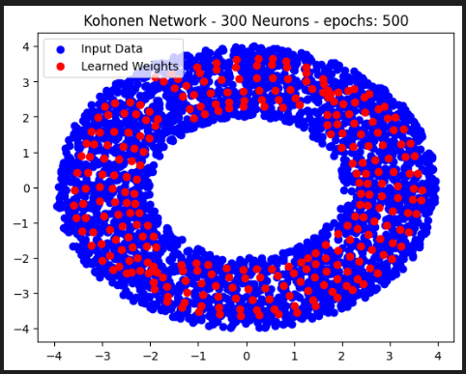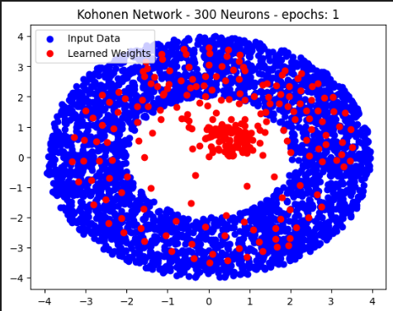

* 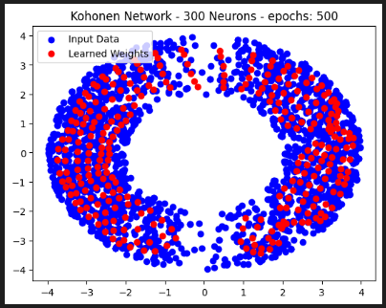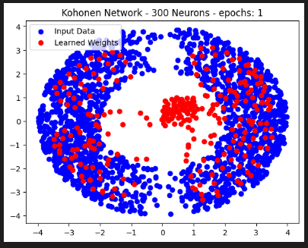Non-uniform distribution based on x-coordinate:
* Non-uniform distribution based on y-coordinate:

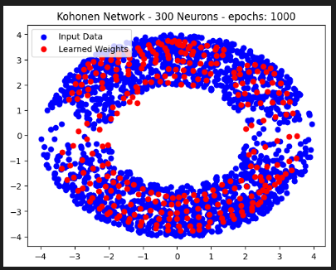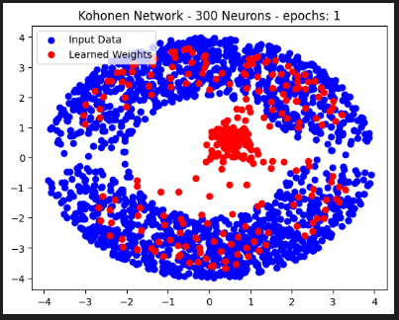

Explanation about the donut:

The difference in distribution between the two examples lies in how the likelihood of picking points within the annular region is assigned based on their coordinates. In the first example, a non-uniform distribution is created by biasing the selection probability towards points with larger x-coordinates, while keeping the y-coordinates uniformly distributed. This results in a higher density of points in regions with larger x-values within the annular region. On the other hand, in the second example, a different non-uniform distribution is achieved by biasing the selection probability towards points with larger y-coordinates, while keeping the x-coordinates uniformly distributed. This leads to a higher concentration of points in regions with larger y-values within the annular region. By manipulating the probabilities associated with the coordinates, we can create variations in the density and distribution patterns within the annular region. These examples demonstrate how adjusting the selection probabilities based on different coordinate values can influence the clustering behaviour and learning process of the Kohonen network.

Before converging, the clusters are in the middle and not adapted to the input data but after enough iterations, they adapt to the donut and give a better form.