**Docker multistage:**

**I have a python application: I Will dockerise it without multistage and with multistage.**

**Multistaging reduces the size by 80%**

**1.Without multistage:**

**Dockerfile:**

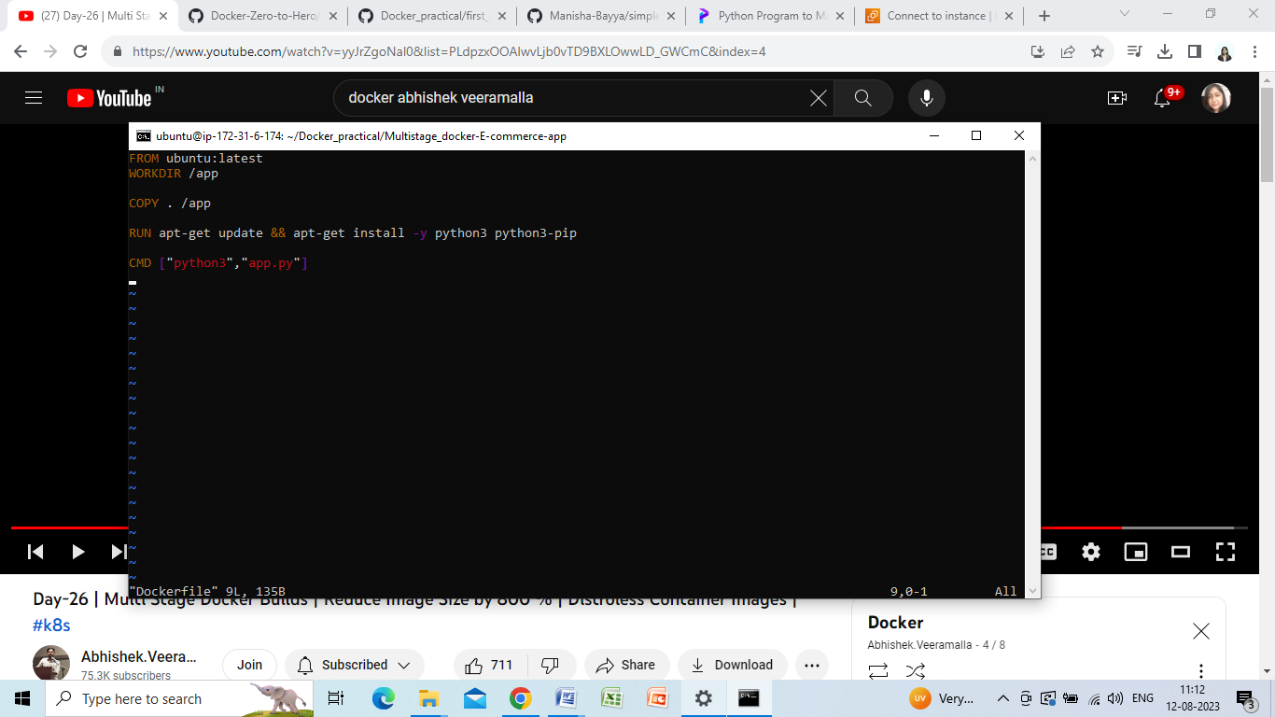

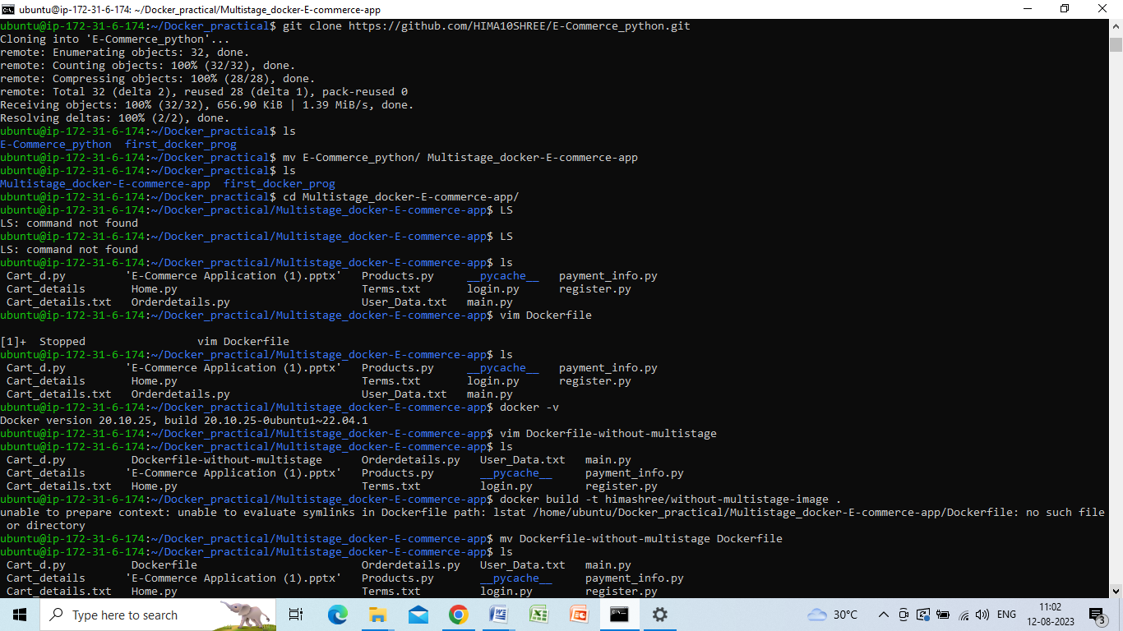

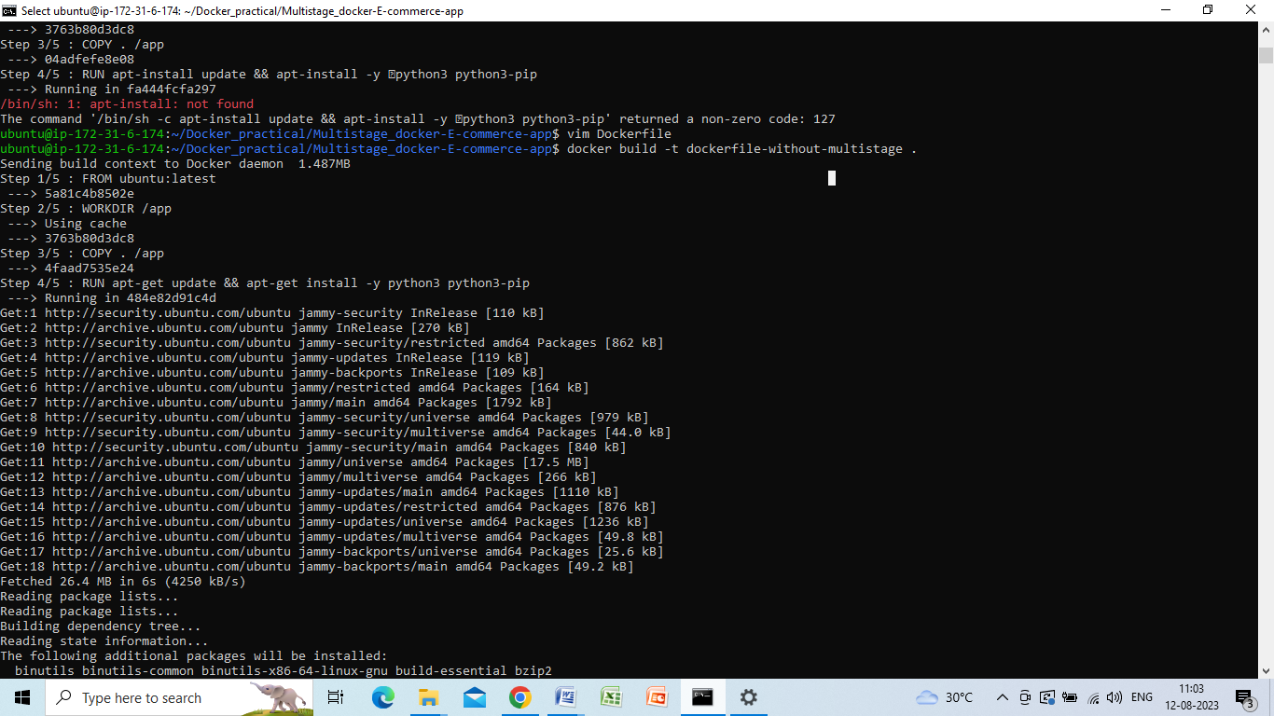

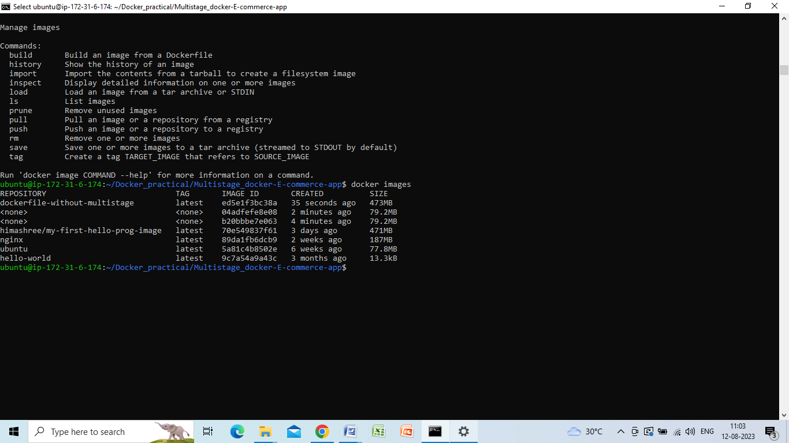

**Without multistage it is 473 mb**

**Lets see with multistage:**

**Dockerfile:**

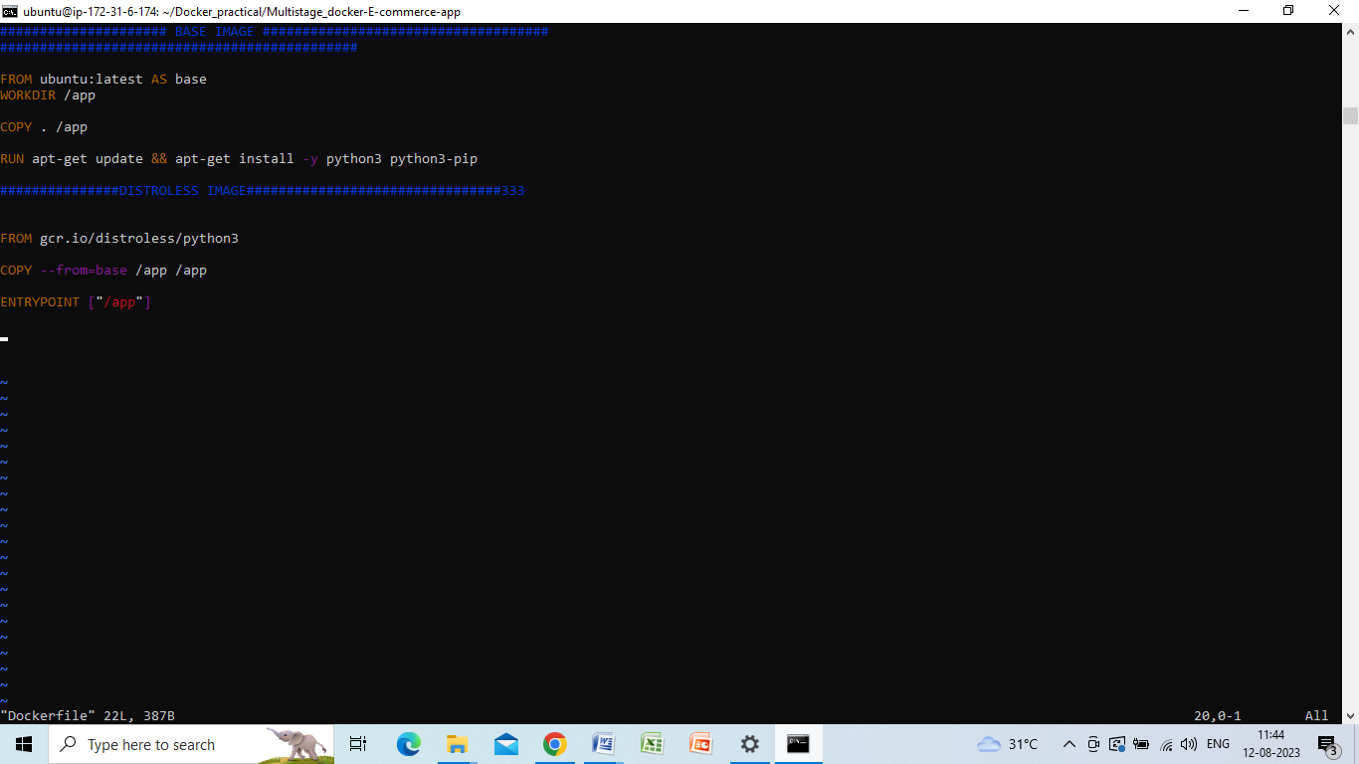

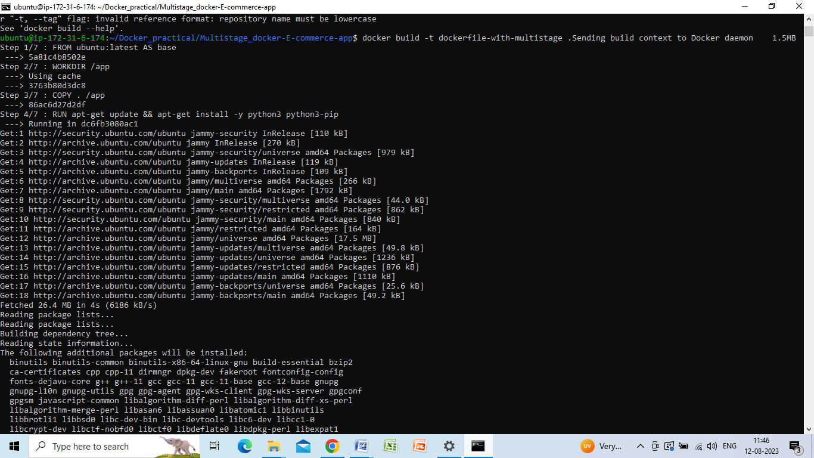

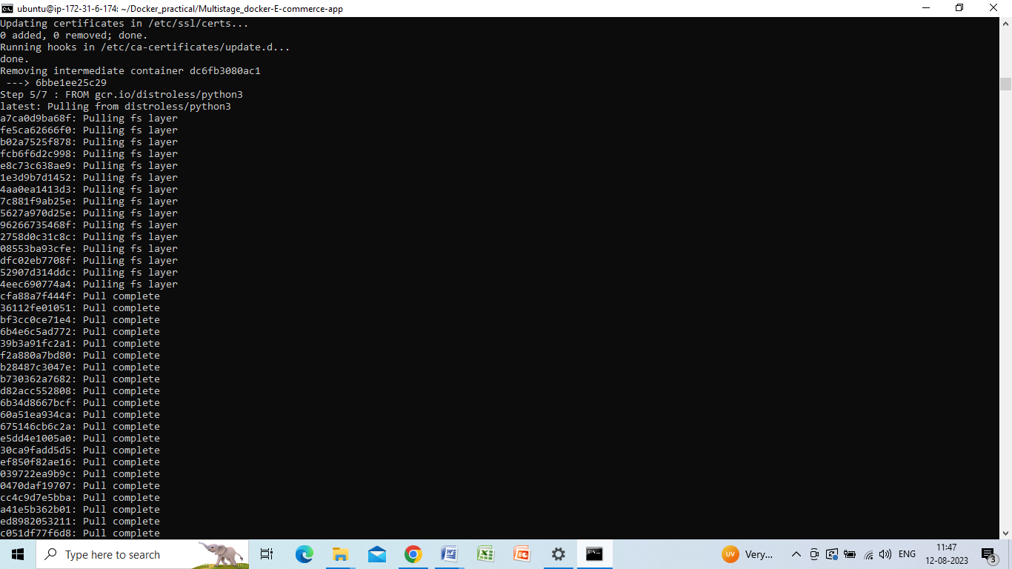

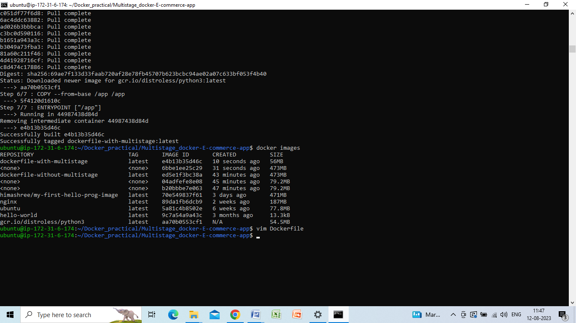

**Size reduced to 56 mb**