**GUIDELINES:**

**Code Build:**

1.buildspec.yml file is created which builds and pushes docker image to the container registry.

2.in the code build service role the following permission should be given to authenticate to ecr.

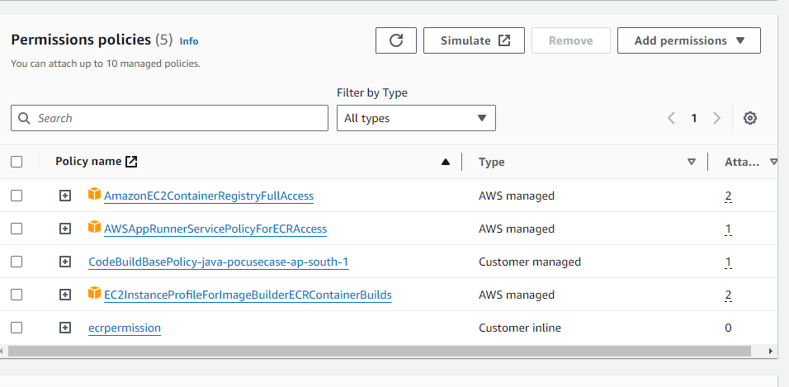

**For ecrpermission:**

{

"Version": "2012-10-17",

"Statement": [

{

"Sid": "Statement1",

"Effect": "Allow",

"Action": [

"ecr:GetAuthorizationToken",

"ecr:BatchCheckLayerAvailability",

"ecr:BatchGetImage",

"ecr:InitiateLayerUpload",

"ecr:UploadLayerPart",

"ecr:CompleteLayerUpload",

"ecr:PutImage"

],

"Resource": "*"

}

]

}

2. Once the permission is given run the code build .

Environment details:

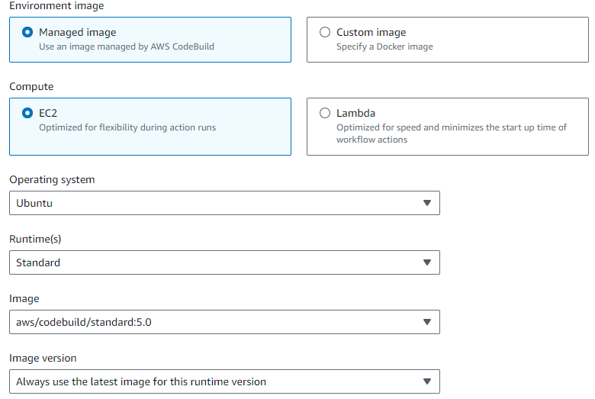

Create the ECS :

1.Create Cluster

2.task definition

3.service

In the code deploy ,set the deploy target as ECS and set a S3full access and ECS policy for the aws user:

ECS Policy:

{

"Version": "2012-10-17",

"Statement": [

{

"Sid": "VisualEditor0",

"Effect": "Allow",

"Action": "ecs:*",

"Resource": "*"

}

]

}

