YUVA INTERN — WEEK 1 REPORT
Data Cleaning and Preliminary Analysis with R
Dataset: Titanic Passenger Dataset | Language: R | Tools: Base R, ggplot2, dplyr
Submitted by: Himani Memane
Note: Run the accompanying R script in R/RStudio to reproduce the outputs and save the cleaned CSV files and charts. Replace the author name if your internship portal requires a different format.

1. Executive Summary
This report documents a reproducible data-cleaning and preliminary exploratory analysis workflow using R on the public Titanic passenger dataset. The dataset contains passenger demographics, ticket class, fare, family relationships, cabin information, embarkation port, and survival outcome. It is suitable for this task because it contains both numerical and categorical variables and realistic missingness in Age, Cabin, and Embarked.
The workflow examines data structure and descriptive summaries, audits missing values and duplicate records, applies justified imputation, creates useful derived variables, investigates potential fare outliers using the interquartile range (IQR), encodes categorical predictors, and normalizes selected numerical features using min-max scaling. Preliminary analysis focuses on survival counts and how survival proportions vary by sex and passenger class. The work is exploratory; observed associations do not establish causation.

2. Objectives
- Select a public dataset with numerical and categorical fields and missing values.
- Use str(), summary(), head(), and data-quality checks to understand the raw data.
- Quantify and treat missing values with documented reasoning.
- Inspect potential outliers without automatically deleting legitimate observations.
- Encode categorical variables and normalize numerical predictors.
- Produce descriptive statistics, correlation results, and visual evidence.
- Provide a reproducible R script that exports cleaned data and charts.

3. Dataset Overview
The Titanic dataset is a widely used public passenger dataset commonly distributed with the Kaggle Titanic machine-learning challenge. This report uses a public mirror maintained in the DataScienceDojo datasets repository. It contains 891 passenger records and 12 original columns.
Source CSV: https://raw.githubusercontent.com/datasciencedojo/datasets/master/titanic.csv
Variable | Meaning | Type / treatment
PassengerId | Passenger record identifier | Integer; identifier, not a predictor
Survived | 0 = did not survive; 1 = survived | Binary outcome; converted to factor for analysis
Pclass | Ticket class: 1, 2, or 3 | Categorical / ordinal
Name | Passenger name | Text; retained for provenance, not encoded in this task
Sex | Recorded sex category | Categorical
Age | Age in years | Numeric; missing values imputed
SibSp | Siblings/spouses aboard | Integer count
Parch | Parents/children aboard | Integer count
Ticket | Ticket identifier | Text; not used as a numerical predictor
Fare | Ticket fare | Numeric; outlier investigation and normalization
Cabin | Cabin identifier | Text; high missingness handled using CabinKnown flag
Embarked | Port code C, Q, S | Categorical; missing values imputed

4. Tools and Reproducibility
The analysis uses R and the ggplot2 and dplyr packages. The provided script reads the CSV directly from the public source, so an internet connection is required on first run. Run the script from an RStudio project or a working directory where you have permission to save files.
install.packages(c("ggplot2", "dplyr")) # run once if needed\nsource("week1_data_cleaning.R")
The script produces age_distribution.png, survival_by_sex.png, survival_by_class.png, titanic_cleaned.csv, and titanic_model_ready.csv in the working directory.

5. Initial Data Exploration

5.1 Structure and dimensions
dim(titanic_raw)\n# Expected: 891 rows and 12 columns\nstr(titanic_raw)\nsummary(titanic_raw)\nhead(titanic_raw)
dim() checks the dataset size. str() reveals the data types and sample values. summary() provides variable-specific summaries such as numeric quartiles and categorical frequency counts. These checks help identify variables that need type conversion before analysis.

5.2 Missing-value audit
missing_count <- sapply(titanic_raw, function(x) sum(is.na(x)))\nmissing_pct <- round(100 * missing_count / nrow(titanic_raw), 2)
Variable | Missing records | Approx. missing %
Age | 177 | 19.87%
Cabin | 687 | 77.10%
Embarked | 2 | 0.22%
Other original columns | 0 | 0%
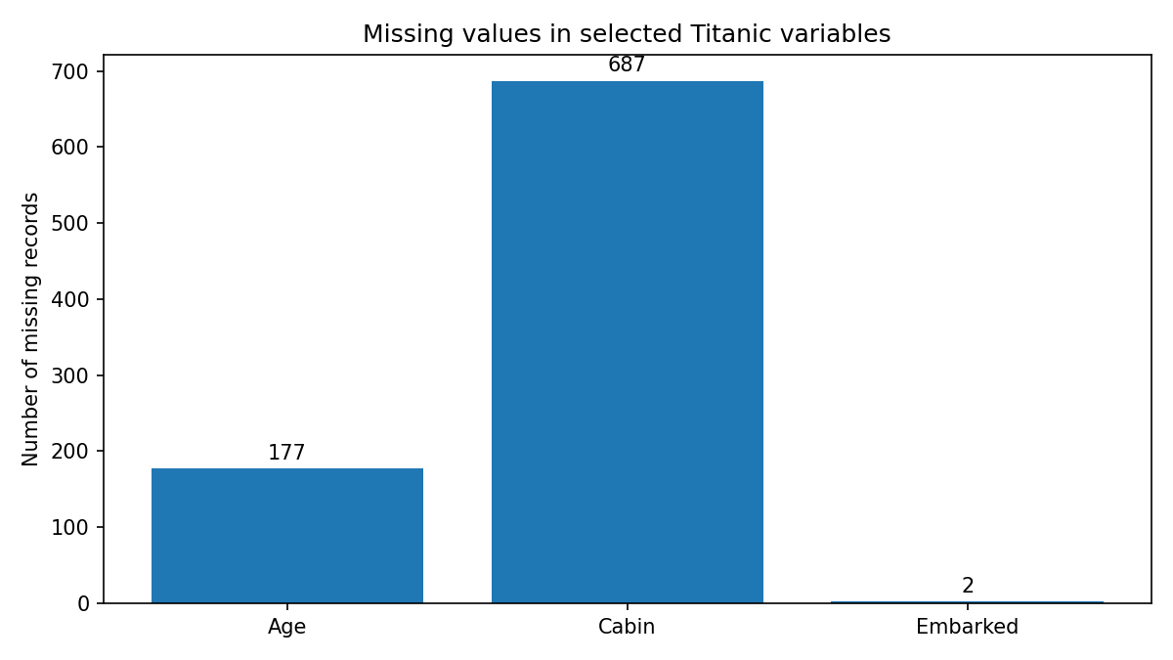
Cabin has the greatest missingness (about 77%). Age is missing for roughly one-fifth of passengers, while Embarked has only two missing records. Missingness should be handled by variable rather than by dropping every row with any missing field, which would discard useful records.

6. Data Cleaning and Preprocessing

6.1 Data types and duplicates
Survived is converted into a labelled factor, Pclass into a three-level factor, and Sex and Embarked into factors. PassengerId is an identifier and is not treated as a continuous measurement. Duplicate rows are checked using duplicated(); the script reports the number found rather than deleting records blindly.
sum(duplicated(titanic_raw))

6.2 Missing Age values
Age is imputed using the median for the corresponding Pclass and Sex group. The median is less sensitive to extreme ages than the mean, and grouping preserves broad differences in age distributions across passenger classes and sex. If a group median is unavailable, the overall non-missing age median is used as a fallback. Imputed values should be treated as estimates, not observed ages.
age_group_medians <- aggregate(Age ~ Pclass + Sex, data = titanic_raw,\n FUN = function(x) median(x, na.rm = TRUE))\n# Missing Age values are replaced with their Pclass-by-Sex group median.

6.3 Missing Embarked values
The two missing Embarked values are replaced with the mode (the most frequent category). This is a simple, transparent approach when only a small number of categorical values are missing.
mode_value <- names(which.max(table(titanic_raw$Embarked)))\ntitanic$Embarked[is.na(titanic$Embarked)] <- mode_value

6.4 Cabin field with high missingness
Because Cabin is missing for most records, imputing a specific cabin value would create unsupported detail. Instead, the workflow creates CabinKnown (1 if a cabin was recorded, otherwise 0) and removes the sparse Cabin text field. This preserves the information that a cabin entry was or was not available without inventing cabin numbers.

6.5 Outlier detection using IQR
Fare is inspected using the IQR rule. The lower fence is Q1 − 1.5 × IQR and the upper fence is Q3 + 1.5 × IQR. Observations outside these fences are flagged for review. A flagged value is not automatically an error: higher fares may be legitimate first-class fares or reflect group tickets. Therefore, the script retains these observations and records the number flagged.
q1 <- quantile(titanic$Fare, 0.25, na.rm = TRUE)\nq3 <- quantile(titanic$Fare, 0.75, na.rm = TRUE)\niqr_fare <- IQR(titanic$Fare, na.rm = TRUE)\nlower_fence <- q1 - 1.5 * iqr_fare\nupper_fence <- q3 + 1.5 * iqr_fare

6.6 Feature transformation and encoding
FamilySize is calculated as SibSp + Parch + 1, counting the passenger. IsAlone is 1 when FamilySize equals 1 and 0 otherwise. Nominal categories Sex, Embarked, and Pclass are one-hot encoded using model.matrix(). This avoids implying a numerical distance between categories. The target Survived is kept separate as a labelled outcome.
titanic$FamilySize <- titanic_raw$SibSp + titanic_raw$Parch + 1\ntitanic$IsAlone <- ifelse(titanic$FamilySize == 1, 1, 0)\nencoded <- model.matrix(~ Sex + Embarked + Pclass - 1, data = titanic)

6.7 Min-max normalization
Selected numeric features (Age, Fare, and FamilySize) are transformed to a 0–1 range using (x − minimum) / (maximum − minimum). Normalization is useful when numeric variables have different units or ranges. For predictive modelling, scaling parameters should be learned from the training set only and then applied to test data to prevent data leakage.
minmax <- function(x) (x - min(x, na.rm = TRUE)) /\n (max(x, na.rm = TRUE) - min(x, na.rm = TRUE))

7. Preliminary Exploratory Analysis

7.1 Survival counts
Outcome | Count | Approx. proportion
Did not survive | 549 | 61.62%
Survived | 342 | 38.38%
Total | 891 | 100%
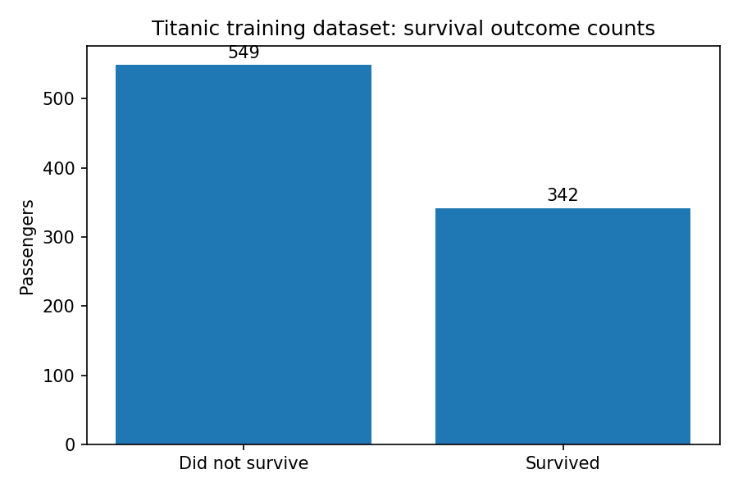
In the dataset, 342 of 891 passengers survived, corresponding to an overall survival proportion of approximately 38.4%. The outcome is not evenly distributed: non-survivors are the larger group.

7.2 Survival by sex and passenger class
The R script calculates row-wise survival proportions using prop.table(table(...), 1). This is preferable to comparing raw counts alone because the numbers of passengers in each group differ. The plots generated by ggplot2 show within-group proportions for sex and passenger class.
round(prop.table(table(titanic$Sex, titanic$Survived), 1) * 100, 1)\nround(prop.table(table(titanic$Pclass, titanic$Survived), 1) * 100, 1)
The standard Titanic dataset shows a strong descriptive association between recorded sex and survival, and survival proportions differ by passenger class. These patterns are consistent with the historical context and emergency evacuation conditions, but this exploratory analysis alone cannot establish causal effects.

7.3 Numeric summaries and correlation
summary(titanic_raw[, c("Age", "SibSp", "Parch", "Fare")])\nnum_data <- titanic_raw[, c("Survived", "Age", "SibSp", "Parch", "Fare")]\nround(cor(num_data, use = "pairwise.complete.obs"), 2)
The correlation matrix uses pairwise-complete observations, so each pair of variables is correlated using records where both values are present. Pearson correlation describes linear association among numeric variables; it does not prove causation. Survived is coded 0/1 in the raw data for this calculation, so correlations involving it can be interpreted as point-biserial associations.

8. Verification After Cleaning
sum(is.na(titanic))\ndim(titanic)\nwrite.csv(titanic, "titanic_cleaned.csv", row.names = FALSE)\nwrite.csv(model_ready, "titanic_model_ready.csv", row.names = FALSE)
The script checks the number of missing values remaining after imputation and the dimensions of the cleaned table. It exports both a cleaned, interpretable dataset and a model-ready table containing selected numeric features plus encoded categorical predictors. The report intentionally does not invent a console transcript: run the R script and insert or capture the actual console output from your own environment before final submission.

9. Key Findings and Insights
- The raw data has 891 records and 12 original variables.
- Age has 177 missing values (about 19.9%); Cabin has 687 missing values (about 77.1%); Embarked has 2 missing values (about 0.2%).
- The chosen strategies are median imputation by Pclass and Sex for Age, mode imputation for Embarked, and a CabinKnown flag for the sparse Cabin field.
- The IQR rule is used to flag potential Fare outliers, but flagged fares are retained unless there is evidence of data error.
- Sex, Embarked, and Pclass are one-hot encoded; Age, Fare, and FamilySize are min-max normalized in the model-ready output.
- The observed overall survival proportion is approximately 38.4% (342 of 891 records). Survival proportions differ across sex and passenger class, warranting further investigation.

10. Limitations and Ethical Considerations
The dataset is historical and may not represent modern populations. Some variables contain measurement and recording limitations. Imputation can reduce missingness but introduces uncertainty, and a missing Cabin value does not prove that a passenger had no cabin. Outlier rules are screening tools, not proof of errors. Sex and passenger class associations are descriptive and should not be generalized beyond the dataset without further evidence. No personally sensitive inference is attempted.

11. Conclusion
This task demonstrates an end-to-end first-pass data-quality workflow in R: import, inspect, audit missingness, make reasoned cleaning decisions, engineer and encode features, normalize selected numeric variables, investigate outliers, summarize data, visualize distributions, and export reproducible outputs. The next stage could include more detailed hypothesis testing or predictive modelling, but those activities are outside the scope of this Week 1 preliminary analysis.

12. References
DataScienceDojo. Titanic dataset public CSV mirror. https://github.com/datasciencedojo/datasets/blob/master/titanic.csv
R Core Team. R: A language and environment for statistical computing. https://www.r-project.org/
Wickham, H. ggplot2: Elegant Graphics for Data Analysis. https://ggplot2.tidyverse.org/

Appendix A. Complete R Script
The complete executable script is supplied as a separate file named week1_data_cleaning.R. It includes dataset import, missing-value treatment, IQR outlier checks, feature encoding, normalization, preliminary statistics, plots, and CSV exports.

