*Entertainer Data Analysis LLD Author:* Himani

Entertainer Data Analysis

# Low Level Design

**Author: *Himani***

1

*Entertainer Data Analysis LLD Author:* Himani

# Index

|  |  |  |
| --- | --- | --- |
| **Sl. No.** | **Title** | **Page no.** |
| 1 | Abstract | 3 |
| 2 | Given Tasks | 3 |
| 3 | Scope | 3 |
| 4 | Architecture | 4 |
| 5 | Data Description | 5,6,7,8 |
| 6 | Connect Data with Tableau & Deployment | 9 |

2

*Entertainer Data Analysis LLD Author:* Himani

**Abstract**

➤ Normal life can be stressful, and people need to relax. Being entertained by others is a

wonderful way to take some time out of life. It can reduce stress and make life's issues easier to face. The media and entertainment industry consists of film, television, radio and print. These segments include movies, TV shows, radio shows, news, music, newspapers, magazines, and books. Entertainment industry is a group of sub-industries devoted to entertainment. Entertainment industry is used to describe the mass media companies that control the distribution and manufacture of mass media entertainment.

## Given Tasks

➤ **Task #1** - In a word document write the process and data added to the current dataset. In addition, mention the theme on which you will be creating the dashboard.

➤ **Task #2** - You can add your data as per your convenience.

➤ **Task #3** – Do the data preparation part.

➤ **Task #4** – Build the dashboards

➤ **Task #5** – Build a Storyline

## Scope

➤ My main theme is the number of awards won by entertainers throughout their life. I have

made two dashboards showing their award winning performance. Dashboards show the highest number of nominees, Oscar awards, Emmy awards, Grammy awards and other awards etc. so that each and every one can analyze which entertainer is the best according to their thought process.

➤ My main theme is to create dashboards on top entertainers with their highest number of awards and nominees and make visualizations on it.

3

*Entertainer Data Analysis LLD Author:* Himani

## Architecture

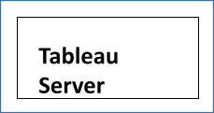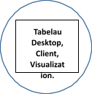➤ The **architecture** of entire project is shown below:

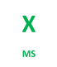

➤ Our entire data source is our **Excel** file.

➤ After **Excel** I am pushing this dataset in **Pandas** (Python library) in pandas in manipulated the tables and **merged** them into one table using the .**concat** function. Then in converted that table into excel file to push into **Tableau** server to make a **dashboard**.

➤ This excel file is connected to the **Tableau** server. From the server, data can be shown and

**accessed**

➤ **Tableau** server has various architectural components regarding how to solve the query.

➤ The functionalities show the result according to a query entered by the end user or client.

➤ Screen of **Tableau** desktop, client and various charts and **dashboard** (screen) of Tableau are present at client side.

➤ Client entered the query to show the **graph**. After selecting the data in the form of rows

and columns it will go inside the tableau server. In the tableau server, it understands the query and generates the best recommended charts based on selected data and returns it into the tableau screen.

➤ Based on recommended charts, clients can make the visual aspect the same.

➤ If a client is not **satisfied** with the result, he/she has to select data accordingly otherwise make required changes to show the expected result.

4

*Entertainer Data Analysis LLD Author:* Himani

## Data Description

➤Data was given into three parts in excel file which are Entertainer – Basic Info, Entertainer

– Breakthrough Info and Entertainer - Last work Info.

➤Basic Info includes name, gender and birth year of the entertainer.

➤Breakthrough Info includes year of breakthrough/#1 hit/award nomination, breakthrough name, year of first Oscar/grammy/emmy along with name of entertainers.

➤Last work Info includes last major work (arguable), year of death (if they are) along with names of entertainers.

➤Glimpse of Entertainer – **Basic Info**:

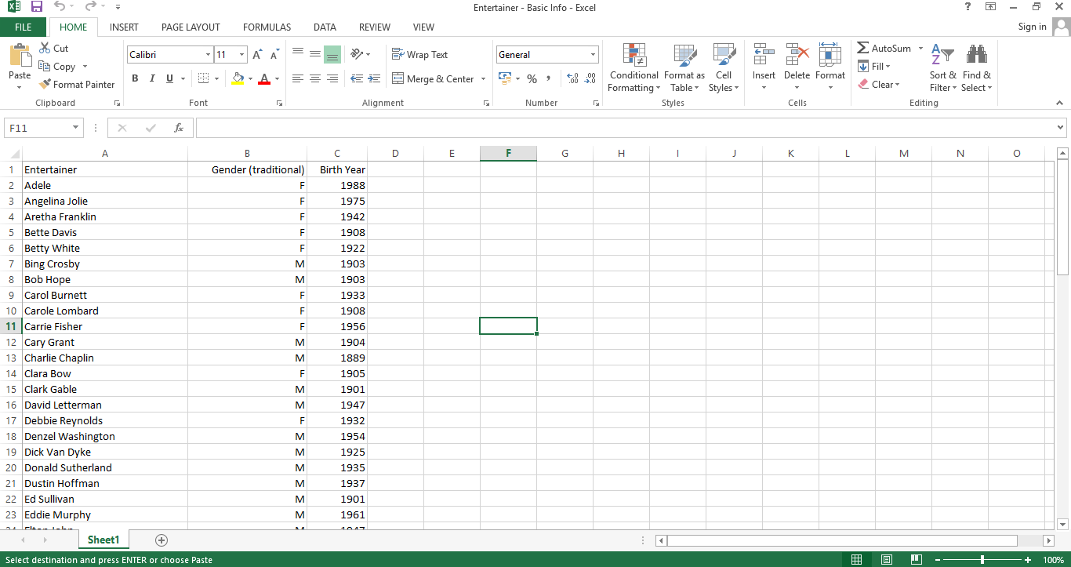

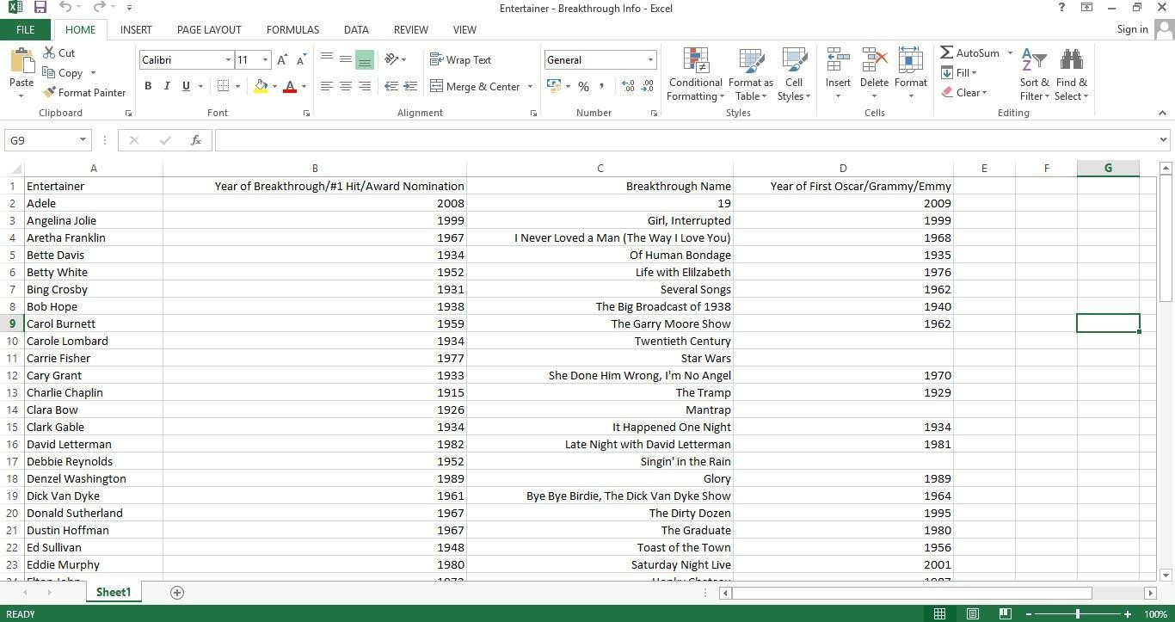➤Glimpse of Entertainer – **Breakthrough Info**:

5

*Entertainer Data Analysis LLD Author:* Himani

➤Glimpse of Entertainer – **Last work Info**;

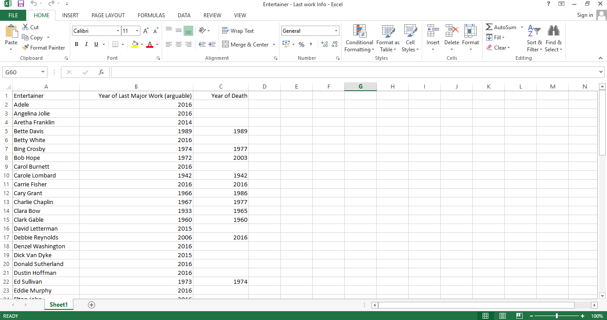

➤After this, I combined this data into one Table using Pandas as this screenshot describes how I merged the tables using .**concat** function .As this screenshot shows I worked in

**Jupyter Notebook** as it is easy and perfect for **Data Analysis** and **Data Science .** And named

this file as **Entertainer-final_dataset**

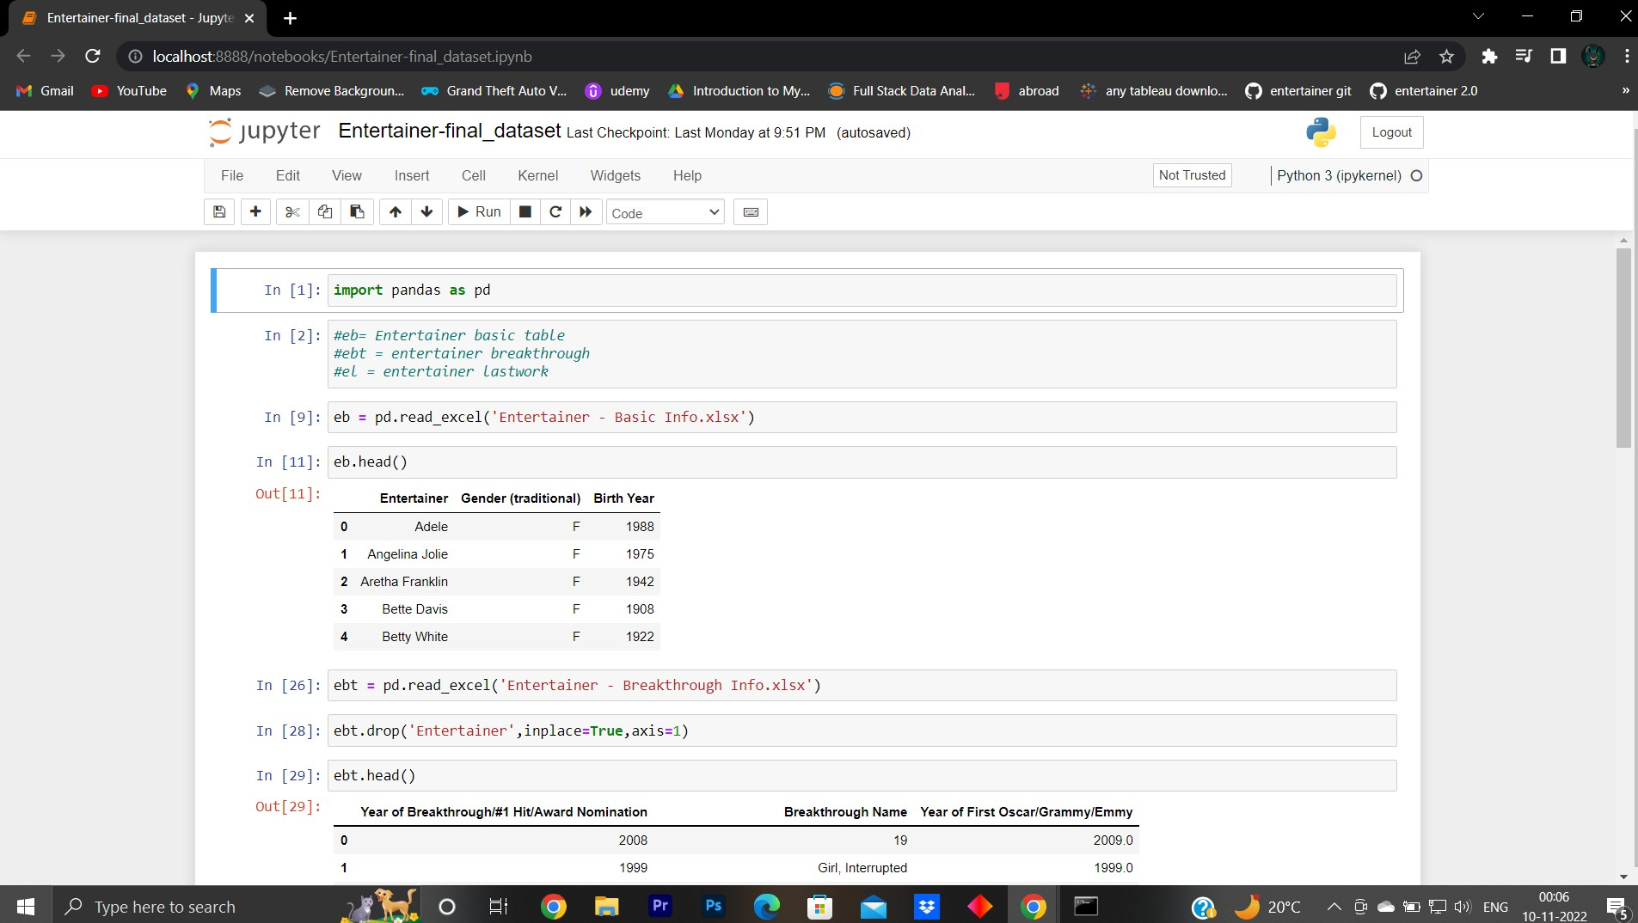

6

*Entertainer Data Analysis LLD Author:* Himani

➤ Here the image shows how I saved the table in **excel** format as it is easy to apply in the **tableau**

server and build the **dashboard** as per our convinience.As named **main_data.xlsx**

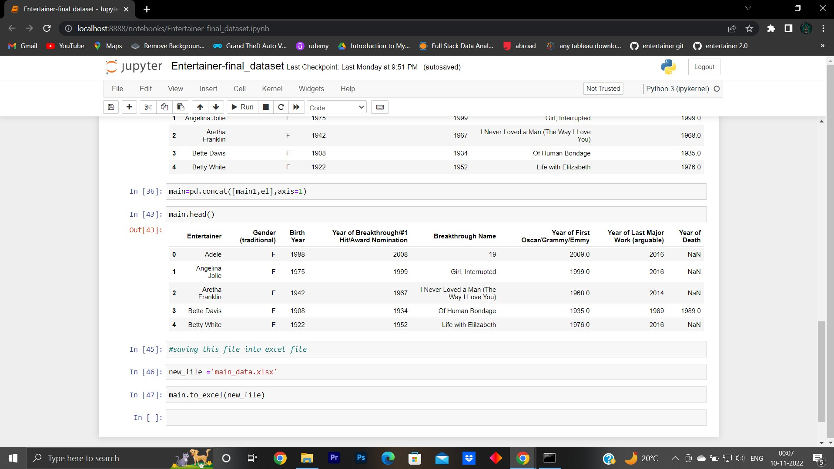

➤ After this, I combined this data into one sheet named **Entertainer-final-data,** but this data was not sufficient to do analysis and make a dashboard on it. For this, I have added some external information like awards they won, nominees etc. from **IMDb’s** official website (IMDb).

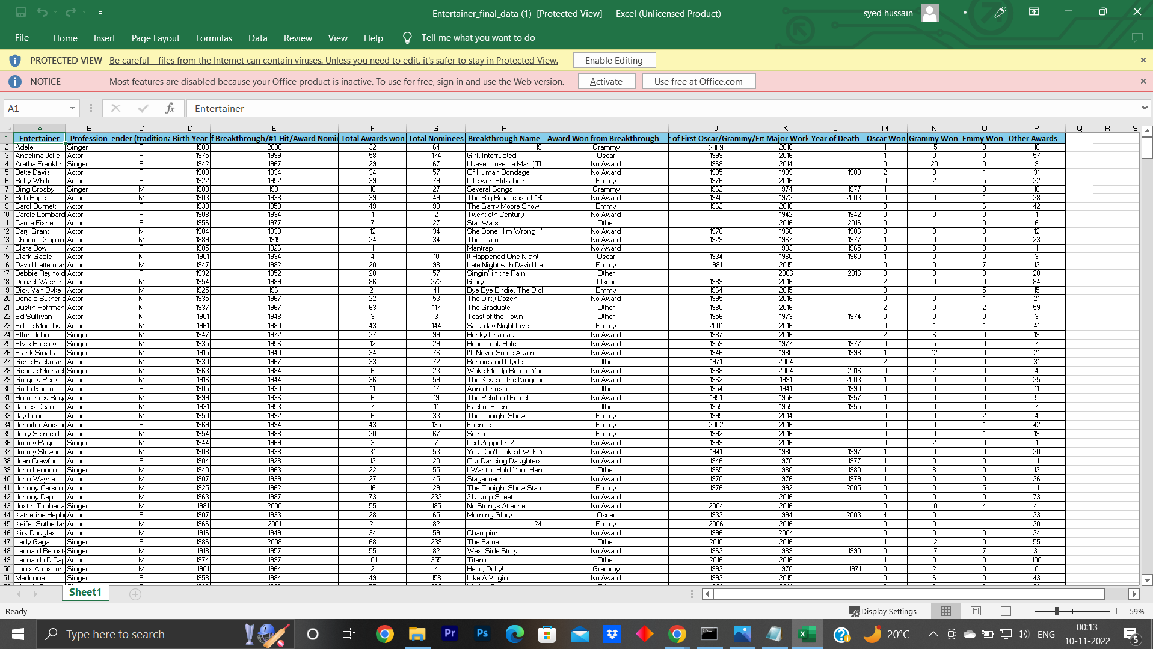

➤ *Then I pushed the data into the Tableau server as you will see in the last page.*

7

*Entertainer Data Analysis LLD Author:* Himani

➤ **Entertainer**: Name of the entertainer.

➤ **Gender (traditional)**: Gender of that entertainer

➤ **Birth Year**: Birth year of that entertainer

➤ **Year of Breakthrough/#1 hit/Award Nominatio**n: Here, breakthrough means super hit or career changing performance. Column shows year of breakthrough

➤ **Breakthrough Name:** Name of breakthrough. It can be either a musical album or TV show or movie.

➤ **Year of first Oscar/Grammy/Emmy:** Year of first mega award they won.

➤ **Year of Last Major Work (arguable):** Last major show or movie or album. You can also say last appearance.

➤ **Year of Death:** Entertainer’s year of death, if they die.

➤ **Award won from Breakthrough:** Any award/s from breakthrough. I only wrote about the mega awards they won in this column. If they had other awards for breakthroughs, I wrote “other”, if they didn't, I wrote “No Award”. If they have a mega award, I wrote that award name.

➤ **Total Awards Won:** Total awards that entertainer won throughout.

➤ **Total Nominees:** Total nominees for which they have chosen for award.

➤ **Profession:** Category of entertainer either singer or actor. Pop stars and dancers are included in singers and TV hosts and TV actors are included in actors.

➤ **Oscar won:** Number of total Oscar awards they won.

➤ **Grammy won:** Number of total Grammy awards they won.

➤ **Emmy won:** Number of total Emmy awards they won.

➤ **Other Awards:** Number of other awards they won apart from Oscar, Grammy and Emmy

8

*Entertainer Data Analysis LLD Author:* Himani

**Connect Data with Tableau & Deployment**

➤ First of all, open Tableau Public on your desktop. At the first screen, it will ask you to connect your files from various sources like MS Excel, SQL Server, Tableau Server etc.

➤ First screen of Tableau looks like:

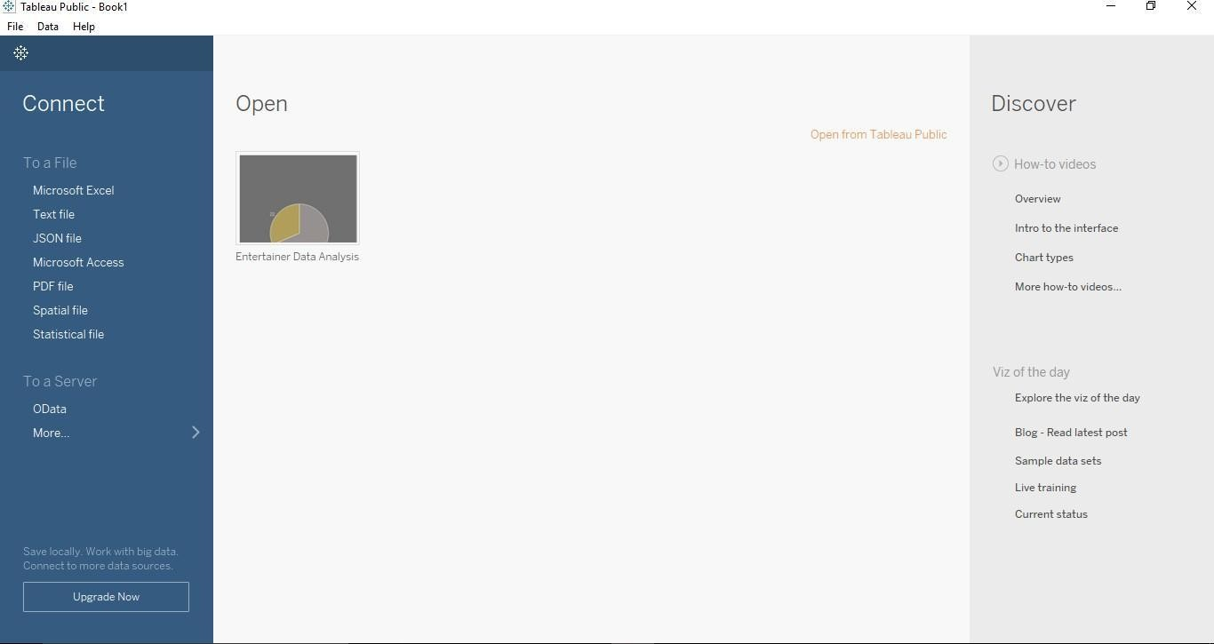

➤ Make sure the internet connection is connected well while working with tableau, otherwise it will show the error.

➤ After completion of work, you can simply press ctrl + s or save it from the file menu. It

will let you to tableau public’s website and ask you for signing in. After sign-in, your work will be saved on tableau's website. There, all can see the work.

➤ In **Tableau** we can make professional dashboards as you can in the dashboards provided to you on Tableau public server

9