**WEEK-5 (Part-2)**

**REPORT ON TOURIST GUIDE FOR TORONTO**

Prepared By: Himani Thakar

For Purpose: IBM Data Science Capstone Project

Introduction:

I have already given all the codes in Part-1. Although it is requirement for Part-2 to give all the codes, I have arranged all the screenshots of my work in this MS Word file.

I have divided all the codes into two sections:

1. Codes for Data Requirements

2. Codes for Methodology

As per the given instructions for part-2, this is my report for the codes:

**1. Codes for Data Requirements:**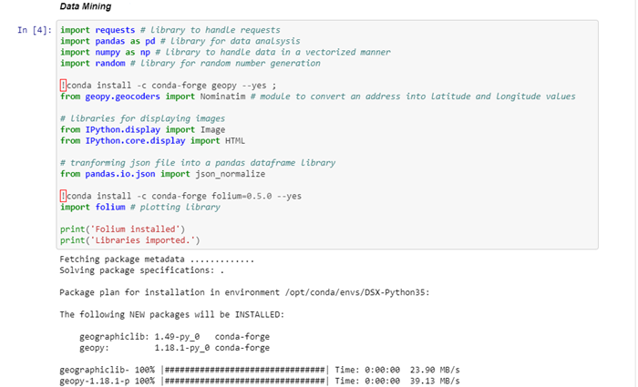

Figure : Screenshot-1

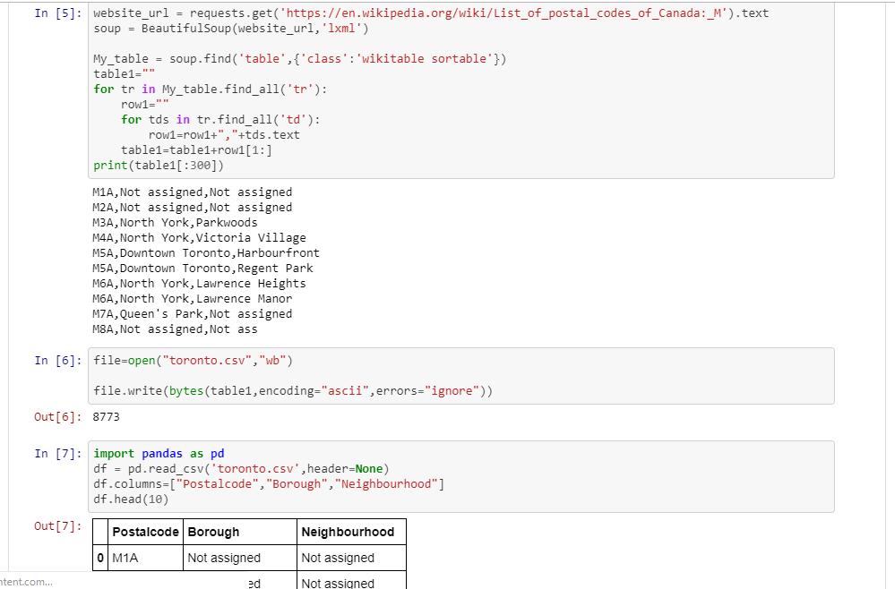

Figure : Screenshot 2

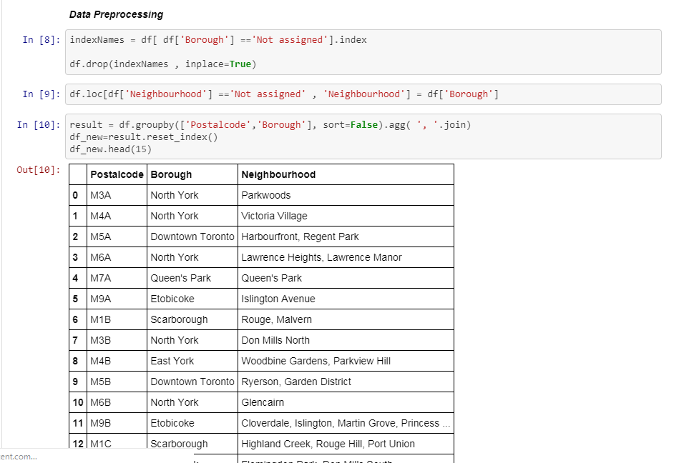

Figure : Screenshot-3

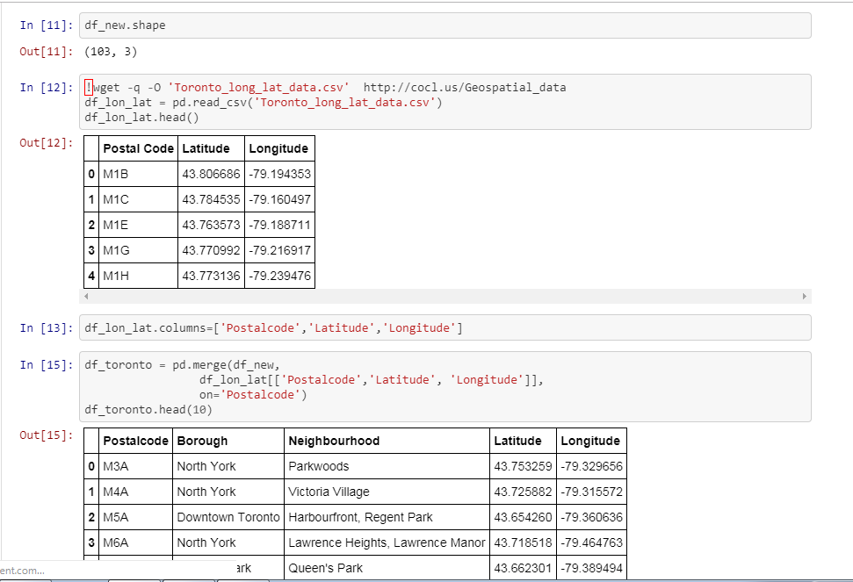

Figure : Screenshot 4

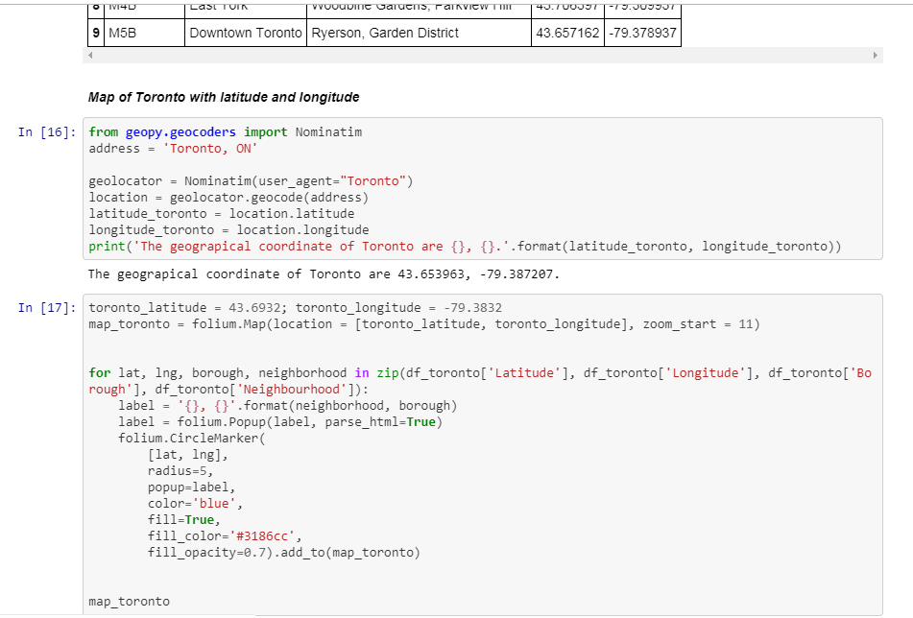

Figure : Screenshot-5

2. Codes for Methodology:

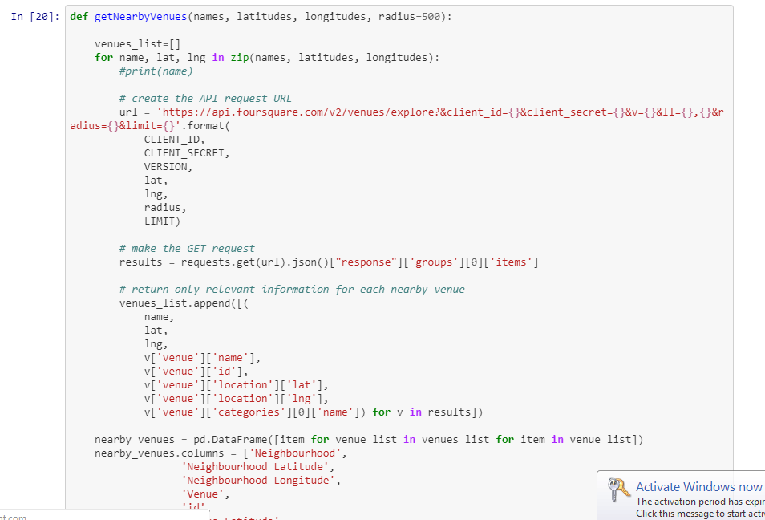

Figure : Screenshot-6

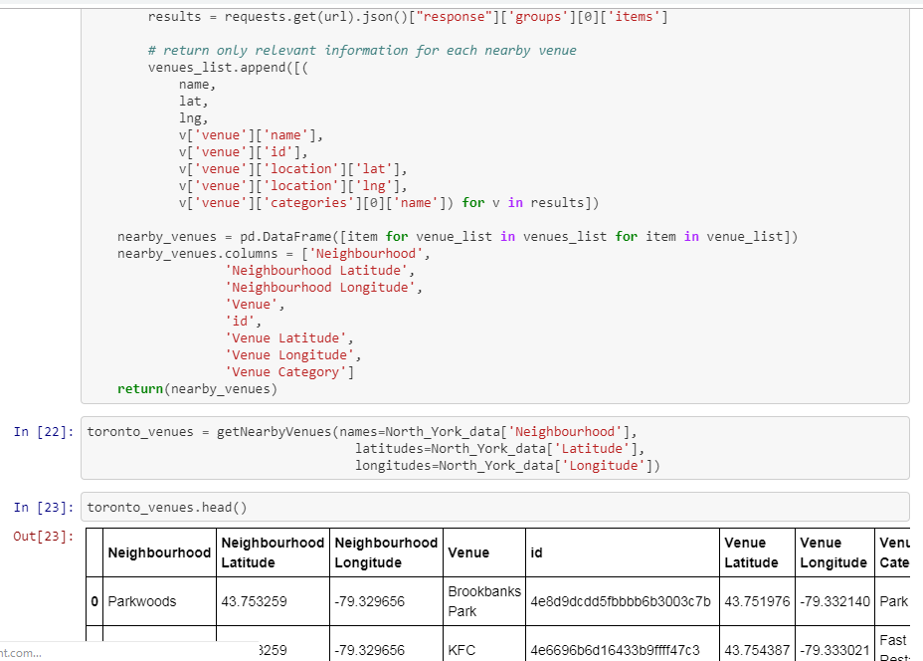

Figure : Screenshot 7

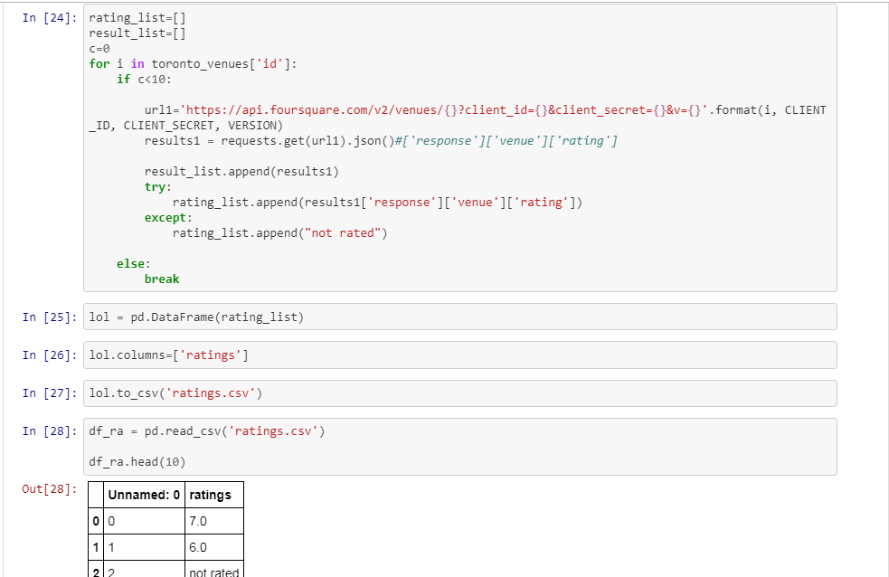

Figure : Screenshot 8

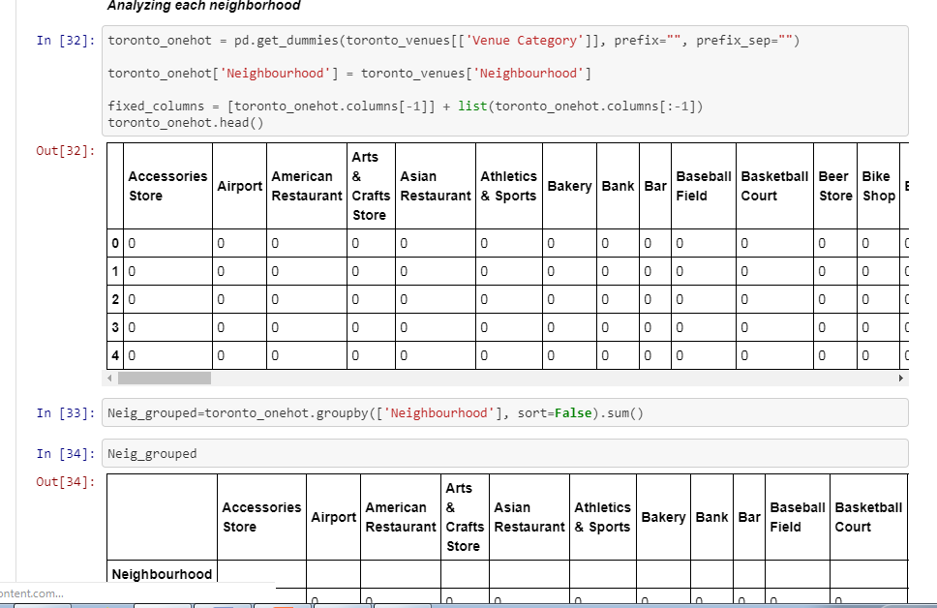

Figure : Screenshot 9

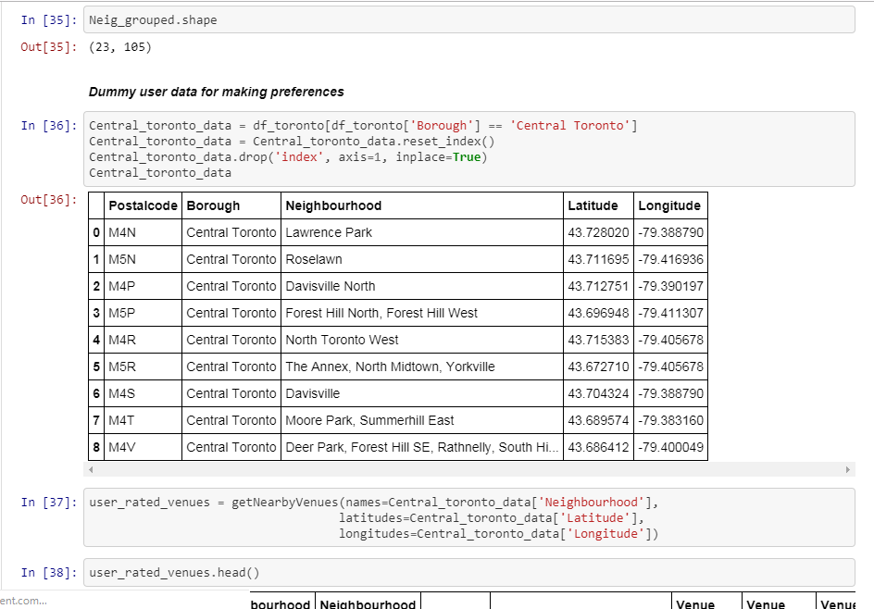

Figure : Screenshot 10

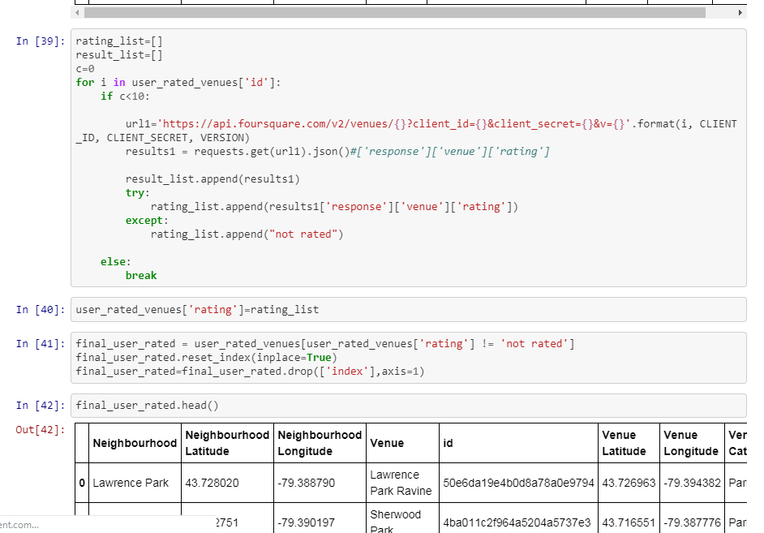

Figure : Screenshot 11

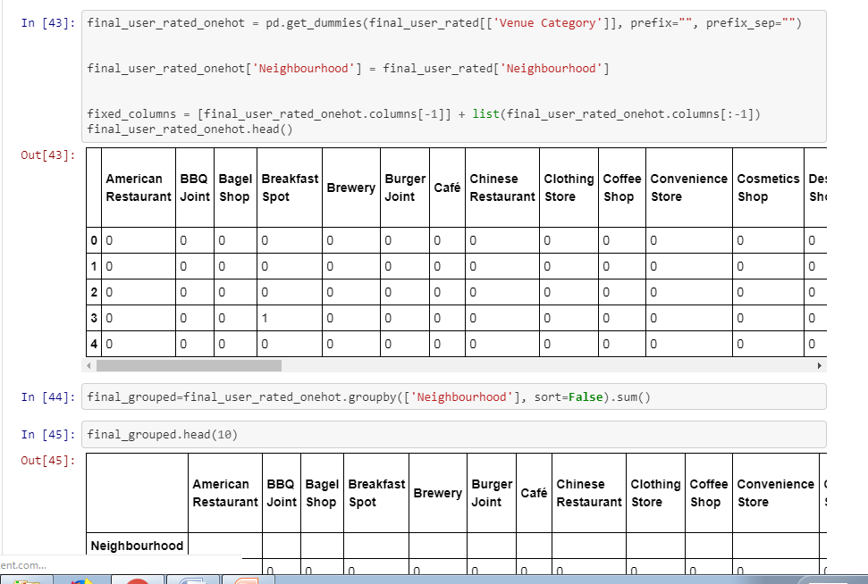

Figure : Screenshot 12

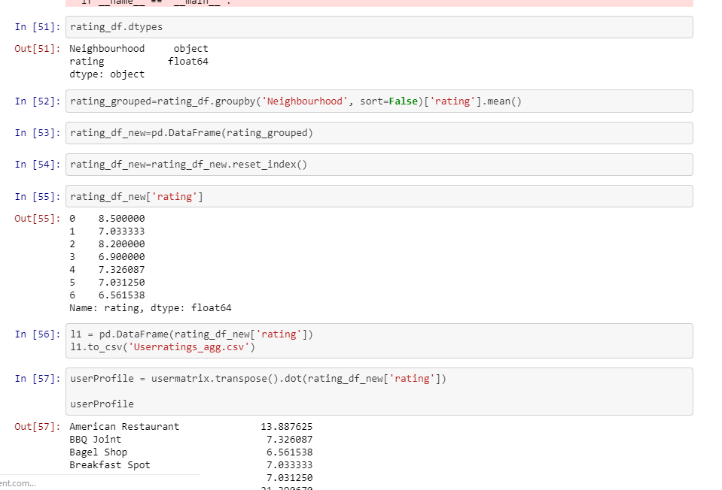

Figure : Screenshot 13

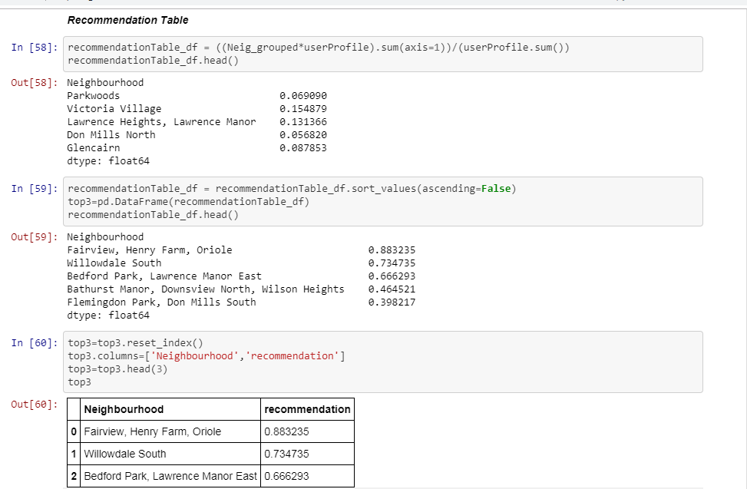

Figure : Screenshot 14

**CONCLUSION:**

As per the requirement of the report, I have sent Codes for my project in form of Screenshots. I have put my all the efforts to make it as better as possible.

THANKS FOR READING....