**Lab Assignment- 02**

**Objective:** Find out the names of all the clients from client_mast table.

**Solution:**

select name from client_mast;

**Output:**

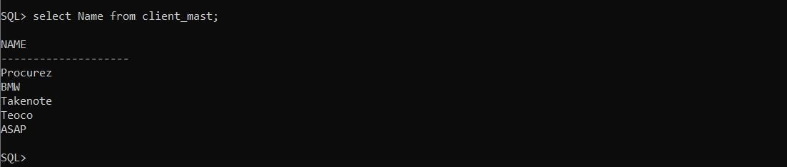

**Objective:** Retrieve all the records from client_mast table.

**Solution:**

Select * from client_mast;

**Output:**

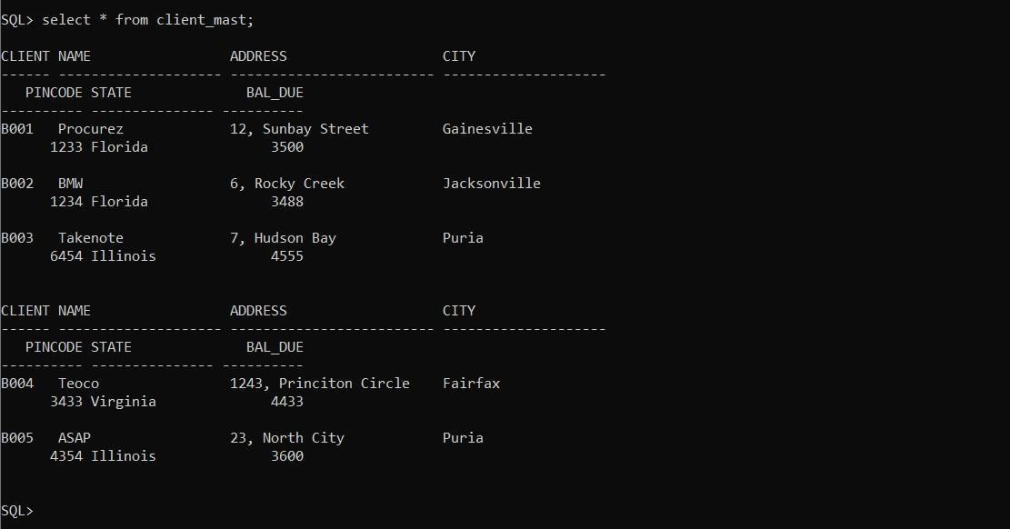

Retrieve the list of names, address and city of all the clients from client_mast.

**Solution:**

Select name, address, city from client_mast;

**Output:**

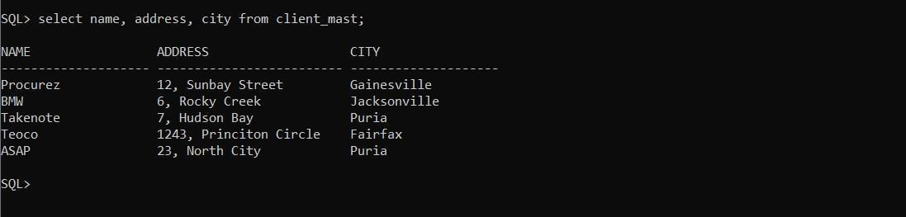

**Objective:** List all the clients who are staying in Florida from client_mast

**Solution:**

Select name from client_mast where state = ‘Florida’;

**Output:**

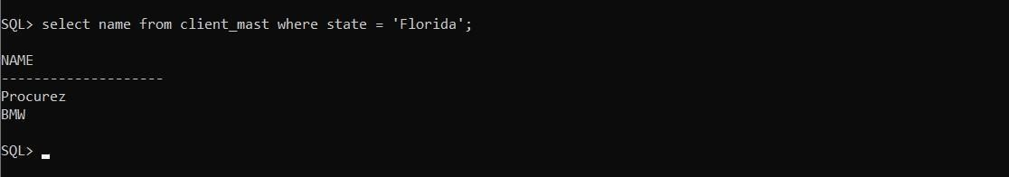

List the names of the employee who have a salary less than Rs 3000 from employee table.

**Solution:**

select ename from employee where basic_sal < 3000;

**Output:**

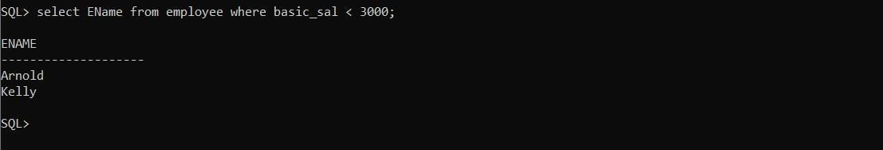

**Objective:** List the employee name, job and department no, of everyone whose name fall in the alphabetical range ‘C’ to ‘L’ from employee table.

**Solution:**

Select ename, job, dept_no from employee where ename between ’C%’ and ‘L%’;

**Output:**

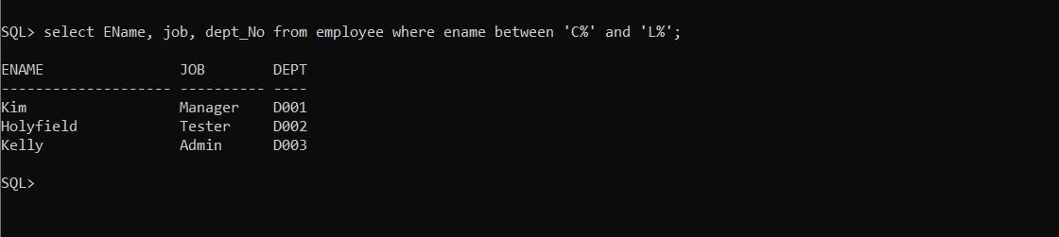

List all the employees whose name starts with the letter ‘K’ from employee table.

**Solution:**

select ename from employee where ename like ‘K%’;

**Output:**

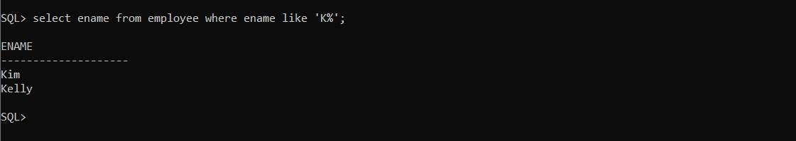

**Objective:** List the department name which is Located in Noida and Rocky creek from Dept table.

**Solution:**

Select dname from dept where loc = ‘Rocky Creek’ or loc = ‘Noida’;

**Output:**

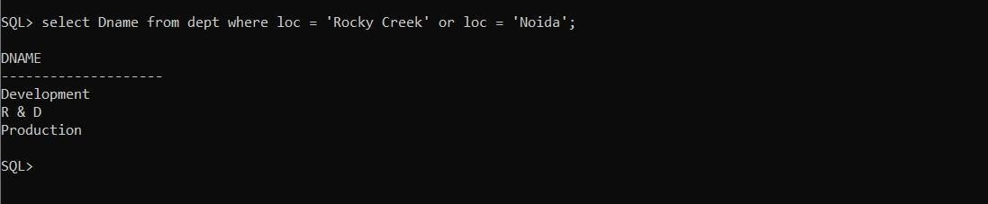

List the employee name working in department D002, D003 from employee table.

**Solution:**

Select ename from employee where dept_no = ‘D002’ or dept_no = ‘D003’;

**Output:**

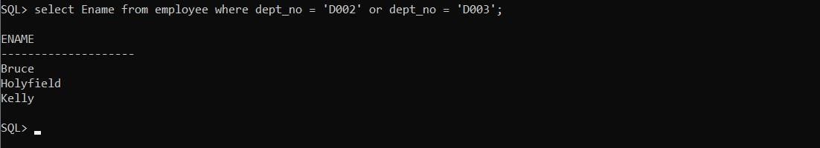

**Objective:** List all employee whose name start with ‘A’ and end with ‘D’ from employee table.

**Solution:**

Select ename from employee where ename like ‘A%’ and ename like ‘%d’; **Output:**

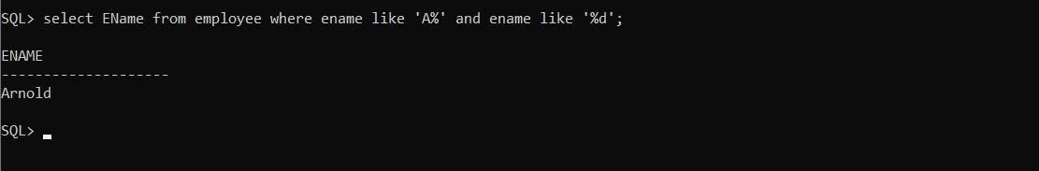

List all managers and salesman with salary over 2500 from employee table.

**Solution:**

select ename from employee where basic_sal > 2500 and (job = ‘Manager’ or

job= ‘Salesman’);

**Output:**

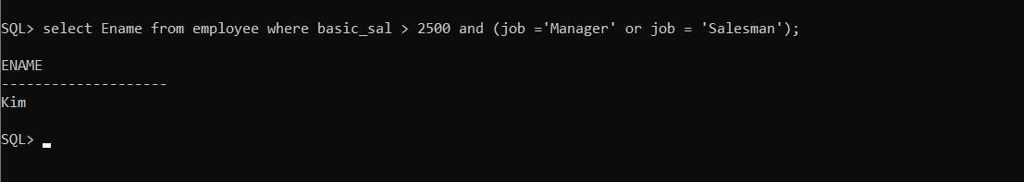

**Objective:** Display all the employee names in the ascending order of their date of joining from employee table.

**Solution:**

select ename from employee order by hiredate;

**Output:**

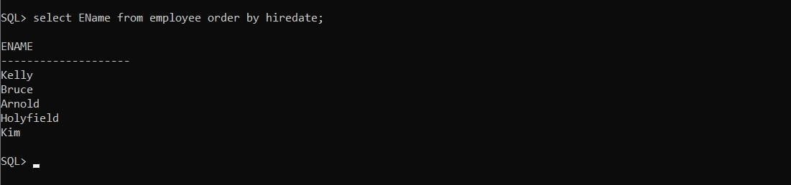

Display all the employees in alphabetical order from employee table.

**Solution:**

select ename from employee order by ename;

**Output:**

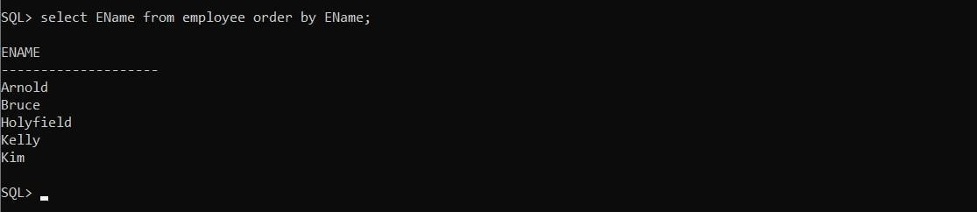

**Objective:** List all employee who were hired during 1999 from employee table.

**Solution:**

select ename from employee where hiredate like ‘%-%-99’;

**Output:**

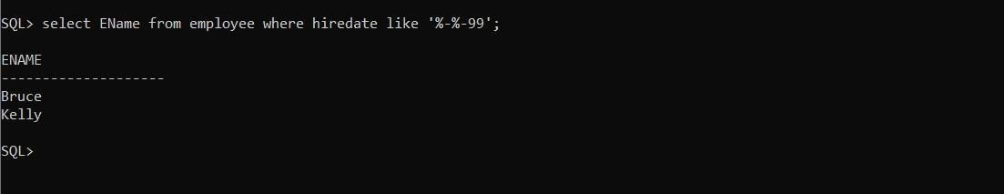

List all the employees whose commission is more than Rs. 300 from employee table.

**Solution:**

select ename from employee where comm > 300;

**Output:**

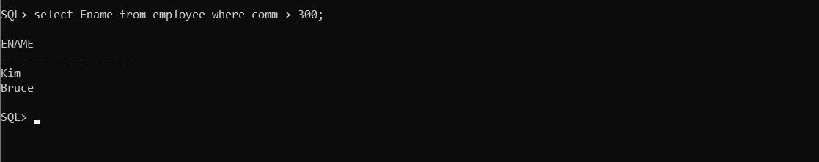

# Lab Assignment- 03

**Objective:** Change the city of client_no ‘B001’ from ‘Gainesville’ to ‘Paul Street’ from client_mast table.

**Solution:**

Update client_mast set city = ‘Paul Street’ where client_no = ‘B001’;

**Output:**

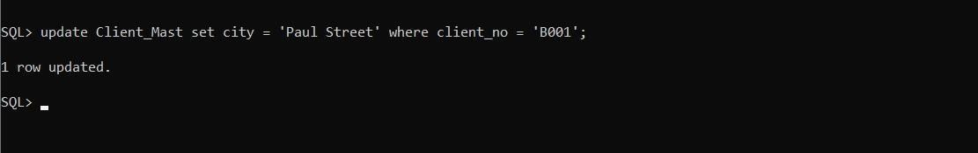

**Objective:** Change the bal_due of client_no B005 to Rs. 2000 from client_mast table.

**Solution:**

Update Client_mast set bal_due = 2000 where client_no = ‘B005’;

**Output:**

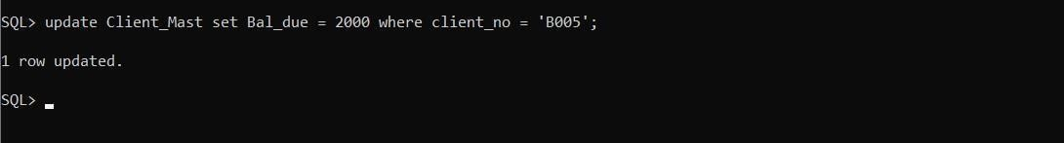

Change the name to ‘infospace’ of client_no B004 in the table client_mast table.

**Solution:**

Update Client_Mast set name = ‘Infospace’ where clietnt_no = ‘B004’;

**Output:**

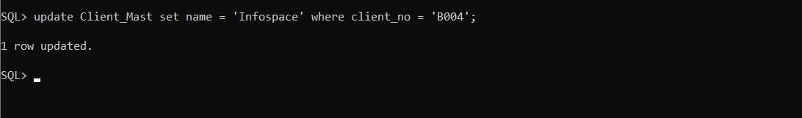

**Objective:** Change the client_no ‘B004’ to ‘B009’ in the table client_mast.

**Solution:**

Update client_mast set client_no = ‘B009’ where client_no = ‘B004’;

**Output:**

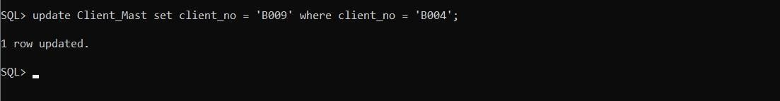

Change the city of salesman from ‘Jacksonville’ to ‘Huston’ from salesman_mast table.

**Solution:**

Update Salesman_mast set city = ‘Huston’ where cirty = ‘Jacksonville’;

**Output:**

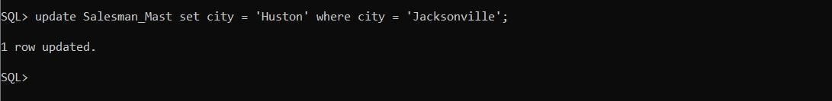

**Objective:** Change the basic salary Rs 3000 where basic salary less than 2500 from employee table.

**Solution:**

Update employee set Basic_sal = 3000 where Basic_sal <2500;

**Output:**

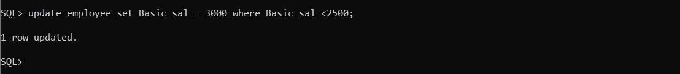

Change the basic_sal = 3000 where job in clerk from employee table.

**Solution:**

Update employee set Basic_sal = 3000 where job = ‘Clerk’;

**Output:**

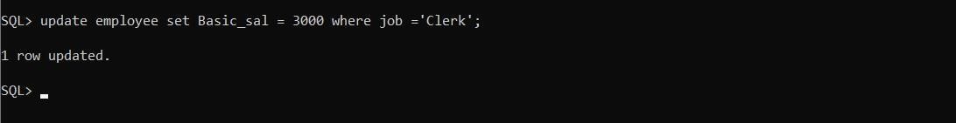

**Objective:** Change the basic salary of Employee Number E004 to Rs. 3500 from employee table.

**Solution:**

Update employee set basic_sal = 35000 where empNo = ‘E004’;

**Output:**

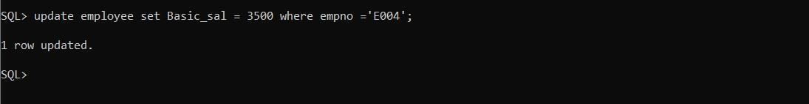

Change the Department name to ‘Sales’ from dept table where Deptno is ‘D004’.

**Solution:**

Update dept set dname = ‘Sales’ where deptno = ‘D004’;

**Output:**

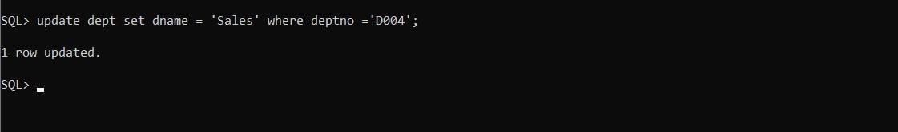

**Objective:** Change the description of product number ‘PR065’ to AC in the product_mast table.

**Solution:**

Update product_mast set description = ‘AC’ where product_no = ‘PR065’; **Output:**

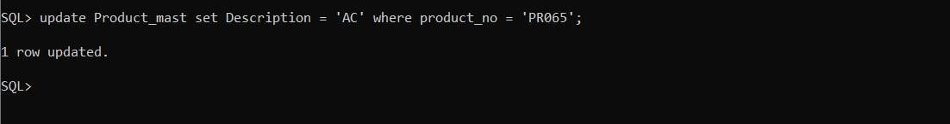

Change the Profit percernt of Product Number ‘PR065’ to 25% in the Product_mast table.

**Solution:**

Update product_mast set profit_perc = 25 where product_no = ‘PR065’;

**Output:**

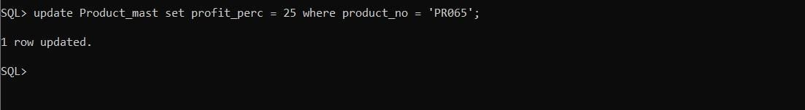

**Objective:** Change the available quantity of Product Number ‘PR065’ to 120 in the Product_Mast table.

**Solution:**

Update product_mast set qty_available = 120 where product_no = ‘PR065’;

**Output:**

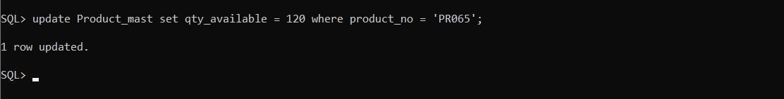

Change the cost price and selling price of Prodecu Number ‘PR065’ to 5000 and 6250 in the Product_mast table.

**Solution:**

Update product_mast set cost_price = 5000, sell price = 6250 where product_no = ‘PR065’;

**Output:**

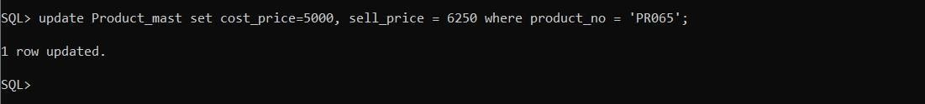

**Objective:** Change the units where Product Number ‘PR065’ to ‘pack of 10’ in the Product_mast table.

**Solution:**

Update Product_mast set units = ‘Pack of 10’ where product_no = ‘PR065’;

**Output:**

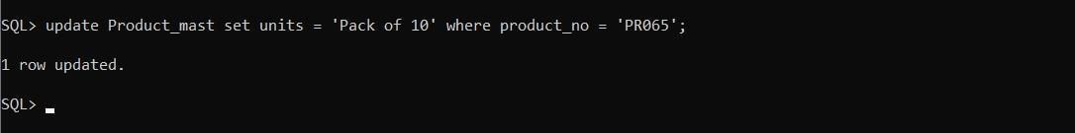

Create a sequence named counter which is incremented by 1 and

starts with 1.

**Solution:**

create sequence counter start with 1 increment by 1;

**Output:**

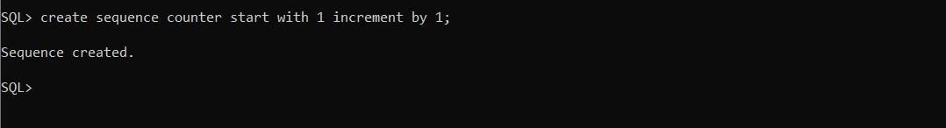

**Objective:** Create a sequence named counter which is incremented by 5 and starts with 25.

**Solution:**

Create sequence counter start with 25 increment by 5;

**Output:**

