ANALYSING HOUSING PRICES IN METROPOLITAN AREAS OF INDIA

**PROJECT REPORT**

**1.INTRODUCTION:**

**1.1 OVERVIEW:**

At First, I created an EMPATHY MAP, A map which has four quadrants (Says , Thinks, Does and feels ) .In that map , I included the difficulties & problems faces by the peoples when they started to predict the housing prices in meteropolitan areas of India and other facilities in the houses & near by the houses . And then I created the BRAINSTORM in that, I & my team discuss about the problems & difficulties faced by the peoples & we findout the solutions for that problems. Moreover, I have created Data Analysing Dashboard & Story then I published it in Tableau pubic .

**1.2 PURPOSE:**

Data Analysing helps a business & also for peoples to optimize the performance , to perform more efficiently or strategically guided decisions . The techniques & processes of Data Analytics have been automated into mechanical processes & algorithms that work over raw data for human consumption .

**PROBLEM DEFINITION &DESIGN THINKING:**

**1.2 EMPATHY MAP:**

An Empathy map was originally created by Dave Gray and has gained much popularity within the agile community .

An Empathy map is a collaborative tool, used in design thinking to build an emotional representation of a user or the customer . It’s versatile activity that may be used to generate new production ideas as well as better understand existing ones .

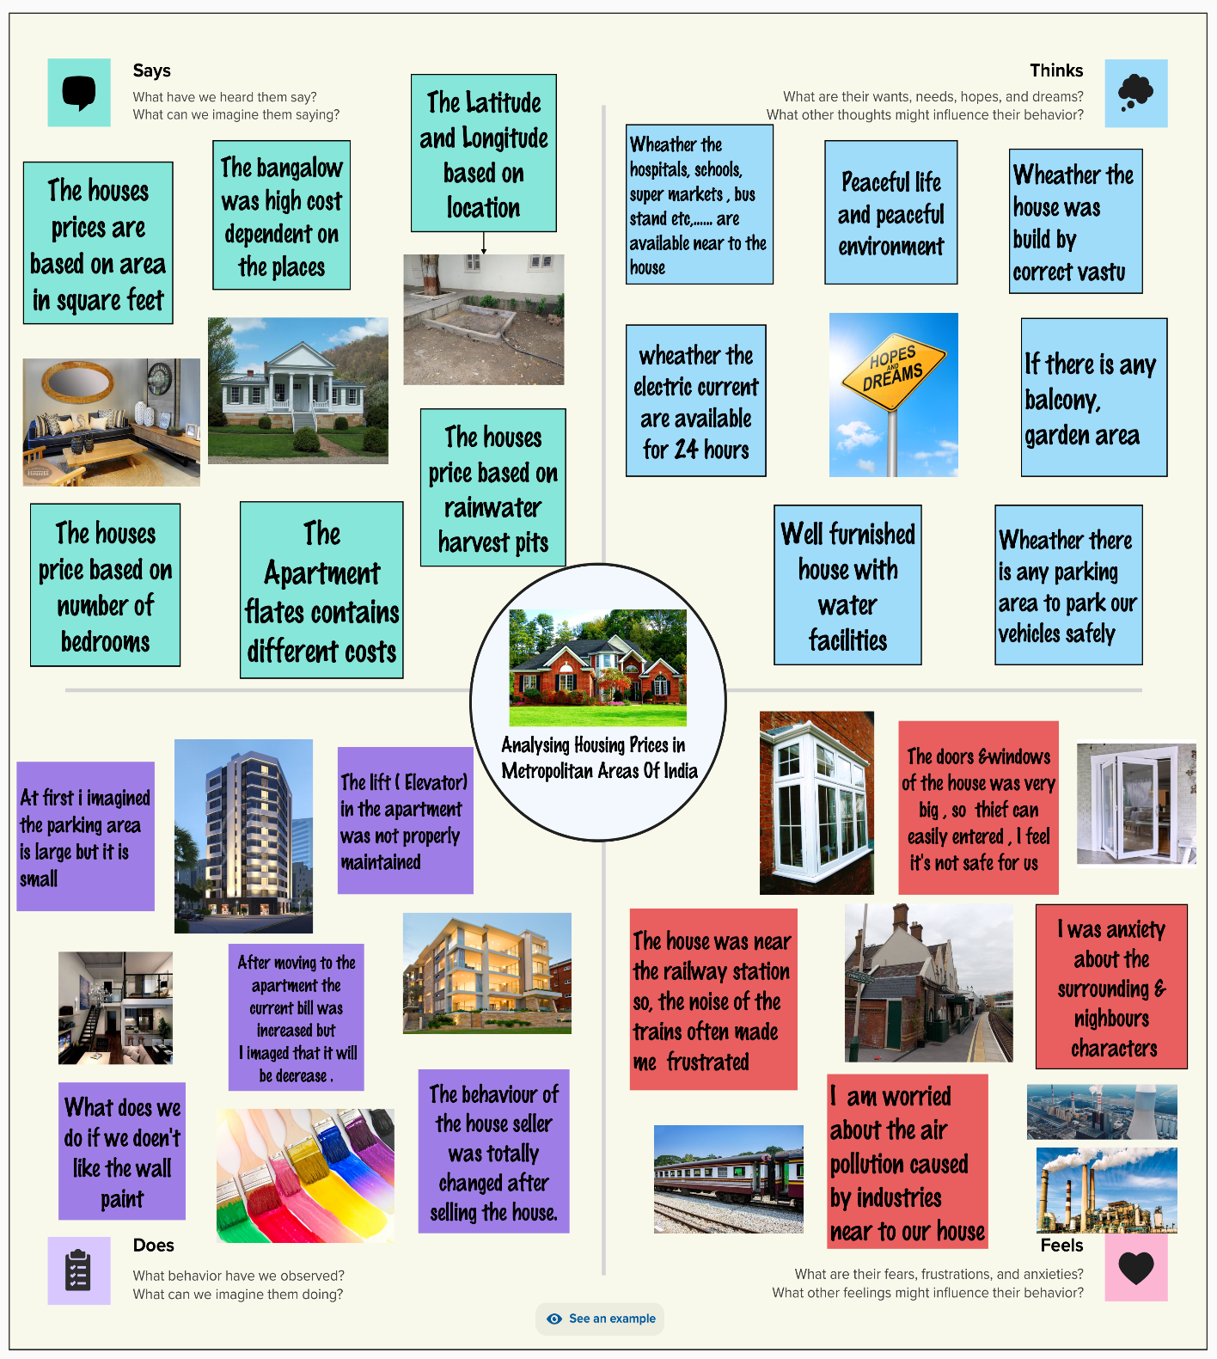

**2.2 IDEATION & BRAIN STORMING MAP:**

Brain storming is agroup of solving method that involves the spontaneous contribution of creative ideas &solutions . This technique requires intensive , freewheeling discussion in which every member of the group is encouraged to think aloud and suggest the many ideas as possible based on their diverse knowledge .

These principles led Osborn to establish , withhold criticism, welcome unusual ideas , combine & improve ideas .

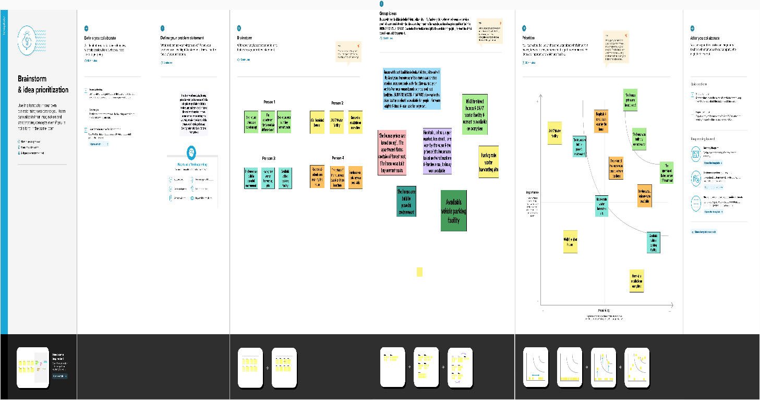

**3.RESULT:**

**DASHBOARD 1**

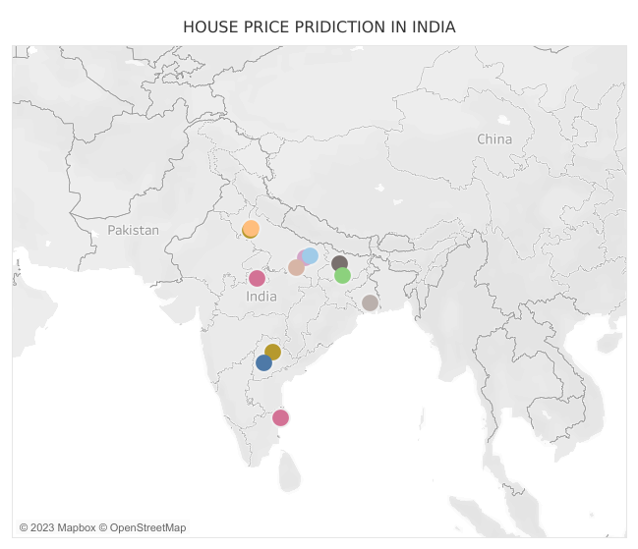

**DASHBOARD 2**

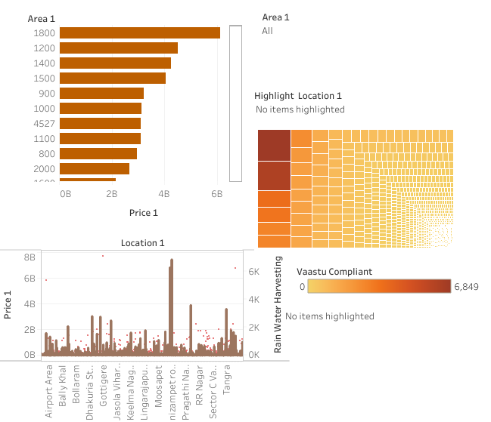

**DASHBOARD 3**

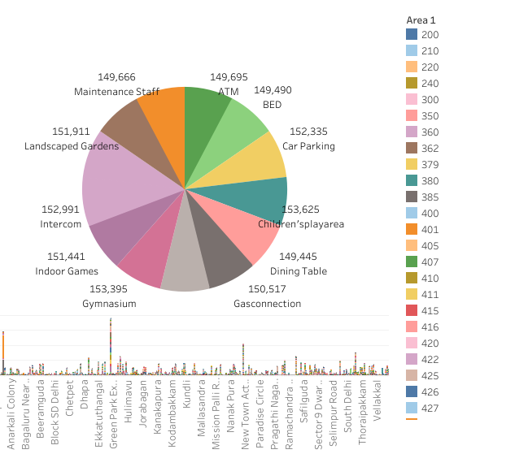

**DASHBOARD 4**

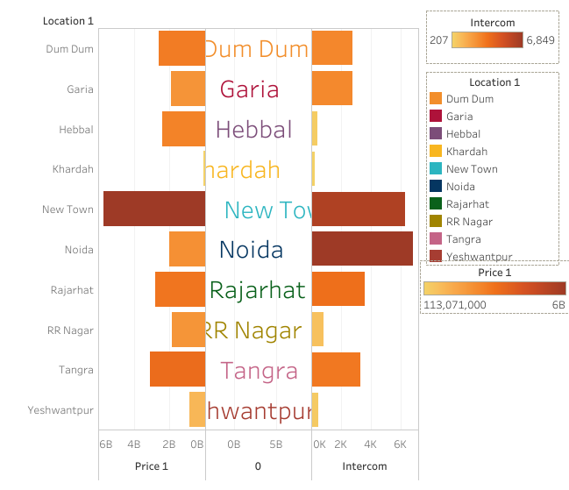

**STORY 1**

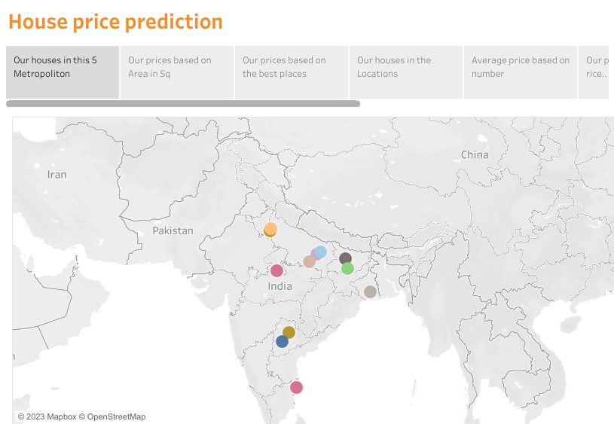

**STORY 2**

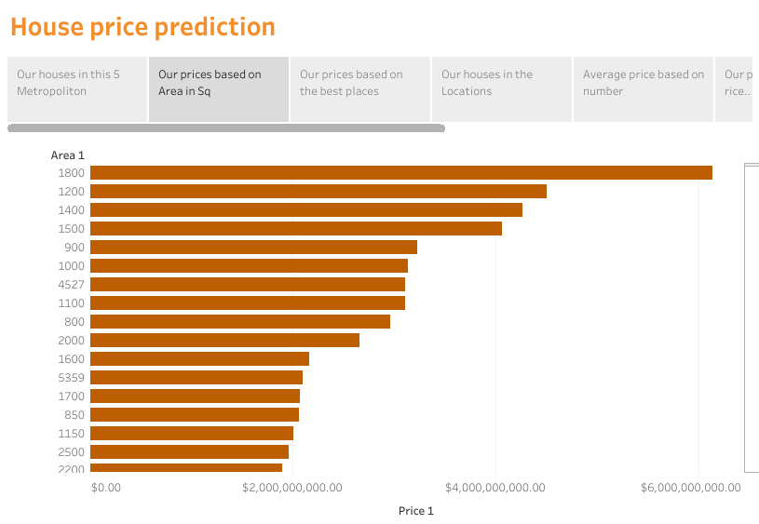

**STORY 3**

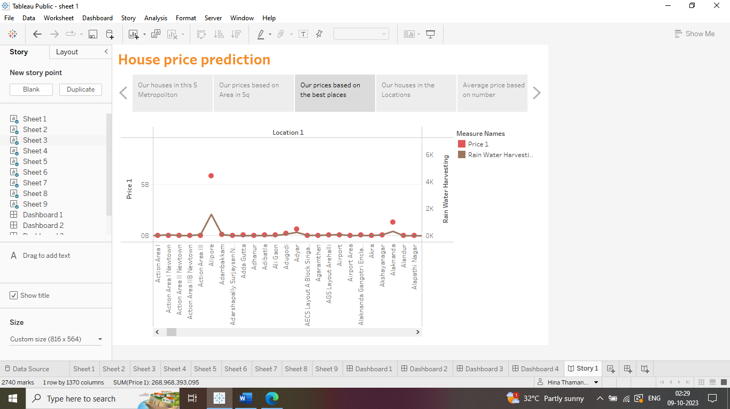

**STORY 4**

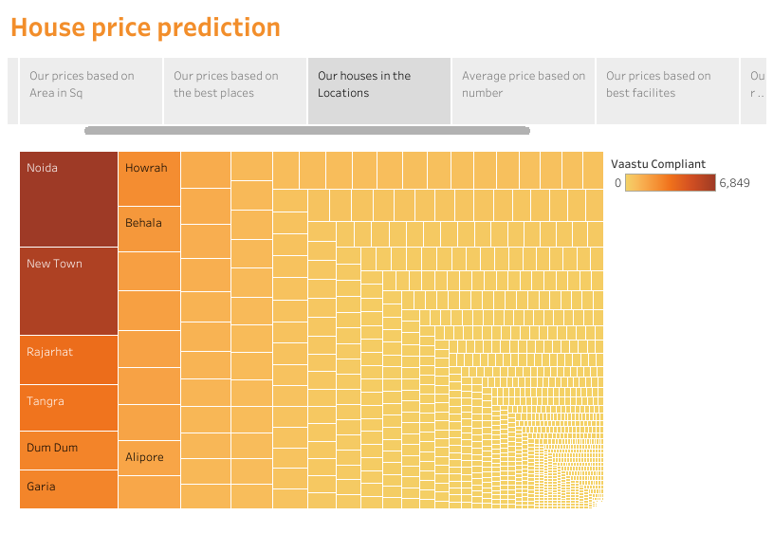

**STORY 5**

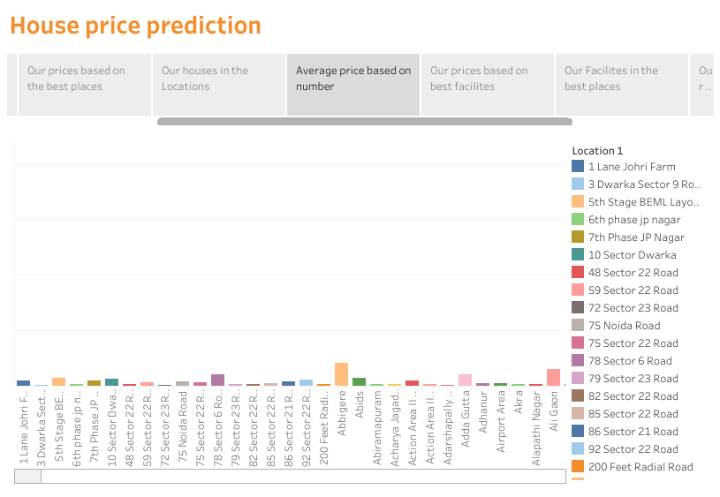

**STORY 6**

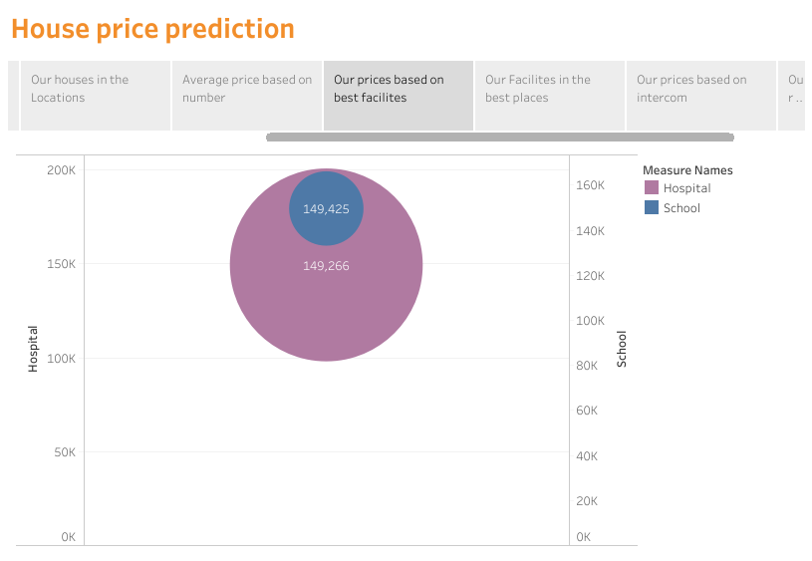

**STORY 7**

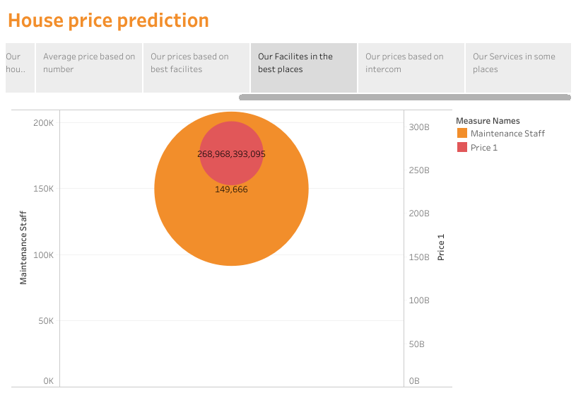

**STORY 8**

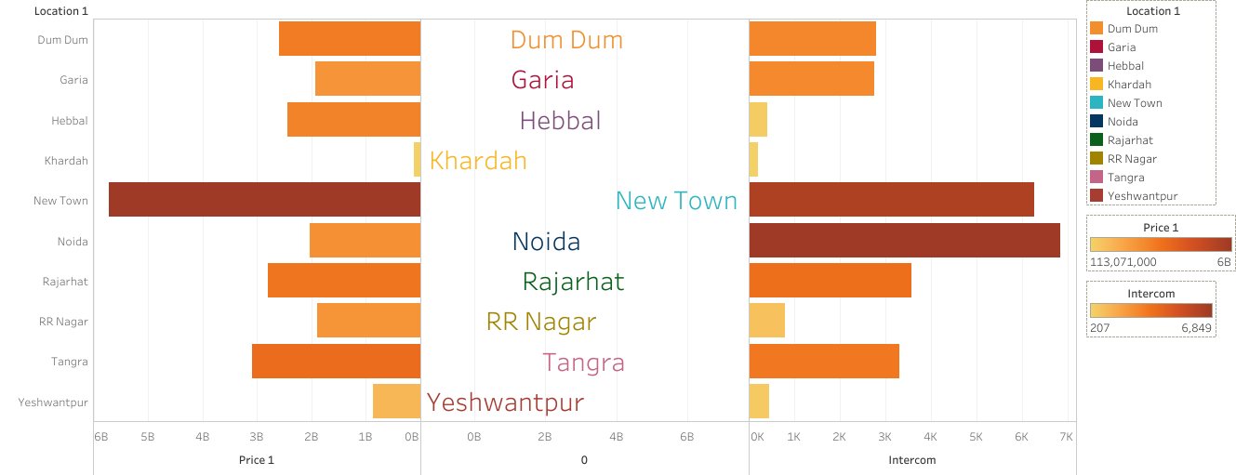

**STORY 9**

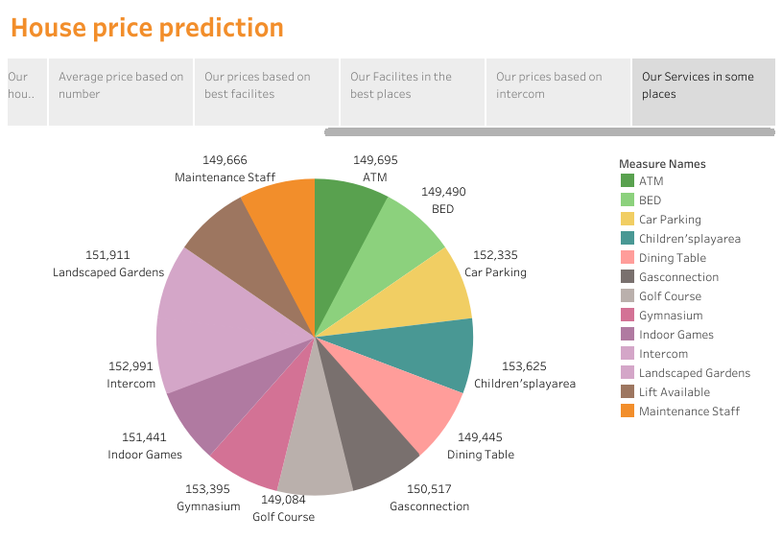

**4. PROS AND CONS:**

**PROS:**

* House price prediction can help the developer to determine the selling price of a house & can help the customer to arrange the right time to purchase a house .
* There are three factors that influence the price of a house which include **Physical condition , concepts & location .**

**CONS:**

* It doesn’t predict future prices of the houses mentioned by the customer.
* Due to the risk in investment in an apartment or an area increases considerably.
* To minimize the error , customer tend to hire an agent which again increases the cost of the process.

**5 . APPLICATIONS:**

House price prediction can help the developer to determine the selling price of a house and can help the customer to arrange the right time to purchase a house . The values of X and Y variables are training datasets for the model representation of linear regression . Linear regression is a valuable tool for predicting house prices based on specific feature.

**6.** **CONCLUSION:**

Based on the criterion of price convergence , **house prices in 15 metropolitan cities do not converge to the loop ,** this implies that the markets in the different areas operate as segmented independent local markets.

**7. FUTURE SCOPE:**

Future scope is **a value of an investment or asset on specific data in the future** . As per various reports, **real** **estate in India is poised for immense growth** , According to the housing prices 2023 will be momentous year for the industry .

In fact, 2023 is considered as a boom year for real estate .To put it another way, future is the amount of money a given investment will be worth after a certain period , assuming a specific rate of return . An India **2023 has predicted an economic boom for india , which will make it the third largest country in the world by the year of 2007** .