**727721EUIT054**

**HIROSINI P**

**II IT A**

DAY – 4

TASK – 1: [ Selenese Commands ]

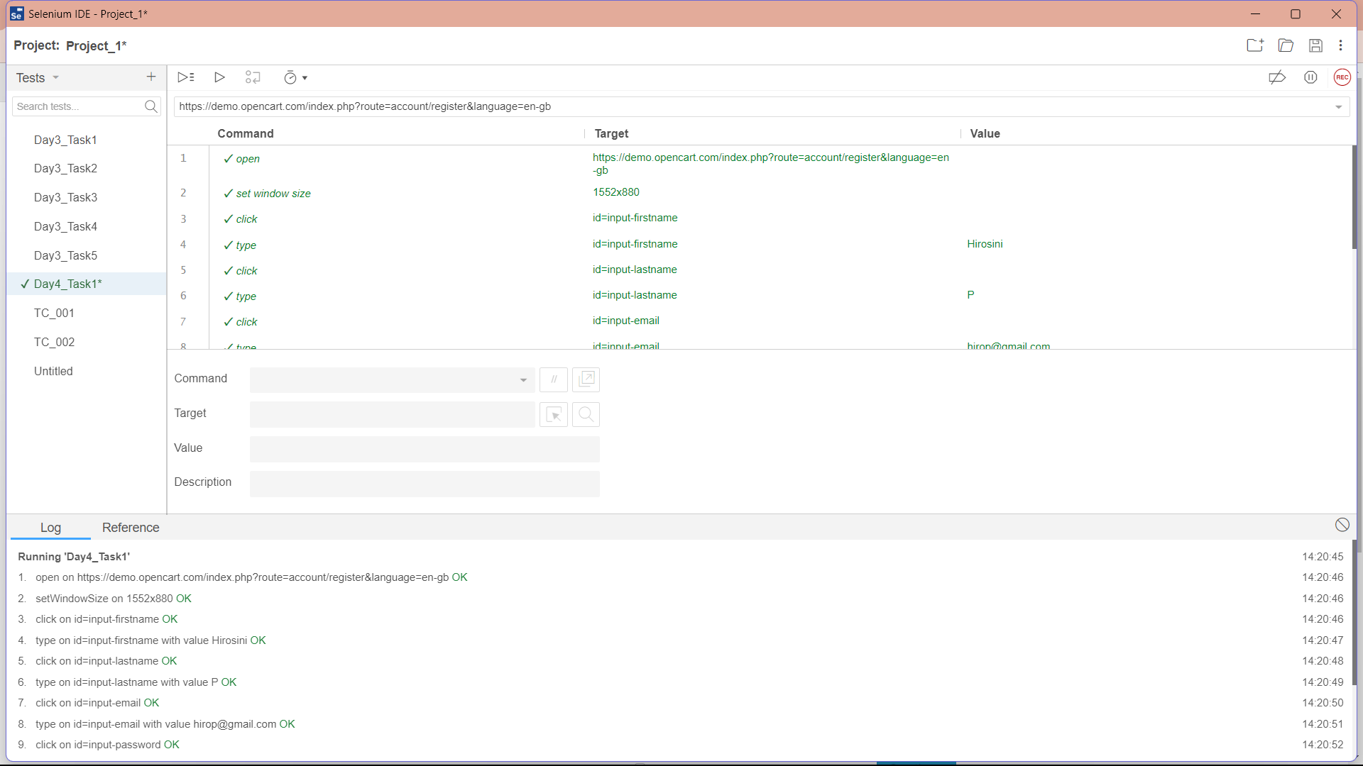

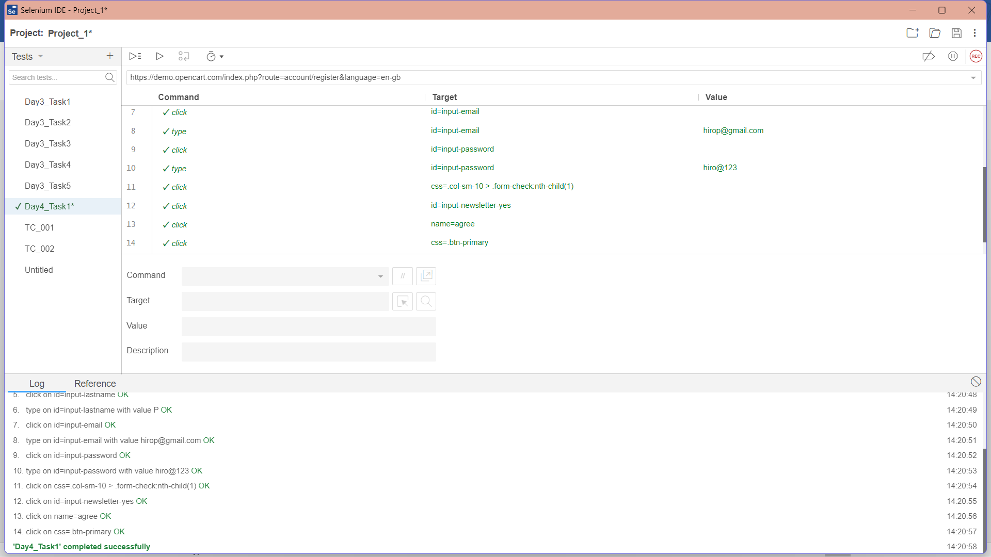

TASK – 2: [ LOCATOR ]

CODE:

package com.selenium.test1.selenium1;

import org.openqa.selenium.By;

import org.openqa.selenium.WebDriver;

import org.openqa.selenium.WebElement;

import org.openqa.selenium.chrome.ChromeDriver;

import org.openqa.selenium.chrome.ChromeOptions;

import io.github.bonigarcia.wdm.WebDriverManager;

public class Day4T2

{

public static void main(String args[])

{

WebDriverManager.chromedriver().setup();

ChromeOptions co=new ChromeOptions();

co.addArguments("--remote-allow-origins=*");

WebDriver driver=new ChromeDriver(co);

driver.get("https://demo.opencart.com/index.php?route=account/register&language=en-gb");

driver.manage().window().maximize();

WebElement fn=driver.findElement(By.id("input-firstname"));

System.out.println(fn);

WebElement ln=driver.findElement(By.id("input-lastname"));

System.out.println(ln);

WebElement email=driver.findElement(By.id("input-email"));

System.out.println(email);

WebElement pw=driver.findElement(By.id("input-password"));

System.out.println(pw);

WebElement sb=driver.findElement(By.id("input-newsletter-yes"));

System.out.println(sb);

}

}

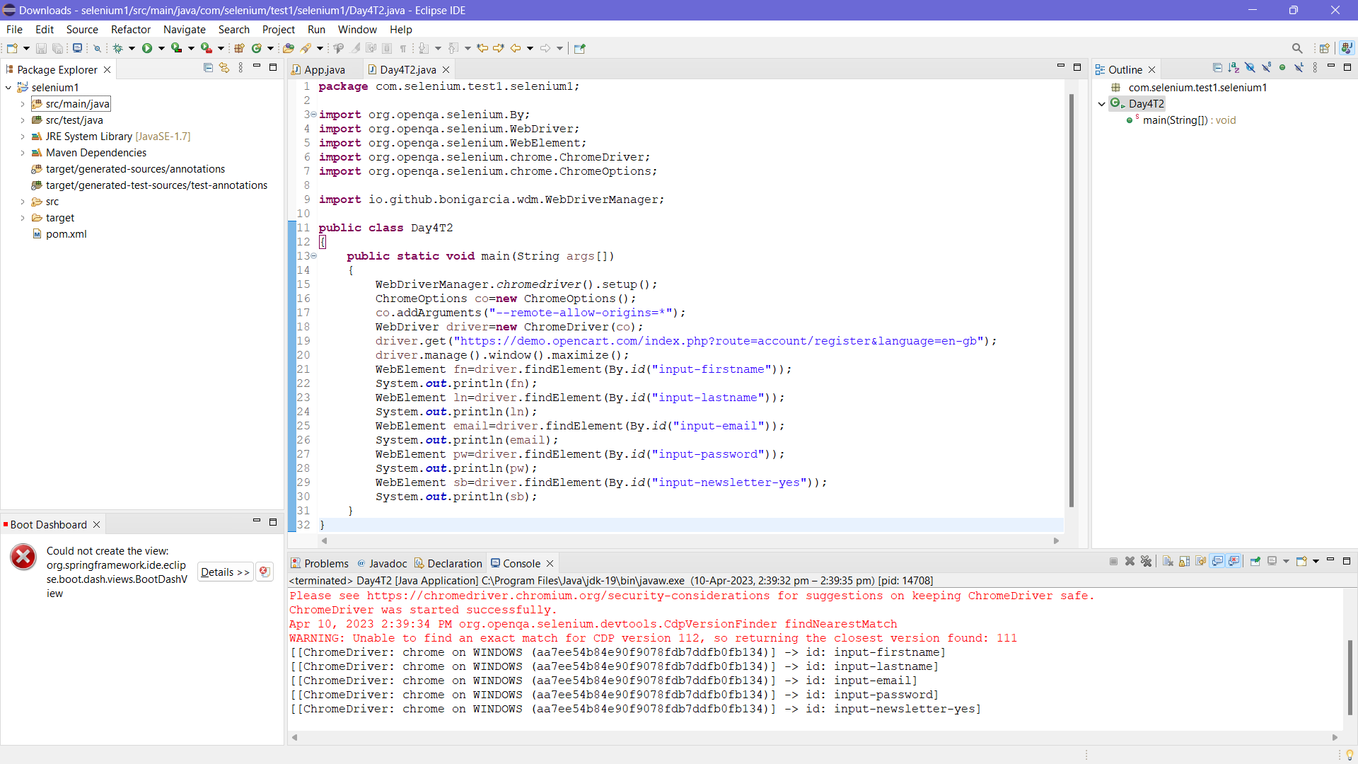

TASK – 3 [ Using XPATH ]

CODE:

package com.selenium.test1.selenium1;

import org.openqa.selenium.By;

import org.openqa.selenium.WebDriver;

import org.openqa.selenium.WebElement;

import org.openqa.selenium.chrome.ChromeDriver;

import org.openqa.selenium.chrome.ChromeOptions;

import io.github.bonigarcia.wdm.WebDriverManager;

public class Day4T3

{

public static void main(String args[])

{

WebDriverManager.chromedriver().setup();

ChromeOptions co=new ChromeOptions();

co.addArguments("--remote-allow-origins=*");

WebDriver driver=new ChromeDriver(co);

driver.get("https://demo.opencart.com/index.php?route=checkout/voucher&language=en-gb");

driver.manage().window().maximize();

WebElement rn=driver.findElement(By.xpath("//*[@id=\"input-to-name\"]"));

System.out.println(rn);

WebElement remail=driver.findElement(By.xpath("//*[@id=\"input-to-email\"]"));

System.out.println(remail);

WebElement name=driver.findElement(By.xpath("//*[@id=\"input-from-name\"]"));

System.out.println(name);

WebElement email=driver.findElement(By.xpath("//*[@id=\"input-from-email\"]"));

System.out.println(email);

WebElement gc=driver.findElement(By.xpath("//*[@id=\"input-theme-8\"]"));

System.out.println(gc);

WebElement mess=driver.findElement(By.xpath("//*[@id=\"input-message\"]"));

System.out.println(mess);

WebElement am=driver.findElement(By.xpath("//*[@id=\"input-amount\"]"));

System.out.println(am);

}

}

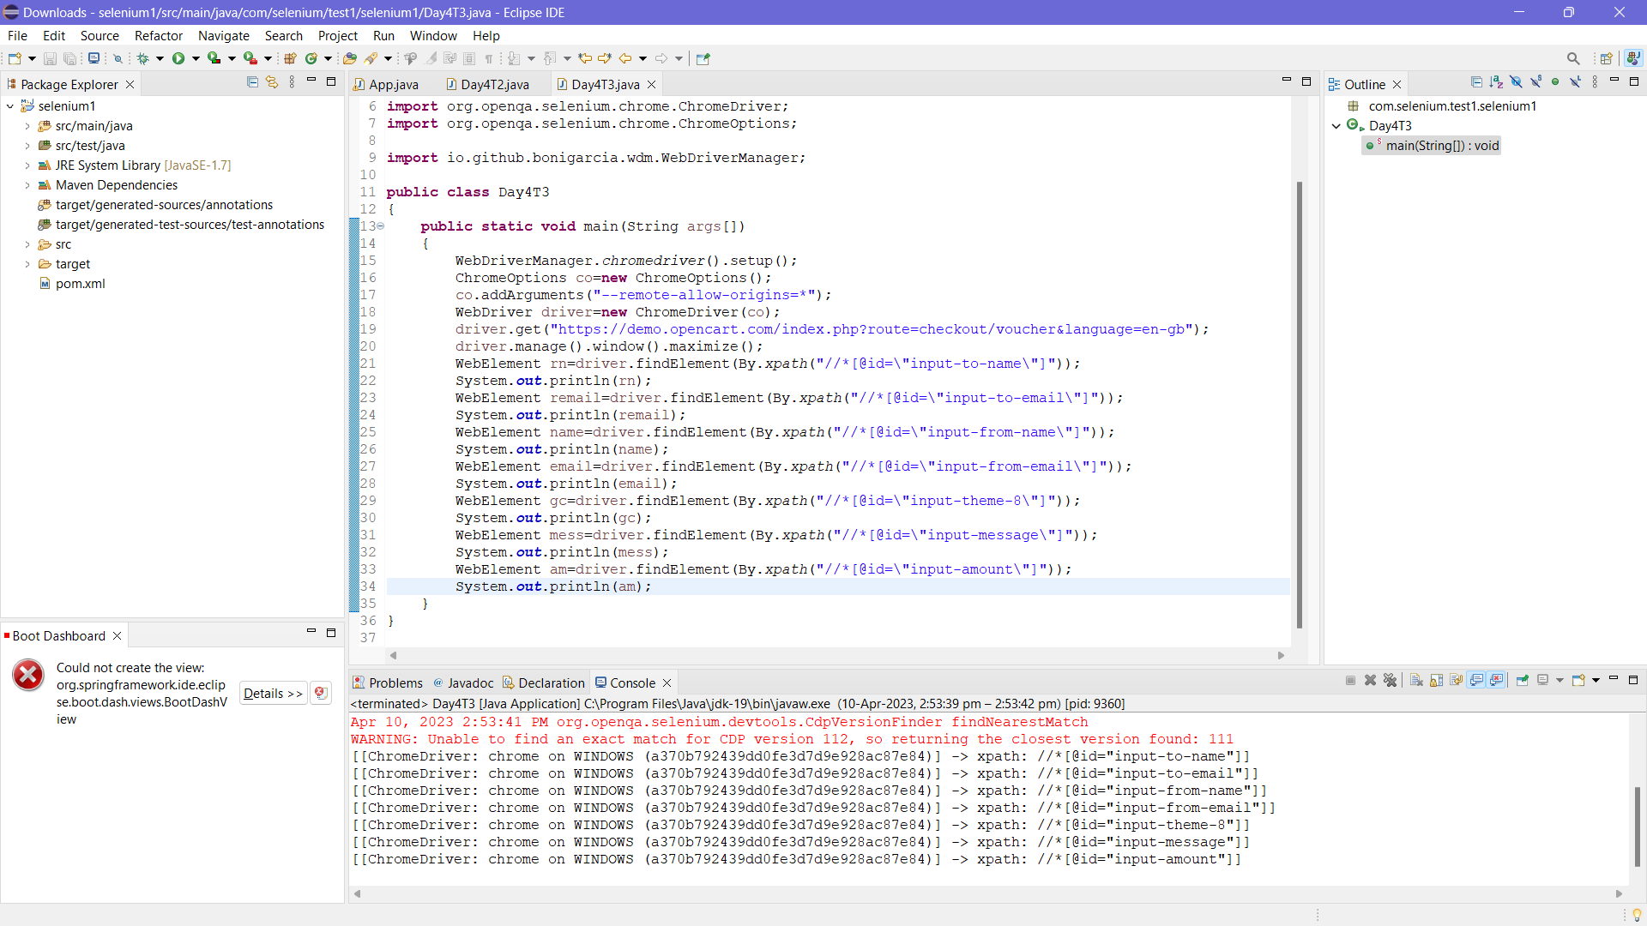

TASK – 4 [ WEB NAVIGATION COMMANDS ]

CODE:

package com.selenium.test1.selenium1;

import org.openqa.selenium.By;

import org.openqa.selenium.JavascriptExecutor;

import org.openqa.selenium.WebDriver;

import org.openqa.selenium.chrome.ChromeDriver;

import org.openqa.selenium.chrome.ChromeOptions;

import io.github.bonigarcia.wdm.WebDriverManager;

public class Day4T4

{

public static void main(String args[])

{

WebDriverManager.chromedriver().setup();

ChromeOptions co=new ChromeOptions();

co.addArguments("--remote-allow-origins=*");

WebDriver driver=new ChromeDriver(co);

driver.get("https://j2store.net/free/");

driver.manage().window().maximize();

JavascriptExecutor js=(JavascriptExecutor) driver;

js.executeScript("window.scrollBy(0,1000)","");

driver.findElement(By.linkText("Clothing (5)")).click();

driver.navigate().back();

driver.navigate().forward();

driver.navigate().refresh();

driver.quit();

}

}

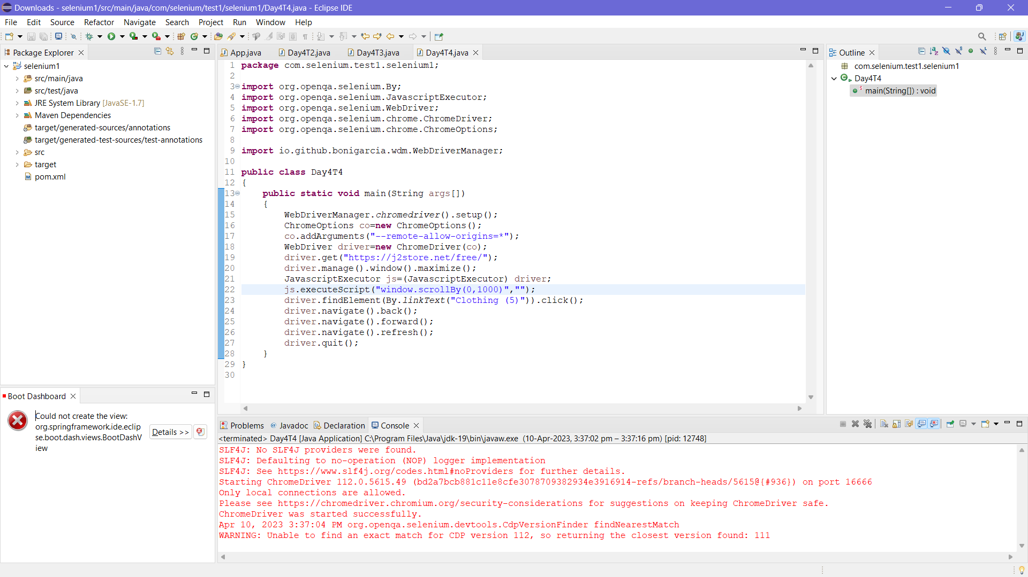

TASK – 5 [ 5.1 – WEB DRIVER COMMANDS ]

CODE:

package com.selenium.test1.selenium1;

import org.openqa.selenium.By;

import org.openqa.selenium.JavascriptExecutor;

import org.openqa.selenium.WebDriver;

import org.openqa.selenium.chrome.ChromeDriver;

import org.openqa.selenium.chrome.ChromeOptions;

import io.github.bonigarcia.wdm.WebDriverManager;

public class Day4T5_1

{

public static void main(String args[])

{

WebDriverManager.chromedriver().setup();

ChromeOptions co=new ChromeOptions();

co.addArguments("--remote-allow-origins=*");

WebDriver driver=new ChromeDriver(co);

driver.get("https://j2store.net/free/");

driver.manage().window().maximize();

String url1="https://j2store.net/free/";

String url2="";

url2=driver.getCurrentUrl();

if (url1.equals(url2))

{

System.out.println("Correct 1st Page URL");

}

JavascriptExecutor js=(JavascriptExecutor) driver;

js.executeScript("window.scrollBy(0,1000)","");

driver.findElement(By.linkText("Clothing (5)")).click();

url1=driver.getCurrentUrl();

if (url1.equals("https://j2store.net/free/index.php/shop?filter_catid=11"))

{

System.out.println("Correct 2nd Page URL");

}

}

}

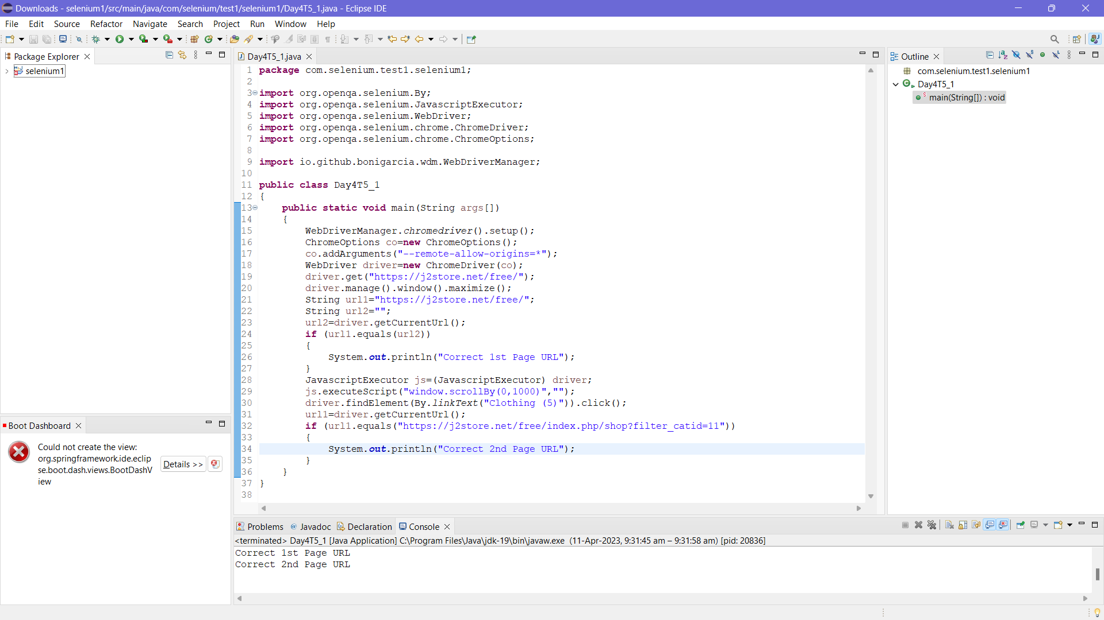

TASK – 5 [ 5.2 – WEB DRIVER COMMANDS ]

CODE:

package com.selenium.test1.selenium1;

import java.util.List;

import org.openqa.selenium.By;

import org.openqa.selenium.JavascriptExecutor;

import org.openqa.selenium.WebDriver;

import org.openqa.selenium.WebElement;

import org.openqa.selenium.chrome.ChromeDriver;

import org.openqa.selenium.chrome.ChromeOptions;

import io.github.bonigarcia.wdm.WebDriverManager;

public class Day4T5_2

{

public static void main(String args[]) throws InterruptedException

{

WebDriverManager.chromedriver().setup();

ChromeOptions co=new ChromeOptions();

co.addArguments("--remote-allow-origins=*");

WebDriver driver=new ChromeDriver(co);

driver.get("https://j2store.net/free/");

driver.manage().window().maximize();

JavascriptExecutor js=(JavascriptExecutor) driver;

js.executeScript("window.scrollBy(0,1000)","");

driver.findElement(By.linkText("Clothing (5)")).click();

Thread.sleep(5000);

List<WebElement> li=driver.findElements(By.xpath("//h2[@class='product-title']"));

for (WebElement link:li)

{

System.out.println(link.getText());

}

}

}

