**727721EUIT054**

**HIROSINI P**

**II IT A**

**DAY – 5**

**TASK – 1 :**

**package** com.selenium.test1.selenium1;

**import** org.openqa.selenium.By;

**import** org.openqa.selenium.WebDriver;

**import** org.openqa.selenium.WebElement;

**import** org.openqa.selenium.chrome.ChromeDriver;

**import** org.openqa.selenium.chrome.ChromeOptions;

**import** org.openqa.selenium.interactions.Actions;

**import** io.github.bonigarcia.wdm.WebDriverManager;

**public** **class** Day5T1

{

**public** **static** **void** main(String args[]) **throws** Exception

{

WebDriverManager.*chromedriver*().setup();

ChromeOptions co=**new** ChromeOptions();

co.addArguments("--remote-allow-origins=*");

WebDriver driver=**new** ChromeDriver(co);

driver.get("https://demoqa.com/droppable/");

WebElement drag=driver.findElement(By.*id*("draggable"));

WebElement drop=driver.findElement(By.*id*("droppable"));

Actions act=**new** Actions(driver);

act.dragAndDrop(drag, drop).build().perform();

}

}

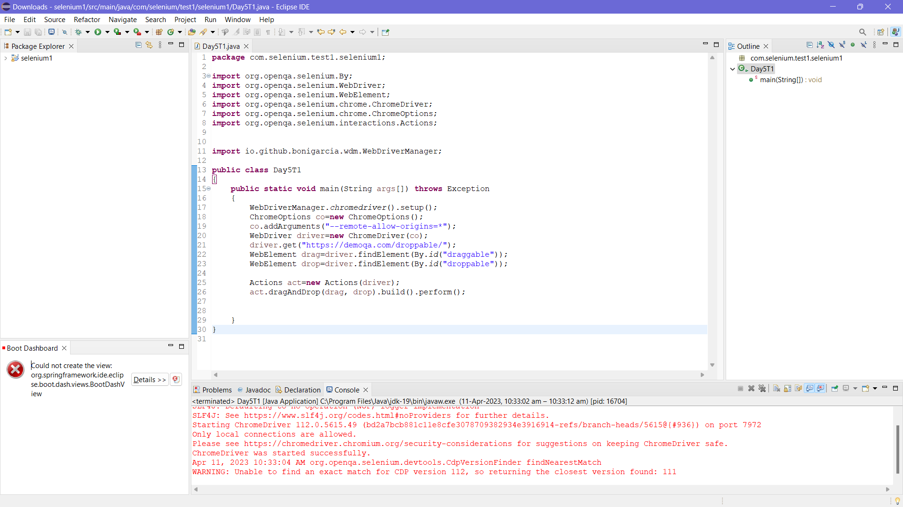

**TASK – 2:**

**package** com.selenium.test1.selenium1;

**import** org.openqa.selenium.By;

**import** org.openqa.selenium.WebDriver;

**import** org.openqa.selenium.WebElement;

**import** org.openqa.selenium.chrome.ChromeDriver;

**import** org.openqa.selenium.chrome.ChromeOptions;

**import** org.openqa.selenium.interactions.Actions;

**import** io.github.bonigarcia.wdm.WebDriverManager;

**public** **class** Day5T2

{

**public** **static** **void** main(String args[]) **throws** Exception

{

WebDriverManager.*chromedriver*().setup();

ChromeOptions co=**new** ChromeOptions();

co.addArguments("--remote-allow-origins=*");

WebDriver driver=**new** ChromeDriver(co);

driver.get("https://jqueryui.com/droppable/");

driver.switchTo().frame(0);

WebElement drag=driver.findElement(By.*id*("draggable"));

WebElement drop=driver.findElement(By.*id*("droppable"));

Actions act=**new** Actions(driver);

act.dragAndDrop(drag, drop).build().perform();

}

}

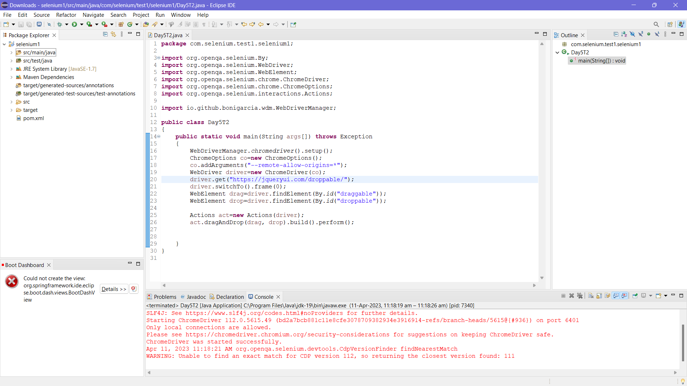

**TASK – 3:**

**package** com.selenium.test1.selenium1;

**import** org.openqa.selenium.Alert;

**import** org.openqa.selenium.By;

**import** org.openqa.selenium.WebDriver;

**import** org.openqa.selenium.WebElement;

**import** org.openqa.selenium.chrome.ChromeDriver;

**import** org.openqa.selenium.chrome.ChromeOptions;

**import** io.github.bonigarcia.wdm.WebDriverManager;

**public** **class** Day5T3

{

**public** **static** **void** main(String args[]) **throws** Exception

{

WebDriverManager.*chromedriver*().setup();

ChromeOptions co=**new** ChromeOptions();

co.addArguments("--remote-allow-origins=*");

WebDriver driver=**new** ChromeDriver(co);

driver.get("https://demo.guru99.com/test/delete_customer.php");

driver.manage().window().maximize();

//enter & click

WebElement txt1=driver.findElement(By.*name*("cusid"));

txt1.sendKeys("401");

driver.findElement(By.*name*("submit")).click();

//handling alert boxes

Alert alt=driver.switchTo().alert();

Thread.*sleep*(5000);

alt.dismiss();

txt1.clear();

txt1.sendKeys("402");

driver.findElement(By.*name*("submit")).click();

Thread.*sleep*(5000);

alt.accept();

Alert alt2=driver.switchTo().alert();

String txt2=alt2.getText();

alt2.accept();

System.***out***.println(txt2);

}

}

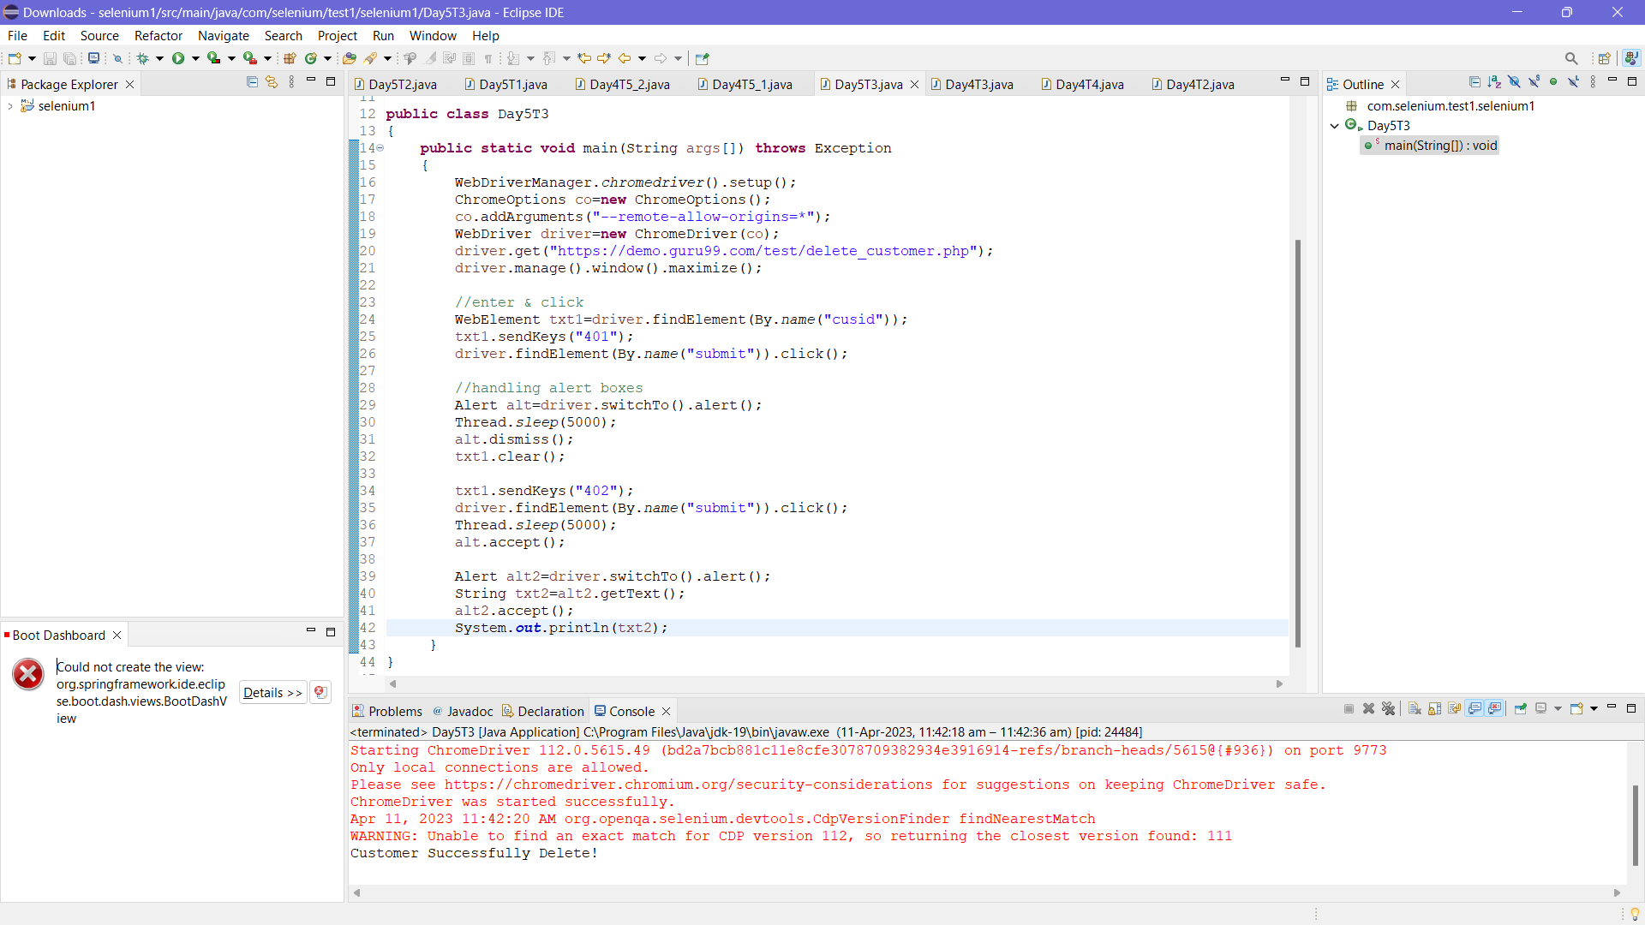

**TASK – 4:**

**package** com.selenium.test1.selenium1;

**import** org.openqa.selenium.By;

**import** org.openqa.selenium.JavascriptExecutor;

**import** org.openqa.selenium.WebDriver;

**import** org.openqa.selenium.WebElement;

**import** org.openqa.selenium.chrome.ChromeDriver;

**import** org.openqa.selenium.chrome.ChromeOptions;

**import** io.github.bonigarcia.wdm.WebDriverManager;

**public** **class** Day5T4

{

**public** **static** **void** main(String args[])

{

WebDriverManager.*chromedriver*().setup();

ChromeOptions co=**new** ChromeOptions();

co.addArguments("--remote-allow-origins=*");

WebDriver driver=**new** ChromeDriver(co);

driver.manage().window().maximize();

driver.get("https://www.abhibus.com/bus-ticket-booking");

WebElement s=driver.findElement(By.*xpath*("//*[@id=\"source\"]"));

s.sendKeys("Coimbatore");

driver.findElement(By.*xpath*("//*[@id=\"destination\"]")).sendKeys("Chennai");

WebElement dp=driver.findElement(By.*xpath*("//*[@id=\"datepicker1\"]"));

JavascriptExecutor js=(JavascriptExecutor) driver;

js.executeScript("arguments[0].setAttribute('value','04/03/2023')",dp);

}

}

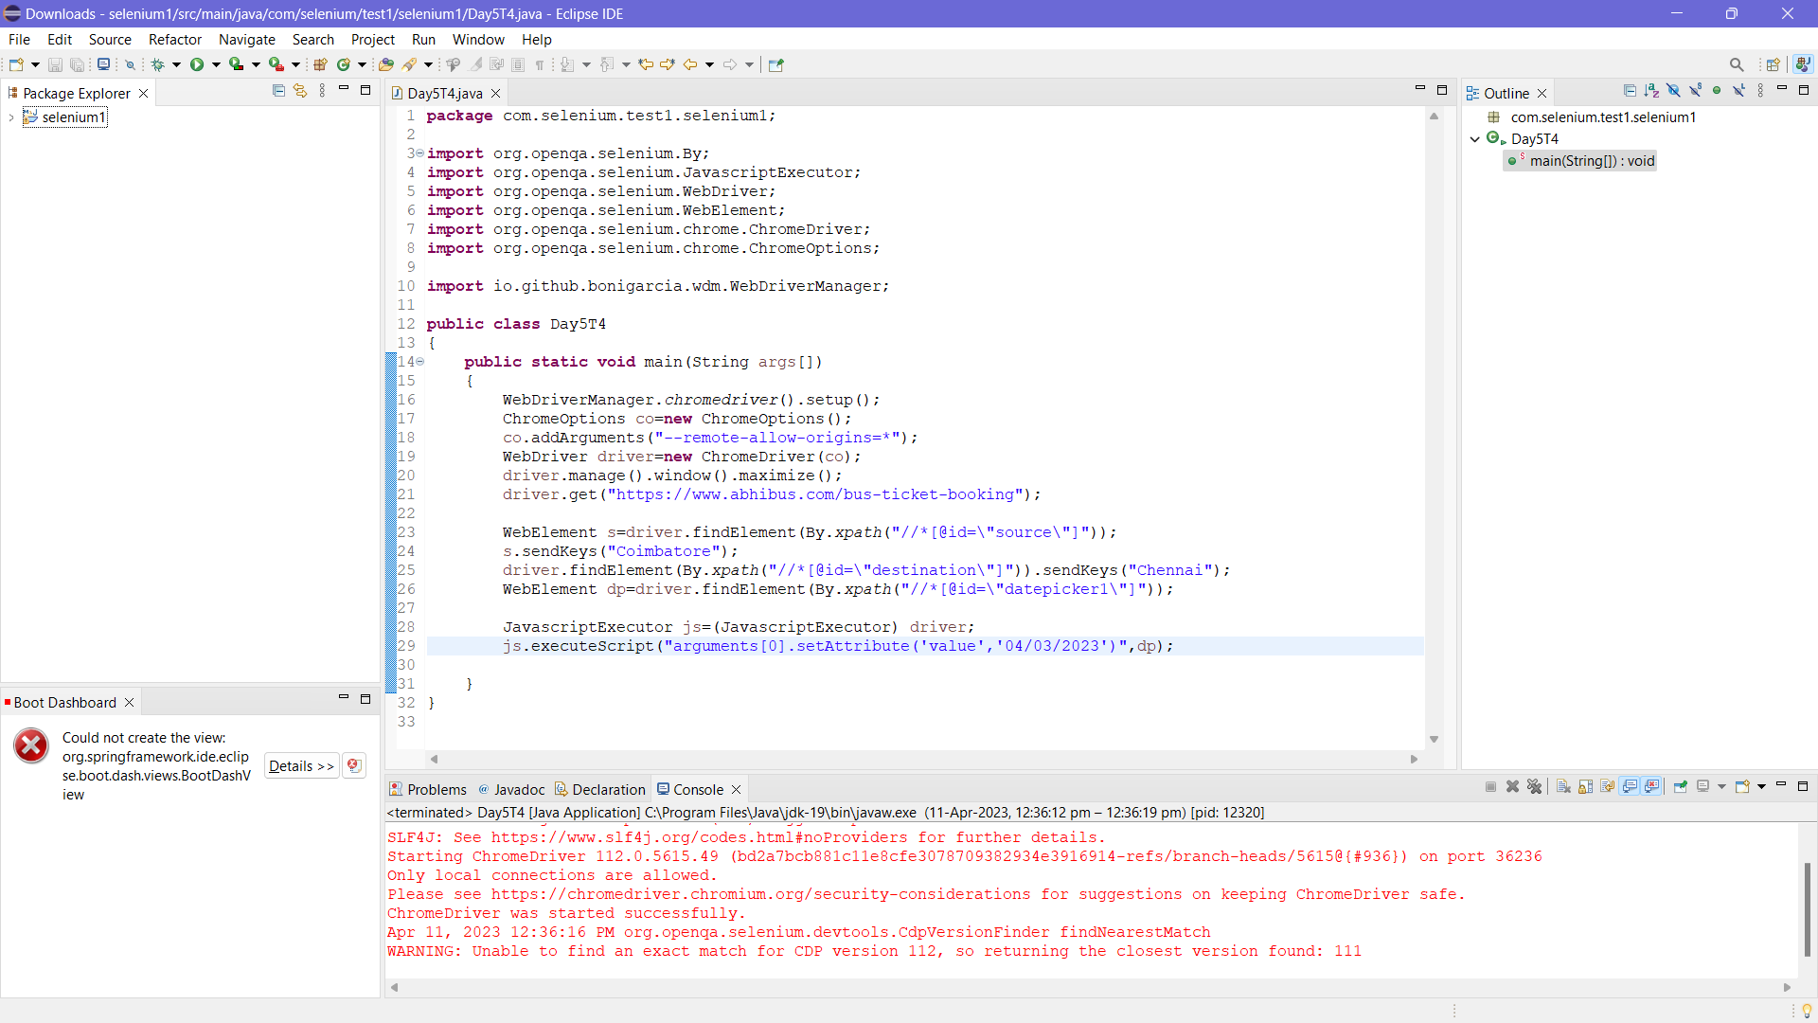

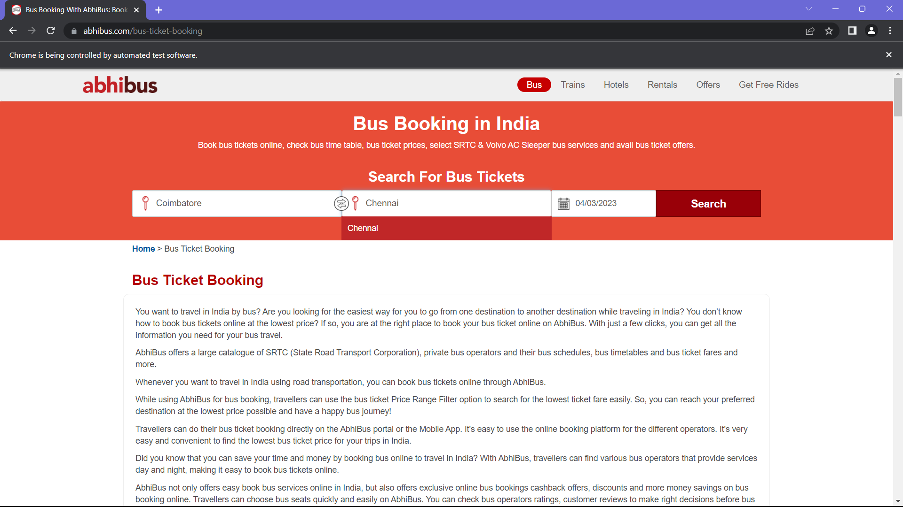

**TASK – 5:**

**CODE – 1:**

**package** com.selenium.test1.selenium1;

**import** org.openqa.selenium.By;

**import** org.openqa.selenium.Keys;

**import** org.openqa.selenium.WebDriver;

**import** org.openqa.selenium.chrome.ChromeDriver;

**import** org.openqa.selenium.chrome.ChromeOptions;

**import** org.openqa.selenium.edge.EdgeDriver;

**import** org.openqa.selenium.firefox.FirefoxDriver;

**import** io.github.bonigarcia.wdm.WebDriverManager;

**public** **class** Day5T5

{

**public** **static** **void** main(String args[])

{

//Chrome

WebDriverManager.*chromedriver*().setup();

ChromeOptions co=**new** ChromeOptions();

co.addArguments("--remote-allow-origins=*");

WebDriver driver=**new** ChromeDriver(co);

driver.get("https://google.com");

driver.manage().window().maximize();

driver.findElement(By.*name*("q")).sendKeys("Apple");

driver.findElement(By.*name*("q")).sendKeys(Keys.***ENTER***);

String p=driver.getWindowHandle();

System.***out***.println(p);

String t=driver.getTitle();

System.***out***.println(t);

//Edge

WebDriverManager.*edgedriver*().setup();

//EdgeOptions e=new EdgeOptions();

//e.addArguments("--remote-allow-origins=*");

WebDriver driver1=**new** EdgeDriver();

driver1.get("https://google.com");

driver1.manage().window().maximize();

driver1.findElement(By.*name*("q")).sendKeys("Selenium");

driver1.findElement(By.*name*("q")).sendKeys(Keys.***ENTER***);

String p1=driver1.getWindowHandle();

System.***out***.println(p1);

String t1=driver1.getTitle();

System.***out***.println(t1);

//Firefox

WebDriverManager.*firefoxdriver*().setup();

//FirefoxOptions f=new FirefoxOptions();

//f.addArguments("--remote-allow-origins=*");

WebDriver driver2=**new** FirefoxDriver();

driver2.get("https://google.com");

driver2.manage().window().maximize();

driver2.findElement(By.*name*("q")).sendKeys("Cucumber");

driver2.findElement(By.*name*("q")).sendKeys(Keys.***ENTER***);

String p2=driver2.getWindowHandle();

System.***out***.println(p2);

String t2=driver2.getTitle();

System.***out***.println(t2);

}

}

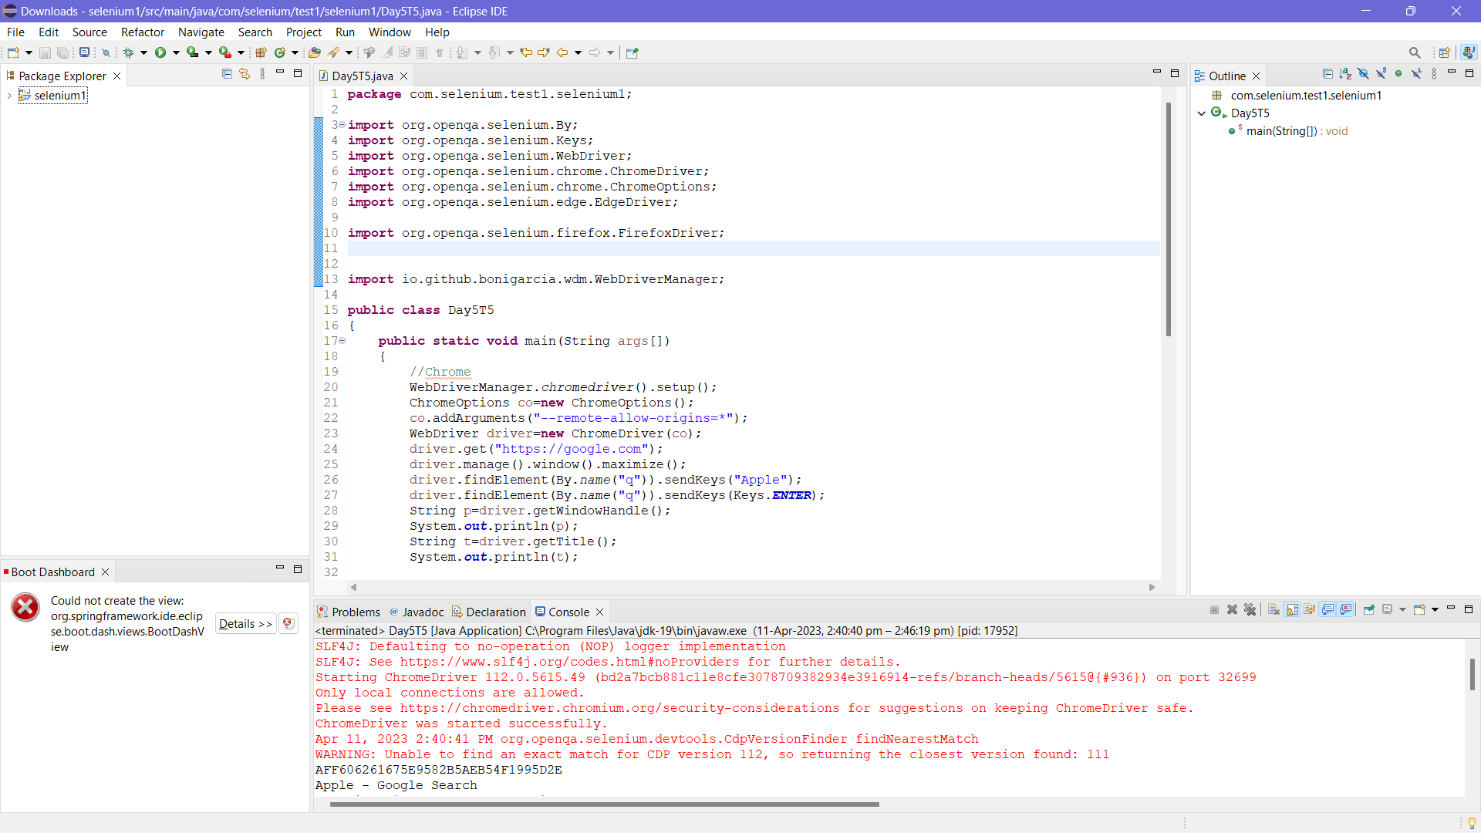

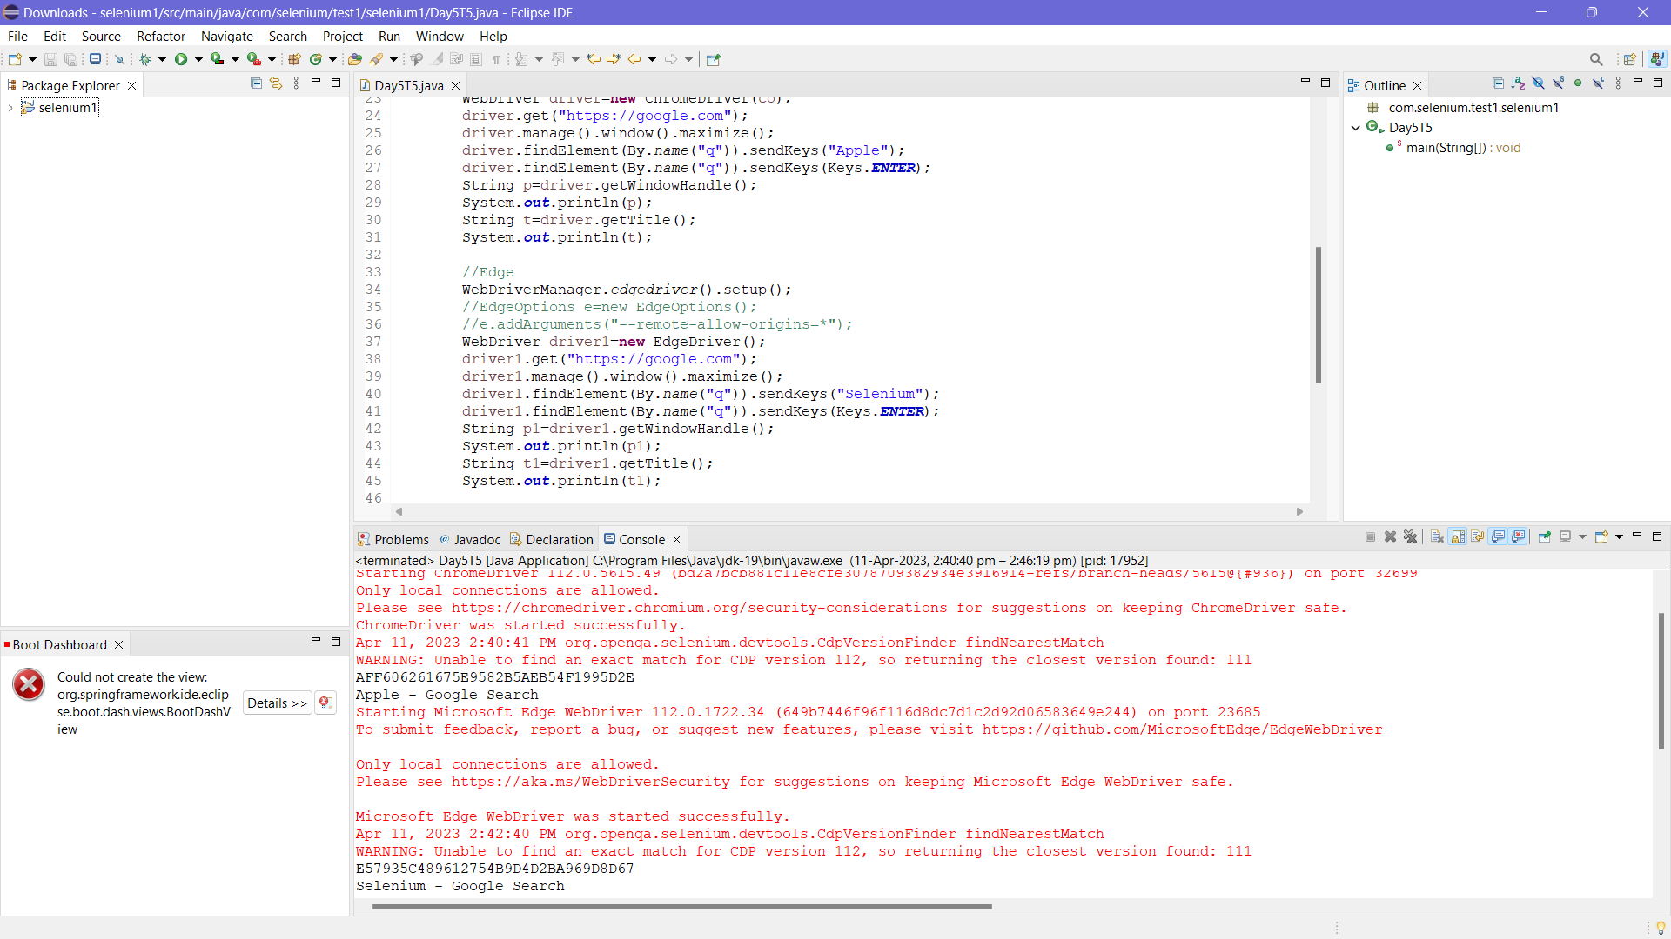

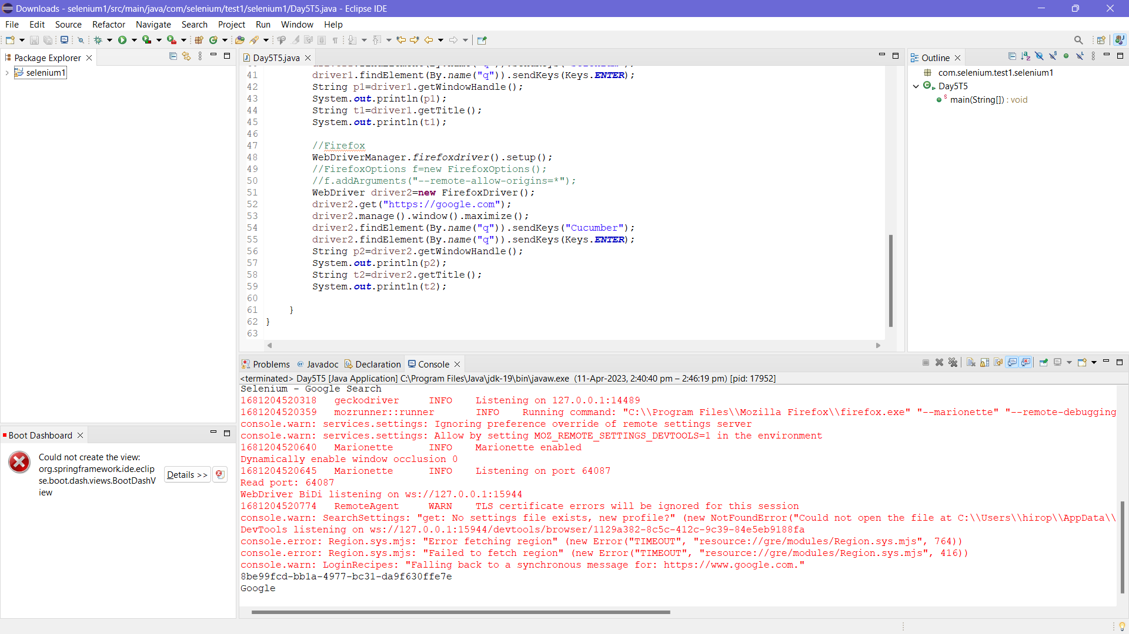

**CODE – 2:**

**package** com.selenium.test1.selenium1;

**import** java.util.Iterator;

**import** java.util.Set;

**import** org.openqa.selenium.By;

**import** org.openqa.selenium.Keys;

**import** org.openqa.selenium.WebDriver;

**import** org.openqa.selenium.WindowType;

**import** org.openqa.selenium.chrome.ChromeDriver;

**import** org.openqa.selenium.chrome.ChromeOptions;

**import** io.github.bonigarcia.wdm.WebDriverManager;

**public** **class** Day5T5_1 {

**public** **static** **void** main(String[] args) {

// **TODO** Auto-generated method stub

//chrome

WebDriverManager.*chromedriver*().setup();

ChromeOptions co=**new** ChromeOptions();

co.addArguments("--remote-allow-origins=*");

WebDriver driver=**new** ChromeDriver(co);

driver.get("https://google.com");

driver.manage().window().maximize();

driver.findElement(By.*name*("q")).sendKeys("Apple");

driver.findElement(By.*name*("q")).sendKeys(Keys.***ENTER***);

String parent=driver.getWindowHandle();

System.***out***.println(parent);

System.***out***.println(driver.getTitle());

driver.switchTo().newWindow(WindowType.***TAB***);

driver.get("https://google.com");

driver.manage().window().maximize();

driver.findElement(By.*name*("q")).sendKeys("Selenium");

driver.findElement(By.*name*("q")).sendKeys(Keys.***ENTER***);

driver.switchTo().newWindow(WindowType.***TAB***);

driver.get("https://google.com");

driver.manage().window().maximize();

driver.findElement(By.*name*("q")).sendKeys("Cucumber");

driver.findElement(By.*name*("q")).sendKeys(Keys.***ENTER***);

Set<String>s=driver.getWindowHandles();

Iterator<String> I1=s.iterator();

**while**(I1.hasNext())

{

String child=I1.next();

**if**(!parent.equals(child))

{driver.switchTo().window(child);

System.***out***.println(driver.switchTo().window(child).getWindowHandle());

System.***out***.println(driver.switchTo().window(child).getTitle());

}

}

}

}

