DAY – 3:

TASK – 1: [ Create and Replay ]

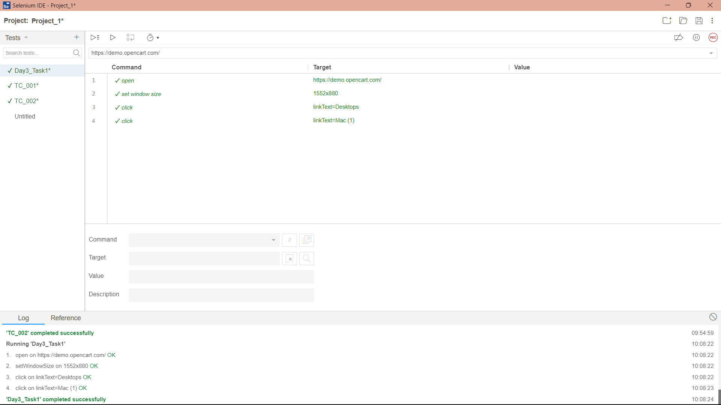

TASK – 2: [ Selenese Commands ]

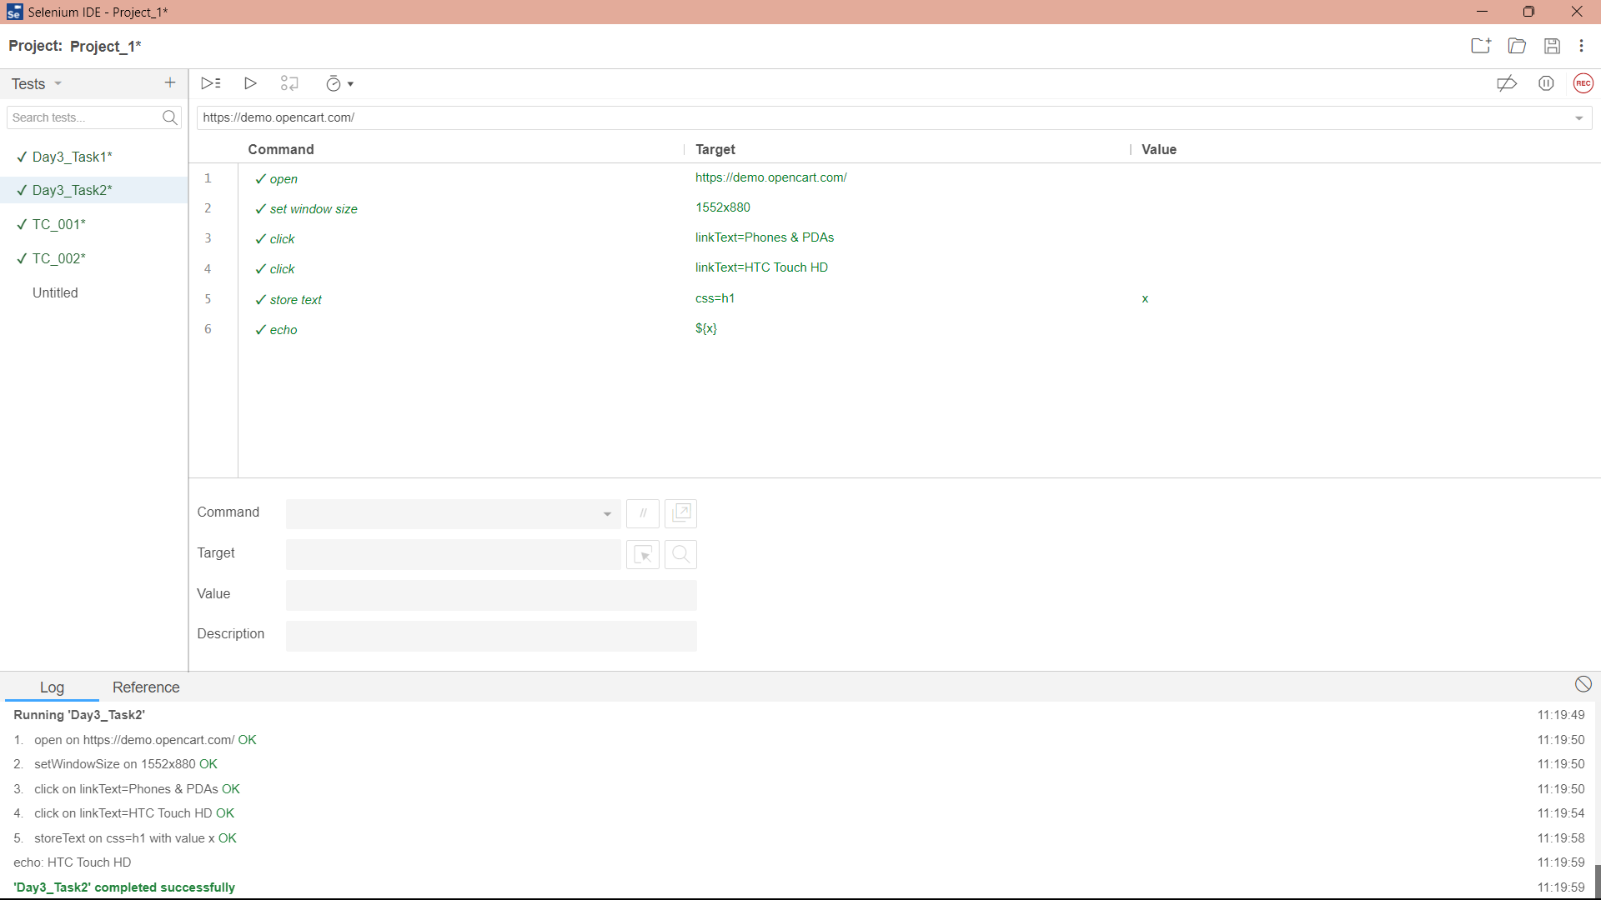

TASK – 3: [ Selenese Commands ]

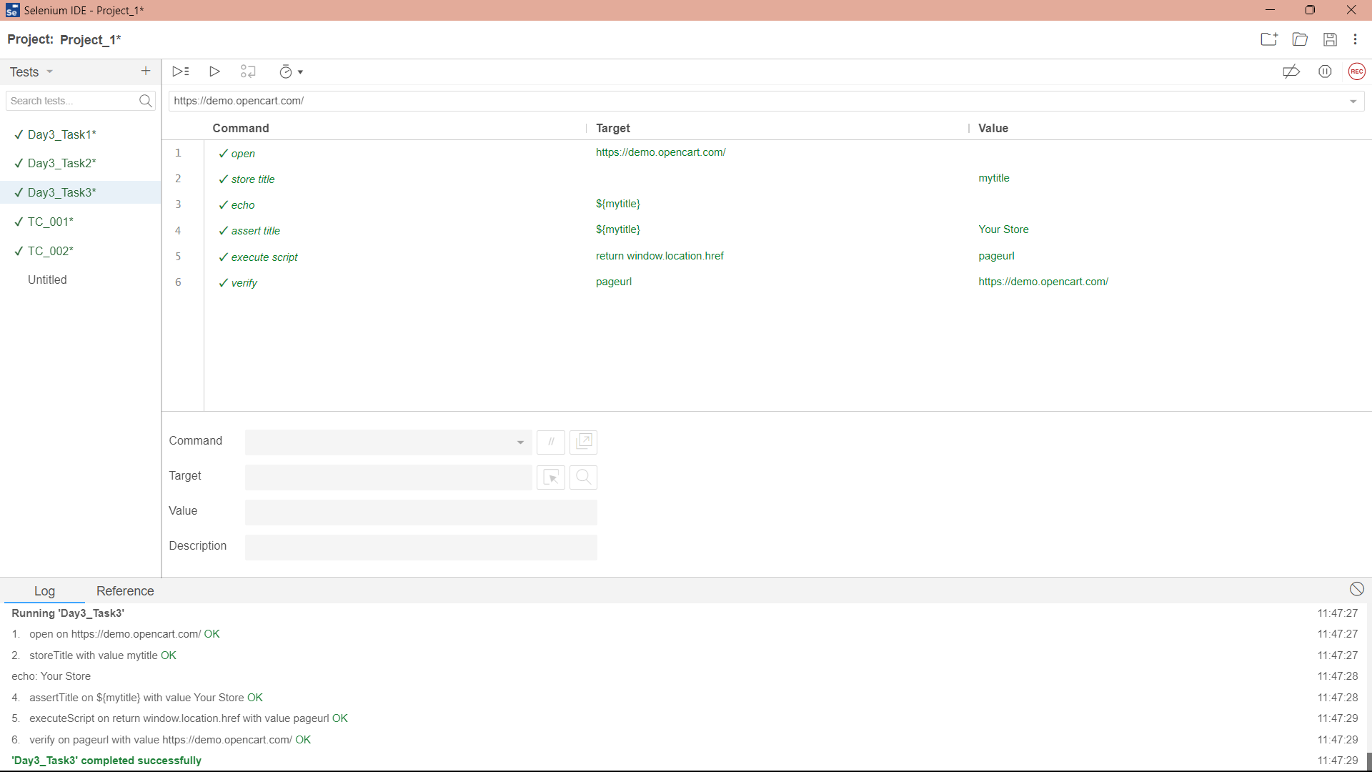

TASK – 4 : [ Selenese Commands ]

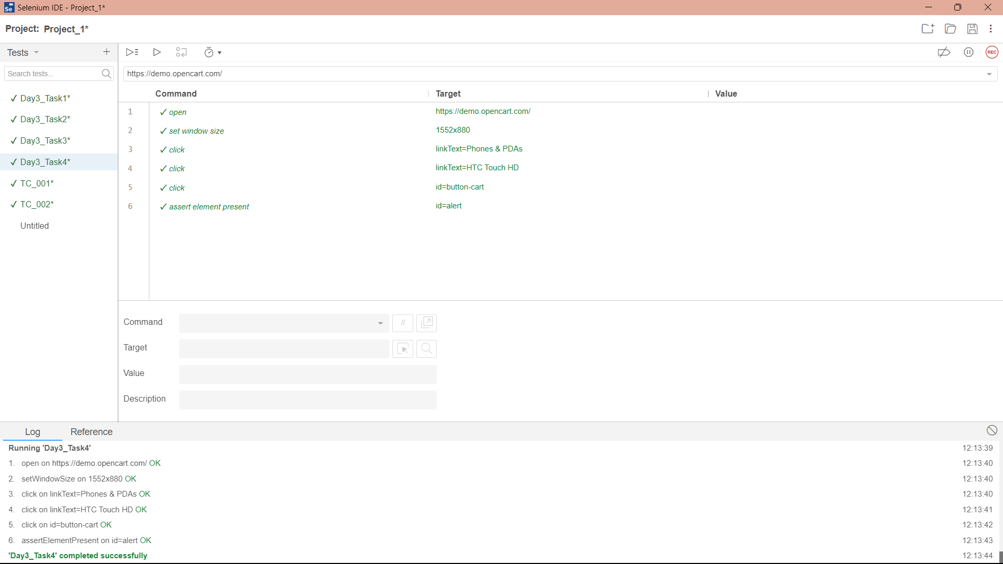

TASK – 5 : [ Selenese Commands ]

