**727721EUIT054**

**HIROSINI P**

**II IT A**

**CC - 1**

1.

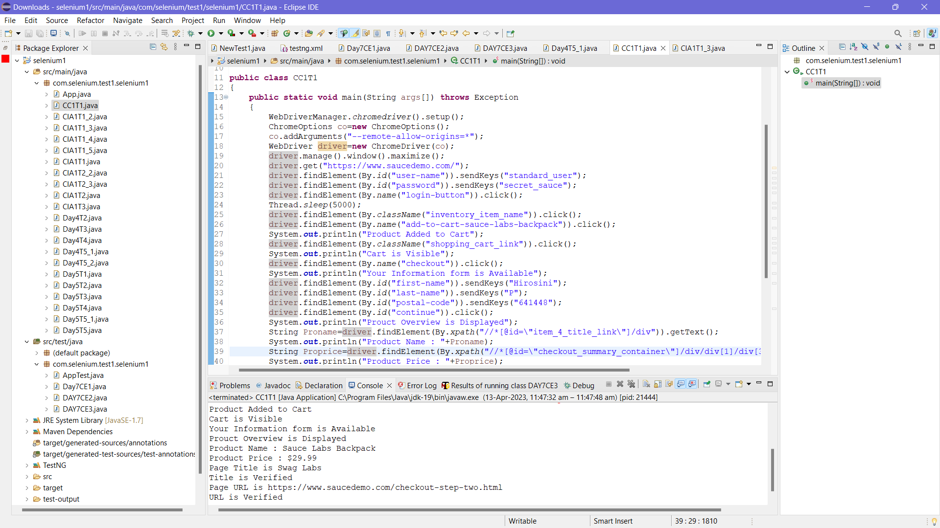

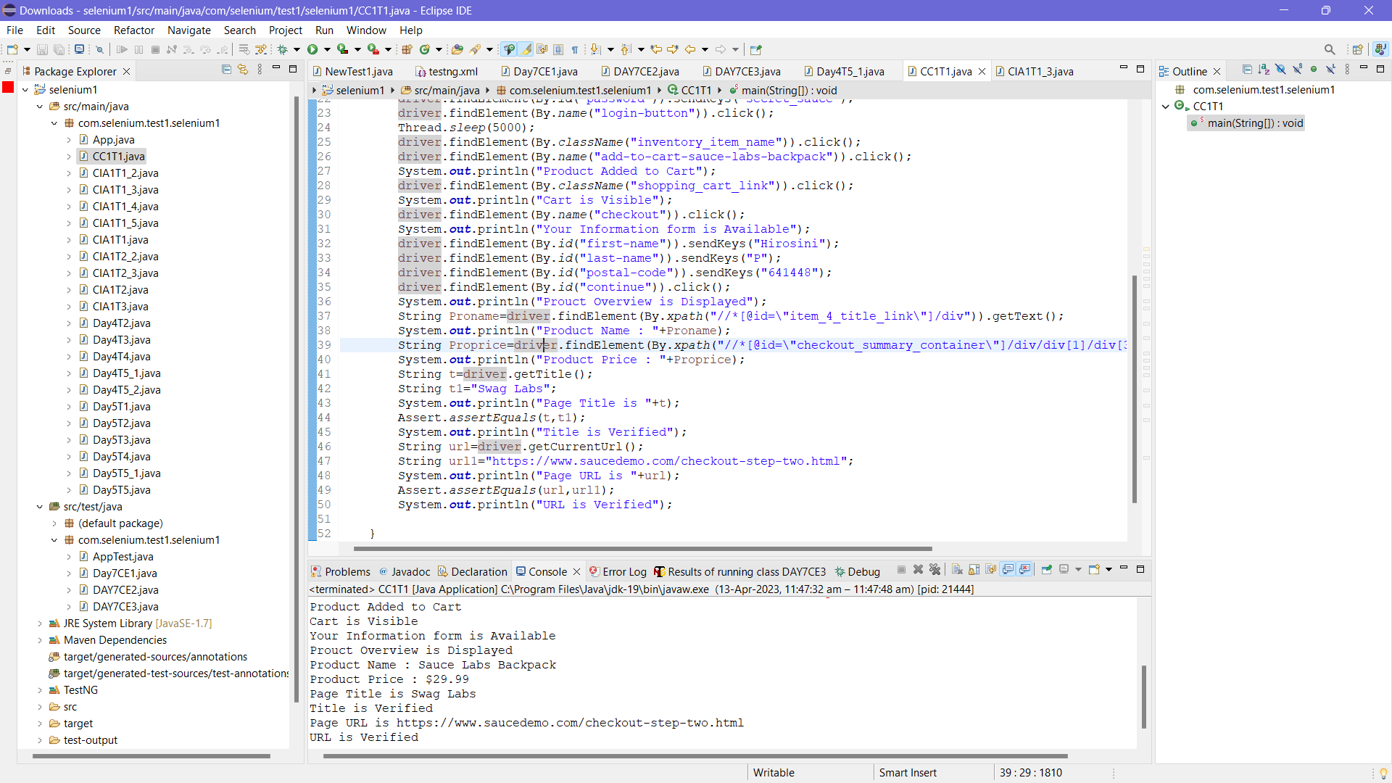

**CODE:**

package com.selenium.test1.selenium1;

import org.openqa.selenium.By;

import org.openqa.selenium.WebDriver;

import org.openqa.selenium.chrome.ChromeDriver;

import org.openqa.selenium.chrome.ChromeOptions;

import org.testng.Assert;

import io.github.bonigarcia.wdm.WebDriverManager;

public class CC1T1

{

public static void main(String args[]) throws Exception

{

WebDriverManager.chromedriver().setup();

ChromeOptions co=new ChromeOptions();

co.addArguments("--remote-allow-origins=*");

WebDriver driver=new ChromeDriver(co);

driver.manage().window().maximize();

driver.get("https://www.saucedemo.com/");

driver.findElement(By.id("user-name")).sendKeys("standard_user");

driver.findElement(By.id("password")).sendKeys("secret_sauce");

driver.findElement(By.name("login-button")).click();

Thread.sleep(5000);

driver.findElement(By.className("inventory_item_name")).click();

driver.findElement(By.name("add-to-cart-sauce-labs-backpack")).click();

System.out.println("Product Added to Cart");

driver.findElement(By.className("shopping_cart_link")).click();

System.out.println("Cart is Visible");

driver.findElement(By.name("checkout")).click();

System.out.println("Your Information form is Available");

driver.findElement(By.id("first-name")).sendKeys("Hirosini");

driver.findElement(By.id("last-name")).sendKeys("P");

driver.findElement(By.id("postal-code")).sendKeys("641448");

driver.findElement(By.id("continue")).click();

System.out.println("Prouct Overview is Displayed");

String Proname=driver.findElement(By.xpath("//*[@id=\"item_4_title_link\"]/div")).getText();

System.out.println("Product Name : "+Proname);

String Proprice=driver.findElement(By.xpath("//*[@id=\"checkout_summary_container\"]/div/div[1]/div[3]/div[2]/div[2]/div")).getText();

System.out.println("Product Price : "+Proprice);

String t=driver.getTitle();

String t1="Swag Labs";

System.out.println("Page Title is "+t);

Assert.assertEquals(t,t1);

System.out.println("Title is Verified");

String url=driver.getCurrentUrl();

String url1="https://www.saucedemo.com/checkout-step-two.html";

System.out.println("Page URL is "+url);

Assert.assertEquals(url,url1);

System.out.println("URL is Verified");

}

}

2.

**TASK – 1:**

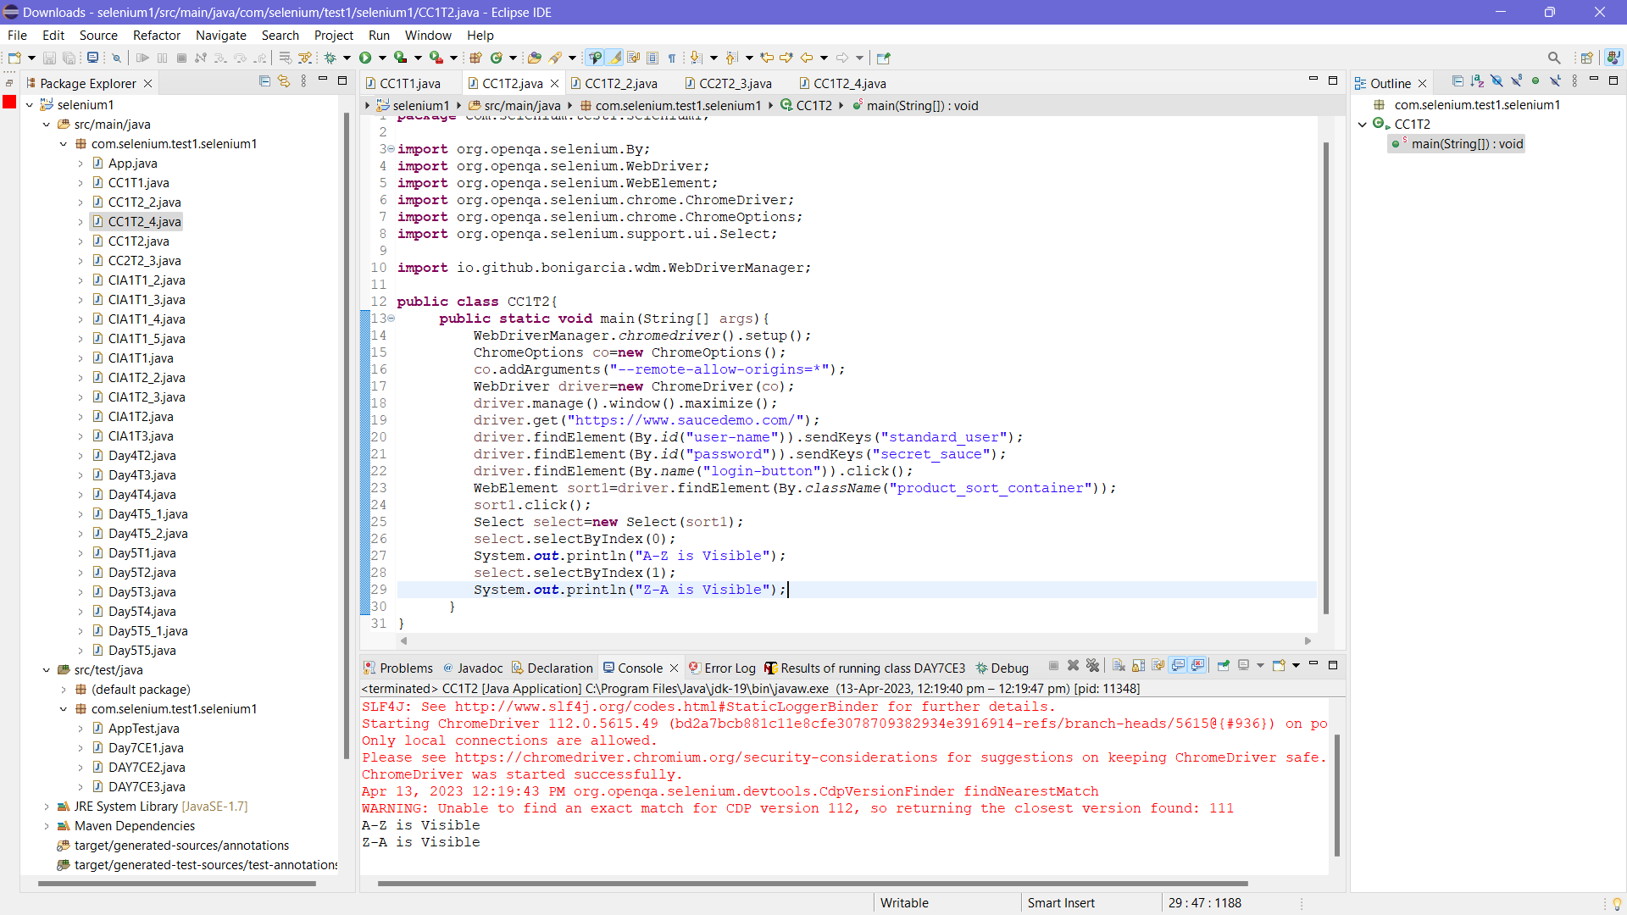

**CODE**:

package com.selenium.test1.selenium1;

import org.openqa.selenium.By;

import org.openqa.selenium.WebDriver;

import org.openqa.selenium.WebElement;

import org.openqa.selenium.chrome.ChromeDriver;

import org.openqa.selenium.chrome.ChromeOptions;

import org.openqa.selenium.support.ui.Select;

import io.github.bonigarcia.wdm.WebDriverManager;

public class CC1T2{

public static void main(String[] args){

WebDriverManager.chromedriver().setup();

ChromeOptions co=new ChromeOptions();

co.addArguments("--remote-allow-origins=*");

WebDriver driver=new ChromeDriver(co);

driver.manage().window().maximize();

driver.get("https://www.saucedemo.com/");

driver.findElement(By.id("user-name")).sendKeys("standard_user");

driver.findElement(By.id("password")).sendKeys("secret_sauce");

driver.findElement(By.name("login-button")).click();

WebElement sort1=driver.findElement(By.className("product_sort_container"));

sort1.click();

Select select=new Select(sort1);

select.selectByIndex(0);

System.out.println("A-Z is Visible");

select.selectByIndex(1);

System.out.println("Z-A is Visible");

}

}

**TASK – 2:**

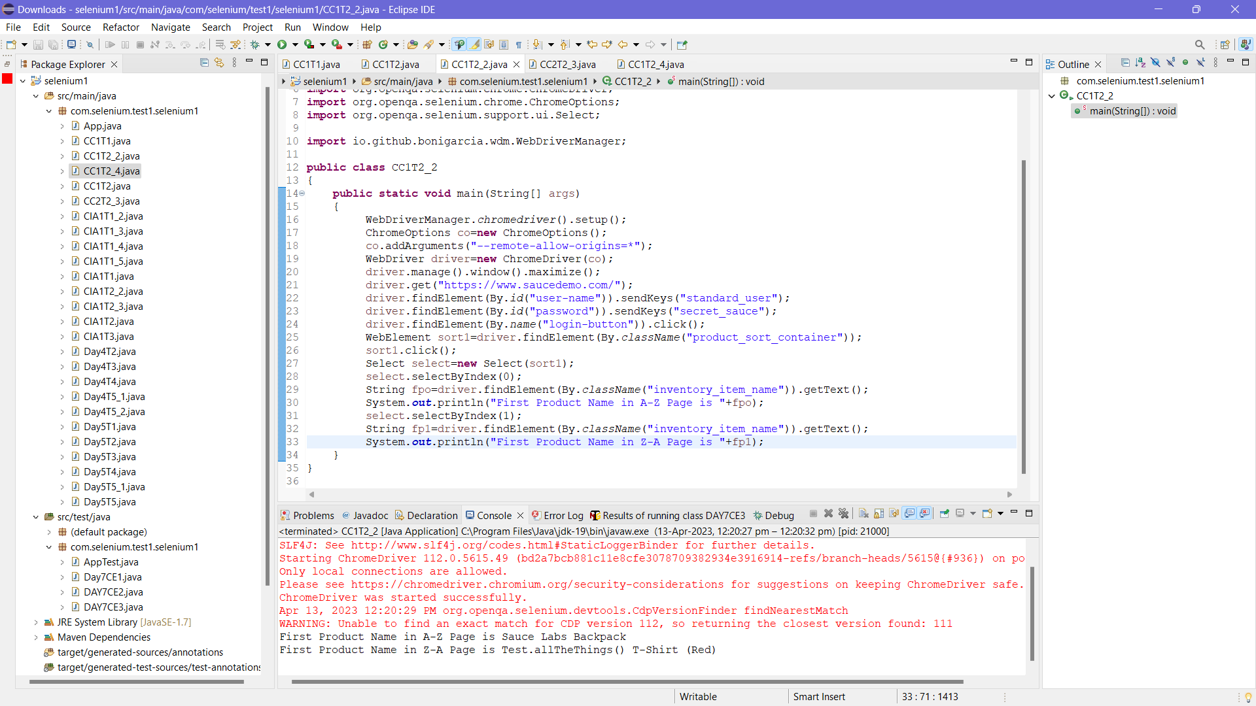

**CODE:**

package com.selenium.test1.selenium1;

import org.openqa.selenium.By;

import org.openqa.selenium.WebDriver;

import org.openqa.selenium.WebElement;

import org.openqa.selenium.chrome.ChromeDriver;

import org.openqa.selenium.chrome.ChromeOptions;

import org.openqa.selenium.support.ui.Select;

import io.github.bonigarcia.wdm.WebDriverManager;

public class CC1T2_2

{

public static void main(String[] args)

{

WebDriverManager.chromedriver().setup();

ChromeOptions co=new ChromeOptions();

co.addArguments("--remote-allow-origins=*");

WebDriver driver=new ChromeDriver(co);

driver.manage().window().maximize();

driver.get("https://www.saucedemo.com/");

driver.findElement(By.id("user-name")).sendKeys("standard_user");

driver.findElement(By.id("password")).sendKeys("secret_sauce");

driver.findElement(By.name("login-button")).click();

WebElement sort1=driver.findElement(By.className("product_sort_container"));

sort1.click();

Select select=new Select(sort1);

select.selectByIndex(0);

String fpo=driver.findElement(By.className("inventory_item_name")).getText();

System.out.println("First Product Name in A-Z Page is "+fpo);

select.selectByIndex(1);

String fp1=driver.findElement(By.className("inventory_item_name")).getText();

System.out.println("First Product Name in Z-A Page is "+fp1);

}

}

**TASK-3:**

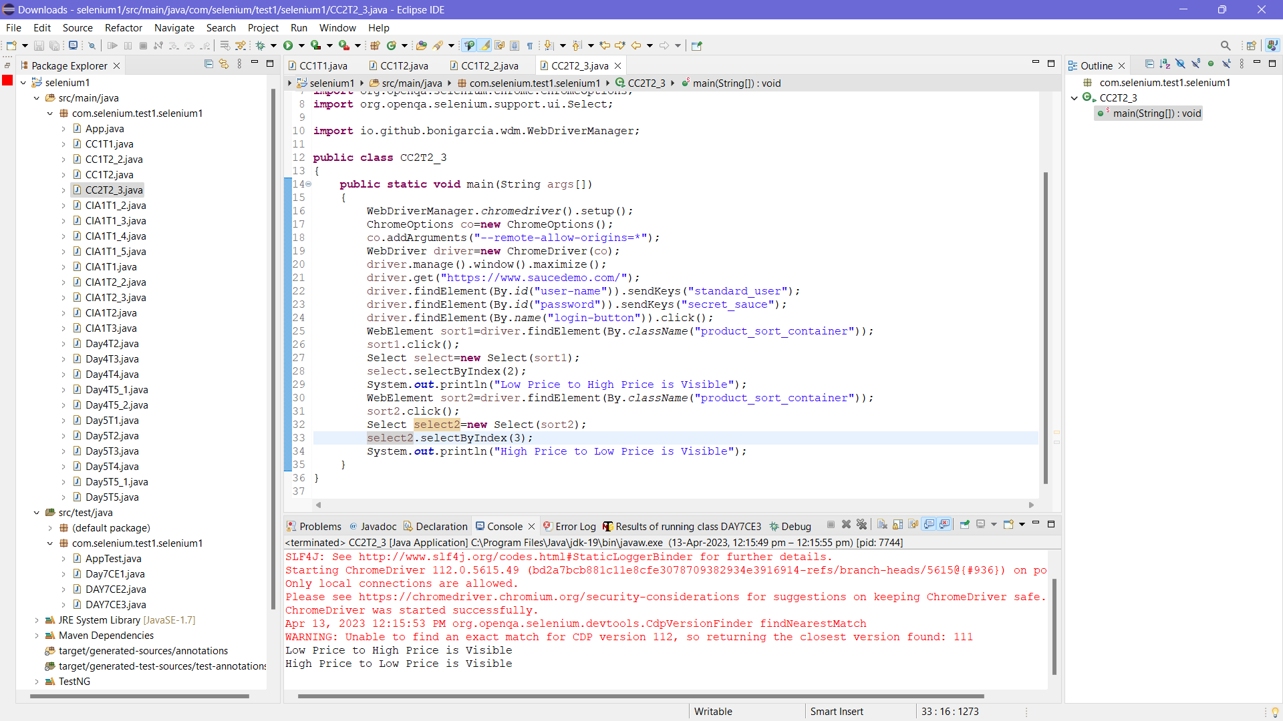

**CODE:**

package com.selenium.test1.selenium1;

import org.openqa.selenium.By;

import org.openqa.selenium.WebDriver;

import org.openqa.selenium.WebElement;

import org.openqa.selenium.chrome.ChromeDriver;

import org.openqa.selenium.chrome.ChromeOptions;

import org.openqa.selenium.support.ui.Select;

import io.github.bonigarcia.wdm.WebDriverManager;

public class CC2T2_3

{

public static void main(String args[])

{

WebDriverManager.chromedriver().setup();

ChromeOptions co=new ChromeOptions();

co.addArguments("--remote-allow-origins=*");

WebDriver driver=new ChromeDriver(co);

driver.manage().window().maximize();

driver.get("https://www.saucedemo.com/");

driver.findElement(By.id("user-name")).sendKeys("standard_user");

driver.findElement(By.id("password")).sendKeys("secret_sauce");

driver.findElement(By.name("login-button")).click();

WebElement sort1=driver.findElement(By.className("product_sort_container"));

sort1.click();

Select select=new Select(sort1);

select.selectByIndex(2);

System.out.println("Low Price to High Price is Visible");

WebElement sort2=driver.findElement(By.className("product_sort_container"));

sort2.click();

Select select2=new Select(sort2);

select2.selectByIndex(3);

System.out.println("High Price to Low Price is Visible");

}

}

**TASK – 4:**

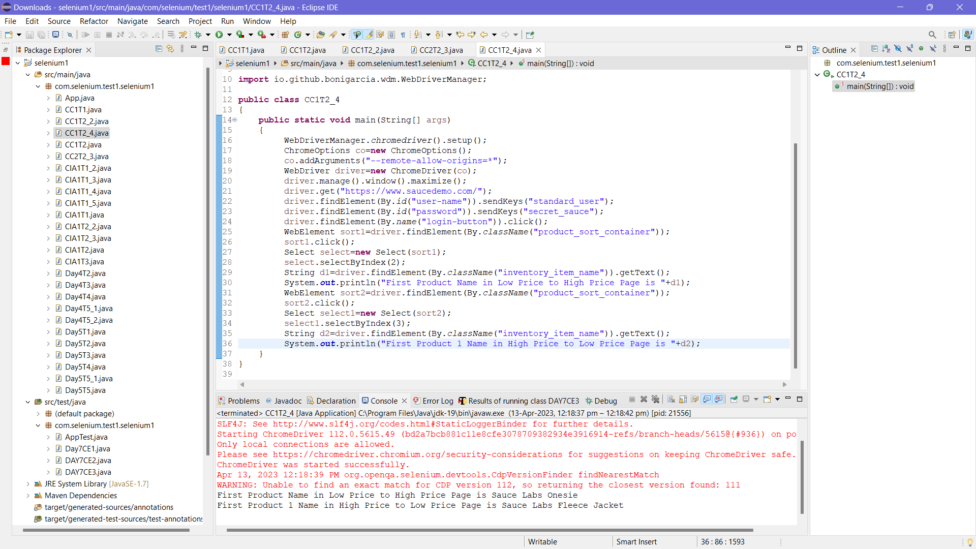

**CODE:**

package com.selenium.test1.selenium1;

import org.openqa.selenium.By;

import org.openqa.selenium.WebDriver;

import org.openqa.selenium.WebElement;

import org.openqa.selenium.chrome.ChromeDriver;

import org.openqa.selenium.chrome.ChromeOptions;

import org.openqa.selenium.support.ui.Select;

import io.github.bonigarcia.wdm.WebDriverManager;

public class CC1T2_4

{

public static void main(String[] args)

{

WebDriverManager.chromedriver().setup();

ChromeOptions co=new ChromeOptions();

co.addArguments("--remote-allow-origins=*");

WebDriver driver=new ChromeDriver(co);

driver.manage().window().maximize();

driver.get("https://www.saucedemo.com/");

driver.findElement(By.id("user-name")).sendKeys("standard_user");

driver.findElement(By.id("password")).sendKeys("secret_sauce");

driver.findElement(By.name("login-button")).click();

WebElement sort1=driver.findElement(By.className("product_sort_container"));

sort1.click();

Select select=new Select(sort1);

select.selectByIndex(2);

String d1=driver.findElement(By.className("inventory_item_name")).getText();

System.out.println("First Product Name in Low Price to High Price Page is "+d1);

WebElement sort2=driver.findElement(By.className("product_sort_container"));

sort2.click();

Select select1=new Select(sort2);

select1.selectByIndex(3);

String d2=driver.findElement(By.className("inventory_item_name")).getText();

System.out.println("First Product 1 Name in High Price to Low Price Page is "+d2);

}

}