Lab Information Management System (LIMS)
Design DOCUMENT
Version 1.0
09/02/2015

Version History

Version  Number | Implemented  By | Revision  Date | Approved  By | Approval  Date | Description of  Change
1.0 | C.Kachaje | 09/02/2015 |  |  | First draft

TABLE OF CONTENTS

Table of Contents
1 Introduction 4
1.1Purpose of The Design Specification Document 4
2General Overview and Design Guidelines/Approach 5
2.1Assumptions / Constraints / Standards 5
3Architecture Design 7
3.1Logical View 10
3.2Hardware Architecture 11
3.3Software Architecture 12
4System Design 13
4.1Business Requirements 13
4.2Database Design 13
4.3Data Conversion 15

Introduction

Purpose of The Design Specification Document
This Design Document seeks to provide a way of documenting a Laboratory Information Management System (LIMS) that is to be developed for the Ministry of Health based on requirements gathered by the Technical Task-force setup to analyze the requirements for implementing such a system. The system will be developed by Baobab Health Trust and will be piloted at Kamuzu Central Hospital. LIMS is a tool that will be used to provide an interfaces in health care facility:
- Wards to:
  - order laboratory tests for patients that have already been registered at the respective health care facilities
  - confirm drawing of samples once the care providers do so
  - printing of specimen labels to accompany samples for further processing in the laboratory
  - display summaries of all transactions as they occur on dashboards in the ward
  - view patient test statuses on specific patient dashboards on patient care devices for further actions
  - printing of patient results when they are available from patient care devices
- Laboratories to:
  - display orders and draw event summaries on dashboards mounted at the laboratory reception before the samples are sent to the laboratory
  - receive samples as they come into the laboratory and carry out preliminary screening on whether the samples are viable or not
  - display event summaries in the relevant laboratory department dashboards of any samples that have been received at the reception that would be expected to be received in the respective departments for processing
  - receive the samples as they come for processing
  - change sample statuses when processing has started and broadcast change of status to all interested status tracking points
  - enter test results after tests are done
  - allow for verification of tests results by supervisors after results are entered and publish to all receiving points in the system
  - capture disposing of samples when it happens for sample tracking and disposal logging

General Overview and Design Guidelines/Approach
This section describes the principles and strategies to be used as guidelines when designing and implementing the system.

Assumptions / Constraints / Standards
The implementation of the project is expected to be in 3 main phases with some overlaps in some cases due to dependency issues which were realized after the initial gathering of system requirements. The following constraints and assumptions were made in coming up with the requirements for the system:
- The system is expected to only handle patients that have already been registered using external patient registration systems which will provide all relevant patient demographics for use in the system.
- A common results broadcasting framework will be provided for broadcasting all patient sample and test events to all authorized subscribing systems that may have to be updated on events as they occur in the system.
- The primary data transmission protocol between the system and all collaborating systems will be HL7 version 2.x in exceptional cases JSON will also be used where HL7 may be found lacking.
- A subscription model for message transmission will be used for all message broadcasts to allow external consumers to be able to pull data when so required in which case the external systems will be responsible solely to provide mechanisms to get access to any latest available broad-casted messages.
- When test results are available, compatible systems are expected to be able to consume the results for further processing.
- User management credentials for all ward instances of the system are expected to be compatible with user credentials that they use in accessing other systems used in the wards provided by Baobab Health wherever possible.
- User management credentials for the laboratory are expected to be unique to the laboratory such that their management will be managed from the laboratory whenever it becomes necessary.
- In most of the wards, mobile units are expected to be used as clients for the system from where ordering, drawing and viewing of results will also be possible.
- The mobile units in the wards are expected to be able to print test result summaries with comprehensive results being possible to print from other collaborating systems that have access to the broadcasting framework.
- The system is expected to provide reporting data to LIMS Secretariat and Ministry of Health in aggregated form.
- The system is expected to be able to provide access to laboratory test results to multiple authorized sites when they are available thereby allowing for patient continuity of care as well as distribution of loads across multiple laboratories where relevant while at the same time allowing for results access at the source sites.

Architecture Design
This section outlines the system and hardware architecture design of the system that is being built.
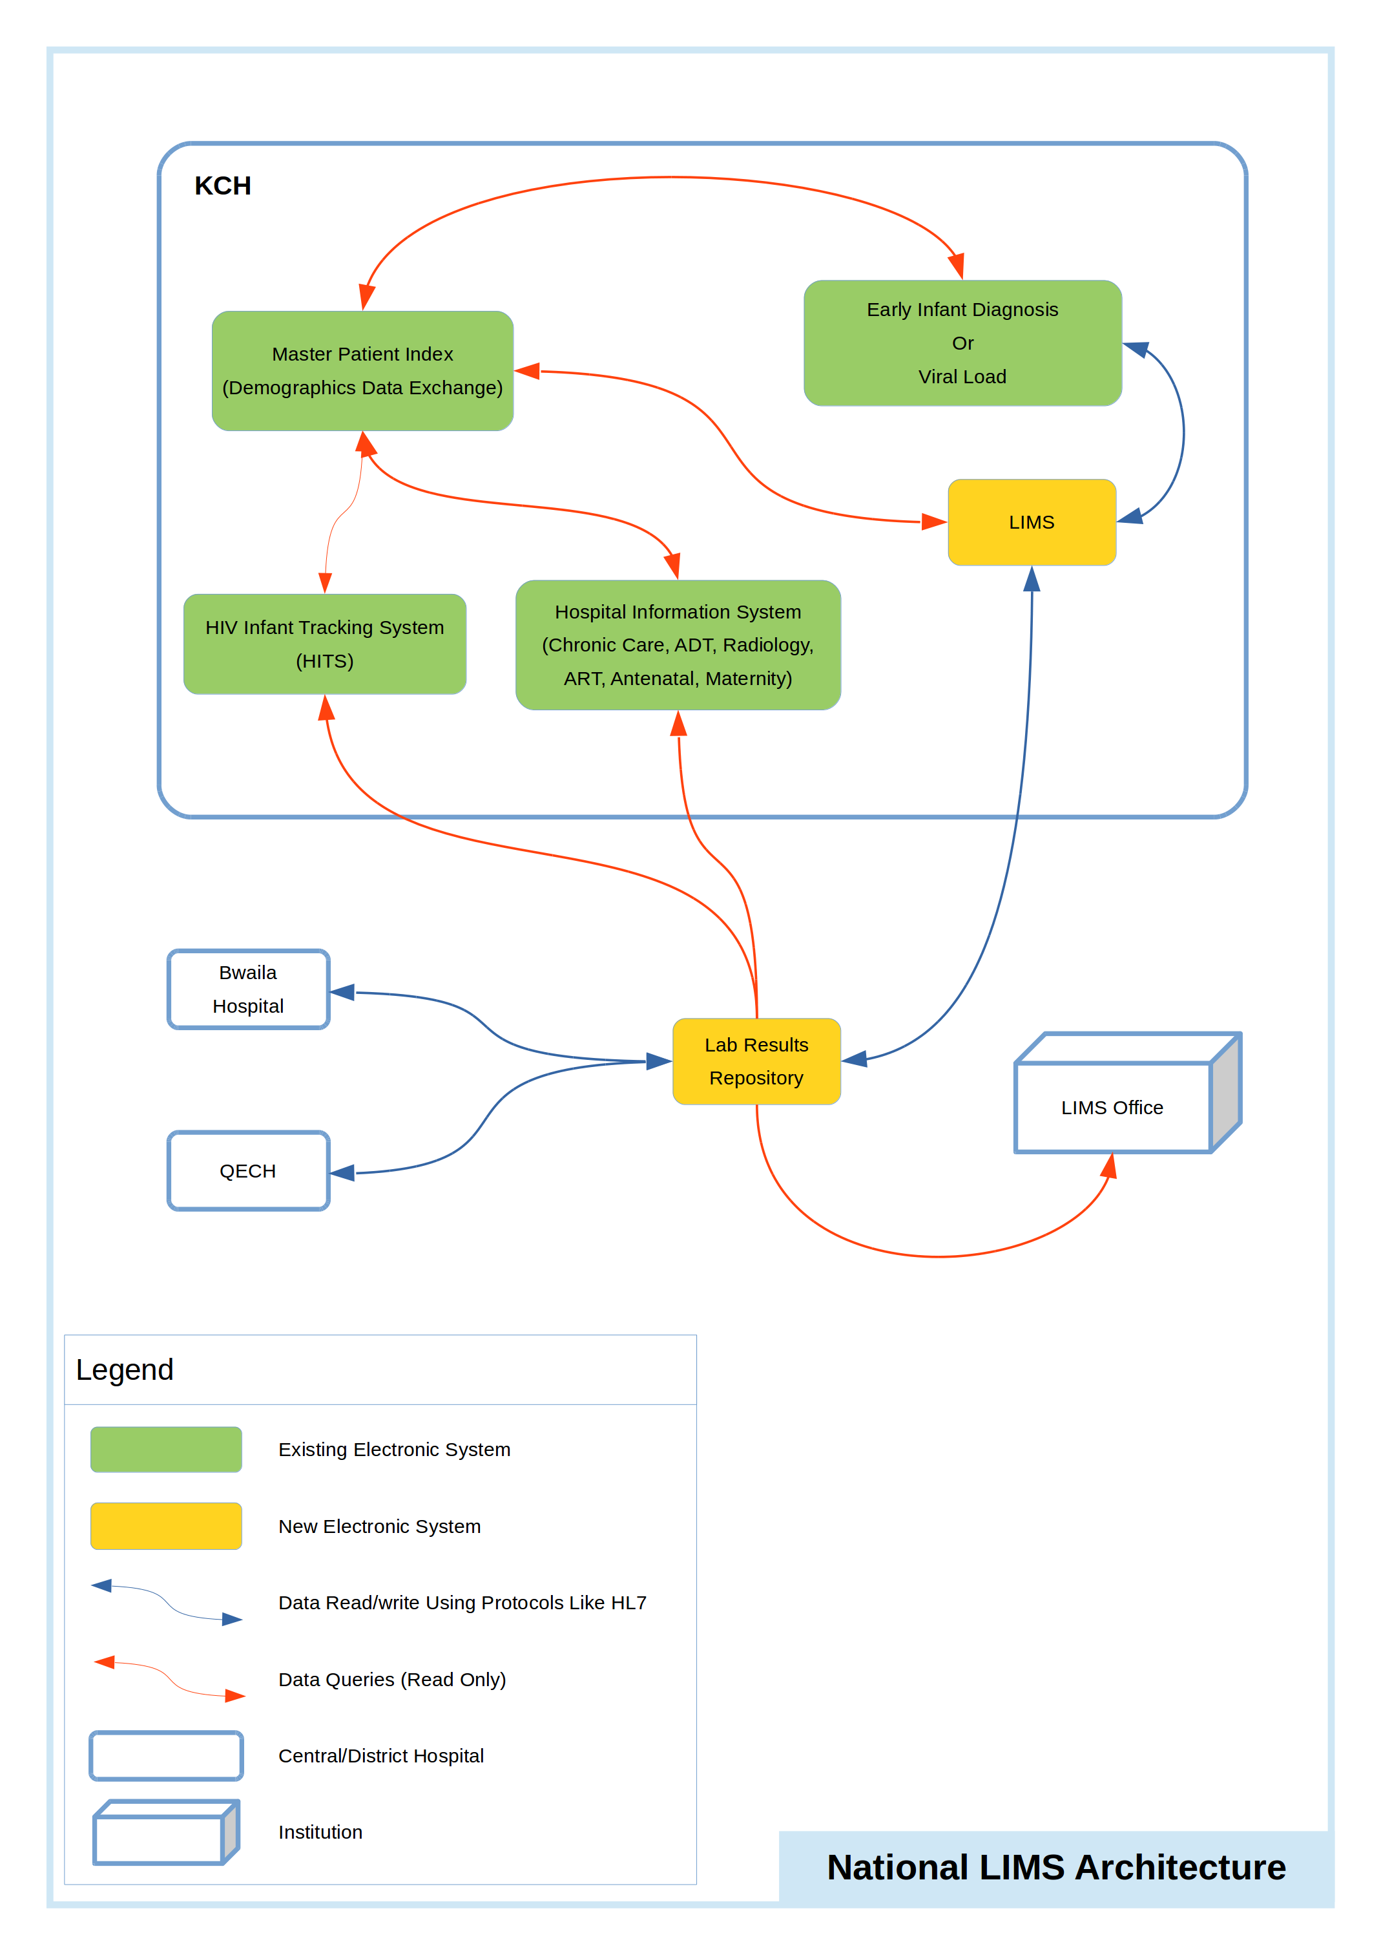Figure 1
The system is expected to be work in conjunction with other existing components in the provision of patient care. It is expected to be able to get patient demographics data from an existing demographics data exchange system at the facility it will be operated in.

Every patient that interacts with electronic systems is expected to be registered into the centralized demographics data exchange system, which is a master patient index system so their records can be reused by different electronic systems at respective health facilities. If they do not exist in such a demographics data exchange system, it will not be possible for the patients to be served using the system as it does not have it's own capability by design to capture patient demographics data. Each patient is also expected to have a valid patient national identifier barcode with them for them to have their electronic records accessed through the system as the system will not provide any textual search of patient demographics. This design decision was mainly arrived at to allow for accuracy in access to right patient demographics when accessing patient records as any errors in identification can be catastrophic through mis-allocation of patient tests and results.

As shown in Figure 2, a typical transaction work-flow would proceed as follows:
- A patient would present their national patient identifier barcode to a health care provider in the ward if there is a need to have a lab test carried out for them.
- The provider would then scan the barcode in LIMS to search for the patient demographics if they exist in the master patient index system.
- Having found the patient demographics, the care provider would then proceed to create a lab order for the tests required and draw a sample for testing.
- All transactions that are relevant to the ward will be continuously displayed on the specific ward dashboard based on relevance as events occur on the ordered tests.
- Relevant notifications will also be displayed on specific dashboards continuously based on relevance to section.
- When the sample arrives at the lab, it is first received at the reception based on viability and notifications sent out to concerned recipients in the system.
- Samples are then received again in the relevant lab departments where tests would be done and update notifications also made. When processing of the sample starts, the event is again captured in the system to reflect the same to all concerned recipients of updates. When results are available, they are also entered into the system and are not published until they are first verified by a supervisor.
- Once results are available, a supervisor is expected to verify them first so they can be released for publishing to all subscribing agents in the system.
- Once the results are verified, they are now available in the wards electronically where the care provider is prompted to print them and make them available to the patient for further actions.
- All transactions as they occur will in the background be pushed to the lab results repository.
- While all the earlier transactions are taking place, continuous updates will be sent to all subscribing systems and organizations.
- Continuous updates will also be made to the LIMS office as transactions occur.
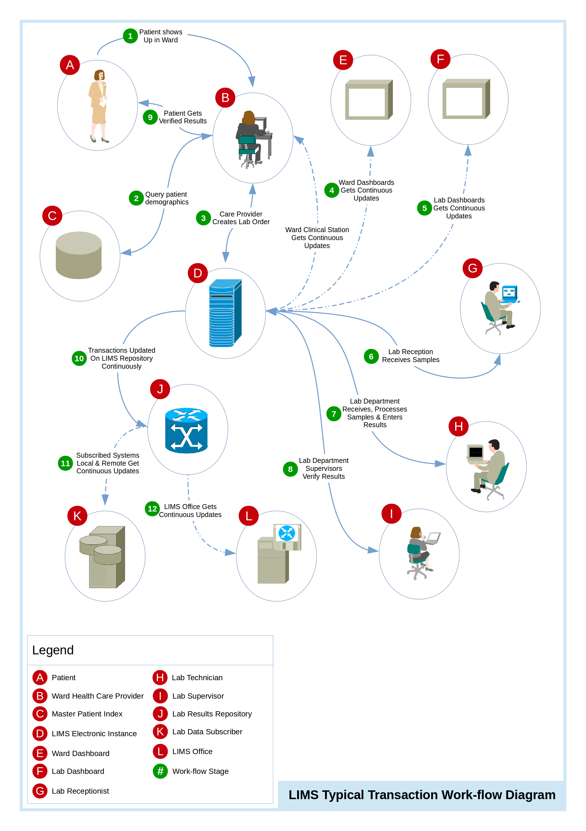Figure 2

Logical View
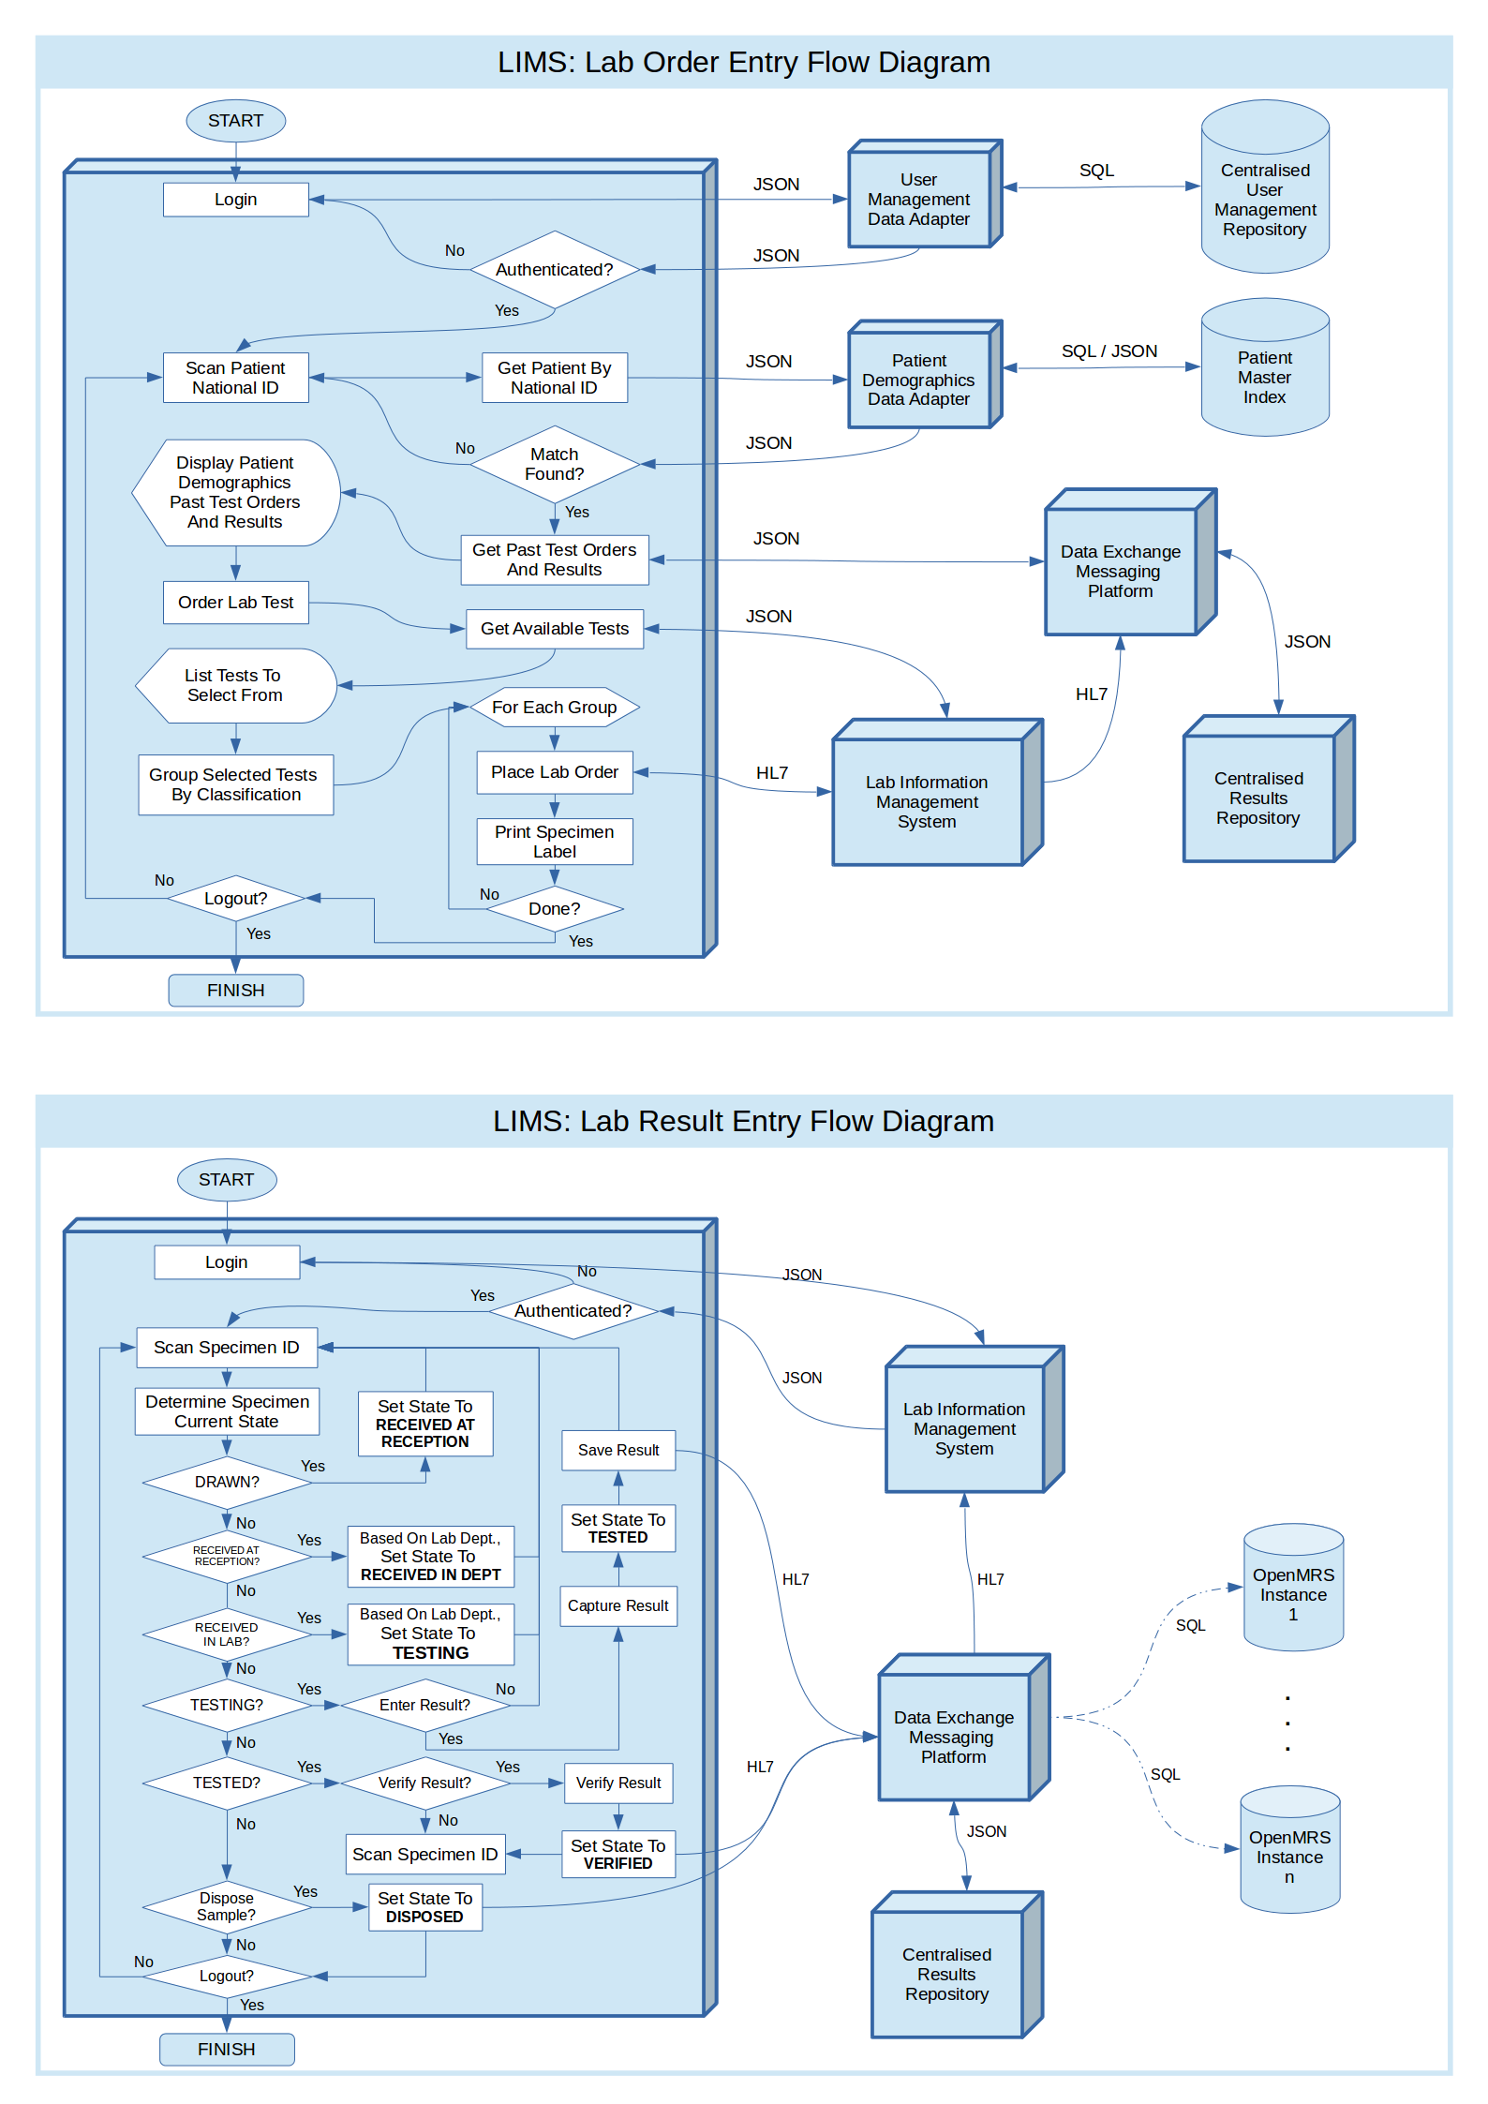Figure 3

Hardware Architecture
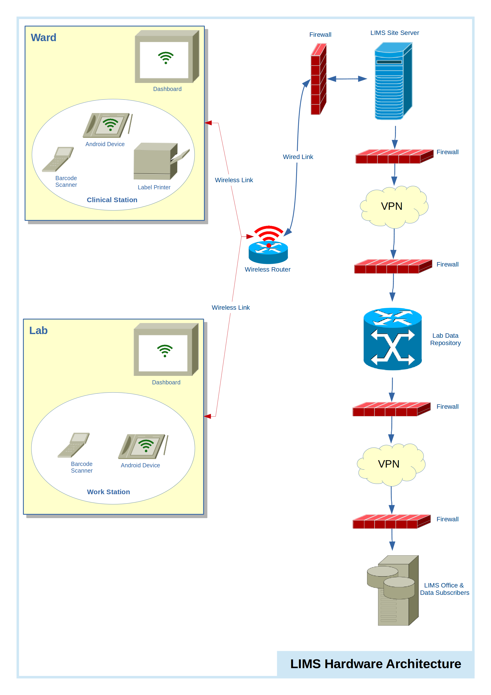Figure 4

Software Architecture
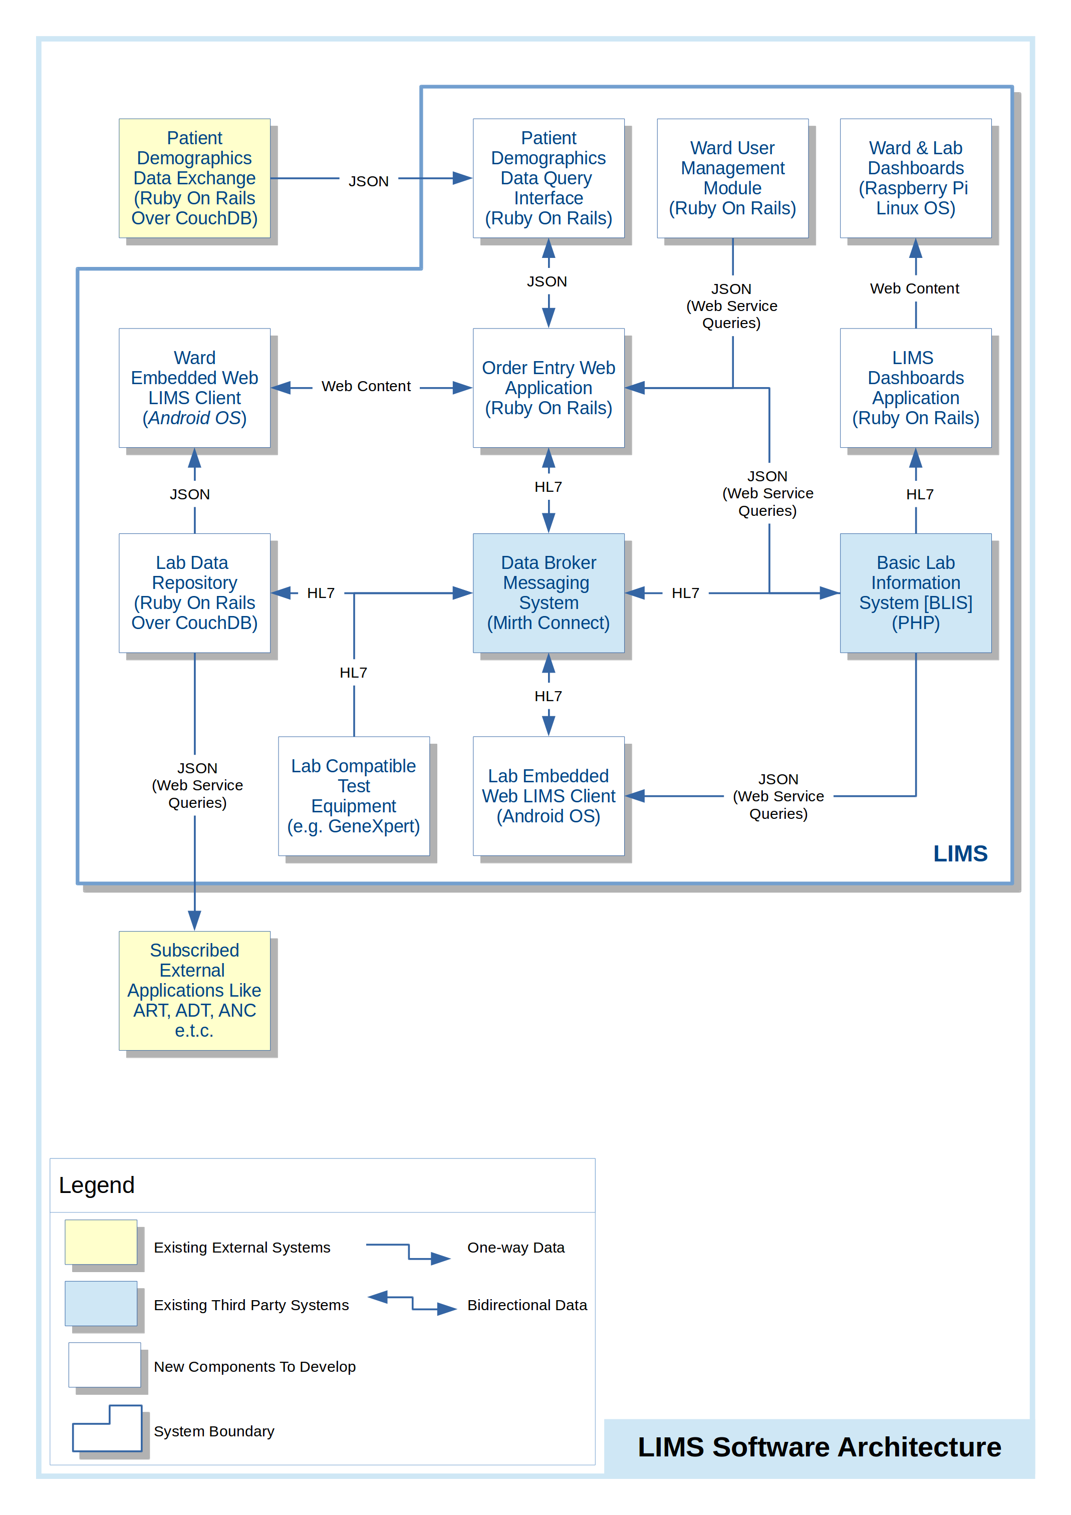Figure 5

System Design

Business Requirements
A separate business requirements document exists and is supposed to have accompanied this design document.

Database Design
For the most part, the structure of databases to be used will depend on the third party lab information system selected to be used. The only data structure presented in this document is that of data documents in the CouchDB database that stores data for the Lab Results Repository which is as shown in Figure 6 below.

The database type chosen for the Lab Results Repository is CouchDB due to it inherent ability to synchronize data across different geographic locations by design. This ability is critical in the implementation of this system as it provides a reliable way to broadcast updates to records as they occur as well as according to the availability of connectivity.

In this database framework, every record is stored as a complete document on its own hence the presentation of the structure of a document in Figure 6.
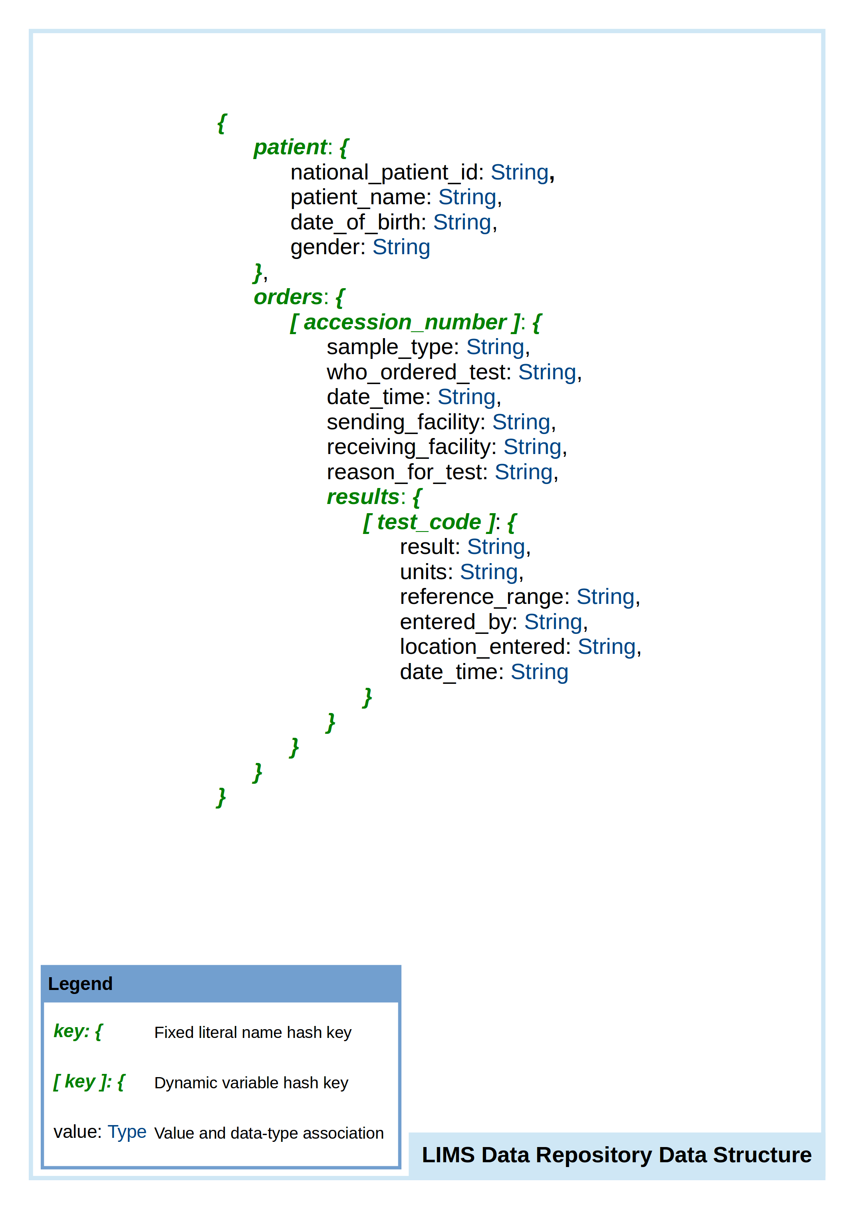Figure 6

Data Conversion
Appendix D shows some of the data formats for HL7 used for placing lab orders.Appendix A: Design Specification Approval
The undersigned acknowledge that they have reviewed the Lab Information Management System Design Specification and agree with the information presented within this document. Changes to this Design Specification will be coordinated with, and approved by, the undersigned, or their designated representatives.
[List the individuals whose signatures are desired. Examples of such individuals are Business Owner, Project Manager (if identified), and any appropriate stakeholders. Add additional lines for signature as necessary.]

Signature: |  | Date:
Print Name:
Title:
Role:

Signature: |  | Date:
Print Name:
Title:
Role:

Signature: |  | Date:
Print Name:
Title:
Role:

APPENDIX B: REFERENCES
[Insert the name, version number, description, and physical location of any documents referenced in this document. Add rows to the table as necessary.]
The following table summarizes the documents referenced in this document.
Document Name | Description | Location

APPENDIX C: KEY TERMS
The following table provides definitions and explanations for terms and acronyms relevant to the content presented within this document.
Term | Definition
LIMS | Lab Information Management System
OS | Operating System
BLIS | Basic Laboratory Information System
JSON | JavaScript Object Notation
HL7 | Health Level-7
VPN | Virtual Private Network

APPENDIX D: HL7 Lab Order Message Definition

