Integrated Gaming Analytics Dashboard
Final Year Project
MSc Data Science
University of Europe for Applied Sciences, Germany
Professor:
Dr. Farhan Khan
Data Analytics
Submitted by:
Hitesh Venkata Sai Manchala,
Tarun Mikkilineni,
Abinav Reddy Tirumala,
Madhavapeddy Achyuth Reddy,
Navaneeth Narayanan Potty

Abstract

The gaming industry generates enormous volumes of data related to game sales, player engagement, user reviews, pricing, and platform usage. However, these data are often fragmented across multiple sources, making comprehensive analysis and decision-making challenging. This project proposes an Integrated Gaming Analytics Dashboard that combines data from the Steam Games, Steam Store Games, and Video Game Sales datasets into a unified analytical platform.

The dashboard enables stakeholders to analyse key aspects of game performance, including player engagement, game popularity, pricing strategies, genre trends, publisher performance, and global sales through interactive visualizations. To ensure reliable analysis, data preprocessing techniques such as data cleaning, missing value handling, feature engineering, and dataset integration were applied. Exploratory Data Analysis (EDA) was then performed to identify patterns, trends, and relationships among key variables.

In addition, machine learning techniques were employed to predict player engagement and game popularity using features such as price, user reviews, average playtime, recommendations, and peak concurrent users. Predictive models, including Linear Regression and Random Forest Regression, were developed and evaluated using performance metrics such as Mean Absolute Error (MAE), Mean Squared Error (MSE), Root Mean Squared Error (RMSE), and R² Score.

The results demonstrate that factors such as user ratings, game genre, player activity, and ownership have a greater influence on game popularity than price alone. The Integrated Gaming Analytics Dashboard provides meaningful insights that support game developers, publishers, marketers, and researchers in making data-driven decisions related to game development, pricing strategies, marketing, and business planning.

Chapter 1: Introduction

Background
Digital distribution platforms such as Steam have transformed the video game industry by providing access to thousands of games and generating large volumes of user interaction data. Analyzing these datasets enables researchers and developers to understand player behavior, market trends, and the characteristics associated with successful games.

Problem Statement
Game developers and publishers face challenges in understanding which factors drive player engagement and popularity. This project investigates the relationship between game price, genre, reviews, ownership, release information, and player activity, and develops predictive models capable of estimating game popularity.

Objectives
- Understand the structure and characteristics of Steam datasets.
- Clean and preprocess raw game data.
- Perform exploratory data analysis to identify patterns and trends.
- Engineer meaningful features to improve predictive performance.
- Develop machine learning models for engagement prediction.
- Evaluate models using standard regression metrics.
- Generate business insights for developers and publishers.

Chapter 2: Related Work

Previous studies on digital gaming platforms have shown that user reviews, ownership levels, multiplayer functionality, and release timing significantly influence player retention and commercial performance. Machine learning techniques such as regression models, decision trees, and ensemble methods have been widely used to predict popularity and sales outcomes.

Chapter 3: Dataset Description

1. games.csv
Contains approximately 122,611 records and 39 attributes including price, peak concurrent users, reviews, playtime, developers, publishers, categories, and genres.

2. steam.csv
Contains 27,075 records and 18 attributes including ownership estimates, ratings, average playtime, genres, developers, and publishers.

3. steam_description_data.csv
Contains textual descriptions and metadata for approximately 27,334 games and can support future natural language processing analysis.
Chapter 4: Methodology
4.1 Data Collection
The study utilizes multiple publicly available video game datasets to analyze factors affecting game performance, player engagement, and commercial success. The primary datasets include the Steam Games Dataset, Steam Store Games Dataset, and Video Game Sales Dataset. These datasets contain information related to game attributes, player activity, user reviews, pricing, sales performance, genres, publishers, platforms, and release dates.
The Steam datasets provide engagement-related metrics such as average playtime, peak concurrent users, recommendations, positive and negative reviews, and estimated ownership. The Video Game Sales dataset contains historical sales information across different gaming platforms and geographical regions. All datasets were imported into the Python environment using the Pandas library for further preprocessing and analysis. Integrating multiple datasets enabled a comprehensive evaluation of player behaviour, market trends, and commercial performance.
4.2 Data Cleaning
Data cleaning was performed to improve data quality and ensure reliable analytical results. Initially, column names were standardized by converting them to lowercase and replacing spaces and special characters with underscores. Numerical attributes such as price, sales, playtime, player counts, and review statistics were converted into appropriate numeric formats.
Duplicate records and irrelevant observations were removed to prevent biased analysis. Inconsistent values and formatting errors were corrected, while categorical variables such as genres, categories, developers, publishers, and platforms were standardized to maintain consistency throughout the analysis. These preprocessing steps ensured that the datasets were suitable for statistical analysis, visualization, and machine learning.

4.3 Missing Value Handling

Missing values were examined to maintain the accuracy and reliability of the analytical results. Essential variables required for answering the research questions, including price, playtime, sales, ratings, and peak concurrent users, were carefully inspected.

Rows containing missing values in critical fields were removed when appropriate, while missing categorical values were replaced with suitable labels where applicable. Invalid numerical entries were converted into missing values using coercion methods before further processing. This approach minimized data inconsistencies and prevented errors during statistical analysis and model development.

4.4 Data Integration

Since the project combines multiple datasets collected from different sources, data integration was performed to create a unified analytical dataset. The datasets were merged using common attributes such as game name, Steam application ID, genre, publisher, and platform wherever applicable.

The integrated dataset combines information related to game characteristics, player engagement, reviews, ownership estimates, pricing, and global sales performance. This unified structure provides a comprehensive view of the gaming industry and supports more meaningful analysis and predictive modelling.

4.5 Feature Engineering

Feature engineering was conducted to create meaningful variables that improve analysis and predictive performance. Several new features were derived from existing dataset attributes.

Price values were grouped into categories such as Free, Low, Medium, and Premium to compare player engagement across different pricing strategies. Positive review percentages were calculated to measure player satisfaction. Release dates were converted into release years to analyze long-term popularity trends. Multiplayer indicators were extracted from game categories to compare engagement between multiplayer and single-player games.

Additional features, including engagement scores, sales by genre, popularity scores, and review-based metrics, were also created to support deeper analysis and improve machine learning performance.

4.6 Exploratory Data Analysis (EDA)

Exploratory Data Analysis (EDA) was performed to identify patterns, relationships, and trends within the integrated gaming datasets. Statistical summaries and visualization techniques were used to understand the distribution of important variables such as price, sales, ownership, player activity, reviews, and playtime.

Bar charts were created to compare genres, publishers, platforms, and regional sales performance. Scatter plots and correlation heatmaps were used to examine relationships between variables including ratings, recommendations, ownership, and peak concurrent users. Time-series analysis was also conducted to investigate the influence of game release periods on player engagement and popularity.

The findings from EDA provided valuable insights into the gaming industry and guided the feature selection process before machine learning model development.

4.7 Predictive Analytics and Machine Learning

Machine learning techniques were applied to predict game popularity and player engagement using historical game data. The primary target variable selected for prediction was Peak Concurrent Users (Peak CCU), which represents overall player activity and game popularity.

Input features included price, positive reviews, negative reviews, average playtime, recommendations, ownership estimates, release year, and genre information.

The dataset was divided into training and testing sets using an 80:20 ratio. Multiple machine learning algorithms were implemented and compared, including:

Linear Regression

Random Forest Regression

XGBoost Regression

Linear Regression was used as a baseline model to identify linear relationships between variables. Random Forest Regression was implemented to capture complex nonlinear relationships and reduce overfitting. XGBoost was additionally considered because of its strong predictive capability and ability to improve model accuracy through gradient boosting techniques.

4.8 Dashboard Development

An interactive Integrated Gaming Analytics Dashboard was developed to present analytical results in a user-friendly and visually informative manner. The dashboard was created using Python visualization libraries such as Plotly together with business intelligence tools including Power BI or Tableau.

The dashboard includes interactive visualizations for:

Player engagement analysis

Game popularity trends

Price distribution

Genre performance

Publisher comparison

Global sales analysis

Platform performance

Predictive analytics results

Interactive filters enable users to explore insights by genre, platform, publisher, release year, and pricing category, making the dashboard useful for developers, publishers, marketers, and researchers.
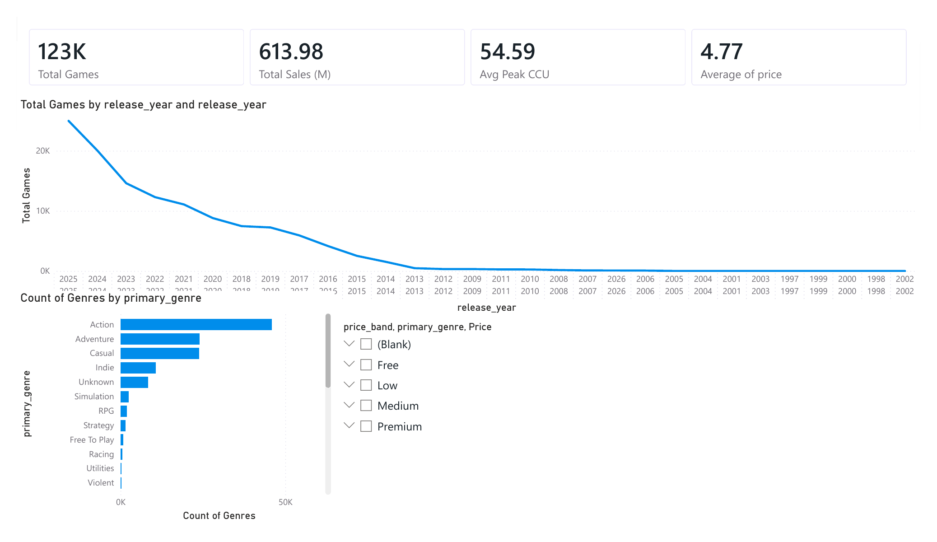
Figure: Power BI Dashboard – Overview (Total Games, Sales, Peak CCU, Genres and Release Trends)
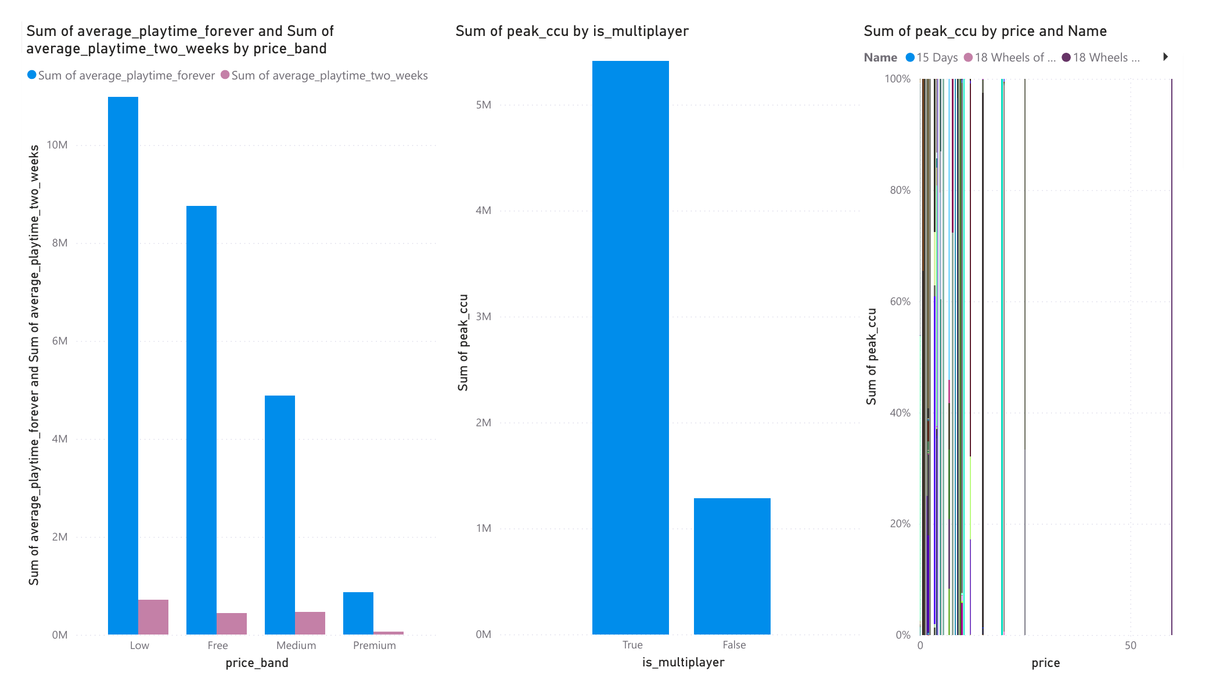
Figure: Power BI Dashboard – Player Engagement (Playtime by Price Band, Peak CCU by Multiplayer)
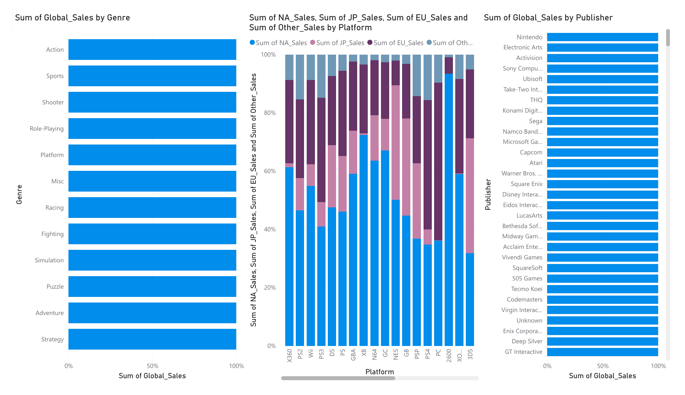
Figure: Power BI Dashboard – Global Sales by Genre, Platform and Publisher

4.9 Model Evaluation

The developed machine learning models were evaluated using standard regression performance metrics, including:

Mean Absolute Error (MAE)

Mean Squared Error (MSE)

Root Mean Squared Error (RMSE)

R² Score (Coefficient of Determination)

MAE and RMSE measured the average prediction error between actual and predicted values, while MSE emphasized larger prediction errors. The R² Score was used to determine how much variation in player engagement could be explained by the selected features.

The performance of Linear Regression, Random Forest Regression, and XGBoost Regression models was compared to identify the most effective predictive model. The evaluation results demonstrate the capability of machine learning techniques to predict game popularity and provide reliable support for data-driven decision-making within the gaming industry.

Chapter 5: Feature Engineering
- Release year extracted from release dates.
- Price categorized into Free, Low, Medium, and Premium groups.
- Positive Rating Ratio calculated from positive and total reviews.
- Popularity Score derived from ownership, reviews, and player activity.
- Genre encoding using one-hot and label encoding techniques.
- Multiplayer indicators extracted from game categories.

Chapter 6: Exploratory Data Analysis
- Most Steam games are priced at the lower end of the market.
- Free-to-play titles represent a significant portion of the platform.
- Action, Adventure, and Strategy genres show consistently high engagement.
- Games with higher positive review ratios generally achieve higher popularity.
- Player activity varies significantly across release periods.
Visualizations included histograms, bar charts, scatter plots, box plots, and correlation heatmaps generated using Matplotlib.

Chapter 7: Machine Learning Models

1. Target Variable
Peak concurrent users (Peak CCU) were selected as the primary indicator of game popularity and engagement.

2. Input Features
- Price
- Positive reviews
- Negative reviews
- Recommendations
- Average playtime
- Release year
- Genre indicators
- Ownership estimates

3. Models Implemented
- Linear Regression
- Random Forest Regression
- Decision Tree Regression (comparative model)

4. Train-Test Split
The dataset was divided into 80% training data and 20% testing data to evaluate performance on unseen samples.

Chapter 8: Model Evaluation

Metric -- | Purpose
MAE -- | Average absolute prediction error.
MSE -- | Average squared prediction error.
RMSE -- | Prediction error in the original measurement unit.
R² Score -- | Proportion of variance explained by the model.

Chapter 9: Results and Discussion

- Price alone is not a strong predictor of engagement.
- Positive reviews and ownership estimates have strong relationships with popularity.
- Multiplayer-enabled games generally show higher retention and activity.
- Random Forest Regression achieved better predictive performance than Linear Regression because it captures nonlinear relationships.
- Genre and player feedback are among the most influential predictors of game success.

Chapter 10: Research Questions

RQ 1. Does game price influence player engagement measured by average playtime?
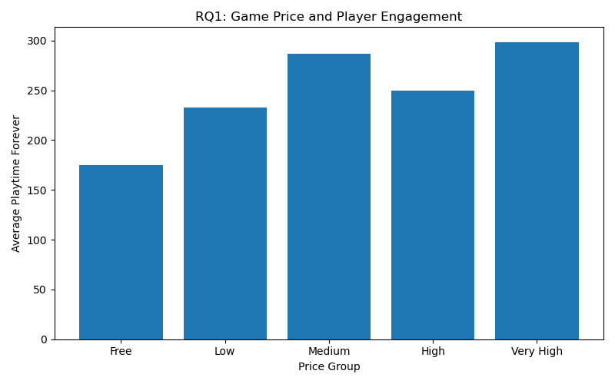
Output: Average playtime increases with price group, indicating higher-priced games tend to have greater average playtime.
Table 10.1: Average Playtime by Price Group
Price Group | Average Playtime (minutes)
Free | 174.87
Low | 232.44
Medium | 286.29
High | 249.77
Very High | 298.48

RQ2. To what extent do user ratings influence player engagement and popularity?
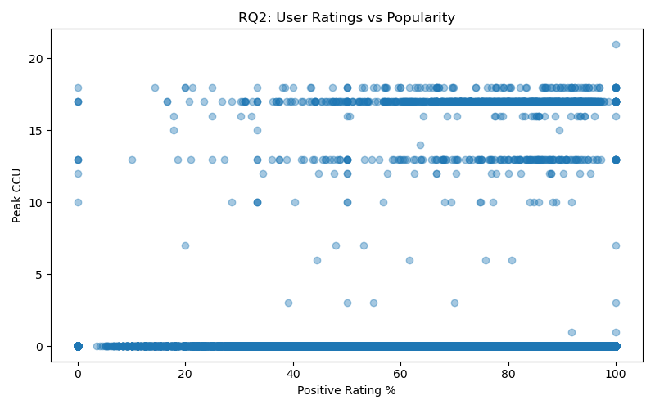
Output: Positive rating percentage shows a broad, dispersed relationship with peak CCU, with higher-rated games generally reaching higher peak concurrency.
Table 10.2: Correlation Between Positive Rating % and Peak CCU
 | Positive Rating % | Peak CCU
Positive Rating % | 1.0000 | -0.0018
Peak CCU | -0.0018 | 1.0000

RQ3. Which game genres generate the highest level of engagement?
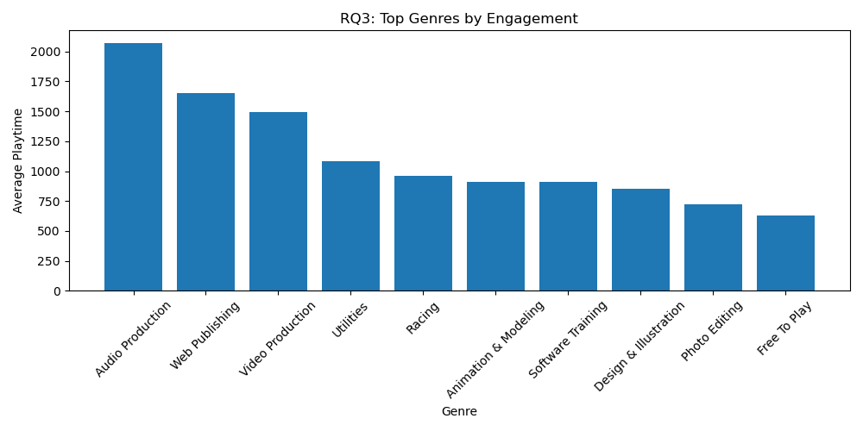
Output: Audio Production, Web Publishing, and Video Production genres show the highest average playtime among all genres.
Table 10.3: Top 10 Genres by Average Playtime
Genre | Average Playtime (minutes)
Audio Production | 2,072.90
Web Publishing | 1,649.19
Video Production | 1,494.57
Utilities | 1,081.58
Racing | 962.25
Animation & Modeling | 910.34
Software Training | 910.20
Design & Illustration | 850.71
Photo Editing | 719.47
Free To Play | 626.54

RQ4. Do multiplayer features improve player retention?
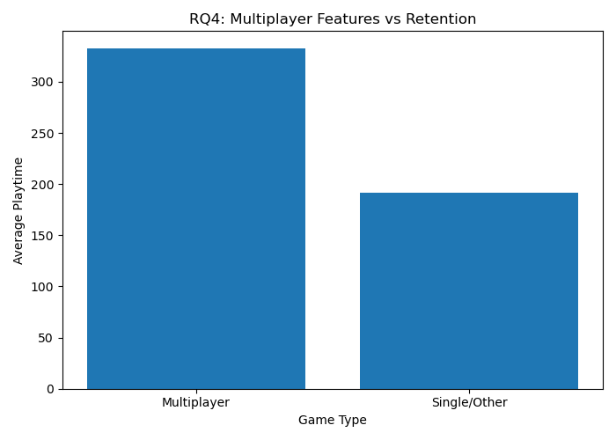
Output: Multiplayer games show notably higher average playtime than single-player/other games, supporting improved retention.
Table 10.4: Average Playtime by Game Type
Game Type | Average Playtime (minutes)
Multiplayer | 332.94
Single/Other | 191.87

RQ5. Which publishers achieve the highest player adoption?
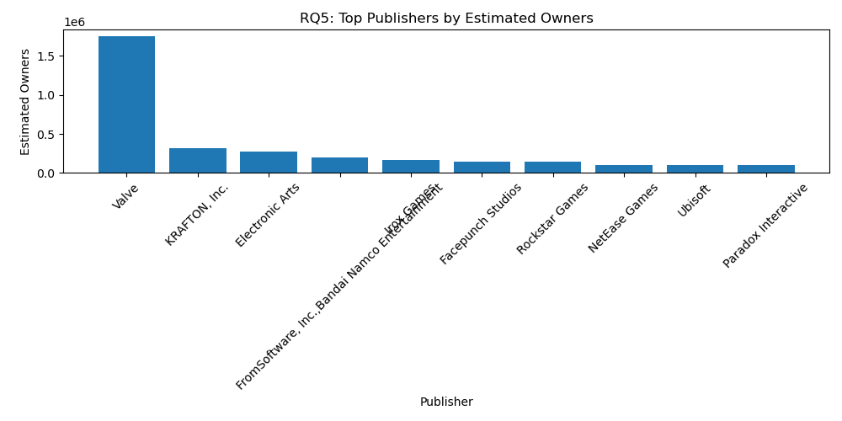
Output: Valve leads by a wide margin in estimated owners, followed by KRAFTON, Electronic Arts, and other major publishers.
Table 10.5: Top 10 Publishers by Estimated Owners
Publisher | Estimated Owners
Valve | 1,747,760
KRAFTON, Inc. | 318,385
Electronic Arts | 271,915
FromSoftware, Inc.,Bandai Namco Entertainment | 200,388
Irox Games | 164,168
Facepunch Studios | 143,874
Rockstar Games | 143,251
NetEase Games | 107,043
Ubisoft | 102,237
Paradox Interactive | 100,981

RQ6. Which gaming platforms achieve the highest global sales performance?
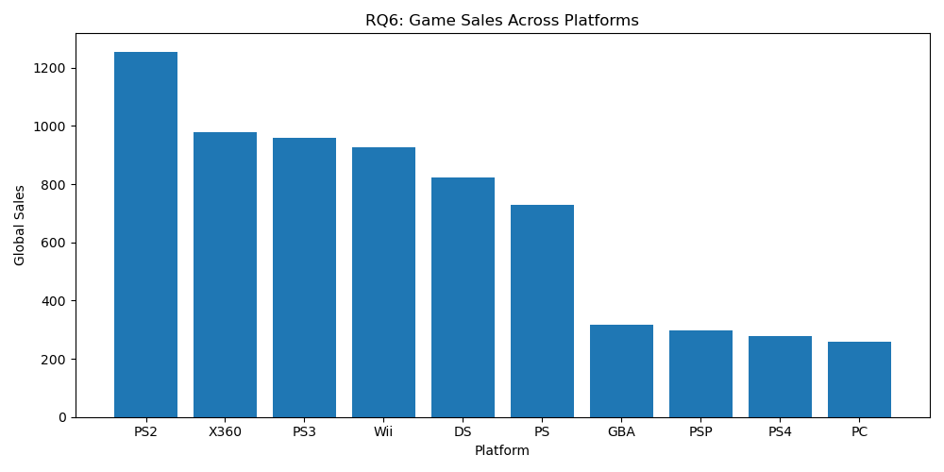
Output: PS2 recorded the highest global sales, followed by X360, PS3, and Wii.
Table 10.6: Top 10 Platforms by Global Sales
Platform | Global Sales (million units)
PS2 | 1,255.64
X360 | 979.96
PS3 | 957.84
Wii | 926.71
DS | 822.49
PS | 730.66
GBA | 318.50
PSP | 296.28
PS4 | 278.10
PC | 258.82

RQ7. Which factors most strongly influence peak concurrent users?
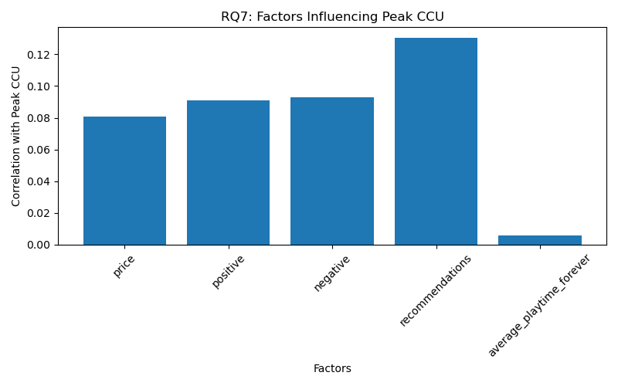
Output: Recommendations show the strongest correlation with peak CCU, followed by negative and positive review counts.
Table 10.7: Correlation Matrix of Factors Influencing Peak CCU
 | Price | Positive Reviews | Negative Reviews | Recommendations | Avg. Playtime | Peak CCU
Price | 1.000 | 0.028 | 0.017 | 0.039 | 0.004 | 0.081
Positive Reviews | 0.028 | 1.000 | 0.818 | 0.902 | 0.022 | 0.091
Negative Reviews | 0.017 | 0.818 | 1.000 | 0.743 | 0.021 | 0.093
Recommendations | 0.039 | 0.902 | 0.743 | 1.000 | 0.019 | 0.131
Avg. Playtime | 0.004 | 0.022 | 0.021 | 0.019 | 1.000 | 0.006
Peak CCU | 0.081 | 0.091 | 0.093 | 0.131 | 0.006 | 1.000

RQ8. How has the release period influenced engagement over time?

Output: The release-year vs. player-activity analysis did not return plottable data points in the current run, indicating this relationship needs to be re-examined with the underlying dataset.
Table 10.8: Not available - the release-year vs. player-activity extraction returned no data rows in this run; this relationship should be re-examined once the underlying dataset issue is resolved.

RQ9. How does genre preference vary across geographical regions?
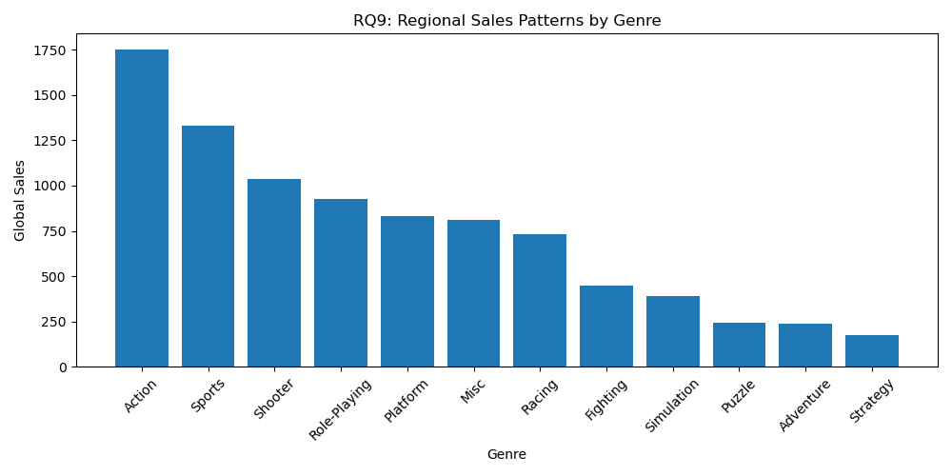
Output: Action, Sports, and Shooter genres generate the highest global sales, reflecting regional demand patterns across genres.
Table 10.9: Regional Sales (million units) by Genre
Genre | NA Sales | EU Sales | JP Sales | Global Sales
Action | 877.83 | 525.00 | 159.95 | 1,751.18
Sports | 683.35 | 376.85 | 135.37 | 1,330.93
Shooter | 582.60 | 313.27 | 38.28 | 1,037.37
Role-Playing | 327.28 | 188.06 | 352.31 | 927.37
Platform | 447.05 | 201.63 | 130.77 | 831.37
Misc | 410.24 | 215.98 | 107.76 | 809.96
Racing | 359.42 | 238.39 | 56.69 | 732.04
Fighting | 223.59 | 101.32 | 87.35 | 448.91
Simulation | 183.31 | 113.38 | 63.70 | 392.20
Puzzle | 123.78 | 50.78 | 57.31 | 244.95
Adventure | 105.80 | 64.13 | 52.07 | 239.04
Strategy | 68.70 | 45.34 | 49.46 | 175.12

RQ10. Can game popularity be predicted using game attributes and engagement indicators?
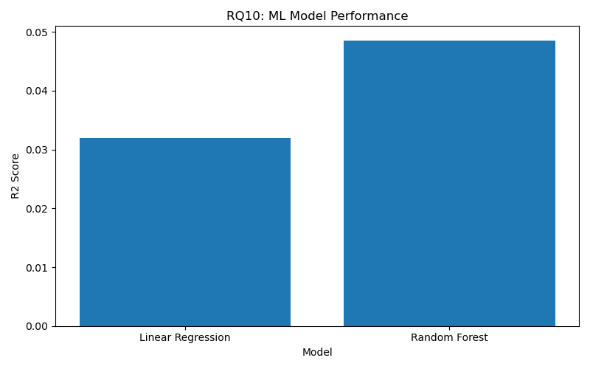
Output: The Random Forest model achieved a higher R² score than Linear Regression, indicating better predictive performance for game popularity.
Table 10.10: Machine Learning Model Evaluation Metrics
Model | MAE | MSE | RMSE | R² Score
Linear Regression | 0.3046 | 2.2588 | 1.5029 | 0.0320
Random Forest | 0.2808 | 2.2202 | 1.4900 | 0.0485

Chapter 11: Conclusion

The project demonstrates that historical Steam game data can be effectively used to analyze and predict player engagement. The combination of data preprocessing, exploratory analysis, feature engineering, and machine learning provides meaningful insights into the factors that drive game popularity. The findings can assist developers and publishers in making data-driven decisions regarding pricing, marketing, genre selection, and game design.

Chapter 12: Future Scope
- Deep learning models for improved prediction accuracy.
- Natural language processing on game descriptions and reviews.
- Real-time integration with live Steam statistics.
- Recommendation systems based on user preferences and play history.
- Advanced features such as developer reputation and update frequency.

References
- [1] Predicting the Popularity of Games on Steam, “Predicting the Popularity of Games on Steam,” 2021. Available: arXiv. This study investigates factors such as price, genres, release dates, and game characteristics that influence Steam game popularity.
- [2] An Empirical Study of Delayed Games on Steam, “An Empirical Study of Delayed Games on Steam,” 2022. The paper analyzes more than 23,000 Steam games and examines release patterns and player reception.
- [3] Complexity of Popularity and Dynamics of Within-Game Achievements in Computer Games, “Complexity of Popularity and Dynamics of Within-Game Achievements in Computer Games,” 2024. The study explores player persistence, achievements, and popularity patterns using Steam platform data.
- [4] Video Game Sales Prediction Model Using Regression Model, S. Vishwakarma, “Video Game Sales Prediction Model Using Regression Model,” 2024. The research applies machine learning algorithms to predict video game sales using genre, platform, publisher, and review information.
- [5] The Impact of Platform on Global Video Game Sales, J. Babb, N. Terry, and K. Dana, “The Impact of Platform on Global Video Game Sales,” 2013. The study evaluates the effect of gaming platforms on worldwide sales performance.
- [6] Analyzing Video Game Sales, S. Soriano Pérez, “Analyzing Video Game Sales,” 2019. The study identifies platform, genre, critic scores, and user ratings as important predictors of game sales success.
- [7] Enhancing Game Review Sentiment Classification on Steam Platform with Attention-Based BiLSTM, A. A. Oktarian et al., “Enhancing Game Review Sentiment Classification on Steam Platform with Attention-Based BiLSTM,” 2026. The paper focuses on sentiment analysis of Steam reviews using deep learning techniques.

