哈尔滨工业大学计算机科学与技术学院
2015年秋季学期《软件工程》
Lab 3：MVC编程与云平台部署

姓名 | 学号 | 联系方式
杨悦羽霄 | 1130340102 | 594912907@qq.com/18665434442

目 录

1 实验要求 1
2 开发环境配置 1
3 图书SaaS设计 1
3.1 Settings.py 1
3.2 urls.py 1
3.3 View中的各方法 1
3.4 辅助类 2
3.5 Templates 2
3.6 各view/template之间的调用和消息传递关系 2
4 图书SaaS核心代码 2
4.1 按作者查询 2
4.2 展示图书详细信息 2
4.3 删除图书 2
4.4 新增图书/作者(可选) 2
4.5 更新图书信息(可选) 3
4.6 数据库连接与访问 3
5 图书SaaS的SAE部署 3
5.1 步骤 3
5.2 外在访问结果 3
6 计划与实际进度 3
7 小结 3

[文档全部完成之后，请更新上述区域]

实验要求
简要复述实验手册中要求达到的实验目标与过程。
使用MySQL或SQLite建立一个“图书数据库BookDB”,包含两张表: – Book {ISBN (PK), Title, AuthorID (FK), Publisher, PublishDate, Price}
– Author {AuthorID (PK), Name, Age, Country}
▪ 手工输入足够多的若干测试数据;
▪ 开发以下功能:
– 输入作者名字,查询该作者所著的全部图书的题目;
– 当用户点击某本图书的题目时,展示图书详细信息和作者详细信息; – 当用户点击“删除”按钮时,将对应行的图书从数据表中删除;
– (opt)用户可新增一本图书,若该书作者不在库中,还需增加新作者; – (opt)用户可更新一本图书的作者、出版社、出版日期、价格

开发环境配置
采用屏幕截图加文字说明的方式给出你自己配置MySQL、Django等的各步骤。
Win8 \django1.8.5\python2.7
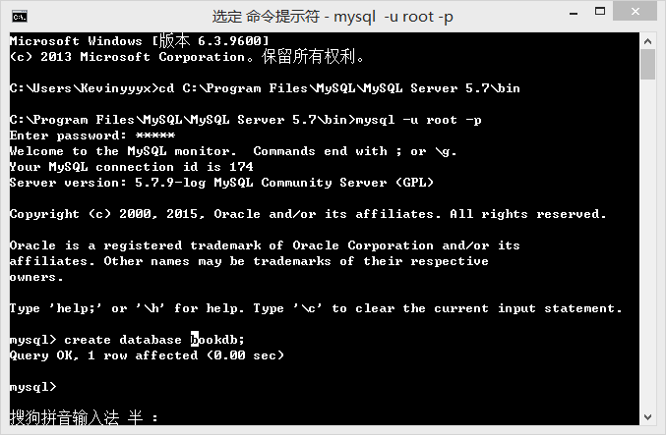
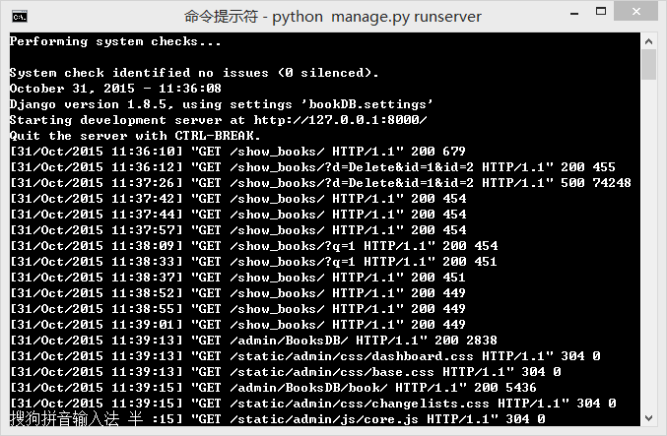
c:\Python27>django-admin.py startproject bookDB

c:\Python27>cd bookdb

c:\Python27\bookDB>python manage.py startapp
usage: manage.py startapp [-h] [--version] [-v {0,1,2,3}]
[--settings SETTINGS] [--pythonpath PYTHONPATH]
[--traceback] [--no-color] [--template TEMPLATE]
[--extension EXTENSIONS] [--name FILES]
name [directory]
manage.py startapp: error: You must provide an application name.

c:\Python27\bookDB>python manage.py startapp BookDB
CommandError: 'c:\Python27\bookDB\BookDB' already exists

c:\Python27\bookDB>python manage.py startapp BooksDB

c:\Python27\bookDB>python manage.py syncdb
C:\Python27\lib\site-packages\django\core\management\commands\syncdb.py:24: Remo
vedInDjango19Warning: The syncdb command will be removed in Django 1.9
warnings.warn("The syncdb command will be removed in Django 1.9", RemovedInDja
ngo19Warning)

Operations to perform:
Synchronize unmigrated apps: staticfiles, messages
Apply all migrations: admin, contenttypes, auth, sessions
Synchronizing apps without migrations:
Creating tables...
Running deferred SQL...
Installing custom SQL...
Running migrations:
Rendering model states... DONE
Applying contenttypes.0001_initial... OK
Applying auth.0001_initial... OK
Applying admin.0001_initial... OK
Applying contenttypes.0002_remove_content_type_name... OK
Applying auth.0002_alter_permission_name_max_length... OK
Applying auth.0003_alter_user_email_max_length... OK
Applying auth.0004_alter_user_username_opts... OK
Applying auth.0005_alter_user_last_login_null... OK
Applying auth.0006_require_contenttypes_0002... OK
Applying sessions.0001_initial... OK

You have installed Django's auth system, and don't have any superusers defined.
Would you like to create one now? (yes/no): ^C
c:\Python27\bookDB>python manage.py syncdb
C:\Python27\lib\site-packages\django\core\management\commands\syncdb.py:24: Remo
vedInDjango19Warning: The syncdb command will be removed in Django 1.9
warnings.warn("The syncdb command will be removed in Django 1.9", RemovedInDja
ngo19Warning)

Operations to perform:
Synchronize unmigrated apps: staticfiles, messages
Apply all migrations: admin, contenttypes, auth, sessions
Synchronizing apps without migrations:
Creating tables...
Running deferred SQL...
Installing custom SQL...
Running migrations:
Rendering model states... DONE
Applying contenttypes.0001_initial... OK
Applying auth.0001_initial... OK
Applying admin.0001_initial... OK
Applying contenttypes.0002_remove_content_type_name... OK
Applying auth.0002_alter_permission_name_max_length... OK
Applying auth.0003_alter_user_email_max_length... OK
Applying auth.0004_alter_user_username_opts... OK
Applying auth.0005_alter_user_last_login_null... OK
Applying auth.0006_require_contenttypes_0002... OK
Applying sessions.0001_initial... OK

You have installed Django's auth system, and don't have any superusers defined.
Would you like to create one now? (yes/no): yes
Username (leave blank to use 'kevinyyyx'): kevin
Email address: 594912907@qq.com
Password:
Password (again):
Superuser created successfully.
想·

图书SaaS设计

Settings.py
源代码(py)
附加关键部分的说明
#SAE
import sae.const
MYSQL_DB = sae.const.MYSQL_DB
MYSQL_USER = sae.const.MYSQL_USER
MYSQL_PASS = sae.const.MYSQL_PASS
MYSQL_HOST_M = sae.const.MYSQL_HOST
MYSQL_HOST_S = sae.const.MYSQL_HOST_S
MYSQL_PORT = sae.const.MYSQL_PORT
DATABASES = {
'default': {
'ENGINE': 'django.db.backends.mysql',
'NAME': MYSQL_DB,
'USER': MYSQL_USER,
'PASSWORD': MYSQL_PASS,
'HOST': MYSQL_HOST_M,
'PORT': MYSQL_PORT,
}
}

运用SAE的服务的DATABASE

urls.py
源代码(py)
# -*- encoding: utf-8 -*-
from django.conf.urls import include, url
from django.contrib import admin
from BooksDB.views import show_books,book_details,book_delete,book_update,add_author,add_book
admin.autodiscover()
urlpatterns = [
url(r'^admin/', include(admin.site.urls)),
url(r'^$', show_books),
url(r'^book_details/$', book_details),
url(r'^book_delete/$', book_delete),
url(r'^book_update/$', book_update),
url(r'^add_author/$', add_author),
url(r'^add_book/$', add_book),

]

附加关键部分的说明

View中的各方法
序号 | 方法名称 | 作用
1 | show_books | 1 展示所有图书  2 搜索框及搜索结果  3 新添书籍（链接）  4 展示图书细节（链接）  5 删除书籍  6 更新书籍
2 | Book_details | 展示书籍  Title/authorid/publisher/publishdate/isbn/price
3 | Book_delete | 删除一本书籍
4 | Book_update | 1 更新书籍信息  2 新增作者（链接）
5 | Add_author | 新增作者实现

辅助类
序号 | 方法名称 | 作用
1 | AddBookFrom | 新增书籍的表单model，使新增的书籍符合model形式输入保存
2 | Book
3 | Author

Templates
序号 | 页面名 | 作用 | 页面核心元素(form) | Form对应的action name | Form中提交的数据项
1 | Show_books | 1 展示所有图书  2 搜索框及搜索结果  3 新添书籍（链接）  4 展示图书细节（链接）  5 删除书籍  6 更新书籍 | Q | Search_author | 待查的作者名
2 | Add_author | 新增作者实现 | AuthorID | author.AuthorID | 作者ID
2 | Add_author | 新增作者实现 | Age | author.Age | 作者年龄
2 | Add_author | 新增作者实现 | Country | Author.country | 作者国籍
2 | Add_author | 新增作者实现 | Name | Author.name | 作者名字
3 | Add_book | 新增书籍 | Title | Book.title | 书籍名
3 | Add_book | 新增书籍 | Author | Author.id(foreignkey) | 选择作者信息
3 | Add_book | 新增书籍 | Publisher | Book.publisher | 出版商
3 | Add_book | 新增书籍 | Isbn | Book.isbn | ISBN信息
3 | Add_book | 新增书籍 | Price | Book.price | 价格
4 | Update | 更新书籍 | Title | Book.title | 书籍名
4 | Update | 更新书籍 | Author | Author.id(foreignkey) | 选择作者信息
4 | Update | 更新书籍 | Publisher | Book.publisher | 出版商
4 | Update | 更新书籍 | Isbn | Book.isbn | ISBN信息
4 | Update | 更新书籍 | Price | Book.price | 价格

各view/template之间的调用和消息传递关系
给出一张图示描述彼此之间的数据传递和调用关系。
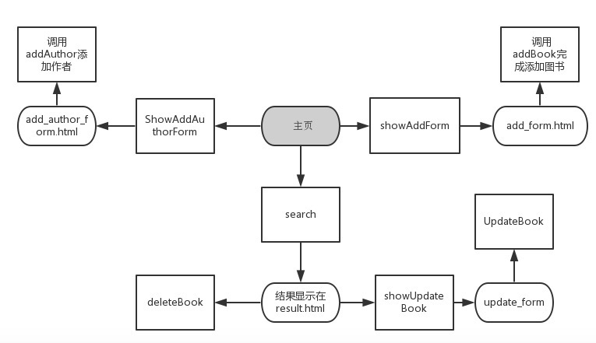

图书SaaS核心代码
针对下列功能，分别给出view类和template页面中的核心代码。

按作者查询
def show_books(request):

books_list = Book.objects.order_by('AuthorID')
'''
context = {'books_list': books_list}
return render(request, 'show_books.html', context)
'''

errors = []
if 'q' in request.GET:
q = request.GET['q']
if not q:
errors.append('Enter a search term.')
elif len(q) > 20:
errors.append('Please enter at most 20 characters.')
else:
search_author = Author.objects.filter(Name__icontains=q)

if len(search_author) == 0 :
errors.append('there is no such author named '+q)
books_list = []
else:
for author in search_author:

books_list = Book.objects.filter(AuthorID_id=author.id)
if len(books_list) == 0:
books_list = []
errors.append(q+" has no books")
return render(request,'show_books.html',
{'books_list': books_list,'errors':errors, 'query': q})
return render(request,'show_books.html',
{'books_list': books_list,'errors': errors})

Template:
<html>
<head>
<title>Search authors</title>
</head>
<body>
{% if errors %}
<ul>
{% for error in errors %}
<li>{{ error }}</li>
{% endfor %}
</ul>
{% endif %}
<form action="" method="get">
<input type="text" name="q">
<input type="submit" value="Search">
</form>
</body>
<li>{{ author_list }} </li>
{% if books_list %}
<ul>
<p> author name: books' title </p>
{% for book in books_list %}
<li> {{ book.AuthorID }} : {{ book.Title }} <a href="../../book_details/?id={{book.id}}">details</a> <a href="../../book_delete/?id={{book.id}}"> delete</a> <a href="../../book_update/?id={{book.id}}"> update</a>

</li>

{% endfor %}
</ul>
{% else %}
<p>No books are available.</p>
{% endif %}
<p> <a href="../../">Show all books</a></p>
<p> <a href="../../add_book/">Add book</a></p>
</html>

展示图书详细信息

def book_details(request):
bookID = request.GET['id']
book = Book.objects.get(id=bookID)
author = book.AuthorID.Name
return render_to_response('book_details.html',locals())

Template：
<head>
<title> Book Details </title>
</head>
<p>Details:</p>
<li>tittle: {{ book.Title }}</li>
<li>author id: {{ book.AuthorID }}</li>
<li>publisher: {{ book.Publisher }}</li>
<li>publish date: {{ book.PublishDate }}</li>
<li>isbn: {{ book.ISBN }}</li>
<li>price: {{book.Price }}</li>
<p><a href="../../book_delete/?id={{book.id}}"> delete</a></p>
<p><a href="../../"> back to the index</a>
<p><a href="../../book_update/?id={{book.id}}">update the book</a>

删除图书
def book_delete(request):

if 'id' in request.GET:
ID = request.GET['id']
book = Book.objects.get(id=ID)
book_Title = book.Title
book.delete()
return render_to_response ('delete.html',locals())

Template：
<head>
<title>deleted</title>
</head>

<body>
<p> you have deleted a book named {{book_Title}}<p>

<p>&nbsp</p>
<p>&nbsp</p>
<p>&nbsp</p>

<p> <a href="../../">back to the index</a></p>

</body>
</html>

新增图书/作者(可选)

from BooksDB.form import AddBookForm
from django import forms
def add_book(request):
if 'success' in request.GET:
is_success = True
if request.method == 'GET':
book_form = AddBookForm(request.GET)
if book_form.is_valid():
book_form.save()
return HttpResponseRedirect("../../add_book/?success=1",locals())

else:
book_form = AddBookForm()
return render_to_response('add_book.html',locals())
def add_author(request):
if 'id' in request.GET:
book = Book.objects.get(id=request.GET['id'])
if 'AuthorID' in request.GET:
if not (len(request.GET['AuthorID']) == 0 or len(request.GET['Name'])==0 or len(request.GET['Age'])==0 or len(request.GET['Country'])==0):
Author.objects.create(
AuthorID = request.GET['AuthorID'],
Name = request.GET['Name'],
Age = request.GET['Age'],
Country = request.GET['Country'],
)
return HttpResponseRedirect("../../add_author/",locals())
return render_to_response('add_author.html',locals())

Template：
{% if is_success %}
<p>You have added a book!</p>
{% endif%}
<form action="" method="get">
<table>
{{ book_form.as_table }}
</table>
<input type="submit" value="Submit">
</form>

<p><a href="../../add_author/">Add new Author</a></p>
<a href="../../">Go back to index</a>

<html>
<head>
<title> Add author</title>
</head>
<form action="/add_author/" method="get">

<p>add a NEW Author</p>
<p>Author ID (number only)<input type="text" name="AuthorID"></p> <p>Name <input type="text" name="Name"></p>
<p>Age(number only) <input type="text" name="Age"></p>
<p>Country <input type="text" name="Country"></p>

<th>
<form action="" method="get">
<input type="submit" value="Add">
</from>
{% if book %}
<a href="../../book_update/?id={{book.id}}">go back to update</a>
{% endif %}
</th>
<p><a href="../../">Go back to index</a></p>
</tr>

更新图书信息(可选)
def book_update(request):
if 'id' in request.GET:
ID = request.GET['id']
book = Book.objects.get(id=ID)

if 'name' in request.GET:
name = request.GET['name']

try:
author = Author.objects.get(Name=name)
except:
add_author(request)
return render_to_response('update.html',locals())
else:
book.AuthorID = author
book.Publisher = request.GET['publisher']
book.Title = request.GET['title']
book.PublishDate = request.GET['publishdate']
book.Price = request.GET['price']
book.save()

return render_to_response('update.html',locals())

Template：

<html>
<head>
<title> Update book </title>
</head>
<form action="/book_update/" method="get">

<table>
<tr>
<th>Title</th><th>Author</th><th>Publisher</th><th>PublishDate</th><th>Price</th>
</tr>
<tr>
<td>{{ book.Title }}</td>
<td>{{ book.AuthorID.Name }}<a href="../../add_author/?id={{book.id}}"> add a new author</a>
</td>
<td>{{ book.Publisher }}</td>
<td>{{ book.PublishDate }}</td>
<td>{{ book.Price }}</td>
</tr>

<tr>
<td><input type="text" name="title"></td>
<td><input type="text" name="name"></td>
<td><input type="text" name="publisher"></td>
<td><input type="date" name="publishdate"></td>
<td><input type="text" name="price"></td>
</tr>
<table>
<tr>

<th>
<form action="" method="get">
<input type="hidden" name="id" value="{{ book.id }}">
<input type="submit" value="Update">
</from>
</th>
</tr>
</table>
</table>
</form>
<p><a href="../../"> back to the index</a>
<p><a href="../../book_details/?id={{book.id}}"> book details</a>

</body>
</html>

数据库连接与访问
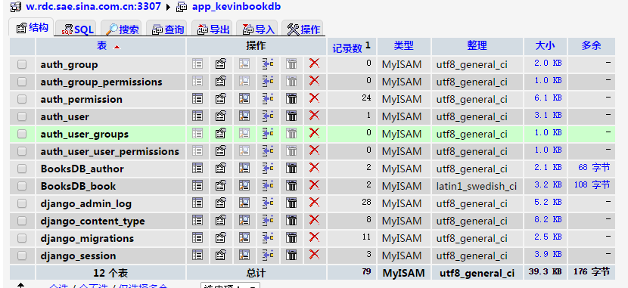

图书SaaS的SAE部署

步骤
采用屏幕截图的方式给出你自己在SAE上注册、创建应用、导入应用、配置MySQL等步骤的过程。
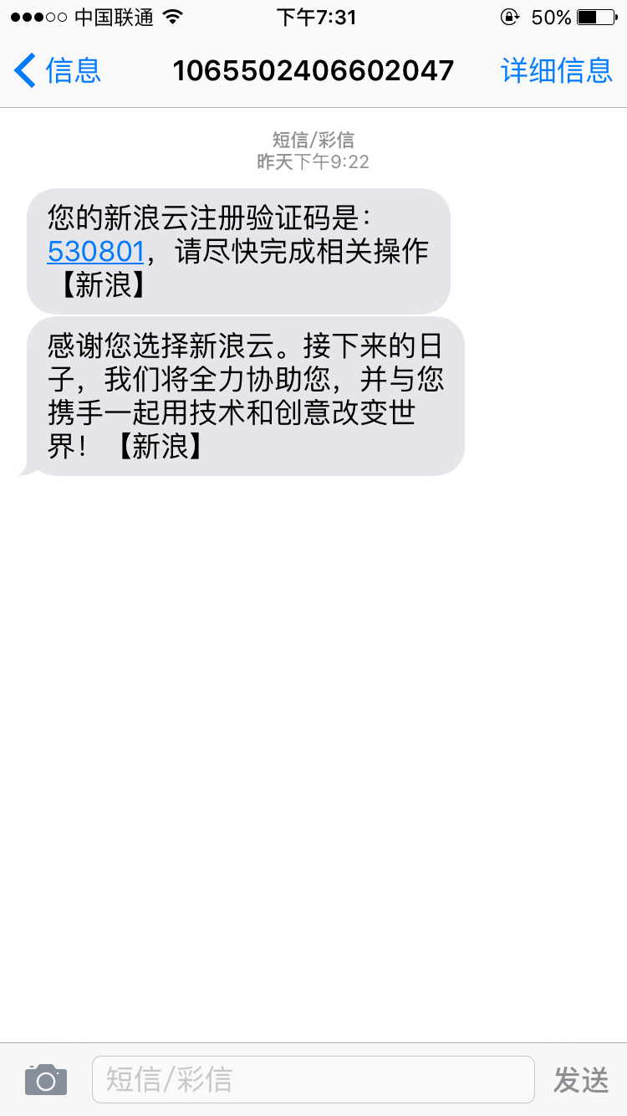
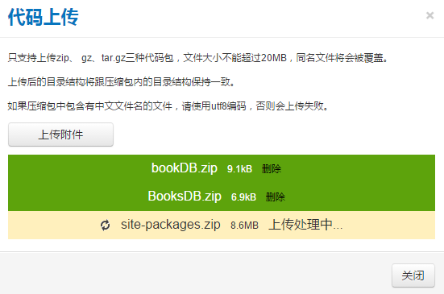
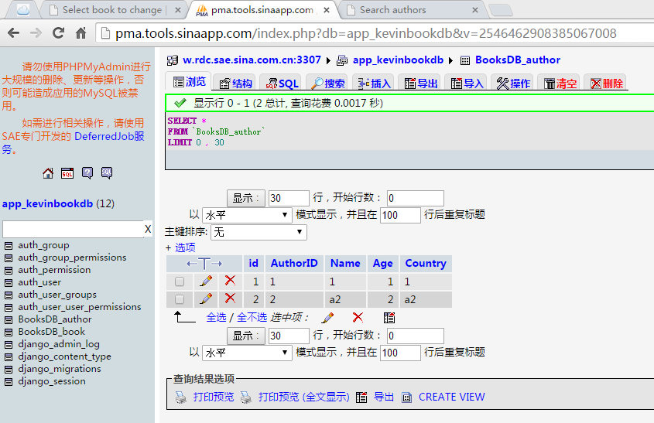

外在访问结果
给出访问SAE上的图书SaaS的地址；
http://2.kevinbookdb.sinaapp.com/

给出屏幕截图结果，要展示出核心功能。
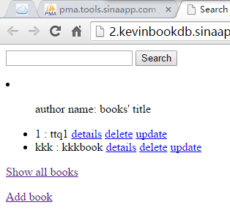
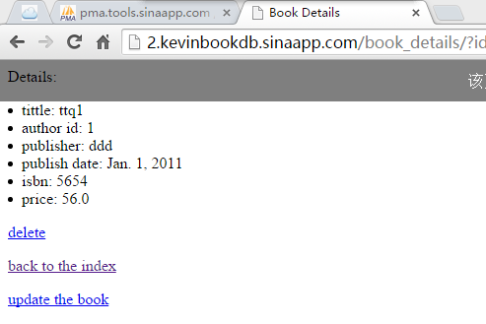
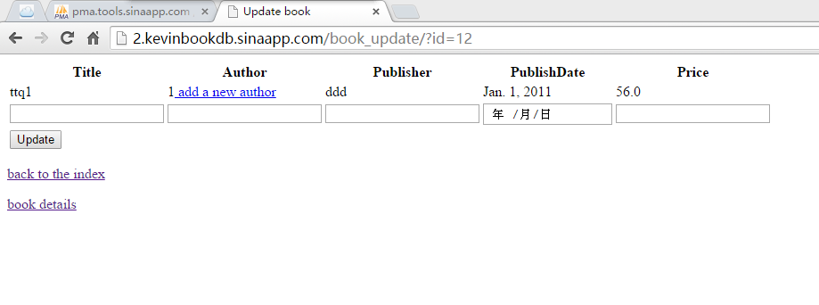
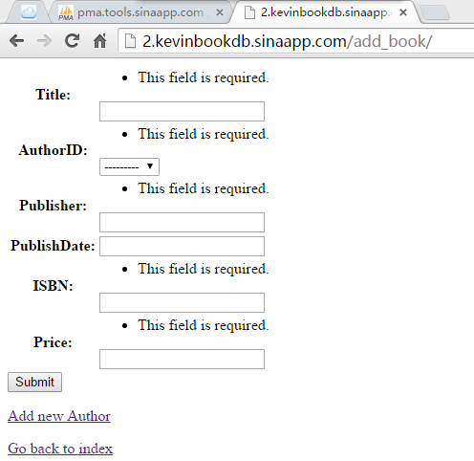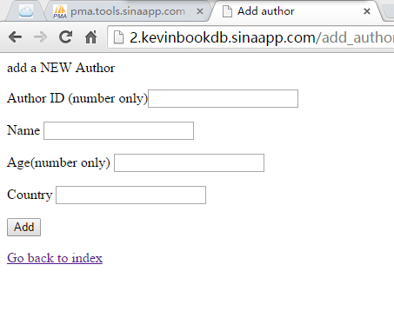

计划与实际进度
任务编号 | 计划时间长度（分钟） | 实际耗费时间（分钟） | 提前或延期的原因分析
1 | 120 | 240 | 对django不熟悉
2 | 180 | 240 | 重新学习表单的机制
3 | 120 | 120 | 部署有点费劲

小结
对本次实验过程和结果的思考。

对于本次实验，相当于重新捡回了Django，同时熟悉了部署SAE和SVN上传，对于project受益匪浅。

