# Introduction

## Background

Nora operates a small family-run restaurant that offers a delightful range of breakfast items, Chinese cuisine, and dinner, focusing on Cantonese dishes. Many of her regular customers place their orders in advance through her WeChat group and pick up their food at designated times. However, as the number of customers has grown, so has the size of the WeChat group. This increase in volume has led to challenges: sometimes the restaurant is too busy to check WeChat, customers may send multiple messages and miss their orders, or forget to include special requests, resulting in numerous complaints. To address these issues, Nora needs an online booking system capable of managing customer orders, promptly communicating special requests to the kitchen, and facilitating online payments. The proposed Restaurant Online Order System would allow customers to view the menu, and the ingredients used in each dish. Customers can browse the menu, place their orders online according to their preferences, pay for their orders, and select a pick-up time. When an order is placed, the restaurant receives an alert and communicates the details to the kitchen. The kitchen prepares the food at the specified time and places it at the front desk. Customers will be notified when their order is ready for pick-up. Additionally, the system should allow for order cancellations within a specified timeframe.

## Problem Statement

The Restaurant Online Order System is designed to solve the problem of inefficient, traditional order management in restaurants.

* **What the problem is:**

Traditional manual ordering methods are prone to errors, delays and inefficiencies. Customers often must wait long to place their orders, especially during peak hours, while restaurant staff have difficulty tracking multiple orders efficiently.

* **Why it’s a problem:**

If restaurants do not have a streamlined ordering system, they may lose customers due to dissatisfaction and mismanagement. Mistakes in order processing can result in wasted resources and higher costs. Additionally, the absence of a digital platform can diminish a restaurant's competitive edge, especially among tech-savvy customers who prefer online service.

## Project Goals

Build a website that enables restaurant customers to book the dishes they want and receive them at the scheduled time. Improving the reservation service will generate positive feedback from customers and increase business revenue.

## Project Team

* **Academic Supervisors:** **Atefeh**

# Method

**Project management methodology: Agile Framework**

I will choose the Agile methodology to execute the project because Agile is well-suited to this project. The Agile methodology is flexible, iterative development and focuses on collaboration and continuous improvement.

**Justification:**

* Flexibility: The system’s scope includes various functions (menu browsing, order placement, payment integration, etc.) that can be developed and refined over time.
* Rick Mitigation: An agile, iterative approach reduces risk by delivering small functional system components early and allowing for timely adjustments.
* Adaptability to change: As NOLA Restaurants grows, needs may evolve. Agile allows changes to be made mid-project without disrupting the entire workflow.

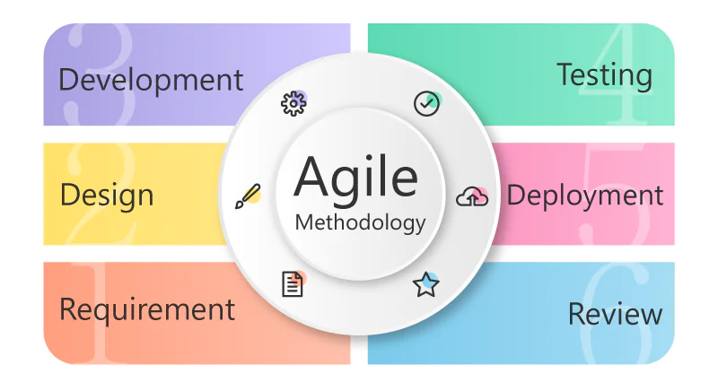

(*What Is Agile Methodology? - Overview of Agile Software Development and Agile Models*, 2022)

**Techniques and Methods**

**Phase1: Requirement gathering and planning**

* Goal: Identify and prioritize system features, e.g. Menu display, order notifications, and cancellation.
* Techniques:

1. Interviews will be conducted with Nora to gain insights into her challenges and workflow.
2. To analyse customer feedback to identify common complaints and preferences.
3. To develop user stories to outline functionality from the perspectives of customers and restaurant staff.

**Phase 2: Design**

* Goal: Develop an initial user interface prototype for customer and staff interaction.
* Techniques:

1. Design wireframes for menu browsing, order placement, and payment screens.
2. Use tools like Figma for mockups to collect early feedback on usability.

**Phase 3: Development**

* Goal: Develop system parts progressively to guarantee both functionality and reliability.
* Techniques:

1. Backend: Build the order management system, integrating a database for menu items, orders and cancellations.
2. Frontend: Develop responsive user interfaces for desktop and mobile users.

**Phase 4: Testing**

* Goal: Validate that the system addresses the key pain points for the restaurant.
* Techniques:

1. Conduct beta testing with a small group of regular customers. Gather feedback on order placement and usability to identify areas for improvement.
2. Allow the restaurant staff to test the order alerts and preparation timing workflows.

**Phase 5: Deployment**

* Goal: Launch the system in phases to ensure a smooth transition.
* Techniques: Complete deployment will occur after resolving any bugs or usability issues identified during the soft launch.

**Phase 6: Review**

* Goal: Ensure the system remains functional and current with the restaurant’s growing needs.
* Techniques:

1. Develop a monitoring system to track order flows and send notifications.
2. Based on user feedback, schedule regular updates to introduce new features or improve existing functionality.

## Tools and Technologies

Software: Node.js, MySQL, CSS, JavaScript

Other Resources: Balsamiq, Lucid Chart, Gantt Chart, GitHub, Excel, Figma

## New and Advanced Skills to be Gained

In this project, I'm learning Node.js and Express.js to create the backend server for managing APIs and processing orders. This new knowledge may be helpful in my future work. Collecting feedback is an important feature of a project. To do so, it is necessary to be in close contact with stakeholders continuously. All of these have helped me improve my communication skills. I also learnt how to make a Gantt Chart using Excel.

# Deliverables

## Deliverables

### Project proposal document: Set the foundation for the project by defining the goal, subgoal, and requirements.

### System diagram: A clear and scalable system design.

### Wireframes and UI: Establish the system's visual and functional layout to help the restaurant visualize how it will meet customer needs and allow for early adjustments.

### Source code repository: Ensure developers and stakeholders can review, reuse, or enhance the project in the future.

### Deployment plan: Ensure the system is live and functional without significant issues.

### Final report: Document the project’s success and provide insights for future improvements.

## Testing and Validation

* Conduct beta testing with a small group of regular customers. Gather feedback on order placement and usability to identify areas for improvement.
* Allow the restaurant staff to test the order alerts and preparation timing workflows.

# Project Timeline

## Milestones

|  |  |
| --- | --- |
| Milestone | Deadline |
| Milestone 1 | 24/11/2024 |
| Milestone 2 | 15/12/2024 |
| Milestone 3 | 26/01/2025 |
| Milestone 4 | 02/02/2025 |
| Milestone 5 | 05/02/2025 |

## Task Breakdown

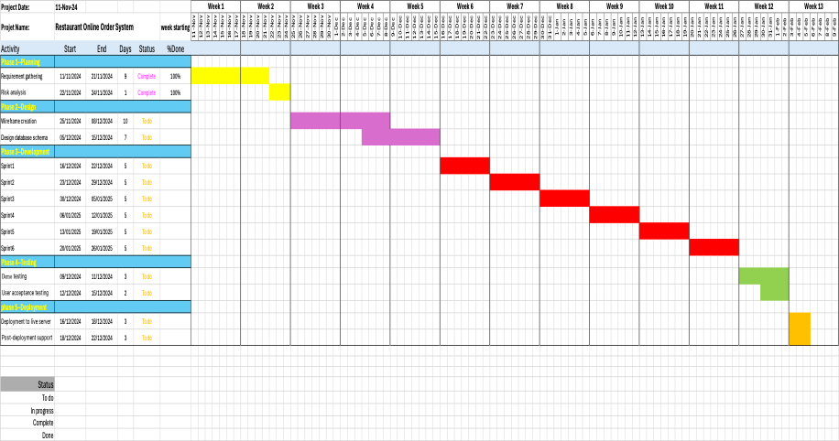

(McLachlan, 2022)

# Risk Management Plan

|  |  |  |
| --- | --- | --- |
| Risk | Mitigation Strategy | Contingency Plan |
| Technical Challenges | Learning new technologies like Figma and Node.js | Use my spare time to watch some relevant video to learn more knowledges. |
| Delayed Feedback | Schedule regular feedback when stuck on specific issues. | Communication in time. |
| Time Overruns | Overview of Agile Software Development and Agile Models. | Reassess priorities and focus on delivering key functionality. |