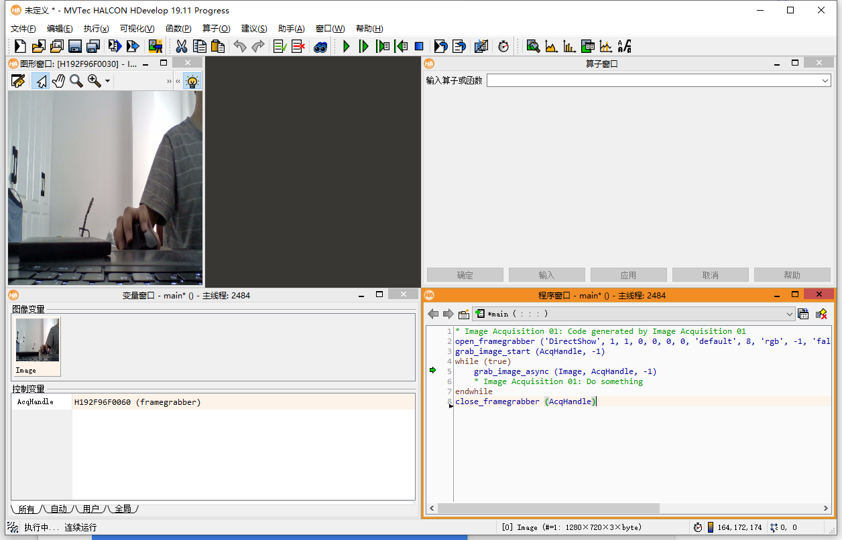

* Image Acquisition 01: Code generated by Image Acquisition 01

open_framegrabber ('DirectShow', 1, 1, 0, 0, 0, 0, 'default', 8, 'rgb', -1, 'false', 'default', '[0] Integrated Camera', 0, -1, AcqHandle)

grab_image_start (AcqHandle, -1)

while (true)

grab_image_async (Image, AcqHandle, -1)

* Image Acquisition 01: Do something

endwhile

close_framegrabber (AcqHandle)