机器视觉第三次作业
190320225 王福栋

一、使用HALCON实现摄像头访问
代码：

* Image Acquisition 01: Code generated by Image Acquisition 01
open_framegrabber('DirectShow',1, 1, 0, 0, 0, 0, 'default', 8, 'rgb',\
-1, 'false', 'default', '[0] Integrated Camera', 0, -1, AcqHandle)
dev_open_window (0, 0, 480, 360, 'black', WindowHandle)
grab_image_start (AcqHandle, -1)
while (true)
grab_image_async (Image, AcqHandle, -1)
* Image Acquisition 01: Do something
* 为了让C程序也能顺利显示出图像，添了个窗口创建和图像resize
zoom_image_size(Image, ZoomedImage, 480, 360, 'bilinear')
dev_display(ZoomedImage)
endwhile
close_framegrabber (AcqHandle)

效果：
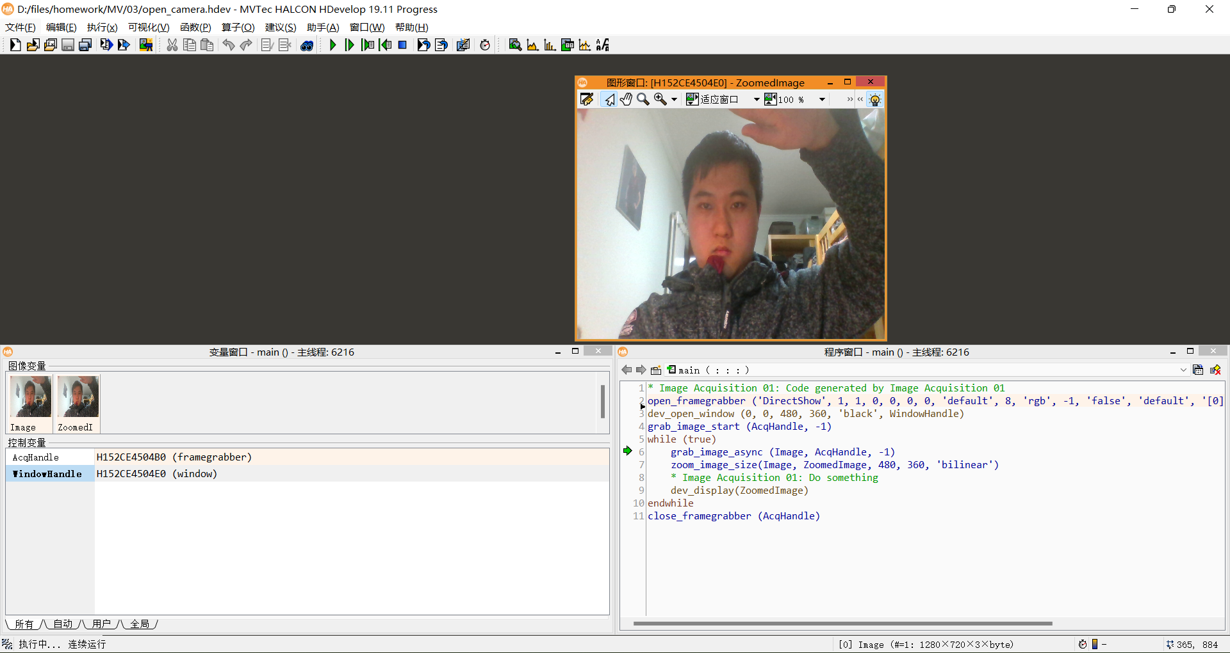

二、导出C++程序并运行
代码较长，见文档最下方。
代码运行效果：
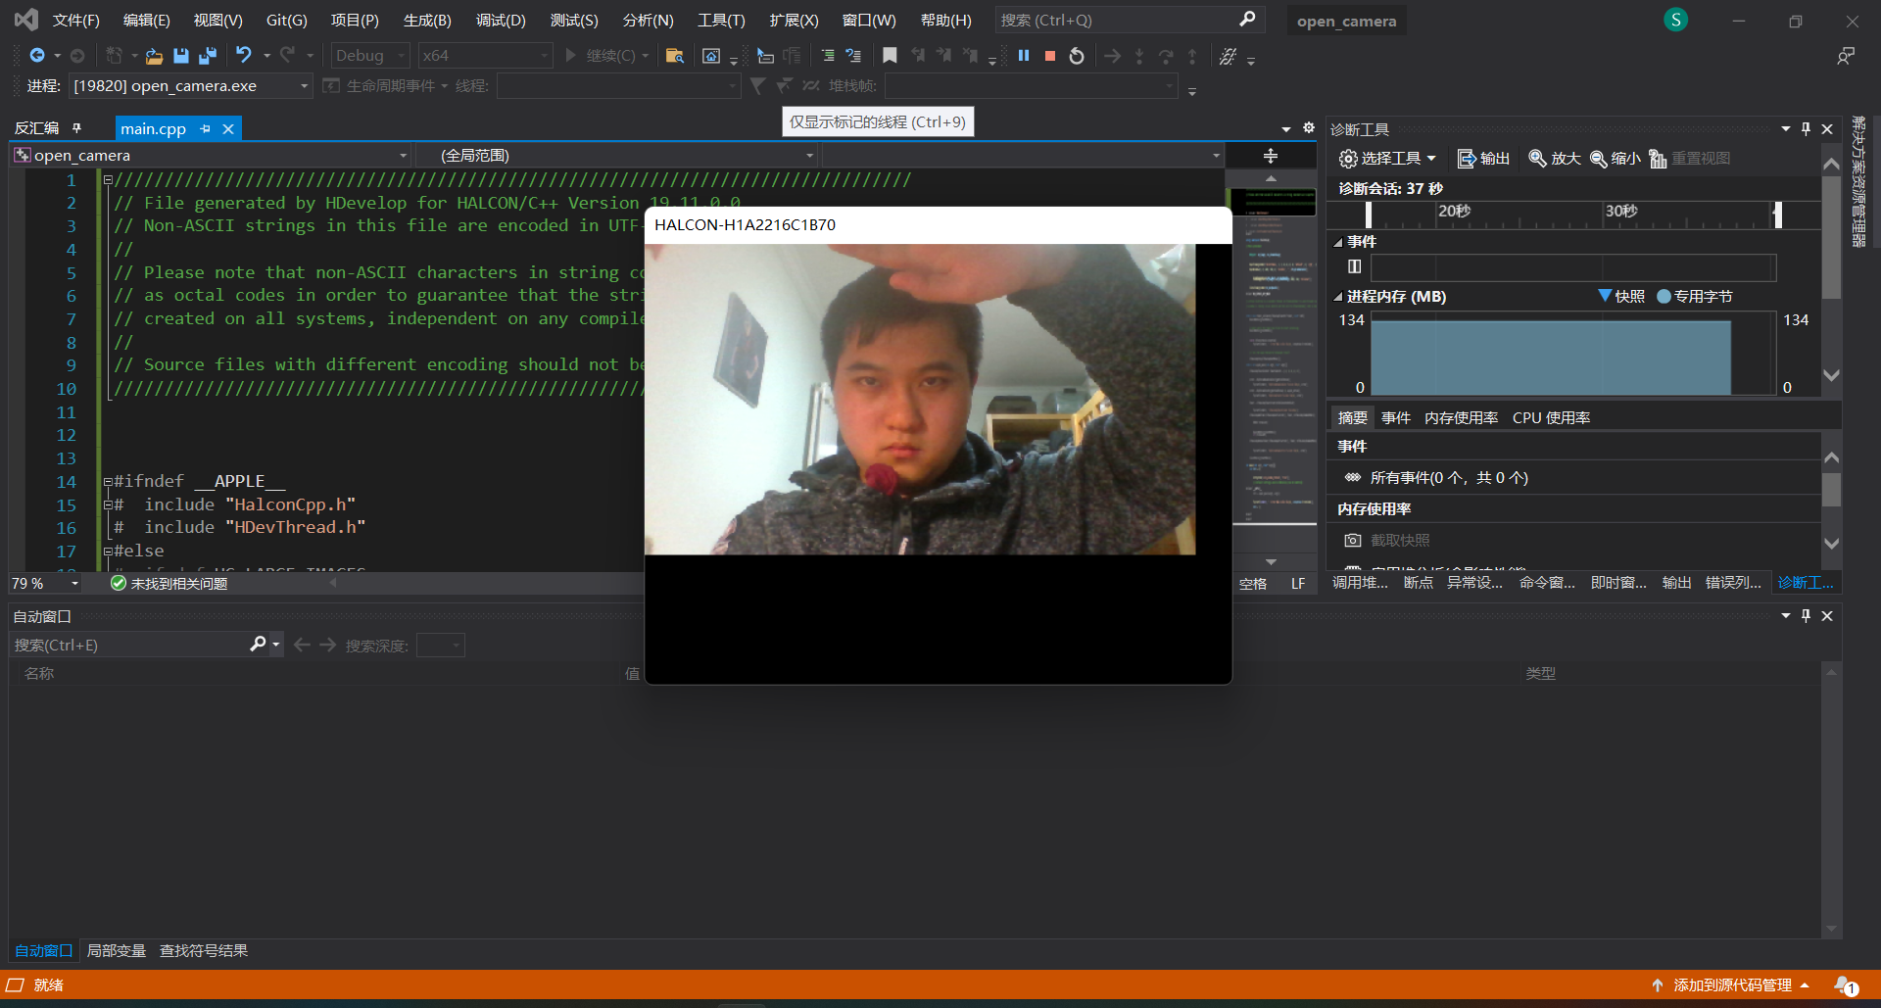
（发现VS编译出来的图像缩放与HALCON内运行出来的图像缩放效果不太一样）

HALCON生成的C程序代码：

///////////////////////////////////////////////////////////////////////////////
// File generated by HDevelop for HALCON/C++ Version 19.11.0.0
// Non-ASCII strings in this file are encoded in UTF-8.
//
// Please note that non-ASCII characters in string constants are exported
// as octal codes in order to guarantee that the strings are correctly
// created on all systems, independent on any compiler settings.
//
// Source files with different encoding should not be mixed in one project.
///////////////////////////////////////////////////////////////////////////////
#ifndef __APPLE__
# include "HalconCpp.h"
# include "HDevThread.h"
#else
# ifndef HC_LARGE_IMAGES
# include <HALCONCpp/HalconCpp.h>
# include <HALCONCpp/HDevThread.h>
# include <HALCON/HpThread.h>
# else
# include <HALCONCppxl/HalconCpp.h>
# include <HALCONCppxl/HDevThread.h>
# include <HALCONxl/HpThread.h>
# endif
# include <stdio.h>
# include <CoreFoundation/CFRunLoop.h>
#endif
using namespace HalconCpp;
#ifndef NO_EXPORT_MAIN
// Main procedure
void action()
{
// Local iconic variables
HObject ho_Image, ho_ZoomedImage;
// Local control variables
HTuple hv_AcqHandle, hv_WindowHandle;
//Image Acquisition 01: Code generated by Image Acquisition 01
OpenFramegrabber("DirectShow", 1, 1, 0, 0, 0, 0, "default", 8, "rgb", -1, "false",
"default", "[0] Integrated Camera", 0, -1, &hv_AcqHandle);
SetWindowAttr("background_color", "black");
OpenWindow(0, 0, 480, 360, 0, "visible", "", &hv_WindowHandle);
HDevWindowStack::Push(hv_WindowHandle);
GrabImageStart(hv_AcqHandle, -1);
while (0 != 1)
{
GrabImageAsync(&ho_Image, hv_AcqHandle, -1);
ZoomImageSize(ho_Image, &ho_ZoomedImage, 480, 360, "bilinear");
//Image Acquisition 01: Do something
if (HDevWindowStack::IsOpen())
DispObj(ho_ZoomedImage, HDevWindowStack::GetActive());
}
CloseFramegrabber(hv_AcqHandle);
}
#ifndef NO_EXPORT_APP_MAIN
#ifdef __APPLE__
// On OS X systems, we must have a CFRunLoop running on the main thread in
// order for the HALCON graphics operators to work correctly, and run the
// action function in a separate thread. A CFRunLoopTimer is used to make sure
// the action function is not called before the CFRunLoop is running.
// Note that starting with macOS 10.12, the run loop may be stopped when a
// window is closed, so we need to put the call to CFRunLoopRun() into a loop
// of its own.
HTuple gStartMutex;
H_pthread_t gActionThread;
HBOOL gTerminate = FALSE;
static void timer_callback(CFRunLoopTimerRef timer, void* info)
{
UnlockMutex(gStartMutex);
}
static Herror apple_action(void** parameters)
{
// Wait until the timer has fired to start processing.
LockMutex(gStartMutex);
UnlockMutex(gStartMutex);
try
{
action();
}
catch (HException& exception)
{
fprintf(stderr, " Error #%u in %s: %s\n", exception.ErrorCode(),
(const char*)exception.ProcName(),
(const char*)exception.ErrorMessage());
}
// Tell the main thread to terminate itself.
LockMutex(gStartMutex);
gTerminate = TRUE;
UnlockMutex(gStartMutex);
CFRunLoopStop(CFRunLoopGetMain());
return H_MSG_OK;
}
static int apple_main(int argc, char* argv[])
{
Herror error;
CFRunLoopTimerRef Timer;
CFRunLoopTimerContext TimerContext = { 0, 0, 0, 0, 0 };
CreateMutex("type", "sleep", &gStartMutex);
LockMutex(gStartMutex);
error = HpThreadHandleAlloc(&gActionThread);
if (H_MSG_OK != error)
{
fprintf(stderr, "HpThreadHandleAlloc failed: %d\n", error);
exit(1);
}
error = HpThreadCreate(gActionThread, 0, apple_action);
if (H_MSG_OK != error)
{
fprintf(stderr, "HpThreadCreate failed: %d\n", error);
exit(1);
}
Timer = CFRunLoopTimerCreate(kCFAllocatorDefault,
CFAbsoluteTimeGetCurrent(), 0, 0, 0,
timer_callback, &TimerContext);
if (!Timer)
{
fprintf(stderr, "CFRunLoopTimerCreate failed\n");
exit(1);
}
CFRunLoopAddTimer(CFRunLoopGetCurrent(), Timer, kCFRunLoopCommonModes);
for (;;)
{
HBOOL terminate;
CFRunLoopRun();
LockMutex(gStartMutex);
terminate = gTerminate;
UnlockMutex(gStartMutex);
if (terminate)
break;
}
CFRunLoopRemoveTimer(CFRunLoopGetCurrent(), Timer, kCFRunLoopCommonModes);
CFRelease(Timer);
error = HpThreadHandleFree(gActionThread);
if (H_MSG_OK != error)
{
fprintf(stderr, "HpThreadHandleFree failed: %d\n", error);
exit(1);
}
ClearMutex(gStartMutex);
return 0;
}
#endif
int main(int argc, char* argv[])
{
int ret = 0;
try
{
#if defined(_WIN32)
SetSystem("use_window_thread", "true");
#endif
// Default settings used in HDevelop (can be omitted)
SetSystem("width", 512);
SetSystem("height", 512);
#ifndef __APPLE__
action();
#else
ret = apple_main(argc, argv);
#endif
}
catch (HException& exception)
{
fprintf(stderr, " Error #%u in %s: %s\n", exception.ErrorCode(),
(const char*)exception.ProcName(),
(const char*)exception.ErrorMessage());
ret = 1;
}
return ret;
}
#endif
#endif

