C++语言程序设计作业1
Note
班级:自动化3班 姓名:卞常灿 学号:2023312216
- 输入一行字符，分别统计出其中英文字母、空格、数字和其他字符的个数。
#include <iostream>
#include <cctype>
int main() {
std::cout<<"Input:";
std::string str;
int alphaNum = 0, digitNum = 0, spaceNum = 0, otherNum = 0;
std::getline(std::cin, str); // 读取整行，可以包括空格
for (char ch: str) { // C++新写法，范围for循环
if(isalpha(ch)) alphaNum++;
else if(isdigit(ch)) digitNum++;
else if(isspace(ch)) spaceNum++;
else otherNum++;
}
std::cout<<"Number of alphas:"<<alphaNum<<std::endl;
std::cout<<"Number of digits:"<<digitNum<<std::endl;
std::cout<<"Number of spaces:"<<spaceNum<<std::endl;
std::cout<<"Number of others:"<<otherNum<<std::endl;
}
运行结果:
Input:1 2 ,1;34... 23&*() asw 2 a
Number of alphas:4
Number of digits:8
Number of spaces:6
Number of others:9
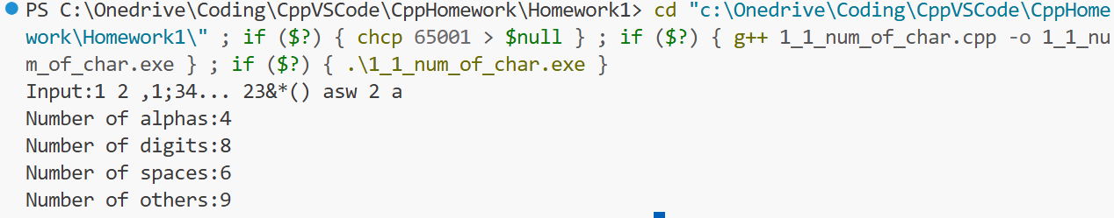
- 给出一个百分制的成绩，要求输出成绩等级‘A'，‘B'，’C'，‘D'，’E‘。90分以上为'A’，80~89分为‘B’，70~79分为'C‘，60~69分为’D‘，60 分以下为'E’。
#include <iostream>
int main() {
std::cout<<"Input score:";
int score = 0;
std::cin>>score;
if (score > 90) std::cout<<"grade:A"<<std::endl;
else if (score > 80) std::cout<<"grade:B"<<std::endl;
else if (score > 70) std::cout<<"grade:C"<<std::endl;
else if (score > 60) std::cout<<"grade:D"<<std::endl;
else std::cout<<"grade:E"<<std::endl;
return 0;
}
运行结果:
Input score:91
grade:A
Input score:42
grade:E
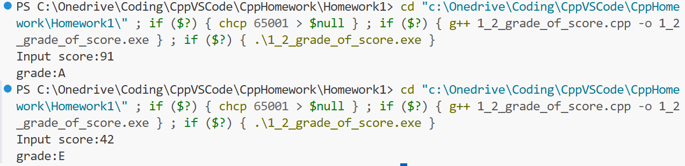
- 输入两个正整数 m和n，求其最大公约数和最小公倍数。
#include <numeric>
#include <iostream>
using namespace std;
int main() {
int m = 0, n = 0;
cout << "Input m: ";
cin >> m;
cout << "Input n: ";
cin >> n;
int g = gcd(m,n);
int l = lcm(m,n);
cout << "GCD:" << g << endl;
cout << "LCM:" << l << endl;
return 0;
运行结果:
Input m: 24
Input n: 36
GCD:12
LCM:72
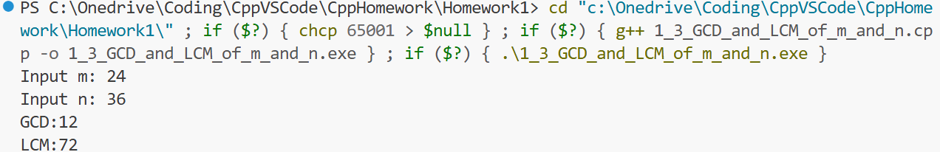
- 一个数如果恰好等于它的因子之和，这个数就称为“完数”。例如，6 的因子为1，2，3，而6=1+2+3，并因此6是“完数”。编写程序找出 1000 之内的所有完数，按下面格式输出其因子: 6, its factors are 1，2，3
#include <iostream>
#include <vector> // 使用C++新特性作动态数组使用
#include <algorithm> // 用于排序
#include <cmath>
using namespace std;
int findAllFactors(int number, vector<int> &factors);
bool isPerfectNumber(int number, vector<int> &realFactors);
int main() {
vector<int> realFactors;
for (int i = 1; i <= 1000; i++) {
if(isPerfectNumber(i,realFactors)) {
cout << i << ", its factors are ";
for (int factor : realFactors) {
cout << factor;
if (factor != realFactors.back()) cout << ", ";
}
cout << endl;
}
}
return 0;
}
/*寻找整数的所有因子并存储到std::vector<int>类型变量中，返回因数个数*/
int findAllFactors(int number, vector<int> &factors) {
int limit = sqrt(number); // 只需遍历1到数的平方根，因为因数都是成对出现的
for (int i = 1; i <= limit; i++) {
if (number % i == 0) {
factors.push_back(i);
if (i*i != number) factors.push_back(number/i);
}
}
sort(factors.begin(),factors.end()); // 将因数从小到大排列
return factors.size();
}
/*判断一个整数是否为完数，并将真因数保存到vector<int>类型中*/
bool isPerfectNumber(int number, vector<int> &realFactors) {
realFactors.clear();
int sum = 0;
findAllFactors(number,realFactors);
realFactors.pop_back(); // 真因数不包含数本身，因此去除最后一个数
for (const int temp : realFactors) sum += temp;
return sum == number;
}
运行结果:
6, its factors are 1, 2, 3
28, its factors are 1, 2, 4, 7, 14
496, its factors are 1, 2, 4, 8, 16, 31, 62, 124, 248


